Victorian Agri–Food Employment in 2021–22

July 2024

Table of Contents

Key highlights 2

Victoria is Australia’s second largest agriculture employer 2

Victoria’s agriculture industries 3

Agrifood Manufacturing 5

Recent changes in employment in Victorian agriculture and food manufacturing 7

Data Tables 9

Technical Notes 15

# Key highlights

* Victoria’s agri-food production and manufacturing industries together employed 153,840 people in 2021–22.
* This includes 68,870 people in Victoria’s agriculture production industries, and 84,970 jobs in food and beverage processing in 2021–22. A further 5,260 people were employed in Agriculture Services.
* Victoria is Australia’s second largest employer within agriculture (24.5 per cent of the national workforce), and its largest employer within agri–food processing (31.2 per cent).
* Victoria’s largest agriculture industry by employment in 2021–22 was Dairy (13,290 people) followed by Beef (10,800) and grains (9,810).
* Production and processing across Victoria’s broader Food and Fibre industries collectively employed 189,050 people in 2021–22 (this includes forestry and logging, aquaculture, fishing, trapping and hunting, as well as agriculture and agriculture services).

# Victoria is Australia’s second largest agriculture employer

* **Australia’s second largest agriculture workforce** (24.5 per cent, after NSW on 27.0 per cent of Australian agriculture employment in 2021-22)
* **Australia’s largest agri-food processing workforce** (31.2 per cent compared to NSW at 27.7 per cent in 2021-22)
* **#1 Dairy employer** (57.3 per cent of Australian dairy employment in 2021-22)
* **#1 in Amenity Horticulture** (33.8 per cent of Australian horticulture employment in 2021-22)
* **#2 in Poultry** (24.7 per cent of Australian poultry employment in 2021-22)
* **#2 in Vegetables** (25.0 per cent of Australian vegetable employment in 2021-22)
* **#2 in Fruit and Nuts** (20.6 per cent of Australian fruit and nut employment in 2021-22).

Figure 1: Agriculture employment by state and territory (2021-22)

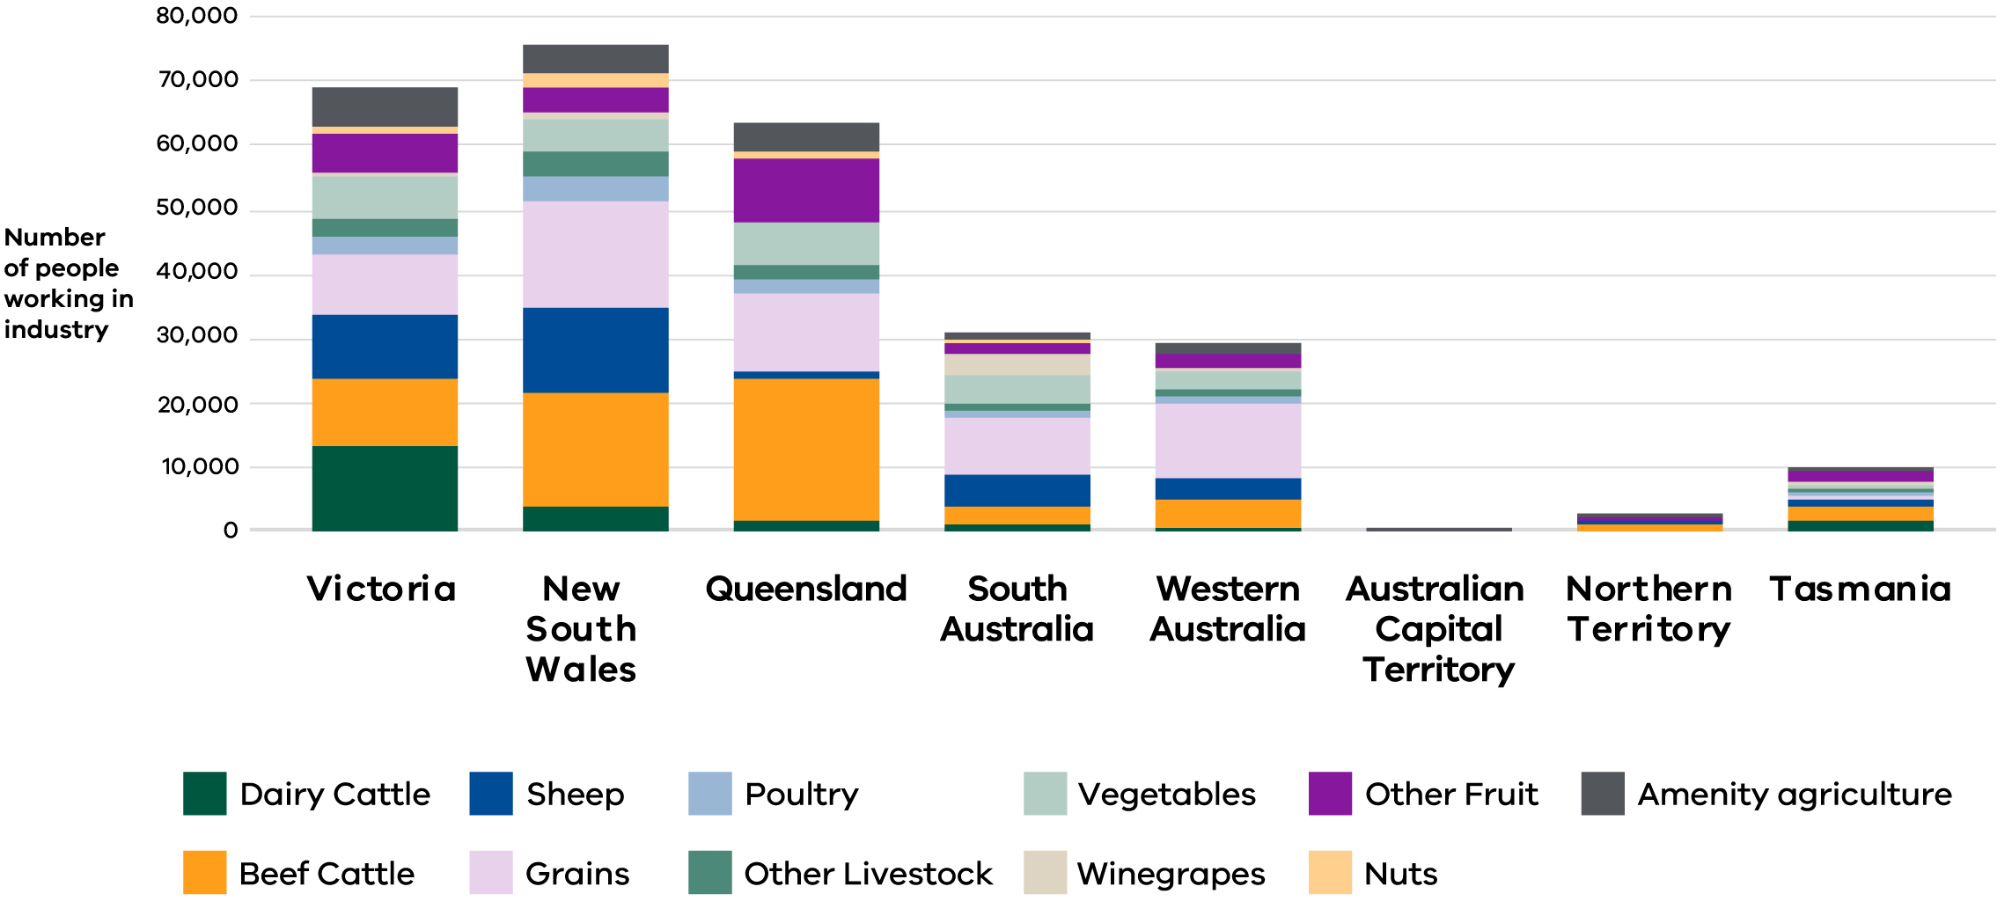

# 

# Victoria’s agriculture industries

* **Dairy:** Victoria is Australia’s largest dairying state (57.3 per cent of national employment in 2021-22), and dairy has Victoria’s largest agricultural workforce with 13,290 people. Dairy employment declined by 3.3 per cent per annum in the five years to 2020-21.
* **Beef:** In 2021-22, 10,800 people worked in Victoria’s beef industry. This equates to 15.7 per cent of national beef industry employment, and 15.7 per cent of Victoria’s total agriculture employment. Beef makes up Victoria’s second largest agricultural workforce. Employment in Victoria’s beef industry grew at 1.9 per cent per annum in the five years to 2020-21.
* **Grains:** has Victoria’s third largest agricultural workforce at 9,810 employees (14.2 per cent of Victorian agriculture employment). Grains industry employment increased at 2.7 per cent per annum in the five years to 2020-21.
* **Sheep:** Victoria’s sheep industry employed 9,500, people in 2021-22, which was 13.8 per cent of Victorian agriculture employment and 27.3 per cent of national sheep employment. The number of people who work in the Victorian sheep industry increased at 1.5 per cent per annum during the five years to 2020-21.
* **Fruit and Nuts:** employed 7,540 people in Victoria in 2021-22. Victoria has Australia’s second largest Fruit and Nut workforce (20.1 per cent). Employment increased by 2.1 per cent per annum during the five years to 2020-21.
* **Vegetables:** employed 6,720 people in 2021-22. Vegetable industry employment grew at 3.2 per cent per annum in the five years to 2020-21. This was the second largest increase among Victorian agriculture industries.
* **Amenity Horticulture:** includes nurseries, floriculture and turf-growing. It employed 6,000 people in 2021-22. Employment grew at 3.9 per cent per annum in the five years to 2020-21 (the highest rate of growth in Victorian agriculture production)
* **Poultry:** 2,550 people worked in Victoria’s poultry industry in 2021-22. Poultry employment grew 1.2 per cent per annum in the five years to 2020-21.
* **Other Animals:** other animal industries, such as pigs, bees, deer and goats, employed 2,660 people in Victoria in 2021-22. Overall these grew at a rate of 0.1 per cent per annum in the five years to 2020-21. Employment in bee-keeping grew by 8.0 per cent per annum, whereas employment in pig production declined 5.8 per cent (see Table 9).
* **Agriculture Services:** employed 5,260 people in 2021-22. It grew 5.8 per cent per annum during the five years to 2020-21: faster than any Victorian agriculture production industry.

Figure 2: Employment by major industry and Victorian Regional Partnership Region (2021-22)

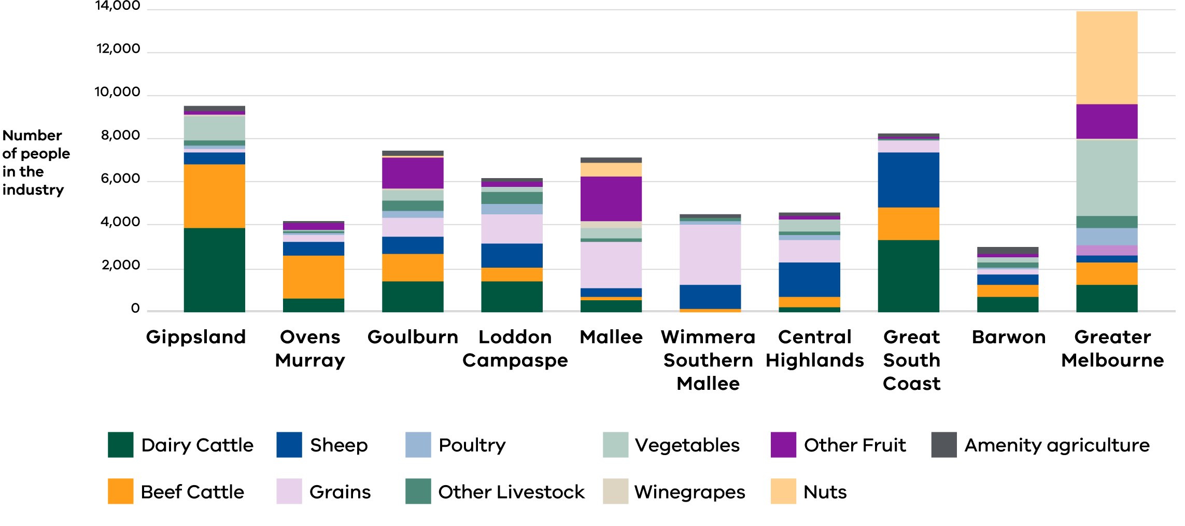

# 

# Agrifood Manufacturing

* Victoria’s food and drink manufacturing industries employed 84,970 people in 2021-22. Employment in Victoria’s food and drink manufacturing industries was dominated by the following industries: Other Food Products (40.0 per cent; more than half of which was Bakery Products), Meat and Meat Products (21.8 per cent), Dairy (16.1 per cent) and Beverages (12.4 per cent, especially Wine and Spirits).
* Victoria’s food and drink manufacturing industries grew by 2.0 per cent per annum in the five years to 2020-21. This equated to an additional 7,620 jobs. This was driven especially by growth in the processing of meat and meat products, dairy and beverages.
* Non-agricultural food and fibre processing industries contracted by 1.2 per cent per annum during this period.
* The fastest growing food and drink manufacturing industries in the five years to 2020-21 were Seafood (8.4 per cent annual growth), Oil and Fats (6.1 per cent) and Grain and Cereal Products (5.4 per cent). No food or beverage processing industries experienced decline, however Tobacco Product Manufacturing experienced a 56.0 per cent per annum decline.
* Growth in Victoria’s food and beverage manufacturing industries was unevenly distributed across Victoria during the five years to 2020-21. Growth was highest in Barwon (increasing 3.9 per cent per annum), Melbourne (2.8 per cent) and Gippsland (1.2 per cent). Food and beverage processing industries experienced employment decline in Goulburn (-1.6 per cent per annum) and Loddon Campaspe (-0.5 per cent).
* While Dairy Manufacturing grew for Victoria overall (by 2.6 per cent annually), it contracted in nearly all areas outside of Melbourne and Geelong. This included Goulburn (-1.5 per cent), Loddon Campaspe (-0.8 per cent), Great South Coast
* (-0.7 per cent), and Ovens Murray (-0.8 per cent). Growth was concentrated most especially in Melbourne (growing 2.6 per cent per annum; 1,560 jobs over the five years), Barwon (3.5 per cent per annum, or 120 jobs) and Central Highlands (8.7 per cent per annum, or 60 jobs).

Figure 3: Size and composition of agri-food processing employment in Victoria’s Regional Partnership regions (2021-22)

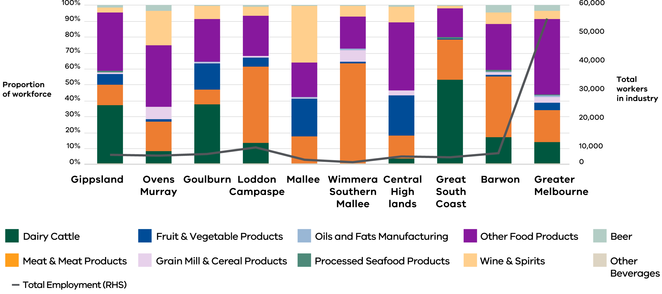

# 

# Recent changes in employment in Victorian agriculture and food manufacturing

* The most reliable data on recent changes in agriculture employment is from the Census of Population and Housing (‘the Census’). Census data indicates that Victoria’s agriculture workforce increased by 3,360 people in the five years to 2020-21, which was equal to 1.0 per cent compound annual growth.
* Amenity Horticulture was the strongest area of employment growth in Victorian agriculture between 2015-26 and 2020-21 (e.g. nurseries, which had an annual growth rate of 3.9 per cent), followed by Vegetables (growth rate of 3.2 per cent).
* Victorian Dairy industry employment declined 3.3 per cent per annum on average between 2015-16 and 2020-21.
* Employment growth in Victorian agriculture was concentrated especially in Greater Melbourne, driven by Amenity Horticulture, Vegetables and Fruit and Nuts. The next strongest growth occurred in the Central Highlands and Mallee Regional Partnership regions. Agriculture employment declined in Gippsland.
* Dairy was the only agriculture industry whose employment numbers declined statewide during this period (by 3.3 per cent per annum).

# Data Tables

Table 1: Employment in Victoria’s food and fibre production and manufacturing industries (2021-22)

| Industry | Employment in 2021-22 | Imputed growth rate FY21 to FY22* | Average CAGR FY16 to FY21* | Share of AFF, 2021-22 | Share of Agriculture, 2021-22 | Share of AFF Manufacturing, 2021-22 |
| --- | --- | --- | --- | --- | --- | --- |
| **Agriculture, Forestry  and Fishing (AFF)** | **77,569** | **3.3** | **1.3** | **100.0** |  |  |
| Agriculture | **68,871** | 3.3 | 1.0 | **88.0** | **100.0** |  |
| Dairy | 13,286 | 3.3 | -3.3 |  | 19.3 |  |
| Beef | 10,799 | 3.3 | 1.9 |  | 15.7 |  |
| Sheep | 9,498 | 3.3 | 1.5 |  | 13.8 |  |
| Grains | 9,809 | 3.3 | 2.7 |  | 14.2 |  |
| Poultry | 2,553 | 3.3 | 1.2 |  | 3.7 |  |
| Other livestock | 2,664 | 3.3 | 0.1 |  | 3.9 |  |
| Fruit and Nuts | 7,539 | 3.3 | 2.1 |  | 10.9 |  |
| Vegetables | 6,723 | 3.3 | 3.2 |  | 9.8 |  |
| Amenity horticulture | 6,001 | 3.3 | 3.9 |  | 8.7 |  |
| AFF Support Services | **5,920** | 3.3 | **5.8** | **7.6** |  |  |
| Aquaculture | **364** | 3.3 | **1.2** | **0.5** |  |  |
| Fishing, Hunting and Trapping | **580** | 3.3 | **-3.8** | **0.7** |  |  |
| Forestry and Logging | **1,834** | 3.3 | **2.0** | **2.4** |  |  |
| **Food and Fibre Manufacturing** | **111,484** | **3.3** | **1.2** |  |  | **100.0** |
| Beverages | 10,506 | 3.3 | 2.5 |  |  | 9.4 |
| Food Products | 74,461 | 3.3 | 1.9 |  |  | 66.8 |
| Pulp, Paper and Converted Paper Products | 7,323 | 3.3 | -0.3 |  |  | 6.6 |
| Wood Products | 9,139 | 3.3 | -1.5 |  |  | 8.2 |
| Textile, Leather, Clothing and Footwears | 10,056 | 3.3 | -1.6 |  |  | 9.0 |
| **Food and Fibre Production and Manufacturing** | **189,053** | **3.3** | **1.2** |  |  |  |

* The most meaningful data on recent trends in the agri-food industry workforce is from the 2016 and 2021 Censes. Statistically reliable data is not available for annual growth in agricultural employment between 2020-21 and 2021-22, due to the small sample size for Victorian agriculture in the Labour Force Survey (see Technical Notes). For growth between 2020-21 and 2021-22, this fact sheet takes a conservative approach and assumes that employment in Victoria’s food and fibre production and processing industries grew at the same rate as the national workforce, as indicated by the LFS.

Table 2: State and territory by agriculture industry (employment, 2021-22)

|  | Victoria | New South Wales | Queens-land | South Australia | Western Australia | Australian Capital Territory | Northern Territory | Tasmania | Total |
| --- | --- | --- | --- | --- | --- | --- | --- | --- | --- |
| Dairy Cattle | 13,286 | 3,823 | 1,667 | 1,363 | 1,008 | 27 | 8 | 2,009 | 23,190 |
| Beef Cattle | 10,799 | 17,827 | 22,063 | 2,516 | 4,212 | 40 | 1,592 | 1,820 | 60,869 |
| Sheep | 9,498 | 13,454 | 1,327 | 5,304 | 3,539 | 85 | 7 | 1,639 | 34,853 |
| Grains | 9,809 | 16,365 | 12,207 | 8,753 | 11,442 | 15 | 38 | 363 | 58,993 |
| Poultry | 2,553 | 3,660 | 1,961 | 923 | 924 | 105 | 4 | 205 | 10,336 |
| Other Livestock | 2,664 | 4,202 | 2,165 | 1,050 | 1,055 | 57 | 45 | 247 | 11,486 |
| Vegetables | 6,723 | 4,811 | 6,906 | 4,360 | 2,621 | 10 | 244 | 1,253 | 26,928 |
| Winegrapes | 546 | 829 | 2 | 3,401 | 803 | 0 | 0 | 431 | 6,012 |
| Other Fruit | 6,129 | 4,187 | 9,697 | 1,646 | 2,006 | 27 | 273 | 1,474 | 25,438 |
| Nuts | 864 | 2,224 | 1,284 | 563 | 247 | 0 | 0 | 29 | 5,210 |
| Amenity horticulture | 6,001 | 4,387 | 4,071 | 1,072 | 1,460 | 146 | 140 | 505 | 17,780 |
| Total | 68,871 | 75,767 | 63,350 | 30,951 | 29,317 | 512 | 2,351 | 9,976 | 281,095 |

Table 3: Regional Partnership region by agriculture industry (employment, 2021-22)

|  | Gippsland | Ovens Murray | Goulburn | Loddon Campaspe | Mallee | Wimmera Southern Mallee | Central Highlands | Great South Coast | Barwon | Greater Melbourne | Total |
| --- | --- | --- | --- | --- | --- | --- | --- | --- | --- | --- | --- |
| Dairy Cattle | 3,911 | 615 | 1,387 | 1,438 | 527 | 4 | 180 | 3,296 | 678 | 1,251 | 13,286 |
| Beef Cattle | 2,896 | 2,014 | 1,288 | 627 | 198 | 108 | 514 | 1,580 | 536 | 1,038 | 10,799 |
| Sheep | 615 | 616 | 779 | 1,114 | 331 | 1,121 | 1,550 | 2,549 | 478 | 344 | 9,498 |
| Grains | 118 | 319 | 919 | 1,300 | 2,151 | 2,779 | 1,060 | 492 | 235 | 436 | 9,809 |
| Poultry | 205 | 33 | 338 | 503 | 62 | 193 | 224 | 36 | 148 | 809 | 2,553 |
| Other Livestock | 172 | 118 | 480 | 604 | 112 | 114 | 226 | 37 | 216 | 585 | 2,664 |
| Vegetables | 1,181 | 79 | 467 | 180 | 474 | 30 | 538 | 68 | 235 | 3,470 | 6,723 |
| Winegrapes | 7 | 39 | 34 | 27 | 320 | 1 | 18 | 4 | 7 | 89 | 546 |
| Other Fruit | 165 | 253 | 1,428 | 227 | 2,106 | 35 | 130 | 31 | 115 | 1,639 | 6,129 |
| Nuts | 13 | 67 | 75 | 5 | 660 | 0 | 4 | 0 | 0 | 40 | 864 |
| Amenity horticulture | 259 | 82 | 239 | 187 | 217 | 126 | 175 | 144 | 312 | 4,260 | 6,001 |
| Total | 9,542 | 4,234 | 7,435 | 6,212 | 7,158 | 4,513 | 4,618 | 8,237 | 2,961 | 13,960 | 68,871 |

Table 4: Regional Partnership region by agri-food processing industry (employment, 2021-22)

|  | Gippsland | Ovens Murray | Goulburn | Loddon Campaspe | Mallee | Wimmera Southern Mallee | Central Highlands | Great South Coast | Barwon | Greater Melbourne | Total |
| --- | --- | --- | --- | --- | --- | --- | --- | --- | --- | --- | --- |
| Dairy Products | 1,337 | 290 | 1,451 | 869 | 6 | 0 | 116 | 1,416 | 734 | 7,485 | 13,703 |
| Meat Products | 478 | 632 | 358 | 3,076 | 290 | 568 | 424 | 662 | 1,640 | 10,423 | 18,552 |
| Fruit & Vegetable | 237 | 52 | 653 | 357 | 396 | 10 | 756 | 12 | 37 | 2,482 | 4,992 |
| Cereals Products | 38 | 257 | 5 | 74 | 11 | 65 | 97 | 0 | 65 | 1,846 | 2,458 |
| Oils & Fats | 0 | 0 | 25 | 4 | 8 | 6 | 0 | 0 | 24 | 514 | 581 |
| Seafood | 31 | 0 | 4 | 0 | 0 | 0 | 0 | 31 | 55 | 231 | 353 |
| Other Foods | 1,325 | 1,306 | 1,034 | 1,589 | 359 | 183 | 1,285 | 481 | 1,242 | 25,019 | 33,822 |
| Wine & Spirits | 116 | 733 | 306 | 369 | 595 | 58 | 292 | 39 | 310 | 2,680 | 5,498 |
| Beer | 45 | 118 | 21 | 58 | 5 | 3 | 26 | 9 | 182 | 1,836 | 2,304 |
| Other Beverages | 10 | 22 | 13 | 36 | 15 | 34 | 23 | 4 | 23 | 2,524 | 2,704 |
| Total | 3,617 | 3,410 | 3,870 | 6,432 | 1,685 | 927 | 3,019 | 2,654 | 4,312 | 55,040 | 84,967 |

# Technical Notes

* This fact sheet reports ABS data from the Labour Force Survey (LFS) and Census of Population and Housing (‘the Census’).
* In order to reduce statistical volatility in the LFS data, the LFS has been used to determine the size of Australia’s national workforce, while the Census has been used to determine the structure of this workforce (by industry and region).
* This approach has been endorsed by the Agriculture Workforce team of the Australian Bureau of Agricultural and Resource Economics and Sciences (ABARES).

#### Agriculture Policy and Programs

**Contact:**

Peter Parbery: [peter.parbery@agriculture.vic.gov.au](mailto:peter.parbery@agriculture.vic.gov.au)

‘Source: ABS 2021-22. Produced using data from the Labour Force Survey (2021-22) and Census of Population and Housing (2021). As of July 2024, 2021-22 is the latest year for which a complete set of agriculture data is available.’

**End of document.**