Sampling soil, vegetables, fruit and grain for residue testing
To determine whether agricultural produce complies with maximum residue limits (MRLs) for chemical residues, or maximum levels (MLs) for metal residues, or whether soil contains organochlorine insecticide residues such as dieldrin or DDT which could be a concern to your agricultural interests, it is necessary to provide a representative sample to the laboratory for analysis. No matter how carefully laboratory analyses are carried out, the results will be of limited value unless the sample provided is truly representative of the produce or soil being tested.
These guidelines aim to provide the information necessary to allow you to take a representative sample that can be sent to National Association for Testing Authorities (NATA) accredited laboratories for testing. You can then be more confident that the results obtained are a true indication of the residue status of the crop, paddock or product lot tested, and that decisions are based on accurate information.

General rules for sampling fruit, vegetables and grains
The following procedures are based on methods of sampling recommended by the Codex Alimentarius Commission and the Food and Agriculture Organisation.
- Separate samples should be sent for distinct lots of produce. Submit separate samples to the laboratory if you are dealing with different fruits, vegetables or grains; different cultivars or varieties; areas of crop which have had different chemical treatments, or which have been sprayed on different days; produce sourced from different growers for repacking or processing.
- Do not freeze fresh produce. As a general rule all samples, especially samples of perishable fresh produce, should be kept cool BUT NOT FROZEN. However, samples of already frozen foods should be kept frozen until they reach the laboratory.
- Individual fruits and vegetables should not be cut or divided

Taking Produce samples in the field
Representative samples of the crop must be taken by a recognised procedure. Each plant or fruit should have an equal chance of being chosen. Even when using the best possible sampling techniques there will be variability between different samples. For a better estimate of the residue status of a crop, take duplicate samples.
- Sample the parts of the crop that normally constitute the marketable produce.
- Avoid taking diseased or under-sized crop parts or produce at a stage when it would not normally be harvested.
- Take samples in such a way as to be reasonably representative of typical harvesting practice.
- Take care not to remove surface residues during handling, packing or preparation.
- Sample and bag the required weight of samples in the field and do not sub-sample.
- Keep records of the samples taken and the method used. The sampling procedure to be followed and the minimum amount to be sampled are given in Tables 1-6.

Fruit and tree nuts
- Circle each tree or bush and select fruit from all segments of the tree or plant, high and low, exposed and protected by foliage. For small fruits grown in a row, select fruit from both sides, but not within 1 metre of the end of the row.
- Select the quantity of the fruit according to its density on the tree or plant, i.e., take more from the heavily laden parts.
- Take both large and small fruits where appropriate, but not so small or damaged that they could not be sold.
- Take samples of fruit juices, cider and wine in a manner reflecting common practice.

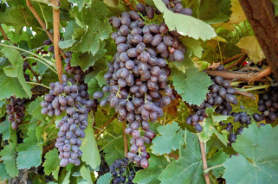
Figure 1 Table grapes
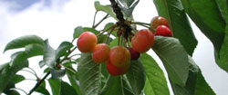
Figure 2 Cherries

Commodity |  | Quantity, method of collection
Citrus fruits e.g., orange, lemon, mandarin, pomelo, grapefruit, clementine, tangelo,  tangerine |  | A total of 12 fruits from several places on 4 individual trees.  (If this produces a sample weight of less than 2 kg, more fruit should be taken to yield a 2kg sample)
Pome fruits e.g., apples, pears, quinces, medlars
Large stone fruit e.g., apricots, nectarines, peaches, plums
Miscellaneous fruit e.g., avocados, guavas, mangoes, papayas, pomegranates, persimmons, kiwifruit, litchi
Small stone fruit e.g., cherries |  | A total of 1 kg from several places on 4 trees
Grapes |  | A total of 12 bunches, or parts of 12 bunches, from separate vines to give at least 1 kg
Currants, raspberries and other small berries |  | A total of 0.5 kg from 12 separate areas or bushes
Strawberries,  Gooseberries |  | A total of 1 kg from 12 separate areas or bushes
Miscellaneous small fruits e.g., olives, dates, figs |  | A total of 1 kg from several places on 4 trees
Pineapples |  | A total of 12 fruits
Bananas |  | A total of 24 fruits. Take two fingers each from top, middle and lowest hand of four harvestable bunches
Tree nuts e.g., walnuts, chestnuts, almonds |  | A total of 1 kg
Coconut |  | A total of 12 nuts
Fruit juices, wine, cider |  | 1 litre

Table 1. Sampling of fruits

Bulb, root and tuber vegetables
- Take samples from all over the plot, excluding 1 metre at the edges of the plot and the ends of the rows. The number of sampling points depends on the sample size of the crop (see below).
- To provide a representative sample of the raw commodity, adhering soil may have to be removed. This may be done by brushing and, if necessary, gentle rinsing with cold running water.
- Trim off tops according to local agricultural practice. Details of any trimming should be recorded. Where the tops are not used as animal feed (carrots, potatoes) they should be discarded; otherwise (e.g., turnips, beets) they should be bagged separately.
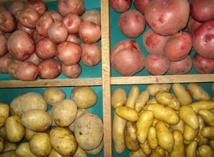
Figure 3 Potatoes

Table 2. Sampling of bulb, root, and tuber vegetables

Commodity | Quantity, method of collection
Fodder beets,  sugar beets | 12 plants
Potatoes | 12 tubers (the sample should weigh at least 2 kg - where necessary, take a larger number to produce a 2kg sample)
Other root crops e.g., carrots, red beet, Jerusalem artichoke, sweet potato, celeriac, turnip, swede, parsnip, horseradish, salsify, chicory, radish, scorzonera | 12 roots (the sample should weigh at least 2 kg - where necessary, take a larger number to produce a 2kg sample)
Leeks,  bulb onions | 12 plants
Spring onions | 24 plants (the sample should weigh at least 2 kg - where necessary, take a larger number to produce a 2kg sample)
Garlic,  shallots | 12 bulbs from 12 plants (the sample should weigh at least 2 kg - where necessary, take a larger number to produce a 2 kg sample)

Brassica vegetables, leafy vegetables, stalk and stem vegetables, legume vegetables and fruiting vegetables
- Take the sample from all parts of the plot, leaving 1 metre at the edges and ends of rows. The number of sampling points depends on the sample size of the crop (see below)
- Sample items of crops such as peas or beans protected from the spray by foliage and also from parts exposed to the spray.

Table 3. Sampling of other vegetables

Commodity | Quantity, method of collection
Large brassica crops e.g., cabbage, cauliflower, kohlrabi | 12 plants
Broccoli | 1 kg from 12 plants
Brussels sprouts | 1 kg from 12 plants. Buttons to be taken from at least two levels on each plant
Cucumbers | 12 fruits from 12 separate plants
Gherkins, courgettes, squash | 12 fruits from 12 plants (the sample should weigh at least 2 kg - where necessary take a larger number of fruit to produce a 2kg sample)
Melons, gourds, pumpkins, watermelons | 12 fruits from 12 separate plants. In case of large crops, a sample consisting of 12 units could be 50-100 kg or more. In such cases the sample size may be reduced to 5 units
Egg plants (aubergines) | 12 fruits from 12 separate plants
Sweet corn | 12 ears (the sample should weigh at least 2 kg - where necessary take a larger number of items to produce a 2kg sample)
Mushrooms | 12 items (the sample should weigh at least 0.5 kg - where necessary take a larger number of items to produce a 0.5 kg sample)
Tomatoes,  peppers | 24 fruits from small-fruiting varieties, 12 from large fruiting varieties. From 12 plants in all cases (the sample should weigh a minimum of 2 kg - where necessary take a larger number of items to produce a 2kg sample)
Endive | 12 plants
Lettuce | 12 plants
Spinach,  chicory leaves | 1 kg from 12 plants
Kale | 2 kg from 12 plants sampled from two levels on the plant
- To provide a representative sample of the raw commodity, adhering soil may have to be removed. This may be done by brushing and, if necessary, gentle rinsing with cold running water.
- Do not trim except for the removal of obviously decomposed or withered leaves. Details of any trimming should be recorded.

Cereals
- If the plot is small, cut the whole yield.
- If the plot is large but mechanical harvesting is not carried out, cut not less than twelve short lengths of row chosen from all over the plot. Cut stalks 15 cm above the ground and remove the grain from the straw.
- Care should be taken to avoid contamination when mechanical methods are used to separate the parts of the crop. The operation is best carried out in the laboratory.
- If the plots are harvested mechanically, take not less than twelve grab samples of grain and straw from the harvester at uniform intervals over the plot.
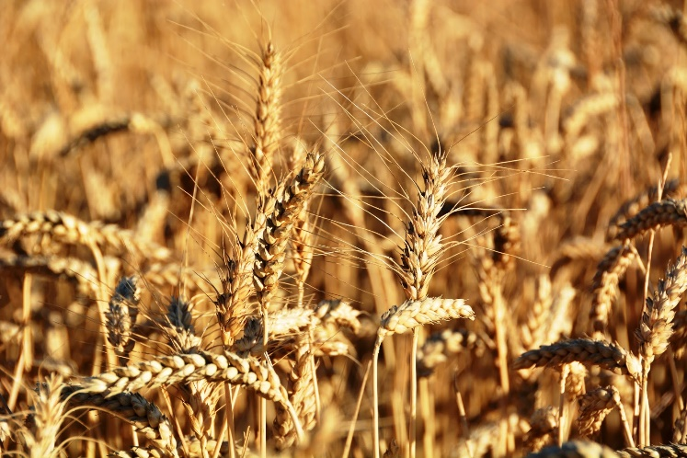
- Do not sample within 1 metre of the edges of the plot.
Figure 4 Wheat

Table 4. Sampling of cereals
Commodity | Quantity, method of collection
Cereal grains e.g., wheat, barley, oats, rye, triticale and other small grain cereals; maize (off the cob), rice, sorghum | 1 kg
Straw of the above crops | 0.5 kg
Maize straw, fodder and forage  (mature plants excluding cobs) | 12 plants (Cut each stem into three equal lengths with leaves attached. Take top portion from stems 1 to 4, middle portion from stems 5 to 8 and bottom portion from stems 9 to 12, thus ensuring that parts of all 12 stems are included in the sample)
Green or silage maize | 12 plants (cut each stem and subsample as in previous item, retaining any cobs present on the appropriate portions of stem)
Maize cobs | 12 ears (the sample should weigh at least 2 kg - where necessary, take a larger number of ears to produce a 2kg sample)

Grasses, forage and animal feed
- Cut with shears at normal harvest height (usually 5 cm above the ground) the vegetation from not less than twelve areas uniformly spaced over the entire plot, leaving 1 metre at the edges of the plot.
- Record height of cutting and avoid soil contamination.
- Crops which are harvested mechanically can be sampled by taking not less than twelve grab samples from the harvester at uniform intervals over the plot.

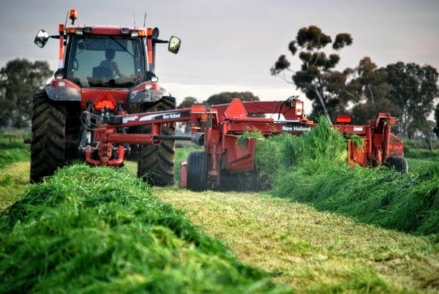
Table 5. Sampling of forage crops and animal feed
Commodity | Quantity, method of collection
Green forage or silage crops of alfalfa, clover, pea and bean forage, vetch, sainfoin, lotus, soya bean fodder and forage, rye forage, fodder cereals, sorghum forage | 1 kg
Dry hay of the above crops | 0.5 kg

Figure 5 Silage crop

Herbs and spices, tea leaves, hops
- Take samples in a manner reflecting common practice.
- The freshly harvested produce is not normally required for tea although herbs, such as parsley and chives, should be sampled fresh. In the case of hops, both fresh and dried cones should be supplied.

Table 6. Sampling of herbs and spices; tea leaves and hops
Commodity | Quantity, method of collection
Garden herbs and medicinal plants e.g., parsley, thyme | 0.5 kg fresh  0.2 kg dry
Teas (dry leaves) | 0.2 kg
Hops (dry cones) | 0.5 kg

Taking a sample of harvested produce
Each laboratory sample should be made up of several individual sub-samples. As far as possible, sub-samples should be taken randomly throughout the lot and should be of a similar size. For example: sub-samples would consist of a single fruit or vegetable for larger items; a single bunch or bundle for grapes, asparagus, etc.; a single punnet or a small scoop of produce for small items (peas, berries etc.). If produce has been packaged, sub-samples should be taken from more than one box in the lot.
For cereals and other materials shipped in bulk, take a number of sub-samples (at least 10) from different places. In some cases, it may be possible to do this by taking small grab samples while it is being unloaded, or else use a grain sampling probe which allows for sampling at different depths.
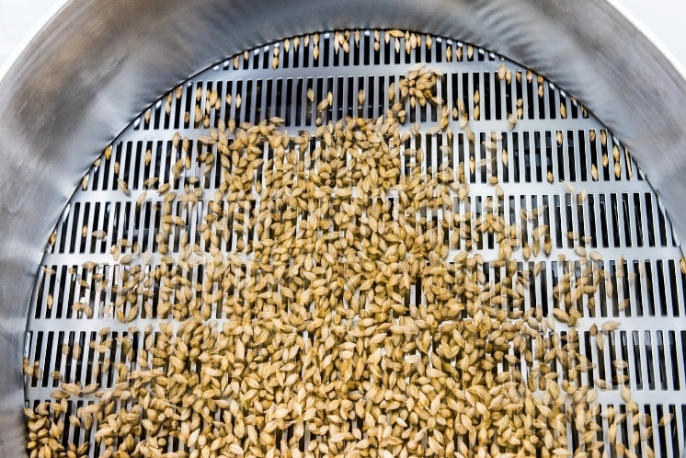
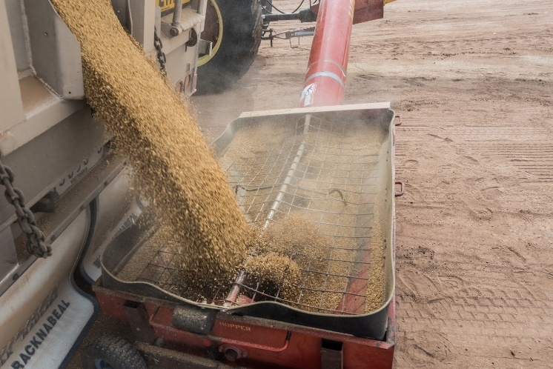
The minimum number of sub-samples to be taken is given in Table 7. The minimum quantity that should be sent to the laboratory is given in Table 8. Ensure that the requirements in both Table 7 and Table 8 are met.
Figure 6 Grain being unloaded
Figure 7 A subsample of grain

Table 7: Subsampling
Weight of lot (kg) | Minimum number of sub-samples
Less than 50 | 3
50 - 500 | 5
More than 500 | 10
For product in bulk which can be assumed to be well mixed or homogenous e.g., grains, the laboratory sample should consist of at least 10 sub-samples.
For processed products in cans, bottles, packages or other small containers, especially when the weight of the lot is unknown, the following sampling plan may be followed
Number of cans, packages or containers in the lot | Minimum number of sub-samples
1-25 | 1
26-100 | 5
More than 100 | 10

Table 8: Sample quantity required
Commodity | Examples | Minimum quantity required
Small or light products, unit weight up to about 25 g | Berries, peas, asparagus (if not bunched), olives | 1 kg
Medium sized products, unit weight usually between 25 and 250 g | Apples, pears, citrus, potatoes, broccoli, Chinese vegetables | 1 kg (at least 10 units)
Large sized products, unit weight over 250g | Cabbage, melons, cucumbers,  grapes (bunches) | 2 kg (at least 5 units)
Grains and oilseeds |  | 1 kg
Herbs | Parsley, coriander | 0.5kg (whole units)

Examples
- 2 pallets of apples are to be sampled. They consist of identically marked boxes and are clearly all of the same variety. This is one lot. The total estimated weight of the lot is >500 kg. The minimum number of sub-samples required is 12 (Table 1). This is also the minimum number of units required for the laboratory sample (Table 8). One apple should be taken from each of 12 separate boxes randomly over the two pallets. If 12 apples do not weigh more than 1 kg, take sufficient extra sub-samples to bring the final sample weight up to 1 kg.
- 8 pallets of grapes are to be sampled. 4 pallets consist of sultana grapes and 4 of purple grapes. These are two distinct lots. It is decided to only take samples from the purple grapes. The total estimated weight of the 4 pallets is >500 kg, so at least 10 samples must be taken (Table 7). One bunch of grapes is taken from each of 10 randomly placed boxes throughout the 4 pallets. These combined, give a weight greater than 2 kg, which is more than the minimum quantity required (Table 8), so no more sub-samples need to be taken.
If replicate samples were required, they could be obtained by either repeating the above procedures for each replicate, or by taking two sub-samples from each randomly selected box and placing them into separate sample bags.

Taking a soil sample

General rules for sampling soils
- Individual blocks or paddocks or areas of paddocks likely to have been subjected to different chemical treatments should be sampled separately.
- The area sampled should be of the one soil type.
- Do not mix different soil types.
- Preferably, soil should be collected using a core-type sampling tool. These may be available for loan from your nearest Department of Primary Industries office. Alternatively, you can construct your own using a clean section of metal pipe between 1-3 cm diameter.
- Sample a typical area. Avoid any part of the paddock which is atypical e.g., fence lines, headlands, near gates, troughs, dams or trees.
- Targeted sampling from small areas, e.g., around power poles, fence posts, old tree stumps or old dip sites, may be required to identify residue 'hot spots'.

Because of the variable distribution of chemical residues in soil, this sampling procedure is more rigorous than that required for soil fertility testing.
Each sample should consist of a composite of 40 cores, each 10 cm deep. At least one composite sample should be taken for every 5 ha (12.5 acres). Mentally divide the area to be sampled (no more than 5 ha) into 40 equal areas or zones, using fence posts or other markers as a guide. Take one core from each zone. Alternatively, divide the area into twenty zones and take two cores from each. Combine all the cores in a clean container such as a bucket and mix thoroughly. Remove about 1/2 - 1 kg of soil and package up for transport to the laboratory.

Packaging and transport of samples
Avoid contaminating the sample. Samples should not be stored anywhere near chemicals, or near where chemicals have been stored. If you have been handling chemicals, ensure that your hands and clothing are clean before handling any samples. Do not use any container for the packaging or transport of samples that may have been used for the storage of agricultural chemicals.
Individual samples should be well packaged, so that there is no possibility of sample leakage or cross-contamination (large zip-lock polyethylene bags or foil-lined paper bags are suitable). Sample containers must be well labelled and clearly identified, with no possibility of labels becoming separated from the sample or damaged by moisture. Samples must be kept cool (e.g., in an insulated container with ice packs) and sent to the laboratory as soon as possible, taking any necessary precautions against leakage or spoilage.

References
Codex Alimentarius Commission (1999) Recommended Methods of Sampling for the Determination of Pesticide Residues for Compliance with MRLs, CAC/GL 33-1999.
FAO (2002) Submission and evaluation of pesticide residues data for the estimation of maximum residue levels in food and feed. Rome: Food and Agriculture Organisation.

Further information
National Association of Testing Authorities (NATA) website: https://www.nata.com.au/
Agriculture Victoria Chemical Use website www.agriculture.vic.gov.au/chemicals
AgVic Biosecurity Officers – Chemicals
Email: chemicalstandards@agriculture.vic.gov.au
© THE STATE OF VICTORIA DEPARTMENT OF
JOBS, PRECINCTS & REGIONS, AUGUST 2022.
Accessibility
If you would like to receive this publication in an accessible format, please telephone Agriculture Victoria on 1300 502 656.
This document is also available in PDF and Word format at www.agriculture.vic.gov.au/chemicals

