|  |
| --- |
| Stock Containment Areas  More than a drought measure  October 2018 |

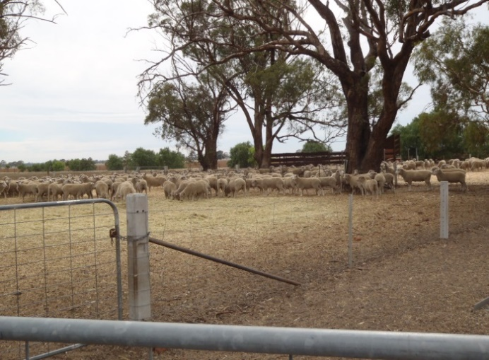A Stock Containment Area (SCA) is a carefully selected, fenced section of the property which is set up to periodically hold, feed and water livestock. They are primarily used to protect soil and pasture resources during adverse seasons such as after a fire, during droughts or late autumn breaks or for general farm management. It should be considered as part of the property management plan and once established should be maintained and available for use during emergencies and to manage other seasonal challenges.

**More Than a Drought Measure**

There are several benefits of containing stock in a SCA. These include:

* facilitation of stock feeding, watering, monitoring and handling
* containing weeds brought on to the property with imported feed
* assist with stock control when large areas of the farm require fencing (i.e. following a fire or other emergency)
* enable faster pasture recovery after drought or fire
* reduce soil erosion or damage to paddocks during a drought or dry conditions
* provide quarantine areas for new stock.

Farmers who have used SCAs have noticed production benefits such as:

* pasture maintenance or improvement due to the ability to rest paddocks and allow pasture to recover
* improvement or maintenance of stock condition
* better animal health (due to closer monitoring of stock health and disease control)
* better use of labour and feeding resources (less time spent feeding, and better management of stock nutrition)
* efficient way of supplying quality water to stock.

**Siting Considerations**

SCA’s should be sited to minimise any environmental or amenity risk and to maximise animal welfare and production efficiencies. Siting considerations include:

* if located within a Declared Water Supply Catchment the SCA should be sited 800 m from a potable water supply, the take-off point or a bore supplying potable water
* adequate setbacks from other waterways to minimise nutrient runoff risk
* adequate setback from neighbouring houses to mitigate dust and odour impacts, with consideration of the prevailing wind direction
* adherence to planning requirements for fixed feeding infrastructure located within 100 metres of a dwelling not in the same ownership, waterway, residential zone or Urban Growth Zone
* sited on moderately sloping, well-drained, stable soils such as a clay or clay loam
* construction across the slope to align with the natural contour of the land and to avoid pen to pen drainage.
* provision of shade and shelter for the stock
* avoiding areas with high value remnant vegetation
* access to good quality water (refer to the Water Supply for SCAs note)
* close proximity to handling facilities.

**Size and Construction / Design**

SCA’s should be constructed and operated to enable efficient and effective livestock management.

* an area of 5 square metres per sheep and 10-15 square meters per beast for cattle is ideal – however sheep producers have used between 7 and 10 square metres per head successfully. The higher space allowances may be associated with larger sheep (e.g. crossbred ewes)
* reliable fencing is required – keeping in mind stock may push up against the fencing or run into it
* a maximum desirable working number of animals for animal welfare and husbandry is 500 sheep or 160 cattle. If you are considering containing more than one class of stock, ensure appropriate subdivision / number of yards to enable the separation of each class of stock, including shy feeders or sick animals
* a vegetative filter strip should be established on the down slope side of the SCA to minimise sediments and nutrients entering waterways or leaving the property boundary. The filter strip may be provided by a vegetation buffer, or by constructing sediment traps from wire netting or straw bales
* there are a number of design options to consider. A separate laneway for grain feeding allows the mixing of feeds and additives before stock begin eating. Refer to the Drought Feeding Guide for Sheep for more options
* consider access for vehicles, ease of filling feed troughs, water and ease of cleaning
* protect any trees with guards if they are within the yards
* feed areas should be located well away from water troughs (e.g. opposite end of the yard) to reduce feed fouling the water supply
* cool livestock will drink less and be less stressed, so it is important that adequate shade is provided. Use existing trees or ensure provision is made for establishing shelter belts. Options for providing artificial shade and shelter include shade cloth, secured and fenced stacked hay bales, galvanised sheeting or custom built commercial shelters. Provide a minimum of 1.3 to 1.5 square metres of shade per sheep or enough shade for all of the animals to lie down / stand up in the hottest part of the day
* it is beneficial to have a grassy / treed buffer between each yard of an SCA, which assists with wind protection and dust movement.
* adequate fire fighting equipment should be available to control a fire in adjoining areas.

**Water Supply**

* SCAs need a constant supply of cool water provided to animals by a trough. The maximum daily demand, for lactating animals, is 14 litres per head per day for sheep, and 120 litres per head per day for cattle. This accounts for animals drinking more water on hot days and when the water is warm
* ensure a minimum of 5 metres of trough edge for sheep or 7 metres of trough edge for cattle is available in each yard
* flow rates are also important. A good rule of thumb is that the flow rate should pump enough water for the mob in 2-3 hours. See the information note Water Supply for Stock Containment Areas for more information
* troughs need to be checked daily and cleaned regularly
* stabilise soils around troughs using stone or gravel where necessary
* 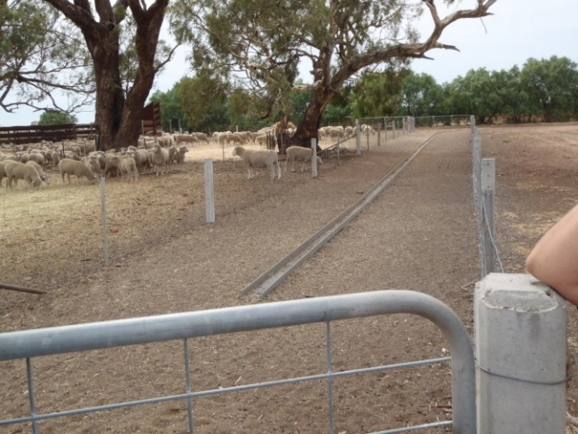measure water supply for salt and algae and bore water for magnesium levels (refer to Water supply for Stock Containment Areas information note).

**Feeding**

It is preferable to avoid feeding directly onto the ground. When feeding grain, 20 centimetres of trough edge per head per animal for sheep is required when all of the animals are feeding simultaneously. Cattle require 40-60 centimetres for each animal when feeding simultaneously. If grain is provided ad lib via lick or self-feeders within the yards 10 centimetres per head for sheep is sufficient. Old conveyor belts or corrugated iron between 2 logs, tractor tyres and 200 litre (44 gallon) drums cut in half have been used. Roof capping, folded roofing iron and suspended shade cloth are other options.

Remember – animals in containment need to be provided with 100% of their diet, including roughage, energy requirements and minerals. It is critical that nutritional and roughage requirements are met for each class of stock. Animals need to be monitored daily for condition and shy feeders or poor performers should be removed.

Energy values of feeds differ, as does the relative cost of the energy they contain. Feed values (energy and protein) can be highly variable. Having the feed tested by a registered laboratory is the best way of being confident about the quality of purchased or home grown feed when formulating rations.

For more detailed information on what to feed refer to the Drought Feeding books (listed in references).

**Induction to SCA**

If feeding a high grain ration, stock need to be trained onto the ration **gradually** before entering the containment area to reduce the risk of acidosis. Regular monitoring for shy feeders and sick animals is important. Sheep and lambs should be vaccinated against pulpy kidney as a 5 or 6 in 1 and drenched upon entry into the SCA.

Monitor worm levels with worm egg count tests before entering SCA to inform the need to drench, and prior to release.

**Releasing animals from SCA**

* prior to releasing animals from containment, ensure that there is sufficient pasture growth in the paddocks to protect the soil, and provide feed. Some supplementary feeding may be required upon release
* sheep and cattle should have access to quality roughage for 12 hours prior
* release late in the day and ensure they are not hungry to reduce gorging on lush pastures
* stock should be introduced to fresh pasture for short exposures, gradually increasing over several days.  This will allow the rumen microbes to adjust.  Stock should always have access to feed and roughage prior to being released onto pasture to ensure that they are not hungry and will not gorge on pasture.

**Animal health considerations**

* stock should be vaccinated (unless they have been vaccinated in the last 3-4 months)
* when livestock are confined to small areas diseases can spread very quickly. Regular monitoring and removal of sick animals is critical
* stock need to be monitored daily and sick animals removed
* yards should be cleaned regularly to prevent effluent build up
* to reduce the incidence of behavioural problems consider enriching the environment of the SCA and ensure plenty of fibre is included in the diet
* problems have been experienced with changes in batches of processed feeds and new sources of grain. Therefore some caution should be taken when changing to a new batch of feed, such as mixing the new and old over a number of feeds.

**Issues to be aware of when using SCAs**

* dust can be an issue in SCAs and wool yields can be lower if dust is excessive. Pink eye can also be a problem due to dust. Dust can be minimised by ensuring the SCA is constructed on an appropriate soil type (such as clay or clay loam), stocking is at a density to increase soil compaction in the yards, and having treed buffer strips between yards can reduce dust from wind movement
* mud can become a problem if heavy rain occurs whilst stock are in containment. If feasible, release the animals until the area has dried and the weather has improved
* although there are benefits in reduced labour when feeding animals in a SCA versus the paddock, regular monitoring is still a time commitment. This can be somewhat alleviated by locating the yards in an accessible location. It may be possible to release stock if livestock managers are away for an extended period of time, providing the appropriate care is taken.

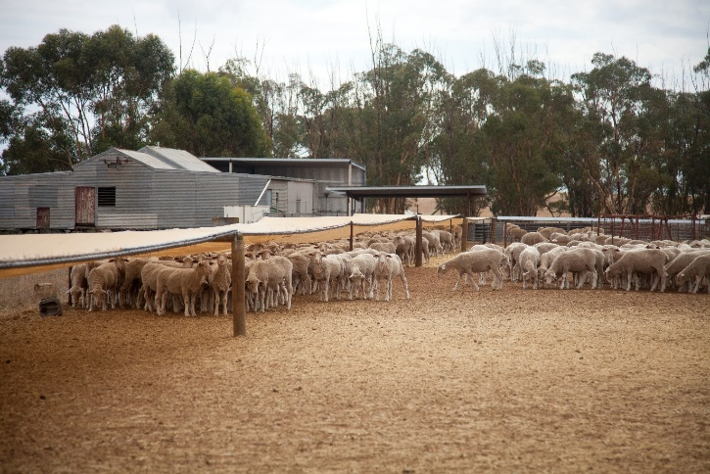

**Other considerations**

It is important to consider your own circumstances when deciding to utilise SCAs which may include:

* cash flow to purchase and supply feed for the length of time in containment.
* ability to access the required quantities of appropriate feed.
* costs of production and potential return for the class of stock, and
* your personal ability and capacity to regularly check, water and feed animals for the duration of containment.

**Planning requirements**

Stock containment areas used for emergency, seasonal or supplementary feeding are considered as being part of *grazing animal production* under the Victorian planning scheme. A permit is not required to build or operate a SCA used for emergency, seasonal or supplementary feeding of livestock in most rural zones.

For more information on stock containment areas and their use as part of *Grazing Animal* Production, refer to the Victorian Grazing and Intensive Animal Production Guidelines, September 2018 or go to

<https://www.planning.vic.gov.au/policy-and-strategy/planning-reform/sustainable-animal-industries> for more information.

A planning permit for Buildings and Works is required for fixed feeding infrastructure (eg. fixed feeding troughs) used for seasonal or supplementary feeding located within 100 metres of a dwelling not in the same ownership, waterway, residential zone or Urban Growth Zone.

**Further information and resources**

* Drought Feeding and Management of Sheep – a Guide for Farmers and Land Managers, DEDJTR 2018
* Drought Feeding and Management of Cattle – a Guide for Farmers and Land Managers, DEDJTR 2018
* Stock Containment Areas for Sheep – a Guide for Farmers and Advisors, DEDJTR 2018
* Water Supply for Stock Containment Areas information note, Agriculture Victoria 2016 <http://agriculture.vic.gov.au/__data/assets/pdf_file/0020/314390/Water-supply-for-sheep-and-beef-cattle-in-Stock-Containment-Areas.pdf>
* Victorian Grazing and Intensive Animal Production Guidelines, September 2018 or go to <https://www.planning.vic.gov.au/policy-and-strategy/planning-reform/sustainable-animal-industries>

|  |  |
| --- | --- |
| © The State of Victoria Department of Economic Development, Jobs, Transport and Resources 2018  by  This work is licensed under a Creative Commons Attribution 3.0 Australia licence. You are free to re-use the work under that licence, on the condition that you credit the State of Victoria as author. The licence does not apply to any images, photographs or branding, including the Victorian Coat of Arms, the Victorian Government logo and the Department of Economic Development, Jobs, Transport & Resources logo. To view a copy of this licence, visit <http://creativecommons.org/licenses/by/3.0/au/deed.en> | **Accessibility**  If you would like to receive this publication in an alternative format, please telephone the DEDJTR Customer Service Centre on 136186, email [customer.service@ecodev.vic.gov.au](mailto:customer.service@ecodev.vic.gov.au) or via the National Relay Service on 133 677 [www.relayservice.com.au](http://www.relayservice.com.au). This document is also available on the internet at www.agriculture.vic.gov.au  **Disclaimer**  This publication may be of assistance to you but the State of Victoria and its employees do not guarantee that the publication is without flaw of any kind or is wholly appropriate for your particular purposes and therefore disclaims all liability for any error, loss or other consequence which may arise from you relying on any information in this publication. |

**Acknowledgements**

This resource has been produced from information from the Stock Containment Areas information note LC0075 published in January 2006 and updated in July 2016 and October 2018

Information has also been obtained from:

* Report to Sustainable Landscapes Department of Primary Industries Victoria on SCA Post-Project Evaluation 2007, Aurora Research, NSW
* Drought Feeding and Management of Sheep – A Guide for Farmers and Land Managers, DEDJTR 2018
* Drought Feeding and Management of Cattle – A Guide for Farmers and Land Managers, DEDJTR 2018
* The National Procedures and Guidelines for Intensive Sheep and Lamb Feeding Systems, MLA 2011
* Water Supply for Stock Containment Areas, information note, Agriculture Victoria 2016 Victorian Grazing and Intensive Animal Production Guidelines, September 2018
* Stock Containment Areas for Sheep – A Guide for Farmers and Advisors, DEDJTR 2018

**For more information or to obtain a copy of the relevant Drought Feeding and Management book contact your local Agriculture Services Extension Officer, or call the customer service centre on 136 186.**