Information for pig owners
Do not feed meat, meat products, some dairy products or anything that has been in contact with meat to your pigs.
Prohibited pig feed (also known as swill) is the name for food scraps or food waste that contains meat or has been in contact with meat.
Feeding of prohibited pig feed is illegal in Australia because meat can be infected with serious diseases that can be passed on to pigs.

Illegal feeding of prohibited pig feed is considered the cause of the devastating 2001 outbreak of Foot and Mouth Disease (FMD) in the UK.
The viruses that can cause serious diseases, such as FMD, cannot be destroyed by chilling, freezing, curing or cooking.

Australia is currently free from FMD and other exotic pig diseases. It is estimated that an outbreak of FMD in Australia would impact the national economy by up to $50 billion over a ten-year period. During the 2001 UK outbreak, thousands of animals had to be destroyed to stop the spread of FMD

What foods are banned?
Meat, meat products and any food that is served on the same plate or that has come into contact with meat is prohibited feed and must not be fed or supplied for
feeding to pigs. Dairy products from overseas are also banned.
Food that cannot be fed to pigs include:
- Salad and vegetables that has been served with meat
- Butcher’s shop waste
- Pies, pasties, deli foods – including bacon and cheese from overseas, and salads that contain meat

What foods can be fed to pigs?
The following material can be fed to pigs:
- Milk and milk by-products (on property or legally imported)
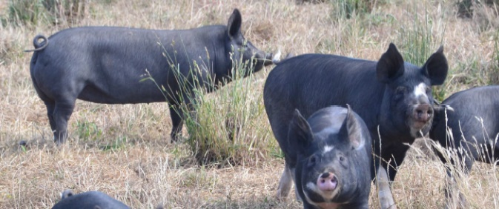
- Commercially prepared pig feed
- Eggs
- Fruit and vegetables from a market or garden
- If in doubt, do not feed leftover food to your pigs.

For the health of your pigs, it is best to have a planned diet. There are specific feeds available that are designed to meet the nutritional needs of pigs and keep them in the best condition.

Responsible disposal of food waste
Businesses that prepare and sell food (eg. restaurants,
bakeries, hotels, fast food outlets, hospitals), have a legal responsibility to dispose of food waste appropriately.
You must report the following activities to Agriculture Victoria immediately on 136 186 if you know someone who may be:
- Feeding prohibited food waste to pigs;
- Supplying prohibited pig feed to a person who feeds it to pigs;
- Collecting prohibited food waste from food premise to provide to a piggery: or
- Storing prohibited pig feed on a premise where pigs are kept.

This is to help ensure Australia maintains its disease-free status.

What should I do if I notice unusual clinical signs in my pigs?
There are many pigs diseases that are exotic to Australia and notifiable under the Livestock Disease Control Act 1994. These include: FMD, classical swine fever, African swine fever, and Aujeszky’s disease. If you notice any unusual deaths or illness in your pigs, you should notify:
- Your local Animal Health and Welfare officers
- Contact our customer call center on 1300 502 656
- The Emergency Animal Disease Watch Hotline on 1800 675 888
For information on pigs, visit the Ag Vic website at www.agriculture.vic.gov.au/agriculture/livestock/pigs.

Accessibility
If you would like to receive this publication in an accessible format, please telephone the Department of Jobs, Precincts and Regions on 1300 502 656.

