Reporting an agricultural chemical use issue to Agriculture Victoria

What Agriculture Victoria will do if you make a report
Agriculture Victoria responds to reports from the public regarding inappropriate or potentially illegal chemical supply/use. Reports are treated seriously and with a high level of respect.
Assessing your report
Agriculture Victoria is responsible for the administration of the Agricultural and Veterinary Chemicals (Control of Use) Act 1992 (the Act) and parts of the Drugs, Poisons and Controlled Substances Act 1981. These Acts regulate the supply and use of agricultural and veterinary chemicals, stock food and fertilisers.
When you make a complaint, an Authorised Officer will discuss with you the harm, impact and risks related to the complaint and what you believe has happened.
Following an initial discussion, the officer may take one or more of the following actions;
- You may be referred to another agency if your report falls outside of the scope of Agriculture Victoria’s responsibilities
- Where your report is within the scope of Agriculture Victoria’s responsibilities the officer may;
  - Collect samples from the area reported as affected to determine if chemical(s) are present
  - Speak to the person who is the subject of the report and provide them with educational material
  - Conduct an audit of the reported persons chemical use to assess their compliance with the Act
  - Undertake a full investigation into the matter to determine if a serious offence(s) has occurred.
It is important to note that some audits may lead to an investigation to determine if a serious offence(s) has occurred.
What is an audit
An audit of chemical use conducted by Agriculture Victoria examines the circumstances of any chemical use/supply and the relevant records that have been kept by the chemical user/supplier. This information is used to assist an Authorised Officer to determine the appropriateness of the chemical users/supplier actions and to give an indication if any offences have occurred.
The investigation process
The aim of an investigation is to assess if the relevant Act has been complied with by the person using the chemical(s).
If Agriculture Victoria conducts an investigation, you may be asked to provide:

- Further information e.g. contact details of the person who is the subject of the report
- Photographs, reports or any other relevant documentation such as spray records
- Permission for officers to enter your property to take samples
- A signed witness statement outlining what you saw and when.
If officers are unable to obtain adequate information from you regarding your report, they may be unable to proceed with an investigation.
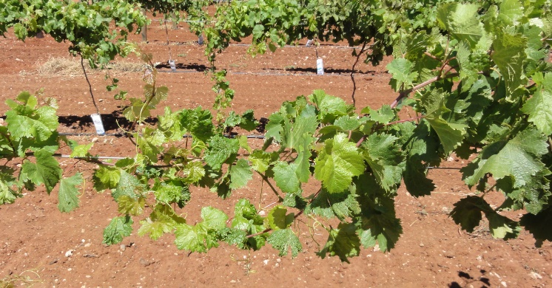
Timeframes for an investigation
Agriculture Victoria aims to undertake and finalise investigations within a reasonable timeframe. Most investigations are completed within three to six months however, this may be extended in some circumstances.
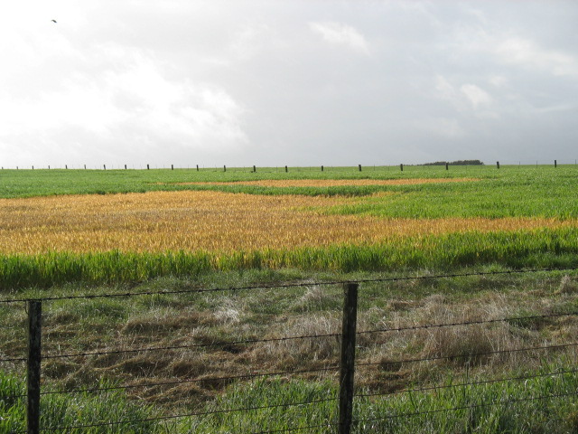
Privacy
Agriculture Victoria will handle information provided in reports or gathered in audits/investigations in accordance with the Privacy and Data Protection Act 2014 (Privacy Act). Please note if there is an existing relationship between you and the person who is the subject of your report (e.g. you are neighbours) then they may easily be able to establish your identity without Agriculture Victoria providing any of your details.
Other options
If you have suffered loss or damage due to another person’s chemical misuse, you can contact a legal practitioner to obtain independent advice regarding alternative courses of action.
Agriculture Victoria doesn’t provide any guidance on civil matters.

