Fact sheet

Yard training and weaning of beef cattle – Enhanced Producer Demonstration Site

Yard training is a method of weaning cattle that can increase weight gains and decrease animal stress around weaning, while making cattle less flighty and safer to work with in the future. It is also a useful method for inducting new cattle onto a farm.

Weaning or inducting of cattle to a new property can be a stressful time for livestock. The handling they receive during these times is critical and can affect their performance over future months. Stress can negatively affect growth rates and product quality, ultimately impacting price and your bottom line.

Yard training involves regular handling of weaner, or newly purchased, cattle within the cattle yards. During this time cattle are educated to handling by people (and optionally dogs). The key to educating cattle is seeking an appropriate response to the handler and then providing a
‘reward’ for the desired behaviour. The reward can be either feed based (hay) or the removal of pressure on the cattle. As the handler moves closer, the cattle will want to move away from the handler. However, once the cattle are displaying the desired behaviour, they are rewarded by the handler ceasing movement towards them, removing any pressure.

Handling procedures

Positive behaviours from handlers will decrease stress levels in cattle. These positive behaviours include: moving slowly and quietly among animals; using a flagstick or rattle rather than an electric prodder; and moving groups rather than individuals. It is particularly important to allow lead animals time to investigate the
environment, as other cattle take their cues from the leaders.

Signs of calm animals include chewing, looking for a pathway to retreat and walking quietly away from pressure.

Negative behaviours from handlers tend to increase stress in animals and include: use of electric prods (particularly on calves); hitting animals; loud noises such as banging gates and shouting; and forcing animals when they have nowhere to move. Stressed animals will raise their heads in the air and move wildly.

Animal handling should not be forceful. Dogs can be used as part of a handling technique but must be under the handler’s control. This means when the cattle are doing what you have asked them to, for example, moving forward, the dog must release pressure and stop pushing them forward. Cattle should not be chased, as this will result in wilder, more stressed animals that will separate from the comfort of the herd.

General tips for weaning and inducting cattle

Ensure adequate feed and fibre (hay or straw), feeding space and good quality water are always available. Feed must meet energy and protein requirements for young, growing animals (13% CP). Calves should be above 200kg at weaning and be vaccinated with 7-in-1.

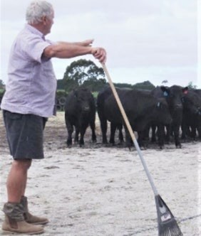
Figure 1: Familiarising weaners to people and allowing time to investigate their surroundings.
To familiarise weaners to humans (Figure 1), walk quietly amongst them two or three times a day. Calves can be moved from a shady yard during the day into a sheltered yard for the evening. Weaners should be moved quietly from pen to pen, using principles of pressure and release.

If an animal is moving forward, do not chase it. Instead, allow it to move forward at its own pace. When moving cattle between pens, allow the calves to find the gates and develop new leaders in the mob. Do not force the animals forward.

To help familiarise calves to novel noises, a vehicle can be left near the yards with the radio playing. This will help the weaners to get used to different sounds and voices, which helps to settle the mob.

Allow yourself plenty of time to work with weaners. Stressed handlers with unreasonable time restraints often lead to bad handling techniques, which can result in stressed animals. Training sessions should be 10–25 minutes, and no longer than 30 minutes. Once animals have been worked, reward them with good quality hay.

Movement should be initiated from the front of the herd, not from behind. The handler should be positioned where the animals can see the handler and where you want them to go.

Use the lead animal to control the pace of the herd. Walking ‘at’ the cattle will increase speed, whereas walking alongside the animals will maintain or decrease speed.

Yards must be surfaced with soft floors and weaners must not be yarded on abrasive concrete floors. Yards should not be overstocked and, while there are varying figures in the literature, space allowances must adhere to minimum yard densities of at least 4m2 space provided per 180–200kg animal and 2.5m2 for
100–170kg animals.

Animals must be allowed enough yard space to stand, lie down, stretch, groom and perform normal patterns of behaviour (Figure 2).
Smaller, more timid animals or shy feeders may need to be separated into a small mob and handled separately.
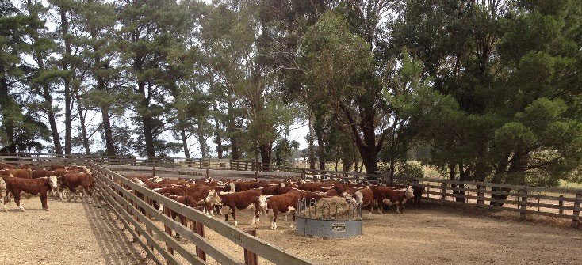
Figure 2: Appropriate set-up for yard weaning.
Suggested training strategy

Day 1:

Cows and calves should be yarded early in the day and allowed to settle.

Calves should be separated from cows, and cows then moved away from yards out of hearing and view of calves, if possible. Yards should be prepared prior to calves’ arrival and the four-day weather forecast evaluated.

The handler will work with animals quietly to introduce calves to hay feeder and water trough. Animals can be moved from corner to corner to induce bunching and start herd movement. This handling session should not be any longer than
20 minutes.

Day 2:

Handler should work with animals to induce bunching, as on day one, but should also educate calves to walk through gateways. Animals must be trained not to rush as rushing is a health and safety hazard and may cause damage to yards and gates. As soon as animals are heading in the
desired direction, the handler must stop applying pressure to reward the cattle performing the desired behaviour.

Days 3 and 4:

If facilities are available, calves can be turned out in a larger yard and worked as a bunch for a
short time. Then, move animals back into the smaller yard and reward with hay.
Gateway education can also continue. Animals can be worked two or three times but never for more than 30 minutes at a time.

Day 5:

Cattle can be turned out into a paddock and worked as a bunch. Once calves have settled and are under the handler’s control, calves can be
left for the day. In the evening, or second session of the day, calves are returned to the yards and rewarded with quality hay and feed.

Days 6 and 7:

Repeat handling sessions from day 5. When calves are fully weaned, they can be turned out to good quality pasture (11.5 MJ ME/kg DM and
16% crude protein).

Further reading

MLA Tips & Tools ‘Yard weaning methods for preparing feeder cattle’ available at: http://www.mla.com.au/publications

More Beef from Pastures manual http://mbfp.mla.com.au/Weaner-throughput/3- Wean-early
Published in March 2020.

For further information contact:

Breanna Downes-Smith
Livestock Extension Officer – Maffra bree.downes-smith@agriculture.vic.gov.au

John Bowman
Livestock Extension Officer – Leongatha john.bowman@agriculture.vic.gov.au

Disclaimer

Any recommendations, suggestions or opinions contained in this publication do not necessarily represent the policy or views of Meat & Livestock Australia (MLA). No person
should act on the basis of the contents of this publication
without first obtaining specific, independent professional advice. MLA takes no responsibility, in any way whatsoever, to any person in respect to the document, including any errors or omissions therein, arising through negligence or otherwise however caused.

© Meat & Livestock Australia 2019 ABN 39 081 678 364

This work is copyright. Apart from any use permitted under the Copyright Act 1968, all rights are expressly reserved. Requests for further authorisation should be directed to the Corporate Communications Manager, PO Box 1961, North Sydney, NSW 2059 or info@mla.com.au.

