What is Evapotranspiration and how do I use it to schedule irrigations?
Evapotranspiration provides a relatively objective and reliable estimate of the water requirements of actively growing plants in a farm situation. Evapotranspiration information can be used by irrigators to more accurately schedule irrigations to help achieve top yields and improve water productivity.

What is Evapotranspiration?
Evapotranspiration is an estimate of the loss of water from both plants and the soil. The main drivers of evapotranspiration are sunlight, wind, humidity and temperature.

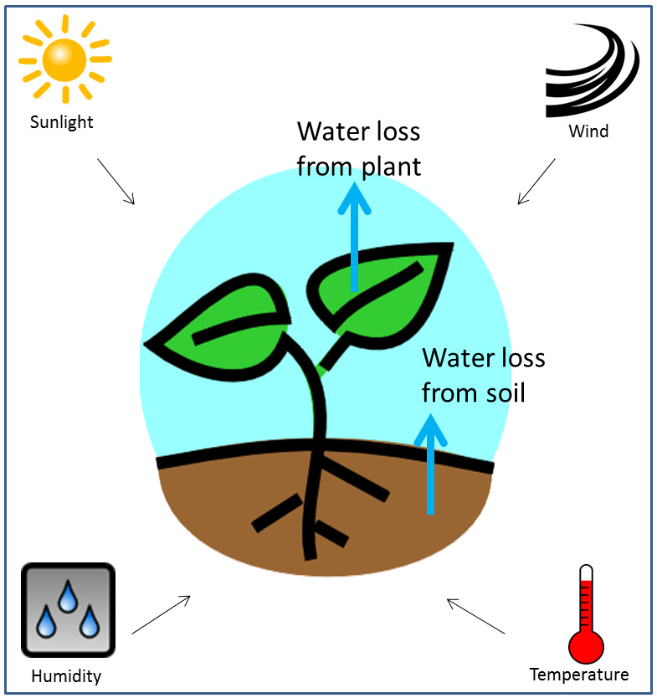
Figure 1 - Evapotranspiration concept diagram, showing the process of evapotranspiration (middle illustration) and the main drivers of evapotranspiration (far corners of the diagram).
‘Reference evapotranspiration’ (ETo) is commonly used as a standard estimate of evapotranspiration. ETo specifically refers to evapotranspiration from a reference stand of actively growing, well-watered grass, 120mm in height. ETo rates are typically measured in millimetres per day (mm/day) and are highest in the summer months and comparatively lower in spring and autumn. For practical purposes, ETo provides a workable representation of the water requirements of good productive pasture on an irrigated farm.
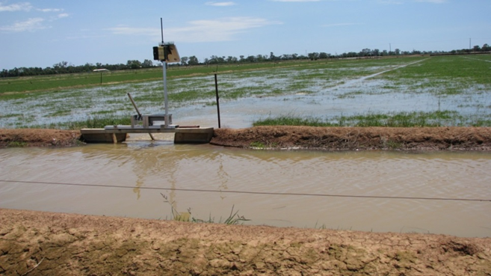

Figure 2. - Pasture being surface irrigated. Tongala, Victoria.

What are the basic principles of using ETo for irrigation scheduling?
In order to match irrigation with actively growing plant requirements, irrigation scheduling needs to be based on the amount of water in the soil that is readily available to plants (also known as “Readily Available Water” or “RAW”) and the water use of the actively growing crop. These two concepts can also be thought of as the “size of the bucket” and the “water use from the bucket.”
i) RAW (or the “size of the bucket”). RAW is the component of soil moisture that can be readily extracted by plants before they suffer from moisture stress and lower growth rates.
Typically RAW will vary depending on the crop and soil type. For example, RAW for crops such as mature lucerne, maize or sorghum is likely to be higher than for pasture because these crops have a deeper and stronger root system to extract moisture.
Soils suited to surface irrigation will typically hold between 30mm to 50mm of RAW for good quality established ryegrass-clover based pasture. For mature maize there will typically be up to 60mm to 70mm of RAW. Where-as for mature lucerne, RAW tends to be in the range of 70mm to 100mm.
RAW will also be lower for newly established plants with a smaller root system. Generally RAW is higher in loam soils, than in sands or heavy clays. Paddock assessments, along with soil moisture monitoring can be used over time to more accurately estimate the appropriate RAW value for specific circumstances.
ii) The water use of the particular crop (or the “water use from the bucket”). The water use of an actively growing crop can be described relative to the reference stand of healthy productive pasture. For example, mature lucerne, maize or sorghum is likely to have a bigger crop canopy and will require more water than pasture under the same conditions for top growth rates.
A “crop coefficient” (Kc) is used to express a crops relative water use. The reference stand of pasture is given a Kc of 1.0. Where-as, the appropriate Kc for mature actively growing lucerne, maize or sorghum is likely to approximate 1.2. A Kc of 1.2 indicates the crop requires 120% of the water needed for good pasture.
The estimated crop water requirement (ETc) for high growth rates is obtained by multiplying the specific crop coefficient (Kc) by reference evapotranspiration (ETo). ie. ETc = ETo x Kc.

How do I use ETo to schedule irrigations for pasture and crops?

Surface irrigation: To optimise growth rates and yield, surface irrigations are typically timed when plant water uptake (which can be estimated using ETo,) has drawn RAW down to a value equal or close to zero.
Usually when surface irrigation occurs, it takes 1 or 2 days for excess water to freely drain from the soil. Optimum irrigation timing is determined by subtracting subsequent (after the soil has drained) daily ETo values from the estimated maximum RAW value (eg. 40mm), until it is close to zero. When RAW is drawn down close to zero, it is time to irrigate again. (Table 1.)
Rainfall: As well as plant water uptake, rainfall can also affect RAW. It is important that the scheduling calculations described above include effective rainfall (“R”), which will extend the irrigation interval (Table 1.) Because of the variation in rainfall over short distances, usually it is preferable to collect individual farm rainfall figures rather than using local Bureau of Meteorology station data.

 | Day 0 | Day 1 | Day 2 | Day 3 | Day 4 | Day 5 | Day 6 | Day 7 | Day 8 | Day 9 | Day 10
ETo (mm) | - | 5.1 | 4.9 | 5.8 | 5.3 | 5.3 | 5.9 | 5.9 | 5.7 | 6.3 | -
Kc | - | 1.0 | 1.0 | 1.0 | 1.0 | 1.0 | 1.0 | 1.0 | 1.0 | 1.0 | -
ETc (ETo x Kc, mm) |  | 5.1 | 4.9 | 5.8 | 5.3 | 5.3 | 5.9 | 5.9 | 5.7 | 6.3
Rain (mm) | - | - | - | 5.0 | - | - | - | - | 6.0 | - | -
ETc-R (mm) | - | 5.1 | 4.9 | 0.8 | 5.3 | 5.3 | 5.9 | 5.9 | -0.3 | 6.3 | -
Cumulative ETc-R (mm) | - | 5.1 | 10.0 | 10.8 | 16.1 | 21.4 | 27.3 | 33.2 | 32.9 | 39.2 | -
RAW (mm) | 40 | 34.9 | 30 | 29.2 | 23.9 | 18.6 | 12.7 | 6.8 | 7.1 | 0.8 | 40
Irrigation | √ | - | - | - | - | - | - | - | - | - | √

Table 1 - Depleting Readily Available Water (RAW). Figures in this table show how daily reference evapotranspiration (ETo) and rainfall (R) figures are used to estimate daily pasture ‘Readily Available Water’ (RAW) to determine the timing of the next surface irrigation. To help optimise water productivity, the next irrigation is timed when RAW is depleted, or close to zero. It is estimated the soil in this case can hold up to 40mm of ryegrass-clover pasture RAW and the soil has freely drained by the end of “Day

Spray irrigation: Typically water is applied more frequently and in smaller applications with spray systems compared to surface irrigation. For example with spray irrigation, effective applications of 25mm (0.25ML /ha) may be regularly applied over a season. In this case, the soil is only being recharged by 25mm, not to the maximum RAW of 40mm as described in the above surface irrigation example.
To optimise water productivity, the timing of regular spray irrigation applications can be determined using a similar process described above for surface irrigation. However, cumulative ‘ETo-R’ is subtracted initially from the effective application amount, in this case 25mm. The next irrigation occurs when the effective application amount (25mm) minus cumulative ‘ETo-R’ equals or is close to zero.
Before a seasonal spray irrigation cycle, care needs to be taken that the soil has not dried out beyond the point that plants can readily extract moisture. If this is the case, extra irrigation will be needed initially to bring the soil back in to the ‘RAW zone.’

Cost and Accessibility
ETo data can be accessed free of charge from a number of sources including:
- Bureau of Meteorology. http://www.bom.gov.au/watl/eto/
- SILO Meteorology for the Land. (Queensland government.) https://www.longpaddock.qld.gov.au/silo/datadrill/
- irriGATEWAY (CSIRO). http://weather.csiro.au/?aws_id=8&view=summary
- The YIELD. App. https://www.theyield.com/products/free-growers-app
- irriSAT https://irrisat-cloud.appspot.com/
- Scheduling Irrigation Diary. https://sid.usq.edu.au/
- Other local weather stations

ETo based advice and scheduling tools
In addition to the above ETo sources, your local Department of Agriculture or equivalent agency may provide local ETo data or ETo related services including irrigation scheduling advice and tools. Interactive tools take the hassle out of doing calculations involved with ETo. “irriSAT” and the “Scheduling Irrigation Diary” (both listed above) are examples of web-based ETo scheduling tools.

Accuracy
Typically ETo provides a relatively accurate and reliable basis on which to determine plant water requirements. ETo values may vary slightly between the different sources (listed above). Where possible it is best to use a single and consistent source of ETo for your own situation.
In terms of accuracy for on-farm purposes, an advantage of using ETo is that it is not “point specific.” ETo provides a measure that applies across a whole paddock and in most cases across a small district. Also in terms of on-farm purposes, forecast ETo information allows you to better anticipate future plant water requirements and more accurately plan for and schedule future irrigation events.
Like any other irrigation scheduling method or tool, ETo should not be used in isolation to inform irrigation scheduling decisions. ETo needs to be part of an irrigator’s scheduling “toolbox” and used in conjunction with other preferred scheduling methods.

Grower experiences
Many irrigators from different agricultural industries and locations around Australia and overseas regularly use ETo information to schedule irrigations.
Irrigators say one of the big benefits of using ETo is they save valuable time determining plant water needs and planning farm irrigations. Importantly, the ETo information assists in getting irrigation right and improving productive water use. One irrigator commented “I'm finding this info very useful. I'm following your advice on suggested irrigation interval (based on ETo data) and are growing the best pastures on this place… Milk production is up as a result (of using ETo based advice and other irrigation related changes made on farm).”
Irrigators have also indicated they use ETo information in different ways including better scheduling irrigations, minimising irrigation pumping costs and helping to calibrate other convenient scheduling methods.

Further Information
A more detailed version of this Fact Sheet can be obtained from the Agriculture Victorian web site http://agriculture.vic.gov.au/agriculture/farm-management/soil-and-water/irrigation
Alternatively further information about evapotranspiration can be obtained from The Food and Agricultural Organisation of the United Nations http://www.fao.org/docrep/X0490E/X0490E00.htm

Acknowledgement
This Information Sheet was prepared by Rob O’Connor (Agriculture Victoria. Telephone 03 5482 1922) with technical input provided by other Agriculture Victoria staff including Kevin Kelly, Dennis Watson, Craig Dyson, Deb Banks and Greg Turner. Amy Fay from Murray Dairy and Monique White (Farm Consultant, Murray Bridge) also provided technical support.

Accessibility
If you would like to receive this publication in an accessible format, please telephone DEDJTR Echuca, Irrigation Program, Robert O’Connor on 03 54821922.
This document is also available in HTML, PDF or Word format at www.victoriangovernmentdepartment.vic.gov.au

