Soil Moisture Monitoring
Soil moisture monitoring (SMM) devices provide information about the water status of soil. Knowing the soil water status can help you plan when to irrigate and how much water to apply.

Why would you use soil moisture monitoring?
Over the last few years there has been a lot of interest in SMM. This is partly due to the rising cost of water and the associated need to improve water productivity. It is also a result of on-farm irrigation system upgrades and irrigation supply system modernisation. Irrigators who have experienced these improvements are finding they have more control over water on their farm and are better positioned to use tools that help them match irrigations with plant needs.
SMM is used to assist with scheduling irrigations to minimise plant stress and the economic losses that under-irrigation and over-irrigation can have on crop yield and quality. SMM will also help you avoid the costly environmental effects of over-irrigation including wasted water and energy, leaching of nutrients or agricultural chemicals into groundwater, and degradation of surface waters with contaminated irrigation runoff.

How do they work?
Commercially available SMM packages have developed noticeably over the last 10 years, particularly in regard to the way data is transmitted from the paddock and how it is presented to the user. Irrigators in the market now have a range of choices related to the type of soil moisture sensor they use, the transmission of data, annual data fee arrangements, the data viewing format and the over-all cost.
The two main types of commercially available soil moisture sensors are: suction based and volumetric based systems.

Suction based sensors
Suction based sensors measure how tight water is held in the soil. The measurement relates directly to how hard the plant has to work to extract water and is therefore consistent across different soil types. Types of suction based tools that are commonly used are tensiometers and gypsum blocks.
Tensiometers directly measure soil moisture suction. The suction reading decreases when the soil around the tensiometer wets up with rain or irrigation. Conversely, the reading increases as the soil dries out.
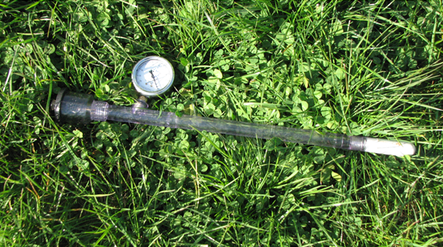

Figure 1. Tensiometer. Typically under pasture the porous ceramic moisture sensor on the end of the tensiometer is buried in the active rootzone at 20cm soil depth.

Gypsum blocks consist of two electrodes embedded in a block of porous material. As with tensiometers, water is drawn into the block from a wetter soil and out of the block from a drier soil. The electrical resistance of the block is proportional to its water content, which is related to the soil water suction of the surrounding soil.
Tensiometers can be used in wetter soil conditions than gypsum blocks, but generally tensiometers will have a higher maintenance requirement and can be more vulnerable in the field. Gypsum blocks are likely to have a more delayed response to changes in soil moisture and may only last several years due to the nature of the material used in gypsum blocks which breaks down over time.

Volumetric based sensors
Volumetric SMM systems measure the total amount of water in the soil. To estimate how much of this water is “readily available” to plants, the soil type needs to be known. In practice, volumetric moisture monitoring tools can be used to guide not only when to irrigate, but how much water to apply.
Commonly used volumetric tools use a measurement of the soil-‘dielectric’ which reflects the capacity of a material to transmit electromagnetic waves or pulses. The dielectric of dry soil is much lower than that of water, so small changes in soil moisture will have a large effect on the dielectric properties of the soil. When a voltage is applied, an electromagnetic frequency can be measured and calibrated to reflect soil moisture content.
Capacitance probes and “total domain reflectometry (TDR)” capacitance spikes are examples of commonly used volumetric monitoring tools. Typically capacitance probes measure soil moisture at increments (usually 10cm) down the soil profile to a depth of 0.8m to 1.2m. (It should be noted soil moisture can also be monitored at different depths using other moisture sensors such as capacitance spikes or gypsum blocks installed at multiple depths.)
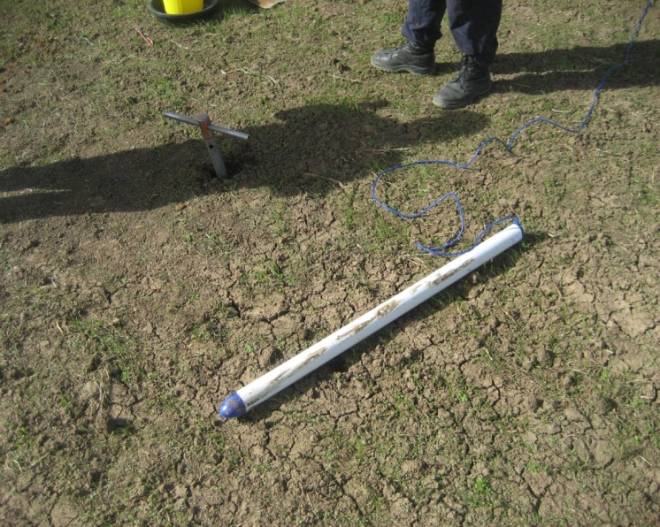
Figure 2. Capacitance probe in the process of being installed. Photo courtesy of Dale Boyd, Agriculture Victoria.

Types of monitoring systems
SMM systems commonly consist of a moisture sensor which is placed in the soil, and a visual display unit. The visual display unit can be ‘manual-read’ where you observe readings directly from the device (figures 1 and 3), or it can be ‘screen-read.’ With screen-read systems, soil moisture data is automatically transmitted by wireless technology to your computer, mobile phone or tablet. It can be viewed in a neat, adjustable graph format that makes it easier to compare and interpret the data (figures 5, 6 and 7). With many devices the data can be accessed and shared anywhere the internet is available. Screen-read systems are becoming more accessible and affordable for irrigators.
Often more labour is involved with manual-read devices, but there is usually a lower up-front cost.

Cost
A manual-read device such as a tensiometer or a “GDot” (figure 3) typically costs a few hundred dollars. Screen-read systems range in price from hundreds of dollars to thousands of dollars, depending on the equipment and number of moisture sensors involved. Screen-read systems normally have an annual data transmission and storage fee in the low to mid hundreds of dollars.

Data transmission fee arrangements
Often the commercially available screen-read SMM systems that have a lower up-front cost (hundreds of dollars), will require an annual data subscription fee for each set of soil moisture sensors installed on farm. Usually a set of up to 3 or 4 sensors can be linked to a single transmitting device. (Refer to figure 4.)
Many of the screen-read SMM systems that have a higher up-front cost (thousands of dollars) will only require one annual subscription fee to be paid for a large number of moisture sensors on farm. Usually with this type of system, additional sensors can be installed over time with no associated requirement for extra subscription fees.
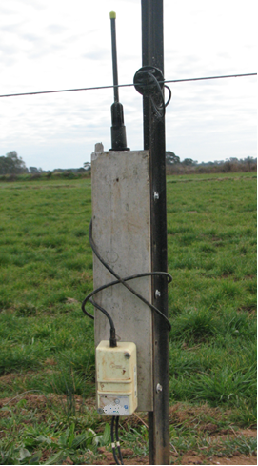
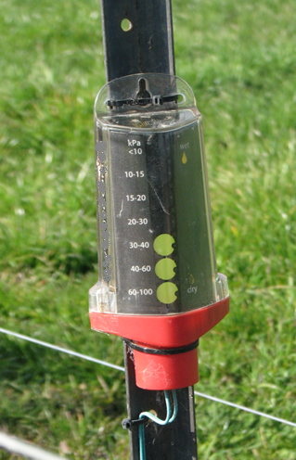
Figure 3. Left: A manual-read visual display unit (“GDot”) mounted on a laneway fence-post. It is hard-wired to a gypsum block moisture sensor installed under irrigated pasture. The irrigator views this unit regularly from a passing motor-bike.
Figure 4. Right: A transmitting device or “node”, hard wired to two TDR capacitance spike soil moisture sensors which are out of view. This unit is part of a screen-read monitoring system that has relatively less equipment on farm than other screen-read systems and a lower associated up-front cost.

Data viewing
Depending on the type of commercial software, it is possible to view soil moisture content over time for individual sensors placed at different depths in the soil profile on your computer, mobile phone or tablet. (Figures 5 and 6.)

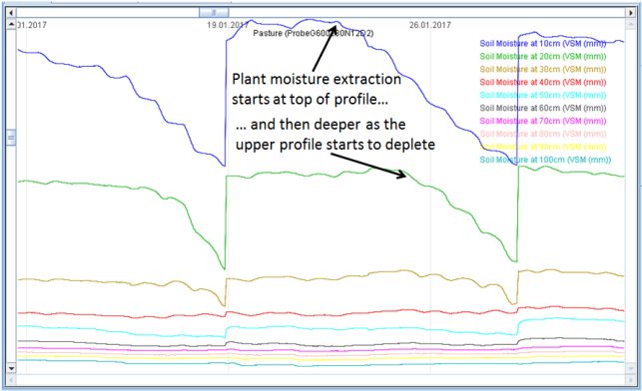

.

Figure 5. Soil moisture content under perennial pasture at different depths in the soil profile as measured by a capacitance probe

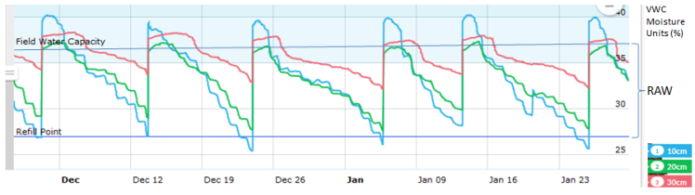

Figure 6. Soil moisture at different depths under surface irrigated pasture measured with TDR capacitance spike sensors.
Some software packages also offer viewing options of moisture content that is averaged or summed from multiple depths. Average or summed moisture configurations are preferably selected from depths of active moisture uptake, which will vary depending on factors including plant species and maturity. In some cases, views of weighted average soil moisture can be configured that reflect differences in plant root extraction patterns in the soil profile. (Figure 7.)

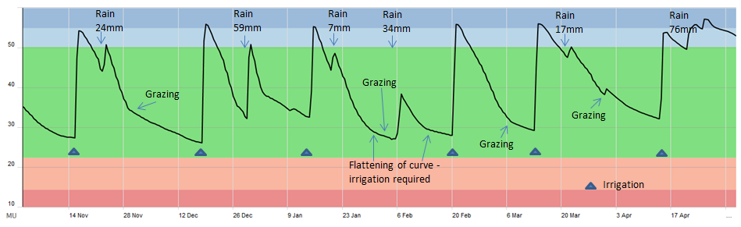

What information do SMM systems provide?
SMM technologies provide soil moisture information, which can be from different soil depths and locations around the farm. More broadly soil moisture monitoring packages can be used to provide information related to:
- Planning of future irrigation events
- Reserves of plant available water
- Changes in the rate of plant water uptake - which can indicate plant moisture stress
- Root activity patterns and development in the soil profile
- Depth and amount of irrigation water applied
- Impact of rainfall on soil moisture reserves
- Impact of cutting hay or grazing on plant water use
- Potential waterlogging
- Water movement beyond the rootzone
- Watertable depth
- Record of past irrigations that can be used to review scheduling practices
- Salinity and movement of fertiliser (particularly urea) through the soil profile*
- Soil temperature*
* Compatible electrical conductivity or temperature sensors are required for the measurement of soil salinity or soil temperature. Some capacitance probes are equipped to measure electrical conductivity or temperature, as well as soil moisture.
Some SMM software packages can also be connected to automatic weather recording devices on farm. Information such as rainfall can be viewed together with soil moisture data to better inform irrigation scheduling decisions.

How can you use this information?
Soil moisture data is primarily used to assist with scheduling the next irrigation to optimise plant growth and water efficiency. For surface irrigators this relates mainly to the timing of irrigations, while for irrigators with pressurised systems, moisture data can also help with deciding how much water to apply.
Typically irrigators use SMM systems to indicate whether soils are in the “zone of Readily Available Water (RAW).” In figure 6, the “RAW zone” has been configured for pasture to be between the “Refill Point” line and the “Field Water Capacity” line.
The irrigator on this farm has been regularly using this soil moisture data to inform scheduling of irrigations over the season. In the graph (figure 6), it appears soil moisture levels are largely being maintained in the estimated RAW zone, helping to minimise moisture stress and improve plant growth.
For suction based sensors, research (Graeme Ward, 2006) has shown ryegrass-white clover pasture growth rates are optimised between 10 and 30 kilopascals (kPa) of soil moisture tension, when buried at 20cm depth. At 35kPa and above, these pasture plants experience difficulties extracting water and growth rates decline. Pasture should be irrigated by the time it reaches this critical point.
Irrigators with SMM devices report these tools provide particular value in autumn and spring when the weather and plant water use tend to be more variable. Soil moisture information is also of particular value for scheduling the first and last irrigations in the season (“start-up” and “finish-up”), which can also be difficult to determine. The impact of rainfall, grazing or cutting hay on soil moisture and plant water uptake can be better assessed with the use of these tools, enabling improved scheduling decisions. (Refer to figure 7).
In figure 7, a decline in the rate of plant water uptake shown as a flattening of the moisture curve in the graph, can indicate depleting plant available moisture, plant stress and a need for irrigation. However, care needs to be taken if using this method to determine irrigation timing because a reduction in plant water uptake can also be caused by other factors such as cooler or cloudy weather or cutting hay. Vigilance also needs to be used to ensure irrigations are not timed later than ideal causing plant stress and a loss of growth. In mixed swards such as pasture, this method of scheduling may favour larger plant species that are better at extracting limited soil moisture.

Potential issues
Usually soil sensors only take moisture measurements from a very small volume of soil around the sensor. Care needs to be taken when applying sensor data across a whole paddock, especially where soil type, plant uptake and irrigation uniformity vary.
Like most other irrigation scheduling tools, SMM is an aid for irrigation decision making and should not be used in isolation. Preferably SMM is used in conjunction with other scheduling tools and methods already used on farm.
Moisture monitoring should not replace farmer’s intuitive estimates of when to water, but instead enable more informed decision making by reducing the subjectivity and guesswork involved. SMM provides an objective measure and can be a very useful learning tool.
When deciding where to locate moisture sensors on farm, soil variability needs to be taken into account. It is important sensors are located in a representative soil type as well as a representative area of crop in terms of its growth stage, health and water use.
Moisture sensors need to be properly installed and protected from stock and machinery damage. It is recommended you seek assistance from someone experienced in these matters such as the manufacturer, retailer, a consultant and /or an irrigation officer to ensure the equipment is properly installed.
Poorly placed or damaged monitoring equipment can potentially result in over or under irrigating. Deep rooted crops such as lucerne may also need sensors at multiple depths in the rootzone.
Choose a SMM system that comes with ongoing support and back-up service. In most circumstances coaching will be required to understand how to access, interpret and use the data to schedule irrigations. Some companies offer a warranty on their equipment.

Product choice and suppliers
There are many different SMM products on the market. This information sheet will help with your choice of product. Many irrigation suppliers are able to provide general advice on SMM as well as providing SMM equipment.
A great source of information is local farmers who are willing to share their experiences with SMM equipment, particularly those who have used the technology on the same crop types as yours.

further information
For additional information about the types of products available, Charlesworth (2005) provides a useful review of equipment. Charlesworth also provides a checklist of features that can assist in selecting the right tool for your requirements as does the Victorian AgNote, Soil Moisture Monitoring – Choosing the Right Device. (See below).
More information on SMM is available from irrigation officers, consultants, SMM manufacturers, retailers, the web or in the following publications:
P. Charlesworth (2005) SOIL WATER MONITORING AN INFORMATION PACKAGE 2nd EDITION. CSIRO/CRC Irrigation Futures Land and Water Australia on behalf of the National Program for Sustainable Irrigation. http://www.insidecotton.com/xmlui/bitstream/handle/1/1778/pr050832.pdf?sequence=2&isAllowed=y
Kelvin Montagu, et.al (2006) Irrigation Insights No. 6 UNDERSTANDING IRRIGATION DECISIONS. Enterprise Planning to the Paddock. Land and Water Australia on behalf of the National Program for Sustainable Irrigation.
AgNote. Soil Moisture Monitoring – Choosing the Right Device. Choosing the right soil moisture monitoring device
Ward et.al, 2006. Making the most of irrigation water in South West Victoria. A guide to improving irrigation water use efficiency on dairy farms. Department of Primary Industries.
This Information Sheet was prepared by Rob O’Connor (Agriculture Victoria. Telephone 03 5482 1922) and Monique White (Farm Consultant, Murray Bridge, SA).Technical input was provided by other Department of Economic Development, Jobs, Transport and Resources staff including Lyndall Ash, Dennis Watson, Dale Boyd, Craig Dyson, Rebecca Pike, Kevin Kelly, Deb Bank, Greg Turner and Dougal Purcell. Amy Fay from Murray Dairy also provided technical support.

Accessibility
If you would like to receive this publication in an alternative format, please telephone the DEDJTR Customer Service Centre on 136 186, email customer.service@ecodev.vic.gov.au or via the National Relay Service on 133 677, National Relay Service. This document is also available on the internet at Agriculture Victoria or htttp://murraydairy.com.au . A shorter version of this document is available on the Dairy Australia web site: https://www.dairyaustralia.com.au/farm/animal-management/technologies/pasture-and-feeding-technologies
DISCLAIMER
This publication may be of assistance to you but the State of Victoria and its employees do not guarantee that the publication is without flaw of any kind or is wholly appropriate for your particular purposes and therefore disclaims all liability for any error, loss or other consequence which may arise from you relying on any information in this publication.
© The State of Victoria Department of Economic Development, Jobs, Transport & Resources, October 2017.

