 

final report

Project code: E.PDS.1410 & L.PDS.1803

Prepared by: Experimental Design and Data Collection - Claire Harris

Report Preparation – Claire Harris, Breanna Downes-Smith, Laura Garland, Martin Dunstan Agriculture Victoria

Date published: 30 June 2019

PUBLISHED BY

Meat and Livestock Australia Limited

Locked Bag 1961

NORTH SYDNEY NSW 2059

EPDS: Weaning Strategies for Improved Productivity

Meat & Livestock Australia acknowledges the matching funds provided by the Australian Government to support the research and development detailed in this publication.

This publication is published by Meat & Livestock Australia Limited ABN 39 081 678 364 (MLA). Care is taken to ensure the accuracy of the information contained in this publication. However MLA cannot accept responsibility for the accuracy or completeness of the information or opinions contained in the publication. You should make your own enquiries before making decisions concerning your interests. Reproduction in whole or in part of this publication is prohibited without prior written consent of MLA.

Executive summary

This producer demonstration was established on six farms in south Gippsland, Victoria, to demonstrate best practice management when weaning or inducting new cattle to a farm. The demonstration focused on the advanced training of livestock as part of the yard weaning process, whilst minimising occupational health and safety risks.

The advanced livestock handling resulted in significantly lower flight speeds at both weeks 1 and 6 compared to the traditional weaning method, resulting in calmer cattle with potentially reduced occupational health and safety risks.

The demonstration found that the advanced livestock handling techniques resulted in significantly greater weight loss (-2.7 kg) in calves in the first week post weaning than traditional weaning methods (0 kg). Weaners from the advanced training mobs tended to be heavier six weeks post weaning than the traditionally weaned groups, although this was not significant.

Four of the six producers directly involved with the demonstration adopted these techniques for future seasons. A field day held in Dumbalk registered forty-four producers in attendance, returning twenty-five evaluations with 84% of producers planning to make a change in their cattle handling techniques as a result.

Further research would be necessary to fully understand possible weight changes due to the implementation of advanced livestock handling techniques that may exist 1) later in life or 2) in subsequent progeny of trained weaners.

Table of contents

1 Background 6

1.1 Producer Group 6

1.2 Producer demonstration site justification 6

1.3 Why and what is ‘Advanced Livestock Handling’ 6

2 Project objectives 9

3 Methodology 9

3.1 Demonstration Sites 9

3.2 Producer Training in Advanced Livestock Handling Skills 10

3.3 Treatments 10

3.3.1 Paddock Weaning 10

3.3.2 Yard Weaning 11

3.3.3 Advanced Livestock Handling and Training (Advanced Training) 11

3.4 Animal Measurements and Data Analysis 11

3.4.1 Liveweight Change 11

3.4.2 Temperament (Flight Speed) 12

3.4.3 Statistical Anaylysis 12

3.5 Impact Evaluation 13

3.5.1 Demonstration Participants 13

3.5.2 Field Day Attendees 13

3.5.3 Potential Adoption by Industry (Modelled) 13

4 Results 13

4.1 Liveweight 13

4.2 Flight Speed 15

4.3 Participant Feedback 17

4.4 Field Day Engagement 21

4.5 Impact Evaluation Results 21

4.6 Perceived Costs and Benefits of Advanced Training Techniques 22

4.7 Monitoring, Evaluation and Reporting (MER) 23

5 Discussion 25

5.1 Liveweight 25

5.2 Flight Speed 26

5.2.1 Practices and skills adopted due to the producer demonstration site 27

5.2.2 Benefits to Producers 28

5.3 Achievement of Project Objectives 28

5.3.1 To determine the effect of weaning or induction method on temperament and weight gain during weaning. 28

5.3.2 To train producer participants in advanced livestock handling techniques to enable them to yard wean/induct and train their cattle in the most effective manner. 28

5.3.3 To highlight the occupational health and safety benefits of quieter cattle and better handling techniques. 28

5.3.4 To produce a resource package outlining the best method of yard weaning/induction to quieten cattle and maintain or gain weight during weaning. This package is to be made available to producers through the BetterBeef Network and More Beef from Pastures delivery framework, as well as the Agriculture Victoria website. 28

5.3.5 To hold an awareness day on the benefits of yard weaning/induction and how to get the best results from yard weaning and induction. 29

6 Conclusions/recommendations 29

7 Bibliography 30

8 Acknowledgements 31

9 Appendix 31

9.1 Farm details and raw data 31

9.1.1 Farm 1 – Advanced Training and Paddock Weaning 31

9.1.2 Farm 2 – Advanced Training and Yard Weaning 34

9.1.3 Farm 3 – Advanced Training and Paddock Weaning 38

9.1.4 Farm 4 – Advanced Training and Yard Weaning 40

9.1.5 Farm 5 – Advanced Training and Paddock Weaning 43

9.1.6 Farm 6 – Advanced Training and Yard Weaning 46

9.2 Demonstration Participant Survey and Interview Questions 50

9.3 Field Day Evaluation Survey 55

9.4 Potential Adoption Modelling Inputs and Outputs 56

9.5 Media Articles 62

9.5.1 Work on weaners pays off – MLA Friday Feedback 62

9.5.2 Weaning Support from man’s best friend – MLA Friday Feedback 63

9.6 Factsheet 64

# Background

## Producer Group

The South Gippsland Beef Producers group is in south Gippsland, Victoria. It comprises ten businesses that collectively manage a total of 11,904 head of cattle. Herd size ranges from 140 to 3,028 head of cattle. Of the ten businesses involved in the group, six participated directly within this demonstration and trialled the advanced weaner management techniques on their own farms.

The group was formed in August 2014 and consisted of both breeders and traders who wanted to focus on defining the best techniques to wean or induct cattle onto the farm to ensure that they were quiet and easy to handle. The expected benefits from implementing these practices are that cattle achieve good weight gains, meet market specifications sooner and have a decreased incidence of dark cutting and bruising. In addition, quiet cattle are expected to reduce occupational health and safety (OH&S) issues on farm and permit greater efficiencies of labour when handling livestock.

## Producer demonstration site justification

The producer demonstration sites were established to determine the most appropriate methods for weaning, or inducting beef cattle onto a farm. Producers aim to quieten cattle and allow them to cope with the stress of confinement when yard weaned, whilst minimising weight loss at weaning. However, they have experienced varying degrees of success in meeting these goals when attempting yard weaning, with weaned and inducted cattle often losing weight during the yard weaning process.

Traders who have purchased “yard weaned” cattle through saleyards find that the variation in temperament is considerable.

Producers do not necessarily have the herd numbers to allow them to cull based purely on temperament, as they must also consider other factors such as fertility and structure. Consequently, they often keep animals of poor temperament to achieve replacement numbers required for their business. Therefore, improving temperament using advanced livestock handling and training techniques during the weaning period may have on-farm benefits beyond the weaning period including increased safety and productivity.

Through this demonstration, group members hoped to find weaning and induction techniques that would make cattle quieter and easier to handle, leading to labour savings and reduced occupational health and safety risks, while increasing productivity and carcass value.

## Why and what is ‘Advanced Livestock Handling’

Advanced livestock handling (Further outlined in section 3.3.3) is a process whereby weaner cattle (or newly purchased cattle) are educated by being handled. The procedures involve the use of both the stock handler and working dogs and is centred on an understanding of animal behaviour, specifically how cattle will respond to ‘pressure’ and ‘reward’.

Flight zone is defined as the distance a handler can approach an animal before the animal begins to retreat. Both individual animals and collective herds of animals have a flight zone (Hutson 1982). Flight zone varies with the tameness of the animal, with tamer animals having a smaller flight zone. Handlers can utilise the flight zone as a way to move cattle by using the point of balance at an animal’s shoulder. When the handler stands still at this point, the animal will not move. If the handler moves toward the rear of the animal, the animal will start to move forward, and if the handler moves forward of the point of balance, the animal will turn away or move backwards (Grandin 2000). Fig. 1 depicts the flight zone and point of balance to move the animal forwards and curve to the left.

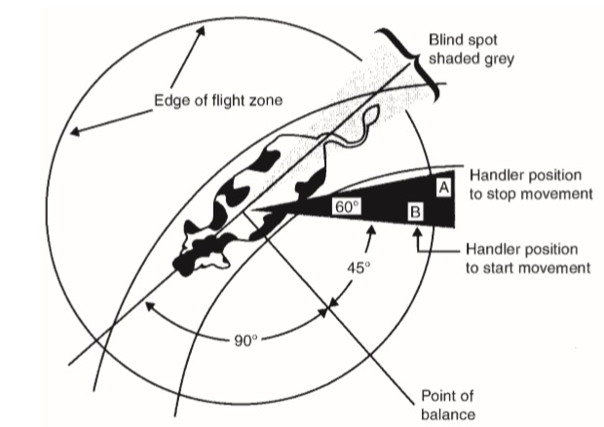

Fig. 1. Flight zone diagram and the most effective handler positions for moving an animal forward (Grandin 2000).

If a handler approaches from the front, they can induce the cattle to move left or right by indicating the opposite way. It must be remembered cattle have a larger flight zone when approached from the front than when approached from the side with a smaller profile. The handler should work on the edge of the flight zone, applying pressure by entering the flight zone, and releasing pressure by leaving the flight zone once the animals are moving. Entering the flight zone too deeply causes anxiety and panic, which can occur if the handler starts to chase the cattle once they are moving. Approaching cattle from behind, in their blind spot, will cause them to turn and look at the handler, halting movement (Grandin 2000). All cattle handling, whether individual animals or large groups, should be done at a walk. Handlers should use their voice softly to let the animals know where the handler is but should not yell or shout (Grandin 2000; Stookey *et al.* 2000).

Moving large groups of cattle utilises the flight zone of the overall mob by utilising the natural instinct of cattle to turn and orientate towards a novel stimulus, their point of balance, loosely bunch together and mill and circle. The handler should walk slowly behind the cattle, zigzagging to induce bunching, as drawn in Fig. 2, ignoring stragglers. These stragglers will catch up when the bunching instinct is triggered. If the collective flight zone is penetrated too deeply, it will result in a scattered herd. The handler must continue zigzagging as the herd starts to move forward, slowly narrowing the width of the arc (Grandin 2000).

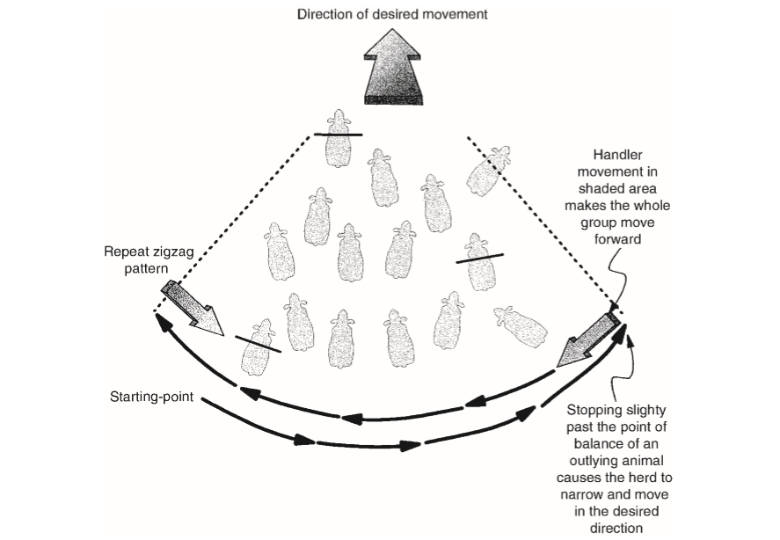

Fig. 2. Handler movement pattern to induce bunching for a herd of cattle (Grandin 2000).

These animals will arrange themselves such that the most insecure and highest flight zoned animals are in the centre of the bunch, with leaders in front. Social behaviour within the herd will determine which animal is a leader, second leader or follower, which are usually static positions with the same leaders leading the herd each time (Reinhardt 1982).

Using dogs to handle livestock is a method of making handling more efficient for the farmer. Cattle can be effectively handled both with and without dogs, however the advanced livestock training techniques used in this producer demonstration site utilised dogs.

Although weaning is a natural occurrence, artificial weaning in cattle enterprises often occurs at a younger stage than naturally would occur. This is a very stressful situation for the young cattle, especially when removed from their dams into a yard where no adult cattle are present. Stressors for the calf include loss of dam, access to udder and milk, as well as changes in the social and physical environment (Enriquez *et al.* 2011).

Fence-line weaning, where the cow and calf can still have physical contact but cannot nurse, has been shown to increase weight gain, with calves heavier than traditionally weaned calves even after 10 weeks (Price *et al.* 2003). The least stressful method of weaning calves uses a two-stage method of first preventing the calf from nursing and then separating several days later. This method does involve handling calves twice, which would increase stress, however this stress is not prolonged (Stookey *et al.* 2000).

Farmers should consider creep feeding before weaning, which allows calves to become used to eating grain prior to the stress of weaning. It also increases the number of animals meeting market specifications at a young age. Animals which have been exposed to solid feed prior to weaning experienced reduced stress, eating more and longer, and thus gaining more weight (Enriquez *et al.* 2011).

Animals which are yard weaned or handled using low stress Advanced Training during weaning are more familiar with yards, feeding routines, stock yards and handlers, as well as forming stronger bonds with other yard weaned animals. Cattle which have been trained using these methods are likely to be less stressed in feedlots and less likely to suffer from bovine respiratory disease (Arthington *et al.* 2005).

# Project objectives

1. To determine the effect of weaning or induction method on temperament and weight gain during weaning.
2. To train producer participants in advanced livestock handling techniques to enable them to yard wean/induct and train their cattle in the most effective manner.
3. To highlight the occupational health and safety benefits of quieter cattle and better handling techniques.
4. To produce a resource package outlining the best method of yard weaning/induction to quieten cattle and maintain or gain weight during weaning. This package is to be made available to producers through the BetterBeef Network and More Beef from Pastures delivery framework, as well as the Agriculture Victoria website.
5. To hold an awareness day on the benefits of yard weaning/induction and how to get the best results from yard weaning and induction.

# Methodology

## Demonstration Sites

Six producer demonstration sites were established to examine the impact of weaning and induction method on weight gain and temperament in weaner cattle. All weaner cattle used in the demonstration project were *Bos taurus*, mostly Angus and Hereford breeds. Weaners were either bred on-farm or purchased from breeders and inducted onto the farm immediately post weaning, as shown in Tables 1 and 2.

Table 1: Source of cattle, treatments and number in each treatment for each site.

|  |  |  |  |  |
| --- | --- | --- | --- | --- |
| **Site** | **Source of cattle** | **Treatment and number of animals per treatment** | | |
| **Paddock weaning** | **Yard weaning** | **Advanced training** |
| **Farm 1** | Purchased | 47 |  | 49 |
| **Farm 2** | Home-Bred |  | 43 | 53 |
| **Farm 3** | Purchased | 39 |  | 39 |
| **Farm 4** | Home-Bred |  | 60 | 38 |
| **Farm 5** | Home-Bred | 38 |  | 38 |
| **Farm 6** | Home-Bred |  | 68 | 64 |

Table 2: Location and enterprise details for each farm.

|  |  |  |  |  |
| --- | --- | --- | --- | --- |
| **Site** | **Location** | **Enterprise** | **Number of head** | **Traditional weaning method** |
| **Farm 1** | Walkerville | Steer finishing operation | 800 Angus steers | Paddock weaning |
| **Farm 2** | Buffalo | Breeder/finisher operation | 500 breeding cows | Yard weaning |
| **Farm 3** | Buffalo | Steer trading/finisher operation | 800 Angus and Hereford steers | Paddock weaning |
| **Farm 4** | Dumbalk | Breeding operation | 500-600 breeding Angus cows, along with 1000-1200 trade cattle purchased each year | Yard weaning |
| **Farm 5** | Dumbalk | Breeding operation | 600 Angus breeding cows, along with 1400 trade stock purchased each year | Paddock weaning |
| **Farm 6** | Sandy Point | Breeding operation | 1000 Angus breeding cows | Yard weaning |

## Producer Training in Advanced Livestock Handling Skills

An advanced livestock handling workshop was run for the six producers by trainer Neil McDonald (<http://www.neilmcdonald.com.au>), followed by further one-on-one training at each participant’s farm. The workshop focused on how to start, stop and create a steady flow of livestock movement. Concepts of pressure and release, anticipation of movement, handler position, effect of body language and the angles of the handler’s feet and head were also incorporated into the training. Teamwork, safety, animal welfare, yard design, mob structure and the use of devices to assist with cattle movement were also covered within the workshop. Neil discussed dog training techniques aiming to achieve above average working dogs as well as how to best utilise multiple dogs.

## Treatments

Each of the six demonstration sites compared the producers’ traditional weaning method (i.e. *Paddock Weaning* or *Yard Weaning*) with *Yard Weaning incorporating Advanced Livestock Handling and Training (abbreviated to Advanced Training)*. These three weaning methods are described as follows:

### Paddock Weaning

Home-bred calves in this treatment were weaned off their dams straight onto a paddock of good quality pasture at a different location on the farm from their dams. Weaners were fed hay daily for 5-10 days. The equivalent to this in a trading operation was to place newly purchased weaners into paddocks and feed them hay daily for 5-10 days.

### Yard Weaning

Home-bred calves in this treatment were weaned into secure cattle yards away from their mothers and fed good quality pellets and roughage. Weaners were given daily contact with humans during feeding and were confined in yards for 5-10 days, according to the individual routine practised on each farm. The equivalent to this method in a trading operation was to do the same with newly purchased weaners after initially giving them a few days on the property to settle.

### Advanced Livestock Handling and Training (Advanced Training)

As with the yard weaning method, home-bred calves were weaned into secure yards away from their mothers and fed good quality pellets and roughage. Weaners were given daily contact with people during feeding as well as undergoing advanced training using the techniques that producers learnt at the workshop and during one-on-one sessions with Neil McDonald. Weaners were confined to yards and trained for 5-10 days.

Training activities included working the weaners in, through and out of the yards using dogs and advanced handling and movement techniques. The weaners were taught to accept pressure from the dogs as they were brought towards the handler, learning that when the desired outcome of moving towards the handler was achieved, the handler relieved the pressure imposed on the weaners from the dogs. When the weaners moved away from the handler (i.e. tried to break) the dogs blocked the cattle up and applied pressure to bring them back to the handler where they were again given relief from pressure.

Eventually, the weaners became educated to the processes of handling and flowed freely forwards through the force pen, race and crush without pressure. If the weaners turned back when going into the force pen, they learnt that pressure would be applied by the handler and dogs. Throughout the process of this education the weaners learned to walk forwards towards the handler and continue to walk through the race and up to the crush, even with the handler standing near the crush.

When worked in a paddock the cattle learnt to stand with the handler and accept direction from the handler, so that they did not move away from the handler without direction. If the weaners did run and break, dogs were again used to block the weaners and herd them back. Once the weaners were again under handler control, they were given relief from the dogs. In this way the weaners learnt to walk calmly while being mustered and when exiting the yards.

The equivalent to this method on a trading property was to do the same with newly purchased weaners after initially giving them a few days on the property to settle.

After undergoing their initial 5-10 day weaning treatments, cattle from both treatments (i.e. paddock weaning or yard waning plus advanced livestock handling and training) were run together as one mob in a paddock for approximately six weeks. All weaners were then bought back into the cattle yards to monitor liveweight and temperament changes.

## Animal Measurements and Data Analysis

### Liveweight Change

On the day of weaning or induction (Day 1), cattle were given a six-hour curfew, tagged with an individual electronic identification tag (if not already tagged) and weighed. Liveweight was again recorded after a period of 1-week (all sites) and then at 6-weeks post-weaning (four sites only – Farms 3, 4, 5 and 6).

### Temperament (Flight Speed)

Flight speed is an easily measured indicator of temperament (Baker et al. 2003) and is based on measuring the speed at which an animal leaves a confined space. Animals with lower flight speeds moved more slowly out of the crush, a sign that they are less stressed by being confined within the crush.

Flight speed was measured in metres per second (m/sec) as animals exited the cattle crush in the yards, it was measured for all animals, at all sites at the start of weaning (Day 1) and one week later (Week 1). A final measurement was taken six weeks post-weaning (Week 6) at four sites – Farms 3, 4, 5 and 6.

Flight speed was measured using the laser crush method. An example set up of this method is shown in Fig. 3. This method involved placing two lasers, 1.8 metres apart, and recording the time taken for the animal to travel between the two beams of light. From this value, flight speed is calculated as $\frac{distance travelled (m)}{time (sec)}$.

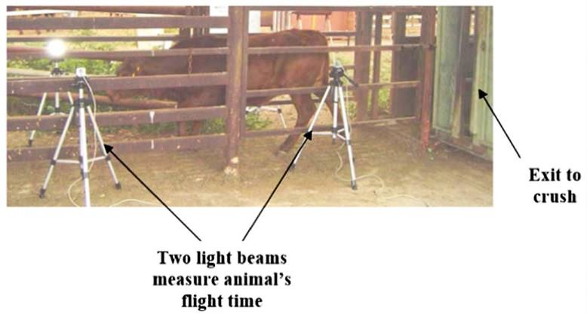

Fig. 3.Laser crush method for calculating Flight Speed (Grandin et al. 2012).

### Statistical Anaylysis

Statistical analysis was conducted using GenStat (17.1 VSN International). A 2-way Analysis of Variance (2-way ANOVA) was used to examine the influence of farm and weaning method as factors influencing both flight speed and liveweight change in weaner cattle. In each analysis, Advanced Livestock Handling and Training was compared with the traditional method of weaning used on the participants’ farms (i.e. *Paddock Weaning* or *Yard Weaning*).

## Impact Evaluation

Impact of the demonstration was assessed through surveying and interviewing the demonstration participants, obtaining feedback from field day participants and by modelling the potential adoption of weaning with the use of Advanced Livestock Handling and Training techniques. Relevant surveys, evaluation questionnaires and the modelling inputs and outputs can be found in the appendix of this report.

### Demonstration Participants

Each of the six demonstration participants (site hosts) were interviewed individually and surveyed to gain a better understanding of 1) their pre-existing weaning management, 2) their behavioural change because of their participation and 3) their attitudes toward and concerns about the advanced livestock handling and training techniques, including barriers to adoption on their property.

### Field Day Attendees

Attendees at the demonstration’s major field day were surveyed to determine their satisfaction with and value obtained from the event, their willingness to recommend the event to others, and any intended changes because of their attendance.

### Potential Adoption by Industry (Modelled)

The CSIRO Adoption and Diffusion Outcome Prediction Tool (ADOPT) was used to predict likely adoption and diffusion characteristics of the practice of weaning with the use of Advanced Livestock Handling and Training techniques. Inputs to the model were generated during a facilitated workshop attended by the demonstration participants. The workshop was conducted at a producer group meeting, after the group had reviewed the demonstration results.

# Results

## Liveweight

Liveweight change over the first week (Day 1 to Week 1) varied between farms, with three farms showing gains for both the advanced training and the control management practice, and three farms showing losses for both groups. Higher total liveweight gains (Day 1 to Week 6) were achieved using the Advanced Training method at two of the four farms where liveweight monitoring was continued to Week 6 (Table 3).

Table 3. Summary of liveweights (mean ± SDA) at day 1, weeks 1 and 6 for advanced training and the control management practice for the six demonstration sites.

| **Site** | **Treatment** | **Liveweight (kg)** | | | **Liveweight change (kg)** | |
| --- | --- | --- | --- | --- | --- | --- |
|  |  | Day 1 | Week 1 | Week 6 | INITIAL  Day 1 to Week 1 | TOTAL  Day 1 to Week 6 |
| **Farm 1B** | Advanced training | 341.9 (± 29.9) | 327.9 (± 30.2) |  | -14.0 |  |
| Paddock weaning | 345.2 (± 24.1) | 335.5 (± 24.3) |  | -9.7 |  |
| **Farm 2B** | Advanced training | 243.2 (± 36.0) | 230.2 (± 34.0) |  | -13.0 |  |
| Yard weaning | 247.1 (± 22.3) | 235.1 (± 22.1) |  | -12.0 |  |
| **Farm 3** | Advanced training | 237.5 (± 22.7) | 230.5 (± 24.0) | 255.5 (± 22.7) | -7.0 | +18.4 |
| Paddock weaning | 245.6 (± 25.7) | 244.2 (± 26.8) | 265.4 (± 25.3) | -1.1 | +19.8 |
| **Farm 4** | Advanced training | 204.3 (± 31.4) | 207.6 (± 31.4) | 211.6 (± 31.6) | +3.3 | +7.3 |
| Yard weaning | 201.4 (± 27.7) | 201.7 (± 28.1) | 209.7 (± 26.7) | +0.3 | +8.3 |
| **Farm 5** | Advanced training | 218. 9(± 20.2) | 226.7 (± 21.7) | 237.5 (± 19.4) | +7.8 | +18.6 |
| Paddock weaning | 206.3 (± 26.3) | 214.0 (± 24.8) | 221.4 (± 23.1) | +7.7 | +15.1 |
| **Farm 6** | Advanced training | 246.9 (± 32.4) | 254.1 (± 36.5) | 260.5 (± 32.8) | +7.2 | +13.6 |
| Yard weaning | 252.0 (± 35.0) | 262.1 (± 35.5) | 253.6 (± 38.7) | +10.1 | +1.6 |

B *Monitoring discontinued after Week 1*

On average animals undergoing Advanced Training lost significantly (P<0.01) more weight in the Day 1 to Week 1 period compared to those being weaned by traditional methods. Over the total six-week period, the average total weight gain achieved for the Advanced Training method was +13.9kg compared to +9.7kg for the traditional weaning method, however this difference was not significant.

Table 4. Summary statistics of liveweight change for the Advanced Training and Traditional weaning methods, and confidence levels for the impact of weaning method, farm and weaning method/farm Interaction.

|  |  |  |  |  |  |
| --- | --- | --- | --- | --- | --- |
|  | **Weaning method** | | **Confidence levels (P value)** | | |
|  | **Advanced training** | **Traditional weaning** | **Weaning method** | **Farm** | **Interaction (weaning method x farm)** |
| Liveweight change to Week 1 (kg) | -2.7 | 0.0 | <0.01 | <0.001 | NS |
| Liveweight change to Week 6 (kg) | 13.9 | 9.7 | NS | <0.05 | NS |

## Flight Speed

At day 1, there were no differences in flight speed between the advanced training treatment and the control management on any of the farms. By Week 1, all Advanced Training groups had average flight speeds that were 0.14 – 0.38 m/sec (7 – 22%, average 15%) lower than their traditionally weaned counterparts.

At Week 6, the four sites that continued to monitor flight speed had average flight speeds for Advanced Training groups that were 0.05 – 0.43 m/sec (3 - 20%, average 11%) lower than their traditionally weaned counterparts (Table 5).

There was some variability in the flight speed outcomes across the six sites. At Week 1, two traditional weaning groups (Farms 1 & 5) showed increased flight speed, while all other traditional weaning and advanced training groups showed a decrease. By Week 6, all four of the monitored traditional weaning and advanced training groups showed flight scores that had decreased by varying magnitudes.

The flight speed of various weaning methods can be compared in terms of 1) the change in flight speed over the six-week period, and 2) as the difference between the flight speed of the weaning treatment groups on any one day.

Table 5: Summary of flight speed (mean ± SD) across farms.

| **Site** | **Treatment** | **Flight speed (m/sec)** | | | **Flight speed difference:**  **advanced training vs traditional (paddock/yard) weaning**  **(m/sec)** | | **Flight speed change since day 1**  **(m/sec)** | |
| --- | --- | --- | --- | --- | --- | --- | --- | --- |
|  |  | Day 1 | Week 1 | Week 6 | Week 1 | Week 6 | Week 1 | Week 6 |
| **Farm 1\*\*** | Advanced Training | 2.30  (± 0.59) | 2.20  (± 0.67) |  | -0.28 |  | -0.10 |  |
| Paddock Weaning | 2.23  (± 0.72) | 2.48  (± 0.93) |  |  |  | +0.25 |  |
| **Farm 2\*\*** | Advanced Training | 3.21  (± 0.58) | 2.50  (± 0.73) |  | -0.51 |  | -0.71 |  |
| Yard Weaning | 3.32  (± 0.65) | 3.01  (± 0.89) |  |  |  | -0.31 |  |
| **Farm 3** | Advanced Training | 2.27  (± 0.71) | 1.86  (± 0.76) | 1.54  (± 0.57) | -0.14 | -0.05 | -0.41 | -0.73 |
| Paddock Weaning | 2.06  (± 0.71) | 2.00  (± 0.85) | 1.59  (± 0.67) |  |  | -0.06 | -0.47 |
| **Farm 4** | Advanced Training | 2.55  (± 1.28) | 1.66  (± 0.70) | 1.67  (± 0.75) | -0.46 | -0.43 | -0.89 | -0.88 |
| Yard Weaning | 2.40  (± 0.98) | 2.12  (± 0.77) | 2.10  (± 0.60) |  |  | -0.28 | -0.30 |
| **Farm 5** | Advanced Training | 2.17  (± 0.67) | 1.93  (± 0.69) | 1.78  (± 0.51) | -0.30 | -0.15 | -0.24 | -0.39 |
| Paddock Weaning | 2.22  (± 0.51) | 2.23  (± 0.68) | 1.93  (± 0.58) |  |  | +0.01 | -0.29 |
| **Farm 6** | Advanced Training | 1.90  (± 0.41) | 1.32  (± 0.46) | 1.41  (± 0.32) | -0.38 | -0.24 | -0.58 | -0.49 |
| Yard Weaning | 2.00  (± 0.43) | 1.70  (± 0.44) | 1.65  (± 0.42) |  |  | -0.30 | -0.35 |

\**Standard Deviation – a measure of the spread of data in relation to the mean*

\*\**Monitoring discontinued after Week 1*

Farm had a significant effect on flight speed change at both Week 1 and Week 6 (Table 6). This is not unexpected and would be due to differences in management and environment on individual properties. The flight speeds of animals that underwent advanced training decreased more than those weaned using traditional paddock and yard weaning methods, both at Week 1 (<0.001) and Week 6 (P<0.01) (Table 6).

Table 6. Summary statistics for change in Flight Speed for the Advanced Training and Traditional weaning methods, Farm and Weaning Method/Farm Interaction.

|  | **Weaning Method** | | **P Value** | | |
| --- | --- | --- | --- | --- | --- |
|  | **Advanced Training** | **Traditional Weaning** | **Weaning Method** | **Farm** | **Interaction (Weaning Method x Farm)** |
| Initial flight speed change (day 1 to week 1) | -0.4932 | -0.1362 | <0.001 | <0.001 | NS |
| Total flight speed change (day 1 to week 6) | -0.6194 | -0.3507 | <0.01 | <0.001 | NS |

## Participant Feedback

Participants within this demonstration completed a pre-workshop survey at the initial workshop delivered by Neil McDonald and a post-demonstration survey after applying the advanced training activities on farm. Participants answered the same questions in pre and post-surveys and were asked to self-assess knowledge, attitude, skills, aspirations (KASA) and adoptions of two objectives; 1. Advanced livestock handling techniques, and, 2. Improved occupational health and safety outcomes for cattle handling. After completion of the demonstration participants were also asked a series of interview questions specific to their business, practice change on farm, and, benefits and barriers to adopting the advanced training method of weaning. The KASA survey questions and interview questions can be found in Appendix 2 of this report.

The baseline and post-demonstration self-evaluation data are presented in the graphs below. The demonstration produced significant gains in knowledge, skills and adoption relating to the use of advanced livestock handling techniques. Zero to imperceptible changes in attitudes and aspirations were produced in relation to advanced livestock handling techniques, due to both being rated moderately high in both pre and post surveys. A similar situation existed for attitudes and aspirations towards the occupational health and safety objective, with small gains made in knowledge, skills and adoption.

After participating in this demonstration, producers reported that they were on average 26% more knowledgeable about training weaners and on average 12% more knowledgeable about occupational health and safety related to cattle handling after undertaking the Advanced Livestock Handling course (Fig. 4).

Participants within this demonstration completed a pre-workshop survey at the initial workshop delivered by Neil McDonald and a post-demonstration survey after applying the advanced training activities on farm. Participants answered the same questions in pre and post-surveys and were asked to self-assess knowledge, attitude, skills, aspirations (KASA) and adoptions of two objectives; 1. Advanced livestock handling techniques, and, 2. Improved occupational health and safety outcomes for cattle handling. After completion of the demonstration participants were also asked a series of interview questions specific to their business, practice change on farm, and, benefits and barriers to adopting the advanced training method of weaning. The KASA survey questions and interview questions can be found in Appendix 2 of this report.

The baseline and post-demonstration self-evaluation data are presented in the graphs below. The demonstration produced significant gains in knowledge, skills and adoption relating to the use of advanced livestock handling techniques. Zero to imperceptible changes in attitudes and aspirations were produced in relation to advanced livestock handling techniques, due to both being rated moderately high in both pre and post surveys. A similar situation existed for attitudes and aspirations towards the occupational health and safety objective, with small gains made in knowledge, skills and adoption.

After participating in this demonstration, producers reported that they were on average 26% more knowledgeable about training weaners and on average 12% more knowledgeable about occupational health and safety related to cattle handling after undertaking the Advanced Livestock Handling course (Fig. 4).

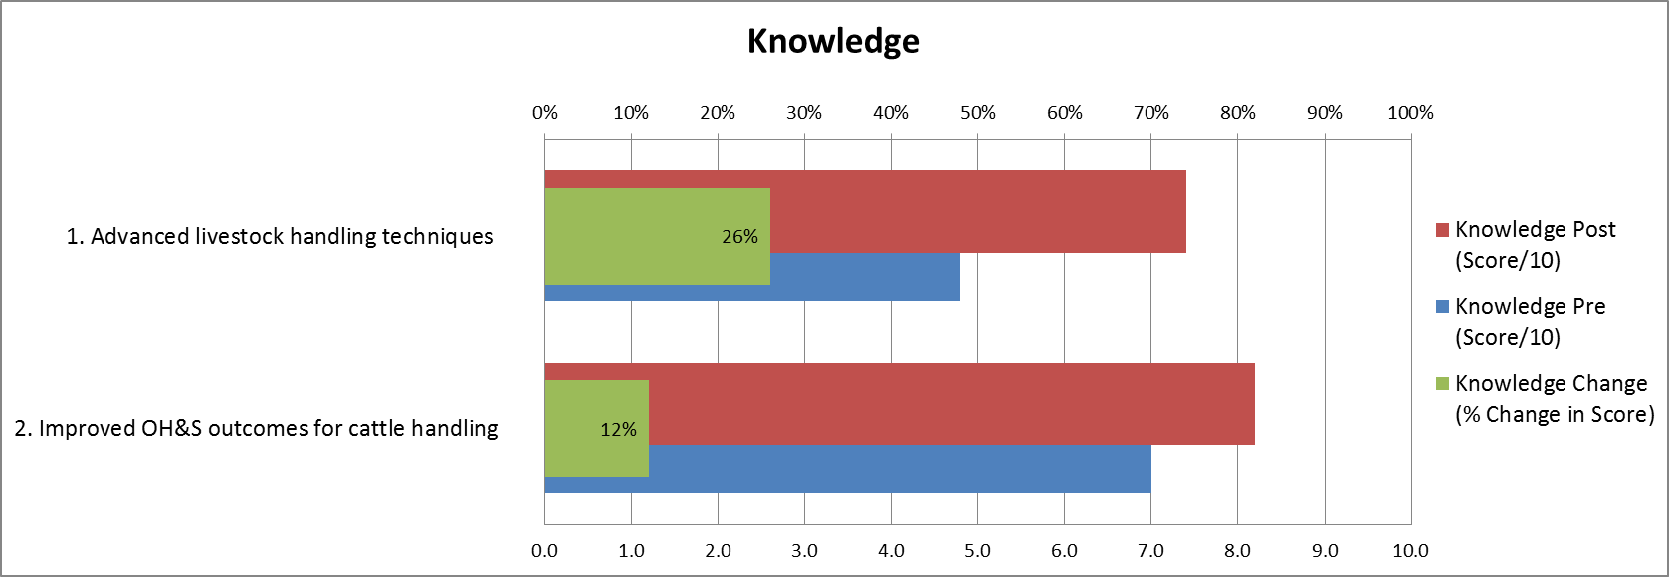Figure 4. Change in knowledge as reported by participants.

When asked to score their attitude towards advanced livestock handling techniques it was reported that the average participant score in the pre-survey of 7.5 was reduced to 7.4 out of 10 in the post-survey results (Figure 3). When examining individual scores towards attitude it was noted that one participant scored their attitude post-workshop and after being involved with the demonstration as a score of 1 out of 10; 1 being associated with a negative attitude towards advanced training of weaners after completing the course. This producer commented that, in implementing the advanced livestock handling methods, they believed the method stressed the weaners, that there were too many people and dogs involved in the process and the method changed the way cattle moved and flowed through yards. When asked if the demonstration was a worthwhile trial for their business, this producer believed that for the time required, the weight gains observed in weaners were not significant enough.

Given the weighting this participant’s post-score had on the average, the scores were again analysed excluding this individual’s responses for this objective. The attitudes of other producers towards advanced training of weaners increased by 12% (average score increasing from 7.8 to 9.0 out of 10 in the pre and post-survey) (Figure 5).

There was no apparent change in attitude towards occupational health and safety improvements; however, this was scored very high (average 9.2 out of 10) by the participants initially in pre-workshop survey and again in the post-demonstration survey (figure 4 and 5).

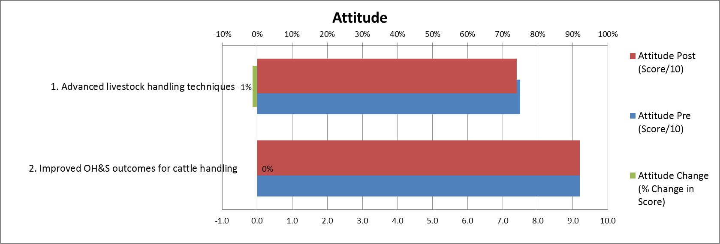

Fig. 5. Change in attitude as reported by all participants.

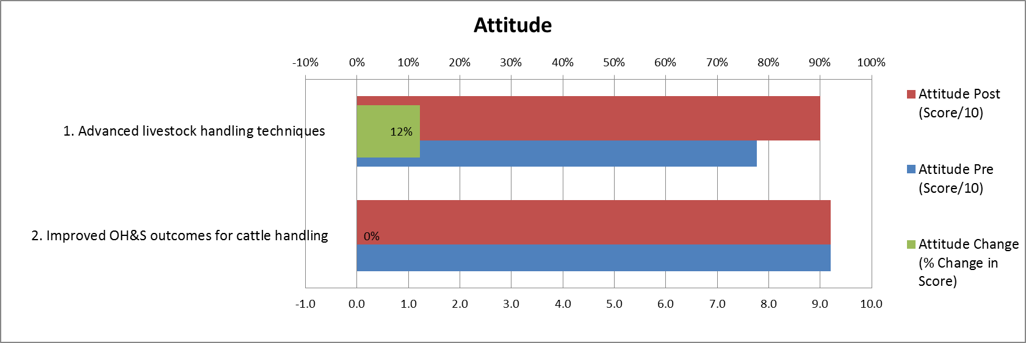Fig. 6. Change in attitude as reported by participants (excluding one participant's responses due to the heavy weighting this had on the average score for the cattle handling objective).

Participants reported a change in skill level for training weaners using advanced handling techniques by 34%; improving from an average score of 5.1 to 8.5 out 10 in the pre and post-surveys, respectively (Figure 7). This was the greatest change seen in the KASA measured within the demonstration. There was a 12% increase in in participants’ skills to manage occupational health and safety risks around cattle.

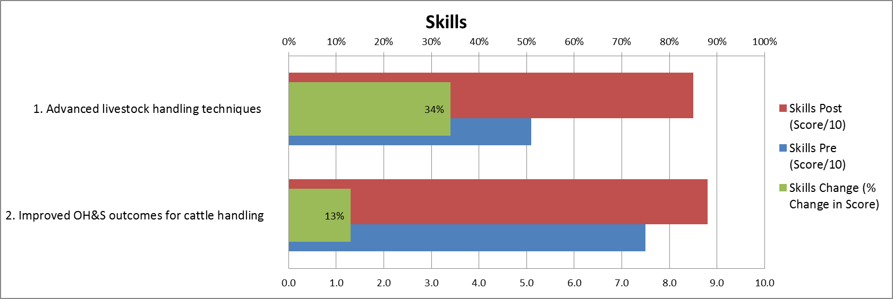 Fig. 7. Change in skill level as reported by participants.

When measuring aspirations, and more specifically, how motivated producers were to improve their livestock handling and implement advanced training within their enterprise, participants reported an increased motivation of 1% to undertake Advanced Training, with an average pre-course score of 7.4 increasing to 7.5 out of 10 (Figure 7). Similar to the responses collected around attitude to advanced livestock handling techniques, the same participant who scored their attitude after being involved with the demonstration as low (1 out of 10) also scored their aspirations, or motivation, post-workshop as 1 out of 10. This again had an impact on the participant’s average score, as such the scores were again analysed excluding this individual’s responses for this objective. It can be seen in figure 7 that among the other producers their aspirations or motivation towards advanced training of weaners increased by 12% (average score increasing from 7.8 to 9.1 out of 10 in the pre and post-survey, respectively).

There was no apparent change in attitude towards occupational health and safety improvements; however this was scored very high (average 9.2 out of 10) by the participants initially in pre-workshop survey and again in the post-demonstration survey (Figure 6 and 7).

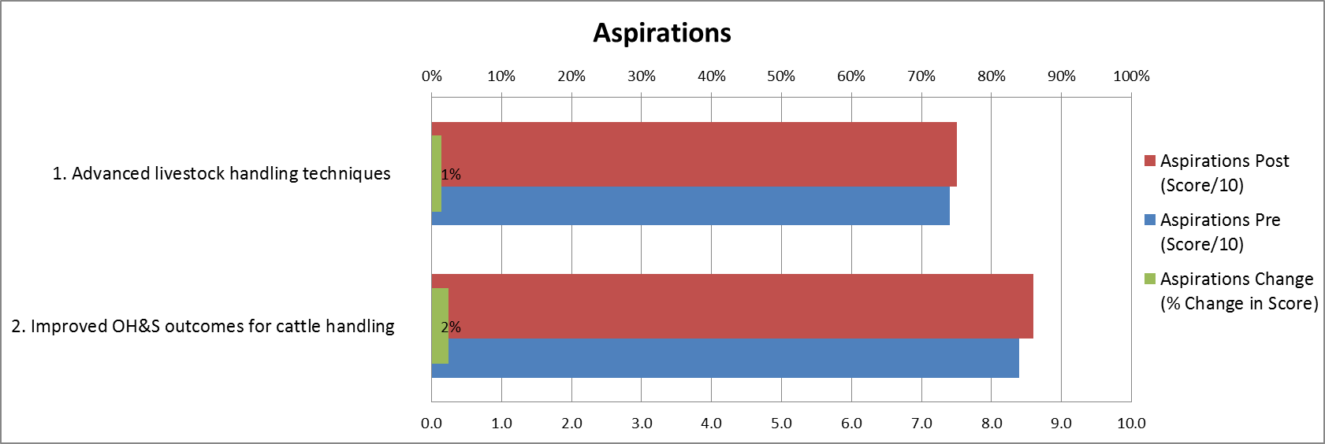

Fig. 8. Change in motivation and aspirations as reported by producer participants.

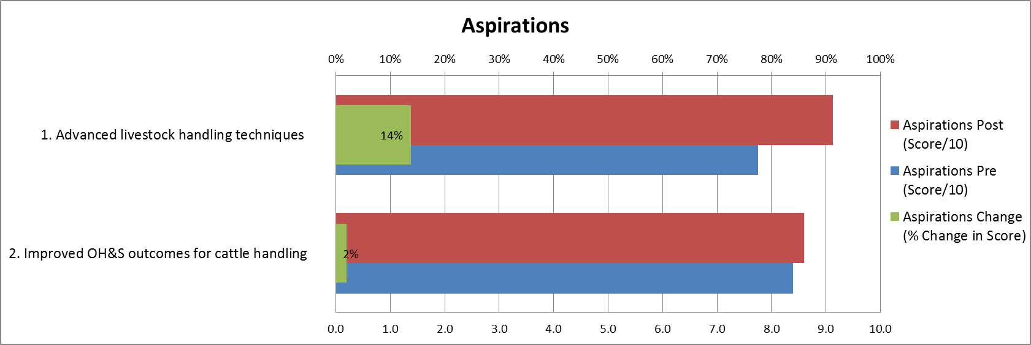

Fig. 9. Change in motivation and aspirations as reported by producer participants.

Lastly, questions regarding the adoption, or use, of advanced livestock handling techniques and improved occupational health and safety outcomes for cattle handling were asked of participants. Participants were asked prior to undertaking the Advanced Livestock Handling course, to what extent are you utilising advanced handling techniques (not just yard weaning)? After the course and demonstration participants were again asked to what extent they were utilising advanced handling techniques. Similar questions were posed for the occupational health and safety outcomes asking to what extent effective occupational health and safety practices were implemented when handling cattle.

Prior to undertaking the course, participants rated themselves, on average, at 5.4/10 in their use of advanced livestock handling techniques and training methods. After completing the course, they reported an increase of 28% in their use of these techniques. Furthermore, participants reported an average increase of 19% in the effective implementation of occupational health and safety practices while handling cattle (Figure 8).

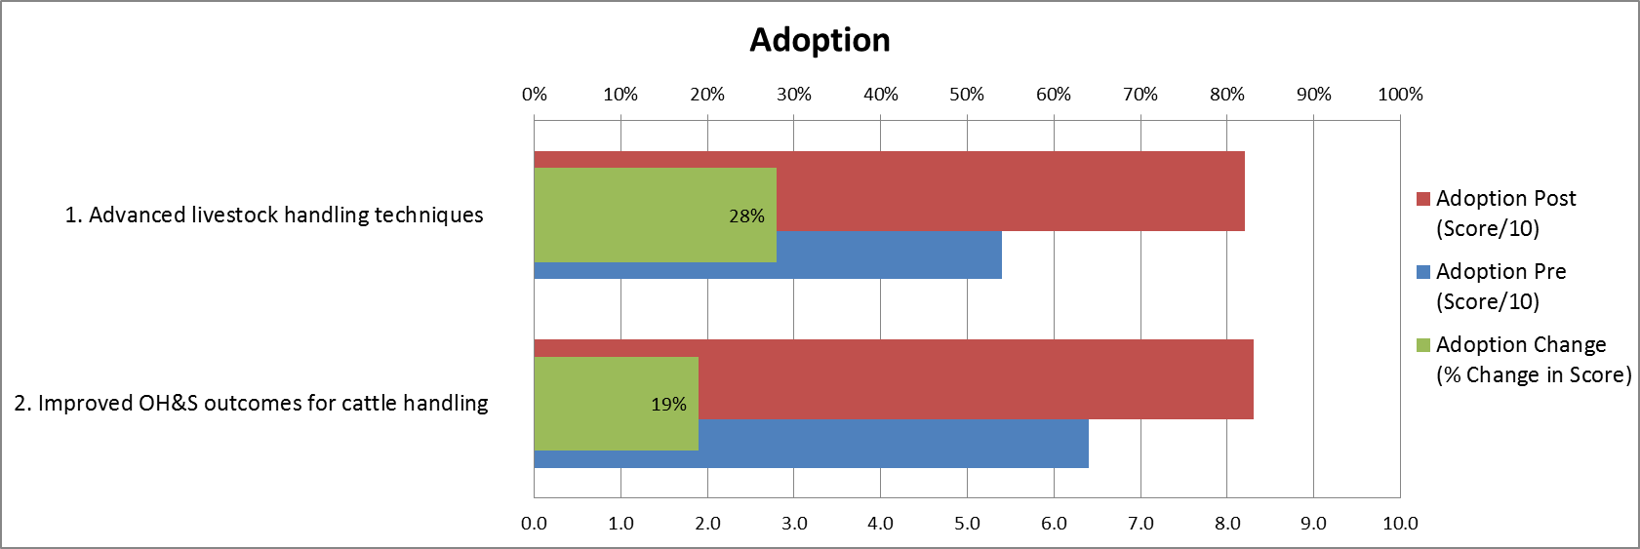

Fig. 10. Change in adoption habit as reported by participants.

## Field Day Engagement

A field day at Dumbalk was held on the 22nd April 2016 which attracted forty-five producers and included a practical demonstration of advanced cattle handling by Neil McDonald. Feedback was collected at the end of the field day from twenty-five participants who collectively manage 6048ha of land and 8256 head of cattle. Satisfaction of the field day was rated 8.3 while value was rated 7.7 out of 10.

When asked if participants would recommend this event to others 84% responded “yes” and 84% of the participants indicating they would make changes on-farm as a result of attending the field day. These changes included reviewing handling practices, taking more time to quieten cattle, increased training of weaners and better training of staff and owners. Other changes reported included implementing yard weaning and low stress handling principles.

## Impact Evaluation Results

This producer demonstration was analysed using ADOPT: an adoption and diffusion outcome prediction tool developed by the Commonwealth Scientific and Industrial Research Organisation (CSIRO). A full copy of this report can be found in Appendix 3. Adoption rate by Gippsland Beef Producers in five years from the start of the producer demonstration site was predicted to be 55.1%, rising to 92.7% after 10 years and peaking at 94% in 13 years. This forms an Adoption Level S Curve.

Decreased adoption may be seen if profits and efficiency gains are not increased, risks are not addressed, and management on-farm is poor and not planned for the long term.

Increased adoption of this weaning technique by producers in Gippsland may be motivated by increased profits, increased efficiency gains for their enterprise, development of new skills and knowledge to implement these techniques with continual learning required. There is a moderate initial investment, with moderate profit advantage in years used and future years. Future profit benefits can be realised immediately, with no net environmental impacts as well as a large increase in ease and convenience. A moderate reduction in occupational health and safety risk as well as reduced risk of poor carcass value can be seen. These techniques are easily trialled on-farm, with the potential to pay somebody to break cattle in becoming an option.

## Perceived Costs and Benefits of Advanced Training Techniques

Table 7: Costs of using dogs in the Advanced Training of weaners.

|  |  |  |
| --- | --- | --- |
| **Item** | **Breakdown** | **Cost** |
| Start-up dog costs | * Buying 4 dogs * Kennels/dog boxes * Training | $20 000 |
| Dog maintenance costs | Feeding | $2600 per year |
| Pet registration | $35 per year per dog |
| Animal health | $60 per month per dog |
| Vet bills |  |
| Replacing an older dog | $1500 per year |
| Training of dogs | Dog school | $1000 for 3 days per year  3 days spent off farm |
| Ongoing training (labour) | 40 minutes per day per dog |

Table 8: Perceived benefits due to advanced training of weaners during yard weaning/induction.

|  |  |  |
| --- | --- | --- |
| **Item** | **Breakdown** | **Saving** |
| Carcass value | Increase in tenderness |  |
| Access to processor | Cattle can be marketed more readily when producer has developed a good reputation for meeting carcass specifications |
| Labour (time) – shifting cattle, yarding and repair | Only requiring one person rather than two to move animals | 6 hours per week saved for a 500 head herd |
| Cutting out a cow or calf from mob is easier | Reduced labour and occupational health and safety risk |
| Reproductive performance | Heifers | Reduced empty rate |
| Occupational health and safety benefits | Decreased use of motorbike | Increased safety |
| Worksafe premium | Lower premium applies if farm has a good safety track record |
| Ability to identify and cull bad tempered cattle | Increased safety |

## Monitoring, Evaluation and Reporting (MER)

Table 9: Benefits due to advanced training weaners during yard weaning/induction.

| Areas of focus | Project targets | Project achievements |
| --- | --- | --- |
| Inputs | Six producers were involved in this demonstration site, with four producers followed to six weeks.  There were another four producers that were observing the demonstration as part of the producer group.  There are around 12,000 head of cattle managed by this producer group, involving 5,131 ha of land.  MLA have invested $25,000 into this project, with DEDJTR providing facilitation and oversight of this demonstration. Six producer members provided facilities, cattle and feed supplement, as well as 82 days of their time.  Neil McDonald provided a discount on Advanced Livestock Handling course fees. | Four of the six producers that commenced the demonstration collected data for the full six weeks – two producers concluded their involvement prior to the end of the demonstration. |
| Outputs | The demonstration sites will demonstrate that animals trained using advanced training techniques will have slower flight speeds and greater weight gains.  A field day will be held to communicate to other producers the benefits of this demonstration project. | It was found that animals which were trained using advanced techniques had slower flight speed after weaning/induction. On all bar one farm, weight gains were found to be higher in animals which were trained using advanced methods.  A field day was held in Dumbalk, with 44 producers attending, with positive feedback received. |
| Changes in knowledge, attitudes and skills | Producers participating in this demonstration site will develop skills in livestock handling and occupational health and safety risk reduction, as well as improved knowledge, attitude, motivation and adoption. | Producers reported increased knowledge, skills, aspirations, and adoption with slightly decreased attitude.  Four out of six producers have adopted these techniques for coming seasons. |
| Practice changes | Producers were confused as to the most effective way to handle their livestock and were trialling different techniques with varied success. After participating in this producer demonstration site, producers will use advanced handling techniques to train their livestock, resulting in quieter cattle and higher weight gains. | Of the six producers, four have adopted Advanced Training techniques as a handling method on their farms. |
| Benefits  Describe the benefits that you are expecting to achieve because of the project: | An increase in carcass value due to reduced bruising and dark cutting.  Increased labour and time inputs are a cost to achieve this outcome. | Producers have noted increased confidence, job satisfaction and increased occupational health and safety.  Increased carcass value and increased weight gain during and after weaning was noted. |
| General observations | Research gaps included project design and extraneous variables which were not or could not be controlled.  Project learnings included an increase in knowledge, slight decrease in average attitudes to this practice, an increase in skills, aspirations and adoption of these techniques for cattle training and occupational health and safety risk reduction. | Unexpected benefits included increased bull sales.  Barriers to change included weather and time factors, with some producers indicating that they may be willing to employ someone to quieten their cattle. |

# Discussion

## Liveweight

On Farms 1, 2, and 3 there was an average loss in weight over the first week post-weaning in both treatments with the greatest average weight losses seen in the advanced training groups on farms 1 and 2 (-14kg and -13kg, respectively). This differed to farms 4, 5 and 6 in which both groups of weaners experienced weight gain over the first week post-weaning. When advanced training was compared with the traditional method of weaning on-farm, the weaners that underwent advanced training lost significantly more weight than those in the traditional weaning groups (yard or paddock weaning) after the first week. This significance in comparative weight loss between groups on-farm may be attributable to a combination of factors, including; stress of weaning, sudden introduction of dogs and new training processes as well as a likely reduction in the time weaners within the advanced training groups spent eating and ruminating.

After 6-weeks post-weaning, although average weight gain tended to be greater across animals in the advanced training treatment (+13.9kg versus +9.7kg), there was no significant difference in weight gain between the treatment groups. It should be noted that only one group of weaners (Farm 6 – yard weaning) lost weight between week 1 and week 6; average weight gain was +10.1kg during week 1 and this was reduced back to +1.6kg at week 6. During the demonstration period this group was the most variable in terms of live weight and at 6-weeks post-weaning this group had the greatest weight variation (amongst groups) with a standard deviation of ± 38.7kg.

The farm where each demonstration was undertaken had a significant effect on liveweight change over the demonstration period. This was expected, due to differences in animals, management practices on-farm (including previous handling prior to weaning) and other factors which contribute to animal performance.

Within the workshop, the importance of having well-trained working dogs when handling and training weaners was emphasised to participants. The use of poorly trained or young dogs may hinder the training process if dogs constantly push cattle, potentially causing weaners to be flightier during handling. It is vital that dogs are good at reading the flight zone of the cattle and giving relief at the appropriate time. It is possible that despite uniform training approaches, differences in performance between farms may have been linked to differences in quality of dogs and weaner training practices.

Other factors that may have influenced the weight gain results found in this demonstration could have included but are not limited to; exposure to supplementary feeding pre-weaning (imprint feeding), the use of different scales and equipment/infrastructure on each property, and, whether all six farms had collected weight measurements at 6-weeks post weaning. An indirect effect that may have also confounded results was the potential for the weaners in the yard weaning treatment being exposed to stimuli outside of what would have traditionally occurred during weaning on-farm. Producers taking more interest in these groups of weaners may have caused these animals to potentially get more treatment, feed, and exposure to novel situations, simply due to being part of the demonstration.

Despite this demonstration finding no significant difference in weight gains through to six weeks post weaning, other studies such as Fell *et al.* (1998) have shown that cattle that are yard weaned or trained had significantly higher weight gain in feedlots, with reduced morbidity and mortality when compared to paddock weaned controls. Furthermore, cattle with flighty temperament have been shown to have consistently lower feed intakes and growth rates relative to calm cattle (Busby, 2010) whilst good temperament is associated with higher weight gains in feedlots for both tropically adapted and British breeds. Daily weight gain in the feedlot for steers with the best temperament is approximately 0.4 kg/day higher than steers with the worst temperament.

This indicates that the trend towards greater liveweight gain six weeks post weaning for cattle subjected to advanced livestock handling at weaning, may be continued and ultimately become significant in later life, resulting in higher weight gains during a subsequent finishing period.

## Flight Speed

Flight speed (m/sec) of weaners decreased on all farms within the advanced training group after both the first week and at six-weeks post-weaning.

Weaners that underwent advanced training had a significantly greater change in flight speed than weaners in the traditional weaning groups after 1-week (P<0.001) and 6-weeks (P<0.01) post-weaning (Table 6). It was found that after 6-weeks post-weaning, the average change in flight speed in animals in the advanced training groups across all farms was -0.62m/sec compared to -0.35m/sec for animals in the traditional weaning groups on all farms.

For animals weaned using the traditional method of weaning (paddock or yard weaned) most farms experienced decrease in flight speed after the first week (except farm 1 and 5) and all saw a decrease at 6-weeks post weaning, however these decreases in flight speed were not as great as those from the advanced livestock handling groups.

As with weight gain, farm had a significant effect on change in flight speed both initially and over the complete weaning period. This was not unexpected, due to differences in animals, management practices on-farm, and handling prior to weaning. Differences in infrastructure and yard design are believed to have had an effect between farms; however, this was unable to be quantified. In some yards, weaners had a clear, straight run out of the crush into a holding yard, while other yards had a shorter race away from the crush with drafting gates; forcing animals to turn and potentially influencing exit speed. While comparisons between treatments on-farm are still valid, comparisons of flight speed between farms requires caution.

Animals with a slow flight time are more likely to perform well in feedlots, with higher weight gains obtained. Haematological analysis demonstrates that these animals usually have low cortisol, low total white cell count, low neutrophil count, high cytotoxic T cell and lymphocyte percentage, high proliferation of lymphocytes and high antibody (IgA) concentration, indicating that these animals are less stressed and have more active immune systems than animals with a fast flight time (Fell *et al.* 1999).

Although the weaners from both treatments were grouped and turned out together, the average flight speed in nearly all groups of weaners continued to decrease over the 6-weeks post weaning, particularly in the traditionally weaned cattle. Although all groups had decreased average flight speeds from the first measurement at the start of weaning to the measurements taken at 6-weeks post weaning, the significant difference in decreased flight speed between the treatments showed that weaners that underwent advanced training are likely to be calmer and less stressed during future handling. It was also noted by some producers that an overall improvement was visually observed in groups which were weaned using advanced livestock handling in comparison to the animals weaned using the traditional method of weaning as per the farms’ standard practice.

The reduction in flight speeds associated with advanced livestock handling of animals during either weaning or induction are likely to offer multiple benefits. Physical hazards of handling cattle including kicking and crushing, which can both result in serious injuries and fatalities are likely to be reduced. Cattle which are moved through the yards, or weaned in the yards, are more likely to be easier to handle in the future, due to lower stress levels and increased familiarity. Grandin (1984, 1987) suggests that compared to cattle having previous experience with rough handling, animals with previous gentle handling will be calmer and easier to handle in the future.

Stressed cattle have reduced meat quality due to increased bruising and decreased glycogen levels, increasing the incidence of ‘dark cutters’. Bruising costs the Australian beef industry around $30million per annum, or $4 per animal at the point of slaughter. This loss is attributed to stressed animals and damage from horns (CSIRO 2015).

Rough handling will double incidence of bruising, with stock that are stressed being more likely to damage themselves in yards and during trucking, regardless of infrastructure set up. Animals which have been trained to handle yarding, trucking and lairage situations will have a better flow rate, reducing need for handlers to force cattle, and reducing use of prodders and sticks (Grandin 1980).

The cost of dark cutting for Australian beef producers is more than $36 million annually (Ponnampalam *et al.* 2016). It is caused by low glycogen levels at slaughter, which results in a higher ultimate pH, above 5.70, resulting in coarse textured meat with a purple appearance. Good cattle handling minimises stress, reducing the rate of glycogen loss in the animal, thus reducing incidence of dark cutting.

### Practices and skills adopted due to the producer demonstration site

Four of six producers have adopted skills learnt in the advanced handling workshop for use on farm in coming seasons. Producers also found the opportunity to communicate ideas and techniques with other producers was beneficial.

Information and skills learnt in the Advanced Livestock Handling course has influenced decisions made on farm by producers. Four of the producers now choose to buy trained working dogs, are making changes or adjustments to race and yard design and are beginning to cull based on temperament. One producer has also made the decision to employ a full-time member of staff to work cattle with dogs. After completing the workshop, training and involvement in the demonstration most of the producers found using dogs was more efficient and will continue to do so in the future.

### Benefits to Producers

Producers have benefited from participating in this demonstration by increasing confidence and skills to use the techniques of advanced training and livestock handling when weaning or inducting cattle, and as a result are seeing improvements in the temperament and handling ability of their livestock. Other reported benefits from adopting the advanced livestock management include a reduced incidence of carcass damage (anecdotal producer comments), reduced occupational health and safety concerns, reduced time devoted to stock handling, greater use of rotational grazing, and a reduced requirement to spend money on infrastructure

## Achievement of Project Objectives

### To determine the effect of weaning or induction method on temperament and weight gain during weaning.

Advanced livestock handling resulted in a significant decrease in animal flight speeds at weeks one and six, indicating that weaners or newly purchased animals that had been educated to handling in such a way would be quieter and easier to handle with less occupational health and safety risks.

Animals that had been subjected to advanced livestock handling at weaning or induction had significantly greater weight loss in the first week post weaning, although this was not evident six weeks post weaning. While animals from the advanced livestock handling groups tended to be heaver six weeks post weaning, we are unable to say if this trend continued beyond the six-week period of this demonstration.

### To train producer participants in advanced livestock handling techniques to enable them to yard wean/induct and train their cattle in the most effective manner.

Producers reported an average 26% increase in knowledge about training weaners after being coached in and implementing advanced livestock handling for weaners on their farms.

Producer experience was mostly positive, with four of six producers adopting this practice for coming seasons. An increase in skills, knowledge, aspirations and adoption was clearly seen, with a slight decrease in attitudes towards cattle handling and occupational health and safety risk reduction. Benefits of participation as reported by producers included a reduction in labour requirement, increased joining success, carcass value and safety and communication with other producers for the sharing of knowledge and ideas.

### To highlight the occupational health and safety benefits of quieter cattle and better handling techniques.

Producers reported that they were 12% more knowledgeable about occupational health and safety related to cattle handling after undertaking the Advanced Livestock Handling course. They have also reported that less time needs to be spent on handling unruly cattle.

### To produce a resource package outlining the best method of yard weaning/induction to quieten cattle and maintain or gain weight during weaning. This package is to be made available to producers through the BetterBeef Network and More Beef from Pastures delivery framework, as well as the Agriculture Victoria website.

A fact sheet was produced for use by producers and BetterBeef groups and has been placed on the Agriculture Victoria website.

In addition, multiple presentations have been made by the project team about the demonstration findings, with the development of a PowerPoint presentation incoporating video footage. The presentation and video were provided at a webinar for the BetterBeef network as well as at the Border Beef Conference (2016) and the Hamilton BetterBeef Conference (2017). The presentation has also been provided interstate.

### To hold an awareness day on the benefits of yard weaning/induction and how to get the best results from yard weaning and induction.

A field day was held in Dumbalk in April 2016, with 44 producers in attendance. Evaluations of this event were positive with 84% of attendees indicating they planned to make changes on their farms because of this event. Further awareness activities have included publication of two media releases in MLA Friday Feedback as well as a tech note in the Agriculture Victoria Beef and Sheep Newsflash.

# Conclusions/recommendations

Advanced livestock handling at weaning/induction reduced animal flight speeds more than traditional weaning/induction methods. Consequently, it was observed by most participants that cattle undergoing the advanced training were calmer and easier to handle.

When comparing change in liveweight, weaners subjected to advanced livestock handling during weaning lost significantly more weight than traditionally weaned calves in the first week of weaning, but that there was no difference in liveweight six weeks after weaning. We did however observe that there was a trend towards greater liveweight gain six weeks post weaning for cattle subjected to advanced livestock handling at weaning. Based on published research that shows increased weight gains during finishing (particularly in feedlots) in trained and well-handled cattle it is possible that this trend towards increased growth rates of cattle from the advanced handling groups may continue and ultimately become significant in later life, resulting in higher weight gains during a subsequent finishing period.

While the demonstration looked to quantify possible benefits of advanced livestock handling at weaning in relation to flight speed and growth rates, there were several additional unintended benefits. Producers also reported a reduction in labour requirements, increased joining rates, greater carcass values and safety as areas of their businesses that benefitted because of improved weaner management.

We recommend that due to benefits associated with ease of handling and improved occupational health and safety, producers would be well served by incorporating principles associated with advanced livestock handling when weaning or induction of calves onto their properties. These principles include the education of cattle to being handled during weaning, which had a range of subsequent benefits to producers.

# Bibliography

Arthington J, Spears J, Miller D. (2005) The effect of early weaning on feedlot performance and measures of stress in beef calves *Journal of Animal Science* **83**(4), 933-939.

Baker J, Randel R, Long C. (2003) Breed type and gender effects on chute exit velocity and chute temperament score in beef calves. *Journal of Animal Science* **81**(120).

Busby, D. (2010) Disposition – Convenience trait or economically important. AAofBP Conference, New Mexico.

CRC for Beef Genetic Technologies (Beef CRC), Selecting for improved temperament and the benefits for beef production. (Fact Sheet) Available from <http://www.beefcrc.com/documents/publications/fact-sheets/FS15-SelectingforImprovedTemperament.pdf>.

CSIRO (2015) *Breeding hornless cattle* accessed 12/05/2016 http://www.csiro.au/en/Research/AF/Areas/Animal-Science/Premium-livestock-breeds/Hornless-Cattle.

Enriquez D, Hotzel M, Ungerfeld R. (2011) Minimising the stress of weaning beef calves: a review. *Acta Veterinaria Scandinavica* **53**(1), 2-8.

Fell L, Walker K, Reddacliff L, Davies L, Vallance H, House J, and Wilson S. (1998) Effects of yard weaning and pre-feedlot vaccination on feedlot performance of *Bos taurus* steers *Animal Production in Australia* **22**, 173-176.

Grandin, T. (1984) Reduce stress of handling to improve productivity of livestock. Vet. Med. **79**, 287-831.

Grandin, T. (1987) Animal handling. Vet. Clin. Nth Am. **3**,323-338

Grandin T (2000) Behavioural Principles of Handling Cattle and other grazing animals under extensive conditions *Livestock Handling and Transport 2nd ed.* CAB International Publishers United States of America.

Grandin T (2016) Behavioural principles of livestock handling *Professional Animal Scientist* **5**(2), 1-11.

Grandin T, Vetters M, Engle T, Ahola J. (2012) Comparison of flight speed and exit score as measurements of temperament in beef cattle. *Journal of Animal Science* **91**(1), 374-381.Haskell M,

Kuehne G, Llewellyn R, Pannell D, Wilkinson R, Dolling P, Ouzman J. (2013) *ADOPT: The Adoption and Diffusion Outcome Prediction Tool (Public Release Version 1.0, June 2013)* [Computer Software] Adelaide South Australia; CSIRO. Available from [www.csiro.au/ADOPT](http://www.csiro.au/ADOPT)

Meat and Livestock Australia (2015) *Temper temper – selecting for quieter cattle.* Accessed 11/05/2016 <http://www.mla.com.au/Extension-training-and-tools/Producer-case-studies/Temper-temper-selecting-for-quieter-cattle>.

Meat Standards Australia (2013) *Beef Information Kit* Meat and Livestock Australia Ltd Australia.

Ponnampalam E, Bekhit A, Hopkins D, Bruce H, Li D. (2016) Causes and contributing factors to dark cutting: current trends and future directions *Australian Meat Processor Corporation* Sydney, New South Wales.

Price E, Harris J, Borgward R, Sween M, Connor J. (2003) Fenceline contact of beef calves with their dams at weaning reduces negative effects of separation on behaviour and growth rate *Journal of Animal Science* **81**(1), 116-121.

Reinhardt V. (1982) Movement orders and leadership in a semi-wild cattle herd *Behaviour* **83**(3-4), 251-264.

Stookey J, Watts J. (2000) Low-stress restraint, handling and weaning of cattle *Livestock Handling and Transport 2nd ed.* CAB International Publishers United States of America.

Voisinet, B.d. et al. (1997) Feedlot cattle with calm temperaments have higher average daily gains than cattle with excitable temperaments. J.Anim.Sci. **75**, 892-896.

Worksafe Victoria (2006) A practical safety guide: Beef cattle handling. Accessed 11/05/2016 https://www.worksafe.vic.gov.au/__data/assets/pdf_file/0015/12372/WSV1079_Beef_web.pdf

# Acknowledgements

The authors would like to thank the producer group members who made their properties available for this producer demonstration site: Rob Liley, Ross and Madeline Batten, Andrew and Joan Carmichael, Shane Harris, Ian Hengstberger, Frances Toohey and David Pilkington. As well as Meat and Livestock Australia for co-funding the demonstration.

Thanks also to Martin Dunstan and John Bowman from Agriculture Victoria and to Neil and Helen McDonald, Dog Training and Livestock Handling Trainers.

# Appendix

## Farm details and raw data

### Farm 1 – Advanced Training and Paddock Weaning

**Beef Enterprise Details:**

This property is located in Walkerville, South Gippsland, and is a steer finishing enterprise of around 800 head.

**Source of cattle used in this demonstration:**

Cattle were purchased.

**Normal weaning/induction method used on this property:**

Animals are inducted onto this property by being confined for a week in a half hectare holding area during the day, with animals being held in the yards overnight. These animals are fed hay and silage from feeders with water available at all times.

**Treatment and number of animals compared on this property:**

Advanced Training (49 animals)

Paddock weaning (46 animals)

**Monitoring:**

Day 1 weaning

1-week post-weaning/induction

**Liveweight Results:**

At induction (Day 1), the average liveweight of the paddock inducted weaners was slightly heavier (3.31kg) than the average weight of the advanced training group of weaners. Both treatment groups lost weight over the first week. the advanced training group experienced an overall loss of 14.0kg, in comparison with 9.7kg for the paddock weaning group.

Figure 15 shows that the spread or variability of liveweight across both treatment groups recorded at the start of weaning and at approximately 1-week post weaning. It can be seen that although both groups lost weight, the general weight range and variation within the group remained the same.

Table 11: Comparison of liveweight change between Advanced Training and Paddock weaning on Farm 1.

|  |  |  |  |  |  |  |
| --- | --- | --- | --- | --- | --- | --- |
| **Site** | **Treatment** | **Liveweight (kg)** | | | **Initial change in liveweight between Day 1 and Week 1** | **Change in liveweight between Day 1 and Week 6** |
|  |  | *Day 1* | *Week 1* | *Week 6* | *Liveweight (kg)* | *Liveweight (kg)* |
| **Farm 1** | Advanced Training | 341.9 (± 29.9) | 327.9 (± 30.2) |  | -14.0 |  |
| Paddock Weaning | 345.2 (± 24.1) | 335.5 (± 24.3) |  | -9.7 |  |
| Difference (kg) | 3.3 | 7.6 |  |  |  |

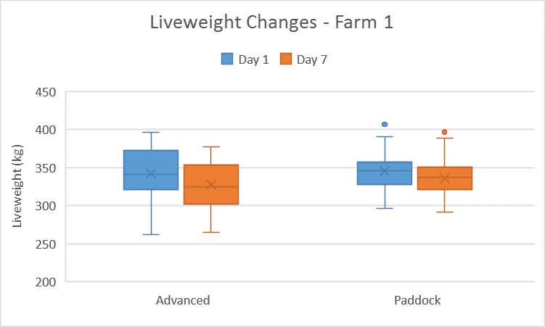

Figure 11. Variability in liveweight in both treatment groups measured on Day 1 and 1-week post-weaning/induction on Farm 1.

**Flight Speed Results:**

At weaning/induction (Day 1), there was a difference of -0.07 m/sec between the two treatment groups, with Advanced Training group having the higher flight speed. After seven days the Advanced Training group had a slightly lower flight speed than the average measured on Day 1 while the paddock weaning group increased their average flight speed by 0.25m/sec.

Table 12: Comparison of Flight Speed across treatments on Farm 1.

|  |  |  |  |  |  |  |
| --- | --- | --- | --- | --- | --- | --- |
| **Site** | **Treatment** | **Flight Speed (m/sec)** | | | **Initial Change in flight speed between Day 1 and Week 1** | **Change in flight speed between Day 1 and Week 6** |
|  |  | *Day 1* | *Week 1* | *Week 6* | *Flight Speed (m/sec)* | *Flight Speed (m/sec)* |
| **Farm 1** | Advanced Training | 2.30 (± 0.59) | 2.20 (± 0.67) |  | -0.10 |  |
| Paddock Weaning | 2.23 (± 0.72) | 2.48 (± 0.93) |  | +0.25 |  |
| Difference (m/sec) | -0.07 | -0.28 |  |  |  |

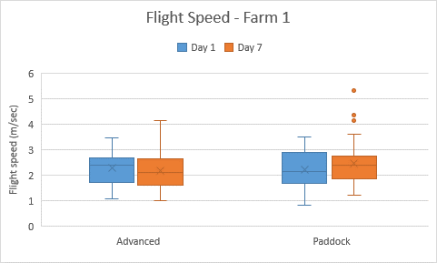

Figure 12. Flight speed on Days 1 and 7 for animals in the Advanced Training and Paddock Weaning treatments.

**Variables which may have affected results on this property:**

This farm was not monitored to six weeks, so it is unknown whether weaners continued to increase or decrease flight speed post-induction. Weight loss in these animals is potentially due to animals being stressed and entering negative energy balance. Extraneous variables such as rumen fill may alter liveweight results if animals were not subjected to a curfew.

**Changes in weaning or induction practice as a consequence of participation in this demonstration:**

Minimal changes were made to this weaning program post course participation. Producers thought that cattle were quiet, with animals that were part of the Advanced Training group potentially quietening others.

**Benefits of participation in this demonstration:**

Benefits of participating in this demonstration included reinforcement of practices and ideas already being performed on the property.

### Farm 2 – Advanced Training and Yard Weaning

**Beef enterprise details:**

This property is located in Buffalo, South Gippsland. 500 cows calve in spring; growing weaner steers to 18 months for feedlot entry while non-replacement heifers are finished on-farm before slaughter.

**Source of cattle used in this demonstration:**

Home-bred

**Normal weaning/induction method used on this property:**

Animals were locked in yards for several days, with little human or dog interaction. It was reported by the producer that after several years using this weaning method they had little success in quietening weaners as well as having weight losses after weaning. Cattle were also moved using motorbikes, resulting in cattle becoming more agitated and flightier.

Advanced Training had already begun to be implemented on this property as the owner had attended several courses over the past four years. This changed the way cattle were handled on this property as motorbikes were no longer used and dogs were utilised more during handling.

**Treatments and number of animals compared in this demonstration:**

Advanced Training (53 animals)

Yard weaning (43 animals)

**Monitoring:**

Day 1

1 Week post-weaning

**Liveweight Results:**

|  |  |  |  |  |  |  |
| --- | --- | --- | --- | --- | --- | --- |
| **Site** | **Treatment** | **Liveweight (kg)** | | | **Initial change in liveweight between Day 1 and Week 1** | **Change in liveweight between Day 1 and Week 6** |
|  |  | *Day 1* | *Week 1* | *Week 6* | *Liveweight (kg)* | *Liveweight (kg)* |
| **Farm 2** | Advanced Training | 243.2 (± 36.0) | 230.2 (± 34.0) |  | -13.0 |  |
| Yard Weaning | 247.1 (± 22.3) | 235.1 (± 22.1) |  | -12.0 |  |
| Difference (kg) | 3.9 | 4.9 |  |  |  |

Table 13: Comparison of liveweight change between advanced training and yard weaning on Farm 2.

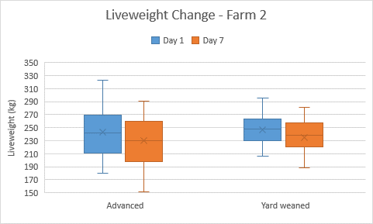

Figure 13. Live weight change over seven days on Farm 2.

At weaning (Day 1), the yard weaning group had a heavier average liveweight (+4kg) in comparison to the advanced training group. Both groups lost weight over the first week and at approximately Day 7, the Advanced Training group had lost an average of 13kg, in comparison with 12 kg for the yard weaning group.

Figure 13 shows that the variability of weight amongst the weaners that underwent the traditional yard weaning method was less compared with the weight ranges of the weaners within the advanced training group. This is particularly evident looking at the interquartile range of liveweights, approximately 60kg range within the advanced training group compared to an approximate 30kg range in the yard weaned group, this being further supported by the differences in standard deviations between the two groups (Table 13).

**Flight Speed Results:**

Table 14: Average Flight Speed over a week between two treatments on Farm 2.

|  |  |  |  |  |  |  |
| --- | --- | --- | --- | --- | --- | --- |
| **Site** | **Treatment** | **Flight Speed (m/sec)** | | | **Initial Change in flight speed between Day 1 and Week 1** | **Change in flight speed between Day 1 and Week 6** |
|  |  | *Day 1* | *Week 1* | *Week 6* | *Flight Speed (m/sec)* | *Flight Speed (m/sec)* |
| **Farm 2** | Advanced Training | 3.21 (± 0.58) | 2.50 (± 0.73) |  | -0.71 |  |
| Yard Weaning | 3.32 (± 0.65) | 3.01 (± 0.89) |  | -0.31 |  |
| Difference (m/sec) | 0.11 | 0.5 |  |  |  |

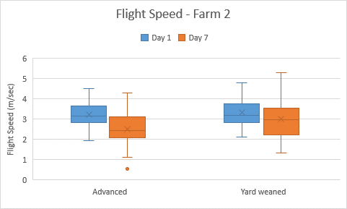

Figure 14. Flight speed on Days 1 and 7 for animals in the Advanced Training and Yard Weaning treatments on Farm 2.

At weaning (Day 1), there was a difference of 0.11 m/sec between the two treatment groups, with the yard weaning group having the higher flight speed. This was reversed after seven days, with the advanced training group having a slightly lower flight speed in comparison with the paddock weaning group.

Over the seven-day monitoring period, the Advanced Training groups flight speed decreased by 0.71 m/sec, in comparison with 0.32 m/sec for the Yard Weaning group.

Figure 18 clearly shows the change in flight speed within the advanced training group while the variation in flight speed was greatest in the yard weaned treatment after the first week post-weaning.

**Variables which may have affected results on this property:**

Extraneous variables may have included animals subconsciously being checked more often to see how they were going, thereby accidentally increasing their exposure to humans, dogs and vehicles.

**Changes in weaning or induction practice as a consequence of participation in this demonstration:**

Animals were kept in yards but were worked with dogs one to two times daily. Animals were supplied with ample good quality northern hay and transferred straight onto feed.

There was a reduction in use of motorbikes. Dogs were utilised more, with the owners buying several trained dogs and starting to use three or four dogs when mustering cattle.

**Benefits of participation in this demonstration:**

Producers thought that a more professional weaning process with better looking and less stressed animals was developed. The Advanced Training course reinforced practices which had already begun to be implemented on farm.

At pregnancy testing this year, Advanced Trained animals recorded lower empty rates, as well as no dark cutters from 82 animals sent to slaughter.

The Advanced Training course has given the property owners the confidence to wean earlier, particularly after a bad season.

### Farm 3 – Advanced Training and Paddock Weaning

**Beef enterprise details:**

Around 800 British bred cattle, mostly Angus or Hereford, are traded each year. The property is located in Buffalo.

**Source of cattle used in this demonstration:**

Cattle were imported from Tasmania.

**Normal weaning/induction method used on this property:**

Animals are bought as weaned or unweaned but are all treated as unweaned on arrival at the property. They are held in a holding paddock and separated into mobs based on gender and age classes. Cattle are rotationally grazed and brought into the yard for medical procedures and weighing. They then move slowly out of the yards into ungrazed laneways, slowly making their way into the next paddock. A single dog is used for mustering and dogs are not used in the yards.

**Treatments and number of animals compared in this demonstration:**

Advanced Training (39 animals)

Paddock weaning (39 animals)

**Monitoring:**

Day 1 weaning

|  |  |  |  |  |  |  |
| --- | --- | --- | --- | --- | --- | --- |
| **Site** | **Treatment** | **Liveweight (kg)** | | | **Initial change in liveweight between Day 1 and Week 1** | **Change in liveweight between Day 1 and Week 6** |
|  |  | *Day 1* | *Week 1* | *Week 6* | *Liveweight (kg)* | *Liveweight (kg)* |
| **Farm 3** | Advanced Training | 237.5 (± 22.7) | 230.5 (± 24.0) | 255.5 (± 22.7) | -7.0 | +18.4 |
| Paddock Weaning | 245.6 (± 25.7) | 244.2 (± 26.8) | 265.4 (± 25.3) | -1.1 | +19.8 |
| Difference (kg) | 8.1 | 13.7 | 9.9 |  |  |

1-week post-weaning/induction

6-week post-weaning/induction

**Liveweight Results:**

Table 15: Comparison of liveweight change between treatments on Farm 3.

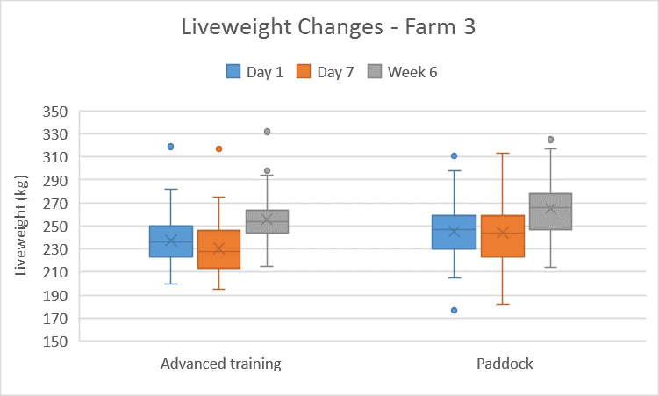

Figure 15. Liveweight changes on Farm 3 over six weeks.

At induction (Day 1), the paddock inducted group had a heavier average liveweight (8.1kg) but there was a similar range in weight across the two groups (Figure 15). Both treatment groups lost weight over the first week. After six weeks, the advanced training group had experienced an overall liveweight change of 18 kg, in comparison to 20 kg for the paddock weaning group.

**Flight Speed Results:**

Table 16: Differences in average flight speed on Farm 3.

|  |  |  |  |  |  |  |
| --- | --- | --- | --- | --- | --- | --- |
| **Site** | **Treatment** | **Flight Speed (m/sec)** | | | **Initial Change in flight speed between Day 1 and Week 1** | **Change in flight speed between Day 1 and Week 6** |
|  |  | *Day 1* | *Week 1* | *Week 6* | *Flight Speed (m/sec)* | *Flight Speed (m/sec)* |
| **Farm 3** | Advanced Training | 2.27 (± 0.71) | 1.86 (± 0.76) | 1.54 (± 0.57) | -0.41 | -0.73 |
| Paddock Weaning | 2.06 (± 0.71) | 2.00 (± 0.85) | 1.59 (± 0.67) | -0.06 | -0.47 |
| Difference (m/sec) | 0.21 | 0.14 | 0.05 |  |  |

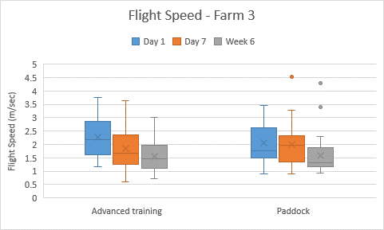

Figure 16. Flight Speed on Farm 3 at Day 1, Week 1 and Week 6 for the advanced training and paddock weaning groups.

At weaning/induction (Day 1), there was a difference of 0.21 m/sec between the two treatment groups, with Advanced Training group having the higher flight speed. This was reversed after seven days and six weeks with the Advanced Training group having a slightly lower flight speed in comparison with the Paddock Weaning group.

Over the six-week monitoring period, the advanced training groups flight speed decreased by 0.73 m/sec, in comparison with a decrease of 0.47 m/sec for the paddock weaning group.

**Variables which may have affected results on this property:**

Drones were being used to film the training process. In addition, the cattle were being moved by three people in the yards. The cattle were not used to this and after the training session were moved by only one individual in the yards.

**Changes in weaning or induction practice as a consequence of participation in this demonstration:**

After completing the course, minimal changes were made to the weaning program. Producers thought that cattle were quiet, with animals that were part of the advanced training group potentially quietening others. Cattle were mustered to water points and other points of interest.

**Benefits of participation in this demonstration:**

Participation in this demonstration was beneficial to gain other people’s perspectives and reinforcing what was already being done on this property. The differences in weight gains achieved were not great enough for this property to adopt Advanced Training as a technique; however, if a really wild mob were bought in, they would consider paying someone to break the cattle in.

### Farm 4 – Advanced Training and Yard Weaning

**Beef Enterprise Details:**

Located at Dumbalk, South Gippsland, property runs between 500-600 spring calving Angus cows as well as 1000-1200 trade cattle are purchased and brought onto the property. The property typically weans between 500-600 head per year as well as inducting weaners within their trade operation.

**Source of cattle used in this demonstration:**

Home bred

**Normal weaning/induction method used on this property:**

Fence line weaning was originally used. This resulted in problems such as animals breaking through fences, as well as wild, untamed cattle which were difficult to manage. Often, these animals had had zero exposure to humans, as some are born on a lease block before being brought onto the main property for weaning.

**Treatment and number of animals compared on this property:**

Advanced Training (38 animals)

Yard Weaning (60 animals).

**Monitoring:**

Day 1 weaning

1-week post-weaning

6-weeks post-weaning

**Liveweight changes:**

|  |  |  |  |  |  |  |
| --- | --- | --- | --- | --- | --- | --- |
| **Site** | **Treatment** | **Liveweight (kg)** | | | **Initial change in liveweight between Day 1 and Week 1** | **Change in liveweight between Day 1 and Week 6** |
|  |  | *Day 1* | *Week 1* | *Week 6* | *Liveweight (kg)* | *Liveweight (kg)* |
| **Farm 4** | Advanced Training | 204.3 (± 31.4) | 207.6 (± 31.4) | 211.6 (± 31.6) | +3.3 | +7.3 |
| Yard Weaning | 201.4 (± 27.7) | 201.7 (± 28.1) | 209.7 (± 26.7) | +0.3 | +8.3 |
| Difference (kg) | 2.9 | 5.9 | 1.9 |  |  |

Table 17: Liveweight changes over six weeks on this property in advanced training and yard weaning.

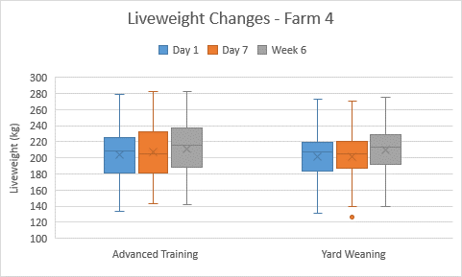

Figure 17. Liveweight changes over six weeks on Farm 4.

At weaning (Day 1), the advanced training group had a heavier average liveweight by 2.9kg, however after 6-weeks this difference was reduced back to 1.9kg. It can be seen from the box-plots in figure 17 the yard weaning group had a similar total weight range at the start and end of the demonstration period, however, a tighter interquartile range in comparison to the advanced training group.

**Flight Speed Results:**

Table 18: Flight speed results for advanced training and yard weaning on Farm 4.

|  |  |  |  |  |  |  |
| --- | --- | --- | --- | --- | --- | --- |
| **Site** | **Treatment** | **Flight Speed (m/sec)** | | | **Initial Change in flight speed between Day 1 and Week 1** | **Change in flight speed between Day 1 and Week 6** |
|  |  | *Day 1* | *Week 1* | *Week 6* | *Flight Speed (m/sec)* | *Flight Speed (m/sec)* |
| **Farm 4** | Advanced Training | 2.55 (± 1.28) | 1.66 (± 0.70) | 1.67 (± 0.75) | -0.89 | -0.88 |
| Yard Weaning | 2.40 (± 0.98) | 2.12 (± 0.77) | 2.10 (± 0.60) | -0.28 | -0.30 |
| Difference (m/sec) | 0.15 | 0.45 | 0.43 |  |  |

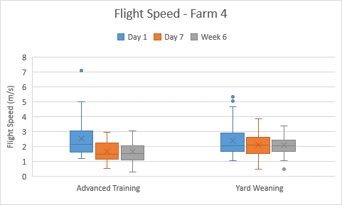

Figure 18. Flight Speed variation between treatment groups on Farm 4.

At weaning (Day 1), there was a difference of 0.15m/sec between the two treatment groups, with the advanced training group having a higher average flight speed. The flight speeds for the advanced training group decreased more than those seen in the comparison yard weaning group after one week and remained consistent out to six weeks as seen in table 18 and figure 18 above.

**Variables which may have affected results on this property:**

Gut fill may have affected liveweight results on this property by altering the actual liveweight recorded for the animal at each weighing. Reduced time was available to the producer to train cattle through the yards, which may have also had an impact on results obtained.

**Changes in weaning or induction practice as a consequence of participation in this demonstration:**

A combination of yard weaning and training is used, weather depending. Portable panels are placed around a water trough to contain animals for the weaning/induction process, removing issues such as lameness from concrete floors. Animals are worked through these yards with dogs multiple times per day, time and weather permitting.

Animals are now being culled based on temperament. Animals weaned using these techniques are observed to be quieter and easier to manage.

**Benefits of participation in this demonstration:**

Benefits included communication with other producers about what worked or did not work for them, as well as reinforcement of thoughts and picking up finer points in livestock handling.

### Farm 5 – Advanced Training and Paddock Weaning

**Beef Enterprise Details:**

This property runs 600 breeder cows as its primary enterprise as well as also trading stock. When stocking rate is highest around 2000 head of cattle are on the property. Sixty-five Angus bulls are sold from this property each year.

**Source of cattle used in this demonstration:**

Home bred

**Normal weaning/induction method used on this property:**

Paddock weaning by separating cow and calf in paddock was undertaken, with varying success, as there was infrastructure damage from cows and calves breaking through fences. Yard weaning was then adopted, with animals simply being locked in the yards for several days, reducing fence line damage but increased incidence of pneumonia and pestivirus was noted.

**Treatment and number of animals compared on this property:**

Advanced Training (38 animals)

Paddock Weaning (38 animals)

**Monitoring:**

Day 1 weaning

1-week post-weaning

6-weeks post-weaning

**Liveweight Results:**

|  |  |  |  |  |  |  |
| --- | --- | --- | --- | --- | --- | --- |
| **Site** | **Treatment** | **Liveweight (kg)** | | | **Initial change in liveweight between Day 1 and Week 1** | **Change in liveweight between Day 1 and Week 6** |
|  |  | *Day 1* | *Week 1* | *Week 6* | *Liveweight (kg)* | *Liveweight (kg)* |
| **Farm 5** | Advanced Training | 218. 9(± 20.2) | 226.7 (± 21.7) | 237.5 (± 19.4) | +7.8 | +18.6 |
| Paddock Weaning | 206.3 (± 26.3) | 214.0 (± 24.8) | 221.4 (± 23.1) | +7.7 | +15.1 |
| Difference (kg) | 12.6 | 12.7 | 16.1 |  |  |

Table 19: Differences in average liveweight of weaners in advanced training and paddock weaning treatments on Farm 5.

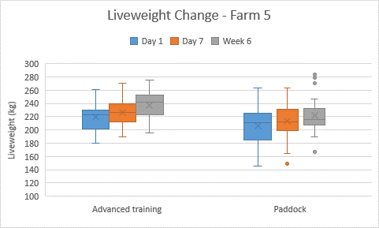

Figure 19. Variation in liveweight between advanced training and paddock weaning treatment groups on Farm 5.

At weaning (Day 1), there was a difference of 12 kg, with the Advanced Training group having a higher average starting weight (Table 19). It should be noted; however, in these treatment groups the variation in weight was greater within the paddock weaned group as seen in figure 19 and with a standard deviation of 26.3kg in comparison to the advanced training group with a standard deviation of 20.2kg (Table 19) at the start of the demonstration period.

**Flight Speed Results:**

Table 20: Average flight speed results for advanced training and paddock weaning groups on Farm 5.

|  |  |  |  |  |  |  |
| --- | --- | --- | --- | --- | --- | --- |
| **Site** | **Treatment** | **Flight Speed (m/sec)** | | | **Initial Change in flight speed between Day 1 and Week 1** | **Change in flight speed between Day 1 and Week 6** |
|  |  | *Day 1* | *Week 1* | *Week 6* | *Flight Speed (m/sec)* | *Flight Speed (m/sec)* |
| **Farm 5** | Advanced Training | 2.17 (± 0.67) | 1.93 (± 0.69) | 1.78 (± 0.51) | -0.24 | -0.39 |
| Paddock Weaning | 2.22 (± 0.51) | 2.23 (± 0.68) | 1.93 (± 0.58) | +0.01 | -0.29 |
| Difference (m/sec) | 0.05 | 0.30 | 0.15 |  |  |

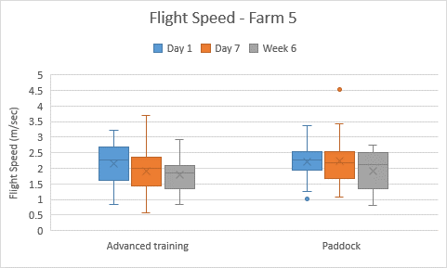

Figure 20. Variation in Flight Speed (m/sec) within advanced training and paddock weaning treatment groups on Farm 5.

At weaning (Day 1), there was a difference of 0.05m/sec between the two treatment groups, After the first week of weaning the advanced training group had reduced flight speed by 0.24m/sec while the paddock weaned cattle had no change in average flight speed. At 6-weeks post weaning the advanced training group continued to decrease average flight speed to 1.78m/sec while average fight speed of the paddock weaned group was 1.93m/sec (Table 20).

**Changes in weaning or induction practice as a consequence of participation in this demonstration:**

This property has employed a full time worker with seven dogs to work cattle daily. This has meant that weaning or inducting cattle can be achieved in three days, rather than seven.

Bikes are no longer used on the property to move cattle, instead walking slowly and allowing dogs to bring cattle to the handler before removing pressure. Cattle are eager to come to the handler and will approach without being forced.

**Benefits of participation in this demonstration:**

Less infrastructure is required to handle cattle, as well as reduced damage to existing infrastructure. Producers thought that cattle were quietened, safer to handle and gained more weight after implementing techniques learnt in this demonstration. Increased bull sales were also seen.

### Farm 6 – Advanced Training and Yard Weaning

**Beef Enterprise Details:**

This beef enterprise is located in Sandy Point with a lease property in Alberton. Approximately 1000 head of split-calving Angus breeders are managed by this property.

**Source of cattle used in this demonstration**

Home bred

**Normal weaning/induction method used on this property:**

A combination of yard and paddock weaning was used, with animals spending a minimum of two nights in the yards, returning to paddocks during the day. Weaners were run through the yard using one or two dogs and fed heifer development pellets.

**Treatment and number of animals compared on this property:**

Advanced Training (64 animals)

Yard Weaning (68 animals).

**Monitoring:**

Day 1 weaning

1-week post-weaning

6-weeks post-weaning

**Liveweight Results:**

Table 21: Change in average liveweight between advanced training and Yard weaning treatments on Farm 6.

|  |  |  |  |  |  |  |
| --- | --- | --- | --- | --- | --- | --- |
| **Site** | **Treatment** | **Liveweight (kg)** | | | **Initial change in liveweight between Day 1 and Week 1** | **Change in liveweight between Day 1 and Week 6** |
|  |  | *Day 1* | *Week 1* | *Week 6* | *Liveweight (kg)* | *Liveweight (kg)* |
| **Farm 6** | Advanced Training | 246.9 (± 32.4) | 254.1 (± 36.5) | 260.5 (± 32.8) | +7.2 | +13.6 |
| Yard Weaning | 252.0 (± 35.0) | 262.1 (± 35.5) | 253.6 (± 38.7) | +10.1 | +1.6 |
| Difference (kg) | 5.1 | 8.0 | 6.9 |  |  |

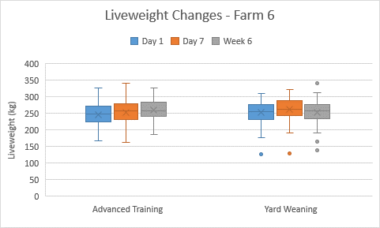

Figure 21. Variability in liveweight within the advanced training and yard weaning treatment groups on Farm 6.

At weaning (Day 1), there was an average liveweight difference of 4.98 kg between the two treatment groups, in favour of the Yard Weaning group.

Both treatment groups gained a small amount of weight over the first week. After six weeks, the Advanced Training group had experienced an overall liveweight change of 13.33 kg, in comparison with 0.77 kg for the Yard Weaning group.

**Flight Speed Results:**

Table 22: Average flight speed results for advanced training and yard weaning groups on Farm 6.

|  |  |  |  |  |  |  |
| --- | --- | --- | --- | --- | --- | --- |
| **Site** | **Treatment** | **Flight Speed (m/sec)** | | | **Initial Change in flight speed between Day 1 and Week 1** | **Change in flight speed between Day 1 and Week 6** |
|  |  | *Day 1* | *Week 1* | *Week 6* | *Flight Speed (m/sec)* | *Flight Speed (m/sec)* |
| **Farm 6** | Advanced Training | 1.90 (± 0.41) | 1.32 (± 0.46) | 1.41 (± 0.32) | -0.58 | -0.49 |
| Yard Weaning | 2.00 (± 0.43) | 1.70 (± 0.44) | 1.65 (± 0.42) | -0.30 | -0.35 |
| Difference (m/sec) | 0.10 | 0.38 | 0.14 |  |  |

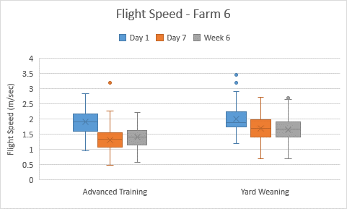

Figure 22. Variation in Flight Speed in advanced training and yard weaning treatment groups on Farm 6.

At weaning (Day 1), there was a difference of 0.10 m/sec between the treatment groups, with Yard Weaning group having the higher flight speed. This continued to seven days and six weeks, with the advanced training group having a slightly lower flight speed in comparison with the yard weaning group (Table 22). Over the six week demonstration period, the advanced training group average flight speed decreased by 0.49 m/sec, in comparison with a decrease of 0.35 m/sec for the yard weaning group (Table 22).

**Changes in weaning or induction practice as a consequence of participation in this demonstration:**

Yards are being more fully utilised, with a large yard being integral to the process. Dogs are used inside yards, always using three to four dogs at one time, as it has been found that they work better as a team. The animals are worked with dogs for no medical procedures, stress or reason, which reduces stress when medical procedures are required. Nutrition of weaners has been altered, with grain now being fed from feeders as well as strip grazing during the day.

**Benefits of participation in this demonstration:**

Dogs are better utilised and are working better. Increased job satisfaction and confidence.

## Demonstration Participant Survey and Interview Questions

**Your name:** _________________________________________

**How to fill out this evaluation:**

Hard Copy Option: Please answer the following questions by circling the appropriate number for you in each row. There is a similar set of questions relating to each specific objective of the demonstration project. Additional comments relating to each objective can be made at the bottom of each page.

**Objective 1: Equip producer participants with advanced livestock handling skills to improve the manageability and growth rates of weaners following yard weaning/induction**

1. How much did you know about yard training *before and after* undertaking the advanced livestock training course?

|  |  |  |  |  |  |  |  |  |  |  |
| --- | --- | --- | --- | --- | --- | --- | --- | --- | --- | --- |
|  | Nothing | | | Some | | | | All I Need | | |
| Circle a number: BEFORE | 1 | 2 | 3 | 4 | 5 | 6 | 7 | 8 | 9 | 10 |
| Circle a number: AFTER | 1 | 2 | 3 | 4 | 5 | 6 | 7 | 8 | 9 | 10 |

1. Please indicate your *attitude* to this practice *before and after* participating in the project (e.g. Did you think yard training was a worthwhile course of action prior to undertaking Neil McDonalds course? What do you think after having completed the training course?)

|  |  |  |  |  |  |  |  |  |  |  |
| --- | --- | --- | --- | --- | --- | --- | --- | --- | --- | --- |
|  | Negative attitude | | | Undecided | | | | Positive Attitude | | |
| Circle a number: BEFORE | 1 | 2 | 3 | 4 | 5 | 6 | 7 | 8 | 9 | 10 |
| Circle a number: AFTER | 1 | 2 | 3 | 4 | 5 | 6 | 7 | 8 | 9 | 10 |

1. Did you have all the skills required to undertake yard weaning or induction *before* undertaking the advanced handling course? After undertaking the course, do you feel you had all of the skills required to undertake yard weaning or training?

|  |  |  |  |  |  |  |  |  |  |  |
| --- | --- | --- | --- | --- | --- | --- | --- | --- | --- | --- |
|  | None | | | Some | | | | All I Need | | |
| Circle a number: BEFORE | 1 | 2 | 3 | 4 | 5 | 6 | 7 | 8 | 9 | 10 |
| Circle a number: AFTER | 1 | 2 | 3 | 4 | 5 | 6 | 7 | 8 | 9 | 10 |

1. How motivated were you to improve this area of management prior to undertaking the course? How motivated are you now that you have completed the course?

|  |  |  |  |  |  |  |  |  |  |  |
| --- | --- | --- | --- | --- | --- | --- | --- | --- | --- | --- |
|  | Not motivated | | | Undecided | | | | Motivated | | |
| Circle a number: BEFORE | 1 | 2 | 3 | 4 | 5 | 6 | 7 | 8 | 9 | 10 |
| Circle a number: AFTER | 1 | 2 | 3 | 4 | 5 | 6 | 7 | 8 | 9 | 10 |

1. Prior to undertaking Advanced Livestock Handling course, to what extent were you utilising yard *training* (not just yard weaning)? Now that you have completed the course, to what extent are you utilising these advanced handling techniques.

|  |  |  |  |  |  |  |  |  |  |  |
| --- | --- | --- | --- | --- | --- | --- | --- | --- | --- | --- |
|  | Never | | | Sometimes | | | | Always | | |
| Circle a number: BEFORE | 1 | 2 | 3 | 4 | 5 | 6 | 7 | 8 | 9 | 10 |
| Circle a number: AFTER | 1 | 2 | 3 | 4 | 5 | 6 | 7 | 8 | 9 | 10 |

**Any additional comments?**

**Objective 2: To improve Occupational Health and Safety (OH&S) through having quieter cattle and improved handling techniques**

1. How much knowledge and awareness about OH&S issues related to cattle handling did you have prior to undertaking the Advanced Livestock Handling course? How do you feel about your knowledge of OH&S issues since undertaking the course?

|  |  |  |  |  |  |  |  |  |  |  |
| --- | --- | --- | --- | --- | --- | --- | --- | --- | --- | --- |
|  | Negative | | | Undecided | | | | Positive | | |
| Circle a number: BEFORE | 1 | 2 | 3 | 4 | 5 | 6 | 7 | 8 | 9 | 10 |
| Circle a number: AFTER | 1 | 2 | 3 | 4 | 5 | 6 | 7 | 8 | 9 | 10 |

1. Please indicate your *attitude* to OH&S improvement before and after undertaking the Advanced Livestock Handling course (e.g. Did/do you think this is an important issue for your situation?)

|  |  |  |  |  |  |  |  |  |  |  |
| --- | --- | --- | --- | --- | --- | --- | --- | --- | --- | --- |
|  | Negative attitude | | | Undecided | | | | Positive Attitude | | |
| Circle a number: BEFORE | 1 | 2 | 3 | 4 | 5 | 6 | 7 | 8 | 9 | 10 |
| Circle a number: AFTER | 1 | 2 | 3 | 4 | 5 | 6 | 7 | 8 | 9 | 10 |

1. Did you have all the skills required to manage your OH&S risks around cattle handling *before* undertaking the Advanced Livestock Handling course? After undertaking the course, do you feel you have the skills required to do this?

|  |  |  |  |  |  |  |  |  |  |  |
| --- | --- | --- | --- | --- | --- | --- | --- | --- | --- | --- |
|  | Not motivated | | | Undecided | | | | Motivated | | |
| Circle a number: BEFORE | 1 | 2 | 3 | 4 | 5 | 6 | 7 | 8 | 9 | 10 |
| Circle a number: AFTER | 1 | 2 | 3 | 4 | 5 | 6 | 7 | 8 | 9 | 10 |

1. How motivated were you to improve OH&S prior to completing the Advanced Livestock Handling course? What is your level of motivation to improve OH&S after completing the course?

|  |  |  |  |  |  |  |  |  |  |  |
| --- | --- | --- | --- | --- | --- | --- | --- | --- | --- | --- |
|  | Not motivated | | | Undecided | | | | Motivated | | |
| Circle a number: BEFORE | 1 | 2 | 3 | 4 | 5 | 6 | 7 | 8 | 9 | 10 |
| Circle a number: AFTER | 1 | 2 | 3 | 4 | 5 | 6 | 7 | 8 | 9 | 10 |

1. To what extent did you implement effective OH&S practices when handling cattle prior to undertaking the Advanced Livestock Handling course? To what extent are you doing this since undertaking the course?

|  |  |  |  |  |  |  |  |  |  |  |
| --- | --- | --- | --- | --- | --- | --- | --- | --- | --- | --- |
|  | Not motivated | | | Undecided | | | | Motivated | | |
| Circle a number: BEFORE | 1 | 2 | 3 | 4 | 5 | 6 | 7 | 8 | 9 | 10 |
| Circle a number: AFTER | 1 | 2 | 3 | 4 | 5 | 6 | 7 | 8 | 9 | 10 |

**Any additional comments?**

**Interview Questions (for Demo Site Co-Operators only)**

1. Please provide a brief outline of your beef business and location:
2. Please describe your traditional weaning or inducting method:
3. Please include whether you yard wean, paddock wean, or other method. How many days do you do this for? What feed do you feed to these animals? Do you move between yards or paddocks?
4. What did you do differently last season after attending the Neil McDonald workshop?
5. What were the benefits of participating in this training?
6. Did you have any concerns?
7. Was it a worthwhile trial for your business?
8. Which system will you adopt for the coming season?
9. Are there any barriers that might prevent you from adopting this Advanced Training technique?

## Field Day Evaluation Survey



## Potential Adoption Modelling Inputs and Outputs

ADOPT: the adoption and diffusion outcome prediction tool

Adoption report for:

**Weaning Using Advanced Livestock Handling Techniques 160531**

31 May 2016

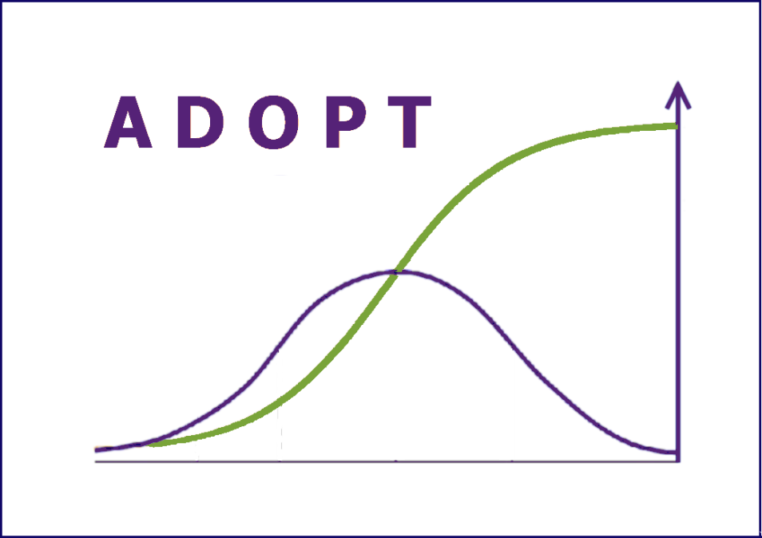

For more information about ADOPT contact:

adopt@csiro.au

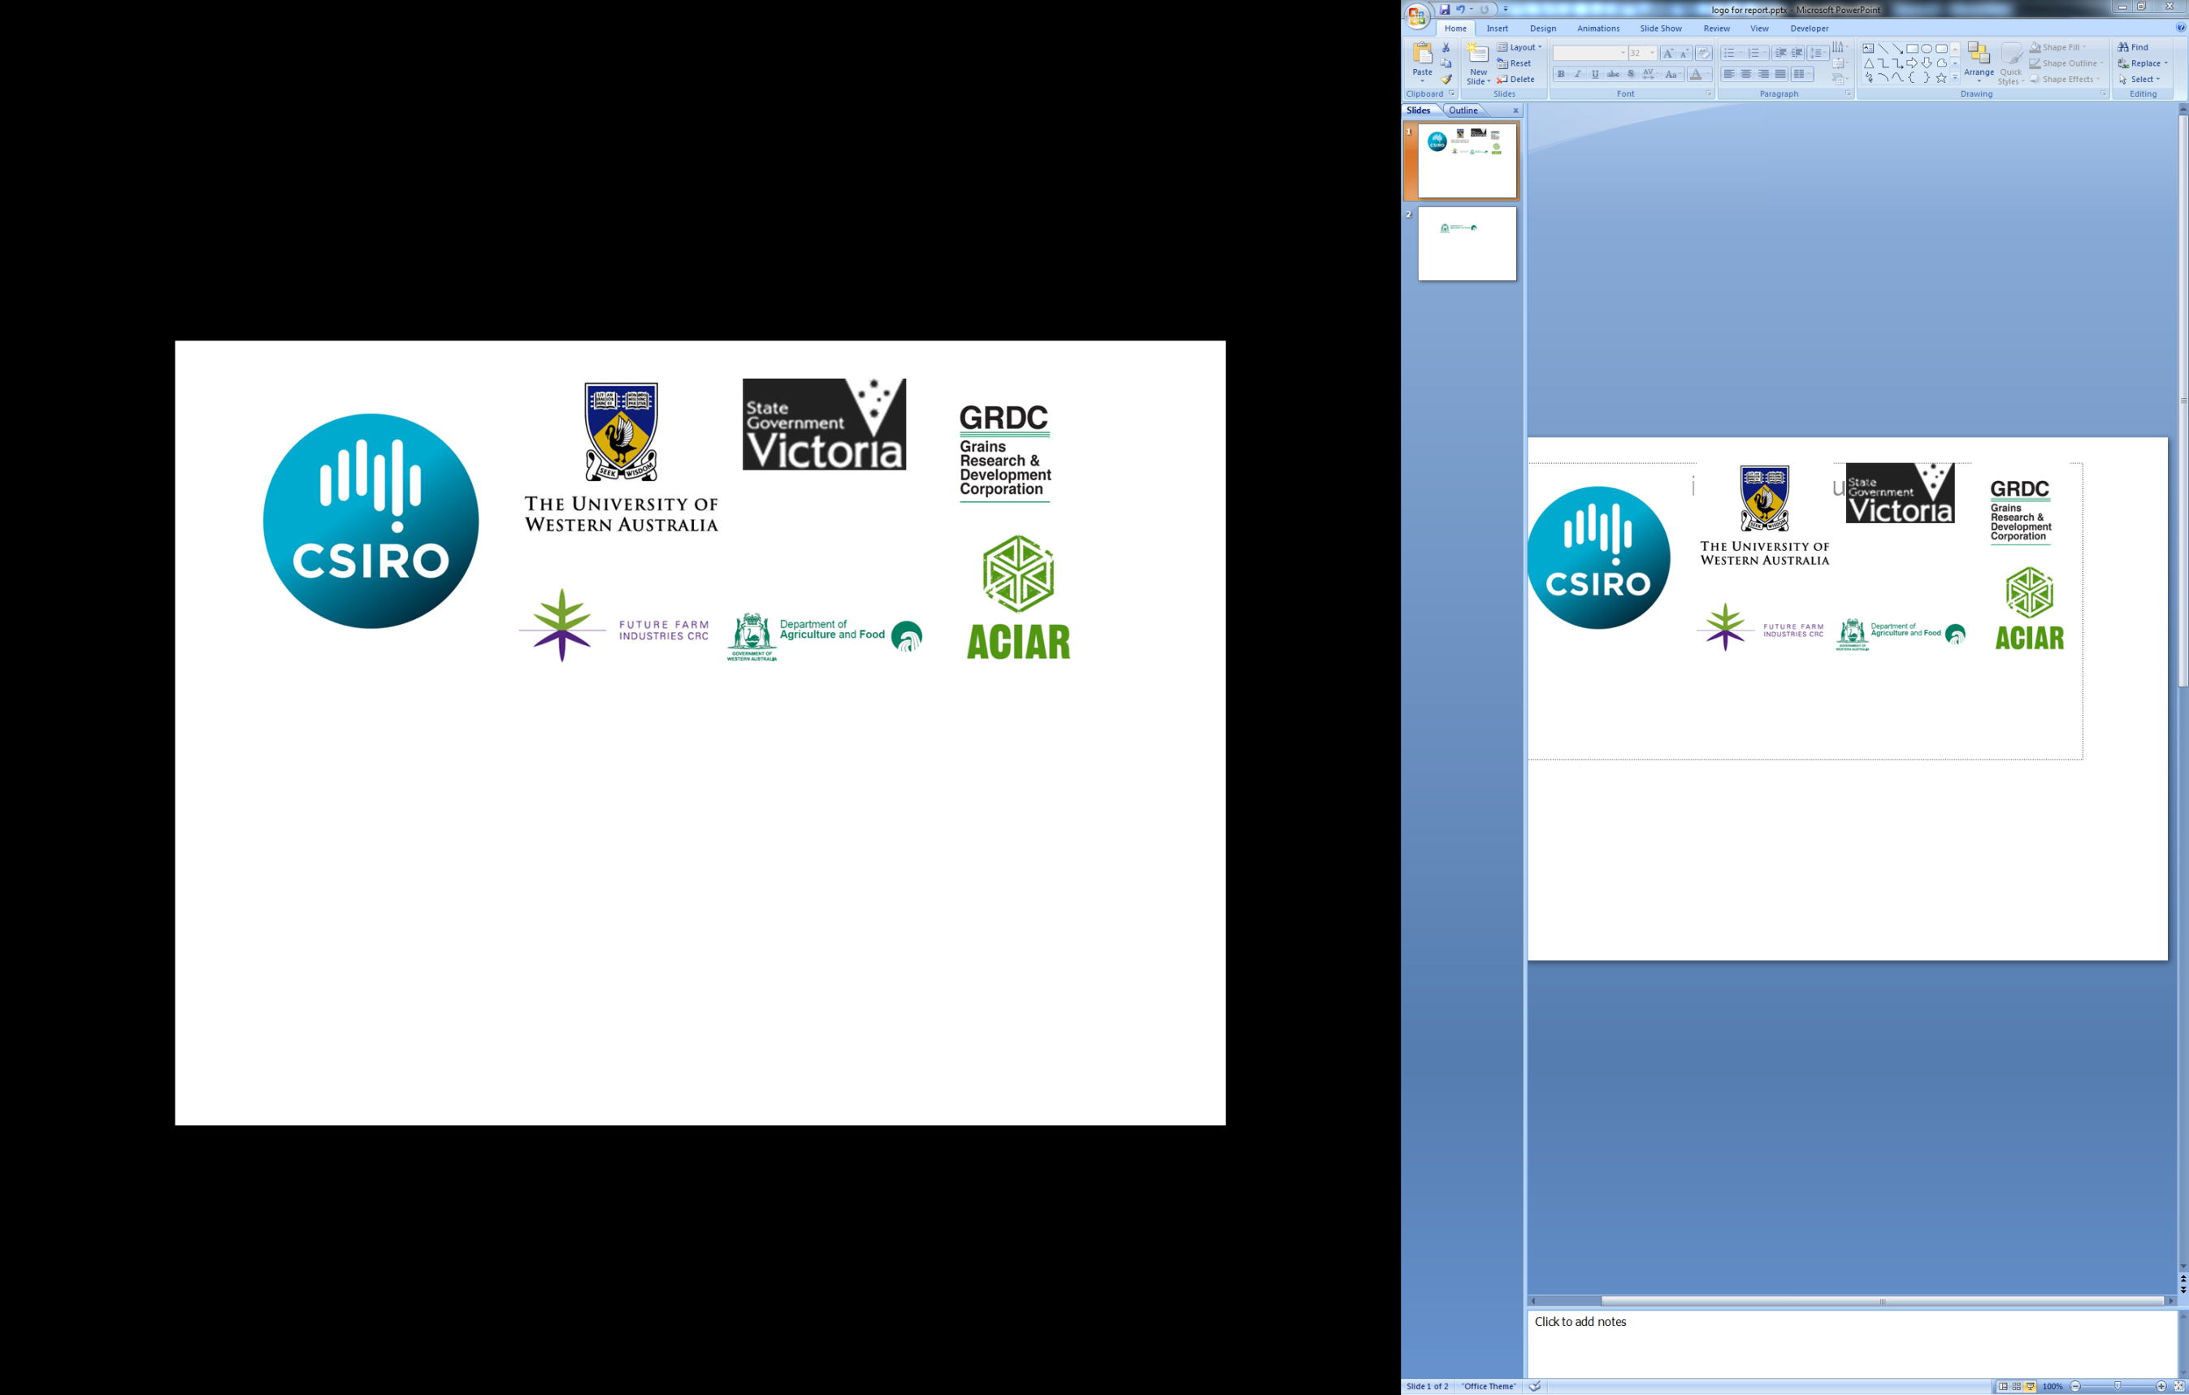

**Description of the Innovation**

Weaning using advanced livestock handling (training) techniques

**Description of the Population**

Gippsland Beef Producers

**Predicted Adoption Levels**

|  |  |
| --- | --- |
| Predicted peak level of adoption1 | 94% |
| Predicted years to peak adoption2 | 13 |
| Predicted years to near-peak adoption3 | 9 |
| Year innovation first adopted or expected to be adopted | N/A |
| Year innovation adoption level measured | N/A |
| Adoption level in that year | N/A |
| Predicted adoption level in 5 years from start | 55.1% |
| Predicted adoption level in 10 years from start | 92.7% |

PLEASE NOTE:

1. The predictions of ‘Peak Adoption Level’ is a numeric output that is provided to assist with insight and understanding and like any forecasts should be used with caution.

2. The prediction of ‘Time to Peak Adoption Level’ is a numeric output that is provided to assist with insight and understanding and like any forecasts should be used with caution

3. ‘Time to Near Peak Adoption’ represents the time to 95% of the maximum predicted adoption level.

**Predicted Adoption Curve**

**Sensitivity Analysis**

The following charts show the effects on Peak Adoption Level and Time to Peak Adoption of single step changes up and down for all questions.





**S-Curve Sensitivity**

The following chart shows how the S-Curve is predicted to change when a single step change is made to the most sensitive question(s) with respect to Peak Adoption Level.



The following chart shows how the S-Curve is predicted to change when a single step change is made to the most sensitive question(s) with respect to Time to Near Peak Adoption



**Information Entered into ADOPT**

The above predictions are based on the following information entered into the Adoptability and Diffusion Outcome Prediction Tool.

|  |  |  |
| --- | --- | --- |
| Question | Response | Reasoning |
| Relative Advantage for the Population | | |
| 1: Profit orientation | 3: About half have maximising profit as a strong motivation | Lifestyle, sustainability and family also important |
| 2: Environmental orientation | 3: About half have protection of the environment as a strong motivation | Increased awareness of environment. |
| 3: Risk orientation | 2: A minority have risk minimisation as a strong motivation | No evidence of addressing risk (e.g. drought planning) |
| 4: Enterprise scale | 4: A majority of the target farms have a major enterprise that could benefit | Doesn't matter what scale of enterprise, the efficiency gains are worthwhile. |
| 5: Management horizon | 2: A minority have a long-term management horizon | Uncertainty about the future and general lack of succession planning. Volatility of beef market. |
| 6: Short term constraints | 3: About half currently have a severe short-term financial constraint | Diversity of individual situations |
| Learnability Characteristics of the Innovation | | |
| 7: Trialable | 5: Very easily trialable | Can pay someone to do it, don't need to purchase dogs to use techniques |
| 8: Innovation complexity | 5: Not at all difficult to evaluate effects of use due to complexity | Own observation |
| 9: Observability | 5: Very easily observable | Agents are in the know, other producers discuss. |
| Learnability of Population | | |
| 10: Advisory support | 1: Almost none use a relevant advisor | Little evidence of consultants being used on farm |
| 11: Group involvement | 1: Almost none are involved with a group that discusses farming | Few are involved with BBN in Gippsland |
| 12: Relevant existing skills & knowledge | 2: A majority will need new skills and knowledge | Continual learning required |
| 13: Innovation awareness | 2: A minority are aware that it has been used or trialled in their district | Only one demo conducted. |
| Relative Advantage of the Innovation | | |
| 14: Relative upfront cost of innovation | 3: Moderate initial investment | $20K will set it up. Minor cost compared to other enterprise expenses. |
| 15: Reversibility of innovation | 5: Very easily reversed |  |
| 16: Profit benefit in years that it is used | 6: Moderate profit advantage in years that it is used |  |
| 17: Future profit benefit | 6: Moderate profit advantage in the future | Compounding benefits. |
| 18: Time until any future profit benefits are likely to be realised | 5: Immediately |  |
| 19: Environmental costs & benefits | 4: No net environmental effects |  |
| 20: Time to environmental benefit | 6: Not Applicable |  |
| 21: Risk exposure | 6: Moderate reduction in risk | occupational health and safety, profit, dark cutting risk. Not everyone will get it right even if they adopt it. |
| 22: Ease and convenience | 7: Large increase in ease and convenience |  |

## Media Articles

### Work on weaners pays off – MLA Friday Feedback

**Work on weaners pays off**

08 July 2016

An MLA-funded on-farm project has found the determining factor in the success of any cattle weaning technique is maximum human and dog contact with the stock.

Martin Dunstan, Farming Systems Demonstration Project Leader at Agriculture Victoria, will discuss the outcomes of an on-farm weaning demonstration, co-funded with Agriculture Victoria, in South Gippsland at this month’s [Border Beef Conference](http://www.eventbrite.com.au/e/2016-border-beef-conference-registration-25708405533) in Albury, NSW.

Six farms took part and each trialled two of the three weaning methods being assessed - paddock weaning, yard weaning and advanced training.

“By preparing weaners well, we can reduce the incidence of dark cutting due to high stress levels, minimise bruising during handling or loading, increase weight gains, reduce the need for repairs to cattle infrastructure and improve on-farm safety for stock managers," Martin said.

 “Yard weaning is generally accepted as a proven technique for improving ease of handling and the ability of cattle to handle stress.

“However, producers involved in the trial had reported mixed success and so were keen to compare a range of weaning and induction methods in a demonstration.”

Advanced training, taught in this demonstration by stock training consultant Neil McDonald, is similar to yard weaning but involves more hours of human and dog contact including familiarisation sessions with the stockyards, going into the race, through the crush and into small holding yards as well as being moved between small paddocks.

“Some producers did not want to use dogs and adapted their usual cattle moving techniques to the process," Martin said.

**The results**

The weaners were weighed and their flight speed from the crush measured (as an indicator of quietness) on day one, at the end of week one and again at the end of week six.

“Results showed that, at weeks one and six post-weaning, average flight speed was lower in the advanced training groups than in the yard and paddock weaned groups,” Martin said.

“There was considerable variability in the results of the demonstration, but the group concluded handling weaners more during yard weaning produces cattle that are quieter and easier to handle.”

There were no consistent weight gain benefits observed for the advanced training groups with other factors such as genetics, temperament and feed likely to impact differently on individual animals.

Martin said the take-home message from the exercise was that spending time with weaners and familiarising them with the yards, being handled and moved was a valuable investment for both home-bred and purchased weaners.

“In most commercial situations it is difficult to make decisions on temperament alone, so we have to make compromises,” he said.

More information: Martin Dunstan T: 03 5561 9903 E: [martin.dunstan@ecodev.vic.gov.au](mailto:martin.dunstan@ecodev.vic.gov.au)

To register for the Border Beef Conference on Wednesday, 20 July, 2016 visit <http://www.eventbrite.com.au/e/2016-border-beef-conference-registration-25708405533>

For more information on weaning techniques visit MLA’s More Beef from Pastures Manual at <http://mbfp.mla.com.au/Weaner-throughput/3-Wean-early>

### Weaning Support from man’s best friend – MLA Friday Feedback

**Weaning support from man's best friend**

02 December 2016

An MLA-funded on-farm demonstration has found the determining factor in the success of any cattle weaning technique is maximum human and dog contact with the stock.

Martin Dunstan, Farming Systems Demonstration Project Leader at Agriculture Victoria, managed the demonstration and said six farms took part, with each trialling two of the three weaning methods being assessed – paddock weaning, yard weaning and advanced training.

“By preparing weaners well we can reduce the incidence of dark cutting due to high stress levels, minimise bruising during handling or loading, increase weight gains, reduce the need for repairs to cattle infrastructure and improve on-farm safety for stock managers," Martin said.

Advanced training, taught in this demonstration by stock training consultant Neil McDonald, is similar to yard weaning but involves more hours of human and dog contact, including familiarisation sessions with the stockyards, going into the race, through the crush and into small holding yards and being moved between small paddocks.

**Dogs for weaning**

Trained dogs were used to educate the calves in the weaning trial using simple pressure-relief training principles.

The calves were taught to accept pressure from the dogs, learning that as they moved towards the handler, relief would be provided (the dogs would be told to sit and keep their distance).

If cattle moved away from the handler or tried to break from the mob, dog pressure would be re-applied, and then removed again as soon as the calves submitted.

**Systematic weaning process yields results**

It only took about half an hour of watching Neil McDonald demonstrate advanced training techniques with weaning their cattle to convince the Ross and Madeleine Batten that good working dogs were just what they needed. They run 500 breeders producing offspring for the feedlot market on 450ha at Buffalo, south-east of Leongatha in Victoria's south Gippsland region.

“It was an epiphany really,” Ross said.

“During the weaner trial we got to compare how our cattle performed under two different weaning regimes – our yard weaning method compared to the advanced training technique using dogs.

“After all these years of ad hoc approaches to weaning and unclear advice from industry, here was a systematic process that made sense and produced the desired result.”

At the end of the weaner trial, the advanced-trained mob and the yard-weaned mob were both about 13kg lighter than at the start of weaning and the advanced training mob had a slightly slower flight speed. However, Ross felt the figures didn’t accurately tell the story.

“I think there are often external influences that make flight speed measurements unreliable and they can’t be extrapolated across properties,” he said.

Ross traditionally put weaners in a yard for about 10 days on water and hay with limited interaction from him and the working dogs.

“They ate a lot of hay but they still weren’t quiet,” he said.

“The end result of the trial was that the advanced training mob was considerably quieter than the yard-weaned mob. By applying the advanced training technique with weaners each year since, my herd’s docility has vastly improved.”

Ross believes their initial investment and the cost of continued maintenance of their dog team are more than compensated in the labour savings this approach to stock work achieves.

“We rotationally graze and move large mobs of cattle every three days,” he said.

“It used to take two or three people to do that each time.

“Now, except for when I’m moving cows and calves, I just need the dogs.

“I’m hoping in a couple of years I’ll be able to use dogs on our cows and calves as well.”

**More information**

Ross Batten E: [ross.batten@ozemail.com.au](mailto:ross.batten@ozemail.com.au)

Martin Dunstan T: 03 5561 9903 E: [martin.dunstan@ecodev.vic.gov.au](mailto:martin.dunstan@ecodev.vic.gov.au)

For more information on weaning techniques visit MLA’s More Beef from Pastures Manual at [www.mbfp.mla.com.au/Weaner-throughput](http://www.mbfp.mla.com.au/Weaner-throughput)

## Factsheet

## 