Veterinary Diagnostic Services
Diagnostic Laboratory Services Price List 2019

Contents

01. General laboratory information

02. Laboratory testing

03. Business terms
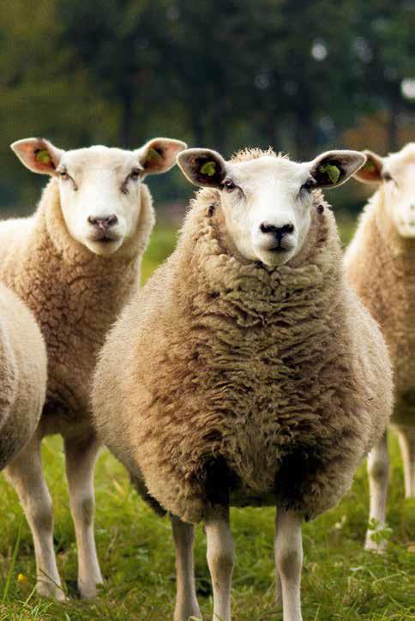

General Laboratory Information
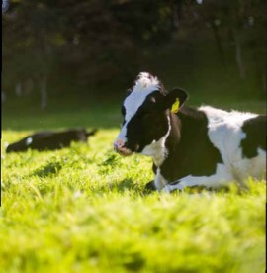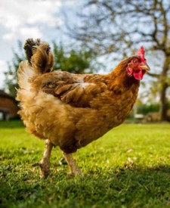

1.1 Quality Assurance and Standards
Veterinary Diagnostic Services, is accredited by the National Association of Testing Authorities (NATA) against the International Standard ISO 17025 –Testing accreditation. Veterinary Diagnostic Services obtained NATA accreditation status in March 2001and regularly undergoes both internal and external audits which continually assess the laboratory services, and provides ongoing assurance of our quality systems, improvement processes, quality control and technical competence. Veterinary Diagnostic Services offers a broad range of certified tests within the disciplines of veterinary microbiology, bacteriology, virology, serology, histopathology and necropsy services and issues NATA endorsed reports for tests performed within the scope of accreditation. Non-certified test results are identified as such on NATA reports or issued on unendorsed reports.

1.2. Approved Veterinary Diagnostic Laboratory
Veterinary Diagnostic services is approved and registered as a Veterinary Diagnostic Laboratory in Victoria by the Chief Veterinary Officer. Such approval is granted subject to maintaining and providing capabilities for the diagnosis of endemic and certain exotic diseases of livestock, fish and birds.

1.3 Professional Staff and Expertise
Experienced and qualified veterinary and laboratory staff perform the diagnostic and health certification analysis. The laboratory supports personnel in the disciplines of gross pathology and histopathology, virology, arbovirology, bacteriology, serology, molecular biology, basic parasitology, Anthrax, and Johne’s Disease investigation. Please contact sample reception for consultation or advice from appropriate staff in these areas.

1.4 Independence
As a State Government Laboratory, submitters are assured of independent advice and services.

Laboratory Testing Information
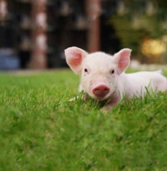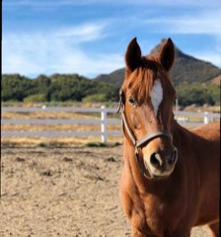
2.1. Scope of Diagnostic Examinations
Veterinary Diagnostic Services offers a wide range of tests and procedures for the diagnosis of diseases of commercial livestock including mammals, birds and fish. A range of tests are also offered for companion animals required for export or health certification purposes. The Laboratory maintains reference capabilities for diseases and supports Victorian and National disease control programs for Anthrax and Johne’s Disease.

2.2. Daily Testing Schedule
Submitters are reminded that not all of the tests offered are conducted each day. Please contact Sample Reception for further information. If specific tests are required urgently, please contact Sample Reception, as rescheduling of tests may be possible to meet specific client requirements. An additional fee may be levied for out-of-schedule analysis.

2.3. Turnaround Time
Submitters are advised that the turnaround time between receipt of samples and reporting of final results can vary considerably depending on the type of analysis required, the day and time of receipt of specimens, whether confirmation testing is required and whether analysis is completed at this or another laboratory. Upon receipt of samples the laboratory sends a confirmation of receipt report to submitter which includes information on the analyses to be undertaken. Submitters are encouraged to allow sufficient turnaround time of results, particularly when required for export shipment. Please clearly indicate the export date on submission forms to assist with timely analysis and reporting.

2.4. Large Volume Analysis
To ensure we have adequate reagents and resources for large volume testing, please contact the laboratory within a minimum of 15 working days before the date of receipt of samples at the laboratory. Please contact vet.diagnostics@agriculture.vic.gov.au if you require a special quote for large volume testing.

2.5. Delays in Analysis
The laboratory will inform the submitter if a situation arises that compromises turnaround time.

2.6. Dispatch of samples to the laboratory
It is the responsibility of the sender to pay courier charges and ensure adherence to packaging standards of material dispatched to the laboratory.

2.7. Weekend Services
A surcharge will be levied where the submitter requires the laboratory to conduct testing or report results on weekends and public holidays. Please contact Sample Reception if this service is required.

2.8. Tests Referred to Other Laboratories
Close links are maintained between DJPR Veterinary Diagnostic Services and other accredited Australian laboratories that undertake diagnostic, health certification and toxicological testing for animals and animal diseases. Samples submitted fortests that are not conducted by this laboratory will be forwarded to an appropriate laboratory. These requests will incur a Courier fee for this service. Fees for these tests will be at the rate of the laboratory conducting the testing.

2.9. Submission Fee
Please note that a Submission fee of $30.50 (Inc GST) will be charged for all submissions. A submission is defined as being all the analyses requested on a single request form.

2.10. Cancellation Fee
A Cancellation fee of $30.50 (inc GST) will be charged for cancellation of sample testing where the submission has been generated, but testing has not yet been initiated. A higher cancellation fee will be charged for samples cancelled after testing has commenced. The fee is determined by the amount of testing that has been completed when the cancellation was requested.

2.11. Pathology Services
Pathology services i.e necropsy, histopathology and clinical pathology are available as part of Agriculture Victoria subsidised programs eg. Signigicant Disease Investigations (SDI), National Transmissible Spongiform Encephalopathy (TSE) surveillance program. Please contact your District Veterinary Officer for more information.

2.12. List of Notifiable Diseases
The list of notifiable diseases for Victoria can be found at: agriculture.vic.gov.au/agriculture

2.13. Abbreviations
AGID Agar Gel Immunodiffusion
CFT Complement Fixation Test
ELISA Enzyme Linked Immunosorbent Assay
HI Haemagglutination Inhibition
IFAT Indirect Fluorescent Antibody Test
ICT Immunochromatographic Test
JD Johnes Disease
MAT Microscopic Agglutination Test
PCR Polymerase Chain Reaction
POA Price on Application
RBC Red Blood Cell
RBRSAT Rose Bengal Rapid Slide Agglutination Test
RSAT Rapid Slide Agglutination Test
VNT Virus Neutralisation Test
VTM Viral Transport Medium

Business Terms
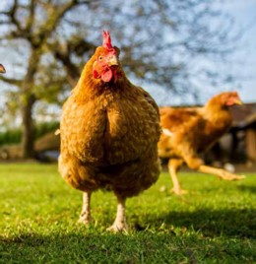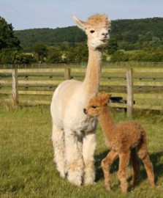

3.1. Payment for Services
Submitters are advised that payment for services is required within 30 days of the invoice date. Interest may be charged on overdue accounts.

3.2. Overdue Accounts
Persistent overdue account holders will be asked for full outstanding payments including payment for current received samples before analysis is instigated.

3.3. Price Increases
The laboratory reserves the right to increase published prices if circumstances beyond our control result in significant cost increases.

Tests and Charges

Miscellaneous
Code | Service or Test Name | Sample required | Price (incl. GST)
777 | Special Test Setup - Non-Scheduled Test | NA | $117.27
770 | Submission Fee | NA | $30.25

Courier Charges
Code | Service or Test Name | Sample required | Price (incl. GST)
771 | Courier to external laboratory | NA | $66.00
774 | Packaging and courier to AAHL | NA | $44.00

Bacteriology & Parasitology
Code | Service or Test Name | Sample required | Price (incl. GST)
698 | Actinobacillus seminis Culture | Fluid, Swab in transport  media, Tissue | $50.60
699 | Aerobic Culture | Fluid, Swab in transport  media, Tissue | $50.60
700 | Anaerobic Culture | Fluid, Swab in transport  media, Tissue | $50.60
724 | Anthrax Rapid ICT | EDTA blood | $16.50
697 | Antibiotic Sensitivity | Fluid, Swab in transport  media, Tissue | $36.75

Bacteriology & Parasitology
Code | Service or Test Name | Sample required | Price (incl. GST)
738 | Leptospira icterohaemorrhagiae MAT | Serum | $13.65
739 | Leptospira pomona MAT | Serum | $13.65
740 | Leptospira tarassovi MAT | Serum | $13.65
712 | Listeria Culture | Fluid, Swab in transport  media, Tissue | $50.60
748 | Methylene Blue Stain | EDTA blood | POA
753 | Modified ZN Stain | faeces, tissues | $23.10
713 | Mycobacterial Culture | Tissue | $146.25
741 | Mycobacterium paratuberculosis  Strain Typing | Culture | $72.45
742 | Mycobacterium avium subsp.  paratuberculosis PCR | Culture | $65.15
714 | Mycoplasma Culture - EP Method * | see note* | $109.20
715 | Mycoplasma Culture * | see note* | $60.90
743 | Mycoplasma gallisepticum PCR | Culture | $82.52
744 | Mycoplasma synoviae PCR | Culture | $82.52
716 | Salmonella Culture | Faeces, Fluid, Swab in  transport media, Tissue | $72.45
717 | Streptococcus equi spp. equi Culture | Fluid, Swab in transport  media, Tissue | $50.60
718 | Taylorella equigenitalis (CEM) Culture* | Swab in charcoal media | $72.45
719 | Total Plate Count | Fluid, Swab in transport  media, Tissue | $42.00
720 | Trichomonas Culture * | see note* | $38.85
721 | Vibrio Culture | Fluid, Swab in transport  media, Tissue | $71.03
755 | Wet Preparation for Fungi | Tissue | $34.65
764 | Worm Egg & Coccidian Oocyst Count | Faeces | $17.60
722 | Yersinia Culture | Fluid, Swab in transport  media, Tissue | $48.30
751 | ZN Stain | Faeces, tissues | $23.10
752 | ZN Stain for Cryptosporidium | Faeces | $23.10
746 | 16S DNA Sequencing | Culture | $288.75

*Note:
Refrigerate samples and deliver to laboratory as soon as possible. Samples for CEM (Taylorella) must reach the laboratory within 48 hours of the samples being collected. Samples of intestinal tissue are unsuitable for testing.Chlamydia culture samples must be submitted in Chlamydia transport medium, available on request. VTM is not to be used.*Contact laboratory for transport media. 1-2 weeks notification required for media.

Molecular Diagnostics RDU
Code | Service or Test Name | Sample required | Price (incl. GST)
814 | Abalone Viral Ganglioneuritis qPCR (includes ORF 49 and ORF 66) | resh Tissue | $150.04
414 | Anthrax from soil qPCR | Soil | POA
414 | Anthrax qPCR | EDTA blood, whole blood, fresh tissue | $75.02
416 | Avian Paramxyovirus-1 (NDV) qPCR (includes F, L & M Gene) | Swab in VTM | $150.04
419 | Avibacterium paragallinarum qPCR | Swab in saline | $75.02
421 | Blue Tongue Virus qPCR | EDTA blood, Tissue | $75.02
802 | Bovine Coronavirus qPCR | Swab in VTM | $75.02
803 | Bovine Parainfluenza 3 Virus qPCR | Swab in VTM, Tissue | $75.02
423 | Chlamydia spp PCR (Conventional PCR) | Swab in saline, Tissue or blood | $75.02
816 | Classical Swine Fever qPCR | EDTA blood | $75.02
424 | Equine Herpes Virus-1 qPCR | Fresh tissue | $119.79
429 | Footrot qPCR (Dichelobacter nodosus) | Swab in EDTA-PBS media | $75.02
430 | Hendra Virus qPCR | Swab in VTM, EDTA blood | $75.02
432 | High throughput Johne's (HTJ) PCR | Faeces | POA
420 | Infectious Bovine Rhinotracheitis––(Bovine Herpesvirus-1 ) qPCR | Swab in VTM,  Tissue | $75.02
433 | Infectious Laryngotracheitis Virus qPCR | Swab in VTM, Tissue | $75.02
426 | Influenza Type A qPCR | Swab in VTM | $75.02
435 | Leptospira qPCR | Tissue, Urine | $75.02
436 | Murray Valley Encephalitis Virus qPCR | EDTA blood, Tissue | $75.02
437 | Parapoxvirus qPCR | Swab in VTM, Tissue | $75.02
438 | Pestivirus qPCR (border disease & BVD) | EDTA blood, Tissue,  Swab in VTM | $75.02
439 | Pigeon Paramyxovirus qPCR | Swab in VTM | $75.02
440 | Ross River Virus qPCR | EDTA blood, Tissue | $75.02
775 | Rotavirus qPCR | Swab in VTM | $75.02
434 | West Nile Virus (Kunjin) qPCR | EDTA blood, Tissue | $75.02

Molecular diagnostic assays detect nucleic acid (DNA or RNA) of infectious disease agents within test specimens. Preferred specimens for each test are listed above. Submit all samples as quickly as possible and keep them chilled during transport to the lab for best results. Swabs for virology PCR testing: Viral swabs should be submitted in Viral Transport Medium (VTM). If VTM is not available, swabs should be placed in 2 ml sterile saline. Do not send dry swabs. Swabs for bacterial PCR testing: Swabs should be submitted in 2 ml sterile saline. Swabs submitted in bacterial transport media are not suitable for PCR testing. DO NOT USE: Cotton-tipped or calcium alginate swabs, swabs with wood or paper handles or swabs in Bacterial transport media and agar are not suitable. Residual bleach and other chemicals in cotton swabs and wooden handles and agar in the bacterial transport media can be inhibitory to PCR. Fresh tissues: Whenever possible, submit fresh tissues in a sterile container. Portions should be about 1cm cubes. Submit chilled. Whole blood: Use tubes containing anti-coagulants such as EDTA (purple stopper). Faeces: Submit approximately 5-10gm in securely closed sterile container. Outer surfaces of the container must be clean and dry. Do not submit faeces in plastic bags or gloves.

Serology
Code | Service or Test Name | Sample required | Price (incl. GST)
510 | Aino VNT | Serum | $45.62
455 | Akabane Virus AGID | Serum | $17.61
473 | Akabane Virus Antibody ELISA | Serum | $19.80
511 | Akabane Virus VNT | Serum | $45.62
 | Avian Influenza AGID | Serum | $17.61
494 | Avian Influenza HIT | Serum | $14.70
456 | Bluetongue Virus AGID | Serum | $17.61
467 | Bluetongue Virus CFT | Serum | $30.79
474 | Bluetongue Virus Competitive ELISA | Serum | $19.80
498 | Bovine Parainfluenza Virus Type 3 HIT (>10 samples) | Serum | $30.00
TEST PACK | Bovine Respitory Ab ELISA – Adenovirus 3, BoHV-1, BRSV, BVD 1, BPI3 | Serum | $66.00
491 | Bovine Viral Diarrhoea Virus Antigen Capture ELISA | Whole blood, Blood clot, Serum, Ear notch, Tissue, Leucocytes | $18.90
518 | Bovine Viral Diarrhoea virus VNT | Serum | $38.85
463 | Brucella abortus (melitensis & suis) CFT | Serum | $15.40
477 | Brucella abortus ELISA | Serum | $19.80
465 | Brucella ovis CFT | Serum | $15.40
480 | C. perfringens toxins ELISA matrix | faeces, intestinal contents | $138.60
TEST PACK | Calf diarrhea (calf scours) ELISA - Coronavirus, E. coli (k99), Rotavirus | Serum | $39.60
479 | Caprine Arthritis Encephalitis ELISA | Serum | $19.80
460 | Caprine Johne's Disease AGID | Serum | $15.40
483 | Enzootic Bovine Leucosis ELISA(Pooled samples) | Serum | $23.10
482 | Enzootic Bovine Leucosis ELISA | Serum | $19.80
457 | Enzootic Bovine Leucosis AGID | Serum | $17.61
512 | Ephemeral Fever Virus VNT | Serum | $38.85
458 | Epizootic Haemorrhagic Disease AGID | Serum | $17.61
Serology
Code | Service or Test Name | Sample required | Price (incl. GST)
514 | Equine Arteritis Virus VNT | Serum | $46.20
513 | Equine Herpesvirus (Type 1 & 4) VNT | Serum | $46.20
459 | Equine Infectious Anaemia AGID | Serum | $19.80
805 | Fasciola hepatica - Liver fluke Antigen ELISA (Coproantigen ELISA herd test) | faeces,  intestinal contents | $220 per 10 samples
485 | Flavivirus ELISA | Serum | $36.75
487 | Infectious Bovine Rhinothracheitis  Virus ELISA | Serum | $18.90
515 | Infectious Bovine Rhinothracheitis Virus VNT | Serum | $38.85
495 | Influenza A H5 HIT | Serum | $14.70
496 | Influenza A H7 HIT | Serum | $14.70
472 | Influenza A Virus Competitive ELISA | Serum | $19.80
469 | Johne's Disease CFT | Serum | $15.40
488 | Johne's Disease ELISA | Serum | $14.70
489 | Kunjin Virus ELISA | Serum | $36.75
490 | Murray Valley Encephalitis ELISA | Serum | $36.75
497 | Newcastle Disease Virus HIT | Serum | $14.70
461 | Ovine Johne's Disease AGID | Serum | $15.40
462 | Pestivirus (BVD) AGID | Serum | $17.61
499 | Porcine Parvovirus HIT | Serum | $14.70
470 | Q Fever CFT | Serum | $23.10
504 | Rose Bengal RSAT | Serum | $14.70
519 | Ross River Virus VNT | Serum | $46.20
806 | Schmallenberg Virus (Simbu group) Antibody ELISA | Serum | $19.80

Virology
Code | Service or Test Name | Sample required | Price (incl.GST)
582 | Allantoic Sac Inoculation | Swab in VTM, Tissue in VTM | $172.20
583 | Amniotic Sac Inoculation | Swab in VTM, Tissue in VTM | $172.20
585 | Chorioallantoic Membrane Inoculation | Swab in VTM, Tissue in VTM | $172.20
580 | Virus Isolation in Eggs: AvianEncephalomyelitis | Swab in VTM, Tissue in VTM | $288.75
581 | Virus Isolation: Avian Influenza | Swab in VTM, Tissue in VTM | $172.20
584 | Virus isolation: Bluetongue | Swab in VTM, Tissue in VTM | $211.37
596 | Virus Isolation: Bovine Parainfluenza 3 (3 passages) * | see note* | $199.49
595 | Virus Isolation: Bovine Parainfluenza 3 * | see note* | $144.89
593 | Virus Isolation: Bovine Viral Diarrhoea virus (BVD) (3 passages) * | see note* | $199.49
594 | Virus Isolation: Bovine Viral Diarrhoea virus (BVD) * | see note* | $144.89
586 | Virus Isolation: Equine Arteritis Virus * | see note* | $144.89
587 | Virus Isolation: General * | see note* | $288.75
589 | Virus Isolation: Infectious Bovine Rhinotracheitis (3 passages) | Swab in VTM, Tissue in VTM | $199.49
590 | Virus Isolation: Infectious Laryngotracheitis | Swab in VTM, Tissue in VTM | $172.20
591 | Virus Isolation: Newcastle Disease | Swab in VTM, Tissue in VTM | $172.20
592 | Virus Isolation: Parvovirus * | see note* | $144.89
588 | Virus isolation:Infectious bovine  rhinotracheitis * | see note* | $144.89

*Note:
With the exception of fluids, all samples for virus isolation must be submitted in Viral Transport Medium (VTM) and transported chilled as soon as possible to the laboratory. Samples for virus isolation must NOT be sent in a dry state. If VTM is not available, a small quantity of sterile normal saline can be added to keep the samples moist. Unless specified, two passages will be conducted on submissions for virus isolation in cell cultures. Additional passages for cell culture or egg culture can be performed on request. Extra charges will apply for egg culture in SPF eggs. If additional confirmatory testing is required, further charges may apply. A minimum of 1ml of semen (e.g. 5 straws) is required per collection. If more than one collection is required to be tested, 1ml per collection is required from each collection. * Consult laboratory for the sample type appropriate for the specific virus.

Published by Agriculture Victoria
Department of Jobs, Precincts and Regions AgriBio, 5 Ring Road, Bundoora 3083 Telephone (03) 9032 7000 September 2019. © Copyright State Government of Victoria 2019 This publication is copyright. No part may be reproduced by any process except in accordance with provisions of the Copyright Act 1968. Authorised by the Victorian Government, Melbourne. Designed by DJPR Design Studio ISBN 978-1-76090-155-4 (Print) ISBN 978-1-76090-156-1 (pdf/online/MS word)

Disclaimer
This publication may be of assistance to you but the State of Victoria and its employees do not guarantee that the publication is without flaw of any kind or is wholly appropriate for your particular purposes and therefore disclaims all liability for any error, loss or other consequence which may arise from you relying on any information in this publication. While every effort has been made to ensure the currency, accuracy or completeness of the content we endeavour to keep the content relevant and up to date and reserve the right to make changes as require. The Victorian Government, authors and presenters do not accept any liability to any person for the information (or the use of the information) which is provided or referred to in the report. Unless indicated otherwise, this work is made available under the terms of the Creative Commons Attribution 3.0 Australia licence. To view a copy of this licence, visit creativecommons.org/licenses/by/3.0/au. It is a condition of this Creative Commons Attribution 3.0 Licence that you must give credit to the original author who is the State of Victoria.

Accessibility
If you would like to receive this publication in an accessible format,such as large print or audio, please telephone 03 9032 7515 or email vet.diagnostics@agriculture.vic.gov.auThis document is available in PDF at agriculture.vic.gov.au/agriculture

