BetterBeef and BestWool/BestLamb – Stock handling, farm technology and safety equipment
Ballarat Group - June 2021
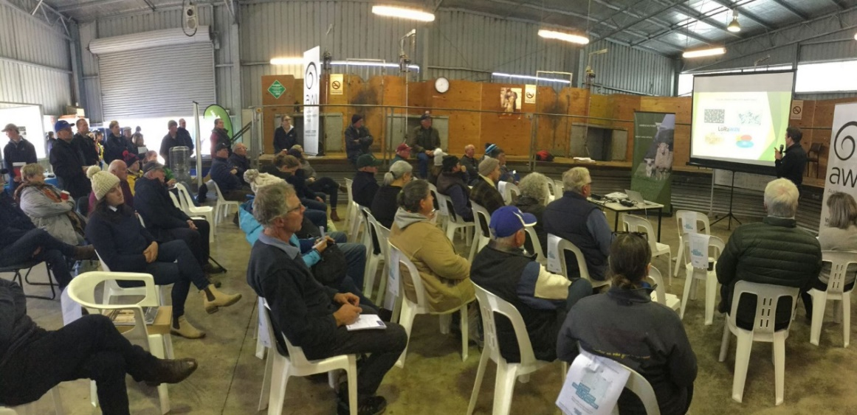

Group – Ballarat Group
Coordinator – Neil James
The Ballarat BetterBeef plus Pyrenees and Smeaton BestWool/BestLamb groups recently held a stock handling and farm safety field day and trade display. The day was a huge success with eighty-three participants from across south west Victoria. Participants included beef and sheep producers from across south west Victoria, as well as local agriculture high school and university students
Guest speakers included Fiona Baker (Agriculture Victoria) speaking about the implications of increasing cattle size that has been seen over recent years. This included the impacts on feed resources and allocation, ability to target markets and the safety requirements to consider, such as handling through yards and crush requirements.
Emily King (Australian Wool Innovation) spoke on the completion of a study on wool shed design. This study focused on the safety of woolsheds for shearers and key design points that can aid in a reduction of workplace injuries. A link to a video on the project can be viewed on wool.com
Erica Schelfhorst (Agriculture Victoria), outlined results from a producer demonstration site, co-funded by Agriculture Victoria and Meat and Livestock Australia, investigating the use of drones to monitor ewes at lambing. To date, the drones on-farm project has completed two lambing cycles (autumn, winter, spring 2019/2020) and two summer cycles (2020/2021).
The early indications from the demonstration are the speed and height of the drone flight path have serious implications for the flight response of sheep when sheep are not conditioned to the noise. Producers found the drones useful over summer to check water supplies, irrigation channels and even pasture. The demonstration has also developed insights into considerations for buying a drone for livestock properties.
Johnathan Jenkin (Glenelg Hopkins Catchment Management Authority) spoke on the completion of the Grassland Society of Southern Australia and Southern Farming Systems on-farm demonstration, investigating the use of technology on farm. The demonstration trialed the use of sensors such as tank and trough monitors and electric fencing. Lots of products are currently on the market and information on the products trialed can be found at ‘Ag Tech Bytes’ on the Agriculture Victoria website, navigate to the Ag tech- sensors and network demonstration.
The day also included a small trades display which highlighted infrastructure such as yarding and handling facilities for both beef and sheep, cattle tags, specialist drones and farm safety.
The Ballarat BetterBeef group is looking for new members in the Ballarat area, for more information on becoming a member please email Neil James Agriculture Victoria or fill out an online membership form.

Accessibility
If you would like to receive this publication in an accessible format, contact Agriculture Victoria on beef.sheepnetworks@agriculture.vic.gov.au
This document is also available in PDF and Word format at http://agriculture.vic.gov.au/on-farm-demos

Disclaimer
This publication may be of assistance to you but the State of Victoria and its employees do not guarantee that the publication is without flaw of any kind or is wholly appropriate for your particular purposes and therefore disclaims all liability for any error, loss or other consequence which may arise from you relying on any information in this publication.
Issued July 2021

