Significant Disease Investigation Guide PIGS
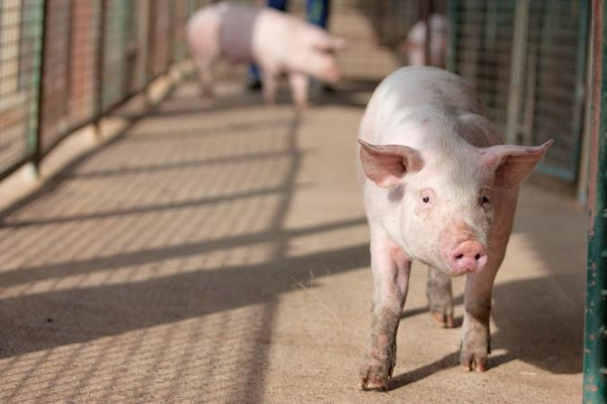

When veterinarians report and investigate significant animal disease events they are playing a critical role in protecting the health of people, livestock, companion animals and wildlife.
This booklet aims to help you conduct a Significant Disease Investigation involving pigs, and provides information about reporting notifiable diseases, as prescribed under the Victorian Livestock Disease Control Act 1994.
Companion editions to this guide have been produced for horse, cattle and sheep diseases. You can obtain copies by contacting cvo.victoria@agriculture.vic.gov.au

Disclaimer
This publication may be of assistance to you but the State of Victoria and its employees do not guarantee that the
publication is without flaw of any kind or is wholly appropriate for your particular purposes and therefore disclaims all
liability for any error, loss or other consequence which may arise from you relying on any information in this publication. This guide was produced with the assistance of the Faculty of Veterinary and Agricultural Sciences, University of Melbourne, the Department of Agriculture, Fisheries and Forestry, the Government of Western Australia, the Northern Territory Government and the Queensland Government. Thanks to Agriculture Victoria staff who also provided pictures.

The Victorian Significant Disease Investigation program

The Victorian Significant Disease Investigation (SDI) program aims to boost Victoria’s capacity for the early detection of significant diseases in livestock (including horses, pigs and poultry) and wildlife by increasing the participation of veterinarians and subsidising the cost of investigating significant or unusual disease incidents.
Subsidies are available for initial field investigations, including clinical examination and necropsy, laboratory testing and follow-up investigations. Subsidy details can be found on the Agriculture Victoria Significant Disease Investigations website page agriculture.vic.gov.au/SDI

To be considered a significant disease, one or more of the following criteria must be met:
- an unusual or atypical manifestation of disease, including high morbidity, mortality and/or rate of spread,
- an initial investigation fails to establish a diagnosis, including when veterinary treatment does not produce an expected response, or
- findings suggesting a possible effect on trade, public health, biodiversity or the viability of the farm, industry or region, excluding events where there is a genuine suspicion of an emergency animal disease.
If you wish to access this program, you must contact your local Agriculture Victoria veterinarian for approval prior to submitting samples.
Where there is a genuine suspicion of an exotic or emergency animal disease, Agriculture Victoria will lead and cover the cost of the disease investigation.
If you suspect an exotic or emergency animal disease, call the EAD Hotline 1800 675 888.

Report suspicion (or confirmation) of notifiable diseases
Under the Victorian Livestock Disease Control Act 1994, a person knowing or having reason to suspect that a notifiable disease is present in livestock (or livestock products) that are either:
- owned by that person or in the possession, control or charge of that person; or
- on land owned and occupied by that person; or
- dealt with by that person as a veterinary practitioner, an inspector under the Meat Industry Act 1993 or the Export Control Act 1982, operator of a meat processing facility licensed under the Meat Industry Act 1993 where a quality assurance program is in force;
- dealt with by the owner or person in charge of premises registered as a veterinary diagnostic laboratory, knacker, stock agent or other person dealing with livestock, livestock products or hives by way of a profession, trade or business;
must report the disease or the suspicion of disease.

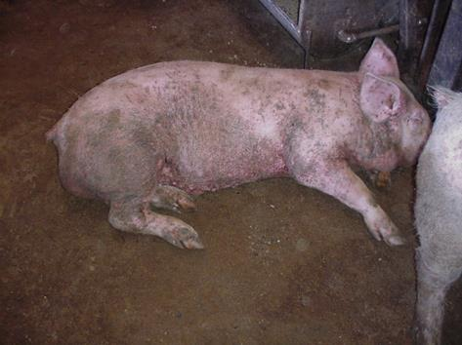

Table 1. Endemic diseases of pigs that are notifiable in Victoria
Report immediately | Report within 12 hours | Report within 7 days
Anthrax | Swine brucellosis (Brucella suis) | Salmonellosis
 | Japanese encephalitis | Verocytotoxigenic E.
 |  | Leptospirosis
 |  | Avian tuberculosis (Mycobacterium avium)

A full list of notifiable diseases, including exotic diseases, can be found on the Agriculture Victoria website, agriculture.vic.gov.au or see the “Notify Now” smartphone app to access the current list of notifiable diseases on your phone. Download the app for free from the AppStore or Google play; just search on “notify now’ and ‘Victoria’.
Notification can be made by
- contacting your local Agriculture Victoria Animal Health and Welfare staff, or
- using the “Notify Now” smartphone app, or
- calling the all-hours Emergency Animal Disease Hotline on 1800 675 888.
A disease notification form can also be downloaded from the Agriculture Victoria website. Details of where to forward the report are provided on the form.

Practice Good Biosecurity in Consultation with the Farm

Vehicles, clothing, footwear and equipment can all spread disease between properties
- Prior to visiting, contact the manager to ascertain the farm biosecurity protocols, i.e. mandated time away from pigs prior to entry, where established clean/dirty demarcation lines are, arrangements for showering on, parking, boots, clothes and entry of equipment.
- Always carry detergents/disinfectants, including wipes, disposable overalls, disposable cover boots and rubbish bags in your vehicle. You may need gear for restraint and euthanasia.
- Plan to leave your vehicle outside the property clean/dirty line. Put on cover boots to walk to and from your car to the property entry point. Do not enter unescorted or without authorisation.
- Put on your clean overalls/boots before entry unless required to change into farm clothes/boots.
- Establish or confirm the clean and dirty zones at the entrance to the property.
- Equipment, clothing and footwear that have been in contact with the dirty zone, must be cleaned, discarded or placed in bags when exiting the dirty zone.
- Wear disposable gloves to collect samples and use other personal protection equipment (PPE)if zoonotic diseases are suspected.
- If using your own postmortem gear, do not take it into sheds. Instead move carcases to a clean area away from the sheds to undertake the examinations. Make sure you have a bucket of soapy water and appropriate disinfectant to clean your equipment before leaving the farm.

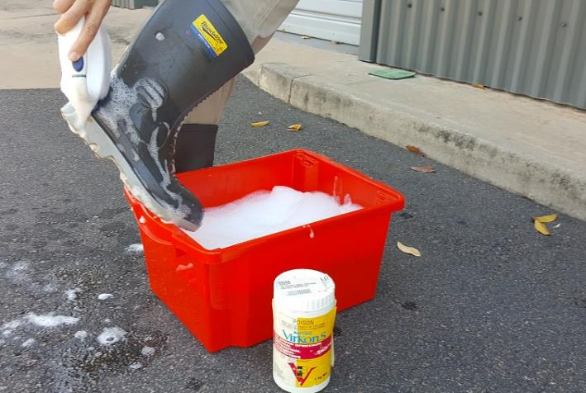

If you suspect an emergency animal disease, call the hotline immediately, 1800 675 888, before leaving the property.

Pig Diseases

While many farms are “farrow-to-finish” and hold breeders, lactating sows and suckers, weaners, growers and finishers (usually in separate facilities reflecting their differing housing needs) larger farms and contractors more commonly hold one age group of pigs i.e. they are grow-out only or a weaner site or a breeder site. This will have an impact on the diseases seen on these farms and their presentations. Diseases like influenza A may affect all age groups on farm, but with most diseases clinical signs are limited to, or are predominantly seen in one production group e.g. coccidiosis is usually only seen in suckers.

Always consider potential zoonotic diseases
It is important to remember that some diseases have the potential to infect humans as well as animals. Some of these diseases cause significant clinical disease in pigs (e.g. erysipelas, Nipah virus infection) while others often cause mild or no disease (e.g. leptospirosis, hepatitis E, Balantidium coli, trichinellosis, porcine cysticercosis caused by Taenia solium, and hydatid cyst disease caused by Echinococcus spp). Even without clinical signs these diseases may still present a zoonotic risk. Pigs are susceptible to both rabies and anthrax however both are rare even in endemic areas due to the lack of exposure. Influenza A is considered a reverse zoonosis with the virus being transmitted from pigs to people and also from people to pigs.

- Always assume that a zoonotic disease may be present, and ensure good hygiene and safety practices
- Ensure all people in contact with the animals also take appropriate safety precautions
- Do not conduct a necropsy if anthrax is suspected. Perform an in-field anthrax ICT test if there is any suspicion of anthrax
- Take care not to ingest food or water potentially contaminated with faecal material or other secretions
- Avoid splashing or inhaling body fluids
- Pay particular attention to your own skin wounds (i.e. cover the wound to prevent infection)
- Consider vaccination against diseases such as seasonal influenza, Q fever and Japanese encephalitis.
- If you are unsure about a safety procedure, do not proceed until you have sought advice. (No query is foolish if it protects your own health)
- Seek medical advice if you are concerned about exposure to a zoonotic agent
- Apply effective mosquito repellants to all exposed skin to avoid mosquito bites and reduce the risk of acquiring an arboviral disease (such as Japanese encephalitis).

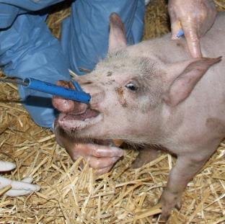

What should be collected in the field
To complete the Record of Disease Event form (RODE) and laboratory submission form you will need to gather these details:
• Species. Is more than one species affected?
• Number of deaths, number sick, number at risk, number examined.
• Age, condition score, sex.
• History and predisposing factors
- When did the outbreak begin?
- What is the recovery time?
- What vaccinations and treatments have the animals had?
- Recent livestock introductions? Consider possible sources of introduction/spread. Live pigs, semen, visitors, staff, contractors and vehicles, feed, and changes in water source or quality. Weed species may be important in free range systems.
- Clinical history and signs.
- Primary syndrome.
- Lesions and necropsy findings.
- Owner and property details including the Property Identification Code.
Samples
- From affected animals.
• Perform a necropsy.
- Check the sample collection guide.
- Describe lesions and take measurements.
- Be aware of zoonoses – collect samples carefully and wear appropriate PPE.

Photographs and videos
- Sick and dead animals
- Lesions / pathology

Timeline
- Sequence dates of disease cases and note clusters
  - Find the first case – what happened before it?
  - Note other events that happened on the property within the timeline.
  - What’s different when cases don’t occur?
Details of the location
- Physical factors.
  - Shed, affected pens or areas of sheds
- Photos of layout.
- Spatial map of where cases occurred.
Forms can be downloaded from www.agriculture.vic.gov.au/SDI
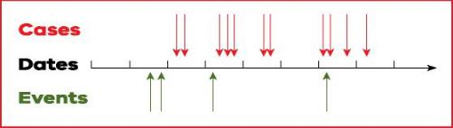

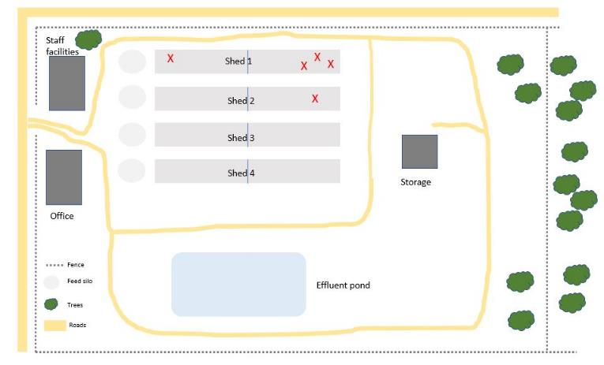

Syndromes and age groups of pigs most commonly affected.
In progeny pigs, that is young pigs other than selected breeders, diseases that do not result in the short term in mortality, are likely to produce unthrifty animals. Ill-thrift is also associated with poor environmental conditions such as an inappropriate temperature range or drafts, particularly in suckers and weaners. In these situations, disease agents might be secondary.

Clinical disease in pigs has been associated with a large number of dietary deficiencies and toxicities as well as environmental contaminant toxicities and weed intoxications. These are rarely seen in pigs on commercial diets but should be considered with home mixers with inadequate on-farm storage or poor dietary formulation. They are not listed here.

In Table 2, Zoonotic diseases have an “N” in brackets and notifiable diseases in Victoria are in Bold.
S= sucker pig; 0 to 4 weeks of age, 1-9kg average weight
W= weaner pig; 4 to 9 weeks of age, 10-30kg average weight
G= grower pig; 10 to 16 weeks of age, 30 to 65kg average weight
F= finisher pig; 17-25 weeks of age, 70 to 100kg average weight
B= Breeder; Adult pigs

Table 2. Syndromes and disease of pigs
Affected system |  | Cause | Age Groups |  | Most likely age affected (weeks) |  | Signs in order of significance
Anaemia |  | Iron Deficiency | S,W |  | 2- 6 |  | Slow growth, subcutaneous oedema, coughing
 |  | Gastric ulcer | W,G,F,B |  | 9-20 |  | Dark scour, sudden death
 |  | Lawsonia intracellularis | G,F,B |  | 8-21 |  | Dark scour, sudden death, illthrift
 |  | Mycoplasma suis | F,B |  | 20-Adult |  | Anaemia in stressed pigs, eg sows at farrowing
Gastrointestinal |  | Enterotoxigenic E coli | S |  | 1 |  | Watery scour, dehydration
 |  | Clostridium perfringens | S |  | 1 |  | Haemarrhagic scour, sudden death
 |  | Clostridium difficile (N) | S |  | 1-2 |  | Yellow/brown scour, sudden death
 |  | Rotavirus | S |  | 1-2 |  | Watery scour
 |  | Transmissible gastroenteritis | S, W, G, F, B |  | 1-Adult |  | Vomiting & profuse scour, high mortality
 |  | Porcine epidemic diarrhoea | S, W, G, F, B |  | 1-Adult |  | Vomiting & profuse scour, high mortality
 |  | African swine fever | S, W, G, F, B |  | 1-Adult |  | Fever, lethargy, haemorrhage, scour, vomiting, abortions, coughing
 |  | Classical swine fever | S, W, G, F, B |  | 1-Adult |  | Fever, lethargy, haemorrhage, scour, vomiting, abortions, coughing
 |  | Aujeszky’s disease | S, W, G, F, B |  | 1-Adult |  | Fever, incoordination, vomiting, coughing
 |  | Haemagglutinating encephalomyelitis virus (HEV) | S, W |  | 1-2 |  | Retching, vomiting, dehydration
 |  | Coccidiosis | S |  | 2-4 |  | Pasty yellow scour, low impact
 |  | Enterotoxigenic E coli  Enterotoxaemic E coli | S, W |  | 2-8 |  | Watery scour, dehydration  Sudden death, oedema
 |  | Round worms, whipworms | W,G,F |  | 4-Adult |  | Mild scour, maybe bloody with whipworm, coughing with ascaris
 |  | Porcine Circovirus 2 | W,G,F |  | 8-20 |  | Weight loss, scouring, coughing, skin lesions with PDNS
 |  | Salmonellosis | W,G,F |  | 6-18 |  | Watery scour, fast spreading
 |  | Lawsonia intracellularis | W,G,F |  | 8-Adult |  | Watery or tarry scour, ill thrift
 |  | Brachyspira hyodysenteriae | W,G,F |  | 8-16 |  | Mucoid scour with blood flecks
 |  | Anthrax (rare in pigs) (N) | S, W, G, F, B |  | 1-Adult |  | Cervical form – oedema, lethargy, inappetence, fever, vomiting, and scours or septicaemic form - lethargy, tremors, pyrexia and sudden death
 |  | Faecal scald (antibacterial break-down) | G,F |  | 11-18 |  | Scour, perineal erythema of varying severity
Affected system | Cause |  |  | Age Groups |  | Most likely age affected (weeks) |  | Signs in order of significance
Respiratory | Mycoplasma hyorhinis |  |  | W,G |  | 3-10 |  | Sneezing, polyserositis, arthritis, fever, conjunctivitis
 | Porcine reproductive and respiratory syndrome |  |  | S, W, G, F, B |  | 1-Adult |  | Dyspnea, abortions, high preweaning mortality, anorexia, emaciation
 | Mycoplasma hyopneumoniae |  |  | W,G,F |  | 8-20 |  | Coughing, dyspnea
 | Actinobacillus pleuropneumoniae |  |  | W,G,F |  | 8-20 |  | Coughing, dyspnea, sudden death, epistaxsis
 | Influenza A virus (N) |  |  | S, W, G, F, B |  | 1-Adult |  | Dyspnea, abortions, high preweaning mortality, emaciation
 | Pasteurella multocida |  |  | W,G,F |  | 8-20 |  | Coughing, dyspnea, sudden death
 | Glasserella (Haemophilus) parasuis |  |  | W,G |  | 4-8 |  | Coughing, polyserositis, lameness, sudden death, fever, cns signs
 | Nipah virus infection (N) |  |  |  |  |  |  | Severe coughing,
 | Glaesserella australis |  |  | G,F |  | 12-20 |  | Mild coughing, lesions may be confused with APP
 | Actinobacillus suis |  |  | W,G,F,B |  | 1 - Adult |  | Cough, fever, sudden death, lesions may be confused with APP
Lameness | Foot and mouth disease and other vesicular diseases |  |  | S, W, G, F, B |  | 1-Adult |  | Fever, acute lameness, vesicles, inappetence, abortions
 | Streptococcus suis (N) |  |  | S,W |  | 2-10 |  | Arthritis, meningitis, serositis, pneumonia
 | Mycoplasma hyosynoviae |  |  | W,G |  | 8-18 |  | Acute painful lameness, reluctance to move
 | Erysipelothrix rhusiopathiae (N) |  |  | G,F,B |  | 12-Adult |  | Fever, arthritis, severe lameness, skin lesions, sudden death, inappetence, abortions
 | Glasserella (Haemophilus) parasuis |  |  | W,G |  | 4-8 |  | Coughing, polyserositis, lameness, sudden death, fever, cns signs
Sudden Death | Mulberry Heart Disease |  |  | S,W |  | 2-6 |  | Sudden death
 | Enterotoxaemic E. coli |  |  | W |  | 4-6 |  | Subcutaneous oedema
 | Enceplalomyocarditis virus |  |  | S, B |  | 1-3 Adult |  | Sudden death in young pigs, reproductive failure in sows
 | Aujeszky’s disease |  |  | S, W, G, F, B |  | 1-Adult |  | Severe CNS signs, sudden death in younger animals
 | Cystitis-pyelonephritis Actinobaculum suis |  |  | B |  | Adult |  | May see signs of fever, cystitis
 | Actinobacillus pleuropneumoniae |  |  | W,G,F |  | 8-20 |  | Coughing, dyspnea, sudden death, epistaxsis
 | Pasteurella multocida |  |  | W,G,F |  | 8-20 |  | Coughing, dyspnea, sudden death
 | Nipah virus infection (N) |  |  | S, W, G, F, B |  | 1-Adult |  | Sudden death in adults, respiratory & CNS in younger pigs
 | African swine fever |  |  | S, W, G, F, B |  | 1-Adult |  | Fever, lethargy, haemorrhage, scour, vomiting, abortions, coughing
 | Classical swine fever |  |  | S, W, G, F, B |  | 1-Adult |  | Fever, lethargy, haemorrhage, scour, vomiting, abortions, coughing
Neurological conditions | Hypoglycaemia |  |  | S |  | 1 |  | Vocalization, tremor proceeding to mental dullness, hypothermia
 | Atypical porcine pestivirus |  |  | S |  | 1 |  | Neonatal trembling
 | Streptococcus suis, (N) |  |  | S, W |  | 3-10 |  | Fever, lameness, polyarthritis, septicaemia, paddling, opisthotonus
 | Glasser’s disease (Glasserella (Haemophilus) parasuis) |  |  | S, W |  | 3-10 |  | Peracute to fever, coughing, swollen joints, paddling and trembling.
 | Salt poisoning |  |  | W,G,F,B |  | 4-Adult |  | Associated with lack of water over 18+ hours, not dietary,
 | Aujeszky’s disease |  |  | S, W, G, F, B |  | Adult |  | Severe CNS signs, sudden death, reproductive failure
 | Teschen disease |  |  | W,G,F |  | 6-20 |  | Fever, listlessness and hindlimb ataxia, proceeding to death
 | Porcine sapelovirus |  |  | W,G,F |  | 6-20 |  | Fever, listlessness and forelimb ataxia, proceeding to death
 | Rabies (rare in pigs) (N) |  |  | S, W, G, F, B |  | 1-Adult |  | Severe CNS signs, sudden death, reproductive failure
 | Tetanus (rare in modern pig production) |  |  | S, W, G, F, B |  | 1-5 |  | Recent wound, spasms, stiffened gait progressing to opisthotonus
Reproductive | Brucella suis (N) |  |  | B |  | Adult |  | Herd may be clinically normal, reduced reproductive performance in sows, orchitis
 | Leptospirosis (pomona) (N) |  |  | B |  | Adult |  | Late abortions
 | Aujeszky’s disease |  |  | B |  | 1-Adult |  | Reproductive failure depending on the stage of gestation, very high mortality in young pigs
 | Japanese encephalitis (N) |  |  | B |  | Adult |  | Mummified piglets, weak born pigs and stillbirths. Boars may show fever, swollen testicles, epididymitis and poor semen quality.
 | Porcine reproductive and respiratory syndrome |  |  | S, W, G, F, B |  | 1-Adult |  | Reproductive failure depending on the stage of gestation, very high mortality in young pigs
 | Porcine circovirus type 2 and 3 |  |  | B |  | Adult |  | Late term abortions, stillbirths, mummification low farrowing rates
 | Porcine parvovirus |  |  | B |  | Adult |  | Mummified piglets
 | Toxoplasma gondii |  |  | B |  |  |  | Stillbirths, prolonged gestation. abortion rare
Oral lesions | Foot and mouth disease |  |  | All |  | All |  | Fever, vesicles, inappetence, lameness
 | Swine vesicular disease |  |  | All |  | All |  | Fever, vesicles extending to legs
 | Vesicular exanthema |  |  | All |  | All |  | Fever, anorexia, foot lesions, variable lameness
 | Vesicular stomatitis |  |  | All |  | All |  | Fever, vesicles on snout,
 | Seneca Valley virus |  |  | All |  | All |  | Fever, vesicles, lethargy and lameness
 | Phototoxic dermatitis |  |  | All |  | All |  | Lesions on the skin of the nose, erythema on nose and ears. Notably celery and parsley tops
Skin | Greasy pig disease (Staphylococcus hyicus) |  |  | W,G |  | 2-7 |  | Erythematous, moist, scalded appearance leading to a thick brown crust, anorexia and death
 | Mange (Sarcoptes scabei) |  |  | G,F, B |  | 12-Adult |  | Diffuse, proliferative, pruritic, scaly build up in ears in adults
 | Ringworm |  |  | F, B |  | Adults mainly |  | Circular red to brown roughened skin, can be very large with dry crusts at the periphery
 | Porcine dermatitis and nephropathy syndrome (PCV2 associated disease) |  |  | G, |  | 10-17 |  | Multifocal red raised macules and heamorrhagic papules on face, ears, lower limbs and hindquarters.
 | Erysipelas (Erysipelothrix rhusiopathiae) (N) |  |  | G,F,B |  | 12-Adult |  | Fever, arthritis, severe lameness, skin lesions, sudden death, inappetence, abortions

Always consider potential exotic diseases and know which diseases are notifiable
A full list of notifiable diseases, including exotic diseases, can be found on the Agriculture Victoria website, agriculture.vic.gov.au or see the Notify Now smartphone app
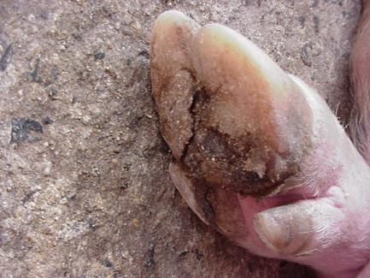
Table 3. Differential diagnosis for syndromes seen in pigs
Syndrome | Exotic Disease | Endemic Disease
Sudden Death | Aujeszky’s disease | Mulberry Heart Disease
 | African swine fever | Enterotoxaemic E coli
 | Classical swine fever | Enceplalomyocarditis virus
 | Transmissible gastroenteritis | Erysipelas Erysipelothrix rhusiopathiae
 | Porcine epidemic diarrhoea | Pasteurella multocida
 |  | Glasser’s Disease Glasserella (Haemophilus) parasuis
 |  | Gastric ulcer
 |  | haemorrhagic enteropathy Lawsonia intracellularis
 |  | Enterotoxigenic E coli
 |  | Clostridium perfringens
 |  | Clostridium difficile
 |  | Heat Stroke
 |  | Torsions – splenic, liver, gastric
 |  | Cystitis-pyelonephritis Actinobaculum suis
 |  | Anthrax
 |  | Actinobacillus pleuropneumoniae
 |  | Actinobacillus suis
Respiratory signs | Porcine reproductive and respiratory syndrome | Mycoplasma hyorhinis
 | African swine fever | Enzootic pneumonia Mycoplasma hyopneumoniae
 | Classical swine fever | Pleuropneumonia Actinobacillus pleuropneumoniae
 | Nipah virus infection | Ascarid migration
 | Porcine respiratory coronavirus | Influenza A virus
 | Blue eye paramyxovirus | Pasteurella multocida
 | Adenovirus | Glasser’s Disease Glasserella (Haemophilus) parasuis
 | Aujeszky’s disease | Toxoplasmosis
 |  | Porcine circovirus type 2
 |  | Atrophic Rhinitis
 |  | Bordertellosis
 |  | Toxoplasmosis
 |  | Methane toxicity
 |  | Carbon monoxide toxicity
 |  | Klebsiella septicaemia and pneumonia
 |  | Lung worm
Vesicular Diseases | Foot and mouth disease | Phototoxic dermatitis
 | Swine vesicular disease
 | Vesicular exanthema
 | Vesicular stomatitis
 | Seneca Valley virus
Reproductive | Aujeszky’s disease | Brucella suis
 | African swine fever | Influenza A virus
 | Classical swine fever | Leptospirosis (Pomona)
 | Porcine reproductive and respiratory syndrome | Porcine parvovirus
 | Blue eye paramyxovirus | Enceplalomyocarditis virus
 | Seneca Valley virus | Erysipelas Erysipelothrix rhusiopathiae
 |  | Menangle virus
 | Porcine circovirus type 3 | Bungowannah virus
 | Getah virus | Porcine circovirus type 2
 |  | Mycoplasma suis
 |  | Zearalenone
 |  | Japanese encephalitis
Congenital Tremor | Classical swine fever | Atypical porcine pestivirus
 |  | Trichlorfon toxicity
 |  | Genetic syndromes in Landrace, Saddlebacks
 |  | Japanese encephalitis
Neurological | Aujeszky’s disease | Hypoglycaemia
 | Teschen disease (Porcine enterovirus encephalomyelitis) | Brain or spinal cord injuries  Porcine sapelovirus  Salt poisoning
 | Porcine reproductive and respiratory syndrome | Tetanus
 |  | Botulinism (rare)
 | Nipah virus infection | Glasser’s Disease Glasserella (Haemophilus) parasuis
 | Blue eye paramyxovirus | Streptococcus suis
 | Porcine reproductive and respiratory syndrome | E.coli
 | Rabies (rare in pigs) | Toxoplasma gondii
 |  | Enceplalomyocarditis virus
 |  | Middle ear infections
 |  | Various toxicities
Gastrointestinal | Transmissible gastroenteritis | Haemagglutinating encephalomyelitis virus (HEV)
 | Porcine epidemic diarrhoea | Enterotoxigenic E coli
 | African swine fever | Clostridium perfringens
 | Classical swine fever | Clostridium difficile
 | Aujeszky’s disease | Rotavirus
 | Porcine delta coronavirus | Lawsonia intracellularis
 |  | Swine dysentery - Brachyspira hyodysenteriae
 |  | Various Brachyspira species
 |  | Gastric ulcer
 |  | Vomitoxin
 |  | Salmonellosis
 |  | Ascaris suum
 |  | Trichuris suis
 |  | Coccidiosis
 |  | Porcine circovirus type 2
 |  | Water quality
 |  | Rectal strictures
 |  | Hair balls and foreign bodies

Correct collection and handling of blood samples is essential for achieving an accurate diagnosis

Routinely collect the full range of recommended samples
Blood sample collection
- Always ensure the correct tube is used for the required tests.
- Fill blood tubes, if possible.
- Do not allow sample tubes to become too hot (store blood samples at 4ºC).
- To avoid haemolysis:
  - remove the needle before transferring blood from a syringe to a collection tube
  - ensure samples that are required to clot remain upright always mix anticoagulant tubes gently
  - don’t allow blood samples tubes to cool too quickly.

Tube type | Description | Tests
Serum separation and clot activator  Allows the clot to form so serum can be analysed. | Gold and red tops | Serology, Antibody and antigen tests, Clinical biochemistry
EDTA  Contains anticoagulant | Purple tops | Haematology, Virus isolation, Polymerase chain reaction (PCR)
Lithium heparin  Contains anticoagulant | Green tops | Clinical biochemistry

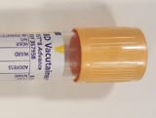
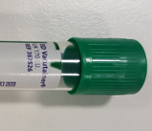
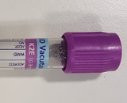

Tissue sample collection
Ensure samples are representative of lesions
- Sample the interface with normal tissue.
- Sample areas of different colour or consistency.
- Consider multiple sections for large lesions.
Collect fresh and fixed tissue samples
Fixed tissue
- Use 10 times the volume of 10% buffered formalin as tissue.
- Allow at least 24 hours for tissues to fix.
- Fixed tissues can be drained before transportation; seal the contain well and add a few mL of formalin to ensure the tissue remains moist.
Fresh tissue
- Place fresh tissues in individual sterile containers and cool in an esky or refrigerator

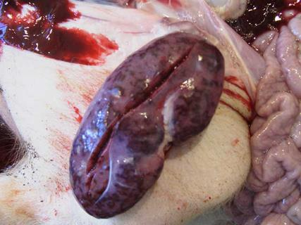

Contact the AgriBio duty pathologist on 03 9032 7515 during business hours for specific sample collection advice.

Tissue sample collection

Table 4 Sample collection Guide
Neurological | Brain & spinal cord – tissues, surface swabs for bacteriology and viral testing, also liver, kidney heart and skeletal muscle
Oral lesions | Vesicular fluid, epithelium from lesions, oral, tonsillar swabs in viral transport medium, also spleen, lymph nodes liver, lung, GIT
Reproductive | Aborted fetuses, stillborn piglets, mummies whole. Pericardial and intrathoracic fluid from foetus. Blood samples from sows. Also collect EDTA and clotted blood for PCR and serology.  Abortions: - Placenta:fresh and fixed, Foetuses:sample 1-3 aborted/stillbirths, preferably not mummified. Fresh: lung, heart, kidney or peritoneal fluid. Fixed (non mummified): lung, heart, liver, kidney, brain.
Respiratory | Target samples to affected organs ie positive swabs from the upper respiratory tract are not always reliable indicators of lung disease. Nasal swabs for influenza, sera and lung for PCV and PRRS, lung for mycoplasma, Pasteurella, streps, E coli, Glasser’s and pleuropneumonia.
Gastrointestinal | Faecal samples for Brachspira spp, Clostridium, Salmonella spp and E coli, faeces and/or gut for rotavirus and coronaviruses and Lawsonia sp.
Skin | Skin lesion, scrapings
Sudden death | Blood, brain, liver, kidney, heart, spleen, skeletal, muscle, lymph nodes, spleen and lesions

Organ | Sample size | Don’t forget
Gastrointestinal tract | Fresh: 10cm SI segment, colon contents (2-5ml).  Fixed: Stomach, duodenum, jejunum, ileum, caecum, colon
Kidney | Fresh: half  Fixed: 5 cm slice through centre | Cortex, medulla, pelvis and stones
Lung | Fresh: 4-5cm pieces (should fit into yellow top container).  Fixed: 2x2x1 cm, 3 pieces | 3 pieces with different gross appearance
Lymph Nodes | Fresh: Whole  Fixed: 1cm thickness | Label container to identify the lymph nodes
Spleen | Fresh: 5 cm piece  Fixed: 1 cm thickness
Tonsil & Brain | Fresh: half  Fixed: half
Placenta | Fresh: 2x2cm  Fixed: 2x2cm

* Please note: Do no pool fresh tissue samples if bacteriology is required.

Handling samples in the field

- Ensure samples are taken prior to giving treatments (where possible)
- Ensure enough samples are collected to represent the whole herd
- Collect fresh and fixed samples first, then gut samples

- Label samples as soon as you take them
- Ensure labelling is clear and indelible. Record PIC, animal identification,
date and vet on label.

- Clean any surface contamination from tubes and containers
- Place tubes/vials into zip-lock bags to keep them clean and contained together

- Keep fresh samples cool while in the field with ice bricks
- Don’t leave samples standing in the sun while working
- Use an esky and ice bricks to store samples during transit.
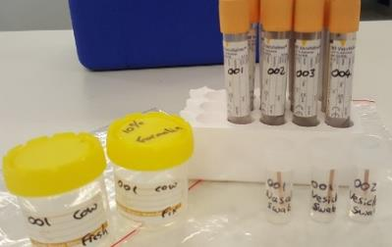

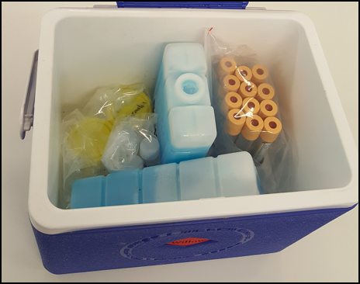

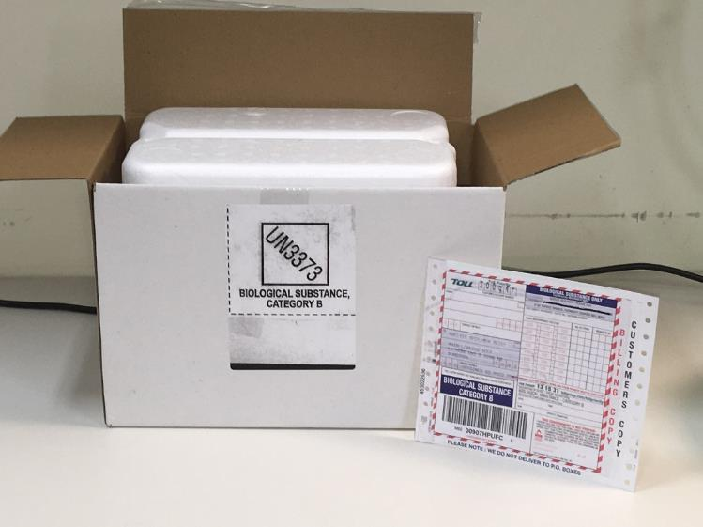

Packaging samples for transport
- Refrigerate samples as soon as you return from the property
- Do NOT freeze samples
- List all samples taken on the submission form
- Samples must be sent to the state veterinary diagnostic laboratory for your location as soon as practical

Triple Package

- Primary receptacle (eg blood tube, tissue pot)
  - Must be leak proof
  - Must not be overfilled
- Secondary receptacle (eg esky or plastic container)
  - Must be sealed
  - Must not contain paperwork, sharps/waste products
  - Should contain absorbent material in case of leakage of primary receptacle
  - May contain frozen blocks
  - Lab submission form should be placed in a ziplock bag and taped to the OUTSIDE of the esky/container
- Outer shipping container
  - Must be rigid (eg cardboard box)
  - Should be oversized, with packaging material used as required
  - Consignment note should be placed on top of sealed package

Submitting samples and reports
Veterinary Diagnostic Services
Agri-Bio specimen reception
Main Loading Dock
5 Ring Rd
Latrobe University
Bundoora 3083
Phone: (03) 9032 7515
Fax: (03) 9032 7604
Email: vet.diagnostic@agriculture.vic.gov.au

Further information
For further information contact your local Agriculture Victoria veterinarian or refer to the Agriculture Victoria website agriculture.vic.gov.au
During business hours contact 136 186 and ask to speak to your local Agriculture Veterinarian to report a significant disease investigation or a suspect emergency animal disease.

And remember, if you suspect an emergency disease, please call the Emergency Animal Disease Hotline 1800 675 888, immediately.

