BetterBeef – Group Profile
Upper Murray and Mudgegonga Groups– September 2022

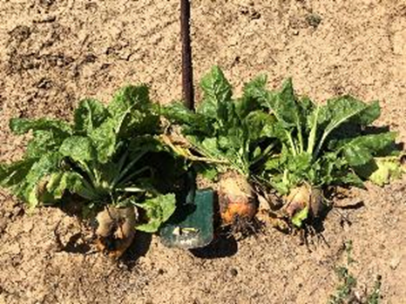

Three fodder beet plants and a shovel

Group/s coordinator Chris Mirams
Agriculture Victoria demonstration coordinator Nick Linden
District Upper Murray, Mudgegonga
Enterprise mix cattle
Fodder beet – high quality feed that justifies the costs? Or a high-risk strategy that may not pay off?
Many producers have seen images of cattle strip grazing across a crop of high-yielding fodder beet. A group of beef producers, from the Upper Murray and Murmungee BetterBeef groups in north east Victoria had seen fodder beet first-hand and were keen to investigate how it would perform in their local environments, what costs would be involved and what issues might they run into. The demonstration was set up in early 2019, with funding from Meat & Livestock Australia (MLA) and Agriculture Victoria.
Background
One of the limitations to profitable beef production from pasture is older animals at slaughter (for the same carcass weight), the result of low growth rates driven by seasonal feed deficits. Older cattle are less productive and profitable for beef operations as effective stocking rate is decreased, and the carcass quality is both reduced and more variable. Additionally, there can be further inefficiencies for replacement heifers that are too light (weight and fat) at their first joining.
Correcting pasture based feed deficits with cereal grains has been one approach, but it is often uneconomic and unsustainable in southern Australia. Furthermore, there are growing international markets for grass-fed beef that excludes grain-fed animals. The pasture systems of Victoria are well positioned to increase in this space, but current productivity and profitability is low. Many producers rate the autumn/winter feed gap as the biggest feed restriction within their current enterprises.
There are several strategic pasture/crop options to fill the late autumn early winter feed deficit. In the mixed farming areas of south east Australia, producers are seeking to utilise early sown grazing cereal crops – which have the added benefit of early grazing followed by a harvestable grain crop.
Fodder beet provides another approach for filling seasonal feed gaps, providing large yields of high energy feed to ‘bank’ for times of feed deficit to finish beef on forage. The crop has potentially large yields (20-40 t DM/ ha) of high energy feed (12 MJ/ kg DM) that lasts for long periods (one year) with little change.
The demonstration
Demonstration fodder beet crops were established at three sites over two growing seasons. A theoretical agronomic plan for establishment and management of the fodder beet crop was developed in conjunction with local agronomists.
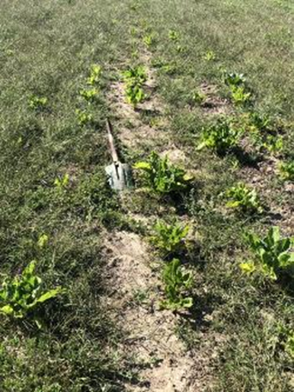
Paddock with low beet plants, high number of weeds
All demonstration crops were sown with a four-row precision seeder loaned courtesy of SeedForce Shepparton. Crops were sown at a rate of 100,000 seeds/ha.
Plant establishment was estimated from an average of the number of plants along five 20m drill rows, multiplied by 1000 (to account for 50cm row spacings). When required, plant counts were replicated approximately three weeks after the initial counts to ensure germination was complete. Average bulb weights were collected at key points throughout the growing season to estimate dry matter production of the fodder beet – through to the point of grazing when final herbage mass estimates were calculated.
Herbage mass (t DM/ha) was estimated by multiplying plant counts by the average plant weights. Plant weights were estimated by digging a representative sample of bulbs (approximately twenty plants) and weighing fresh and dry.
What did we find?
Fodder beet was an expensive crop to establish. Our ‘management plan’ was budgeted at $3,165/ha (seed ($475), chemical ($1,385) and additional fertilizer ($1,305)) excluding tractor hours or contractors. Additional to the high costs, herbicides for fodder beet are not widely used in broadacre agriculture and can be difficult to source.
At the above costings – a 10 t DM/ha fodder beet crop would have cost $316/t DM.
Despite all paddocks having a well worked seed bed, plant establishment was poor at all three sites, averaging 44,888 plants/ha (compared to a target of 85,000 plants/ha). Whilst we are unable to state why plant establishment was so low, we do know that the seed was viable and sowing rates were accurate – it is hypothesized that seeding depth may have played a part.
Dry Matter (DM) production in the first season crops was highly variable and ranged from 2.42 t DM/ha through to 27.4 t DM/ha. In the second season, crop yields were uniformly poor and ranged from 0.4 t DM/ha to 2.4 t DM/ha depending on weed control strategies. Despite having two summers of weed control, two of our demonstration sites were characterized by high weed burdens that had negatively impacted on the performance of the fodder beet crop. None of our sites were able to achieve ‘canopy closure’ – and having worked the paddocks to a fine seedbed, had resulted in an ideal condition for weeds to grow.
Poor crop yields were a factor of low plant numbers and low crop weights. The two low-yielding sites were essentially managed as dryland crops (one site received one irrigation, with further irrigations cancelled on the back of high weed burdens and low crop performance). If similar plant weights were achieved at the plant establishment counts of 80,000 plants/ha there was a potential dry land yield of fodder beet in the Upper Murray of 5.5 t DM/ha.
The higher yielding crop had larger bulb weights, despite having similar low plant establishment, the site had scheduled irrigation on a fortnightly basis and high baseline soil fertility. Crop utilization rates were high (estimated at more than 90 per cent). The high utilization rates had been driven by the high percentage of the bulbs that are above ground (77 per cent) – as the bulbs mature the percentage above ground increased, with bulbs being easily knocked over and removed from the ground at grazing.
Key outcomes
- The upfront costs of seed, chemical and fertiliser mean that fodder beet is an expensive crop to establish. Anything less than a 10 t DM/ha yield and grain will probably be a cheaper source of energy.
- Despite using a precision seeder, all our demonstration crops had low plant establishment rates (despite having viable seed). Sowing into an appropriate seedbed with correct depth control appears to be critical.
- Based on variable input costs and feed quality, a 12.4 t DM/ha fodder beet crop had the same cost of production as a 6 t DM/ha millet crop.
- Group participants reported an increase in knowledge and skills associated with assessing fodder beet, but the overall attitude towards fodder beet declined. Only one of the three producers that hosted demonstration sites was entertaining the idea of sowing fodder beet again.
- Our results indicated limited potential for fodder beet to fill the autumn/winter feed gap in the North East and Upper Murray areas of Victoria. Poor plant establishment and competition from weeds significantly reduced crop yields. These low yields combined with high up front establishment costs has resulted in a commercially unviable cost of production for two of three sites.
Things to consider
- Common fodder beet herbicides are more frequently used in market gardening applications than broadacre agriculture – make sure you have the required products on hand and order them early as sourcing chemicals can be difficult.
- While the fodder beet plants are hardy and will persist, competition from weeds will significantly reduce overall crop yields.
- Fodder beet may not be a common crop in your district – a keen agronomist with first-hand experience in managing weeds within a fodder beet crop should be at the top of your phone contacts.
- Once you get to the point of grazing fodder beet, animals need to be introduced to the crop gradually to allow rumen bacteria to adjust to the diet – much like when introducing grain into the diet of cattle.
- Are there other management interventions that can be investigated to minimise the impacts of the autumn/winter feed gap – such as time of calving?
- The potential of a high-yielding high quality fodder crop that can capitalise on late spring/summer rains and sit in the paddock until required to fill the autumn/winter feed gap remains an attractive proposition. However, the risks associated with fodder beet are not insignificant, the possibility of low yields through a combination of poor plant establishment and high weed burdens, as well as high establishment costs are major limitations to widespread uptake of the crop.

For more information, contact Nick Linden at nick.linden@agriculture.vic.gov.au

Disclaimer
This publication may be of assistance to you, but the State of Victoria and its employees do not guarantee that the publication is without flaw of any kind or is wholly appropriate for your particular purposes and therefore disclaims all liability for any error, loss or other consequence which may arise from you relying on any information in this publication.
Issued September 2022

