Australian Grains Genebank Strategic Business Partnership

Unlocking the genetic potential of the Australian Grains Genebank to accelerate cereal, oilseed, and pulse crop improvement for the benefit of Australian grain growers

The Australian Grains Genebank Strategic Partnership is a $30M joint investment between the Victorian State Government and Grains Research and Development Corporation (GRDC) that aims to unlock the genetic potential of plant genetic resources for the benefit of the Australian grain growers.
The program of work will transform the Australian Grains Genebank (AGG) from a traditional seedbank facility into a future-oriented bio-digital resource centre through digital and genomic innovation to accelerate cereal, oilseed, and pulse crop improvement and the development of climate-change resilient, high-yielding and high-value grain crop varieties for the benefit of Australian grain growers.

About the genebank
The AGG is custodian to one of the largest collections of grain crop species globally including cultivated, landrace and wild relative species of temperate and tropical crops. The AGG manages its germplasm in accordance with Australia’s obligation under the International Treaty on Plant Genetic Resources for Food and Agriculture (ITPGRFA) and is committed to facilitating widespread access to genetic resources for crop improvement aimed at developing more resilient and productive grain crop varieties.
Opened in 2014 as a significant long-term commitment from the Victorian State Government and GRDC, the AGG has the mandate to acquire, conserve, maintain and distribute genetic resources to plant breeders and researchers to underpin the development of more resilient and productive grain crop varieties for the benefit of the Australian grains industry. The AGG is located at the Grains Innovation Precinct Horsham in the heart of the Wimmera cropping region.
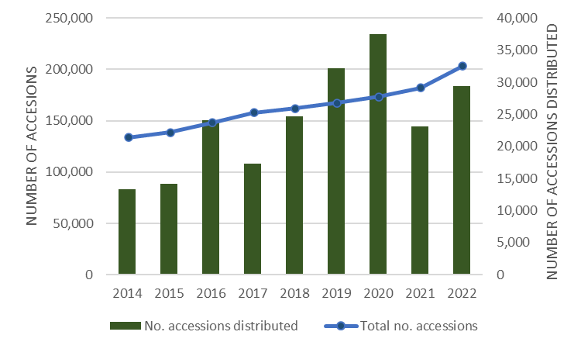
Importance of the genebank
As Australia has few indigenous plant species related to its primary grain crops, it is reliant on plant genetic resources imported and warehoused through the AGG to underpin the development of improved grain crop varieties.
The reliance of the Australian grains industry on the AGG has steadily increased over the years as researcher and breeders seek to overcome current and future production constraints.
Contacts for further information
Dr Sally Norton, AGG Manager, Curator
Phone: 03 5450 8301
Email: sally.norton@agriculture.vic.gov.au
A/Prof Matt Hayden
AGG Strategic Partnership Director
Phone: 03 9032 7084
Email: matthew.hayden@agriculture.vic.gov.au
AGG website
https://agriculture.vic.gov.au/crops-and-horticulture/the-australian-grains-genebank

Our priorities on a page
1  Genetically characterise plant genetic resources | 2  Digital and genomic innovation | 3  International genebank  community engagement | 4  Community of Practise for each major crop | 5  Investment in infrastructure and intellectual capacity
Goal  To use DNA genotyping to characterise plant genetic resources warehoused within the AGG | Goal  To establish web-based data visualisation and analysis tools to make crop biodiversity within the AGG highly accessibility to researchers and breeders. | Goal  To participate in international initiatives to advance best practise genebank management and contribute to data resource and platform establishment. | Goal  To drive a high level of awareness for the importance of plant genetic resource conservation and their role in sustaining national productivity targets into the future. | Goal  To attract infrastructure funding and develop intellectual capacity to future proof the AGG as a key national innovation asset for global food security and climate change adaptation.
Priorities  Understand within-collection diversity and relate the collection diversity to other international genebanks for grain crops.  Increase curation accuracy.  Improve operational efficiencies.  Establish core diversity sets for each crop focused on meeting current and future production constraints and the impacts of climate change. | Priorities  Link plant genetic resources across international genebanks and to research and breeding knowledge through genotypes.  Enable users of plant genetic resources to make informed selections meeting their research and breeding objectives.  Enable molecular passport data for plant genetic resources to be visualised in a biologically informed context that integrates publicly available breeding and research knowledge. | Priorities  Strengthen genebank management and operations through implementation of advances in best practise standards.  Collectively advance capabilities in genebank data management, data resources and data infrastructure.  Establish interoperable data platforms for efficient coordination of data collection, storage and exchange across genebanks so that valuable alleles and genes can be readily identified and deployed in research and breeding. | Priorities  Align AGG operations towards more targeted use of plant genetic resources.  Stronger integration and two-way flow of information between the AGG and users of its plant genetic resources.  Ensure the Australian grains industry has the valuable genetic variation it needs to meet production challenges.  Co-ordinate to collectively characterise plant genetic resources to ensure their genetic and economic potential can be fully realised. | Priorities  Increase infrastructure capacity to meet industry needs to 2050 and beyond.  Consolidate operations at the location of the AGG to drive scale-based efficiency gains.  Develop intellectual capacity through higher degree research training to sustain the AGG as a bio-digital resource centre into the future.

Outcomes  - Australian grains industry has facilitated and informed access to the plant genetic resources it needs to sustain national productivity and resilience targets into the future. | - AGG operates more efficiently and sustainably without compromising its ability to meet its national and international obligations. | Australian Grains Genebank  Strategic Business Partnership

