Report marine pests

Marine pests can attach themselves to pontoons and arriving vessels which is why we need your help to look for them.

Protect our marine environment. Look out for marine pests on:

• vessels

• submerged structures

• pontoons and equipment.
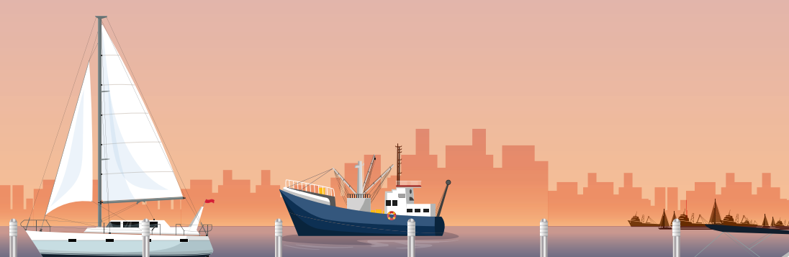

If you see something unusual, report it.
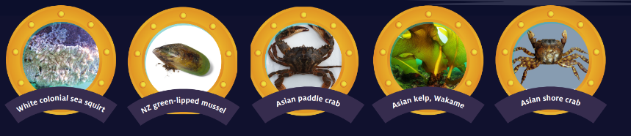

Go to vic.gov.au/marine-pests to learn more.

