Report marine pests

Help protect our marine environment, biodiversity, and infrastructure when you are diving.

Look out for and report marine pests found on:

vessels & marine equipment

submerged structures

natural marine habitats

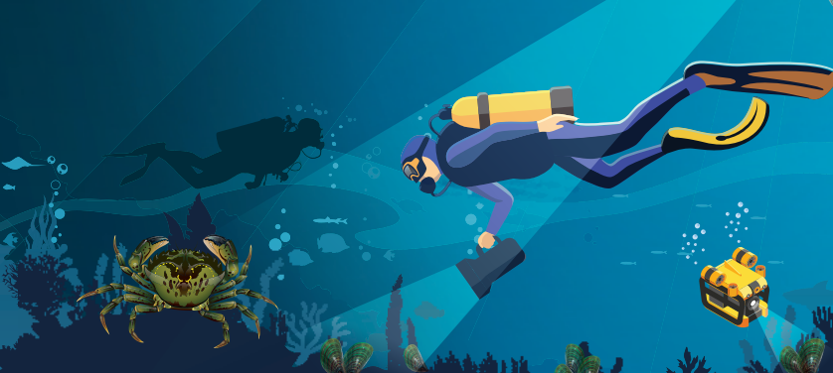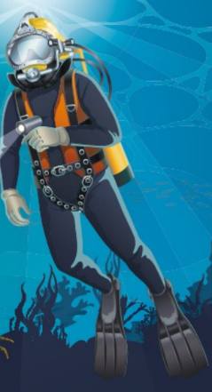

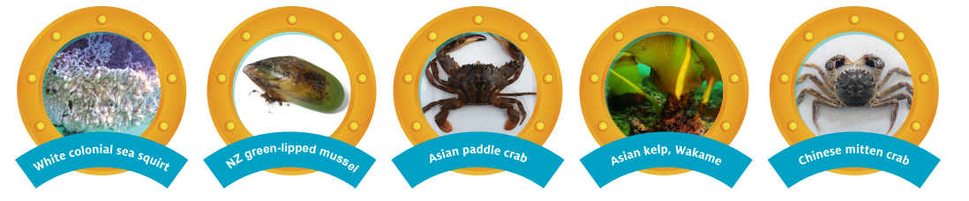

Go to vic.gov.au/marine-pests to learn more.

