


Continuation of the Victorian Strawberry Industry Development Order 2014
Agriculture Victoria Report
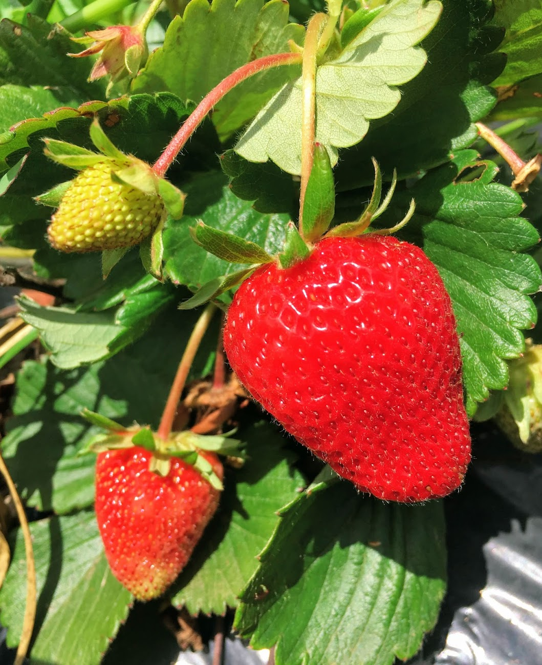


Contents
1. The term of the Victorian Strawberry Industry Development Order is coming to an end 2
1.1. Industry Development Committees 3
1.2. Victorian Strawberry Indsutry Development Committee 3
2. Features of the proposed Order 4
2.1. General clauses 4
2.2. IDC membership 4
2.3. IDC functions 4
2.4. Collection of grower charge 5
2.5. Eligibiltiy to vote and voting 5
3. Amendments being made to the Order 6
4. Proposed Projects for 2026-27 6
5. Next Steps 7
5.1. Industry consultation 7
5.2. Poll on continuing the Order 7
6. Further Information 7
7. Appendices 8

The term of the Victorian Strawberry Industry Development Order is coming to an end
This report is intended to help eligible Victorian strawberry growers decide whether to support the proposal to continue the Victorian Strawberry Industry Development Order 2014 (the Order). It also provides information for affected people who would like to make a submission on the Order, although are ineligible to vote in the producer poll.
The Order will expire on 30 June 2026. To enable the Victorian Strawberry Industry Development Committee (IDC) to continue providing services to growers, the Victorian Strawberry Growers’ Association has petitioned the Victorian Minister for Agriculture to hold a producer poll on the question of whether to continue the Order.
The Minister for Agriculture has directed that a poll of strawberry growers be undertaken by the Victorian Electoral Commission through a postal ballot from 27 January 2026 to 24 February 2026.
A copy of this report has been distributed to all eligible strawberry growers and to runner producers that collect and forward the grower charge to the IDC.
Victorian strawberry growers who are eligible to vote on the Order include:
- a person by whom, or on whose behalf, strawberries are commercially grown or produced in Victoria;
- a person who purchases strawberry runners for resale to commercial strawberry producers or to the public in Victoria; and
- a sole proprietor, partnership, trust, corporation, under a share-farming agreement or any other legal structure where strawberries are commercially grown or produced in Victoria;
The following people are not eligible to vote on the Order:
- a person engaged by an eligible grower as an employee on wages, a salary or piece work rates; or
- strawberry runner growers.
The Victorian Minister for Agriculture may, if satisfied there is majority support for the Order following the poll of strawberry producers and considering written submissions, continue the Order.
If the Order is continued, the IDC will continue to provide research, marketing and biosecurity services over a new four-year term from 1 July 2026 to 30 June 2030. The IDC will fund these services through the collection of charges from eligible growers at the current rate of $12.00 per 1,000 strawberry runners, with the option to increase this up to $14.00 per 1,000 strawberry runners. The charge cannot be increased unless approved by the majority of growers attending an annual general meeting of the IDC.
Eligible and ineligible persons are encouraged to make written submissions in relation to the continuation of this Order by 5pm Thursday 24 February 2026.
Written submissions can be provided by email to:
Daniel Mansell, Senior Policy Analyst
daniel.mansell@agriculture.vic.gov.au

Industry Development Committees
Industry Development Committees (IDCs) are established by Ministerial Order under the Agricultural Industry Development Act 1990 (the Act). IDCs are industry-led bodies with functions that can include marketing or research related to agricultural commodities and the establishment and management of funds for pest and disease control measures. In some instances, IDCs perform their functions and exercise their powers with respect to agricultural commodities across state and territory borders. IDCs have the authority to collect a charge from relevant producers of specific commodities within a defined area, to fund the provision of services to those producers.
Industry Development Orders last for a maximum period of four years, at which time they can be continued or remade at industry’s request. Industry Development Orders prescribe the various functions, powers and obligations of each IDC, including defining the producers who pay charges to fund IDC activities, and how these charges are collected.
Each Industry Development Order includes the provisions for growers to request that they be exempted from paying the charge for a particular year.
There are currently two IDCs operating in Victoria:
- the Victorian Strawberry IDC, and
- the Murray Valley Wine Grape IDC.

Victorian Strawberry Industry Development Committee
The current Victorian Strawberry IDC is established under the Victorian Strawberry Industry Development Order 2014. This Order was continued following a producer poll in 2018 and 2022. The term of the current Order will expire on 30 June 2026.
The IDC, in consultation with regional industry organisations, develops and/or commissions projects that are designed to provide targeted services (mainly marketing, research, development and extension services) to all Victorian strawberry growers.
Under the current Order, strawberry growers can be charged between $12.00 and $14.00 per 1,000 strawberry runners purchased. The current charge is $12.00 per 1,000 runners. Strawberry runner producers collect this charge and pass the funds on to the IDC.
The IDC may receive applications for project funding or may approach other bodies, including government departments and universities to undertake projects to benefit the Victorian strawberry industry. Projects submitted to the IDC must align with the functions outlined in the Order. All projects recommended by the IDC must be submitted to growers for approval.

Features of the proposed Order

General clauses
- The Order will establish an Industry Development Committee known as the Victorian Strawberry Industry Development Committee.
- The Order will have a planned start date of 1 July 2026.
- An Order created under the Act lasts for a maximum term of four years.

IDC membership
The IDC currently consists of a total of 6 voting members nominated by the Victorian Strawberry Growers Association (VSGA) and a Victorian government observer. The 6 voting members comprise:
- 4 grower members
- 2 non-grower members who possess specialist expertise appropriate to the needs of the Strawberry industry in the fields of promotion, marketing, industry development or business administration.
The IDC elects a chairperson from their membership, who will sit as chairperson of the IDC for a period of 12 months at a time.

IDC functions
The functions of the IDC established by the Order are to oversee the collection of the Producer Charge and the provision of the following services:
- promotion of Strawberries grown in Victoria
- research and development into the production, pest and disease control, post-harvest handling, plant breeding and variety evaluation of Strawberries, and related extension activities; and
- pest and disease control measures for the protection of Strawberries in Victoria.

Collection of grower charge
A charge for services provided by the IDC will be collected by strawberry runner sellers on behalf of strawberry growers intending to plant strawberries in Victoria. The new Order will:
- initially set the grower charge at $12 per 1,000 strawberry runners purchased for planting in Victoria
- provide the option for increasing the grower charge to a maximum of $14 per 1,000 strawberry runners purchased. This may only occur where the majority of strawberry growers vote for the increase at an annual general meeting
- require collection of the grower charge at the point and time of sale of strawberry runners
- be collected by strawberry runner sellers by arrangement with and on behalf of the IDC.
All growers affected by the Order will be required to pay the charge. However, a grower can apply for an exemption or a refund of the charges paid if the IDC is satisfied that the grower would not (or did not) benefit from some or all of the services provided in that financial year.

Eligibiltiy to vote and voting
The following strawberry growers are eligible to vote for continuing the Order, as well as decide on projects that the IDC will deliver:
- a person by whom, or on whose behalf, strawberries are commercially grown or produced in Victoria
- a person who purchases strawberry runners for resale to commercial strawberry producers or to the public in Victoria; and
- a sole proprietor, partnership, trust, corporation, under a share-farming agreement or any other legal structure where strawberries are commercially grown or produced in Victoria.
The following people are not eligible to vote:
- a person engaged by an eligible grower as an employee on wages, a salary or piece work rates; or
- strawberry runner growers.
Voting at a poll shall be on the basis of one vote for one of the following:
- Individual strawberry grower
- Company
- Partnership; or
- Share-farming agreement.
A provisional roll of strawberry growers who are eligible to vote in the poll has been prepared. It is the responsibility of each strawberry grower to ensure that he or she is correctly listed on the roll.
If you wish to check your enrolment details, please contact the VEC by 5 pm 17 February 2026 at:
Election Manager
Victorian Electoral Commission
Ph: (03) 9061 0214
Email: anju.mehta@vec.vic.gov.au

Amendments being made to the Order
Following the poll and subject to approval by the Minister for Agriculture, the following minor amendments are intended to be made to the Order.
- The current membership for the IDC requires 4 grower members. Due to the difficulties in filling these roles, the Victorian Strawberry Growers Association has requested that this number be changed to a range of 3–5 grower members.
- Formalise governance arrangements for the employment of a staff member funded by Berries Australia.
- Administrative changes to Department name, VSGA office location and general formatting.

Proposed Projects for 2026-27
The Victorian Strawberry Industry Development Committee will seek submissions for new projects between February and May 2026, with an industry vote on the projects to follow soon after. This will allow for cancellation of projects, should strawberry industry members not support the continuation of the Order at the poll.

Next Steps

Industry consultation
This report is being provided to runner growers and all eligible strawberry growers. Any person wishing to provide a written submission on the Order is encouraged to write to:
Daniel Mansell by email: daniel.mansell@agriculture.vic.gov.au
Written submissions must be received by 5 pm Thursday 24 February 2026.

Poll on continuing the Order
The Victorian Minister for Agriculture has directed that a poll on continuation of the Order be held. This poll will be undertaken by the Victorian Electoral Commission by a postal ballot of all eligible growers.
The proposal to be put to Victoria strawberry growers will be:
“Do you agree to the continuation of the Victorian Strawberry Industry Development Order 2014?”
Growers will be required to vote YES or NO.
The poll will commence on 27 January 2026 and be finalised by 24 February 2026.
Voting by strawberry growers registered on the grower roll is compulsory (see section 2.5 eligibility to vote). The result of the poll will be determined by the valid votes counted, either for or against the proposal.
The Victorian Minister for Agriculture will consider the poll result and any submissions on the Order

Further Information
For further information, please contact:
Amanda Ellery
Manager, Agriculture Industry Development
Agriculture Victoria
T: 0417 943 844
E: amanda.ellery@agriculture.vic.gov.au

Appendices
Appendix 1 Draft Victorian Strawberry Industry Development Order 2014

VICTORIAN STRAWBERRY INDUSTRY DEVELOPMENT ORDER 2014
Citation
- This Order may be cited as the Victorian Strawberry Industry Development Order 2014.
Order made under the Agricultural Industry Development Act 1990
- This Order is made under Part 2 of the Agricultural Industry Development Act 1990.
Purpose of Order
- The purpose of this Order is to establish a Committee, to be known as the Victorian Strawberry Industry Development Committee, to collect and administer charges applied to strawberry producers in Victoria in return for the provision of specified research, promotion, biosecurity and extension services.
Definitions
- In this Order:
‘Act’ means the Agricultural Industry Development Act 1990;
‘Application’ has the meaning given in Clause 19;
‘Charge’ has the meaning given in Clause 14;
‘Committee’ means the Victorian Strawberry Industry Development Committee established by this Order;
‘Exemption’ has the meaning given in Clause 18;
‘Financial Year’ means the period from 1 July to 30 June of the following calendar year;
‘Minister’ means the Minister administering the Act;
‘Producer’ means:
(a) a person by whom, or on whose behalf, Strawberries are commercially grown or produced in the Production Area;
(b) a person who purchases Strawberry Runners for resale to commercial Producers or to the public in the Production Area; and
(c) a sole proprietor, partnership, trust, corporation, under a share-farming agreement or any other legal structure where Strawberries are commercially grown or produced in the Production Area;
but does not include:
(d) a person engaged by a Producer as an employee on wages, a salary or piece work rates; or
(e) Strawberry Runner Growers;
‘Production Area’ means the State of Victoria;
‘Runners’ means Strawberry rootlings or propagules that are produced for sale to Producers;
‘Services’ has the meaning given in clause 10;
‘Strawberry’ and ‘Strawberries’ means any variety of strawberry grown or produced for sale for fresh consumption or processing;
‘Strawberry Runner Growers’ means all Strawberry runner growers producing and supplying (other than by way of re-sale) Strawberry Runners used by Producers for the purpose of producing fresh, frozen, and processed Strawberries; and
‘Victorian Strawberry Growers Association’ means the Victorian Strawberry Growers Association Incorporated (ABN 37 429 179 625), Emerald, Victoria, or any other relevant body that, in the opinion of the Minister, has replaced that body.
Term of the Order
- This Order commenced on 1 December 2014 and continues in force until 30 June 2026.

Establishment of a Committee
- There shall be a Committee to be known as the Victorian Strawberry Industry Development Committee.
Members
- The Committee consists of seven members appointed by the Minister being:
    - four voting Producer members nominated by the Victorian Strawberry Growers Association; and
    - two voting non-Producer members nominated by the Victorian Strawberry Growers Association who possess specialist expertise appropriate to the needs of the Strawberry industry in the fields of promotion, marketing, industry development or business administration; and
    - one non-voting member nominated by the Secretary of the Department of Jobs, Precincts and Regions to attend and observe meetings of the Committee and act as the first point of contact between the Committee and the Victorian Government.
Chairperson
- The members of the Committee must elect one member of the Committee to be Chairperson of the Committee for a period of 12 months.
- The Chairperson must not be an office bearer of the Victorian Strawberry Growers Association.
Services
- The Committee’s functions include overseeing the collection and judicious management of the Charge, and the provision of the following services:
  - promotion of Strawberries grown in the Production Area;
  - research and development into the production, pest and disease control, post-harvest handling, plant breeding and variety evaluation of Strawberries, and related extension activities; and
  - pest and disease control measures for the protection of Strawberries in the Production Area.
Powers of Committee
- The Committee may:
- impose a Charge on all Producers for Services it provides;
- delegate any of its powers, duties or functions (other than the power of delegation) to an employee of the Committee; and
- exempt by written notice, either conditionally or unconditionally, a person or class of persons from compliance with some or all of the requirements of this Order.
Plan of Operations
- The Committee must, within 12 months of the Commencement Date, submit to the Minister a plan of its intended operations during the Term of the Order and update that plan with each annual report it submits to the Minister to cover the remainder of the Term of the Order.
- The plan of operations must be developed in consultation with all Producers, and copies made available to all Producers.
Charge Imposed by Committee
- A Charge for Services provided by the Committee is:
- payable by Producers at the point and time of purchase or supply of Strawberry Runners; and
- to be collected by Strawberry Runner Growers, or their agents, by arrangement with and on behalf of the Committee.
- The first Charge imposed by the Committee shall be at the uniform rate of $12.00 per 1000 Strawberry Runners and will remain in force until 30 April 2015.
- A Charge imposed by the Committee must not at any time during the Term of the Order exceed the rate of $14.00 per 1,000 Runners.
- Any Charges collected by a Strawberry Runner Grower under clause 14 must be paid by that Strawberry Runner Grower to the Committee prior to:
- 30 April each year for Charges collected between 1 September of the previous year and 31 March of the current year; and
- 30 September each year for Charges collected between 1 April and 31 August in that year.
Exemption
18. The Committee may exempt a Producer from liability to pay the Charge for Services (or part thereof) in a particular Financial Year, if the Committee is satisfied that the Producer will not (or did not) benefit from some or all of the Services provided in that Financial Year (Exemption).
19. (1) A Producer may apply for an Exemption by notice in writing to the Committee (Application).
(2) Subject to Clause 19(3), an Application must be made at least four weeks before the start of each Financial Year during the Term of the Order.
(3) The Committee may extend the time for the making of an Application if, before the end of the Financial Year, a Producer advises the Committee that the Producer wishes to make an Application in respect of that Financial Year.
20. An Application must set out information in support of a Producer’s claim that the Producer will not (or did not) benefit from the Services provided in the relevant Financial Year. The Committee may at any time before determining the Application request further information or evidence from the Producer.
      - The Committee must notify the Producer in writing of the Committee’s decision whether or not to grant the Exemption for that Financial Year.
      - Prior to the determination of an Application, the Producer must pay the Charges for the Financial Year to which the Application relates from time to time as they become payable under Clause 14.
      - If an Exemption is granted under Clause 18 after any or all of the Charges for the Financial Year have been paid by or on behalf of the Producer, then unless otherwise agreed to by the Producer the Committee must refund such Charges within ten business days of receiving written notice from the Producer enclosing evidence of the amount of the refund claimed.
Voting
      - For the purposes of voting on projects in accordance with section 39A and Division 3 of Part 3 of the Act, Producers shall be allocated votes as follows:
Total number of Runners purchased by Producer in previous Financial Year | Number of votes
Less than 20,000 | 1
20,000 - 74,999 | 2
75,000 - 149,999 | 3
150,000 - 449,999 | 4
450,000 - 749,999 | 5
750,000 - 999,999 | 6
1,000,000 and above | 7

Meetings
      - The Committee must hold an Annual General Meeting in each financial year.
      - At the Annual General Meeting, the Chairperson of the Committee must report to Producers on the operation and finances of the Committee during the previous 12 months.
      - The timing of all meetings of the Committee, including the Annual General Meeting, is at the discretion of the Committee.
Penalty for Contravening the Order
      - A person who fails to comply with any provision of this Order is liable to a penalty not exceeding 20 penalty units.

