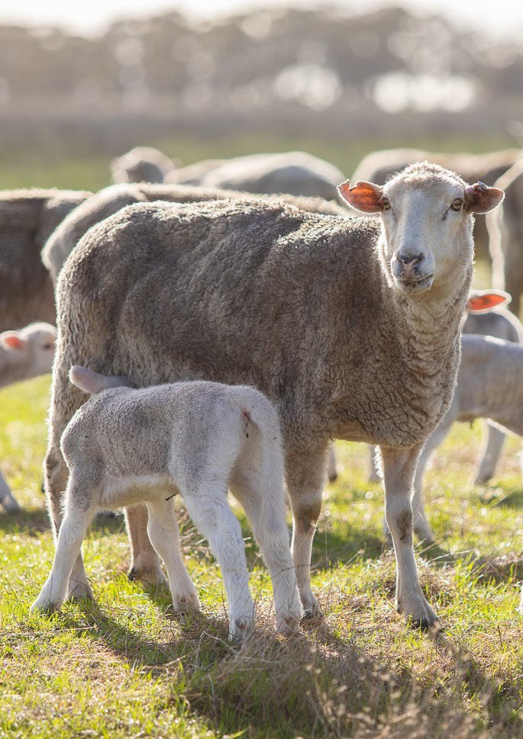
Livestock Farm Monitor Project
Victoria | Annual Report 2025–26

Further information regarding the Livestock Farm Monitor Project may be obtained from:

Sam Henty Agriculture Victoria

195-229 Lyttleton Terrace, Bendigo, Victoria, 3550

sam.henty@agriculture.vic.gov.au

Authorised and published by the Victorian Government, Department of Energy, Environment and Climate Action (DEECA) 2026. © The State of Victoria Department of Energy, Environment and Climate Action 2026.

This publication is copyright. No part may be reproduced by any process except in accordance with the provisions of the Copyright Act 1968.

For more information contact the Agriculture Victoria Customer Service Centre on 136 186.

Creative Commons

This work is licensed under a Creative Commons Attribution 4.0 International licence, visit the Creative Commons website (http://creativecommons.org/licenses/by/4.0/).

You are free to re-use the work under that licence, on the condition that you credit the State of Victoria as author. The licence does not apply to any images, photographs or branding, including the Victorian Coat of Arms, and the Victorian Government and Department logos.

ISSN 1835-9922

Disclaimer

This publication may be of assistance to you, but the State of Victoria and its employees do not guarantee that the publication is without flaw of any kind or is wholly appropriate for your particular purposes and therefore disclaims all liability for any error, loss or other consequence which may arise from you relying on any information in this publication.
Accessibility

If you would like to receive this publication in an accessible format, such as large print or audio, please telephone 136 186.

Deaf, hearing impaired or speech impaired? Call us via the National Relay Service on 133 677 or visit www.relayservice.com.au

This document is also available on the Agriculture Victoria website.

Contents
State summary 3
Key points 3
Business profit 4
Business returns 5
Average performance measures 5
Income 6
Costs 6
Costs by farm size 6
Return on assets by farm size 7
Debt 8
Debt servicing 8
The effect of increasing interest cost on cash flow 9
Gippsland 10
Gross margins 10
Costs 10
Price received 11
Capital structure 12
Return on assets and equity 12
Gippsland regional summary 13
Northern Victoria 14
Gross margins 14
Costs 14
Price received 15
Capital structure 16
Return on assets and equity 16
Northern Victoria regional summary 17
South west Victoria 18
Gross margins 18
Costs 18
Price received 19
Capital structure 20
Return on assets and equity 20
South west Victoria regional summary 21
Appendices 22
Glossary 84
List of abbreviations 87
References 87

Livestock Farm Monitor Project Site Rainfall Deciles: 1 July 2025 – 30 June 2026
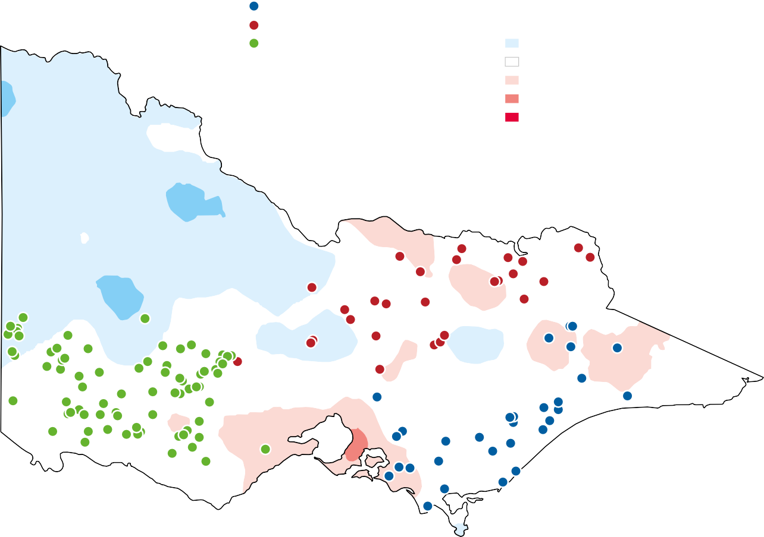
Gippsland
Northern Victoria South West Victoria
Highest on record
Very much above average Above average
Average Below average
Very much below average
Lowest on record

In 2025-26, the Livestock Farm Monitor Project (LFMP) provided 133 Victorian sheep, beef and stock cropping farmers with detailed financial and production performance information. Of the
133 farms that participated, 122 are continuing farms from 2024-25 and 11 farms are new to the project.
Agriculture Victoria collated the individual business performance information of all surveyed farms to provide insights in this report.
The LFMP is Agriculture Victoria’s primary source of farm-level information for sheep and beef production practices, resource use, and economic data.
The results of this annual survey provide farm-level data to inform Agriculture Victoria’s decisions that impact at a farm level, and to inform the direction of future policy design, research themes and service delivery programs.
Farmers who participate in the project increase their understanding of their farm business, supporting more informed business planning and improve their ability to adapt to change.
Results published in this report are not statistically representative of any industry or region.
Agriculture Victoria staff are grateful for the cooperation of the farmers who contributed their data to this project.
This project has been running continuously since 1971 and is funded by Agriculture Victoria.

State summary

Key points
- A strong turnaround in farm profits in 2025-26, with 88% of surveyed farms recording a positive profit. All regions recorded large increases in average farm profit after three years of decline.
- Farm incomes reached historically high levels, supported by record lamb prices and strong cattle, wool and mutton prices.
- Improved seasonal conditions boosted pasture growth, reducing drought-related pressures
in most regions, allowing farms to rebuild feed reserves, increase stocking rates in some areas, and reduce reliance on purchased supplementary feed.

- Reduced reliance on purchased feed helped reduce feeding costs in northern and south west Victoria, while Gippsland farms spent more on purchased feed and pasture inputs.
- Average farm debt remained high, although increased cash flows allowed many farms to reduce debt during the year.

10-yr average 2025–26 10-yr average 2025–26

Financial parameter bars
Gross farm income ($/ha)

$1,405 |  | $1,698
 | $1,060 | $1,248
$1,419 |  | $1,639
Variable costs ($/ha)

$568 | $822
$410 | $487
$591 | $648
Overhead costs ($/ha)

$648 | $709
$466 | $499
$406 | $397
Earnings before Interest and Tax (EBIT) ($/ha)
Physical parameter bars
Effective area (ha)

 |  | 723ha | 676ha
 | 801ha |  | 760ha
1,358ha |  |  | 1,688ha
Stocking rate (DSE/ha)

17.1 DSE |  |  | 18.5 DSE
 |  | 11.5 DSE | 12.7 DSE
 | 15.4 DSE |  | 13.7 DSE
Sheep (head)

 |  | 1,896 |  | 1,084
 | 2,603 |  |  |  | 2,079
7,715 |  |  | 7,995
Cattle (head)

$189 | $168 |  |  |  |  |  | 568 | 596
$183 | $262 |  |  |  |  |  | 418 | 498
$422 | $594 |  |  |  |  |  | 307 | 328
Return on assets (%)
1.1% | 1.0%
1.4% | 1.0%
3.2% | 3.2%
Return on equity (%)

Gippsland Northern Victoria South West Victoria
0.5% |  |  | 0.2%
1.2% |  |  | 1.5%
3.1% |  |  | 3.1%

Business profit
Statewide average farm profit (earnings before interest and tax) rebounded from three consecutive years of decline. Most (88%) surveyed businesses recorded positive farm profits in 2025-26 helping all regions recorded substantial year-on-year increases in average farm profit from the lows of 2024-25. (Figure 1).
Profitability improved across all regions in 2025-26, but the influences differed: South west Victoria benefited from improved seasonal conditions,

lower supplementary feeding costs and strong sheep prices; Northern Victoria experienced a dry spring 2025 and high feed costs despite stronger livestock and wool prices; while Gippsland balanced higher fertiliser and supplementary feeding costs with improved late-season pasture growth, higher stocking rates and strong cattle prices.
Average farm profits in the south west and Northern Victoria increased to be higher than the respective regional 10-year average.

Gippsland Northern Victoria South West Victoria
Earnings before interest and tax ($/ha real)

$700
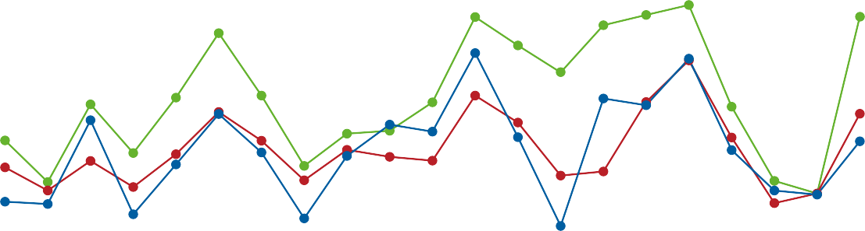  $600 | $594
$500
$400
$300 | $262
$200 | $168
$100
$0
-$100
-$200

Figure 1. Regional average earnings before interest and tax (EBIT) over time (2005-06 to 2025-26) ($/ha real).
2005–06
2006–07
2007–08
2008–09
2009–10
2010–11
2011–12
2012–13
2013–14
2014–15
2015–16
2016–17
2017–18
2018–19
2019–20
2020–21
2021–22
2022–23
2023–24
2024–25
2025–26

Business returns
Statewide average farm returns also had a large increase in 2025-26. Surveyed farms in south west Victoria recorded the highest average return on assets and equity for the state. However, considerable variation remained within regions, with participant farms reporting both strong positive and
negative returns.
Despite the significant improvement in average farm profit, return on assets across all regions remained at or below the 10-year averages. Strong growth in

farmland values over the past decade has increased the asset base faster than profits have grown, constraining return on assets even as farm business net worth has risen through capital appreciation.
The rise in farmland values eased across the state in 2025-26 and in some regions, particularly the south west, farmland values decreased. Decreased capital growth and higher profits resulted in the jump in average return and assets in 2025-26.

8.0%
7.0%
6.0%
5.0%
Return on assets
4.0%
3.0%
2.0%
1.0%
0.0%
-1.0%
-2.0%
-3.0%
2005–06
2006–07
2007–08
2008–09
2009–10
2010–11
2011–12
2012–13
2022–23
2023–24
2024–25
2025–26
Gippsland Northern Victoria
South West Victoria

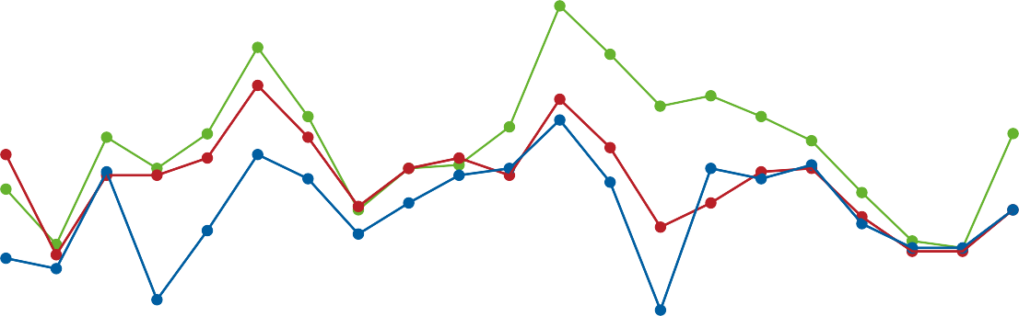
3.2%

1.0%
1.0%

Figure 2. 2025-26 regional return on assets (RoA) over time (2005-06 to 2025-26).
2013–14
2014–15
2015–16
2016–17
2017–18
2018–19
2019–20
2020–21
2021–22

Average performance measures
When the dataset was separated into farm business types (see glossary for definitions), all business types had positive average profits and returns with stock and grain businesses recording the highest average income, profit and returns (Table 1). Specialist beef businesses had the highest average operating (variable plus overhead) costs per hectare and specialist sheep businesses the lowest. Businesses specialising in beef had the lowest average return on assets in 2025-26.

Table 1. Average performance measures for each business type for the 2025-26 LFMP dataset

Business type | Gross Farm Income | Total Variable costs | Total Overhead costs | Earnings before Interest and Tax | Return on Assets | Return on Equity
 | $/ha | $/ha | $/ha | $/ha | % | %
Sheep and beef | 1,604 | 744 | 518 | 343 | 1.7% | 1.6%
Specialist sheep | 1,481 | 595 | 391 | 495 | 2.9% | 2.7%
Specialist beef | 1,593 | 637 | 650 | 306 | 1.4% | 1.4%
Stock and grain | 1,696 | 618 | 392 | 686 | 3.2% | 3.1%

Income
The highest lamb prices received by participants in 56 years combined with strong prices for mutton, wool, beef resulted in gross farm incomes across the state increasing to historically high levels in 2025-26. Increased quantity and value of stock and feed on hand also helped boost farm incomes in 2025-26s.
Average gross farm income was well above the
10-year average in each region with northern Victoria and Gippsland recording the second highest and highest average gross farm income since 2004-05 respectively. South west Victorian farms recorded
the second highest average gross farm income since 1970-71.
Small and large farms derive their income from different enterprise mixes. On the smallest farms, beef cattle sales contributed an average
of 61% of total cash income. In contrast, cattle sales accounted for only 20% of total cash income on the largest farms (Appendix A3). Sheep and wool sales were the dominant income source on larger farms, making up an average of 65% of total cash income, compared with 31% on the smallest farms.

Costs
For most participant farms, annual rainfall was close to long-term average (Appendix B2, C2 and D2).
Improved pasture growing conditions, particularly in the southern regions, enabled greater quantities of homegrown fodder to be conserved. This meant depleted feed reserves were replenished across the state, with average feed inventories increasing in each region.
In northern and south west Victoria, reduced reliance on purchased supplementary feed lowered variable costs, although this was partially offset by higher pasture costs.
Average variable costs increased in Gippsland. Late spring 2025 pasture growth led to higher expenditure on purchased supplementary feed and higher fertiliser costs.

Costs by farm size
When specialist beef and specialist sheep businesses were separated by farm size based on total effective area (ha), there were significant differences in the overhead costs among each of the size group, but less differences for variable costs (Figure 3). Labour was the main contributor to this result. Smaller farms use more labour, particularly owner operator labour per hectare than larger farms. Farms smaller than 400 ha rely heavily on owner operator labour (specialist sheep: 73% of all labour, specialist beef: 79% of labour). This result highlights that larger farms can reduce their total costs through scale by spreading overhead costs, particularly labour over more area and output.

$1,800
Variable costs ($/ha) Overhead costs ($/ha)

$1,600
less than 400 – 900 900 – 1,400 greater than less than
400 ha ha 400 ha
400 – 900
ha
900 – 1,400 greater than
ha
1,400 ha
ha
1,400 ha
$379
$344

$451
$627
$535
$594

$683

$368

$425

$330

$869
$319

$444

$584

$654

$798
$1,400
$1,200
$1,000
Costs ($/ha)
$800
$600
$400
$200
$0

Specialist beef Specialist sheep
Farm size and business type
Figure 3. 2025-26 variable and overhead costs ($/ha) for livestock businesses separated by farm size (defined by total effective area).

Return on assets by farm size
When the LFMP dataset was separated by business size (based on cash income), larger farms had higher average RoA than smaller farms (Figure 4). The smallest surveyed farms, farms with cash income less than
$620,000, had the lowest average RoA.
When profitable, larger farms are more likely to generate higher total profits than smaller farms. This means that those larger farms have a greater capacity to invest in productivity-enhancing assets and technologies.
Figure 4 also shows that high and low individual returns were recorded in all farm size groups.

12.5%
10.0%
7.5%
5.0%
Return on Assets
2.5%

2.3% 2.7%

3.7%
Bar = average

0.0%
-2.5%
-5.0%
-7.5%
-10.0%
-12.5%
0.2%

Smallest 25% Lower mid 25% Upper mid 25% Largest 25%
Farm size

Figure 4. 2025–26 return on assets separated by farm size (defined by total cash income).

Debt
The average level of debt held by farms in 2025-26 across the state was $2,707 per hectare, a slight increase from 2024-25 but significantly higher than the 10-year average (Figure 5).
Debt was part of the business structures of 86% of surveyed farms. Increased cashflows in 2025-26 allowed 45% of surveyed farms to reduce the amount of debt owing. However, 29% of farms increased their debt over the 12 months. This was mostly for capital improvements as managers chose to invest in land, plant and equipment, new fences and other on-farm improvements.

$3,000

$2,707

$2,500
Statewide average farm debt ($/ha real)

$2,000

$1,500

$1,000

$500

$0
2015–16 2016–17 2017–18 2018–19 2019–20 2020–21 2021–22 2022–23 2023–24 2024–25 2025–26
Figure 5. Statewide average debt ($/ha real) over time (2015-16 to 2025-26).

Debt servicing
Higher debt levels and rising interest rates, increased interest costs for LFMP farms in 2025-26. Farms with higher amounts of total debt owing were more likely to spend a large proportion of farm cash income on interest costs (interest cost ratio).
Interest costs accounted for an average of 18 cents of every dollar (18%) of cash income on farms with debt levels above $4.3 million (Figure 6). By comparison, interest costs accounted for one cent of every dollar of cash income on farms with less than $100,000
of debt.

These results highlight that the use of debt increases the obligatory costs of farm businesses as interest (and principal) must be paid in good and poor years. Consequently, farm management strategies employed throughout the year will be influenced by not only seasonal conditions and market prices, but also the level of debt held by the farm business.

18%
11%
7%
1%
less than $100k $100k – $1.4m $1.4m – $4.3m greater than $4.3m
Farm debt owing
Figure 6. The average proportion of farm cash income spent on interest payments in 2025-26 separated by categories of the amount of debt owing (below $100k, $100k - $1.4m, $1.4m-4.3m, above $4.3m).

The effect of increasing interest cost on cash flow

Surveyed farms with a higher proportion of their income going to paying interest expenses, were also likely to have lower net cash flow.
Figure 7 shows the relationship between net cash flow and interest cost ratio during 2025-26. The likelihood of recording a negative cash flow increased as the interest cost ratio increased
Higher debt levels and associated interest costs can make farm businesses more vulnerable to negative cash flows and therefore more reliant on alternate sources of cash (overdraft, cash savings) to pay farm operating costs. However, the results also highlight that farms can have high interest cost ratios and positive cash flows.

$3,000
Less than 5%
5% – 10%
10% – 20%
Greater than 20%

$2,000
Net cash flow after interest ($/ha)

$1,000

$0

-$1,000

-$2,000

-$3,000
Interest cost ratio
Figure 7. 2025-26 net cash flow after interest ($/ha) for farms grouped by interest cost ratio.

Gippsland

Gross margins

35% ↑
5-yr average
72% ↑
5-yr average
4% ↑
5-yr average

Wool sheep | Prime lamb | Beef
2025-26 | 2025-26 | 2025-26
Gross margin ($/ha) | Gross margin ($/ha) | Gross margin ($/ha)
$529 | $1,285 | $728

$1400
Gross margin ($/ha real)
$1200
$1000
$800
$600
$400
$200
$0
2015–16
2016–17
2017–18
2018–19
2019–20
2020–21
2021–22
2022–23
2023–24
2024–25
2025–26
2015–16
2016–17
2017–18
2018–19
2019–20
2020–21
2021–22
2022–23
2023–24
2024–25
2025–26
2015–16
2016–17
2017–18
2018–19
2019–20
2020–21
2021–22
2022–23
2023–24
2024–25
2025–26

Wool sheep gross margin Prime lamb gross margin Beef gross margin
Figure 8. Gippsland average gross margin ($/ha real) for wool sheep, prime lamb and beef (2015-16 to 2025-26).

Gippsland beef gross margins increased to be just above (+4%) the 5-year average after three
consecutive years of decreases (Figure 8). Average prime lamb average gross margin increased in 2025-26 to the second highest recorded in the past ten years and 72% above the 5-year average. Wool sheep average gross margins increased from the lows of 2024-25 to be 35% above the 5-year average and 15% above the 10-year average in 2025-26. Prime lamb and wool sheep enterprises were less common than beef in Gippsland and
enterprise averages were more sensitive to skewing because of outliers.

Costs
2% ↑
5-yr average


Superphosphate 2025-26
price ($/t)
$695

113%
Long term average

Spring 2025 rainfall (mm)
248

$200
Pasture fertiliser cost ($/ha real)

$150

$179

$173
$146
$138
$126
$135
$124
$200

$150
$90
$84
$63
$34
$24
$31
Purchased feed cost ($/ha real)

$149

$100 $100

$50 $50

$0 $0
2019–20
2020–21
2021–22
2022–23
2023–24
2024–25
2025–26
2019–20
2020–21
2021–22
2022–23
2023–24
2024–25
2025–26

Figure 9. Gippsland farms average expenditure ($/ha real) on fertiliser applied to pasture (2019-20 to 2025-26).

Following a dry start to spring (in September-October), rainfall conditions improved significantly through late spring 2025 and into autumn 2026 and grazed pasture consumption increased to 5 tonnes of dry matter per hectare (+7% year-on-year).
All regions experienced higher fertiliser prices. However, additional freight costs meant Gippsland farmers paid more per tonne for delivered fertiliser than farmers in northern or south west Victoria.
Despite these higher prices, good rainfall late spring and autumn led many participant farms to continue apply fertiliser at relatively high rates. Phosphorus application rates declined year-on-year but remained above the 5-year average.
Figure 10. Gippsland farms average expenditure ($/ha real) on purchased supplementary feed (2019-20 to 2025-26).

The combination of high fertiliser prices and continued high application rates resulted in a 28% increase in pasture fertiliser expenditure in 2025-26 (Figure 9). Fertiliser applied to pasture was the largest cost item on Gippsland farms, accounting for an average of 16% of all cash operating costs.
Farmers responded to the dry start in spring 2025 by increasing supplementary feeding. Despite seasonal conditions then improving, this earlier need for supplementary feeding, combined with high market prices for supplements and increased stocking rates, contributed to a 77% increase in purchased supplementary feed costs in 2025-26 (Figure 10).

Price received

1% ↑
5-yr average
25% ↑
5-yr average
1% ↑
5-yr average

Beef | Lamb | Fine wool
2025-26 | 2025-26 | 2025-26
($/ kg LWT) | ($/ kg CWT) | ($/ kg greasy)
$4.60 | $11.20 | $13.60

10-year average
$1800
Gross farm income ($/ha real)
 |  | $1405
$1543 |  | $1170 |  | $1108 |  | $1494 |  | $1443 |  | $1659 |  | $1287 |  | $1408 |  | $1238 |  | $1698
2016–17 |  | 2017–18 |  | 2018–19 |  | 2019–20 |  | 2020–21 |  | 2021–22 |  | 2022–23 |  | 2023–24 |  | 2024–25 |  | 2025–26

$1500
$1200
$900
$600
$300
$0

Figure 11. Gippsland average gross farm income ($/ha real) and 10-year average gross farm income (line) (2015-16 to 2025-26).

Cattle sales made up 75% of average farm income (Appendix D5), making beef enterprises the dominant enterprise on Gippsland farms in 2025-26. Beef prices received increased (+25%) from 2024-25 to be close to (+1%) the 5-year average and above (+8%) the 10-year average price. Lamb prices received increased by 25% year-on-year to the highest prices recorded since 2009-10, when Gippsland prime lamb enterprises were first included in the Project.
Average wool price increased by 20% from 2024-25 but remained around the 5-year average and below the 10-year average. The strong price received across all types of enterprises coupled with increased
feed and livestock inventories meant gross farm income was well above the 10-year average
(Figure 11) and the highest recorded since 2004-05.

Capital structure
28% ↑
5-yr average
Farm debt 2025-26
($/ha)
$3,656

Gippsland farms managed the highest value of total assets per hectare of the LFMP regions, which increased to $26,701/ha and was above the 5-year average. The increase was a result of increased farmland and livestock values. Farm debt levels also increased in 2025-26 to be 28% above the 5-year average. One third (33%) of farms surveyed increased the amount of debt owing during the year while less farms had zero debt.

Return on assets and equity

Return on Assets Return on Equity

5%
4%
3%
2%
1%
0%
-1%
-2%
-3%
-4%
-5%

2016–17

2017–18

2018–19

2019–20

2020–21

2021–22

2022–23

2023–24

2024–25

2025–26

Figure 12. Gippsland return on assets and equity (2016-17 to 2025-26).

Positive return on assets were recorded by 80% of surveyed farms in Gippsland. High levels of debt and interest costs constrained the regions average return on equity with 63% of farms recording positive values. However, the overall better operating conditions meant for the first time in four years average return on assets and return on equity both returned to being positive for the region (Figure 12).

Gippsland regional summary
- Above average spring 2025 rainfall and improved pasture growth allowed farmers to increase stocking rates and feed inventories.
- Red meat and wool prices improved across
all enterprises, with lamb prices reaching their highest level since Gippsland prime lamb enterprises joined the project.
- Strong prices combined with increased livestock and feed inventories, which contributed to the highest gross farm income recorded since
2004-05.

- Gross margins improved across all enterprises, with beef returning to around the 5-year average and both prime lamb and wool sheep recording large year-on-year increases.
- Farm asset values continued to increase due to higher farmland and livestock values.
- Improved operating conditions resulted in 80% of Gippsland farms recording a positive return on assets.
- Despite being positive for the first time in 3 years, regional return on equity was constrained by increased interest costs from higher debt levels.

5-yr average
Enterprise income
Beef income ($/ha)
$1,279
$1,346
2025–26 5-yr average 2025–26
Phosphorus application
Phosphorus applied to pasture (kg/ha)
11kg
12kg

Prime Lamb income ($/ha) Phosphorus applied to pasture (kg/DSE)
$2,062
$1,346

Wool Sheep income ($/ha)

$756
$912

Variable costs
Beef variable costs ($/ha)
$579
$618

Prime Lamb variable costs ($/ha)
$599
$776

Wool Sheep variable costs ($/ha)

$363 $384

Production
Beef sold (kg lwt/ha)
345kg
306kg

Lamb sold (kg cwt/ha)

0.6kg
0.8kg

Business structure
Total assets managed ($/ha)

$23,421
$26,701
Total debt ($/ha)

$3,656
$2,784

Top 5 costs (Proportion of total cash operating costs)
Beef income ($/ha)

Pasture fertiliser costs (%) Livestock Selling costs (%) Wages for permanent staff (%)

9%
6%
5%
5%
16%
Purchased supplementary grain and pellets (%)
Animal Health (%)

133kg
159kg
Wool sheep wool cut (kg Gr./ha)
37kg
32kg

Labour
Labour use efficiency (ha/FTE)
311 ha
327 ha
Labour use efficiency (DSE/FTE)
4,891 DSE
4,918 DSE

Northern Victoria

Gross margins

43% ↑
5-yr average
20% ↑
5-yr average
4% ↑
5-yr average

Wool sheep | Prime lamb | Beef
2025-26 | 2025-26 | 2025-26
Gross margin ($/ha) | Gross margin ($/ha) | Gross margin ($/ha)
$663 | $597 | $622

$1200
$1000
Gross margin ($/ha real)
$800
$600
$400
$200
$0
2015–16
2016–17
2017–18
2018–19
2019–20
2020–21
2021–22
2022–23
2023–24
2024–25
2025–26
2015–16
2016–17
2017–18
2018–19
2019–20
2020–21
2021–22
2022–23
2023–24
2024–25
2025–26
2015–16
2016–17
2017–18
2018–19
2019–20
2020–21
2021–22
2022–23
2023–24
2024–25
2025–26

Wool sheep gross margin Prime lamb gross margin Beef gross margin
Figure 13. Northern average gross margin ($/ha real) for wool sheep, prime lamb and beef (2015-16 to 2025-26).

In 2025-26, prime lamb, wool sheep and beef gross margins all increased and were above their respective 5-year averages. Wool sheep gross margins increased by 221% year-on-year, to finish 40% above the 5-year average. For the first time since 2017-18 wool sheep gross margins ($/ha and
$/DSE) were higher than both prime lamb and beef enterprises (Figure 13).

Costs
3% ↑
5-yr average


Superphosphate 2025-26
price ($/t)
$626

73%
Long term average

Spring 2025 rainfall (mm)
139

$150
$150

$132
$120
$125
$57 $57
$44 $43

$120
Pasture fertiliser cost ($/ha real)

$90
$81
$71
$72
$77
$72 $73
$73

$60
$120

$90
Purchased feed cost ($/ha real)

$60

$30 $30

$0 $0
2019–20
2020–21
2021–22
2022–23
2023–24
2024–25
2025–26
2019–20
2020–21
2021–22
2022–23
2023–24
2024–25
2025–26

Figure 14. Northern farms average expenditure ($/ha real) on fertiliser applied to pasture (2019-20 to 2025-26).

Dry spring 2025 conditions and high fertiliser prices led to the third consecutive year of decreased application rates of pasture fertiliser in northern Victoria. Decreased application rates partially offset the increase in fertiliser prices, with expenditure on fertiliser almost the same as it was for the previous two years (Figure 14). With the lower spending on supplementary feed, fertiliser moved from the third largest cost item in 2024-25 to being the largest item in 2025-26, making up 10% of average farm cash operating costs.
Northern farms received below average spring 2025 rainfall (73%) and above average autumn 2026 rainfall (107%). Annual rainfall was close to the long-term average annual rainfall (98%) (Appendix
Figure 15. Northern farms average expenditure ($/ha real) on purchased supplementary feed (2019-20 to 2025-26).

D2). As a result of the drier spring 2025 conditions, average grazed pasture consumption reduced slightly to 3.3 tonne of dry matter per hectare
(-3% year-on-year). Surveyed farmers reduced stocking rates to match the lower pasture availability and reduce the reliance on supplementary feed.
Purchased supplementary feed costs reduced from the highs of 2024-25 but remained historically high for the region (Figure 15). Prime lamb enterprises were most reliant on supplementary feed, with supplementary feed (primarily grain and pellets) making up 20% of all feed consumed in northern prime lamb enterprises.
High supplementary feed costs resulted in average variable costs remaining at historic highs.

Price received

-3% ↓
5-yr average
30% ↑
5-yr average
12% ↑
5-yr average

Beef | Lamb | Fine wool
2025-26 | 2025-26 | 2025-26
($/ kg LWT) | ($/ kg CWT) | ($/ kg greasy)
$4.50 | $11.60 | $14.80

10-year average
$1400
Gross farm income ($/ha real)
$1060
$974 |  | $916 |  | $853 |  | $1105 |  | $1253 |  | $1315 |  | $1066 |  | $921 |  | $946 |  | $1248
2016–17 |  | 2017–18 |  | 2018–19 |  | 2019–20 |  | 2020–21 |  | 2021–22 |  | 2022–23 |  | 2023–24 |  | 2024–25 |  | 2025–26

$1200

$1000
$800
$600
$400
$200
$0

Figure 16. Northern Victoria average gross farm income ($/ha real) and 10-year average gross farm income (line) (2016-17 to 2025-26).

The dominant source of income on northern Victorian farms was cattle sales (51%) and sheep sales (32%) (Appendix C5). Strong red meat and wool contributed to a 32% annual increase in average gross
farm income prices in 2025-26 (Figure 16). Gross farm income includes cash receipts from sales and changes in inventories of commodities on farm (feed, livestock, wool). Despite the dry spring of 2025, surveyed farmers were still able to increase feed inventories. The positive feed inventory change combined with high red meat and wool prices resulted in an average gross farm income well above the 10-year average and the second highest since 2004-05.

Capital structure
-4% ↓
5-yr average
Farm debt 2025-26
($/ha)
$1,628

Northern Victorian farms reduced average debt levels in 2025–26. Average debt declined because the farms that reduced their debt (41% of surveyed farms) did so by larger amounts than the 21% of farms that increased their borrowings.
The equity (net worth) of 76% of northern farms increased during the year, resulting in an increase in the region’s average equity percentage. The average equity percentage increased from 85% in 2024-25
to 90% in 2025-26 (Appendix A6).

Return on assets and equity

Return on Assets Return on Equity

5%
4%
3%
2%
1%
0%
-1%
-2%
-3%

2016–17

2017–18

2018–19

2019–20

2020–21

2021–22

2022–23

2023–24

2024–25

2025–26

Figure 17. Northern return on assets and equity (2016-17 to 2025-26).

Positive return on assets were recorded by 69% of surveyed farms in northern Victoria, with the regional average increasing to a four year high. For most farms, the increases in farm income offset the high operating expenses, resulting in an increase in return on assets. However, the regional average return on assets remained below the 10-year average (Figure 17).
Although debt levels and interest costs remained relatively high, improved profitability meant that debt had a positive effect on returns to equity for some farms. At the regional level, average return on equity (1.5%) was higher than return on assets (1.0%). (Figure 17).

Northern Victoria regional summary
- Gross margins improved across all enterprises, with wool sheep gross margins increasing by 221% from 2024-25 and becoming the highest of the three enterprise types.
- Improved lamb, mutton, beef and wool prices lifted farm incomes, with average gross farm income reaching its second-highest level since 2004-05.
- Reduced fertiliser application rates helped offset higher fertiliser prices, but fertiliser applied to pasture was the largest cash operating cost item on northern farms.

- Purchased supplementary feed costs were lower than the high of 2024-25 but remained historically high for the region.
- Average variable costs remained elevated due to the ongoing impact of high supplementary feed and pasture costs. Improved profitability lifted returns on assets and equity, with borrowing further increasing returns to equity for some farms

5-yr average
Enterprise income
Beef income ($/ha)
$1,080
$1,122
2025–26 5-yr average 2025–26
Nutrient application
Phosphorus applied to pasture (kg/ha)
7kg
6kg

Prime Lamb income ($/ha) Phosphorus applied to pasture (kg/DSE)
$1,074
$964

Wool Sheep income ($/ha)
$891
$1,164

Variable costs
Beef variable costs ($/ha)
$479
$500

Prime Lamb variable costs ($/ha)
$465
$476

Wool Sheep variable costs ($/ha)
$429
$501

Production
Beef sold (kg lwt/ha)
293kg
284kg

Lamb sold (kg cwt/ha)

0.6kg
0.5kg

Business structure
Total assets managed ($/ha)

$21,114
$23,848
Total debt ($/ha)

$1,628
$1,642

Top 5 costs (Proportion of total cash operating costs)
Beef income ($/ha)

Pasture fertiliser costs (%)
10%
9%
9%
7%
6%

Livestock Selling costs (%)
Purchased supplementary grain and pellets (%)
Wages for permanent staff (%)
Rates (%)

114kg
108kg
Wool sheep wool cut (kg Gr./ha)
40kg
41kg

Labour
Labour use efficiency (ha/FTE)
397 ha
386 ha
Labour use efficiency (DSE/FTE)
4,627 DSE
4,427 DSE

South west Victoria

Gross margins

72% ↑
5-yr average
48% ↑
5-yr average
-41% ↓
5-yr average

Wool sheep | Prime lamb | Beef
2025-26 | 2025-26 | 2025-26
Gross margin ($/ha) | Gross margin ($/ha) | Gross margin ($/ha)
$701 | $949 | $378

$1600
$1400
Gross margin ($/ha real)
$1200
$1000
$800
$600
$400
$200
$0
2015–16
2016–17
2017–18
2018–19
2019–20
2020–21
2021–22
2022–23
2023–24
2024–25
2025–26
2015–16
2016–17
2017–18
2018–19
2019–20
2020–21
2021–22
2022–23
2023–24
2024–25
2025–26
2015–16
2016–17
2017–18
2018–19
2019–20
2020–21
2021–22
2022–23
2023–24
2024–25
2025–26

Wool sheep gross margin Prime lamb gross margin Beef gross margin
Figure 18. South west average gross margin ($/ha real) for wool sheep, prime lamb and beef (2015-16 to 2025-26).

Prime lamb, wool sheep and beef gross margins increased after three consecutive years of decline (Figure 18). Strong lamb, mutton and wool prices and decreases in variable costs resulted in wool sheep and prime lamb gross margins surging
to levels well above the 5-and 10-year averages.
Following two years of dry conditions and destocking, many south west beef producers focused on rebuilding herd numbers in 2025–26. Increased stock retention reduced sales despite rising beef prices, resulting in higher beef inventories. Consequently, beef gross margins improved but remained below the five-year average for the region.

Costs
7% ↑
5-yr average


Superphosphate 2025-26
price ($/t)
$616

117%
Long term average

Spring 2025 rainfall (mm)
194

$150
Pasture fertiliser cost ($/ha real)

$120
$100
$104
$89
$92
$84
$78

$123
$350

$280
$190
$141
$102
$94
$99
$105
Purchased feed cost ($/ha real)

$307

$90 $210

$60 $140

$30 $70

$0 $0
2019–20
2020–21
2021–22
2022–23
2023–24
2024–25
2025–26
2019–20
2020–21
2021–22
2022–23
2023–24
2024–25
2025–26

Figure 19. South west farms average expenditure ($/ha real) on fertiliser applied to pasture (2019-20 to 2025-26).

South west participants received average annual rainfall in 2025-26, with above spring 2025 rainfall (Appendix C2). Timely rainfall and warmer temperatures throughout the year provided better conditions for pasture growth than the previous two years in the region. Additional on-farm pasture growth resulted in annual grazed pasture consumption increasing to an average of 3.5 tonne of dry matter per hectare (+15% year-on-year) (Appendix B2). After multiple years of eroding
on-farm feed reserves, many south west farms
capitalised on the improved seasonal conditions to increase homegrown fodder production and restore reserves.
Many businesses responded to higher cash flows and improved seasonal conditions by increasing application rates of maintenance and capital
Figure 20. South west average farm expenditure ($/ha real) on purchased supplementary feed (2019-20 to 2025-26).

fertiliser. Average expenditure on fertiliser applied to pasture in 2025-26 increased to the highest level in four years (Figure 19).
Improved pasture growth also helped reduce the reliance on supplementary feed. The amount of supplementary feed in diets across all enterprises dropped with prime lamb enterprises recording the largest decline. Supplementary feed made up 15% of all feed consumed in south west prime lamb
enterprises, a 50% decrease from 2024-25. Spending on purchased supplementary feed decreased by 54% in 2025-26, to be the lowest level in three years (Figure 20). However, purchased grain and pellets remained the largest cost item for south west farms in 2025-26, making up an average of 13% of farm cash operating costs.

Price received

3% ↑
5-yr average
28% ↑
5-yr average
5% ↑
5-yr average

Beef | Lamb | Fine wool
2025-26 | 2025-26 | 2025-26
($/ kg LWT) | ($/ kg CWT) | ($/ kg greasy)
$4.70 | $11.50 | $13.90

10-year average
$1800
$1419
$1278
$1349
$1444
$1610
$1607
$1721
$1361
$1056
$1127
$1639
Gross farm income ($/ha real)
$1500
$1200

$900
$600
$300
$0

2016–17

2017–18

2018–19

2019–20

2020–21

2021–22

2022–23

2023–24

2024–25

2025–26

Figure 21. South west average gross farm income ($/ha real) and 10-year average gross farm income (line) (2016-17 to 2025-26).

The main sources of income on south west farms were sheep sales (51%), cattle sales (15%) and wool sales (14%) (Appendix B5). Lamb prices received by surveyed farms increased by 41% year-on-year to the highest prices recorded in 56 years of the Project.
The average wool price received increased by 34% from 2024-25 and was above the 5-year average.
The strong prices received across all enterprises coupled with increased feed and livestock inventories meant gross farm income was well above the 10-year average (Figure 21) and the second highest recorded since 1971.

Capital structure
5% ↑
5-yr average
Farm debt 2025-26
($/ha)
$2,838

In 2025-26, the average amount of farm debt owed by south west farms slightly decreased (-3% year-on-year) but remained high at $2,838/ha. Between July 2025 and June 2026, 50% of farms decreased their debt and 30% increased debt levels, an almost complete reversal from 2024-25 (25% and 56% respectively).
Higher livestock values and a slight reduction in debt levels offset the continued decline in farmland values, leading to an increase in farm equity (net worth)
on 73% of surveyed farms. As a result, the regional average equity percentage rose to 83% in 2025–26, the first increase in four years (Appendix A6).

Return on assets and equity

Return on Assets Return on Equity

10%
8%
6%
4%
2%
0%
-2%
-4%

2016–17

2017–18

2018–19

2019–20

2020–21

2021–22

2022–23

2023–24

2024–25

2025–26

Figure 22. South west return on assets and equity (2016-17 to 2025-26).

South west Victoria recorded the highest regional average RoA and RoE in the state. Better operating conditions across the region meant that both measures rebounded from the lows recorded in 2023-24 and 2024-25. Despite the improvement, average returns remained equal with the 10-year average. Return on equity recorded the largest increase, rising from -2.7% in 2024-25 to 3.1% in 2025-26, with borrowings contributing to the higher return on equity as profitability improved.

South west Victoria regional summary
- Gross margins improved across all enterprises, with wool sheep and prime lamb gross margins rising well above both 5-year and 10-year averages.
- Strong lamb, wool and cattle prices, combined with increases in feed and livestock inventories, contributed to the second-highest regional gross farm income recorded since 1971.
- Improved seasonal conditions and higher fertiliser application rates and expenditure meant many south west farms increased pasture growth.
- Increased pasture growth enabled many farms to rebuild on-farm feed reserves.

- Reliance on supplementary feeding declined substantially, with purchased supplementary feed expenditure falling by 54% from the previous year.
- Improved operating conditions led to many farms recording very high farm profits and average EBIT increased well above the
10-year average.
- South west Victoria recorded the highest regional average return on assets and return on equity but remained equal to the south west 10-year average.

5-yr average
Enterprise income
Beef income ($/ha)
$1,249
$955
2025–26 5-yr average 2025–26
Nutrient application
Phosphorus applied to pasture (kg/ha)
10kg
10kg

Prime Lamb income ($/ha) Phosphorus applied to pasture (kg/DSE)
$1,601
$1,367

Wool Sheep income ($/ha)
$1,039
$1,303

Variable costs
Beef variable costs ($/ha)
$585
$653

Prime Lamb variable costs ($/ha)
$728
$652

Wool Sheep variable costs ($/ha)
$631
$602

Production
Beef sold (kg lwt/ha)

445kg
232kg
Lamb sold (kg cwt/ha)

0.7kg
0.7kg

Business structure
Total assets managed ($/ha)

$19,629
$19,217
Total debt ($/ha)

$2,838
$2,619

Top 5 costs (Proportion of total cash operating costs)
Beef income ($/ha)

Purchased supplementary grain and pellets (%)
6%
6%
8%
10%
13%
Pasture fertiliser costs (%)
Contract shearing and
crutching (%)
Wages for permanent staff (%) Livestock Selling costs (%)

123kg
110kg
Wool sheep wool cut (kg Gr./ha)
46kg
40kg

Labour
Labour use efficiency (ha/FTE)
419 ha
431 ha
Labour use efficiency (DSE/FTE)
5,545 DSE
4,869 DSE

Glossary

Appreciation
An increase in the value of an asset in the marketplace. Often only applicable to farmland value.

Asset
Anything managed by the farm, whether it is owned or not. Assets include owned land and buildings, leased land, plant and machinery, fixtures and fittings, trading stock, farm investments (i.e., Farm Management Deposits), debtors and cash.

Average
The sum of a collection of numbers divided by the count of numbers in the collection.

Business type
Specialist sheep
Businesses with more than 85% of DSE coming from sheep and less than 30% income coming from grain and cropping.
Specialist beef
Businesses with more than 85% of DSE coming from beef and less than 30% income coming from grain and cropping.
Sheep and beef
Businesses with less than 85% of DSE coming from beef, less than 85% DSE coming from sheep and less than 30% income coming from grain.
Stock and grain
Businesses with more than 30% of income coming from grain and cropping sales and greater than zero stock DSE.

Cash income
The sum of all cash income related to the operation of the farm/enterprise.

Cash overheads
All fixed costs have a cash cost to the business. Includes all overhead costs except imputed labour costs and depreciation.

Casual labour
A casual employee is an employee engaged casually and paid by the hour. Casual loading is paid instead of annual leave, a notice of termination, redundancy benefits and other attributes of permanent labour.

Contract labour
A contractor controls the work to be done and how
it is to be performed. They can employ their own staff and can subcontract or delegate.

Concentrate
Category of feed that includes grains, oilseeds, and pellets.

Debt servicing
Servicing debt consists of making interest payments and repaying principal. The proportion of farm cash income spent on interest expenses (interest cost ratio) is useful to determine the capacity of a farm business to service debt.
The equity of a farm business is the total value amount remaining if all assets were sold and all debts were repaid (total assets minus total debts). Equity
is often expressed as percentage and is used to represent the extent to which borrowed funds are used to finance a farm business (also called leverage).
It’s calculated as the proportion of total assets owned outright relative to total assets.

Depreciation
Decrease in value over time of capital asset, usually as a result of using the asset. Depreciation is a non-cash cost of the business but reduces the book value of the asset and is therefore a cost.

Dry sheep equivalent (DSE)
The standard unit used to compare the metabolisable energy (ME) requirements of different classes of stock for feed budgeting purposes. LFMP values 1 DSE at 8.0 MJ ME.

Earnings before interest and tax (EBIT)
Also known as ‘Operating Profit’ or ‘Profit’ is the return on all the capital used in the business before accounting for finance costs. Calculated as gross farm income minus total variable and total overhead costs.

Effective area
Total hectares managed minus the area of land which is of little or no value for livestock or crop production.

Enterprise income
The total income received from an enterprise before any expenses are paid. Includes cash receipts relevant to that enterprise and the value of changes in inventory relevant to that enterprise.

Equity
Total assets minus total liabilities. Equal to the total value of capital invested in the farm business by the owner/operator(s).

Equity per cent
Total equity as a percentage of the total assets owned.
The proportion of the total assets owned by the business.
Equity percentage helps explain the exposure of
a farm business to financial risk and the implications to debt serving and cash flow.

Feed inventory change
An estimate of the quantity and value of grain, hay and silage on hand at the start and end of the financial year.

Full time equivalent (FTE)
Standardised labour unit. Equal to 1,920 hours a year. Calculated as 48 hours a week for 40 weeks a year.

Grazed area
Pasture area plus an estimate of annual cropping area grazed. If a farm has multiple livestock enterprises, the grazed area is apportioned based on the total annual ME demand of each enterprise.

Grazed pasture consumed
Calculated using a back-calculation approach. Grazed pasture is calculated as the difference between the total metabolisable energy requirements livestock over the year and the amount of metabolisable energy consumed from other feed sources (hay, silage, grain, and concentrates).
The total metabolisable energy required by livestock is a factor of age, weight, growth rate, pregnancy and lactation requirements and the number of animals.

Gross farm income
The total income received from a farm. Includes all cash receipts and the value of changes in stock, feed, and wool inventory.

Gross margin
Enterprise income minus enterprise variable costs.

Imputed
An estimated amount is introduced into economic management analysis to allow reasonable comparisons between years and between other businesses.

Interest and lease costs
Total interest plus total lease costs paid. Also known as ‘finance costs’.

Interest cost ratio
Measures the proportion of total income used to pay interest costs. It is calculated as total interest costs divided by cash farm income. Eg An interest cost ratio of 0.09 means 9 cents out of every dollar of income (or 9%) went to paying interest costs.

Liability
Money owed to someone else, e.g., family or a financial institution.

Livestock trading profit
An estimate of the annual contribution to gross farm income by accounting for the changes in the number and value of livestock during the year. It is calculated as the trading income from sales minus purchases, plus changes in the value and number of livestock on hand at the start and end of the year, and accounting for births and deaths. An increase in livestock trading indicates there was an appreciation in the value of livestock per head or an increase in livestock numbers over the year.

Metabolisable energy (ME)
The energy available for use by the animal. It is the energy used for maintenance of body systems, activity, milk production, pregnancy and weight gain. Metabolisable is net of energy lost in the form of urine and methane gas released by rumen and
hind-gut microbes.

Net cash flow
The difference between all cash coming into the business and all cash going out of the business during the financial year.

Net farm income
Earnings before interest and tax (EBIT) minus interest and lease costs. The amount of profit available for capital investment, loan principal repayments and tax.

Nominal terms
Dollar values that have no inflation component.

Livestock costs
All expenses relating to assisting with herd and flock management. Includes animal health costs and shearing contractors.

Livestock marketing costs
All costs associated with buying and selling livestock including freight and cartage.

Operating costs
Overhead and variable costs, i.e., the costs associated with the annual operation of the farm.

Overhead costs
All fixed costs incurred by the farm business that do not vary with the level of production. These include cash overhead costs such as permanent labour and noncash costs such as owner-operator labour, family labour and depreciation of plant and equipment.
It excludes interest, lease costs, capital expenditure, principal repayments, drawings, and tax.

Overhead cost ratio
Measures the proportion of total income used to pay overhead costs. It is calculated as total overhead costs divided by gross farm income. Eg An overhead cost ratio of 0.5 means 50 cents out of every dollar of income (or 50%) went to paying overhead costs.

Owner/Operator labour
Staff members (such as family) that take income from business drawings rather than wages. The operators’ labour and management are an input to make a profit and so these must be costed and deducted to estimate the true profit and return to the capital in the business.

Pasture costs
All costs associated with growing pasture including fertiliser, soil amendments, seed and chemicals.

Permanent labour
Farm staff who have an ongoing expectation of work, generally work standard or set hours, are entitled to paid leave and notice of termination.

Principle of increasing financial risk
When a farm borrows to expand, it takes on increased financial risk. In good years, this borrowing can mean the owner’s net worth (equity) grows more quickly than not having debt. But in poor years, this borrowing can lead to equity being eroded faster than it would have grown in the good years. The rate of building equity and erosion of equity are not symmetrical, which is why the principle is called ’increasing financial risk’.

Profit (s)
See Earnings before interest and tax (EBIT).

Real terms
Dollar values that include an inflation component.

Return on equity (RoE)
Measures the per cent return to owner’s equity. ROE is calculated using your net farm income divided by the total equity (total assets minus total debt). If the farm business has no debts and no leased land, ROE will be the same as ROA.

Return on assets (RoA)
Measures profitability with a ratio dividing earnings before interest and tax by the value of total assets under management, including owned and leased land. Expressing RoA as a percentage allows an easy comparison with the same values from other farms over time for the same farm and with returns from other investments. The same concept is also known as return to capital or return on investment.

Standard deviation
The standard deviation is a measure of how widely values are dispersed from the average value.

Variable costs
Variable costs (sometimes called direct costs) vary directly as the output of an enterprise varies.

Variable cost ratio
Measures the proportion of total income used to pay variable costs. It is calculated as total variable costs divided by gross farm income. Eg A variable cost ratio of 0.4 means 40 cents out of every dollar of income (or 40%) went to paying variable costs.

List of abbreviations

CWT Carcass weight
DEECA Department of Energy, Environment and Climate Action, Victoria
DSE Dry sheep equivalent
EBIT Earnings before interest and tax
ha Hectare(s)
kg Kilograms
Kg Gr. or

References

Kay RD, Edwards WM, Duffy PA ‘Farm Management’ (Mcgraw-Hill Companies)
Malcolm B, Makeham J, Wright V ‘The Farming Game - Agricultural Management and Marketing.’ (Cambridge University Press: Melbourne)
Malcolm B. (2011). Financing matters. Australian Farm Business Management Journal, 8(1), 11-18.

Gr. kg
Kilograms of greasy wool

LFMP Livestock Farm Monitor Project
LWT Live weight

ME or

MJ ME
Megajoules of Metabolisable energy

mm Millimetres
RoA Return on Assets

RoE Return on Equity
t Tonne = 1,000 kg

tDM Dry matter of feed stuffs measured in tonnes
yrs Years old

This page is intentionally blank

2463

agriculture.vic.gov.au

