Recovery after an emergency
Information for farmers

January 2020

Following an emergency, Agriculture Victoria supports farmers who have experienced agricultural impacts such as losses of stock and farming assets.

Agriculture Victoria staff priority focus is to attend to animal welfare concerns, by conducting agricultural asset assessments and referring cases of urgent need to the relief incident management team.
Over the longer period, Agriculture Victoria provides information about managing livestock, crops, water supplies, soils and pastures affected by emergencies.
Agriculture Victoria staff will provide technical information and field days on topics to assist with the recovery of your farm and farming business.

Key Information following a fire

Only return to your property once emergency services declare it safe to enter.

Livestock

After an emergency an assessment of livestock for injury is essential. Livestock producers need to be aware that disease can spread more easily following an emergency.
As soon as farmers are able to safely access their properties, it is important that livestock be assessed quickly, and appropriate action taken to ensure the welfare of their animals
Livestock producers need not wait for Agriculture Victoria staff to visit to euthanise impacted livestock if they are confident they can do so humanely. We do recommend that animals be photographed for insurance purposes.
Bushfire, flood and drought may result in large numbers of animal carcasses requiring disposal.
Farmers who do not have the capability to dispose of dead stock, should contact the appropriate municipal council for assistance.

Managing surviving livestock
Stock that are likely to survive should be placed in a clean (not burnt) paddock that has soft soils, appropriate shade and shelter, good quality feed and water. Many animals will not be hungry for several days and may lose condition before starting to recover.
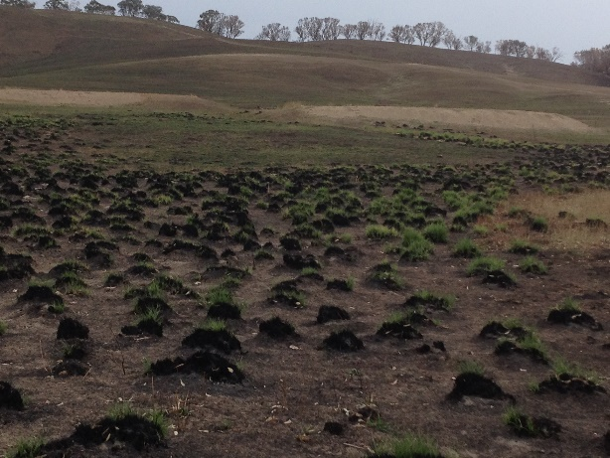

Feed

Under the Emergency Fodder Distribution Agreement, the Victorian Farmers Federation (VFF) arranges the collection and distribution of fodder.

Livestock producers needing emergency fodder or wishing to donate fodder for livestock should contact the VFF on 1300 882 833 or email fodder @vff.org.au.

No two situations of feed availability will be the same. Decisions about feed will need to be reviewed over time. Options of managing stock can be impacted by gaining access to sales at saleyards and access to fodder. Options may include:
- Agistment
- Sell stock
- Feed stock
If feeding stock is an option Agriculture Victoria staff can assist with developing a feed budget. This identifies the amount and quality of feed required for the number and type of stock and also how long it is required for.
If accepting donated feed, consider establishing a sacrifice paddock or stock containment area to reduce the spread of any potential weeds. Also be aware that the quality of feed may vary, and this will impact the amount stock require.

Water
Water availability may be reduced by fire suppression activities and the quality may be affected by contamination from ash and soil.
Dehydration can be a problem with stock often refusing to drink water if it is polluted or tastes different from their normal supply. It's important to watch your stock carefully to ensure they are drinking adequately.
Agriculture Victoria has practical information on maintaining farm water quality and protecting surface catchment once the fire has passed on the website
Planning for water availability should include:
- Carefully evaluate current reserves
- Assess if water quality has been impacted
Staff can assist with developing a water budget to determine your stock requirements.

Re-fencing
Consider prioritising re-fencing based on remaining stock needs, however establish boundary fencing and stock containment in the first instance. If you receive offers of assistance, identify where burnt fences need to be removed and your highest priority fencing to begin recovery.
This as an opportunity to consider internal fences, as part of a broader assessment, of how your property should be managed in the future. Staff can provide workshops on planning your fencing to consider land class, improving access to water and fencing areas of land degradation.

Pasture
Impact to pasture varies depending on the intensity of the fire, the species composition, soil fertility and the time of follow up rains. Pastures may not need to be re-sown, management practices such as fertiliser, weed control and grazing may assist in recovery. Assess recovery before making management decisions and don’t graze pastures too soon.

Erosion
Bushfires destroy vegetation, leaf letter and organic matter. As a result, the soil becomes vulnerable to wind and water erosion. Rainfall and storms following fires can create large movements in sand, silt, gravel and even rocks.
Temporary silt traps constructed out of shade cloth and steel posts, positioned above strategic dams can assist to halt the movement of sediment into dams. In large events dams can completely fill with sediment. If this occurs wait until good ground cover is established before cleaning out the dam.

More Information
Please call the customer service centre on 136 186.

More Information on our web site

The Agriculture Victoria website has a range of information on general farm management as well as farm management following emergencies.
http://agriculture.vic.gov.au/agriculture/emergencies/recovery

Updated January 2020

