
SESSION REPORT
mosaic LAB

AGRICULTURE VICTORIA
BIOSECURITY ROUNDTABLE 2019
4 OCTOBER 2019

INTRODUCTION

Agriculture Victoria hosted the Victorian Biosecurity Roundtable 2019 in Attwood on 3 October 2019. Approximately 70 stakeholders, including industry, agency and community representatives took part in the session. This report provides a record of ‘what was said’ during this session, collating all participant outputs on the day. A survey was also sent out following the session and the results of the survey have also been included in this report.

WORKSHOP PURPOSE

To explore possible future changes to how biosecurity is approached in Victoria
To understand the diversity of current biosecurity approaches
To gather views and perspectives on how the current biosecurity system works well and what can be improved
To identify what issues and areas need further exploration over the coming 12-18 months

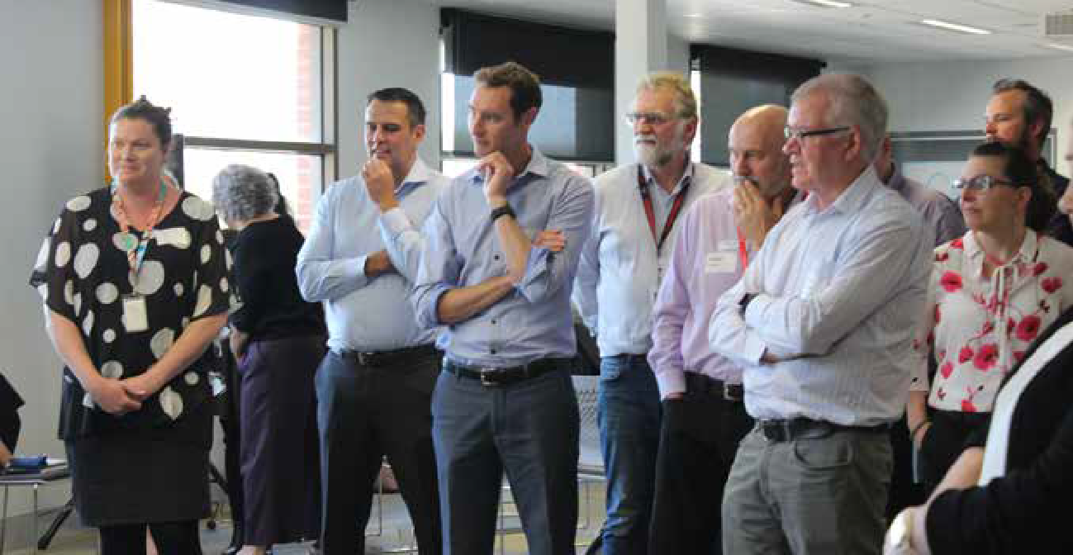

WORKSHOP AGENDA

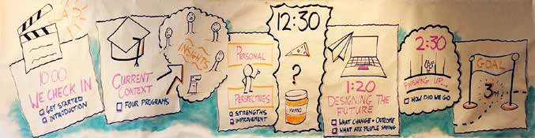

TIME |  | ACTIVITY
9.30 |  | Arrival and registrations – morning tea
10.00 | (30) | Getting Started  Overview of the purpose and agenda, initial introductions and a chance to share the experiences and hopes we are bringing to the session today.
10.30 | (15) | Welcome and introduction by Chief Executive Agriculture Victoria Emily Phillips
10.45 | (45) | Our Current Context  Understanding the diversity of biosecurity approaches currently offered and gathering  insights that could inform future approaches
11.30 | (60) | Personal Perspectives  Defining the current strengths of the biosecurity approaches and where there needs to be  improvements.
12.30 | (45) | LUNCH
1:15 | (75) | Designing the Future  Describing the change that would create the most effective and efficient biosecurity approach  in Victoria.
2:30 | (15) | Finishing up  Our final reflections on the work we have done today and next steps or action list for everyone  Closing words Michael Rosier – Acting ED Biosecurity Services Agriculture Victoria
3.00 |  | SESSION CLOSES

PARTICIPANT OUTPUTS

STAKEHOLDER MAPPING

Participants divided themselves into five broad areas to identify ‘who was in the room’.
These initial categories were:
community
action networks
primary production (single or large
scale)
education, policy and research (non-
government)
government
industry groups

The group then reviewed a diagram mapping out the different ‘players’ in the biosecurity system, which were
divided into broad groups/cohorts (see below).
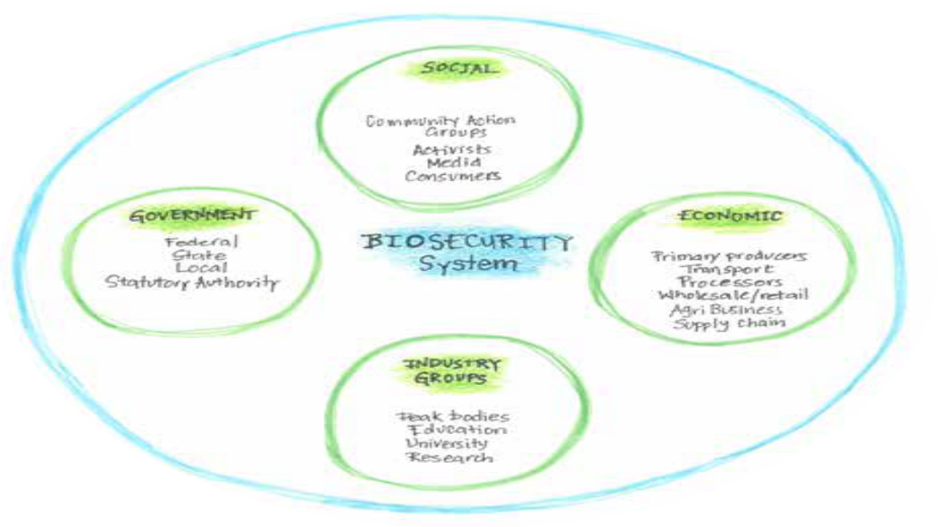

Participants then considered who might be missing (either not represented in the room or listed in the stakeholder diagram) and, therefore, what other voices/perspectives needed to be considered during their conversations.

Land managers – (e.g. others beyond Parks Vic)
- Citrus industry
•
- Public health bodies
- Broader public and recreational users
- Landcare
- Labour hire contractors
- Water industry
- Treasurer/Minister
- Enforcement agencies (police, state, border patrol)
- Media
- Infrastructure – road, rail and sea
- CFA / emergency services.
- Mining industry
- Food safety organisations
- Tourism
- Quarantine agencies
- Customers and supply chain
- Indigenous groups
- Importers / exporters
- Peri-urban areas

- Research and agriculture
- Farmers (diversity i.e. representative groups different to actual farmers)
GROUPS MISSING FROM THE STAKEHOLDER DIAGRAM OR SESSION

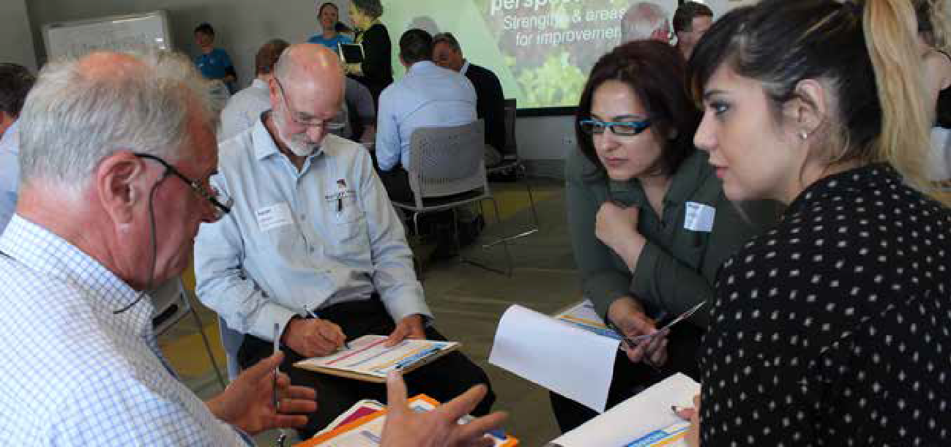

DEFINING BIOSECURITY

Participants reviewed the current national biosecurity statement.
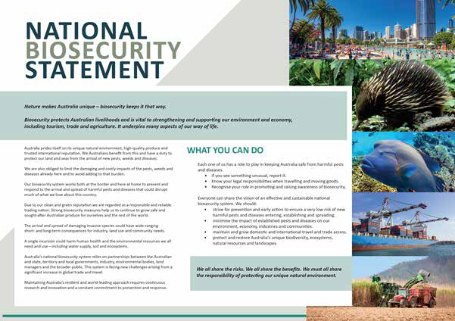

The group had a conversation about what the term biosecurity meant and considered whether additional elements
could be added to the definition of biosecurity.
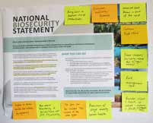
- Risk management issue
- Also about monitoring and surveillance not just incursions

- Impact on mental health and wellness (regulations)
- Trade impacts (including impacts due to regulations)
- No part can be isolated. Take account of the whole system
- Continuum ripple effect
Protection of social amenity and human health
- What we don’t know is part of the issue
•
Broader welfare and health of people - impacts and stock (consequential)
Everyone’s responsibility – partnership
•
•
Bring down to smallest unit of production
•
DEFINITION OF BIOSECURITY: ADDITIONAL IDEAS


COMFORT WITH CURRENT APPROACH

Participants thought about how comfortable they felt with the current biosecurity approach in Victoria. The group was then asked to consider what would make them more comfortable. Some attendees shared their ideas, and these insights have been summarised below.
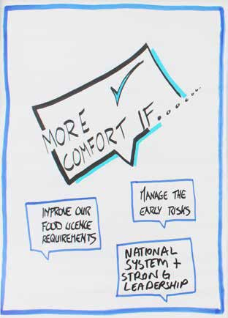
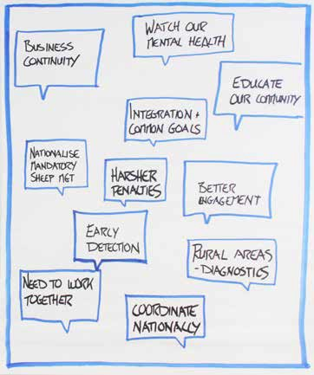
- had rural areas diagnostics
- had integration and common goals
- coordinated nationally
- educated our community
- worked together better
- watched our mental health
- had early detection
- had business continuity
- had better management
- had a national system and strong leadership
- had harsher penalties
- managed the early risks
I WOULD BE MORE COMFORTABLE IF WE …

- improved our food licence requirements • nationalised mandatory sheep management

KEY STRENGTHS AND AREAS FOR IMPROVEMENT

The group brainstormed key strengths and areas for improvement around how we all approach biosecurity.

Key strengths
The key strengths identified have been listed below.

THEME | KEY STRENGTHS PUT FORWARD
Prevention / preparation | - Prevention and preparedness.  - Proactive approach.  - Sophisticated detection and response system in place.
Data and information | - Data! Lots and good quality in many sectors.  - Diversity of knowledge and expertise within industry.
Innovation and technology | - Innovative projects.  - It’s not perfect. We are developing or have developed a robust electronic ID system for production livestock.  - IT and innovation.  - Victoria is innovative in the biosecurity space and willing to try new methods and systems.
Leadership | - Exotics: Government lead and industry engaged - partnerships.  - Endemic pests: Needs improvement to community engagement and reduced role of government in leading response / management (i.e. QFF and endemic weeds – community becomes confused about who responds or who manages an incursion).  - Leadership within the State.  - State government acknowledgement of the importance of Victoria’s biosecurity.
Co-ordination across sectors | - Combined approach and effort in education across industry, government and other  sectors.  - Co-investment from government and industry.  - Ownership and importance of coordinated biosecurity approach – industry, government and community.  - There is a level of timely collaboration industry and government to prepare and respond with incursions.
Passionate people / participants | - Passion and commitment.  - Passionate people.  - Huge expertise and passion in all participants.  - People – passionate, knowledgeable – willing to share and support each other – solutions focused and practical.

THEME | KEY STRENGTHS PUT FORWARD
Existing work and programs | - Learning from some programs as good examples (e.g. FMD).  - The existence of Animal Health Australia and Plant Health Australia.  - Change in culture – better biosecurity practices (regulation - including self - and working together).
Geographic location | - Geographic location and young trade country means we are free of a lot of biosecurity issues (pests and diseases).  - Geographic location (Australia).
Engagement and partnerships | - Collaborative, productive stakeholder engagement.  - ‘Real’ stakeholder engagement.  - Industry collaboration and partnerships leads to success.  - Frameworks are in place to support collaboration.  - Media and communications advances and reach / penetration.  - Community engagement creating greater awareness and ownership.
Other | - Government investment to support change in industry.  - Cost recovery and compensation systems with industry backing.  - Highlights the natural environment is important.
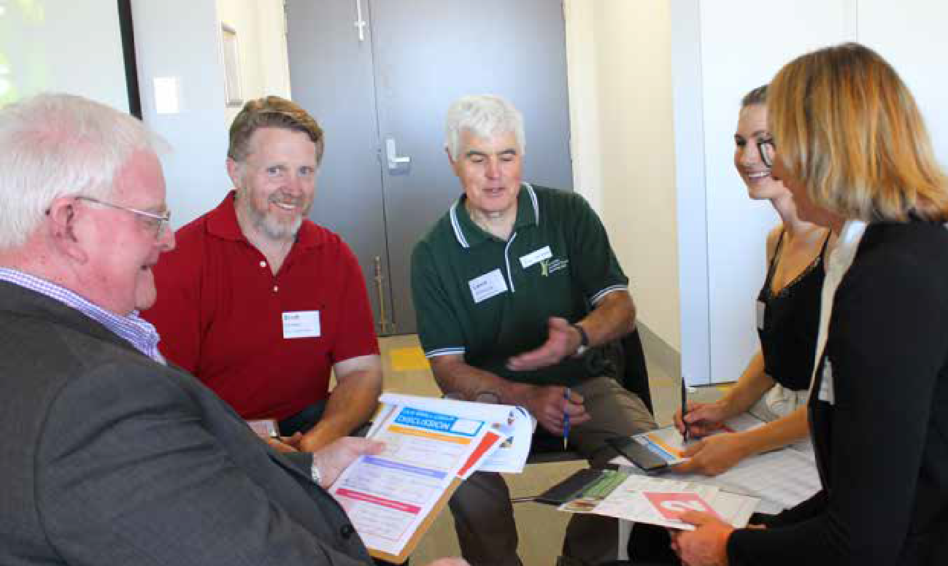

Areas for improvement
The key areas for improvement identified have been listed below.

THEME | KEY AREAS FOR IMPROVEMENT PUT FORWARD
Pre border and at border management | - Improve funding for pre border and at border capabilities to address the issue of high movement of people and commodities.
Extend corporate model | - Extend crop safe model information other industries i.e. potato / horticulture.
Managing peri – urban issues | - Dealing with the peri-urban and ‘lifestyle’ block risks – education and engagement / improve knowledge / resourcing issues.
Robust and accessible data | - Data integrity.  - Access to data.
Cost shifting | - Ensure not cost shifting from government to industry.
Public land biosecurity | - Biosecurity of management.  - Public land.
Role clarity and  accountability | - Role clarity for shared responsibility.  - Better define accountabilities and implement.
Coordination and collaboration across government and industry | - Greater stakeholder (all) investment.  - Design practical systems with government and industry partnerships i.e. trade / pest and disease detections.  - Remove silos across sectors / across states / regions / properties. Share data and lessons learnt.  - Equal responsibility at community, industry and government.  - National strategies - yes! Regional application is essential too (e.g. levy systems for biosecurity).
Managing exotics | - Barriers to exotics reporting.  - Smarter support system around notification of potential exotics.  - An increase of robust impact assessments of exotics pests and diseases.
Education and awareness. | - Education and public awareness – getting everyone on board.  - Community awareness campaigns.  - Clear messaging / education.

THEME | KEY AREAS FOR IMPROVEMENT PUT FORWARD
Early, robust engagement building resilience | - Improvement, engagement then enforcement.  - Additional resources to support innovative collaborative / engagement projects.  - Consideration of affected people / producers.  - Improving resilience - people having some control / broad support networks / preparedness.  - Transparency.  - Maintain early stakeholder engagement.  - Community engagement creating greater ownership of biosecurity across whole community.  - Moving to a community / industry centric approach to biosecurity management. E.g. emergency response.
Industry driven QA | - Industry driven quality assurance programs need to have effective compliance and  enforcement programs.  - Improve the general community’s awareness of and engagement in biosecurity.  - High variations of understanding of biosecurity and its impacts on individual farm level.  - Promote understanding programs are critical – multiple threats – site specific.  - Around on farm biosecurity - make it relevant – make it clear - what is required. Lots of resources for producers and advisors. Or awareness of need.  - Normalising biosecurity (behavioural change).  - Leveraging improvement outcomes through greater community knowledge (understand implications of what they value).
National agreement  - property traceability | - Nationally agreed approaches / roles / stats for assigning and using property  identification codes and traceability.
Continuous improvement | - Continuous improvement as issues and changes occur across the globe.
Improve AG Victoria - agility and flexibility | - Improve Ag Vic ability to be agile and flexible - multifaceted solutions.
Funding and resourcing. | - Increasing ongoing funding for biosecurity.  - New funds should be used to co invest in improve programs.  - Resourcing of staffing and awareness of current and emerging risk pathway.
Efficient regulation. | - Smart and efficient regulation that encourages business continuity.  - Need biosecurity preparedness manual on a national scale for all potential high risk pests / diseases in each industry including diagnostics, management, regulation and impact on trade.

DESIGNING THE FUTURE: IDEAS FOR CHANGE

Group brainstorm
The group reviewed all the key areas for improvement put forward in the previous step. Under each theme, the participants provided thoughts and notes on what changes could engender an effective and efficient biosecurity approach in Victoria.

THEME | GROUP NOTES – PROPOSED CHANGE/S
Pre border and at border management | - Higher level of penalties  - More awareness  - Ongoing and increased investment.  - Leverage technology and data to automate and develop predictive capabilities.  - Awareness of global issues management strategies and legislation  - Tighten up pre entry testing of imported goods – we should be world standard.  - Ensure revenue from incoming ‘container levy’ is entirely spent on biosecurity.
Extend CropSafe model | - Multiple commodities in horticulture and not all horticulture growers use agronomists (poses a challenge) but worth exploring!  - Expand the concept beyond just agronomists e.g. owners, managers, contractors.  - Better understanding of why agronomists are signing up / participating.  - Using agronomists as the ‘pinch point’ is very useful – perhaps livestock sectors should use vets in the same way.
Managing peri – urban issues | - Fund community education – detail costs of not doing anything.  - Need better enforcement for people who don’t comply (after numerous breaches).  - Understand barriers (cost, time, knowledge etc.) and motivators for landholders to act.  - Setting KPI’s for landholders’ engagement in regard to education and enforcement.  - Media campaign to make them aware of issues.  - All - no matter how small - need a PK number.  - Producer directed delivery of programs.  - Engage / recruit local government to access / motivate / communicate with peri-urban population.  - Swill feeding (e.g. ASF, FMD) awareness?  - Managing biosecurity risks during bushfires i.e. manic movement of horses and  community members trying to ‘help animal movement’.
Cost shifting | - Broad understanding of the costs first then agreement as to who / what. Once it  starts parties cannot opt in / out.  - Not to be seen as a ‘easy revenue raising’ mechanism for state governments as there is not a commercial alternative so needs some form of ‘common good’ contribution.  - Focus on building shared capabilities to manage shared risks – a new ‘social contract’ – with responsibilities come rights. Self-regulation (shared accountability)?

THEME | GROUP NOTES – PROPOSED CHANGE/S
Robust and accessible data | - Data that not only can be accessed but presented in a way that can be understood by all.  - Create centralised repository / database for recording data with access to policy makers and others to inform decision making (‘risk – return’).  - What sort of data? Need to define what we need and how to use it.  - Information gathered also needs to be made available to industry to empower greater knowledge and to provide possibly better outcome.  - How about case studies of real life / current incidents available for users as one sort of data?  - ‘Big data’ opportunities and risks (e.g. non-compliance).  - How many years of negative data (evidence of absence) is required to establish area freedom?  - Crop safe can obtain area freedom. PCN status in Victoria – farms that have 20 years of negative surveillance data yet still deemed ‘infested’
Public land biosecurity | - Clarity around clear boundaries / roles in land management (consistency across regions).  - Collaboration across the fence - private landholders able to manage the public side.  - Agriculture Victoria supporting property owner with education and appropriate compliance.  - Increase awareness of how public land is managed (multiple use, prioritisation systems etc).  - Engage other government agencies with biosecurity management on public land (e.g. Parks Victoria).  - Articulate rules and responsibilities.
Role clarity and  accountability | - Need real action / acceptance of shared role - a lot of work, but still silos.  - Regulator or facilitator? Or both? Clarity and transparency in roles.  - Most biosecurity controls have some involvement from relevant service provider sectors so understanding, describing and supporting their role clearly is vital.  - Definition of responsibilities, documentation and language development – culture  changes - normalisation of behaviours.
Coordination and collaboration across government and industry | - Partnerships are needed between government / industry and community – they are all interdependent on each other to achieve sustainable outcomes – this would go a long way to removing silos.  - Look at past / current case studies that are already a ‘partnership’ and use them as models for others to use.

THEME | GROUP NOTES – PROPOSED CHANGE/S
Managing exotics | - Clarify awareness around owner reimbursement costs and impacted nearby businesses and services.  - Social and economic costs of quarantine uncertainty on maintaining marked access.  - People / growers are less likely to report an exotic if they think it will reduce their trade.  - Knock on effects due to stigma attached to reporting exotics seen as the grower’s ‘fault’ or their land is ‘infested’. Growers need knowledge of business continuity and treated as the friend not the enemy.  - Media – ads on tv for importance on biosecurity.  - Biosecurity = food security. Focus on preventing rather than managing.  - Public understanding on exotics and what should be reported.
Early, robust engagement building resilience | - Strong industry liaison function in responses.  - Industry and government have better understanding of role purpose.  - Once there is an ‘outbreak’ the lead agency and lead industry must meet and develop a joint plan.  - Most keep a combination of industry and regulator involved right through the process.  - Important to get it out there without risk of prosecution or embarrassment.  - Enforcement should be a last resort - constant enforcement requirements may be a sign of failure to engage community and improve knowledge.  - Should be a national adopted process so procedure is consistent across the states.
Education and awareness. | - Fund extension community engagement officers to ‘educate’.  - Work and partner with primary producers / industry to provide learning opportunities  / trainings to better engage and educate around ‘why’ we do this.  - Bad case scenarios.  - Update and reprint biosecurity manuals (e.g. bookkeeping).  - Be specific and measure success – not generic - target audience, specific behaviour.  - Activist education and enforcement as a deterrent if they breach protocols.  - Incorporate biosecurity importance and awareness into primary / secondary level education.  - Community needs to understand how and where they fit into biosecurity i.e. exotic  pests – government leads.  - Endemic pests – community and area wide management approach. Community  doesn’t see the difference.  - Improve Snap, send and solve app.  - Marketing - develop a reliable message and use social media to spread appropriate messages – develop language and awareness of issues to share with all.  - Include biosecurity information into already existing council – community workshops (e.g. bee keeping, gardening, and waste management).
Agriculture Victoria Victorian Biosecurity Roundtable 2019 Workshop Report October 2019
13

THEME | GROUP NOTES – PROPOSED CHANGE/S
Industry driven QA | - Compliance data from QA programs available to government and timely government reporting back to industry.  - QA is not the place for biosecurity!  - Incentives / support for self-regulation.  - Governments have a role in assisting with compliance - enforcement.
National agreement  - property traceability | - PIC codes be unique to a piece of land.  - PIC codes only to be merged when land is joining (this is an issue for on farm management especially for holders of many blocks).  - PIC adoption across all production sectors / enterprises.  - Applying for and being granted a PIC is consistent across all stated / territories.  - Why are we not ‘naturally’ working together?  - Utilise existing industry bodies or state-based organisations to eliminate duplicating costs / networks.  - Expand to all horticulture.  - Important but not a cost burden to the landowner – ‘KISS’.
Continuous improvement | - Don’t hesitate when issues occur - empower people to make the right decisions.  - Don’t wait for something to go wrong and react.  - Proactively engage – review – identify gaps - act to clarify/fix.  - Be proactive.  - Information sharing of ‘lessons learnt’ and feeding into future work (a lesson management framework).  - Are reviews done and do actions come out of this?  - Sharing information across the globe – keep up with global issues and think outside Australia.  - Encourage reporting of pests and diseases amongst countries around the globe.  - Regularly scan for risks and fund to develop pre-emptive solutions for mitigating risks.  - Internal QA checks for effectiveness of biosecurity controls?
Improve AG Victoria - agility and flexibility | - International engagement.  - Use industry resources to achieve outcome particularly in data management.  - Models used in other countries where government staff work across multiple  biosecurity issues.  - Increase ability to be agile within an organisation - this could be applied to Ag Vic.  - Vic biosecurity legislation supports standard compliance and enforcement approaches.  - Effectiveness of biosecurity controls at ‘surge’ times (i.e. – inclusions).  - Cross pollination of staff training - broader knowledge base centre ‘champions’ as  local resources and exchange with other agencies (PV, DELWP, CMAs).
Agriculture Victoria Victorian Biosecurity Roundtable 2019 Workshop Report October 2019
14

THEME | GROUP NOTES – PROPOSED CHANGE/S
Funding and resourcing. | - Valuing and risk management of different pests / diseases – why some pests are valued over other pests that might have a larger detrimental impact on the industry (e.g. more funds spent on PCN than blackleg, e.g. wild dogs).  - Fund infrastructure for loading and unloading stock trucks and produce trucks and grain trucks including wash bags.  - Efficient (poo) disposal sites.  - Long term resourcing / funding focus – less ‘ad hoc’ decisions.  - More funds into research and development and communicating science to growers – existing research converted to grower speak.  - ‘Natural’ consistent / accountable funding programs.  - Alignment of RDC funding with industry priorities and government activities.
Efficient regulation. | - Regulation empowers rather than restricts market drivers.  - Regulations around accurate tracking of animal movements electronically need to be a robust as possible.  - From a national perspective, ‘efficient regulation’ = consistent regulation across the  country.  - Regulator versus facilitator role.  - Ag officers all with the same message and levels of enforcement across state (land  managers).  - Involve industry in regulation development so they are practical and workable.  - Need to know where to go / what to do at any level / anyone.  - National (game) biosecurity regulation.  - Flexibility in interpretation and implementation to meet industry and government outcomes.  - We should learn from other countries with more pest and diseases than Australia (e.g. Europe, USA, and NZ) and apply their lessons learnt.  - Discuss internationally what are the key detrimental pests / diseases and how they have managed.  - Also look to the future of climate change what pests / diseases thrive in hot / dry conditions and how are these regulated or not regulated on an international scale.
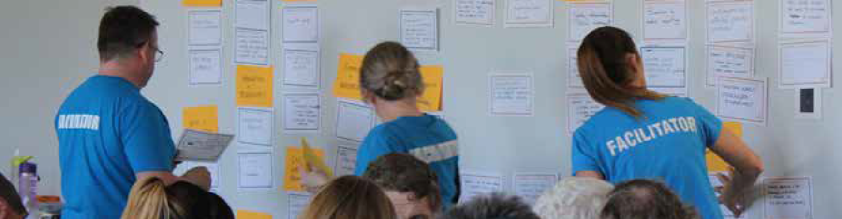

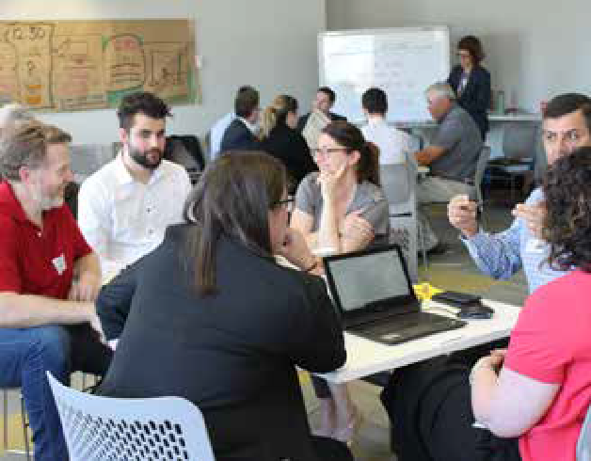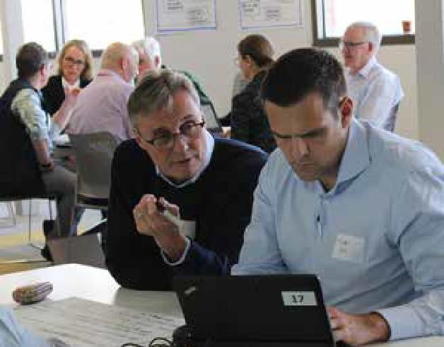

GROUP REPORT

Based on the key areas for improvements and group notes in the previous step, participants worked in small groups to develop more detailed ideas for change. The group used laptops and wrote their own report in Google Docs, which has been inserted directly (unedited) on the following pages.

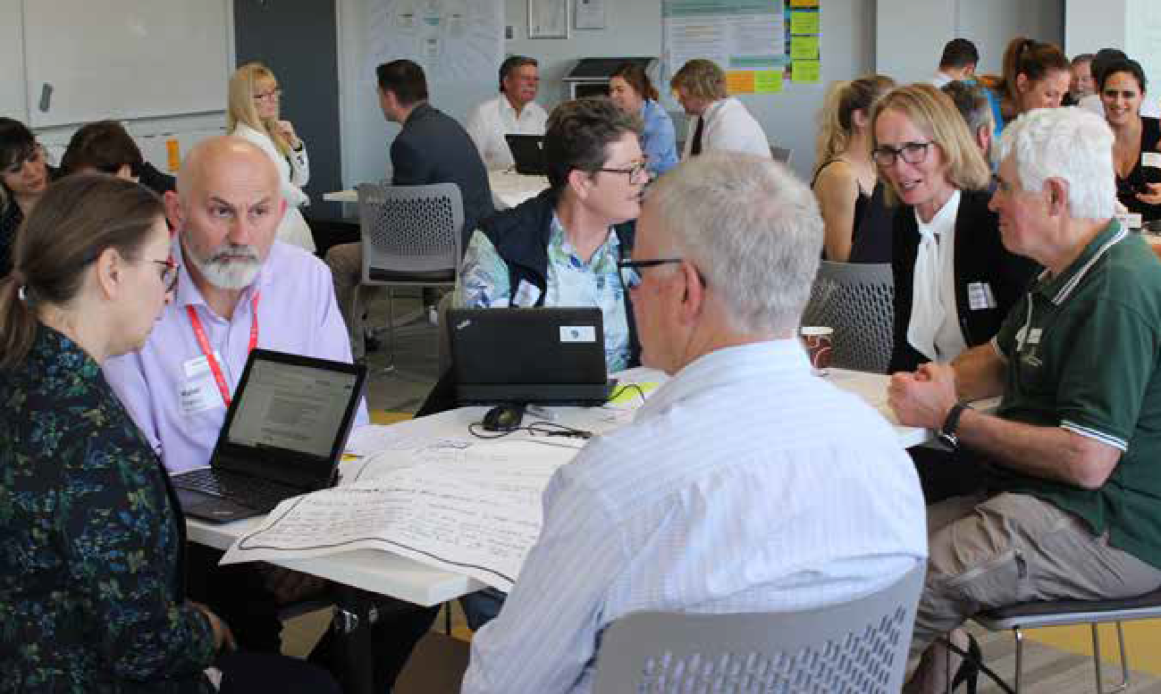

IDEA
1

What change/improvement is suggested?
Long term and strategic funding & resourcing

What would this look like in practice?
What will people be saying about Victoria’s biosecurity if this change was implemented and who will be saying it?

Funding environment to enable strategic planning, coordinated (national) approach, develop and protect core capability - includes R&D&E&A

Investment in innovation to enable govt and industry to work smarter

Co-design - to ensure alignment of RDC and other funding

Pest & disease prioritisation lists created with relevant stakeholders (co-design)

Enabling infrastructure to support biosecurity related operations
- “The funding environment in Victoria has markedly improved our market access, productivity, and lifted terms of trade” - Source VFF President

- “We were in a position to hit the ground running and successfully eradicate Enemy Pest No 1 due to our strong capability in EPPR” - AUSVEG

IDEA
2

What change/improvement is suggested?
Greater understanding of the dynamics involved in exotic assessments, barriers to reporting and costs/consequences to industry, government and community

What would this look like in practice?
What will people be saying about Victoria’s biosecurity if this change was implemented and who will be saying it?

Greater understanding and support from industry.

More industry/community engagement and reporting of suspect exotics

Build a support system for those who report or are IP1-5 to reduce fear
of consequences and to encourage reporting - early reporters viewed as industry champions

Better and more uniform risk assessment (to enable more robust impact/ consequence assessment)
- “Ag Vic can have confidence in the disease status of its plant and animal industries because of the large number of disease investigations that have been undertaken on farm in the last x years.” - Source

- “Quote from CVO Victoria”

- Early reporting of pest and diseases has resulted in substantially lower eradication costs for threat x with substantial savings for industry and limited disruption to market access - Emily Phillips, CEO Agric Vic

IDEA
3

What change/improvement is suggested?
To obtain nationally agreed practices/standard for mandatory traceability (e.g. PICS)

What would this look like in practice?
What will people be saying about Victoria’s biosecurity if this change was implemented and who will be saying it?

- Nationally agreed and mandatory rules and standards - Mandatory for every S&T

- Cross sector adoption where possible

- Victoria taking lead to drive the national agenda

- Pilot projects

- Co design approach across govt, industry supply chain and other stakeholders impacted or those able to influence
  - Marketing advantage for Victoria
  - enhance labelling standards, tighten criteria to achieve surety in product
- VIC Ag Minister - Promote that VIC was leading significant change to this important issue

- Cwlth Minister for Ag - Example Cwlth, S&T working together for better biosecurity and producer outcomes. to improve the national ability to monitor and trace

- Consumers - Would like the fact they know where their food comes from

- Industry - Pride in product, marketing advantage

IDEA
4

What change/improvement is suggested?
Coordination and collaboration across government-industry and community

What would this look like in practice?
What will people be saying about Victoria’s biosecurity if this change was implemented and who will be saying it?

Development of a framework for transparency in communications and strategy throughout the biosecurity continuum.
Government empowering the community so those with the issues or challenges have the opportunity to provide solutions. A partnership approach will eliminate a traditional hierarchy in biosecurity response as information flows can be counterproductive and potential hindering maximum efficiencies and impact.
Create clear pathways for responses with sharing and trust. Using local and industry knowledge to improve response and implementation.
Mutual respect between agencies and industry sectors - expertise and knowledge being shared. One in all in approach to biosecurity funding, cost sharing arrangements and engagement.
Clear responsibilities to ensure all necessary and trusted organisations are engaged and have
adequate resourcing to engage properly with the discussions.
National strategies to have local and industry
specific implementation and goals.
Think global act local.
Industry quote - “A disease detection in Vic has led to an easy eradication, monitoring and surveillance program, due to using existing industry and government systems to ensure they meet expectations, avoiding potential catastrophic consequences”

Other state government agencies and sectors wanting to follow AgVic’s lead in biosecurity preparedness and training programs.

IDEA
5

What change/improvement is suggested?
Extend CropSafe into other industries

What would this look like in practice?
What will people be saying about Victoria’s biosecurity if this change was implemented and who will be saying it?

Single consistent model applied across a broad range of industries which is well integrated.

Offers consistent long-term data that producers trust as a reliable “one source of truth”.

Could include surveillance data, detection data, incursion data.

Could link to PICs?

Leveraging from understanding how the current grains industry make it work so well and applying that to other industries.

Consider other approaches in expanding this model (e.g. Private Practitioner Online), iPhone apps used in wine industry, etc. - i.e.it may be that one size doesn’t fit all - and doesn’t have to.
- “Quote” - Rapid and early detection of pests.

- “Quote” - Significant trust and strong network of expertise that builds trust between industry and government.

IDEA
6

What change/improvement is suggested?
Data accessible to stakeholders - Govt and Industry, in a timely manner to support decision
making, identification of risk and market access.
A well supported, accessible, relevant, central repository of quality data.

What would this look like in practice?
What will people be saying about Victoria’s biosecurity if this change was implemented and who will be saying it?

Open source database with appropriate safeguards and data security that can be used by industry and government.

Validated data from location of industry to pest and disease status (that is, should not underestimate work/investment required to provide quality assurance).

Ability to extract data and analyse it to answer the right questions and generate useful insights and information to support decision-making or validate status for purposes (e.g. market access)

Good metadata standards.

Ability to source data from a variety of appropriate and reliable sources.

Data ownership, sharing and accessibility requirements are clear, appropriate and legal.
- The ability to act and react to an outbreak

- Quality data to support market access data

- Informed decision making to support management decisions

- I know where pests and diseases in my areas

- Advanced systems that support traceability, product integrity and assurance of our treatment systems have built trust that Victoria is one of the world’s safest food producers.

IDEA
7

What change/improvement is suggested?
Building resilience through early, robust engagement

What would this look like in practice?
What will people be saying about Victoria’s biosecurity if this change was implemented and who will be saying it?

- More clear conversations with all parties from the beginning. Defining each strategy clearly and specifically that detail clear outcomes.

- Well tested and understood response plans - people know what will happen, and their role and responsibilities (have control)

- Community continuity plans in place
  - how will industry and community be supported (planned in advance) - consequence management

- Work with stakeholders to implement response and recovery
  - importance of clear, open communication (minimise ‘scare factor’)
- “I’m a farmer, and I know what my responsibilities are” - Farmer

- “Amongst all the uncertainty, we have a future”
  - Farmer

- “We are here with you, working side by side”
  - Premier

IDEA
8

What change/improvement is suggested?
Clarify roles and accountabilities for the different players in biosecurity from government to
industry

What would this look like in practice?
What will people be saying about Victoria’s biosecurity if this change was implemented and who will be saying it?

- Use the existing knowledge

- Providing a directory for knowledge- who to go to and what they know and what triggers it

- Determining whether the roles are in the right place and whether they are addressing what needs to be addressed (government role)

- Conducting resource analysis (does government have the right people? Including future scanning and succession planning. Future planning includes utilisation of new technology and emerging risks)

- Enhancing the visibility of roles in biosecurity- sharing better and across a broader audience (media releases), explaining what the government does for biosecurity to the general public,
how that benefits the public. Importance of these roles. Accountability of the general public.

- Clarifying industry roles in response, where does industry have input?
- Agriculture minister- “By reshaping our agencies the broader community can better understand the overall roles in biosecurity and who does what and when”

- “Redefine and reshaping roles and responsibilities will benefit clarity and provide a more effective/ rapid response to biosecurity incidences’”

- Tax payer – “Here we go again!!!!!”

IDEA
9

What change/improvement is suggested?
INDUSTRY DRIVEN QUALITY ASSURANCE
Industry driven quality assurance programs need to have effective compliance and
enforcement programs
What would this look like in practice?

Compliance data from QA programs available to government Conversely - timely government reporting back to industry Comments from group:
Red meat industry already has industry driven QA programs, that are independently audited by an independent auditor
What are the cost benefits of providing data to government, who owns this data?
QA is not the place for biosecurity
Comments: it is part of most QA programs, about safe food, maximising profits and optimising animal health.
QA program should set the standard and compliance should support this where standards are not being met.
Compliance does not need a QA program, but breaches of reporting if sent to government need to be acted upon, and then reported back to industry in a timely manner.
Effective Communications programs needed; particularly in beekeeping for reporting disease outbreaks or
AFB in Victoria, mapping of disease reporting online. Incentives/support for self-regulation
Incentive needs to be market driven
Governments have a role in assisting with compliance and enforcement Online templates for QA
Market or competitive advantages should result from appropriate QA management - e.g.: the ‘heart tick’ or ‘Australian made’ symbols.
Consider ‘product safety’ as a positive marketing tool to promote consumer confidence, this will give market
advantage.
Auditing enforcement outcomes for entities not complying with regulation
Legislation to support enforcement officers in their role
Sufficient numbers of enforcement officers funded for regions - More apiary inspectors

What will people be saying about Victoria’s biosecurity if this change was implemented and who will be saying it?
- People can be confident that the QA systems we have in Victoria will mean what you are buying is what you want/expect

IDEA
10

What change/improvement is suggested?
Efficient regulation

What would this look like in practice?
Harmonised regulatory arrangements would help build consistency - e.g. consistent legislation or biosecurity acts in place across the country rather than different legislative approaches in each state, this would help drive efficiencies in compliance (e.g. training) and less red tape

Consistent approach to compliance - e.g. regulatory posture

Better understanding of why enforcement is necessary/what has led to this.

Best practice regulation in place - not ambiguous, proportionate. Utilisation of international experience to obtain best practice of regulation

Well trained compliance staff who know what they
are doing.

Get industry involved - train them up to be authorised officers e.g. like the commonwealth model and have industry auditors with government oversight

Reward businesses and people for being compliant with less red tape, better reputation (stamp of approval) and conforming to known standards.
Individuals would be more likely to report if they had knowledge of the process, from detection to regulation to trade.

Incorporate biology of the pest/disease into the regulation (science based)
What will people be saying about Victoria’s biosecurity if this change was implemented and who will be saying it?

- Victoria is leading the way on a best practice system through a harmonised and industry integrated regulatory system - Premier

- Victoria’s new and progressive regulatory system will prove itself by reducing biosecurity costs by 90%

IDEA
11

What change/improvement is suggested?
Biosecurity management of public land is better integrated over public and private land - diseases don’t respect boundaries

What would this look like in practice?
There is clarity around boundaries, roles and responsibilities in land management and this is consistent across regions

Agriculture Victoria and other public land managers support property owners with education and support appropriate compliance

There is collaboration across the fence and private landholders are able to manage on the public side of the fence where it is appropriate

Increased awareness of how public land is managed, who uses the land and public land users are a surveillance network

Public land managers have better signage to support biosecurity in Victoria

Other agencies (Australian Government agencies e.g. Defence and Victorian state agencies DELWP, Local Governments, Water Authorities, VicRoads, VicTracks etc.) are engaged in biosecurity management in Victoria

Public land managers are engaged in biosecurity and are just another land manager in Victoria
What will people be saying about Victoria’s biosecurity if this change was implemented and who will be saying it?

IDEA
12

What change/improvement is suggested?
Improve Agriculture Victoria’s flexibility and agility. (Improve its capacity and ability to respond and prepare for exotic and endemic incursions, in particular with multiple/simultaneous pest and disease incursions.

What would this look like in practice?
What will people be saying about Victoria’s biosecurity if this change was implemented and who will be saying it?

- More funding towards preparedness and response research. Further engagement with industry, especially towards response frameworks. More empowerment with industry with the framework, they will be more willing to help with funding. Industry-led research to fill in the necessary gaps.

- Restructure response frameworks include further engagement with industry (e.g. biosecurity
officer in industry groups) as they have a much better understanding of commercial aspects of biosecurity consequences.

- Improve simulation and readiness for authorised officer to respond to multiple incursions. (African Swine Fever & Brown marmorated stink bug)

- An increase in generalist authorised officers.

- External engagement could involve sharing of knowledge and advice on how to manage and respond to incursions (overseas countries or other states).

- Simplified compliance and enforcement approach and communications. Communication is clear to all stakeholders, especially towards legislation requirements for producers. Enforcement will become lighter as stakeholders will understand their legal requirements and not unintentionally un-comply.
- “It’s good to see industry expertise to be acknowledged and used for Biosecurity research and innovation since we have the on-ground experience with the consequence of a lack of biosecurity” - Industry body.

- “With industry being more actively engaged in Biosecurity innovation and preparedness research, this allows
us to have more breathing room with our own capacity for response and preparedness to support industry” - Agriculture Victoria

IDEA
13

What change/improvement is suggested?
Building partnerships between government and industry around shared outcomes allowing for greater use of resources.

What would this look like in practice?
What will people be saying about Victoria’s biosecurity if this change was implemented and who will be saying it?

Type here

- Government delivered regulatory services should be costed at transparent, efficient costs with common agreement.

- Stewardship and policy development to provide the framework for industry to implement self-regulation allowing for appropriate oversight

- Market driven QA programs provide more efficient regulation than government, providing greater incentive than govt enforcement E.g. Livestock Production Assurance - incentivise compliance, integrity in industry enforcement

IDEA
14

What change/improvement is suggested?
Managing peri-urban biosecurity issues

What would this look like in practice?
What will people be saying about Victoria’s biosecurity if this change was implemented and who will be saying it?

A priority task is to create and deploy a suitable education and awareness campaign which describes the importance of livestock movements, animal disease surveillance and weed control (as examples) to biosecurity control. This campaign, which is hopefully designed to create engagement will convey how biosecurity control impacts on regional and state productivity and risk mitigation.

A second task involves specific awareness within local government (councils) situated in the peri-urban fringes. This awareness involves understanding (and application) of animal identification systems (e.g.
an automatically applied PIC number), compliance required for small scale production animal operations and associated weed/riparium/pest control. Here, an assumption is that, while regulation may be in place, it is poorly understood at the local government level.

A third task is that through education, understanding is increased which then opens the door to more effective regulation and enforcement where biosecurity practices are poorly adopted or ignored in per-urban areas.

All three tasks involve recurrent and suitable funding and, if this is not in place, a poor funding environment increases the risk that change leading to better outcomes will not take place.

A campaign that is similar to skin cancer/anti-smoking campaigns that may raise awareness of the risks
- “The community program to address biosecurity risk in peri-urban
areas has significantly increased awareness among small scale and hobby producers, understanding of compliance and application of the relevant frameworks at the
local government level” - president, Municipal Assoc. Of Vic.

IDEA
15

What change/improvement is suggested?
Increase Education and Awareness

What would this look like in practice?

Leverage community engagement officers and existing council-community workshops (e.g. beekeeping,
gardening, waste management)
Work and partnership with primary producers/industry to provide eLearning opportunities and training to
better engage and influence as to why we do biosecurity. Utilise VFF Stocksense program to deliver biosecurity messages Update and reprint biosecurity manuals
Explaining benefits of biosecurity
Incorporate biosecurity importance and awareness into primary/secondary level education. Activist education and enforcement as a deterrent if they breach protocols
Utilise digital learning platforms for messaging to hobby and peri urban farms Increase community understanding of the roles and responsibilities for biosecurity
e.g. Exotic - Government focus. Endemic pests - Community/industry and wide area management approach Improved ways for community to use mobile devices and apps to report biosecurity issues
Monitor social media for biosecurity issues
Develop appropriate messaging and use social media to spread the messages
Improve the education on the Importance and impact of not having an effective biosecurity system
Community awareness campaigns- utilising Landcare and friends group networks Activist, tourist, trespassers biosecurity awareness- consequences, stronger penalties?

What will people be saying about Victoria’s biosecurity if this change was implemented and who will be saying it?
- “Individual producers can outline their biosecurity status and plan” - Individual farmer

- “Community groups can” - Source

- “In Victoria we have 5 million biosecurity advocates speaking 23 different languages”. State Ag Minister

IDEA
16

What change/improvement is suggested?
Continuous improvement of biosecurity systems and procedures

What would this look like in practice?
What will people be saying about Victoria’s biosecurity if this change was implemented and who will be saying it?

- Decision makers would be more
confident to act in a response

- Producers and the community would have a greater understanding of the need to act

- A protocol within the Australian biosecurity system would exist to scan for and learn from global risks and pre-emptive solutions.

- Learning from previous responses

- More flexible and consultative response framework and biosecurity system

- Internal QA checks for effectiveness
of biosecurity controls

- Regular reviews at farm level and public/border level of effectiveness of systems
- “The recent response was well received by the community” - Source

- “Our biosecurity system was well prepared for this incursion, because of a robust understanding of global risks”

IDEA
17

What change/improvement is suggested?
Improved pre-border and at-border biosecurity management and resourcing.

What would this look like in practice?
The revenue from the biosecurity container levy be quarantined specifically for biosecurity purposes only (i.e. not be left consolidated revenue).

Decrease biosecurity risks through increasing detector dogs, from their current level of 36 nationally to a number which reflects the increase in passengers, mail and agricultural imports.

New training of border staff on developing a more proactive culture of ownership regarding their role in protecting Australia’s biosecurity status.

Fund behavioral insights works to encourage deterrents.

Ensure enforcement of the new penalties for noncompliance for overseas passengers.

Re-evaluation of current pathways for the importation of high-risk products.

New technologies, including diagnostics, to detect incoming pests and weeds.

Review and if necessary, improve inspection and sanitisation procedures for pests on incoming cargo ships.

Develop a formal procedure for data sharing among governments with respect to non-compliance and detection incidents so preventative measures can be improved and/or made more efficient.

Improve predictive technologies so biosecurity risks can be mitigated.
What will people be saying about Victoria’s biosecurity if this change
was implemented and who will be saying it?

- “Through our collaborative investment in data sharing and technology, we have much greater confidence in security at the border, helping the sustainability of our plant and animal industries” - Minister for Agriculture Victoria

- “The XXX industry is so pleased to be seeing the benefits of
the increased and sustained investment in border security. This collaborative approach to biosecurity is reaping benefits for both the industry and the broader community. Chair, XXX Industry Body

- “The flow on effects of” - Source

- “We know once the border has been breached the trade barrier costs soar. This
program has to be proactively managed at the border.” - Unknown, Wine Industry

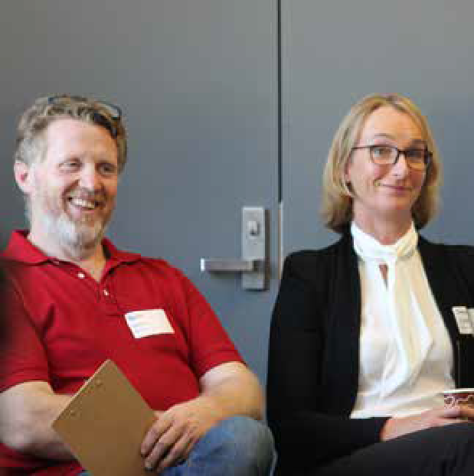

SURVEY: FEEDBACK ON DRAFT IDEAS

Following the session, participants were invited to provide feedback on the ideas drafted in the room.

Attendees were sent an electronic survey, and seven people responded.

The results of this survey are provided as an appendix to this report.
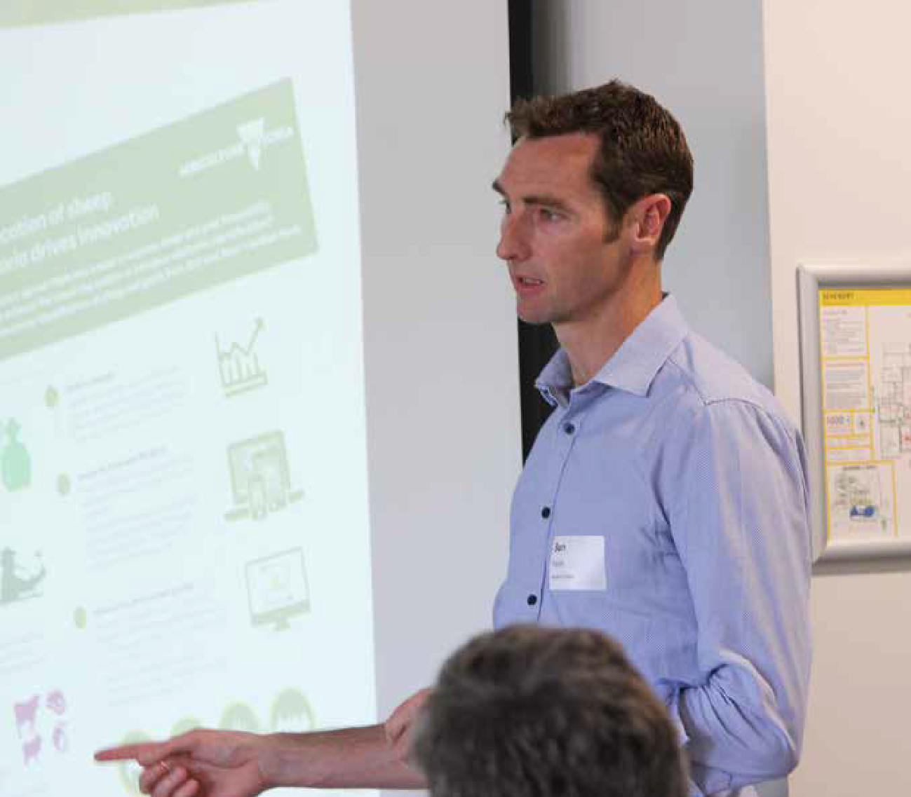

- FINAL REFLECTIONS
At the end of the workshop, participants shared their final reflections. Working in pairs, they captured what they
‘liked’, ‘wished’ and ‘wondered’.

we like

Moving around - network. Good mix of representatives. Good vibe from those attending.

Diversity and size of group brought together enabled good discussion and results.

Open and free conversations to propose and detail real industry / state biosecurity.

Lunch – pace.

Format / tables / google doc.
Opportunity to network and learn and talk back to my work / projects
– opportunity for interactions.

Well facilitated / inclusive / well- structured to meet new people and share ideas.

The broad networking opportunity and having other community groups sector.

The approach well presented. Great diversity / individuals in the room today.

That we were forced to think together and come up with practical solutions.

Dynamic space / networking opportunity.

Approach to strategic planning – refreshing.

Diversity of participants - good
Google doc activity – networking.

From a senior industry representative: depth of thinking in room / maturity of the discussion / general consensus about the need to work together.

Networking and hearing ideas. Answering questions and facilitation.

Format of the day’s program. Networking opportunities
/ communication across stakeholders, government, and industry etc. – good lunch.

Diversity of views / interactive
/ instant feedback follow up by
reflective feedback.

No butchers paper / variety of activities / broad inclusion of industries / good energy in the room.

facilitation and workshop session.
Interaction / breadth of
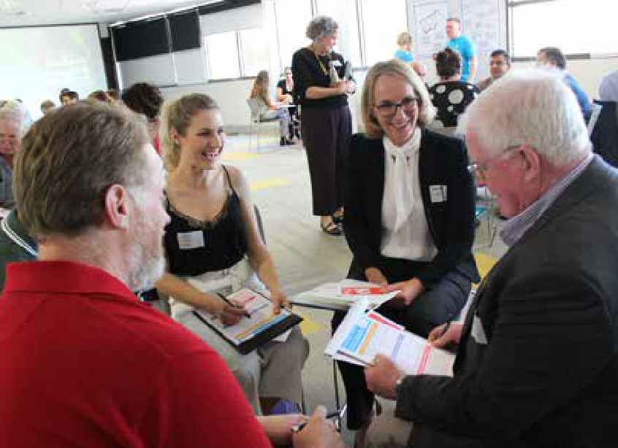
participants e.g. government / industry / plant / animal. Tangible documents to look back on.
Framework that has been used.
Format was refreshing and got everyone involved - good
energy. Good mix of perspectives. Genuine resolve to outcomes.
There will be outcomes and follow ups from the workshop. The format and movement of the day. Colourful drawn agenda.

Networking and learning alternative views / perspectives / ideas / perceptions.

People participate and stay all day, this leads somewhere – continual improvement.

we wish
Harmonisation across all stakeholders.
There was more community action groups included.

To fix all the biosecurity issues mentioned today - addition of farmers and general public / recreation groups.

To have more diverse people

Not twelve months to the next
e.g. from industry and from community and from public.
There was more time in first
session just prior to lunch. More
For a national RFID system for biosecurity traceability! (Lunch was longer - because great conversations were had among industry leaders).

meeting.
livestock associated information in

Go into depth through working
groups on specifics.

That greater diversity within
information / summary session.

Something tangible and practical
comes out of this effort.
More time to cover in-depth.

SME to talk to specific posters
/ focus groups to kick-start discussions.

biosecurity issues are represented
It assists creating a ‘robust’

next round table.

More funding, resourcing and engagement.

Will today’s themes be implemented?

Real change and implementation
– continued collaboration between people in the room.

That less sophisticated sectors or less involved sectors got greater emphasis and thought.
biosecurity system for the future generations. For stronger compliance. For behavioural change.
More service people were in the room to see it e.g. ministers / secretaries.
More stakeholders (diversity) presence today.
Meaningful outcome from workshop.
Mandatory recording animal events.

More time to interact with attendees.

Continuation of the co-design process.

We could have had representatives from other industries and stakeholders e.g. airport Marine and port of Melbourne fishing.

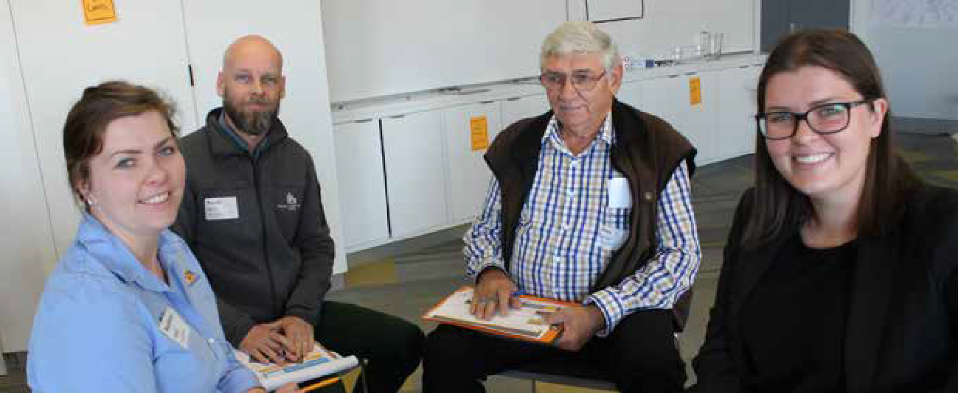

How will Feds use this?

we wonder

If some sectors need more support
If the biosecurity round table treated the approach issues light- heartily.

to bring in line with other sectors.
Biosecurity was not treated

What it will achieve – how to make long lasting meaningful change?

Will this enable change – is it going to effect change around breaking down existing walls?

Who else could have been here- water / public land?

Data ownership – collection and use.

How this ‘operationalises’ – next
What are we working towards?

What will the impact at this exercise be?

What happens after this when taken to national round table?

How this will be incorporated into this national workshop and what sort of alignment is seen with ideas?

How they are going to use this?

What will come of today’s hard work?

Will anything change – is it just a talk fest?

How many people will end up
seriously enough – biosecurity is a serious matter.

If we have the will (think we do) and the capacity to drive the change agenda?

More use of digital tools. Only opportunity for Ag Victoria / industry to engage with some stakeholders.

How we would react if there was a major outbreak?

How much change will occur and how?

If this work will influence upwards
and across borders?

Will this lead to change?

steps and outcomes – if real change could be made from these
reading and reflecting report?

Sustainable against changes in

discussions – how this connects
Can we coordinate nationally
government.

nationally - data - who owns it? (consistently).

Where does this end up? How will Victoria use this?

How a national and consistent approach is achievable?

What next?

If this will get to the cabinet room and Scomo and department secretary. What changes will AgVic make based on all our input and hard work today?

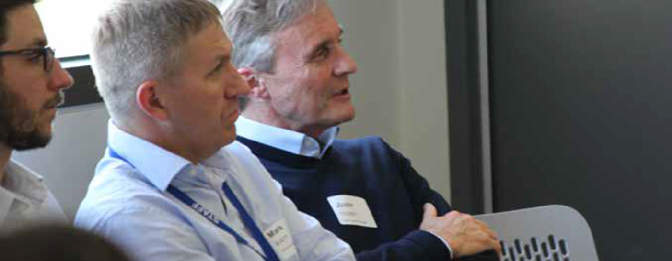

APPENDIX 1: SURVEY RESULTS

(FEEDBACK ON DRAFT IDEAS IN THE GROUP REPORT)
Following the session, participants were invited to provide feedback on the draft ideas outlined in the group’s Google Doc report (see section five above). Attendees were sent an electronic survey via email (and a copy of the full Google Doc group report). Seven people responded.

Respondents were invited to rate each idea on a ‘Love it’ to ‘Loathe it’ scale where:

love it | I am 80-100% comfortable with this option.  Only minor tweaks, if any, are required. I am very happy.
like it | I am 60-80% comfortable with this option.  Some small changes required but I am mostly happy.
live with it | I am 40-60% comfortable with this option.  Some changes are required but I can accept it as it is.
lament it | I am 20-40% comfortable with this option.  There are lots of changes required.
loathe it | I am 0-20% comfortable with this option.  It needs an overhaul, I can’t see it working at all.
  confused | Confused

Respondents could also provide feedback – describing what, if anything, would make them feel more comfortable with each idea. The results have been detailed on the following pages.

Long term and strategic funding & resourcing

Greater understanding of the dynamics involved in exotic assessments, barriers to reporting and costs/consequences to industry, government and community
IDEA
1
IDEA
2

57%

 | 43% |  | 43%

Comments
90%
80%
70%
60%
50%
40%
30%
29%
20%
14%
10%
0%
0% 0%
0%
90%
80%
70%
60%
50%
40%
30%
20%
10%
0%
0%
0%
0%
14%
love it
like it
live with it
lament it
loathe it
confused
love it
like it
live with it
lament it
loathe it
confused
“Co-design and joint decision-making is good but we need to move away from the focus on specific pests and diseases for a lot of work and look at pathways and behaviours that create the risk. This minimises duplication and builds a more strategic approach. Pest/ disease specific investment should only be for detection methodologies and diagnostics - invest more in what creates the risk of new and emerging threats.”
Comments
“I’m not convinced that this is an issue, we have a fairly robust PRA process. The barriers to reporting and changing attitudes is important though.”

IDEA
3
IDEA
4

to obtain nationally agreed practices/ standard for mandatory traceability (eg piCS)

Coordination and collaboration across government-industry and community

71%

43%

Comments
“Absolutely needed asap.”
“Unfortunately, government has been too passive here and this has caused the adhoc approach as industry filled the gap with a focus on their specific commodity.
Horticulture is missing and creates one of the biggest risks to containing a pest/disease outbreak... this needs to be addressed, there’s plenty of examples showing the need for improved traceability in horticulture that would have helped contain biosecurity outbreaks”
“This is a must to have consistency across Bio Security nationally and to assist with application.”
“I think that industry would resist this.”

Comments

90%
80%
70%
60%
50%
40%
30%
20%
10%
0%
0%
0%
0%
14%
14%
90%
80%
70%
60%
50%
40%
30%
20%
10%
0%
0% 0% 0%
29%
29%
love it
like it
live with it
lament it
loathe it
confused
love it
like it
live with it
lament it
loathe it
confused
“Still need leadership from someone. The buck also needs to stop with someone so there is an invested interest
to make sure it works and they can’t fob blame off to someone else.”
“Especially local government engagement.”
“Too many buzzwords as its written now, sounds like it came out of a Minister’s office. What does this actually look like and does industry understand what it is asking for? Is Victoria willing to move to principles- or outcome- based legislation that does give industry some latitude for how they manage their biosecurity risks?”
“Community needs to be educated however strong governance still needs to be controlled by authority.”

extend CropSafe into other industries

Data accessible to stakeholders - Govt and industry, in a timely manner to support decision making, identification of risk and market access. A well supported, accessible, relevant, central repository of
quality data
IDEA
5
IDEA
6

71%

Comments
10%
0% 0% 0%
14%
14%
30%
20%
43%
90%
80%
70%
60%
50%
40%
29%

90%
80%
70%
60%
50%
40%
30%
20%
10%
0%
0%
0%
0%
0%
29%
love it
like it
live with it
lament it
loathe it
confused
love it
like it
live with it
lament it
loathe it
confused
“Does one size fit all?”
“Individual farm visits is an outdated model of engagement that won’t work in many other industries.”
“The concept of a single surveillance system, database etc is good but requires all sectors and government to agree to a set of minimum data standards and how data is then shared.”

Comments
“Assurance of how the data is used and protected. Privacy etc.”
“Open source database, great idea. The Atlas of Living Australia is a good model (if it still operates as I think the feds cut its funding) - open source database that can be customised and was being used by a lot of community groups and NGOs for native species records.”
“Education is the key to learning and prevention.”
“Based on previous experience with AUSPestCheck, I doubt that data would be shared by government with stakeholders. It seems to be a one-way system.”

IDEA
7
IDEA
8

Building resilience through early, robust engagement

Clarify roles and accountabilities for the different players in biosecurity from government to industry

57%

 | 43% |  | 43%

Comments
“Link this to idea 4.”
“Probably more of a communication and awareness issue. I suspect a lot of this exists but either isn’t getting attention from the beneficiaries due to other priorities or the owners of the plans haven’t the resources to communicate. More work needs to be done in industry and in government to understand the role of the Liaison role in an outbreak response.”
“Engagement is fine and good, but issues with the EPPR Deed need to be resolved.”

Comments
90%
80%
70%
60%
50%
40%
30%
20%
10%
0%
0% 0% 0%
14%
90%
80%
70%
60%
50%
40%
30%
20%
10%
14%
0%
0% 0% 0%
29%
love it
like it
live with it
lament it
loathe it
confused
love it
like it
live with it
lament it
loathe it
confused
“Again with local government.”
“Succession planning and future proofing has been an issue for a generation. Until government gives certainty in long-term funding the agency will be subject to savings via attrition and short-term adhoc decisions. Government is losing its expertise and connection to community.”
“Good idea, from my expedience, different states have different expectations on roles and responsibilities.”

industry drive quality assurance programs
- need to have effective compliance and enforcement programs

efficient regulation
IDEA
9
IDEA
10

43%

Comments
10%
0% 0% 0%
14%
14% 14%
50%
40%
30%
20%
57%
90%
80%
70%
60%
90%
80%
70%
60%
50%
40%
30%
20% 14%
14%
10%
0%
0%
0%
29%
love it
like it
live with it
lament it
loathe it
confused
love it
like it
live with it
lament it
loathe it
confused
“Livestock has industry driven QA programs that are audited so struggled where this one came from”
“Lot of education needed for this to work well.”
“The words ‘in practice’ reflect the diversity of views. QA programs owned by the industry with the support of legislation and effective enforcement can be extremely effective. Self-regulation is a failure - don’t go near it. Co- regulation can work but it needs to be resourced at the government end and not neglected when issues arise and there needs to be independent auditing”
“Compliance needs to involve all those that are involved in the chain just not some”
“I doubt that industry would be supportive of compliance data being made available to government.”

Comments
“For serial offenders there has to be a deterrent.”
“A lot of good points here. Talk to Craig who was there as he explained a model with 11 dimensions that made a lot of sense and is being used by the EPA. He teaches it at Melbourne Uni.”
“This is a vague point. Of course, you want efficient regulation, what’s the alternative? Inefficient regulation? Getting harmonisation in approach across states has been a goal since Federation. very little progress has been made.”

IDEA
11
IDEA
12

Biosecurity management of public land is better integrated over public and private land - diseases don’t respect boundaries
improve Agriculture Victoria’s flexibility and agility (improve its capacity and ability to respond and prepare for exotic and endemic incursions) in particular with multiple/simultaneous pest and disease incursions.

71%

71%

Comments

90%
80%
70%
60%
50%
40%
30%
20%
10%
0%
0%
0%
0%
0%
29%

90%
80%
70%
60%
50%
40%
30%
20%
10%
0%
0%
0%
0%
14%
14%
love it
like it
live with it
lament it
loathe it
confused
love it
like it
live with it
lament it
loathe it
confused
“To me this one was more about public land - is poorly managed at the moment!!!!”
“Public land management resourcing needs to be prioritised. A nil tenure cooperative approach is shown to work well.”
“Good idea, but no one wants to pay for biosecurity on public land.”

Comments
“A continuous improvement built in culture as part of everyday business.”
“Definitely, lots of good points there.”
“Must be referenced to the national protocol for consistency”
“You would hope that they improve their systems in light of the recommendations of the reviews carried out at the end of a response. Victoria is lucky compared with other states. It has a lot of resources and has not recently really been tested yet by a big response. It has really just had a series of small responses.”

Building partnerships between government and industry around shared outcomes allowing for greater use of resources

Managing peri-urban biosecurity issues
IDEA
13
IDEA
14

57%

43%

Comments
90%
80%
70%
60%
50%
40%
30%
20% 14%
14%
10%
0%
0%
0%
29%
90%
80%
70%
60%
50%
40%
30%
20%
14%
10%
0%
0%
0% 0%
29%
love it
like it
live with it
lament it
loathe it
confused
love it
like it
live with it
lament it
loathe it
confused
“Avoid duplication”
“Needs to be explored more. Comes across as a Minister’s press release. “
“Having read the “what would it look like in practice” all I read is indecipherable jargon. Agree that QA programs provide more efficient regulation than government.”

Comments
“Major risk that needs continual effort as the people in peri urban areas often move in or out.”
“The role of citizen science could come into this as well. NZ does something about every New Zealander being part of the surveillance effort that is good.”
“Happy with it. Most of the states and DoA are looking into it at the moment. It is a high-risk area.”

IDEA
15
IDEA
16

increase education and awareness

Continuous improvement of biosecurity systems and procedures

57%

Comments
0% 0% 0%
0%
10%
14%
50%
40%
30%
20%
57%
90%
80%
70%
60%
29%
90%
80%
70%
60%
50%
40%
30%
20%
10%
14%
0%
0%
0%
0%
29%
love it
like it
live with it
lament it
loathe it
confused
love it
like it
live with it
lament it
loathe it
confused
“Objective is good. Needs a lot more clarification about what. The goal should be to have ‘biosecurity front of mind’ with everyone. At the moment we struggle to get growers, who benefit from biosecurity, having it front of mind so there’s a long way to go before every backyarder is thinking of it.”
“Good idea, but it is not just a matter of lacking ‘awareness’. Industry are aware of many aspects of the biosecurity system, they oppose some of the content, as it currently stands.”

Comments
“Needs more thinking.”
“Some good points - scanning for global risks (and then communicating them) and reviewing farm-level plans is good but a lot of it is about galvanising people to think and act.”
“Good idea, you would hope this always happens.”

IDEA
17

improved pre-border and at-border biosecurity management and resourcing.

86%

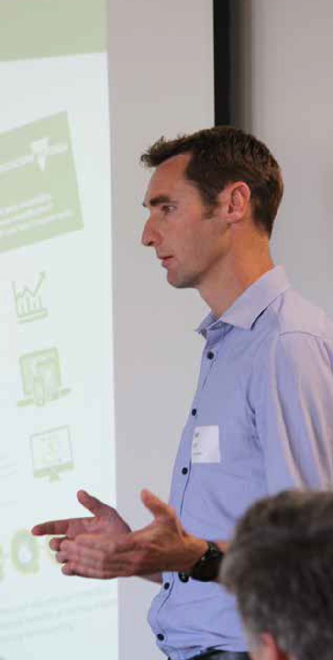
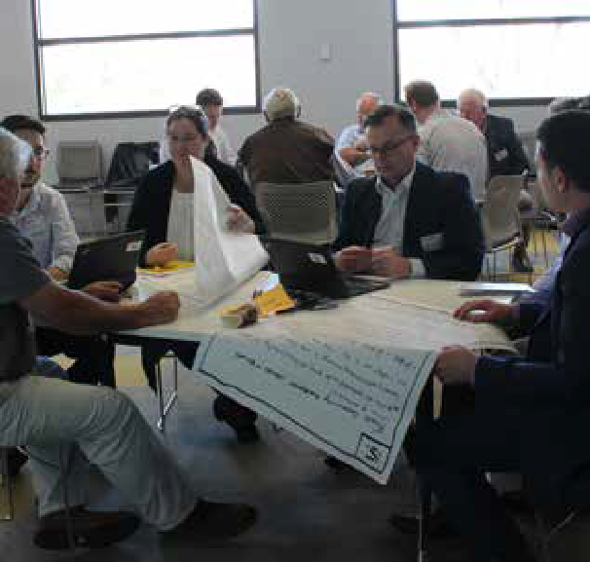
Comments

90%
80%
70%
60%
50%
40%
30%
20%
10%
0%
0%
0%
0%
0%
14%
love it
like it
live with it
lament it
loathe it
confused
“A lot of good points in this - pathways focus, better detection methods, border staff training. Need better transparency as well from the feds. It would be good to have a monthly report showing what was seized (the
product/goods) and why (the biosecurity risk) and what (airport/mail/container) and where (location).”
“Nationally.”
“This is the role of the Commonwealth and they have an obligation to sufficiently resource its function. The
container levy should all be transferred to biosecurity and not siphoned off to other departments.”

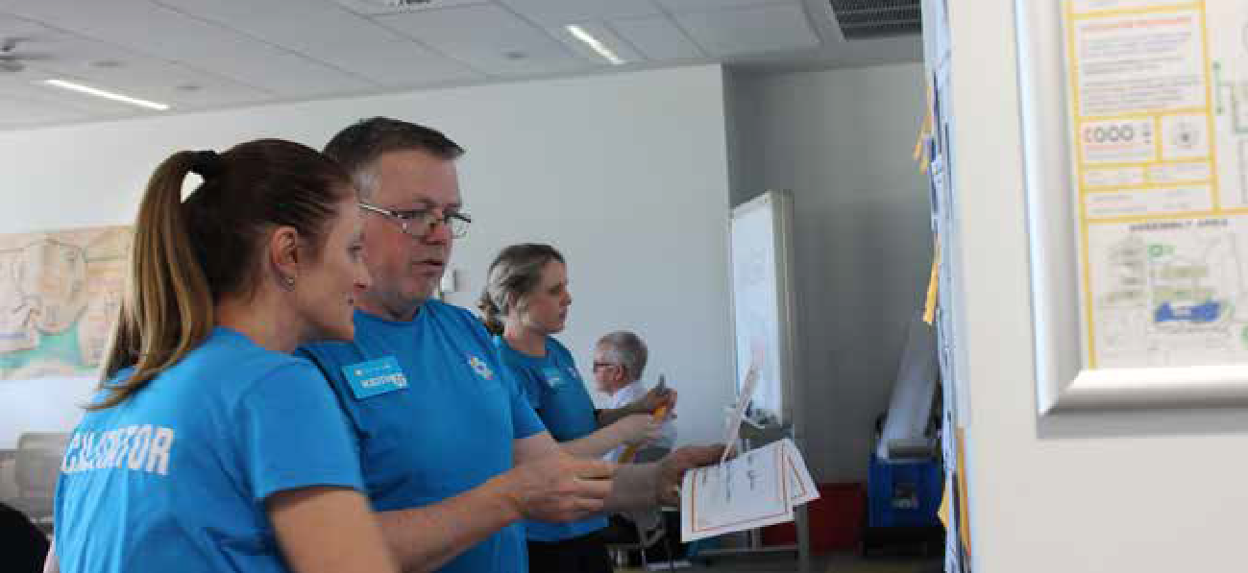
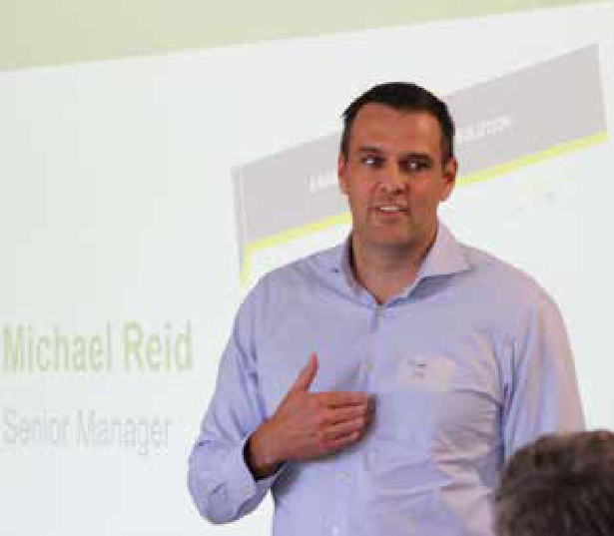
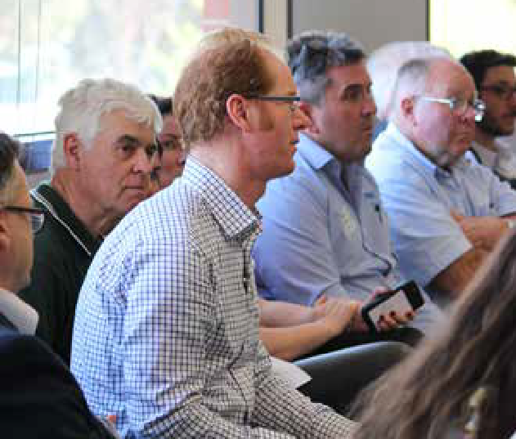
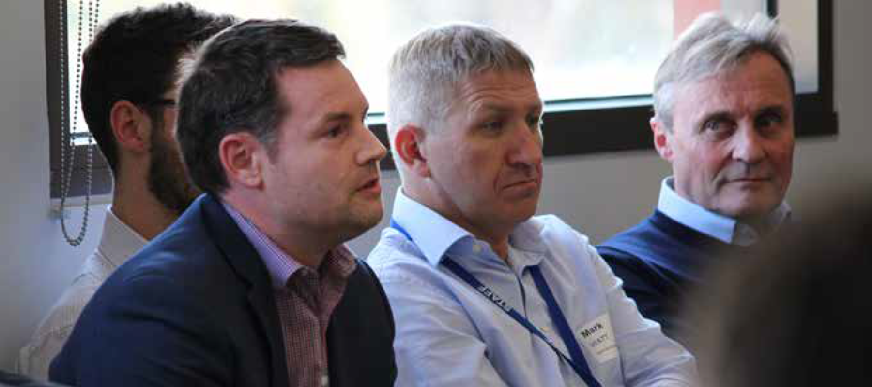


REPORT PREPARED BY:
www.mosaiclab.com.au

