Antibiotic Use in Horses: Stop, Think, Choose wisely
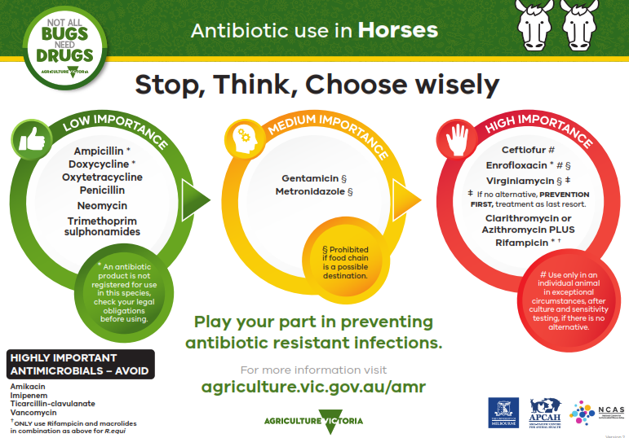

The information provided sets out the prioritisation of antibiotics for use by veterinarians as per Antibacterial Importance Ratings developed by the Australian Government with expert advice from the Australian Strategic and Technical Advisory Group (ASTAG). The antibiotics are displayed in circles corresponding to the colours of a traffic light; green, orange and red.
LOW IMPORTANCE (in a green circle)
Ampicillin (An antibiotic product is not registered for use in this species, check your legal obligations before using)
Doxycycline (An antibiotic product is not registered for use in this species, check your legal obligations before using)
Oxytetracycline
Penicillin
Neomycin
Trimethoprim sulphonamides
MEDIUM IMPORTANCE (in an orange circle)
Gentamycin (Prohibited if food chain is a possible destination)
Metronidazole (Prohibited if food chain is a possible destination)
HIGH IMPORTANCE (in a red circle)
Ceftiofur (Use only in an individual animal in exceptional circumstances, after culture and sensitivity testing, if there is no alternative)
Enrofloxacin (An antibiotic product is not registered for use in this species, check your legal obligations before using. Prohibited if food chain is a possible destination. If no alternative, PREVENTION FIRST, treatment as a last resort.)
Virginiamycin (Prohibited if food chain is a possible destination. If no alternative, PREVENTION FIRST, treatment as a last resort.)
Clarithromycin or Azithromycin PLUS Rifampicin (ONLY use Rifampicin and macrolides in combination as described for R.equi)
HIGHLY IMPORTANT ANTIMICROBIALS - AVOID:
Amikacin
Imipenem
Ticarcillin-clavulanate
Vancomycin
ONLY use Rifampicin and macrolides in combination as above for R.equi
Play your part in preventing antibiotic resistant infections
For more information visit the Antimicrobial resistant infections webpage of the Agriculture Victoria website at agriculture.vic.gov.au/amr
Developed and designed by Agriculture Victoria, the University of Melbourne, the Asia-Pacific Centre for Animal Health and the National Centre for Antimicrobial Stewardship.

