DL Equine Pocket Guide for Antimicrobial Use in Horses
For more information and further resources visit the Veterinary Prescribing Guidelines page of the University of Melbourne website at www.fvas.unimelb.edu.au/vetantibiotics
Sponsored by Equine Veterinarians Australia, National Centre for Antimicrobial Stewardship, Asia-Pacific Centre for Animal Health, The University of Melbourne and Agriculture Victoria.

Page 1: Antibiotic Pharmacokinetics & Pharmacodynamics
Bacteriostatic
- “ECSTaTiC for bacteriostatic”
- Erythromycin (macrolides)
- Clindamycin
- Sulphonamides
- Trimethoprim
- Tetracyclines
- Chloramphenicol

Bactericidal
- “Very Proficient For Complete Cell Murder”
- Vancomycin
- Penicillin
- Fluoroquinolones
- Cephalosporins
- Carbapenems
- Metronidazole

Time-Dependent
- Optimise killing by maximising time above MIC.
- More frequent administration or extended infusion increases efficacy by extending T>MIC.
- Goal exceed MIC by 1-5 times for 50-80% of dosage interval.
- E.g. penicillin, ceftiofur, TMS, tetracyclines, chloramphenicol.

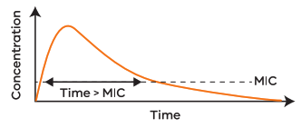 Figure 1 Concentration vs Time graph showing MIC

Concentration Dependent
• Optimise killing by maximising peak concentration.
• Higher doses at less frequent intervals increases efficacy by maximising Cmax:MIC ratio.
• Goal Cmax:MIC >8.
• E.g. aminoglycosides, fluoroquinolones, metronidazole.

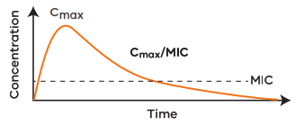 Figure 2 Concentration vs Time graph showing Cmax/MIC

Intrinsic resistance
- All members of a bacterial genus or species have properties that make them naturally resistant to certain antimicrobials.

Acquired resistance
- Previously susceptible bacteria acquire new genes or a mutation occurs conferring resistance.

Page 2: Spectrum of Activity Against Common Bacteria
Refer to local antibiogram for susceptibility rates (if available).

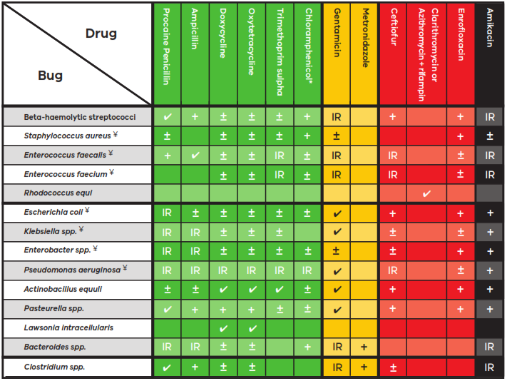
Figure 3 Tabulated traffic light representation of Spectrum of Activity Against Common Bacteria based on ASTAG antimicrobial importance rating system.

Pages 3 and 4: Antibiotic Pharmacotherapy by Class

Commonly used antibiotics are tabulated and described under the headings: Drug class, Importance Rating, Antibiotic, Route, Drug Dose, Adverse Reactions, Clinical Pearls. Many of the recommendations in this guide represent off-label use of antimicrobials. Compliance with the legal requirements of your jurisdiction is your responsibility. Exceptional circumstances defined as use in an individual animal based on culture and susceptibility, where there is no effective alternate therapy and a reasonable chance of survival.

Drug Class: Beta-lactams
Antibiotic | Procaine penicillin
Importance Rating | Low
Route | IM
Drug Dose | 22,000 IU/kg (22 mg/kg) q12h
Adverse Reactions | Diarrhoea. Procaine reaction: Inadvertent intravascular administration of procaine resulting in CNS excitation and frantic, uncontrollable behaviour that generally resolves in minutes. Penicillin hypersensitivity reactions: urticaria, anaphylaxis, immune mediated haemolytic anaemia.
Clinical Pearls | Drug of choice for streptococcal infections. Excellent anaerobic activity (except Bacteroides spp.). Often combined with gentamicin for broad spectrum coverage. Always draw back to check for blood before injecting and keep penicillin refrigerated to reduce risk of procaine reaction.  Long acting penicillin formulations are not suitable for use in horses as they aren’t long acting and don’t reach therapeutic concentrations.
Antibiotic | Benzylpenicillin
Importance Rating | Low
Route | IV
Drug Dose | 22,000 IU/kg (13 mg/kg) q4-6h
Adverse Reactions | Diarrhoea. Procaine reaction: Inadvertent intravascular administration of procaine resulting in CNS excitation and frantic, uncontrollable behaviour that generally resolves in minutes. Penicillin hypersensitivity reactions: urticaria, anaphylaxis, immune mediated haemolytic anaemia.
Clinical Pearls | Drug of choice for streptococcal infections. Excellent anaerobic activity (except Bacteroides spp.). Often combined with gentamicin for broad spectrum coverage. Always draw back to check for blood before injecting and keep penicillin refrigerated to reduce risk of procaine reaction.  Long acting penicillin formulations are not suitable for use in horses as they aren’t long acting and don’t reach therapeutic concentrations.
Antibiotic | Benzylpenicillin
Importance Rating | Low
Route | IU
Drug Dose | 5 million IU for Streptococcus zooepidemicus
Adverse Reactions | Secondary bacterial infection, fungal infection.
Clinical Pearls | Uterine lavage and ecbolics are the primary focus of endometritis therapy. Uterine fluid/exudate may inactivate or dilute antibiotics. Inactivated in solutions with pH <5.5 or >8, do not mix with gentamicin, sulphonamides or sodium bicarbonate. Antibiotic use should be guided by culture, cytology and ultrasound findings.
Antibiotic | Ampicillin sodium
Importance Rating | Low
Route | IV/IM
Drug Dose | 20 mg/kg q6-8h
Adverse Reactions | Ampicillin trihydrate irritant when injected IM.
Clinical Pearls | Greater activity against gram-negative bacteria than penicillin.
Antibiotic | Ceftiofur
Importance Rating | High
Route | IM/IV
Drug Dose | 2.2-4.4 mg/kg q12-24h (Up to 10mg/kg IV q6h has been used in neonatal foals)
Adverse Reactions | Diarrhoea, muscle soreness, hypersensitivity - urticaria, anaphylaxis.
Clinical Pearls | Reserve for multi-drug resistant infections. Does not cross BBB. Ceftiofur is rapidly  metabolised to desfuroylceftiofur to which most coagulase positive staphylococci are  resistant (may appear susceptible in vitro but not in vivo).

Drug Class: Aminoglycosides
Antibiotic | Gentamicin
Importance Rating | Medium
Route | IM/IV
Drug Dose | 6.6 - 9.7 mg/kg q24h (adults)
Adverse Reactions | Nephrotoxic. Muscle soreness if given IM. Hypersensitivity reactions (rare).
Clinical Pearls | Generally, drug of choice for suspected or confirmed gram negative infections. No anaerobic activity. Streptococci & enterococci are intrinsically resistant. Inactivated by purulent material. Must penetrate bacteria to assert their effect, which is enhanced by drugs that interfere with cell wall synthesis – e.g. penicillin. Not effective clinically against Salmonella spp. but may appear susceptible in vitro. If kidney function is reduced, increase  inter-dosing interval.
Antibiotic | Gentamicin
Importance Rating | Medium
Route | IM/IV
Drug Dose | 8.8 - 12 mg/kg q24-36h (foals)
Adverse Reactions | Nephrotoxic. Muscle soreness if given IM. Hypersensitivity reactions (rare).
Clinical Pearls | Generally, drug of choice for suspected or confirmed gram negative infections. No anaerobic activity. Streptococci & enterococci are intrinsically resistant. Inactivated by purulent material. Must penetrate bacteria to assert their effect, which is enhanced by drugs that interfere with cell wall synthesis – e.g. penicillin. Not effective clinically against Salmonella spp. but may appear susceptible in vitro. If kidney function is reduced, increase  inter-dosing interval.
Antibiotic | Gentamicin
Importance Rating | Medium
Route | IU
Drug Dose | 1-2 g buffered with equal volume of 7.5% bicarbonate and diluted in 200ml saline.
Adverse Reactions | Irritates endometrium or induce depigmentation of vulvar skin if not buffered. Secondary bacterial infection, fungal infection.
Clinical Pearls | Generally, drug of choice for suspected or confirmed gram negative infections. No anaerobic activity. Streptococci & enterococci are intrinsically resistant. Inactivated by purulent material. Must penetrate bacteria to assert their effect, which is enhanced by drugs that interfere with cell wall synthesis – e.g. penicillin. Not effective clinically against Salmonella spp. but may appear susceptible in vitro. If kidney function is reduced, increase  inter-dosing interval.
Antibiotic | Amikacin
Importance Rating | High
Route | IV
Drug Dose | 10mg/kg q24h  (adults)
Adverse Reactions | Nephrotoxic.
Clinical Pearls | Use severely restricted in human medicine. Not registered for use in animals and should not be used off-label except in exceptional circumstances**. Reserve for documented gentamicin resistant, amikacin susceptible infections where no alternative. No anaerobic activity. Streptococci & enterococci are intrinsically resistant. Inactivated by purulent material. Not effective clinically against Salmonella spp. but may appear susceptible in vitro. Can be used IA.
Antibiotic | Amikacin
Importance Rating | High
Route | IV
Drug Dose | 25 mg/kg q24h  (foals)
Adverse Reactions | Nephrotoxic.
Clinical Pearls | Use severely restricted in human medicine. Not registered for use in animals and should not be used off-label except in exceptional circumstances**. Reserve for documented gentamicin resistant, amikacin susceptible infections where no alternative. No anaerobic activity. Streptococci & enterococci are intrinsically resistant. Inactivated by purulent material. Not effective clinically against Salmonella spp. but may appear susceptible in vitro. Can be used IA.

Drug Class: Tetracyclines
Antibiotic | Doxycycline
Importance Rating | Low
Route | PO
Drug Dose | 10 mg/kg q12h
Adverse Reactions | Diarrhoea. Bone/tooth discolouration. DO NOT GIVE IV – FATAL.
Clinical Pearls | Excellent broad-spectrum activity, good anaerobic coverage but variable for Bacteroides and Clostridium spp. Drug of choice for Lawsonia intracellularis infection. Doxycycline bioavailability reduced by  feeding; withhold feed before and shortly after dosing. Doxycycline can be used in horses with renal failure. Distributes well into pulmonary, peritoneal and synovial fluid and concentrates in urine.
Antibiotic | Oxytetracycline
Importance Rating | Low
Route | IV
Drug Dose | 6.6 mg/kg q12h
Adverse Reactions | Hypotension & collapse if rapid IV administration of oxytetracycline. Renal tubular necrosis with high doses (i.e. for neonatal foals with contracted tendons). Bone/tooth discolouration. Colitis. Very irritant if extravascular or intramuscular.
Clinical Pearls | Excellent broad-spectrum activity, good anaerobic coverage but variable for  Bacteroides and Clostridium spp. Drug of choice for Lawsonia intracellularis infection. Distributes well into pulmonary, peritoneal and synovial fluid and concentrates in urine. High dose oxytetracycline causes tendon  relaxation in foals with congenital contracted tendons (not acquired) and is most efficacious when given in the first 3 days of life (20 mg/kg IV). Care in foals that are, or may be, dehydrated due to renal effects; consider  administration in 1L hartmans.

Drug Class: Sulphonamides
Antibiotic | Trimethoprim sulphonamide
Importance Rating | Low
Route | PO/slow IV
Drug Dose | 30 mg/kg q12h
Adverse Reactions | Diarrhoea. Thrombocytopaenia with prolonged use. Rapid IV administration can cause tremors and collapse. Concurrent detomidine can result in dysrhythmia, hypotension and death. Concurrent penicillin is antagonistic to sulphonamides. Irritant if given IU or IM.
Clinical Pearls | Excellent broad-spectrum activity. Inactivated by purulent material. Undergoes urinary excretion therefore useful for urinary tract infections.

Drug Class: Macrolides
Antibiotic | Erythromycin
Importance Rating | Low
Route | PO
Drug Dose | 25mg/kg q6h
Adverse Reactions | Severe colitis in adults, variable diarrhoea in foals. Altered thermoregulation in foals (hyperthermia), which seems more common with erythromycin.
Clinical Pearls | Do not use in adults. Generally, only used in foals with Rhodococcus equi, in combination with rifampin. Can be used in young foals with Lawsonia intracellularis infection but not first line choice.
Antibiotic | Clarithromycin
Importance Rating | Low
Route | PO
Drug Dose | 7.5mg/kg q12h
Adverse Reactions | Severe colitis in adults, variable diarrhoea in foals. Altered thermoregulation in foals (hyperthermia), which seems more common with erythromycin.
Clinical Pearls | Do not use in adults. Generally, only used in foals with Rhodococcus equi, in combination with rifampin. Can be used in young foals with Lawsonia intracellularis infection but not first line choice.
Antibiotic | Clarithromycin
Importance Rating | Low
Route | PO
Drug Dose | 10mg/kg q24h
Adverse Reactions | Severe colitis in adults, variable diarrhoea in foals. Altered thermoregulation in foals (hyperthermia), which seems more common with erythromycin.
Clinical Pearls | Do not use in adults. Generally, only used in foals with Rhodococcus equi, in combination with rifampin. Can be used in young foals with Lawsonia intracellularis infection but not first line choice.

Drug Class: Ansamycin
Antibiotic | Rifampin
Importance Rating | High
Route | PO
Drug Dose | 5 mg/kg q12h
Adverse Reactions | Body fluids turn orange. Antagonistic to gentamicin.
Clinical Pearls | Empiric use only for Rhodococcus equi, in combination with a macrolide. Otherwise only use in exceptional circumstances** based on culture and susceptibility and no effective alternative. Never use alone, resistance can develop within hours when used as monotherapy.

Drug Class: Fluoroquinolones
Antibiotic | Enrofloxacin
Importance Rating | High
Route | PO/slow IV
Drug Dose | 7.5 mg/kg q24h
Adverse Reactions | OCD in young horses. DO NOT USE IM, IA, IU or as IVRP as causes necrosis and fibrosis. Oral paste has been associated with severe oral ulceration. Colitis. Fluoroquinolone Have also induced tendonitis in juveniles.
Clinical Pearls | Should be reserved for multi-drug resistant infections based on culture and susceptibility results and no effective lower importance rating option. Generally avoided in horses <4 years of age and during pregnancy. Synergism with beta-lactams and aminoglycosides.

Drug Class: Nirtoimidazoles
Antibiotic | Metronidazole
Importance Rating | Medium
Route | PO
Drug Dose | 25 mg/kg q12h
Adverse Reactions | Inappetence. Can cause neurological signs if underlying hepatic disease.
Clinical Pearls | Excellent anaerobic activity. Use is generally combined with penicillin and gentamicin for broad spectrum coverage where anaerobes are suspected to be contributing (pleuropneumonia, peritonitis). Indicated in cases where Bacteroides spp. may be involved.

Drug Class: Phenicols
Antibiotic | Chloramphenicol
Importance Rating | Low
Route | PO
Drug Dose | 50 mg/kg q12h
Adverse Reactions | Wear gloves and mask when crushing tablets for horses as idiosyncratic aplastic anaemia (not dose related) can develop in people handling this drug. In horses, dose- related anaemia and pancytopenia may develop with prolonged treatment.
Clinical Pearls | Broad spectrum. Prohibited for use in animals that may enter the food chain -which includes horses in some states. Check legislation in your jurisdiction. Do not give concurrently with penicillin, gentamicin, fluoroquinolones or macrolides. Hepatic clearance of phenytoin, phenobarbital, phenulbutazone and xylazine is decreased.

Drug Class: Polypeptides
Antibiotic | Polymyxin B
Importance Rating | High
Route | Slow IV
Drug Dose | 5000 U/kg q8-12hrs (anti- endotoxin dose)
Adverse Reactions | Nephrotoxic.
Clinical Pearls | Generally only used systemically to combat endotoxaemia. Care should be taken as endotoxic patients often have impaired renal perfusion.

Drug Class: Streptogrammins
Antibiotic | Virginiamycin
Importance Rating | High
Route | PO
Drug Dose | 5g/100kg q24h
Adverse Reactions | High importance antimicrobial – banned for Equine use in UK 2014.
Clinical Pearls | Founderguard – reduces fermentative acidosis in the hindgut and may aid in the prevention of pasture-associated laminitis.

Drug Class: Other
Antibiotic | Sodium iodide
Importance Rating | Low
Route | IV
Drug Dose | 20-40mg/kg q24h
Adverse Reactions | Iodinism.
Clinical Pearls | Generally used for chronic fungal or Bacterial infections where antimicrobial  penetration may be poor.

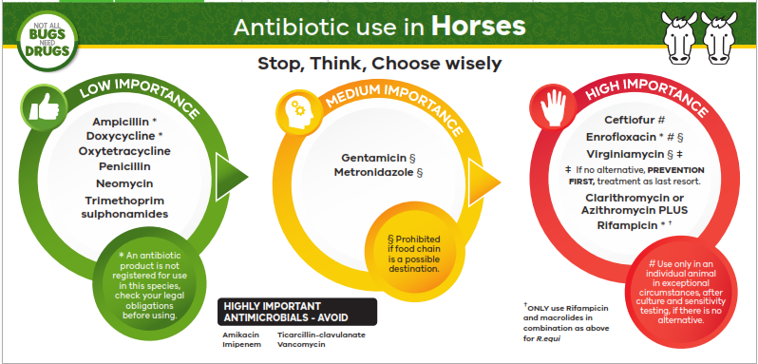
Figure 4 Traffic light card: Antibiotic use in horses

