Managing the risk of chemical cross-contamination in horticulture
Cross-contamination refers to the unintentional transfer of chemicals from a surface to fresh produce.

Sources of cross-contamination
Cross-contamination most commonly occurs during the handling and storage of fresh produce after it has been harvested. The risk of cross-contamination is increased when different commodities are handled with the same equipment, handled in the same premises or when produce is moved between facilities. Sources of chemical exposure include the following:
- Storage or picking bins/boxes
- Packing, sorting or grading equipment (ie conveyor belts, brushes etc)
- Spray tanks and dipping vats
- Cool rooms or storage facilities.
Chemical residues can remain on equipment such as bins for long periods of time. Care should be taken when using equipment that has been used to store or handle a different commodity.
Post-harvest treatments invariably leave residues on all infrastructure and equipment that is used to either apply the chemical or handle the treated produce (eg bins, tanks, vats, conveyor belts, brushes). If the same infrastructure or equipment is used to handle different commodities with different chemical treatments (ie stone and pome fruit, citrus and sultanas) there is a high risk that cross-contamination will occur.
Cross-contamination of fruit after storage in cool rooms has been identified as a risk. The post-harvest scald inhibitor, DPA, which is used on pome fruit can be absorbed onto the walls within cool rooms where treated fruit is stored. It can then later be released from the walls and reabsorbed onto other fruit (eg citrus) that is stored in the same cool room. 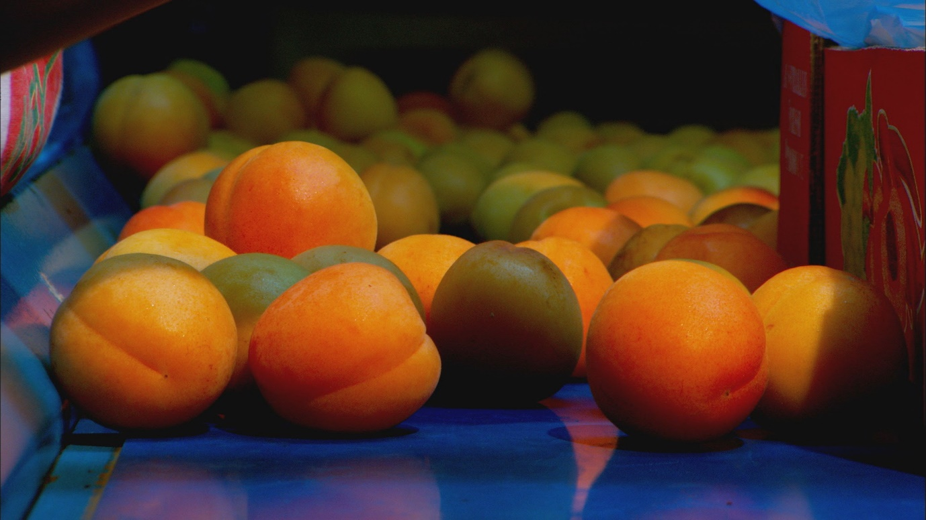

How to manage cross-contamination risks
Growers have a responsibility to manage the risks of cross-contamination so that they do not sell produce with unacceptable chemical residues. Some controls to prevent cross-contamination are:
- Ensure all spray equipment is adequately cleaned and decontaminated between different applications.
- Follow the cleaning specifications outlined by the manufacturer of the chemical product.
- Any infrastructure or equipment that is contacted by produce (especially after post-harvest treatments), should be cleaned and decontaminated after use and before a different commodity comes into contact with that surface. This includes, but is not limited to picking bins, storage bins, sorting and packing conveyor belts, brushes, scrubbers, cool rooms or storage facilities.
- If infrastructure or equipment cannot be adequately decontaminated, other strategies or controls need to be put in place to ensure cross-contamination does not occur.
- Where possible, use different packing and sorting equipment for different commodities.
- If you share equipment (ie bins) with another grower, packer or processor, know how and what the equipment has been used for and what chemicals it may have been exposed to. Ensure that the equipment has been adequately cleaned and is free of agricultural chemicals before you use it.
- When storing fresh produce, ensure that it is segregated from other produce that has had different chemical treatments.
- Only use registered products and ensure the commodities you are treating are specifically approved in the label directions for use.
- Ensure you completely read and understand the product label before using any chemical product. Labels may contain information or requirements relating to decontamination and segregation. 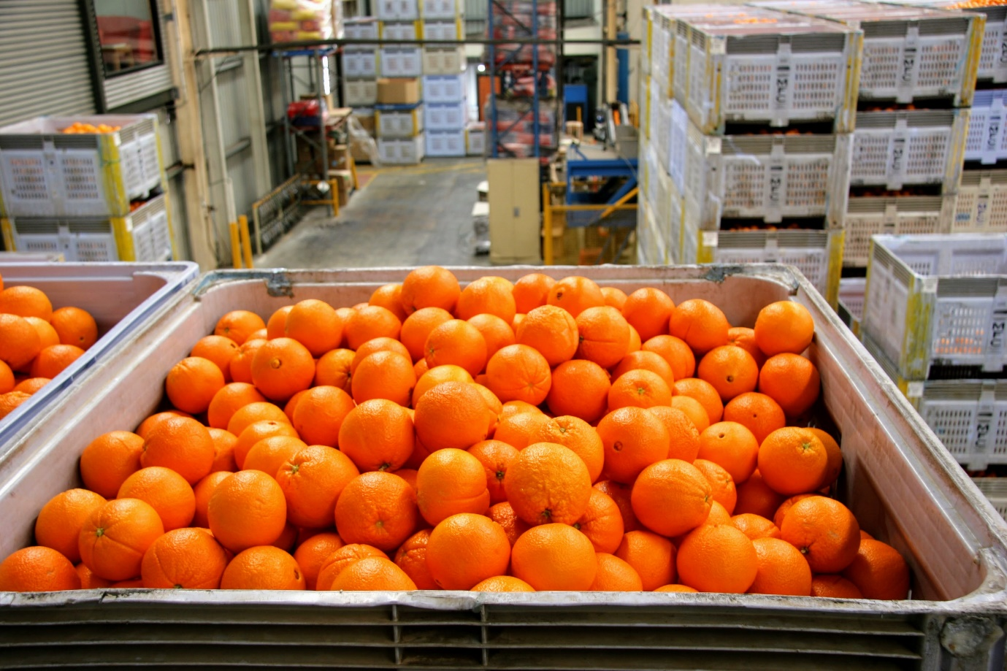

Legal requirements when using chemicals
As laboratory capabilities improve, chemical residues can be detected at extremely low levels. This increases the likelihood of the detection of residues from cross-contamination.
Cross-contamination can result in unacceptable chemical residues in produce, and growers selling contaminated produce.
Agriculture Victoria regulates the use of chemicals in Victoria under the Agricultural and Veterinary Chemicals (Control of Use) Act 1992 (the Act). It is the responsibility of the chemical user to understand their legal responsibilities when using agricultural chemicals and ensure that the use does not result in unacceptable residues in produce.
Under the Act it is illegal for a grower to sell produce that is contaminated regardless of how the residue was incurred.
Maximum residue limits
Maximum residues limits (MRLs) are the maximum concentration of a chemical that is permitted in a commodity. The absence of a relevant MRL for a chemical in a commodity means that no detectable residue is permitted. Produce with residue(s) that do not comply with MRL standards is considered contaminated. MRLs can be exceeded due to cross-contamination.
If a chemical is not registered to be used on a commodity, there will usually be no relevant MRL. Where there is no MRL set for a chemical/commodity combination, any detectable residue is unacceptable. For example, diphenylamine (DPA) is registered for use on pome fruit, but not on citrus fruit. Some growers or packers may handle both types of fruit and cross contamination of the citrus may occur if DPA has been used on the pome fruit. Any detectable residue of DPA on citrus would be considered unacceptable.

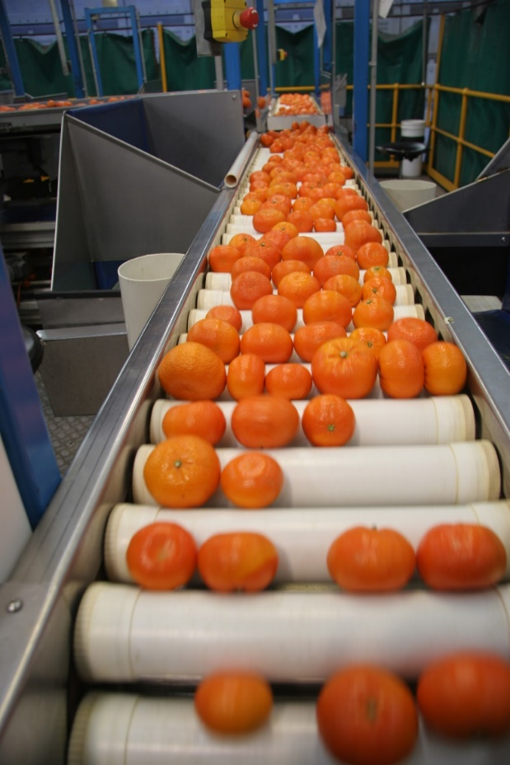

Further information
Visit agriculture.vic.gov.au/farm-management/chemicals or email chemical.standards@agriculture.vic.gov.au

