Significant Disease Investigation Guide HORSES
The role of veterinarians is critical to help protect the health of people, livestock, companion animals and wildlife by reporting and investigating significant disease events.
This booklet aims to help you conduct a Significant Disease Investigation involving horses, and provides information about reporting notifiable diseases, as prescribed under the Livestock Disease Control Act 1994.
Companion editions to this guide have been produced for pigs, cattle and sheep diseases. You can obtain copies by contacting cvo.victoria@agriculture.vic.gov.au

Disclaimer
This publication may be of assistance to you but the State of Victoria and its employees do not guarantee that the publication is without flaw of any kind or is wholly appropriate for your particular purposes and therefore disclaims all liability for any error, loss or other consequence which may arise from you relying on any information in this publication. This guide was produced with the assistance of the Faculty of Veterinary and Agricultural Sciences, University of Melbourne, the Department of Agriculture and Water Resources, the Government of Western Australia, the Northern Territory Government and the Queensland Government. Thanks to Agriculture Victoria staff who also provided pictures.

The Victorian Significant Disease Investigation program
The Victorian Significant Disease Investigation (SDI) program aims to boost Victoria’s capacity for the early detection of significant diseases in livestock (including horses, pigs and poultry) and wildlife by increasing the participation of veterinarians and subsidising the cost of investigating significant or unusual disease incidents.
Subsidies are available for initial field investigations, including clinical examination and necropsy, laboratory testing and follow-up investigations. Subsidy details can be found on the Agriculture Victoria Significant Disease Investigations website page agriculture.vic.gov.au/SDI
To be considered a significant disease, one or more of the following criteria must be met:
- an unusual or atypical manifestation of disease, including high morbidity, mortality and/or rate of spread,
- an initial investigation fails to establish a diagnosis, including when veterinary treatment does not produce an expected response, or
- findings suggesting a possible effect on trade, public health, biodiversity or the viability of the farm, industry or region, excluding events where there is a genuine suspicion of an emergency animal disease.
Where there is a genuine suspicion of an exotic or emergency animal disease, Agriculture Victoria will lead and cover the cost of the disease investigation.
If you wish to take advantage of this program, please contact your local Agriculture Victoria veterinarian prior to submitting samples.
If you suspect an exotic or emergency animal disease, call the hotline 1800 675 888 immediately.

Report suspicion (or confirmation) of notifiable diseases
Under the Victorian Livestock Disease Control Act 1994, a person knowing or having reason to suspect that a notifiable disease is present in livestock (or livestock products) that are either:
- owned by that person or in the possession, control or charge of that person; or
- on land owned and occupied by that person; or
- dealt with by that person as a veterinary practitioner, an inspector under the Meat Industry Act 1993 or the Export Control Act 1982, operator of a meat processing facility licensed under the Meat Industry Act 1993 where a quality assurance program is in force; or
- dealt with by the owner or person in charge of premises registered as a veterinary diagnostic laboratory, knacker, stock agent or other person dealing with livestock, livestock products or hives by way of a profession, trade or business must report the disease or the suspicion of disease. The term ‘livestock’ includes horses under the Act.
If a horse has been seen by a veterinarian and a notifiable disease is suspected, it is usually the veterinarian who notifies Agriculture Victoria

Table 1. Endemic diseases of horses that are notifiable in Victoria
Report immediately | Report within 12 hours | Report within 7 days
Hendra virus | equine herpes virus – type 1  (abortigenic and neurological strains) | equine infectious anaemia
anthrax | cattle tick (Rhipicephalus microplus) | equine viral arteritis
 |  | leptospirosis
 |  | salmonellosis
 |  | strangles
 |  | verocytotoxigenic E. coli

A full list of notifiable diseases, including exotic diseases, can be found on the Agriculture Victoria website, agriculture.vic.gov.au or see the “Notify Now” smartphone app to access the current list of notifiable diseases on your phone. Download the app for free from the AppStore or Google play; just search on “notify’ and ‘Victoria’.
Notification can be made by
- contacting your local Agriculture Victoria Animal Health and Welfare staff, or
- using the “Notify Now” smartphone app, or
- calling the all-hours Emergency Animal Disease Watch Hotline on 1800 675 888.
A disease notification form can also be downloaded from the Agriculture Victoria website. Details of where to forward the report are provided on the form.

Significant Disease Investigation
Ensure all required information is collected at the time of examination
Information required on the record of disease event (RODE) and laboratory submission forms includes:
• Owner and property details including the Property
Identification Code (PIC)
• Species. Is more than one species affected?
• Number affected
- number of deaths
- number sick
- number at risk
- number examined.
• Age, condition score, sex
• History and predisposing factors
- Date the outbreak began
- The time until recovery
- Vaccinations and treatments recently given
- Recent livestock introductions
- Possible sources of introduction and spread
- Grazing/feeding history, pasture/feed type
and weed species
• Clinical history and signs
• Primary syndrome
• Gross lesions and necropsy findings
• Include photographs where relevant
- unwell and dead horses
- gross lesions
RODE forms can be downloaded from www.agriculture.vic.gov.au/SDI

Just a reminder…always practice good biosecurity
To avoid disease spread between properties:
• Always carry disinfectant and cleaning equipment in your vehicle
• If possible, leave your vehicle outside the property
• Include a bucket, brush, disinfectant and bin bags.
• Ensure clothes and boots are clean prior to entering the property
• Wear disposable gloves to collect samples
• Always clean boots and equipment before disinfecting. Soil and organic material can prevent disinfectants from being effective.
• Pay particular attention to footwear, hands and fingernails as well as equipment used on animals.
• Collect all waste and disposable equipment in a plastic bin bag
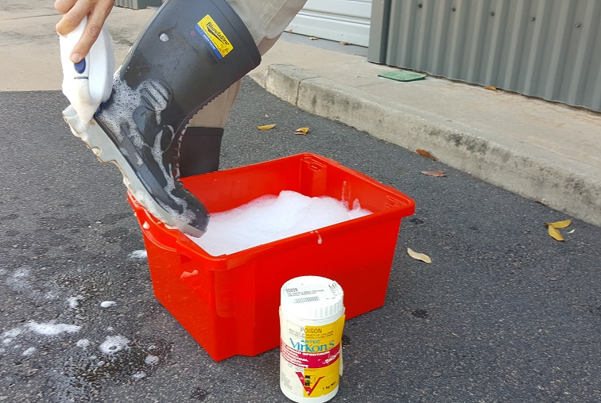
If you suspect an emergency animal disease, call the hotline immediately, 1800 675 888, before leaving the property.

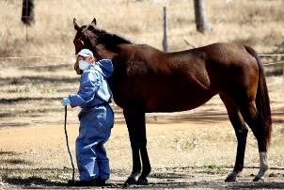

Always consider potential zoonotic diseases prior to examining the horse
When investigating a disease incident, always consider potential zoonotic diseases and ensure those in contact with the horses take appropriate safety precautions, including:
• Always assume that a zoonotic disease may be present, and ensure good hygiene and safety practices (Remember that infected horses may shed disease agents (e.g. Hendra virus) prior to showing clinical signs of disease).
• Do not conduct a necropsy if diseases such as Hendra or anthrax are suspected
• Perform an in-field anthrax ICT test in cases of sudden death or if there is any suspicion of anthrax
• Wear appropriate personal protective equipment when examining horses
• Take care not to ingest food or water potentially contaminated with faecal material or other secretions
• Avoid splashing or inhaling body fluids
• Avoid insect bites such as ticks or mosquitoes (e.g. wear long sleeves and/or use insect repellents)
• Pay particular attention to your own skin wounds (i.e. cover the wound to prevent infection)
• Consider vaccination against diseases such as Q fever and rabies
• If you are unsure about a safety procedure, do not proceed until you have sought advice. (No query is foolish if it protects your own health)
• Seek medical advice if you are concerned about exposure to a zoonotic agent

Table 2. Potential zoonotic diseases of horses
Known to occur in Australia | Mode of transmission
Hendra virus | Contact with infected body fluids or tissues or through droplet transmission.  Nasal secretions may pose a risk of transmission prior to horses showing clinical signs
anthrax (Bacillus anthracis) | Contact with anthrax spores; entry via a wound or scratch  Inhalation of spores
chlamydiosis (Chlamydia psittaci) | Contact with foetal membranes from infected mare, via inhalation or direct inoculation of the eyes or nose  Contact with infected foals
colibacillosis (Escherichia coli) | Ingestion of faecal contaminated material, food and water
cryptosporidiosis (Cryptosporidium spp.) | Ingestion of faecal contaminated material, food or water
dermatophilosis (Dermatophilus congolensis) | Direct contact with lesion or contaminated fomite (e.g. horse tack)
leptospirosis (Leptospira spp.) | Direct contact with urine or tissues of infected animals Inhalation of aerosols of contaminated fluids
MRSA (Methicillin-resistant Staphlococcus aureus) | Direct contact, particularly through skin wounds
Murray Valley encephalitis | Mosquito bite
Q fever (Coxiella burnetii) | Inhalation of the bacteria:  - that is in the air/dust (bacteria can survive in the soil/dust for years and be spread several kilometres by wind)  - when handling infected animal fluids or tissues (particularly reproductive tissues/ fluids, urine, faeces, blood or milk)  - while handling infected animals during routine husbandry procedures  Direct contact with infected animal tissue or fluids on broken skin  Consumption of unpasteurised milk from infected animals
ringworm (Trichophyton and Microsporum spp.) | Direct contact with the lesion or fomites
Ross River virus | Mosquito bite
salmonellosis (Salmonella spp.) | Ingestion of faecal contaminated material, food and water
West Nile virus (Kunjin strain) | Mosquito bite

Table 2. Potential zoonotic diseases of horses
Diseases exotic to Australia | Mode of transmission
brucellosis (Brucella abortus) | A potential cause of poll evil or fistulous withers in horses. Possible transmission via ingestion, inhalation or direct contact through skin abrasions or mucous membranes.
equine encephalitis (eastern, western, St Louis and Venezuelan) | Mosquito bite  Direct transmission through infected blood and cerebrospinal fluid
equine granulocytic anaplasmosis  (Anaplasma phagocytophilum) (formerly Erhlichia equi) | Tick bite
Glanders (Burkholderia mallei) | Direct contact with infected animals or their tissues or body fluids.  Indirect contact through contaminated fomites, food, soil and water.
Lyme disease (Borrelia burgdorferi) | Tick bite
rabies | Infected animal bite (transmission through the saliva)  Direct contact with infected saliva into an open wound or the mucous membranes
screw worm fly | Direct contact
West Nile virus (other than Kunjin strain) | Mosquito bite

Always consider potential exotic diseases and know which diseases are notifiable
Table 3. Syndromes and some potential causes in horses (Diseases notifiable in Victoria are shown in bold type)
Syndrome | Exotic diseases | Endemic diseases
Sudden death | equine piroplasmosis (Babesia caballi,  Theileria equi) | Hendra virus
 | Potomac fever (Neorickettsiae risticii) | anthrax (Bacillus anthracis)
 |  | enteritis
 |  | exercise induced pulmonary haemorrhage (EIPH)
 |  | trauma
 |  | severe haemorrhage (internal or external)
 |  | torsion or rupture (e.g. uterine, intestinal)
 |  | snake envenomation
 |  | plant toxicosis
 |  | blue-green algae toxicosis
 |  | medication (adverse effect)
 |  | cardiovascular anomaly (e.g. aneurysm)
 |  | equine herpesvirus – type 1 (neurological strain)
 |  | monensin toxicosis
 |  | excessive food ingestion/grain overload
 |  | botulism (Clostridium botulinum)
 |  | lightning strike

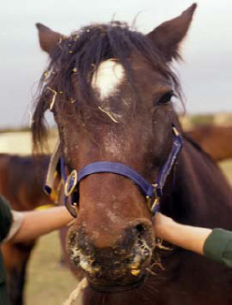

Table 3. Syndromes and some potential causes in horses (Diseases notifiable in Victoria are shown in bold type)
Syndrome | Exotic diseases | Endemic diseases
Respiratory signs | equine influenza | Hendra virus
 | African horse sickness | strangles (Streptococcus equi)
 | glanders (Burkholderia mallei) | pneumonia (infectious, inhalation, aspiration)
 | epizootic lymphangitis (Histoplasma capsulatum; H. farciminosum) | dorsal displacement of soft palate (DDSP)
 | Seen in northern Australia  - meliodosis (Burkholderia pseudomallei) | epiglottic entrapment
 |  | laryngeal hemiplegia (‘roarer’)
 |  | exercise induced pulmonary haemorrhage (EIPH)
 |  | pulmonary oedema
 |  | lung worm
 |  | chronic obstructive pulmonary disease
 |  | ethmoid haematoma
 |  | guttural pouch empyema
 |  | guttural pouch mycosis
 |  | guttural pouch tympany
 |  | equine viral arteritis
 |  | equine herpesvirus – type 1
 |  | equine herpesvirus – type 4
 |  | hyperthermia/exercise exhaustion
 |  | snake envenomation
 |  | tick paralysis (Ixodes holocyclus)
 |  | botulism (Clostridium botulinum)

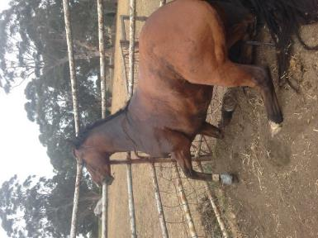
Table 3. Syndromes and some potential causes in horses (Diseases notifiable in Victoria are shown in bold type)
Syndrome | Exotic diseases | Endemic diseases
Neurological | rabies | Hendra virus
 | Japanese encephalitis | Australian bat lyssavirus
 | equine encephalitis (eastern, western and Venezuelan) | cervical static stenosis or cervical vertebral instability (wobbler syndrome)
 | surra (Trypanosoma evansi) | trauma
 | West Nile virus (clinical infection; Kunjin strain is endemic) | blue-green algae toxicosis
 |  | plant toxicosis (e.g. stringhalt)
 |  | snake envenomation
 |  | paralysis tick
 |  | genetic conditions (e.g. cerebellar abiotrophy)
 |  | Ross River virus
 |  | tetanus (Clostridium tetani)
 |  | botulism (Clostridium botulinum)
 |  | lead toxicosis
 |  | Murray Valley encephalitis
 |  | West Nile virus (Kunjin strain; clinical infection)
 |  | vestibular disease
 |  | equine herpesvirus – type 1
 |  | listeriosis (Listeria monocytogenes)

Table 3. Syndromes and some potential causes in horses (Diseases notifiable in Victoria are shown in bold type)
Syndrome | Exotic diseases | Endemic diseases
Oral lesions | vesicular stomatitis | trauma (physical or chemical)
 | Japanese encephalitis

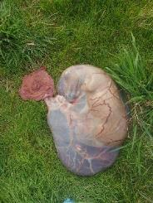
Table 3. Syndromes and some potential causes in horses (Diseases notifiable in Victoria are shown in bold type)
Syndrome | Exotic diseases | Endemic diseases
Reproductive | contagious equine metritis (Taylorella equigenitalis) | equine herpes virus - type 1 (EHV1)
 | dourine (Trypanosoma equiperdum) | chlamydiosis (Chlamydia psittaci)
 | Potomac fever (Neorickettsiae risticii) | equine coital exanthema (EHV3)
 | surra (Trypanosoma evansi) | equine herpes virus – type 4 (EHV4)
 |  | equine viral arteritis
 |  | leptospirosis (Leptospira spp.)
 |  | listeriosis (Listeria monocytogenes)
 |  | Q fever (Coxiella burnetii)

Table 3. Syndromes and some potential causes in horses (Diseases notifiable in Victoria are shown in bold type)
Syndrome | Exotic diseases | Endemic diseases
Gastrointestinal | African horse sickness | internal parasitism (Strongyles)
 | Potomac horse fever (Neorickettsia risticii) | colic (due to intestinal pathology)
 | equine encephalomyelitis (eastern, western, Venezuelan) | colic (other aetiologies)
 |  | salmonellosis (Salmonella spp.)
 |  | verocytotoxigenic Escherichia coli
 |  | other bacterial colitis (e.g. Clostridium spp.)
 |  | anthrax (Bacillus anthracis)
 |  | equine herpesvirus 1 (EHV1)
 |  | other viral infection (e.g. rotavirus)
 |  | protozoal infection (e.g. Cryptosporidium spp.)
 |  | neoplasia (e.g. intestinal lymphosarcoma)
 |  | toxicosis (e.g. plant, blue-green algae, contaminated feed)
 |  | excessive food consumption
 |  | medications (adverse effects)

Table 3. Syndromes and some potential causes in horses (Diseases notifiable in Victoria are shown in bold type)
Syndrome | Exotic diseases | Endemic diseases
Skin lesions | epizootic lymphangitis (Histoplasma capsulatum; H. farciminosum) | dermatophilosis (Dermatophilus congolensis)
 | screw worm fly (Cochliomyia hominivorax, Chrysomya bezziana) | insect bites (wasp stings, mosquito bites, buffalo flies)
 | vesicular stomatitis | insect bite hypersensitivity (e.g. Culicoides)
 | surra (Trypanosoma evansi) | ringworm (Trichophyton and Microsporum spp.)
 | glanders (Burkholderia mallei) | insecticide treatments
 | Seen in northern Australia  - meliodosis (Burkholderia pseudomallei) | lice infestation
 |  | urticaria/allergic reactions
 |  | bullous pemphigoid
 |  | equine collagenolytic granuloma/equine eosinophilic granuloma
 |  | mange (Chorioptic, Psoroptic)
 |  | cattle tick (Rhipicephalus microplus) infestation
 |  | equine viral arteritis
 |  | cutaneous habronemiasis (Habronema spp.)
 |  | myiasis (fly strike)
 |  | onchocercal dermatitis (Onchocerca cervicalis)
 |  | photosensitization
 |  | tick infestation (other than Rhipicephalus microplus)
 |  | papilloma virus
 |  | equine coital exanthema
 |  | equine viral popular dermatitis
 |  | equine sarcoidosis
 |  | granulomatous enteritis

Table 3. Syndromes and some potential causes in horses (Diseases notifiable in Victoria are shown in bold type)
Syndrome | Exotic diseases | Endemic diseases
Ill thrift | equine granulocytic anaplasmosis (Anaplasma phagocytophilum) | internal parasites (Strongyles)
 | equine piroplasmosis (Babesia caballi; Theileria equi) | external parasites (e.g. lice, ticks)
 | glanders (Burkholderia mallei) | gastric duodenal ulcers
 | surra (Trypanosoma evansi) | laminitis
 | Seen in northern Australia  - meliodosis (Burkholderia pseudomallei) | Cushing’s disease
 |  | poor dentition
 |  | chronic liver disease
 |  | chronic obstructive pulmonary disease (COPD)
 |  | chronic pain/arthritis
 |  | chronic renal disease
 |  | equine sarcoidosis
 |  | equine infectious anaemia
 |  | maldigestion/malabsorption
 |  | malnutrition or trace mineral deficiency
 |  | medication (adverse effects of long-term therapy)
 |  | neoplasia (e.g. melanoma, lymphoma)
 |  | toxicosis (e.g. chronic plant, blue-green algae)
 |  | windsucking

Routinely collect the full range of recommended samples
Routine samples should include:
For every live horse submission
- Blood- plain tube collection
- Blood- EDTA tube collection
- Faeces (about 200gm)
- Urine
For every horse necropsy: (Always assess the risk of Hendra virus, anthrax or other zoonotic infection before proceeding with a necropsy)
- Fresh and fixed samples from lesions (include margin) or abnormal system
- Aqueous humour- plain collection tube
- Blood- plain collection tube
- Blood- EDTA tube collection
- Faeces (about 200gm)
- Fresh and fixed samples of
  - lung,
  - spleen,
  - liver,
  - kidney
- Fixed heart tissue
- Urine- dipstick, if abnormal then sterile sample
- Fresh loop of ileum or ileum contents- 40mls chilled
- Fixed gut (duodenum, jejunum, caecum, colon, lymph node (should be opened to expose lumen to allow good fixation)
- Fixed stomach
- Fresh and fixed brain tissue
If system pathology is suspected, also include relevant samples such as:
- Virus medium (or saline solution)- oral ulceration
- Nasal swab
- Fixed oesophagus
- Fixed trachea
- Fresh and fixed nerve tissue
- Fresh and fixed muscle
- Fixed bone marrow (hematopoietic) – rib or sternum
- Fixed bone marrow (starvation) – femur
- Fresh and fixed joint- whole
- Fixed eye- whole (preferably in Bouin’s fixative, formalin OK)
- Fresh stomach contents – 250 ml chilled (sudden/unexplained death - botulism, urea, plant poisoning, toxins)
- Fresh and fixed uterus/foetus
- Fresh and fixed placenta (post-abortion)
- Fresh and fixed spinal cord – multiple sections (neuropathy, ataxia)

What should be collected in the field?
To complete the Record of Disease Event form (RODE) and laboratory submission form you will need to gather these details.
• Species. Is more than one species
affected?
• Number of deaths, number sick,
number at risk, number examined.
• Age, condition score, sex.
• History and predisposing factors.
- When did the outbreak begin?
- What is the recovery time?
- What vaccinations and treatments have the animals had?
- Recent livestock introductions?
Consider possible sources of introduction/spread. Grazing / feeding history, pasture/feed type and weed species (if suspect plant toxicity).
• Clinical history and signs.
• Primary syndrome.
• Lesions and necropsy findings.
• Owner and property details including the Property Identification Code.
Photographs
• Sick and dead animals.
• Lesions / pathology.
Samples
From affected and healthy animals.
• Perform a necropsy.
• Check the sample collection guide.
• Describe lesions and take measurements.
• Be aware of zoonoses – collect samples carefully and wear appropriate PPE.
Timeline
- Sequence dates of disease cases and note clusters
  - Find the first case – what happened before it?
  - Note other events that happened on the property within the timeline.
  - What’s different when cases don’t occur?
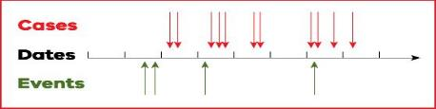
Details of the location
Take GPS coordinates if possible.
• Address and PIC.
• Physical factors.
– Infrastructure
– Geography
– Soil
– Vegetation
– Water sources
• Photos of layout and significant features.
• Spatial mud map of where cases occurred.
– Identify clusters of cases.
– Overlay geography and infrastructure.
RODE forms are available at www.agriculture.vic.gov.au/sdi

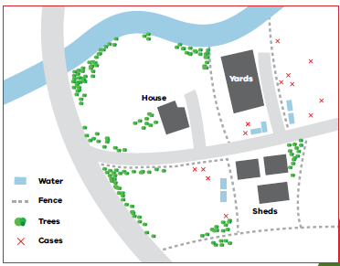

Correct sampling and handling of blood samples is essential to assist in obtaining an accurate diagnosis
• Always ensure the correct tube is used for the required tests.
• Fill blood tubes, if possible.
• Do not allow tubes to become too hot (store blood samples at 4ºC).
• To avoid haemolysis:
– remove the needle before transferring blood from a syringe to a collection tube
– ensure samples that are required to clot remain upright
– always mix anticoagulant tubes gently
– don’t allow blood samples tubes to cool too quickly
– never freeze blood samples.
Tube type | Description | Tests
Serum separation and clot activator  Allows the clot to form so serum can be analysed. | Gold and red tops | Serology, Antibody and antigen tests, Clinical biochemistry
EDTA  Contains anticoagulant | Purple tops | Haematology, Virus isolation, Polymerase chain reaction (PCR)
Lithium heparin  Contains anticoagulant | Green tops | Clinical biochemistry

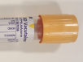
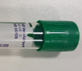
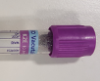

Correct collection and handling of tissue samples is important to assist in obtaining an accurate diagnosis
- Ensure samples are representative of lesions.
- Sample the interface with normal tissue.
- Sample areas of different color or consistency.
- Consider multiple sections for large lesions.
- Collect fresh and fixed tissue samples.
- Place fresh tissues in individual sterile containers and cool in an esky or refrigerator.
- Use 10 times the volume of 10% buffered formalin as tissue.
- Allow at least 24 hours for tissues to fix.
- Fixed tissues can be drained before transportation. Retain a few millilitres of formalin and seal the container well to ensure the tissue remains moist

Handling samples in the field
• Ensure samples are taken prior to giving treatments (where possible)
• Ensure enough samples are collected to represent all horses on the property
• Collect fresh and fixed samples first, then gut samples
• Label samples as soon as you take them
• Ensure labelling is clear and indelible. Record PIC, animal identification, date and vet on label.
• Clean any surface contamination from tubes and containers
• Place tubes/vials into zip-lock bags to keep them clean and contained together
• Keep fresh samples cool while in the field with ice bricks
• Don’t leave samples standing in the sun while working
• Use an esky and ice bricks to store samples during transit.
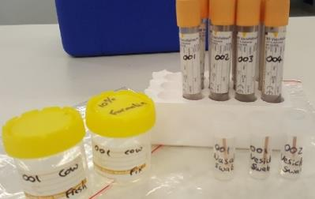
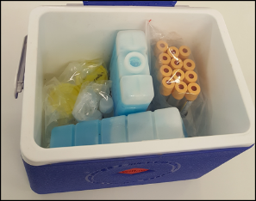

Packaging samples for transport
• Refrigerate samples as soon as you return from the property
• Do NOT freeze samples
• List all samples taken on the submission form
• Samples must be sent to the state veterinary diagnostic laboratory, AgriBio, as soon as practical
• Place all sample containers in zip-lock bags for transport
• Place bags of samples in a rigid container (esky/cool box)
• Use absorbent material to line container in case of leaks
• Pack all samples with ice blocks in the transport container
• Do not pack with wet ice
• Place laboratory submission form in a separate zip lock bag within the transport container
• Seal the container with tape
• If sending via courier, place the consignment note on top of the container.
If samples are travelling by air, packing must comply with the dangerous goods regulations for UN3373, Biological substances, Category B
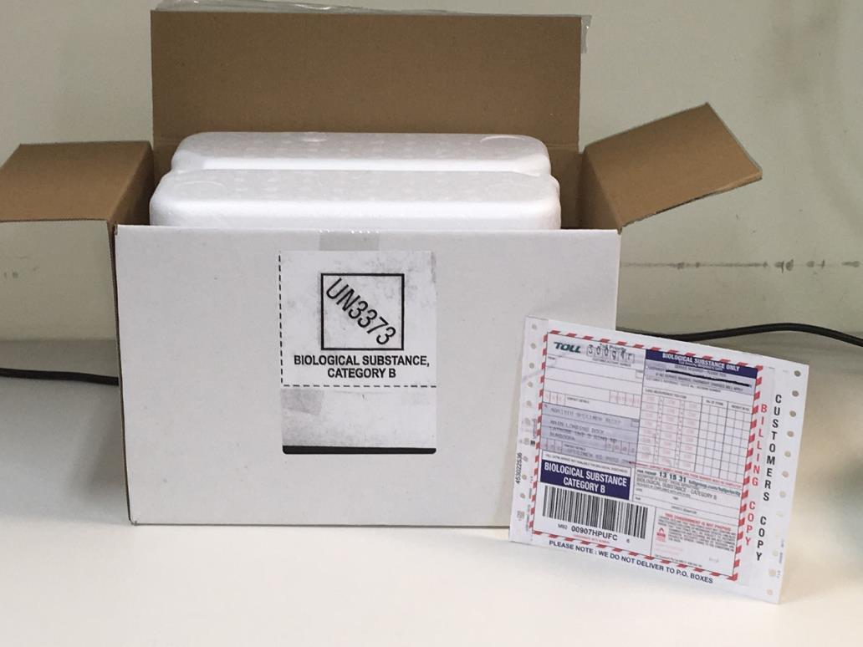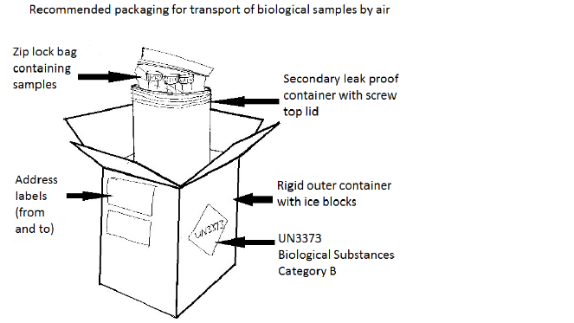

Submitting samples and reports
Veterinary Diagnostic Services
Agri-Bio specimen reception
Main Loading Dock
5 Ring Rd
Latrobe University
Bundoora 3083
Phone: (03) 9032 7515
Fax: (03) 9032 7604
Email: vet.diagnostic@agriculture.vic.gov.au

Please contact your local Agriculture Victoria veterinary officer for further information
ATTWOOD 9217 4200
ELLINBANK 5624 2222
SEYMOUR 5735 4300
BAIRNSDALE 5152 0600
GEELONG 5226 4667
SWAN HILL 5033 1290
BALLARAT 5336 6856
HAMILTON 5573 0900
TATURA 5833 5222
BENALLA 5761 1611
HORSHAM 4344 3111
WANGARATTA 5722 7101
BENDIGO 5430 4444
LEONGATHA 5662 9900
WARRNAMBOOL 5561 9946
COLAC 5233 5504
MAFFRA 5147 0800
WODONGA (02) 6043 7900
ECHUCA 5482 1922
RUTHERGLEN (02) 6030 4500
Information correct 2019.
Please check the Agriculture Victoria website for your current SDI contact

Further information
It is essential that emergency horse diseases are detected quickly to enable rapid response and control of the incident, as well as potentially protect human health. It is also important that we continue to investigate significant or unusual horse disease incidents to maintain a current understanding of conditions affecting the Victorian horse population and to address emerging horse health issues. When it comes to emergency horse diseases, no question is foolish. Don’t be the veterinarian who misdiagnoses the next emergency horse disease to occur in Victoria!
For further information contact your local Agriculture Victoria veterinarian or refer to the Agriculture Victoria website www.agriculture.vic.gov.au or call 1300 502 656.
And remember, if you suspect an emergency disease, please call the Emergency Animal Watch Disease Hotline 1800 675 888, immediately.

