Primary Production

Climate Change Adaptation Action Plan

2022–2026

The Victorian Government has developed 7 climate change adaptation action plans, including this Primary Production Adaptation Action Plan. The plans form a solid foundation for a climate- resilient Victoria in the long term.

Acknowledgement of Aboriginal Victorians
We proudly acknowledge Victoria’s First Nations peoples and their ongoing strength in practising the world’s oldest living culture. We acknowledge the Traditional Owners of the lands and waters on which we live and work, and pay our respect to their Elders past and present.
Victoria’s Aboriginal communities continue to strengthen and grow with the ongoing practice of language, lore and cultural knowledge. We recognise the contribution of Aboriginal people and communities to Victorian life. Traditional Owners have managed Victoria’s land and water for tens of thousands of years and they have deep knowledge and cultural practices in sustainable food and medicinal plant production and ecological land management. We acknowledge their history and their living cultural traditions.

© The State of Victoria Department of Jobs, Precincts and Regions 2022

This work is licensed under a Creative Commons Attribution 4.0 International licence. You are free to re-use the work under that licence on the condition that you credit the State of Victoria as author. The licence does not apply to any images, photographs or branding, including the Victorian Coat of Arms and the Victorian Government logo. To view a copy of this licence, visit http://creativecommons.org/licenses/by/4.0/

ISBN 978-1-76105-876-9 (pdf/online/MS word)

Disclaimer
This publication may be of assistance to you but the State of Victoria and its employees do not guarantee that the publication is without flaw of any kind or is wholly appropriate for your particular purposes and therefore disclaims all liability for any error, loss or other consequence which may arise from you relying on any information in this publication.

This document is available online at djpr.vic.gov.au or by contacting the project team on aap@djpr.vic.gov.au

Accessibility
If you are having issues accessing this document, please call the DJPR Customer Service Centre on 03 9651 9999 or email the project team on aap@djpr.vic.gov.au. Alternatively, contact the National Relay Service via relayservice.com.au or by calling 133 677.

Minister’s foreword

Victoria’s food and fibre sector is one of our most internationally competitive industries.
We have a global reputation as exporters and suppliers of some of the world’s
cleanest, greenest and safest produce.

But as Victoria becomes warmer and drier, and extreme weather events increase, the challenges for our primary industries will grow.
We’ve set targets to achieve net zero emissions by 2050, but we must also adapt to our changing climate and its effects starting in the here-and-now.
Many primary producers are already doing great work preparing for climate change and reducing emissions, but adaptation is an ongoing, long-term process.
A strong primary industries response to climate change is essential for Victorian communities and producers to thrive now and into the future.
The Primary Production adaptation action plan identifies priorities and actions for government to support Victoria’s agriculture, plantation forestry and productive fishery industries and their communities in preparing for a changing climate.
It addresses the immediate challenges of climate change and paves the way for
accelerating adaptation into the long term.
Our primary industries are well-practiced in responding to dynamic market and
weather conditions. The Primary Production adaptation action plan harnesses this experience. It supports the productivity of our primary industries by leveraging the success of existing actions and programs that help businesses prepare for the coming season and for a changing climate.
Despite the climate challenges we face, there are many opportunities that exist for Victoria’s agriculture, plantation forestry and productive fishery industries.
Working together with our primary industries and their communities to respond to climate change impacts will open the door to new ideas, new methods of production and technological breakthrough.
Victoria’s primary industries will continue to innovate.
To change the game. To lead the world.
And they will continue to step up to face our great climate challenge.

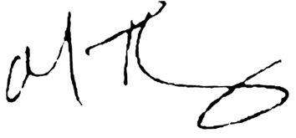

The Hon. Mary-Anne Thomas Minister for Agriculture

Contents
Primary Production Climate Change Adapation Action Plan 2022-2026 1
Executive summary 5
1. Introduction 7
2. Climate change and the Primary Production system: impacts and opportunities 14
3. Non-climatic drivers of change, climate change risks and cross-system risks 20
4. Roles and responsibilities for adaptation in the Primary Production system 25
5. Climate change adaptation in primary production: current policies and initiatives 27
6. Adaptation actions: a 5-year plan 31
7. Monitoring, evaluation, reporting and improvement 37
8. Implementation and next steps 38
Appendices 39

Executive summary

Victoria’s primary industries are important to the state’s economy, and climate change is a growing challenge.

Victoria’s primary industries are major export and wealth generators. They employ more than 190,000 people; more than 80 per cent of whom
are in regional Victoria. The Primary Production system includes agriculture, plantation forestry, productive fisheries and the infrastructure, workforce and communities supporting them. It covers the full value chain: key inputs, growth and harvest, production and processing – everything that gets products to market.
Our state’s primary industries have continued to perform despite many challenges.
However, the impacts of climate change, including on productivity and profitability, are already being felt and are projected to increase. Victoria is likely to become hotter and drier and may experience more frequent and/or extreme events such as heatwaves, bushfires and drought. The availability of fresh water
is likely to become a more critical issue. Climate change is expected to increasingly affect access to key inputs, services and markets and potentially affect supply chains underpinning the food system. Climate change
is also expected to cause shifts in growing conditions and seasons; increasing the risk of negative impacts on worker’s health and safety and animal welfare, and increasing damage from pest and disease outbreaks.
Early and effective action can make a difference by supporting our industries to become more resilient.
Adaptation is essential to prepare for and manage the impacts of climate change, and ensure our industries, regions and communities can continue to grow and thrive.

Victoria is acting now to support primary industries to adapt
The Victorian Government is taking strong and lasting action to reduce Victoria’s emissions to net zero by
2050 and build more resilient communities prepared to deal with the impacts of climate change. Adaptation and risk management are equally important elements of the response to climate change. As the Intergovernmental Panel on Climate Change Sixth Assessment Report makes clear, some degree of climate change is inevitable. Action is needed now to adapt to the potential impacts of historical emissions.
Reducing our emissions can lessen the impact of climate change, but some change is already locked in. Adapting to the impacts of climate change will not only reduce current and future risks, it will also build social and economic resilience and ensure
Victoria is best placed to take advantage of opportunities.
In Victoria, action on climate change is underpinned by
the Climate Change Act 2017 (the Act). Victoria’s Climate Change Strategy sets out the Victorian Government’s current action on climate change and guides our next steps.
Victorian Ministers for 7 distinct but interconnected systems, including Primary Production, are preparing 5-yearly climate change adaptation action plans (AAPs). This is the Primary Production AAP (the plan) for 2022 to 2026.

Adaptation will reduce climate change risks, build resilience and harness opportunities
Climate change will challenge the ways that primary industries and governments operate and make decisions, requiring innovative and targeted responses and
up-to-date skills, tools and information. Adapting to climate change will also create opportunities. Bringing new products to market, generating efficiencies, and diversifying will support business continuity and growth.
Actions in this plan are designed to address the 3 main types of climate change risk facing the Primary Production system:
- capacity to respond to current and new
climate change risks and vulnerabilities

Primary Production Climate Change Adaptation Action Plan 2022–2026 5

- the increased scale and frequency of extreme events such as bushfires and floods
- the challenge of making fundamental changes to current ways of doing things.
There are also risks shared with other systems, such as potential disruptions to
transport networks and supply chains, and the quality and availability of water for a
wide range of competing uses. These cross-system risks demand action within the Primary Production AAP and coordinated action with other AAPs.

Climate change adaptation is already underway across primary industries, but more action is needed
This plan seeks to build on the work that primary industries
are already doing to adapt to climate change. It will enable partnerships to stimulate new research and innovation, boost capacity across the system and build capabilities within government to respond to the changing climate.
Priorities and actions are in Figure 1. The Victorian Government will implement this plan in partnership with industry and other key stakeholders.

Figure 1. Primary Production AAP priorities and actions

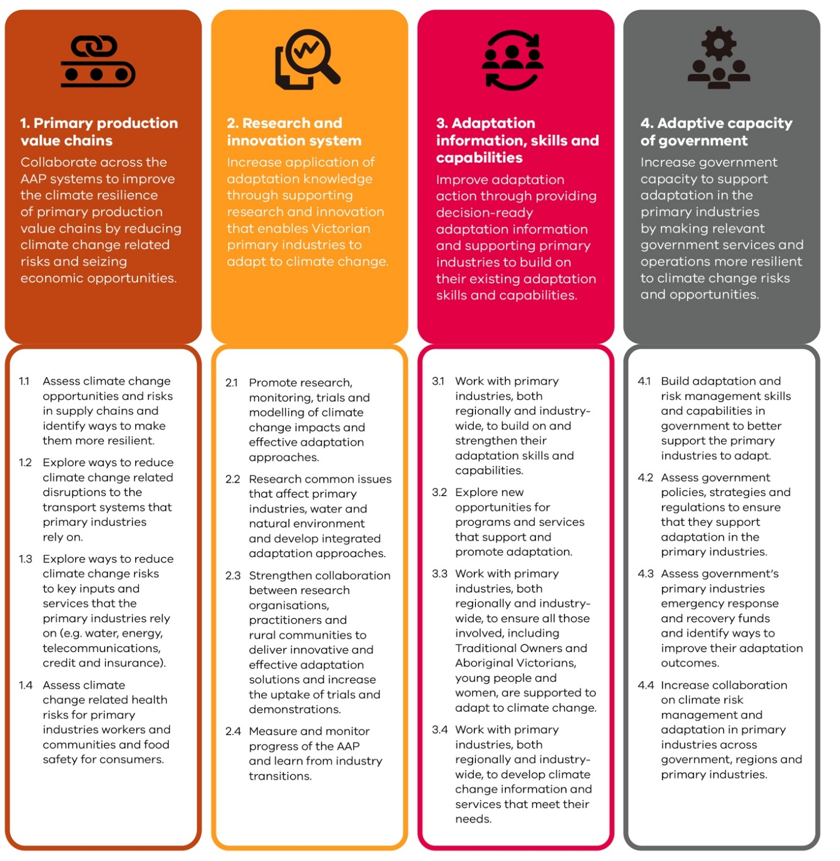

Introduction

The Primary Production system includes agriculture, productive fisheries and plantation forestry, along with the infrastructure, workforce and communities that support them. It covers the full value chain: key inputs, growth and harvest, production and processing – everything that gets products to market.
Agriculture is Victoria’s largest primary industry in terms of revenue and employment. The wild-catch marine sector is the state’s most valuable commercial fishery, while the economic value of the aquaculture sector is growing rapidly. Victoria has the nation’s largest plantation forestry estate – a mix of soft wood and predominantly short- rotation hardwood, mostly eucalypt.
Victoria’s primary industries are a major export and wealth generator, employing more than 190,000 people – 80 per cent in regional Victoria. Victoria accounts for more than 28 per cent of Australia’s food and fibre exports and is on track to reach its $20 billion export target by 2030.
This strong performance has been achieved despite recent challenges, including the COVID-19 pandemic and disruptions to international trade. The effects of climate- related events, such as bushfires and droughts, have also been felt across industries, commodities and regions.
Climate is fundamental to Victoria’s primary production
industries with climatic regions and soil types largely determining the productive landscape. As Victoria becomes warmer and drier due to climate change, the challenges will increase. Reduced runoff and groundwater recharge will affect water availability, and we expect the risk of extreme events like heatwaves, bushfires, droughts and floods to increase. These changes threaten assets and livelihoods and will increasingly test the resilience of primary production value chains.
The infrastructure and services, including the health, education and community facilities that primary industries’ business owners, workers and their families rely on, are mainly in rural and regional areas. They are important in supporting local communities to deal with the effects of climate change.
Victoria’s primary industries have already demonstrated their ability to respond to change, harness opportunities and learn from experience. They have built skills, expertise and networks that help in climate change adaptation. But the challenge is big.
The pace and extent of climate change is difficult to predict and depends on current and future global greenhouse gas emissions. How primary industries will interact with the changing climate is also unpredictable. It’s crucial that uncertainty does not lead to inaction. Planning for the future and flexible decision making is needed.
Adapting rather than waiting will limit the negative impacts of climate change on Victoria’s primary industries and harness opportunities for businesses and the state.
The Victorian Government will take ambitious yet achievable action, over both the short and long terms, to support adaptation in primary industries. This plan will guide actions for the next 5 years.

1.1 CLIMATE CHANGE ADAPTATION IN VICTORIA
The Victorian Government is taking strong and lasting action to reduce Victoria’s emissions to net zero by 2050 and build more resilient communities able to deal with the impacts of climate change. Victoria was one of the first jurisdictions in the world to legislate a net zero emissions target with the Climate Change Act 2017 and set a strong foundation for climate resilience under Victoria’s Climate Change Adaptation Plan 2017–20.
Reducing our emissions can lessen the impact of climate change, but some change is already locked in. Adapting to the impacts of climate change will not only reduce current and future risks, it will also build social and economic resilience and ensure Victoria is best placed to take advantage of opportunities.
Victoria’s Climate Change Strategy sets out the Victorian Government’s current action on climate change and guides our next steps. The strategy identifies:
- 3 priority focus areas – address current climate change impacts, reduce barriers to adaptation and lay the foundations for transformational adaptation
- 4 enablers to support action – capacity building and partnerships, governance and strategic planning, sustainable finance, and leadership and innovation.
The Victorian Government is preparing the first set of 5-yearly adaptation action plans for 7 systems that are either vulnerable to climate change impacts or are essential to ensure Victoria is prepared:
- Built Environment
- Education and Training
- Health and Human Services
- Natural Environment
- Primary Production
- Transport
- Water Cycle.
This Primary Production AAP is part of the first set of plans. It will enable a targeted response to climate change, which focuses on the unique characteristics and needs of primary production while recognising that some issues require coordinated action across systems. It is complemented by regional adaptation strategies developed in partnership with regional communities. They identify, prioritise and deliver place-based action informed by local knowledge and needs for:

- Barwon South West
- Gippsland
- Grampians
- Greater Melbourne
- Hume
- Loddon Mallee.
Work also continues with local governments and community groups to understand and address the risks that climate change poses to local communities.

Development of this plan
This plan was informed by the best available contemporary climate science. It was developed through a collaborative process with input from many stakeholders, including the Victorian Agriculture Climate Change Council (VACCC).

Key milestones
Literature review – the Department of Jobs, Precincts and Regions engaged climate change experts from RMIT to undertake a review of more than 500 scientific papers and research reports, looking at:
- the status of primary production industries and regions in Victoria
- the non-climatic drivers of change
- climate change impacts, risks and opportunities for Victorian primary industries.
Stakeholder engagement – a range of primary industries stakeholders shared their experiences and perspectives in semi-structured interviews.
Collaboration across government – to synthesise key issues and links with other systems.
Gap analysis – existing policies, programs and initiatives that support adaptation and areas for future work.
Testing draft priorities and actions – across government and with stakeholders including VACCC.
Public feedback on the draft version of this plan informed the final plan.
What is adaptation?
- Adaptation means adjusting to an actual or expected climate and its effects. In human systems, adaptation can seek to moderate or avoid harm, or exploit opportunities. Adaptation can be incremental or transformational.
- Incremental adaptation is where an existing system or process is modified with the intention that the changes will allow it to remain viable. In primary production this could include initiatives such as investing in business efficiencies and addressing immediate business challenges, changing to more climate-resilient crops, or adjusting livestock management practices.
- Transformational adaptation is where the fundamental attributes of a system are changed. In primary production this could include changing land uses, shifting to a new location or developing new production models. Transformational adaptation can help businesses anticipate future
- climate change impacts, develop innovative new business models that are resilient to climate change, and deliver long-term benefits to industry and communities.
- Adaptive capacity refers to the ability of systems, institutions, people, plants and animals to adjust to potential damage, take advantage of opportunities or respond to the consequences of climate change.

1.2 OBJECTIVES OF THE PRIMARY PRODUCTION AAP
This plan includes short, medium and long-term adaptation objectives for the Victorian Government, including 4 priorities for 2022–2026 (see Figure 2 and Victoria’s emission reduction targets). It also includes 16 actions in Section 6, which are set out together with the objectives and priorities in Appendix 1.

Figure 2. Objectives and priorities for the Primary Production Climate Change Adaptation Action Plan 2022–2026, and Victoria’s emission reduction targets

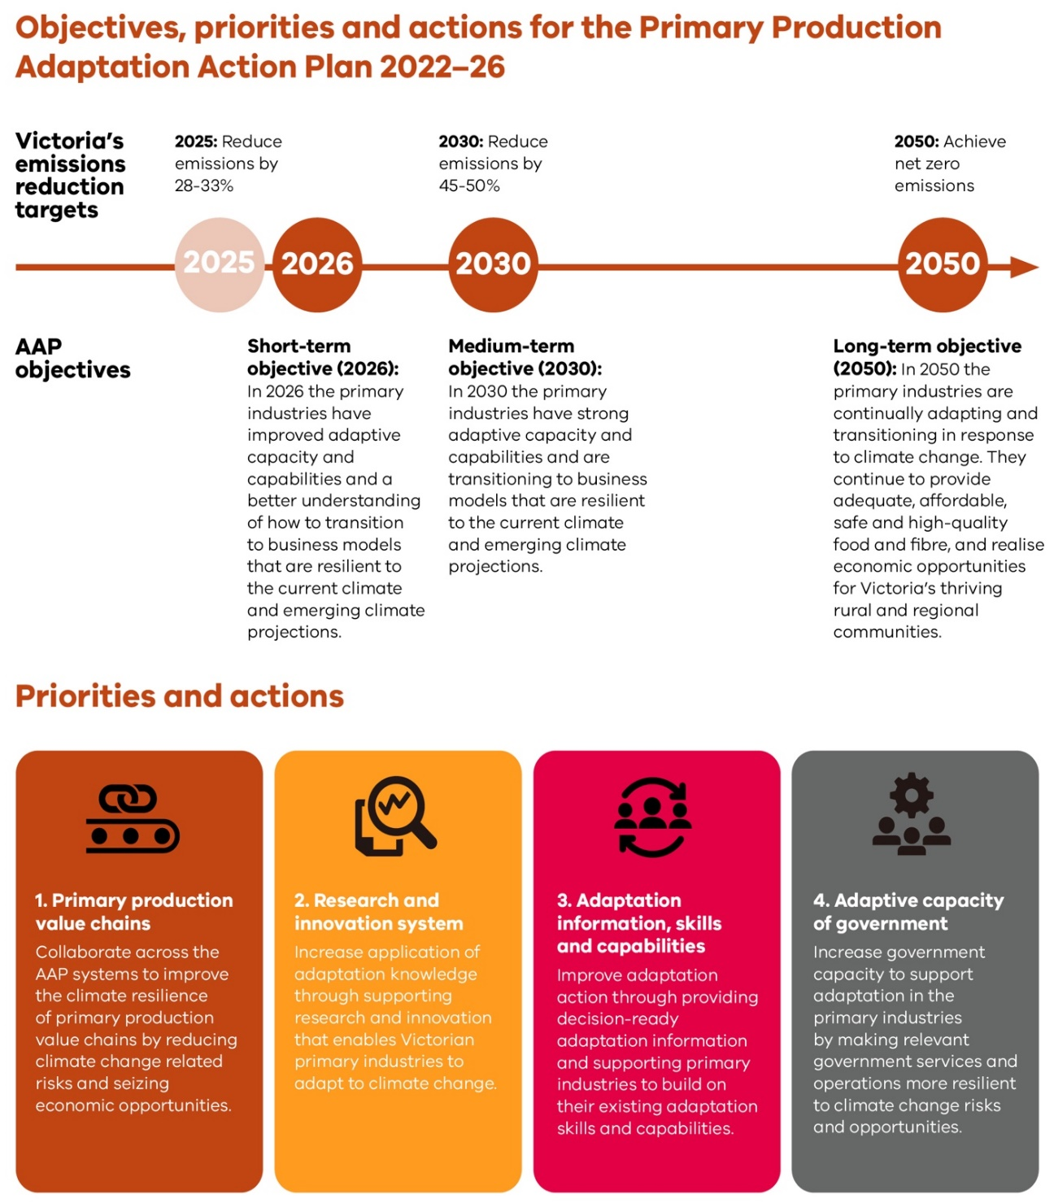

The Victorian Government has set a target of net zero
emissions across the economy by 2050, supported by 5-yearly interim emissions reduction targets and sector emissions reduction pledges. The first 2 emissions reduction targets – a 28 to 33 per cent reduction from 2005 levels by 2025, and a 45 to 50 per cent reduction by 2030 – were announced in May 2021, alongside sector pledges for 2021 to 2025, as part of Victoria’s Climate
Change Strategy. Adaptation and emission reductions
are equally important elements of the response to climate change. As the Intergovernmental Panel on Climate Change Sixth Assessment Report makes
clear, some degree of climate change is inevitable due to historical emissions. Action is needed now to adapt to these impacts.

SCOPE OF THE PRIMARY PRODUCTION SYSTEM
The Primary Production system scope includes agriculture, productive fisheries and plantation forestry, along with the infrastructure, workforce and communities that support them (Figure 3). It covers the full value chain, capturing key inputs, growth and harvest, and processing – everything that supports getting primary products to market.

Figure 3. Scope of the Primary Production system

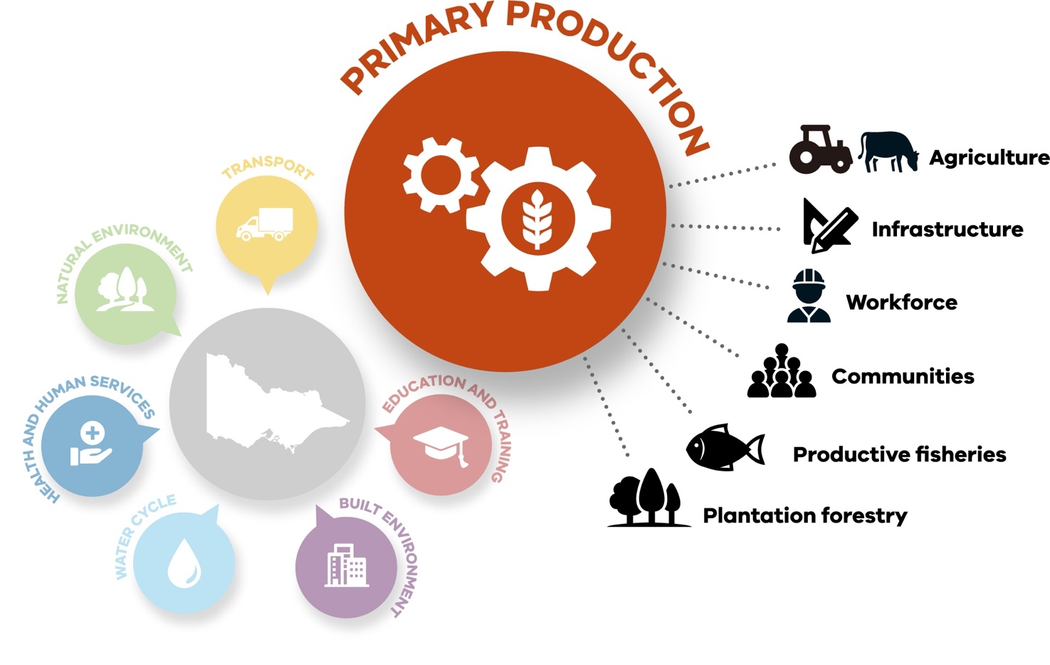

Cross-system connections
The Primary Production system has extensive connections with other systems (Figure 4). For example, the Water Cycle and Natural Environment systems provide key inputs,

while the Transport system is crucial to accessing inputs and markets. Primary Production activities, in turn, affect other systems.
These cross-system connections are presented
in table form in Appendix 2.

Figure 4. Connections between the Primary Production system and other AAP systems

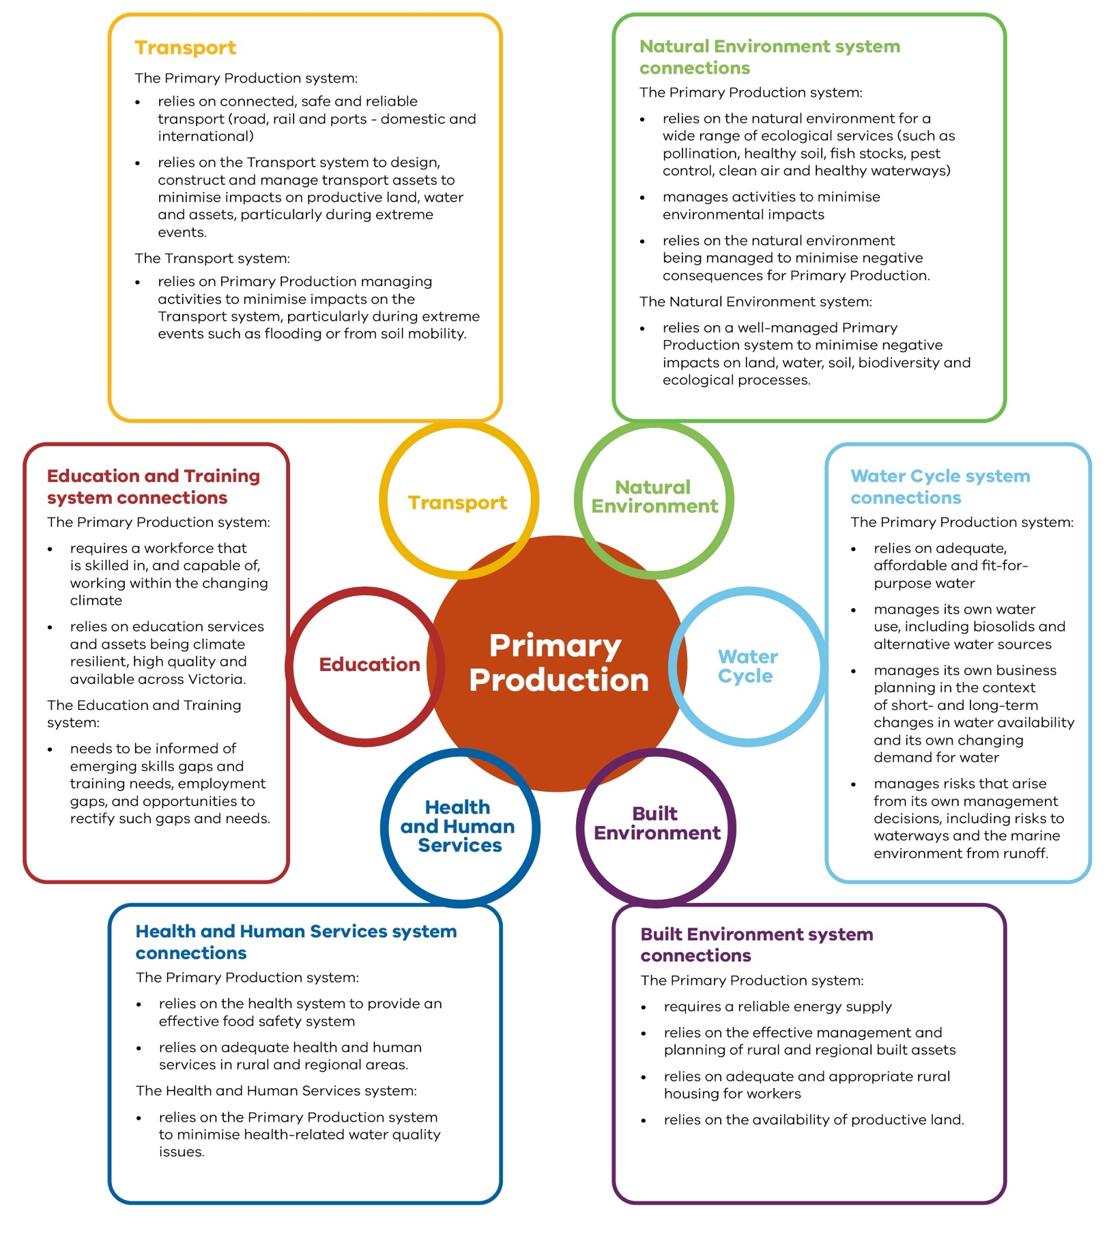

Partners, stakeholders and cross-cutting policy areas
Stakeholder and community collaboration are critical
to adaptation in primary industries. Regional and rural communities, local government and Traditional Owners have a particularly important role to play.

Traditional Owners and Aboriginal Victorians
Traditional Owners have managed Victoria’s land and water for tens of thousands of years. They have deep knowledge and cultural practices in sustainable food and medicinal plant production, and ecological land management.
Building on the foundations of Aboriginal Self-Determination, developing strong and enduring partnerships with Aboriginal communities
will contribute to growing a prosperous, thriving and strong Victorian Aboriginal community.

Rural and regional communities
- Most people involved in primary industries live in rural and regional areas that are highly exposed to the direct and indirect effects of climate change.
- Some people in primary industries are more vulnerable than others, such as some older workers, those with health concerns or from lower socio- economic groups and those living furthest from services.
- Disaster-prone areas are experiencing rising insurance premiums,
leading to non- and under- insurance.
- Key health and social services will be important in supporting local communities as they deal with the effects of climate change. These are often
less extensive in the country than in urban centres.
- There are occupational health and safety concerns, such as heat stress and mental health issues resulting from or exacerbated by drought or extreme weather.
- Vulnerable communities across Victoria may be particularly susceptible to rising food prices and reduced food availability.

Local government
- The Primary Production system needs to work with local government to deliver adaptation actions that align with community priorities and values.
- The Primary Production system relies on connected, safe and reliable transport.
There are 3 key cross-cutting policy areas that span all AAPs. Table 1 outlines the ways these areas interact with the Primary Production system.

Table 1. Connections between the Primary Production system and cross-cutting policy areas
AAP cross-cutting policy areas
Primary Production interactions with cross-cutting policy areas
Marine and coasts The Primary Production system:
  - relies on coastal infrastructure such as roads, groynes, jetties and wharfs
  - is vulnerable to seawater incursion into groundwater supplies that can reduce water quality and affect productive landscapes
  - is vulnerable to changes in ocean chemistry, temperature and circulation patterns that alter marine ecosystems.
Cross-system risks:
  - changes to marine ecosystems
Impacts on marine environment health and flood management are within the scope of the Natural Environment and Water Cycle AAPs.

Emergency management
The Primary Production system:
- relies on effective emergency management systems. Emergency management relies on rural and regional communities.

Energy The Primary Production system:
  - depends on reliable energy supplies
  - can benefit from opportunities to generate local clean energy on productive land. Energy is included within the scope of the Built Environment AAP.

Vulnerable people and communities
- Some primary industries, their workers or their families could face financial hardships making them less able to afford upfront adaptation costs or less likely to have the resources to recover from extreme events.
- Older workers and workers with health conditions are more sensitive to extreme heat. Mental health conditions can be worsened by drought and poor weather conditions.
- Primary industries in disaster-prone areas may experience rising insurance premiums, leading to non- and under-insurance.
- Vulnerable communities and households across Victoria could be particularly susceptible to rising food prices and reduced food availability.

2. Climate change and the Primary Production system: impacts and opportunities

Long-term observed records show that Victoria’s climate is changing due to global
warming. Since official records began in 1910, Victoria has warmed by 1.2 degrees Celsius.¹
Warming has already led to a decrease in average rainfall, especially in cooler
months; increased frequency of extreme heat events; and an increase in dangerous fire weather and the length of bushfire season. These
climate trends and associated impacts are expected to continue.
The latest climate projections suggest:
- By the 2050s, Victoria’s annual temperature may
increase by up to 2.4 degrees Celsius compared to the 1986–2005 average (under a high-emissions scenario), with around twice as many very hot days.
- Across Victoria, annual rainfall will continue to decrease, especially in the cooler seasons. Due to natural variability, extreme rainfall events will still occur. They’re likely to be more intense and potentially increase flash flooding risk in some locations.
- The number of high fire- danger days in Victoria is expected to increase.²
- Sea levels will continue to rise. By the 2050s they’ll have risen around 24 cm
(relative to 1986–2005) under both medium- and high-emissions scenarios.
Reducing greenhouse gas emissions is the most effective strategy to reduce the impacts of climate change. However, even if they ceased today, the climate would keep warming for decades because of past emissions. The magnitude
of climate change’s impacts depends on how quickly the international community acts to cut emissions.

Figure 5. Current and projected climate change impacts for Victoria under high emissions³
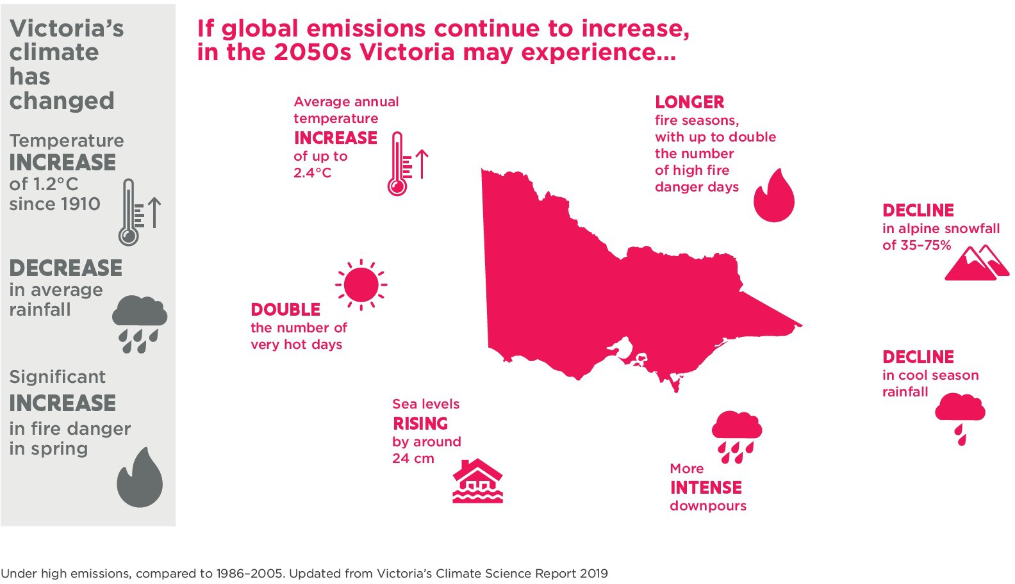

- Projections 2019 Technical Report. CSIRO, Melbourne Australia. Available at: VCP19 Publications (climatechangeinaustralia. gov.au).
- Projections 2019 Technical Report. CSIRO, Melbourne Australia. Available at: VCP19 Publications (climatechangeinaustralia. gov.au).
- Victoria’s Climate Change Strategy, 2021. The State of Victoria Department of Environment, Land, Water and Planning, Melbourne, Australia. Available at: climatechange.vic.gov.au.

CLIMATE CHANGE IMPACTS ON PRIMARY PRODUCTION
Climate change poses many challenges for Victoria’s primary industries. The consequences of a reduction in fresh water resources, seasonal changes and increases in the risk of extreme events, such as heat, fire and drought include:
- disruptions to supply chains including access to inputs and markets
- reduced finance and insurance availability
- geographical shifts in land characteristics, aquatic ecosystems and land use
- damage from pest and disease outbreaks.
Climate change will have complex, overlapping effects on rural and regional communities.
The direct effects of long- term changes in heat and rainfall, and of increased carbon dioxide levels on agricultural production and marine fisheries, are relatively well understood.
However, knowledge of the
compounding impacts of multiple climate hazards, or the wider consequences of climate change for the Primary Production system, is limited.
Climate change impacts matter to Victorian primary industries because:
- production and harvesting
- milk production, plant yields and quality, productive marine species
- are sensitive to climatic conditions and seasonal variability
- heat, bush smoke taint or road closures from bushfires or flooding make products vulnerable to spoilage
- bushfires and floods can disrupt road and rail links that transport vital inputs for primary production and provide access to key markets or strand people from services.
The impacts are set out in Figure 6 and in Table 2.

Figure 6. Key projected climate change impacts on the Primary Production system

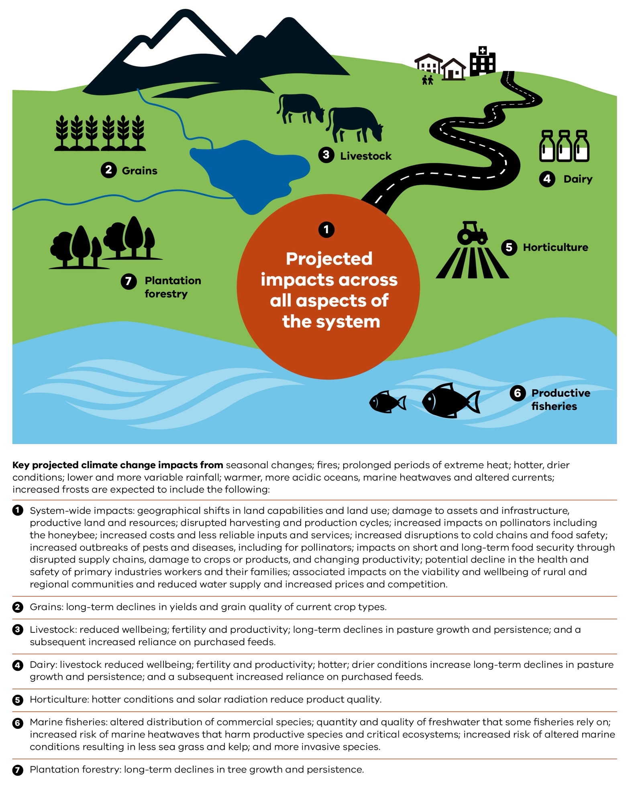
Table 2. Key projected climate change impacts on the Primary Production system
Primary industry Key projected climate change impacts
System-wide • Geographical shifts in land capabilities and land use due to increased demand for more productive land, and land with higher (and more reliable) rainfall. This will increase the potential for stranded assets.
  - Projections of a warmer, drier climate pose water availability and reliability challenges for consumers and amenities, including primary industries and their communities. These are a concern for irrigated and non- irrigated industries and their communities.
  - Increased risk of extreme weather events, including prolonged periods of extreme heat, fire, drought and floods. Such events are likely to affect assets and infrastructure, productive land, vegetation, animals, waterways, food safety, and human health and community wellbeing, particularly for vulnerable or disadvantaged groups.
  - Likely changes to seasonal patterns are expected to result in disruptions to harvesting and production cycles.
  - Potential increased costs and less reliable inputs and services due to disruptions to supply chains, including cold chains, because of climatic extremes.
  - Potential impacts on short-term food accessibility and affordability through disrupted supply chains, damage to crops or products, and long-term food security or changing productivity
over time.
  - Potential increased outbreaks of pests and diseases from current and newly introduced species.
  - Likely impact on distribution and flowering seasons of pollination-responsive crops and blooming cycles, affecting the availability of pollen and nectar resources in a range of settings. Increased fire, heat and smoke, and declining water availability increase stress on pollinators.
  - Potential decline in the health and safety of primary industry workers and their families from climate extremes (for example, heat and fire) and from increasing challenges to business viability.
  - Associated likely impacts on the viability and wellbeing of rural and regional communities that primary industries support and rely on.

Grains • Expected hotter and drier conditions are likely to result in long-term declines in yields and grain quality of current crop types.
  - Expected lower, more variable and intense rainfall patterns are likely to result in reduced supply and increased prices for current crop types, and increased competition for water.
  - Increased frost risks.

Livestock • Expected hotter conditions are likely to reduce livestock wellbeing, fertility and productivity.
  - Expected hotter, drier conditions and consequent water scarcity could result in long-term declines in pasture growth and persistence, and a subsequent increased reliance on purchased feeds.
  - Projections of lower and more variable rainfall may result in reduced supply, increased prices and increased competition for irrigation water.
  - Increased risk of disruptions to cold chains and food safety.

Dairy • Expected hotter conditions are likely to reduce livestock wellbeing, fertility and productivity.
  - Expected hotter, drier conditions increase disruptions to cold chains and food safety.
  - Expected hotter, drier conditions and consequent water scarcity are likely to result in long-term declines in pasture growth and persistence, and a subsequent increased reliance on purchased feeds.
  - Projections of lower and more variable rainfall is likely to result in reduced supply, increased prices and increased competition for irrigation water.
  - Increased risk of disruptions to cold chains and food safety.

Horticulture • Expected hotter conditions and solar radiation reduce product quality.
  - Projections of lower and more variable rainfall, increased water scarcity and reduced water quality are likely to result in reduced supply, increased prices and increased competition for irrigation water.
  - Increased risk of disruptions to cold chains and food safety.
  - Increased frost risks.

Productive fisheries • Projections of warmer, more acidic oceans and altered currents are likely to affect the distribution of commercial species.4
  - Projections of lower and more variable rainfall could reduce the quantity and quality of freshwater that some fisheries rely on.
  - Increased risk of heatwaves that could harm productive species and critical ecosystems, including both marine fisheries and inland aquaculture.
  - Increased risk of disruptions to cold chains and food safety.
  - Increased risk of altered land and marine conditions that could result in less sea grass and kelp, and more invasive species that accelerate the problem.
  - Expected hotter and drier conditions and altered river conditions are likely to result in changes to what fish can grow in different locations.

Plantation forestry • Expected hotter and drier conditions are likely to result in long-term declines in tree growth and persistence.

4 Department of Health and Human Services, 2018. Vulnerable People in Emergencies Policy, p. 10

OPPORTUNITIES FROM CLIMATE CHANGE AND ADAPTATION
While climate change poses many challenges for Victoria’s primary industries, it will
also bring opportunities for industries that are motivated and able to adapt.
Opportunities will arise from:
- harnessing businesses’ strengths and abilities to adapt to changing
market and environmental conditions, and their ability to take advantage of new growing and harvesting conditions, new
management practices and changed land uses
- embracing emerging productive species, market demand for alternative proteins, value adding through processing and developing new markets for Victorian products
- increasing business resilience to a wide range of shocks and stresses
through diversifying incomes and production and harvest models, promoting use
of diverse water sources, and water and energy efficiencies via climate change adaptations
- increasing natural resource condition and managing sustainable landscapes, which might include
adaptation actions such as planting trees on farms, maintaining or increasing organic soil matter, and maintaining or increasing on-farm biodiversity
- diversifying and strengthening business productivity by augmenting income sources via alternate land uses, renewable energy generation or through value adding, processing and developing new markets
- enabling innovative new business models, through transformational adaptation, which are resilient to climate change and deliver longterm benefits to industries and communities
- increasing social networks and community cohesion through adaptation, including at the regional level
- building a focus on primary industries’ adaptation within regional economic development such as tourism, agri-food and native food initiatives
- harnessing the role of urban and peri-urban producers and local food networks to support healthy food production, social, education and biosecurity outcomes
- collaborating at the regional level and along value chains on actions that increase the share of local inputs and reuse waste products (the circular economy approach).

Spotlight: A changing climate opens market opportunities for Victorian primary producers
Shifts in water availability and temperatures on the land, as well as changing currents, chemistry and temperature in our marine environment could bring about a shift in what crops are grown where and what marine species will be harvested in our oceans. Such changes could provide agriculture market opportunities such as alternative proteins, targeting of new productive fish species in Victoria’s marine waters and new aquaculture businesses.
Victorian farmers in the Wimmera and Southern Mallee region are thinking of ways to stay productive and sustainable facing the challenges of extreme events and reduced rainfall.
International and domestic markets are providing opportunities for Australian pulses by the increased demand for plant-based proteins, influenced by a growing awareness for health and wellbeing, animal welfare and environmental concerns.
Recent investments in Horsham to manufacture plant-based protein provide a potential high-value avenue for pulses such as lentils, faba beans and chickpeas, which are routinely grown for disease control and to improve soil quality, and are sold as bulk commodities.
The Grains Research and Development Corporation and Agriculture Victoria are also exploring innovative technologies and tools at the Horsham Grains Innovation Park to ensure research outputs are quickly adopted to help plant breeders increase yields in different regions and adapt to the changing climate.
These align with priorities 1, 2 and 3 of this AAP.

Non-climatic drivers of change, climate change risks and cross-system risks

Climate change risks are dynamic. They result from the interaction of vulnerability, exposure and hazards (Figure 7). Vulnerability is a result of sensitivity to harm and the capacity to adapt. Exposure is being in places or settings that can be affected. Hazards are the potential physical events or trends that can cause impacts. Climate change risks can arise not only from climate change but also from human responses to it. Adaptation approaches need to be reviewed regularly and actions adjusted if need be.

NON-CLIMATIC DRIVERS OF CHANGE
A range of change drivers operate alongside the impacts
of climate change and are helping to shape the primary industries. Understanding climate change risks in the context of these other drivers is critical. They include:
- economic – declining terms of trade, market volatility and threats to market access
- technological and business
–
new technologies; including ‘smart’ technologies; changing insurance, finance and credit arrangements; disruptions to value chains; energy costs
- social – rising consumer and community expectations for animal health and welfare, social justice, traceability, food safety, environmental
sustainability and greenhouse gas emissions reduction
- policy – policy responses to the above changes including biosecurity regulations, requirements for greater transparency in supply chains, global emission reduction commitments, and regulation of competition for land and water.
The drivers of change play out differently from
region to region and across commodities. For adaptation to be effective, these complex drivers must be factored into tailored activity and investment responses.

Figure 7. Climate change risks and vulnerability⁵
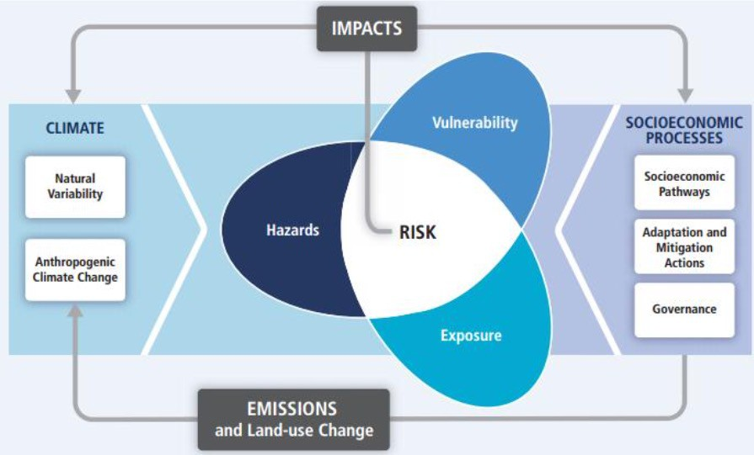

- IPCC, 2014: ‘Summary for policymakers’ in Climate Change 2014: Impacts, Adaptation, and Vulnerability. Part A: Global and Sectoral Aspects. Contribution of Working Group II to the Fifth Assessment Report of the Intergovernmental Panel on Climate Change [Field, C.B., V.R. Barros, D.J. Dokken, K.J. Mach, M.D. Mastrandrea, T.E. Bilir, M. Chatterjee, K.L. Ebi, Y.O.
Estrada, R.C. Genova, B. Girma, E.S. Kissel, A.N. Levy, S. MacCracken, P.R. Mastrandrea, and L.L.White (eds.)]. Cambridge University Press, Cambridge, United Kingdom and New York, NY, USA, pp. 1–32.

Spotlight: The Agriculture Energy Investment Plan (AEIP) is helping farmers reduce energy costs and be better prepared for a changing climate
Improved energy management and the efficiencies that come with it can make businesses more resilient to climate-related challenges. However, energy efficient equipment can be expensive and the technology is changing rapidly.
The Victorian Government Agriculture Energy Investment Plan:
  - supports businesses to reduce energy costs, improve energy efficiency and explore other energy options
  - helps agriculture businesses map energy efficiency opportunities and offers grants for energy efficient or own-generation technology and farm productivity improvements
  - invests in technology demonstrations, links farmers and businesses to information and education resources, and facilitates farming sector research
  - provides evidence of farmers taking climate action that opens market opportunities.

How is the plan supporting climate adaptation?
The following examples show how the plan supports agriculture businesses to become more profitable, energy efficient and competitive.
  - JA & MF Dunn is a partnership that has farmed at North Blackwood since the 19th century. It produces potatoes, fodder crops, grazing lambs and calves. The Dunn family received a grant to upgrade the farm’s irrigation system. They will save energy and water – reducing costs and improving resilience.
  - Bellarine TechBio Pty Ltd. is a family-owned farm at Portarlington producing premium cherry truss tomatoes in a 5,000 square-metre hydroponic glasshouse facility. The business received funding to install a solar photovoltaic system, thermal screens that provide shade and retain heat at night, and a heat buffer tank. The upgrade will generate 44 per cent of the farm’s annual energy consumption, allowing the business to reduce greenhouse gas emissions and be more competitive.
The AEIP aligns with priorities 2 and 3 of this AAP.

CLIMATE CHANGE RISKS
This plan addresses 3 types of climate change risk:
- risks arising from adaptive capacity and existing vulnerabilities
- risks arising from extreme and concurrent events
- risks arising from longer- term transformational adaptation needs.
See Appendix 3 for a more detailed risk analysis and
see Section 6 for further information about relevant actions.

Risks arising from adaptive capacity and existing vulnerabilities
Victoria’s primary industries have capacity to change and collaborate to address
climate risks, though it varies across industries, groups and individuals. This adaptive capacity is affected by climate and non-climate factors like ecosystem health; access to
finance, insurance, skills and training; and availability of assets and services. Some businesses and individuals have vulnerabilities that create additional risks, such as:
- businesses that are already vulnerable to rising input prices, market volatility,
soil degradation, declining populations or limited access to an appropriately skilled workforce
- people who have health concerns, are from lower socio-economic groups,

live far from services or face a combination of vulnerabilities.
Knowledge, information, skills and capabilities for
climate change adaptation are critical to ensure that primary industries, businesses and service providers can take effective and appropriate adaptation action. The knowledge, information and services developed must
be relevant, accessible and continually updated to reflect changing conditions. Focus on primary industry value chains will improve knowledge of the existing vulnerabilities across the system.
Relevant actions: 2.2, 3.4, 4.1
and 4.2.

Risks arising from extreme and concurrent events
The increased magnitude, frequency and concurrence of extreme weather events and their consequences – including impacts from fire, water-quality issues, soil loss and pest outbreaks – mean
even well-adapted businesses can be affected. Extreme
and concurrent events can negatively affect animal welfare, cause disruptions to supply chains, and make
insurance more expensive and difficult for primary producers to access.
An improved understanding of climate change risks across Victoria’s primary production value chains will identify immediate and longer-term concerns and point to further action to address them.
Government systems, assets, operations and services will
be under more pressure as climate risks increase.
Relevant actions: 1.1, 4.3 and
4.4.

Risks arising from longer-term transformational adaptation needs
There is a risk that long-term transformation might be put aside when more pressing climate change risks emerge that affect businesses and value chains in the here and now.
Regional collaboration and planning can create networks and stimulate action that generates co- benefits and long-term resilience. Multidisciplinary research and collaboration
will improve climate change knowledge across the Primary Production system. Stronger transformational adaptation skills and capabilities are needed.
Relevant actions: 2.1, 2.3, 2.4,
3.1, 3.2, 3.3, 3.4 and 4.4.

CROSS-SYSTEM CLIMATE CHANGE RISKS
There are risks that cut across the Primary Production system and require collaboration between AAPs (see Appendix 3 for more detail).
Cross-system climate change risks are particularly challenging as
they might:
- be emerging and not well understood
- occur only during certain climatic conditions (for example, algal outbreaks)
- be large, complex and managed by multiple stakeholder groups (for example, food security)
- raise conflicts about values or goals between different systems (for example, water for different uses).
The cross-system climate change risks most relevant to the Primary Production system are listed below, along with the related actions in
this plan.
- Alternative water supplies
– action 2.2
- Bushfire risk
– actions 1.2, 1.4, 2.2, 3.2
and 4.3
- Flash flooding
– actions 1.2, 1.4, 2.2, 3.2
and 4.2
- Food safety
  - actions 1.1 and 1.4
- Food security
– actions 1.1, 1.2, 1.3, 1.4
and 2.1
- Heat health
  - actions 1.1 and 1.4
- Land use planning and social change
  - actions 1.1, 2.1
- Loss or damage to culturally significant sites
  - actions 3.1, 3.2 and 3.3
- Marine ecosystem changes
  - actions 1.1 and 2.2
- Nuisance and harmful algal blooms
  - actions 1.2 and 2.2
- Plant and animal diseases
  - actions 3.1, 4.2 and 4.3
- Pollination and insect populations
  - actions 1.1, 2.2 and 4.2
- Soil mobility (including soil loss)
  - actions 1.1 and 2.2
- Transport supply chain and service delivery disruptions
  - actions 1.1 and 1.2
- Water availability
  - actions 1.2 and 2.2
- Water quality
  - action 2.2
- Weeds and pests
  - actions 3.1, 4.2 and 4

Food security cross-system risk
Food security means access to adequate, affordable, safe and nutritious food for all Victorians. It is a particular concern for vulnerable communities and lower socio- economic groups, and rural and regional communities
are among those affected.
In extreme events, supply chains could be disrupted and crops could be and damaged causing short-term food availability and affordability issues. Climate change could also cause long-term issues due to changing climate
and market conditions, increased reliance on imported produce and exposure to
risks associated with trade regulations.
Improved management of this cross-sytem risk will directly benefit people in the
primary industries, particularly those in rural and regional communities where access
to adequate, affordable, safe and nutritious food is an issue. Collaboration with the Health and Human Services and Transport systems is crucial
to strengthening short-term access and affordability and long-term food security in Victoria.
This risk is a concern for the adaptation action plan systems of Primary Production, Health and Human Services, and Transport.
The relevant actions in this plan are 1.1, 1.2, 1.3, 1.4 and 2.1.

Pollination and insect populations cross-system risk
Changing climate patterns and extremes could result in risks to insects and native and European honeybee populations affecting pollination of productive crops and other species.
This includes changing distribution and flowering seasons of pollination- responsive crops; more frequent hot days disrupting blooming cycles and affecting the availability of pollen and nectar resources in a range of settings; increased fire, heat, and smoke; declining water availability increasing stress on pollinators; a risk that their pests and diseases will increase in prevalence or range.
The contribution to Australia’s agricultural, horticultural
and silvicultural output from crops and commodities that rely on pollination by insects is significant. Producers
of pollination-responsive crops rely on a range of pollination services, including incidental pollination by either native insects or feral honeybees, or paid services by bees specifically managed and
provided for pollination purposes and/or on bees managed for honey production.This risk is a concern for the adaptation action plan systems of Primary Production and the Natural Environment. The relevant actions in this plan are 1.2, 2.2 and 4.2.

Water availability and quality cross-system risks
Water is vital for primary production. Climate change poses significant concerns for water availability and quality. The Water Cycle Adaptation Action Plan provides 21 actions related to it, several of which are relevant to this plan as listed below.
- Investigate ways to enable greater uptake of stormwater and
recycled water
- Consider all water supply options in updates to relevant water supply planning and use guidelines
- Deliver feasible water infrastructure projects in collaboration with
community, water customers and government partners
- Review Victoria’s emergency water supply point network every 5 years and clarify the responsibility of regional agencies to provide operations and maintenance of any new or upgraded emergency water supply points prior to state government investment
- Consistently incorporate climate adaptation and land use planning into integrated water management plans
- Trial the application of a framework to understand

future changes in algal risks across Victorian water bodies and centralise knowledge sharing to manage these risks
- Develop an iterative climate change communication strategy for the Water Cycle system
- Continue researching climate change impacts on the water cycle system in collaboration with other AAP systems.
Refer to the Water Cycle Adaptation Action Plan for detail on these and other actions to address the risks and opportunties facing the Water Cycle system. The relevant actions in this plan are 1.2 and 2.2.

Roles and responsibilities for adaptation in the Primary Production system

Climate change adaptation is a shared responsibility. Government, industry, businesses and communities all have important roles to play.

VICTORIAN GOVERNMENT
The Victorian Government supports primary industries and their communities by:
- developing and implementing policies,
- services and programs in partnership with industry, businesses, community and other government agencies
- implementing and operating biosecurity, emergency preparedness, response and recovery systems
- facilitating direct adaptation action and offering guidance to primary industries
- investing in research and innovation
- leading a coordinated national approach to climate change and agriculture
- seeking independent and strategic advice on
- responses to climate change through bodies like the Victorian Agriculture and Climate Change Council.

PRIMARY INDUSTRY BODIES, BUSINESSES AND INDIVIDUALS
Primary industry bodies, businesses and individuals already have skills, expertise and networks to support adaptation. These include:
- building on existing knowledge of weather and climate, and the available tools, information and technology
- preparing for, responding to and recovering from climate events
- planning for the future and managing risk
- adapting practices and business decisions to account for climate change
- collaborating and building networks
- contributing to research and innovation
- advocating for adaptation policies and research, and providing independent advice.

Spotlight: Agriculture strategy sets vision to support the sector to manage climate risks
The Strategy for Agriculture in Victoria sets out the Victorian Government’s ambitious vision for a thriving agriculture sector backed by strong new investment.
The strategy lists 5 priority themes for government to partner with the sector to achieve permanent, positive change. The ‘Protect’ theme is especially aligned to this plan. It aims to help industries stay productive and profitable under a changed climate, and position Victoria as a leader in low-emissions agriculture.
This plan’s actions and priorities are aligned with commitments in the strategy and will be part of ongoing conversations with industry partners and regional communities.

Figure 8 Adaptation roles in the Primary Production system

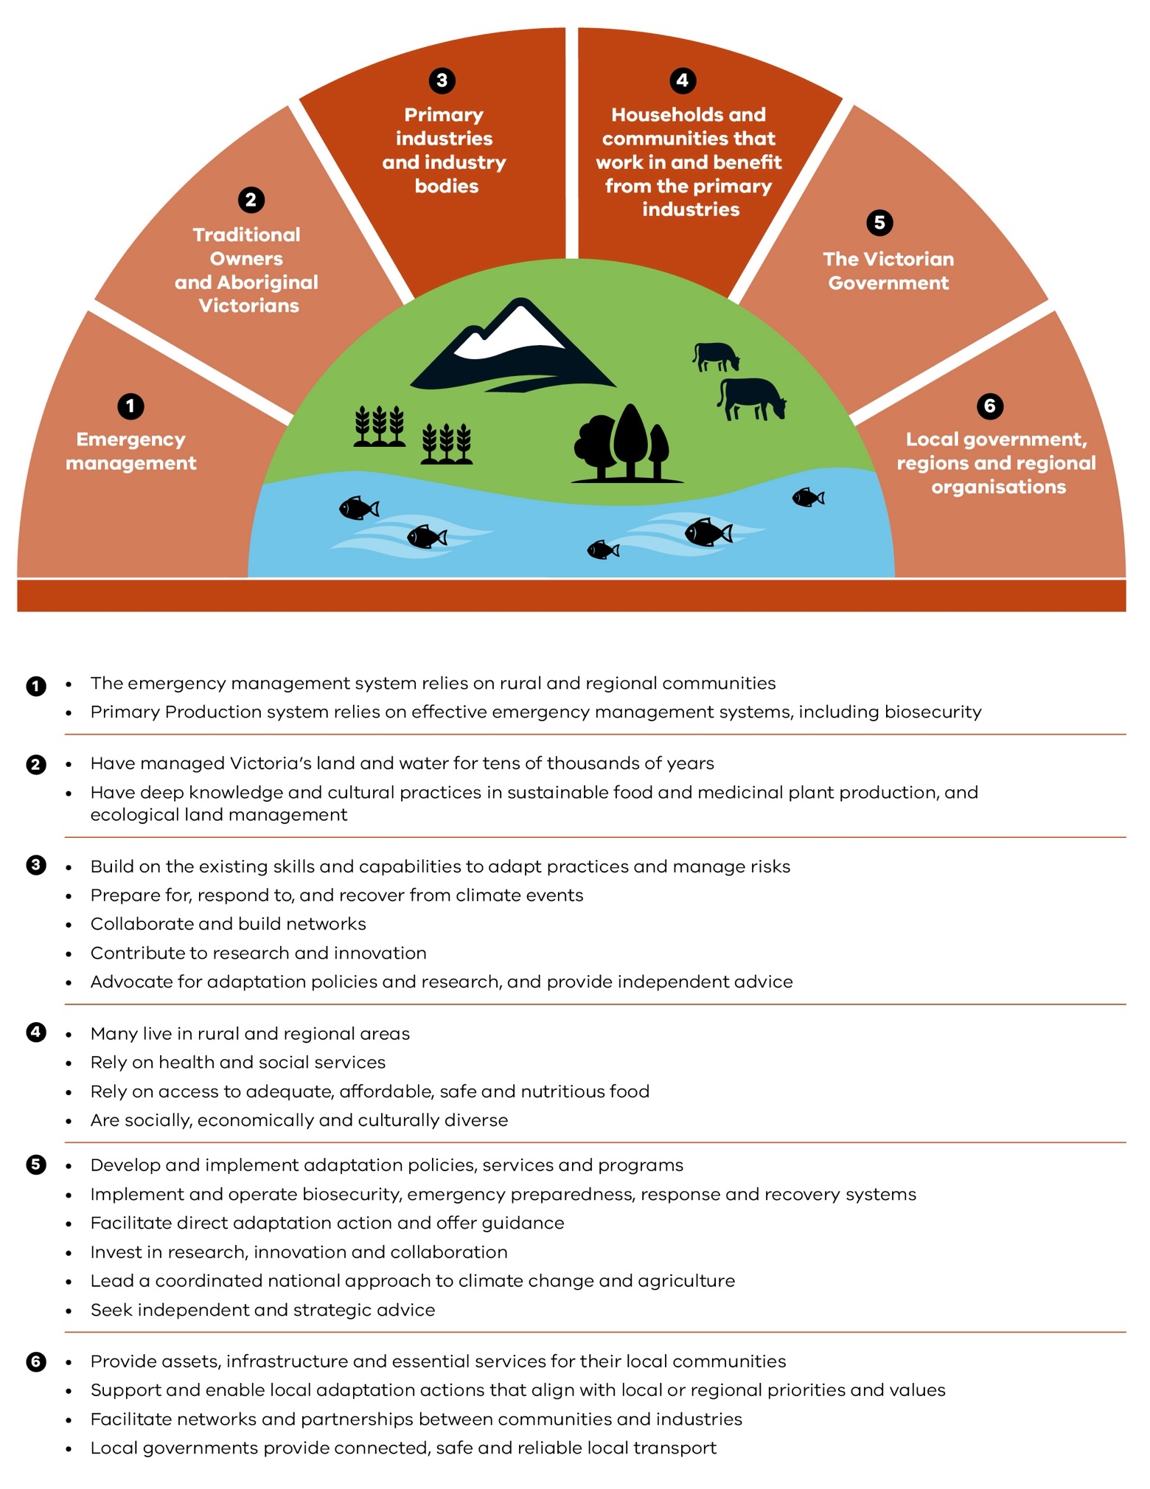

Climate change adaptation in primary production: current policies and initiatives

The Victorian Government has already put in place strategies, policies and programs that contribute to addressing climate change risks and opportunities across agriculture, productive fisheries and plantation forestry (Appendix 4).
Industry, the research sector, local government and community organisations are also making a difference. This includes important work by Traditional Owners, Landcare, industry bodies and catchment management authorities.
All this effort has built a strong foundation for more transformational adaptation in the primary industries.
Victorian Agriculture and Climate Change Statement
The Victorian Government recognises that climate change responses need to incorporate climate adaptation and emissions reduction priorities. Victorian primary industries are already feeling the effects of a changing climate due to historical emissions – and these impacts are going to increase.
The Victorian Agriculture and Climate Change Statement is being developed in partnership with industry to agree on a collective path to be climate resilient and set a long-term vision for the sector’s role in a net zero emission economy. It is being developed as part of the Agriculture Sector Pledge.

ADDRESSING CURRENT CLIMATE CHANGE IMPACTS
There are a range of existing services and tools to support businesses and industries build capacity to adapt to immediate risks from changing seasonal cycles. Established services for farmers that have had high uptake include:
- The Break newsletter’s seasonal forecasts
- Soil Moisture Monitor (soil probe networks) and Land Health
- sustainable land management and farm planning services for irrigation and dryland regions.

There are a range of participants in the service provider sector (private, not- for-profit and government) who each have important roles in supporting farmers with the management, planning and implementation of business decisions. These services include supporting on-farm and coordinated regional adaptation. There remain opportunities and government support for initiatives that work with the existing network of current service providers to strengthen adaptation results for farmers.
Addressing the impacts of climate change includes emergency response systems, relief and recovery as well as preparing for projected increases in extreme events. Reflecting the ‘build back better’ principle and improved climate risk governance across the Primary Production system will improve system resilience. Stress testing existing government systems and operations against immediate and long-term climate change risks is an important part of this approach.

Primary Production Climate Change Adaptation Action Plan 2022–2026 27

Spotlight: System flexibility is helping livestock farmers be better prepared by improving sheep industry outcomes
One of the biggest challenges facing sheep producers in Victoria is lamb survival. As in other livestock farming, improving reproductive outcomes is a key tool for farmers adapting to climate change. If more lambs live, farmers have greater ability to manipulate stocking rates through highly variable seasons. They have the flexibility to make the most of good years and limit losses in bad – destocking and restocking quickly to achieve adaptable, optimal farm performance and productivity.
Strategies include genetic selection, improved fertility, pregnancy management and stock containment to allow pasture growth.
This topic aligns with priorities 2 and 3 of this AAP.

Spotlight: Partnering with industry to protect our changing fisheries
The changing climate is affecting marine and coastal environments, leading to a shift in species distribution throughout south-eastern Australian waters.⁶ While some changes allow fishers to exploit new species, other changes are threatening key fish stocks, such as abalone. The spread and growth of sea urchins is affecting algae and sea grass species, which are critical habitats for key fisheries.
Collaboration with commercial fishers can reduce incursions of black-spined sea urchins and help reef kelp canopy and algal understory recover so they can provide habitat and food for fish populations.
This topic aligns with priorities 2 and 3 of this AAP.

Spotlight: Innovative research and collaboration to help Australia’s dairy industry become more climate resilient
Increases in the risk of extreme climate events pose negative impacts on livestock welfare and farm productivity. Rising energy costs and the greater likelihood of power interruptions further impact profit.
Through Ellinbank SmartFarm, Agriculture Victoria Research is partnering with industry, agribusiness, the education sector and communities to develop SmartFarms, which actively engage in multi-disciplinary research and innovation in key regional centres across Victoria.
The Ellinbank SmartFarm in Gippsland studies and tests creative technologies in a research environment accessible to the dairy industry. Farmers see demonstrations of effective, fit- for-purpose tools that can help them reduce energy costs and be more efficient. Projects include:
  - optimising homegrown feed to improve farm operating profit
  - improving heat health and livestock welfare
  - increasing production performance while reducing costs
  - sustainably increasing annual milk production through nutrition and pasture management
  - testing novel feeding strategies to reduce dairy cow methane emissions (potentially other animals too).
These investments generate deep knowledge of aspects of climate change and primary production, particularly around seasonal challenges or climate-related hazards such as drought or heat, or particular commodities, such as grains or livestock. Longer term and cross-industry challenges due to climate change must also be addressed.
This topic aligns with priorities 2 and 3 of this AAP.

6 Evans K, Bax N & Smith DC (2017). Australia state of the environment 2016: marine environment, independent report to the Australian Government Minister for the Environment and Energy, Australian Government Department of the Environment and Energy, Canberra.

REDUCING BARRIERS TO ADAPTATION
Many people and businesses in the primary industries face barriers to adaptation. This can include poor health, low income, experience of pests, diseases or ecosystem damage, or being far from support networks and services.
Effective adaptation requires primary industries to understand the full range of issues that climate change could pose. Governments, industry and others have invested in research, innovation and trials to test new crops and
improve what we know about producing commodities that are already experiencing and responding to climate change. A sustained focus on research into system-wide issues, regional issues and commodities is needed. Collaboration and information sharing, as well as whole-of-government collaboration and programs on primary production and climate change adaptation, are crucial. There are existing programs building skills and capability in climate change adaptation – many focused on managing seasonal variability and generating business efficiencies.

LAYING THE FOUNDATIONS FOR TRANSFORMATION
The Victorian Government’s commitment to supporting longer-term transformational change in the Primary Production system, driven by climate change and other long-term challenges, is demonstrated by:
- the government’s investment of $110 million in the 2017– 18 Budget to incentivize new plantation development in Gippsland. This will deliver additional plantation wood supply to support the region’s wood products industry to increase jobs and value generation. It includes $10 million to support farmers in developing agroforestry projects on their land, providing alternative revenue streams, sequestering carbon, and diversifying the region’s timber and fibre supply
- scholarships supporting professional development for women and young farmers to take on leadership roles in their industry or community
- agriculture extension services that include a ‘Climate 101’ animation, posters and analogues, and staff support and advice for regional and industry adaptation projects
- updates to the Victorian Land Use Information System (VLUIS), providing industry and government with a current understanding of land use and land use change in Victoria
- the development of an Agriculture Climate Spatial Tool using updated VLUIS data to provide information to farmers at a paddock and farm scale to help them adapt based on future climate change scenarios.
An increased focus on regional initiatives that look across commodities, value chains and industries could build connections and improve knowledge of adaptation needs and actions.
Social and economic drivers of change in primary production practices, and how these operate across the value chain, need to be looked at to provide a foundation for more transformational long-term change.

Spotlight: Unreliable seasons leading to transformation in the grape and wine industry
Weather and microclimates are carefully monitored and managed in vineyards because they directly affect the speed of grape ripening, as well as their acidity and sugar levels. Climate change – including changes in temperature, water availability and harvest dates – is already changing grape qualities and compressing harvests.
As a winery’s local climate becomes less suitable for certain grape varieties, producers might change their wine varieties or move all or part of their business elsewhere. Some Victorian wine producers are already making these changes. For example, in 2016 the Brown Brothers’ board decided to move part of their business from Victoria’s north-east, where they have produced wine for 130 years, to Tasmania, which has become more suitable for growing some of their cooler-climate wines.
The industry has led efforts complementing government action by providing detailed information about how the changing climate could affect Australia’s wine regions up to 2100. This includes The Wine Climate Atlas, a free online resource.
These practices align with priorities 1, 2 and 3 of this AAP.

Spotlight: Supporting resilience in the expanding farm-forestry and plantation sector
The Victorian Forestry Plan commits to phasing out native timber production by 2030. At the same time, there is an opportunity for the plantation and farm-forestry sectors to expand to meet growing domestic and global timber, pulp and fibre demand. However, hotter and drier conditions, and increased risks of extreme events including fire and drought, pose additional challenges.
While the environmental benefits of growing trees are recognised, views vary on land-use change, water-yield implications, fire risks and risks from existing and novel pests and diseases, under a changing climate. This lack of consensus has stymied efforts to increase the farm-forestry and plantation sector’s resilience to
climate change.
Better ‘local level’ climate change projections will help plantation owners manage their estates in the long term. The effects of changing land uses on the natural environment, regional water supply systems (including waterways and reservoirs) and groundwater resources – such as increased plantation forestry or changing agricultural models – must be better understood. This will help government, industry and landholders make more informed planning and investment decisions that better prepare the farm-forestry and plantation sector for climate change.

Adaptation actions: a 5-year plan
Figure 9. Primary Production Climate Change Adaptation Action Plan: priorities and actions 2022–2026

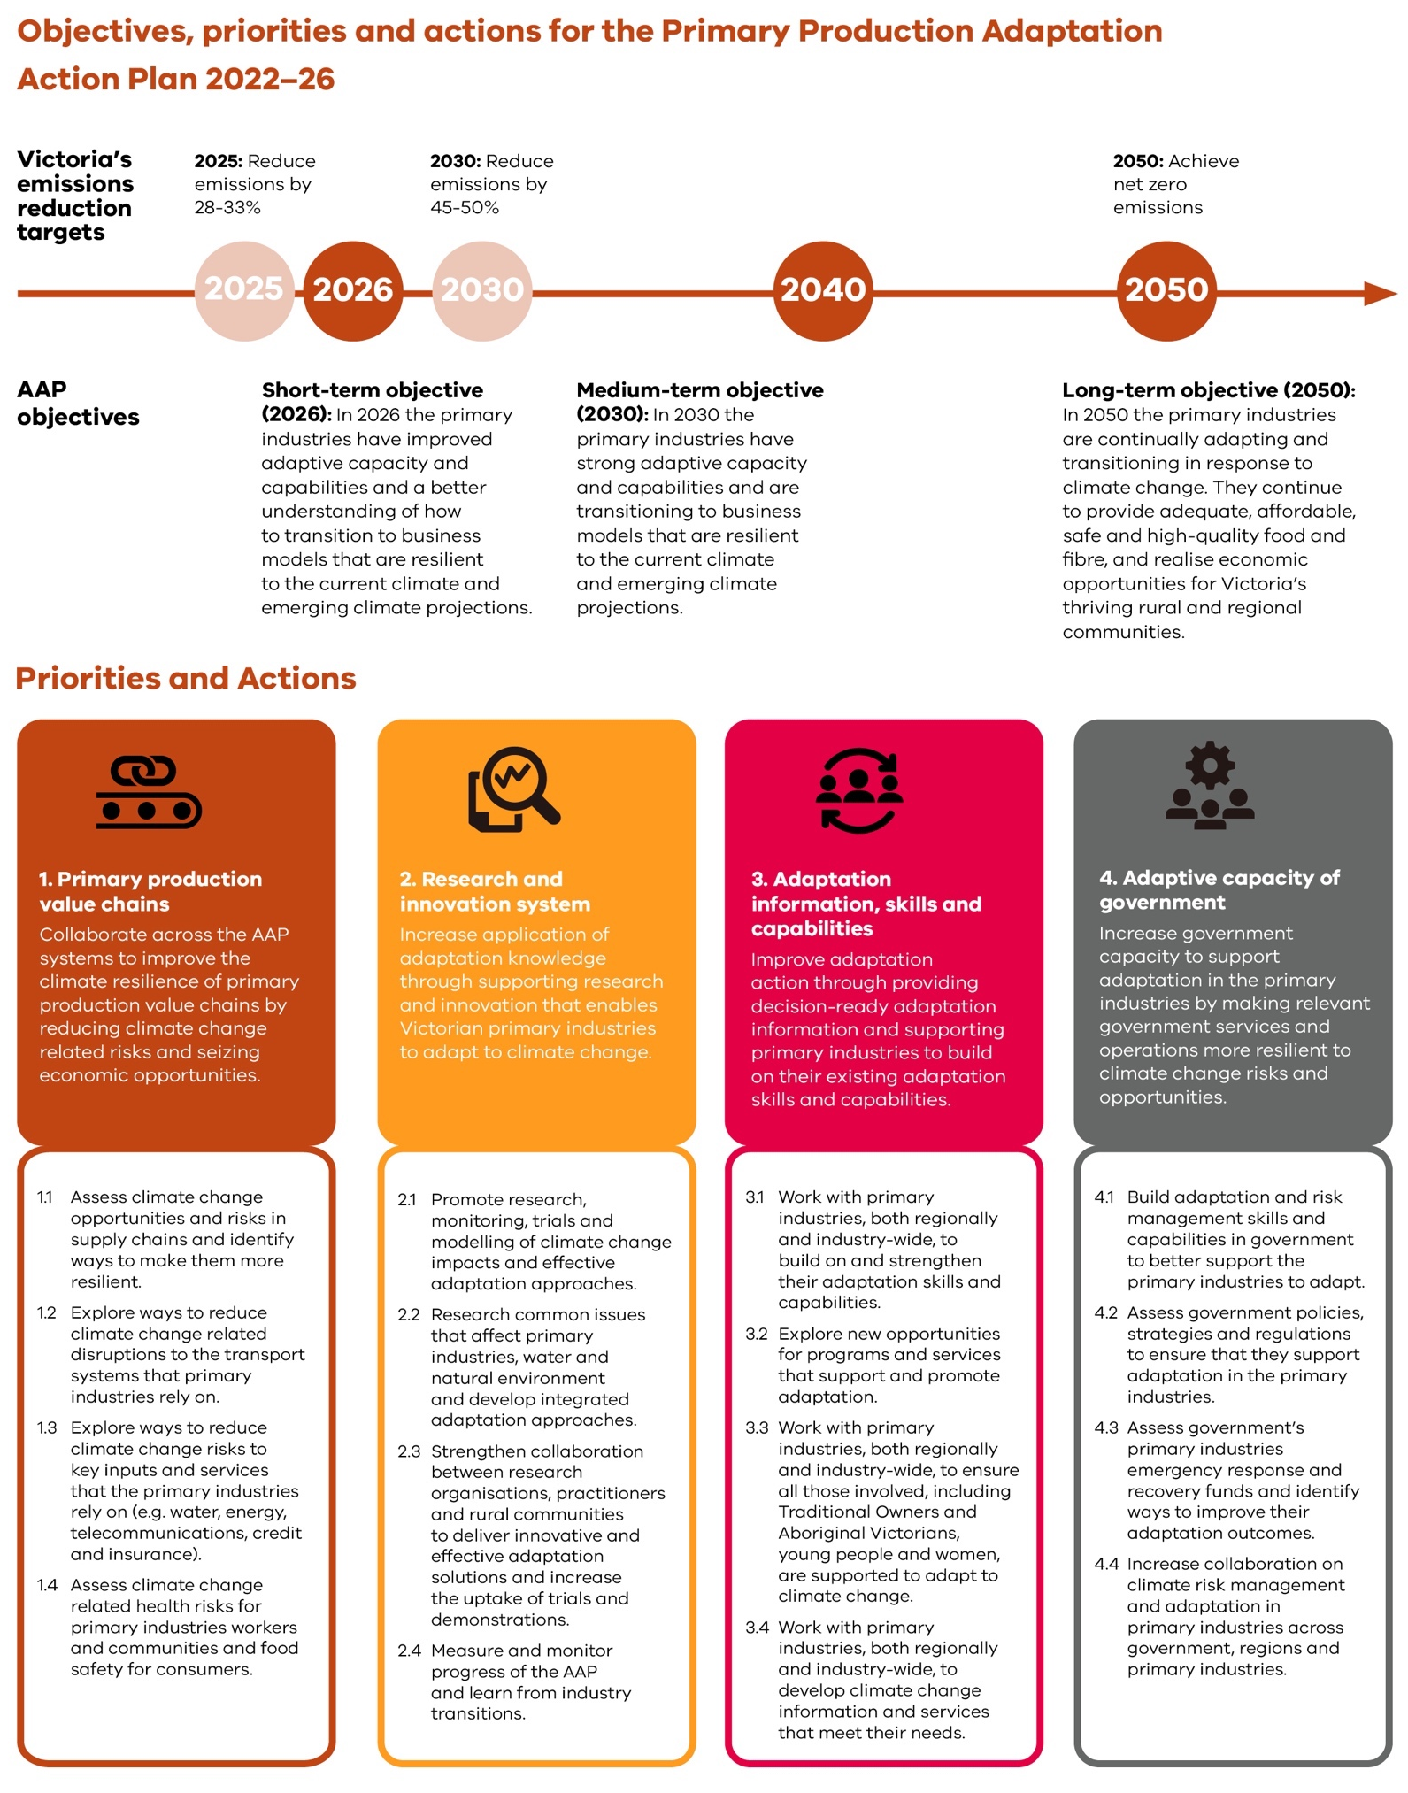
Four priority areas have been identified for inclusion in this plan:
- primary production value chains
- research and innovation system
- climate change adaptation information, skills and capabilities
- adaptive capacity of government.

PRIORITY 1. PRIMARY PRODUCTION VALUE CHAINS
Collaborate across the AAP systems to improve the climate resilience of primary production value chains by reducing climate change related risks and seizing economic opportunities.

Assess climate change opportunities and risks in supply chains and identify ways to make them more resilient.

This action could include working with key stakeholders to map Victorian primary production supply chains, identify specific risks and opportunities posed by climate change and generate ideas for addressing them.
These ideas could consider actions that are incremental or transformational in nature. They could consider potential impacts on short-term food availability and accessibility through disrupted supply chains and damage to crops or products, and the longer- term resilience of the food system.

This would build the evidence base for adaptation across the Primary Production system and will inform the implementation of other actions in this plan.

Explore ways to reduce climate change related disruptions to the transport systems that primary
industries rely on.
This action could include working with the transport sector to better understand and address the potential climate-related disruptions across the Transport system, with a focus on those of particular concern to primary production such as extreme events causing disruptions to key transport routes and supply chains that provide
access to inputs and markets, and risks to short-term access to affordable food. Key concerns include:
- safe and reliable regional and rural routes
- adequate transport services during peak use (for example, around harvest)
- humane care of livestock during transportation
- reliable access to routes during extreme events, which is critical to humane livestock care.
This would improve knowledge of particular risks and locations where focused
effort would address climate-related disruptions across the Transport system.
  - Explore ways to reduce climate change risks to
key inputs and services that primary industries rely on (e.g. water, energy,
telecommunications, credit and insurance).
This action could include partnerships and collaborative actions at a regional level
to assess climate change- related risks to critical inputs and supports, and come up with potential solutions for commodities and businesses.
Collaborative approaches to ongoing work would improve energy and water
management and efficiencies.
This would strengthen existing work to reduce climate change-related risks – to inputs such as water, energy, telecommunications, credit and insurance – and to inform new actions.

Assess climate change related health risks to primary industries workers and communities, and food safety for consumers.
This action could include collaboration with rural and regional communities and with health and human service and occupational health and safety agencies as well as primary industries agencies, to understand and address the way climate change contributes to health and safety risks for consumers, primary industry workers, their families and communities.
This would inform health- related actions to address climate change and health risks.

Spotlight: Bringing adaptation to life in the regions
Water catchments are an environmental asset and are critical to food and fibre production and community wellbeing. In the north-east of Victoria, private landholders manage about 50 per cent of them. It is important for these landholders to receive information about the likely impacts of future climate on water availability and production systems.
The North East Catchment Management Authority is partnering with the cropping, grazing, forestry, horticulture, viticulture and dairy sectors, and 6 local governments to increase the capacity of landholders, communities and local government to adapt to changing regional climatic conditions.
In a participatory process, users of water (land managers and local government) are coming to understand the regional climate projection data they need most to make informed
decisions. Practical, web-based spatial tools have been developed that summarise predicted impacts on regional agricultural productivity and water-balance impacts.
This region-specific information can guide discussions about climate adaptation pathways for industries and communities and help farming businesses make important management and investment decisions.
This project aligns with priorities 1 and 3 of this AAP.

Spotlight: Working together to better understand how climate change is affecting horticulture producers in the Mallee
Climate projections show the Mallee is likely to experience higher summer temperatures, more extreme events and water scarcity, which will affect irrigated agriculture in the region. The Mallee Catchment Management Authority and Agriculture Victoria have worked together to analyse quantitative estimates of these climate change impacts on almond, citrus, dried vine fruit, and wine and table grape crops.
The project modelled:
• phenology – looking at the timing of annual biological events and how these are affected by climate (for example, spring blossoming and summer fruit development)
• yield
• water use of current major crops
• likely production responses to future climate scenarios.
How is the project increasing our understanding of climate change impacts on horticulture?
Research found that climate change will affect the production of all crops analysed unless producers develop and adopt new management practices. A literature review of information on current crop types helped research partners identify possible solutions.
Discussions are underway to develop management strategies and evaluate alternative plant varieties better suited to extreme climates and water-limited conditions.
This project aligns with priorities 2 and 3 of this AAP.

PRIORITY 2. RESEARCH AND INNOVATION SYSTEM
Increase application of adaptation knowledge through supporting research and innovation that enables Victorian primary industries to adapt to climate change.

Promote research, trials, monitoring and modelling of climate change impacts and effective adaptation approaches.
This action could include targeted and practical research across commodity groups and regions to strengthen knowledge of:
- the nature and timing of impacts from cascading and compounding climate change risks from extreme events
- climate change impacts on production and harvest
- new opportunities arising from climate change and adaptation
- adaptation that maintains and improves natural resource conditions and the sustainability of landscapes
- how to build and harness social networks.
This would lead to an improved understanding of the adaptation needs across the Primary Production system and of adaptation action that would improve transformational outcomes.

2.4 Research common issues that affect primary industries, water and natural environment and develop integrated adaptation approaches.
This action could include working with primary industries to understand their options on a property, catchment, ecosystem, regional or statewide scale. Potential topics include:
- how climate change interacts with management practices affecting land and water quality
- pest, disease and biosecurity risks
- risks to pollination and pollination services
- productivity benefits of improving natural resource conditions
- the long-term viability of different business models in varying scenarios.
This would strengthen existing knowledge and identify entry points to address climate change risks and harness opportunities.

2.3 Strengthen collaboration between research organisations, practitioners and rural communities
to deliver innovative and effective adaptation
solutions and increase the uptake of trials.
This action could include building on existing programs and creating stronger collaborations between the primary industries and researchers to identify barriers to adaptation and stimulate adaptation actions. These actions could reflect incremental or transformational adaptation.
This would strengthen transformative climate change adaptation. If done in collaboration with industry, people in primary industries and government, it could accelerate adaptation implementation.
2.4. Measure and monitor progress of the AAP and learn from industry transitions.
This action could include developing and applying a monitoring, evaluation and learning framework to encourage a flexible approach to adaptation, since adaptation itself needs to be adaptable.
Outcomes and learning would be tracked, and plans and programs updated accordingly.

PRIORITY 3. CLIMATE CHANGE ADAPTATION INFORMATION, SKILLS AND CAPABILITIES
Improve adaptation action by providing decision-ready adaptation information and supporting primary industries
to build on existing adaptation skills and capabilities.

3.1. Work with primary industries, both regionally and industry-wide, to build on and strengthen their adaptation skills and capabilities.
This action could include a review of emerging skill and capability needs, and
existing government and other adaptation-related capability building programs and services.
This would inform the adaptation content of existing programs and services
and could contribute to the development of new initiatives that support skills and capabilities to implement incremental or transformational actions.

3.2 Explore new opportunities for programs and services that support and promote adaptation.
This action could include using a range of policy instruments to enable and support adaptation initiatives such as grants, trials, demonstrations and communication products.
Leveraging existing programs and investments to deliver targeted support for practical action and regional partnerships and networks would strengthen
outcomes. This would support local and regional economic development outcomes.

Work with primary industries, both regionally and industry-wide, to ensure all those involved, including Traditional Owners and Aboriginal Victorians,
young people and women, are supported to adapt to climate change.
This action could include assessing the intersecting factors, such as geography and economic challenges, that block some people from accessing outreach and training opportunities. This
knowledge could then be used to inform targeted support.
This would improve the inclusion of diverse primary industries participants.

Work with primary industries, both regionally and industry-wide, to develop climate change information and services that meet their needs.
This action could include a review of existing
information sources to assess opportunities to expand climate change adaptation content and inform longer-term decision making and planning.
This would build on existing strengths and
contribute to better-informed transformational adaptation.

Addressing heat stress in the Northern Victorian dairy industry
Dairy farmers in northern Victoria are used to dealing with periodic heatwaves. However, by 2025 they are predicted to face 10–15 more annual heat-stress days than they did in 2010. At temperatures as low as 26 degrees, cows reduce their grazing time. They produce less milk during a heatwave and this has lasting effects on the rest of the lactation period.
What could adaptation look like?
There is a wealth of existing advice available to the dairy industry:
• The Cool Cows program, run by Dairy Australia, offers a wealth of advice, including tips on tree planting for shade, keeping cows cool and other heat reduction strategies.
• Many farmers are planting trees in paddocks and laneways as part of a long-term strategy for managing climate variability. Trees provide shade and reduce cows’ exposure to radiant heat, offering better control over their heat loads. It’s also more comfortable for workers.
• Shade sheds are a relatively cheap, roofed, loose-housed structure with deep bedding and an adjoining feed pad. Cows can graze after the morning milking and return from the paddock in their own time. The sheds offer significant welfare and productivity benefits, allowing cows to choose their preferred environment.
This project aligns with priorities 2 and 3 of this AAP.

PRIORITY 4. ADAPTIVE CAPACITY OF GOVERNMENT
Increase government capacity to support adaptation in the primary industries by making relevant government services and operations more resilient to climate change risks and opportunities.

Build adaptation and risk management skills and capabilities in government to better support primary industries to adapt.
This action could include government employees undertaking professional development and network building to improve skills and capabilities around climate change adaptation and the Primary Production system.
This would support adaptation programs and improve delivery of the actions in this plan.

Assess government policies, strategies and regulations to ensure that they support adaptation in the primary industries.
This action could include mapping the relevant entry points for adaptation and climate-risk governance and addressing barriers in
regulations, codes of practice and policies to aid stronger adaptation outcomes.
This would contribute to whole-of-government work on climate-risk governance and embed adaptation where relevant in government.

Assess government’s primary industries’ emergency response and recovery funds and identify ways to improve their adaptation outcomes.
This action could include analysing previous relief and recovery efforts contributions to longer-term resilience outcomes. Relief and recovery from particular climate events during the implementation
of the Primary Production AAP could provide further opportunties to analyse these outcomes.
This would inform future government relief and recovery initiatives to support improved long-term outcomes for the primary industries.

Increase collaboration on climate risk management and adaptation in primary production across government, regions and industries.
This action could include assessing institutional capacity across government, scenario planning, stress testing existing systems, assets, operations and services, and identifying their strengths and needs.
This would contribute to improved adaptation outcomes and collaboration between government, industry and people in primary industries.

Monitoring, evaluation, reporting and improvement

The Department of Jobs, Precincts and Regions (DJPR) is committed to building a strong evidence-based culture. This is a critical aspect of strategic decision making, public sector accountability, efficient and effective management and continuous improvement. Monitoring
and evaluation are important aspects of the evidence-based approach at DJPR because they enable us to learn, improve and demonstrate accountability.
A fit-for-purpose monitoring, evaluation and learning framework will be developed within year one to guide the AAP’s implementation. The AAP includes a commitment (action 2.4) to develop and implement a framework that reflects the Primary Production system’s adaptability and transformation. The framework will draw on appropriate
data collection methods and include a mix of quantitative and qualitative data collection methods. This might include,
for example, developing an outcome logic model; identifying key evaluation questions; data collection
methods; judgement criteria and formal evaluation requirements. Data collection to support monitoring and evaluation will be integrated in the day-to-day implementation of the plan to maximise the effectiveness and efficiency of investments.

Implementation and next steps

Victoria’s primary industries are a critical part of our state and regional economies.
They provide employment, food and fibre, and economic opportunities across
Victoria. This plan sets out the objectives, priorities and actions the Victorian Government will take to
support our primary industries to adapt and transition in response to climate change.
The government will implement this plan in partnership with industry and other key stakeholders. In delivering the plan, we aim to achieve lasting positive change for our primary industries and for all of Victoria.

Appendices

APPENDIX 1. OBJECTIVES, PRIORITIES AND ACTIONS FOR THE PRIMARY PRODUCTION AAP 2022–2026

Short-term objective (2026): In 2026 the primary industries have improved adaptive capacity and capabilities and a better understanding of how to transition to business models that are resilient to the current climate and emerging climate projections.
Medium-term objective (2030): In 2030 the primary industries have strong adaptive capacity and capabilities and are transitioning to business models that are resilient to the current climate and emerging climate projections.

Long-term objective (2050): In 2050 the primary industries are continually adapting and transitioning in response to climate change. They continue to provide adequate, affordable, safe and high-quality food and fibre, and realise economic opportunities for Victoria’s thriving rural and regional communities.
Priorities and actions for the Primary Production Adaptation Action Plan 2022–26

- Primary production value chains

Collaborate across the AAP systems to improve the climate resilience of primary production value chains by reducing climate change related risks and seizing economic opportunities.
  - Assess climate change opportunities and risks in supply chains and identify ways to make them more resilient.

  - Explore ways to reduce climate change related disruptions to the transport systems that primary industries rely on.
  - Explore ways to reduce climate change risks to
key inputs and services that the primary industries rely on (e.g. water, energy,
telecommunications, credit and insurance).

  - Assess climate change related health risks for primary industries workers and communities, and food safety for consumers.
- Research and innovation system

Increase application of adaptation knowledge through supporting research and innovation that enables Victorian primary industries to adapt to climate change.

  - Promote research, monitoring, trials and modelling of climate change impacts and effective adaptation approaches.

  - Research common issues that affect primary industries, water and natural environment and develop integrated adaptation approaches.
  - Strengthen collaboration between research organisations, practitioners and rural communities to deliver innovative and effective adaptation solutions and increase the uptake of trials and demonstrations.
  - Measure and monitor progress of the AAP and learn from industry transitions.
- Adaptation information, skills and capabilities

Improve adaptation action through providing decision- ready adaptation information and supporting primary industries to build on their existing adaptation skills and capabilities.
  - Work with primary industries, both regionally and industry-wide, to build on and strengthen their adaptation skills and capabilities.
3.2 Explore new opportunities for programs and services that support and promote adaptation

  - Work with primary industries, both regionally and industry-wide, to ensure all those involved, including Traditional Owners and Aboriginal Victorians, young people and women, are supported to adapt to climate change.
  - Work with primary industries, both regionally and industry-wide, to develop climate change information and services that meet their needs.
- Adaptive capacity of government

Increase government capacity to support adaptation in the primary industries by making relevant government services and operations more resilient to climate change risks and opportunities.
  - Build adaptation and risk management skills and capabilities in government to better support the primary industries to adapt.
  - Assess government policies, strategies and regulations
to ensure that they support adaptation in the primary industries.
  - Assess government’s primary industries emergency response and recovery funds and identify ways to improve their adaptation outcomes.

  - Increase collaboration on climate risk management and adaptation in primary industries across government, regions and primary industries.

APPENDIX 2. CONNECTIONS BETWEEN THE PRIMARY PRODUCTION SYSTEM AND OTHER SYSTEMS

System definition Connections with the Primary Production system Cross-system risks

Water

The collection, storage, treatment, delivery and supply of water, including recycled water; sewerage services, including the collection, treatment and disposal through sewerage systems and treatment plants; drainage services including the operation of drainage systems; flood management services
including the operation and maintenance of infrastructure to manage floods.

Natural Environment

The natural environment consists of land- based ecosystems such as grasslands and forests, aquatic ecosystems such as rivers and wetlands, and coastal and marine ecosystems such as mangroves and
sea-grass meadows. These ecosystems contain more than animals and plants. They are also about the rocks and soil that support life, and the climatic, water and fire conditions that plants and animals have evolved in.

Built Environment

The built environment and how people interact with that system. The built environment means places and structures built or developed for human occupation, use and employment, including cities, buildings, urban spaces, housing and infrastructure.

Health and Human Services

Services and assets primarily engaged in protecting human health from disease resulting from or associated with
communicable disease, food, water or the environment; and the services and assets which provide human physical and mental health care, social support and assistance.

Education and Training

The services and assets primarily engaged in the planning, development, provision and support of education and training, including future workplace skills and needs.
The Primary Production system:
- relies on adequate, affordable and fit-for-purpose water
- manages its own water use, including biosolids and alternative water sources
- manages its own business planning in the context of short- and long-term changes in water availability and its own changing demand for water
- manages risks that arise from its own management decisions, including risks to waterways and the marine environment from run off.
The Primary Production system:
- relies on the natural environment for a wide range of ecological services (such as pollination, healthy soil, fish stocks, pest control, clean air and healthy waterways)
- manages activities to minimise environmental impacts
- relies on the natural environment being managed to minimise negative consequences for primary production.

The Natural Environment system:
- relies on a well-managed Primary Production system to minimise negative impacts on land, water, soil, biodiversity and ecological processes.

The Primary Production system:
- requires a reliable energy supply
- relies on the effective management and planning of rural and regional built assets
- relies on adequate and appropriate rural housing for workers
- relies on the availability of productive land. The Primary Production system:
- relies on the health system to provide an effective food safety system
- relies on adequate health and human services in rural and regional areas.

The Health and Human Services system:
- relies on the Primary Production system to minimise health- related water quality issues.

The Primary Production system:
- requires a workforce that is skilled in, and capable of, working within the changing climate.
- relies on education services and assets being climate resilient, high quality and available across Victoria.

The Education and Training system:
- needs to be informed of emerging skills gaps and training needs, employment gaps, and opportunities to rectify such gaps and needs.
- Water availability
- Nuisance and harmful algal blooms
- Alternative water supplies
- Flash flooding
- Coastal flooding

- Pollination
- Weeds and pests
- Plant and animal diseases (non-human)
- Changes to marine ecosystems
- Soil mobility
- Bushfire risk
- Loss or damage to culturally significant sites
- Land-use planning and social change
- Coastal flooding

- Food safety
- Food security (access to adequate, affordable, safe and nutritious food for all Victorians)
- Heat health
- The spread of diseases
- Nuisance and harmful algal blooms
- Skills and training

Transport

All the components for the movement of persons and goods, namely physical
components, including transport networks, facilities and vehicles; and services components, including passenger, freight, and other transport services to move persons and goods.
The Primary Production system:
  - relies on connected, safe and reliable transport (road, rail and ports – domestic and international).
  - relies on the Transport system to design, construct and manage transport assets to minimise impacts on productive land, water and assets, particularly during extreme events.

The Transport system:
  - relies on primary production managing activities to minimise impacts on the Transport system, particularly during extreme events such as flooding or from soil mobility.
- Soil mobility
- Disruptions to:

- private, public and active transport

- transport supply chains and service delivery
- Roadside services, including pipes, pipelines, poles, cables and wires

APPENDIX 3. CLIMATE CHANGE RISKS AND CROSS-SYSTEM CLIMATE CHANGE RISKS OF CONCERN FOR THE PRIMARY PRODUCTION SYSTEM

Climate change risks

Risks arising from limited adaptive capacity and existing vulnerabilities

Implications for the Primary Production AAP:

Knowledge, information, skills and capabilities for climate change adaptation are critical to ensure that primary industries, businesses and service providers can take effective and appropriate adaptation action. The knowledge, information and services developed must be relevant, accessible and continually updated to remain responsive
to changing conditions. Focus on primary industry value chains will improve knowledge of the existing vulnerabilities across the system.

Relevant actions

2.2, 3.4, 4.1 and 4.2

Risks arising from extreme and concurrent events Implications for the Primary Production AAP:
Improved understanding of climate change risks across Victoria’s primary production value chains will identify immediate and longer-term concerns and point to further action to address them. Government systems, assets, operations and services will be under more pressure as climate risks increase.

Relevant actions

1.1, 4.3 and 4.4

- Victoria’s primary industries have existing adaptive capacities that provide a basis for the on-going adaptation and collaboration needed across the system.
- This adaptive capacity can be either constrained or strengthened by non-climate factors, such as ecosystem health, access to finance and insurance, skills and training, and availability of assets and services.
- Some people in the primary industries have existing vulnerabilities, such as those with health concerns, lower socio-economic groups, and/or those remote from services.
- Some businesses are also more vulnerable due to high input prices, soil degradation, declining populations or limited access to an appropriately skilled workforce.
- Businesses that already face challenging market conditions are less able to prepare for or recover from extreme events. Over time, they might be less able to absorb and adapt to increasing climate stresses. Long term, climate change could lead to business closures, stranded assets, social distress, environmental degradation and other problems that may need rapid and costly responses.

- Increases in the magnitude, frequency and concurrence of extreme weather events and their consequences, which can include impacts of fire, water-quality issues, soil loss and pest outbreaks, mean that even well- adapted businesses can be affected.
- This risk could increase the proportion of businesses requiring emergency assistance and put additional pressure on emergency response capacity and support services.
- If disasters hit during periods of high personnel demand in primary industries – such as the grain harvest – then the business impacts will be especially severe.
- Extreme events can trigger business closures with far-reaching flow-on effects for families, communities and industries.
- Emergency services rely on rural and regional communities to deliver adequate and effective support in times of extreme events and these people may themselves be facing the impacts.
- Extreme events can affect animal welfare.
- More frequent and intense events can increase costs and reduce insurance availability for primary producers.
- Extreme events outside Victoria (or outside Australia) can disrupt transport routes and cause logistical or other value-chain disruptions and problems that negatively affect Victorian primary industries.
- These impacts could reduce access to inputs or markets, increase costs, constrain consumer demand or alter economic or policy settings.

Risks arising from longer-term transformational adaptation needs

Implications for the Primary Production AAP:

Regional collaboration and planning can create networks and stimulate action that generates co-benefits and
long-term resilience outcomes. Multidisciplinary research and collaboration will improve knowledge of climate change across the Primary Production system. Stronger transformational adaptation skills and capabilities are needed.

Relevant actions

2.1, 2.3, 2.4, 3.1, 3.2, 3.3, 3.4 and 4.4

  - Adaptation includes actions in the short-term and those that respond to longer-term trends, as well as transformational adaptation.
  - Proactive, collaborative and well-managed transformations will be more effective and efficient.
  - For the primary industries, transformational adaptation can include adopting new business models and new land uses or relocating the industry.
  - There is a risk that longer-term transformational needs may be missed as climate change risks emerge for crucial links in existing value chains. For example:

    - processors or exporters might suddenly reduce their services, leaving some businesses stranded.

    - high-potential businesses could lose access to value chains and affordable inputs and decide to leave the sector.
  - If a growing number of primary industries and related businesses leave a region, the viability of remaining populations, shared services and infrastructure could diminish.

Cross-system climate change risks
Risk champions are designated for each risk based on either their primary portfolio responsibilities, or available policy or legislative levers to collaborate or drive action to address the risks – in partnership with other linked systems. It is important to note that departments associated with these lead systems may be different to those designated as control agencies for hazards or hazardous events in Victoria’s State Emergency Management Plan.

Cross-system risk: food security
Concerned systems: Health and Human Services, Transport
Food security means access to adequate, affordable, safe and nutritious food for all Victorians. It is a particular concern for vulnerable communities and lower socio-economic groups. Rural and regional communities are among those with the least reliable food security.
Projected increases in frequency and/or intensity of extreme weather events (including floods, droughts, heat and bushfires) can cause damage to products and assets and disrupt critical supply chains and service delivery routes.
The Primary Production system is likely to be increasingly challenged by climate change risks, putting pressure on access to adequate, affordable, safe and nutritious food. This could
increase reliance on imported produce and expose the state to risks associated with trade regulations.
Risk champion: Primary Production Implications for the Primary Production AAP:
Improved food security will directly benefit people in the primary industries, particularly those in rural and regional communities where access to adequate, affordable, safe and nutritious food is an issue. Collaboration with the Health and Human Services system and the Transport system is crucial to strengthening long-term food security in Victoria.
Relevant actions
1.1, 1.2, 1.3, 1.4, 2.1

Cross-system risk: pollination and insect populations
Concerned systems: Primary Production and Natural Environment
Changing climate patterns and extremes could result in risks to insects and native and European honeybee populations affecting pollination of productive crops and other species. This includes:
  - changing distribution and flowering seasons of pollination- responsive crops.
  - more frequent hot days would disrupt blooming cycles, affecting the availability of pollen and nectar resources in a range of settings.
  - increased fire, heat, and smoke and declining water availability increasing stress on pollinators.
  - a risk that their pests and diseases will increase in prevalence or range.
  - reduced honey production and declining honeybee and hive health.
Cross-system risk: nuisance and harmful algal blooms
Concerned systems: Water Cycle, Natural Environment, Primary Production, Health and Human Services
In recent decades, harmful and nuisance algal blooms are becoming more common and may be occurring in new water bodies, during typically cooler months of the year that have never seen blooms or similar species before.
The likelihood, severity and impact of these algal blooms is linked to climate change factors (such as increased temperatures and reduced water inflows) and other factors (such as an increase in nutrients from agricultural runoff).
Cross-system risk: flash flooding
Concerned systems: Built Environment, Natural Environment, Health and Human Services, Primary Production, Transport, Education and Training
  - Increased risk of flash flooding, and resultant damage to built assets and infrastructure, soils and water quality.
  - More intense rainfall events could generate flash flooding in some locations if drainage and/or flood-management structures are overwhelmed.
  - Potential impacts on human health and safety, such as sewage overflows and farm runoff to the surrounding environment (including catchments).
  - Interruptions to critical services and potential damage to natural and built structures, with cascading impacts on the community.
Cross-system risk: water quality
Concerned systems: Primary Production, Health and Human services, Education and Training
Non-climate-related declines in water quality and ecological health could be directly exacerbated by the potential impacts of climate change through increases in bushfire, floods, drought and warmer average temperatures.
Indirect impacts arise could through chemicals and material entering waterways.
Risk champion: Primary Production Implications for the Primary Production AAP:
The contribution to Australia’s agricultural, horticultural and silvicultural output from crops and commodities that rely on pollination by insects is significant. Producers of pollination-responsive crops rely on a range of pollination services including incidental pollination by either native insects or feral honeybees, or paid services by bees specifically managed and provided for pollination purposes and/or on bees managed for honey production.
Relevant actions
1.1, 2.2, 4.2

Risk champion: Water Cycle
Implications for the Primary Production AAP:
Concerns include increased frequency and severity of fish kills, reduced water availability and poorer water quality for primary production purposes. There are potential costs for on-farm management, damage to assets and infrastructure, and reputational damage and risk to the social licence to operate.
Relevant actions
1.1, 2.2

Risk champion: Water Cycle
Implications for the Primary Production AAP:
Direct and indirect damage to land, stock and assets; impacts on human health; animal welfare and impacts on transport access.
Relevant actions
1.2, 1.4, 2.2, 3.2, 4.2, 4.3

Risk champion: Water Cycle
Implications for the Primary Production AAP:
Concerns include reductions to fit-for-purpose water for stock, irrigation, production and domestic purposes, as well as reduced amenity for people living in rural and regional areas.
Relevant actions
2.2

Cross-system risk: water availability
Concerned systems: Natural Environment, Primary Production, Built Environment, Health and Human Services
Projections of a warmer, drier climate pose water availability and reliability challenges for consumers and amenities, including the primary industries and their communities.
Competition for water is an issue across the state exacerbated by climate change impacts such as reduced surface water and groundwater water supplies, as well as changing water market
behaviours and patterns of demand, as land uses shift and adapt.

Cross-system risk: alternative water supplies
Concerned systems: Health and Human Services, Primary Production, Built Environment
Projections of continued decline in rainfall and increasing risk of drought conditions will drive diversification of water sources that must maximise benefits while keeping risks appropriately low.
Diversification of water sources and increased use of alternative water supplies for appropriate uses will be increasingly needed to meet demands for food production, household use, recreation, urban cooling and other purposes.
If not appropriately managed, this has the potential to expose community members to pathogens and chemicals.
Cross-system risk: marine ecosystem changes
Concerned systems: Primary Production, Health and Human Services
- Climate change is contributing to increasing temperatures and acidity in oceans, resulting in changes in abundance and
distribution of marine species – including productive species, and degradation and loss of marine ecosystems.
- Despite the potential for some positive outcomes, the risks to oceans, arising from climate change, are substantial.
- Climate change has contributed to the spread of black-spined sea urchins – a native species that has overgrazed algae and threatens some marine fisheries.
Cross-system risk: plant and animal diseases
Concerned systems: Natural Environment, Primary Production
- The impact of climate change on the spread of plant and animal diseases varies.
- When temperatures are warmer or wetter, development speeds up with faster completion of life cycles, but pathogens and vectors (such as mosquitoes) also die faster.
- Climate change could reduce the ability of host organisms to fight off diseases, which will worsen their impact.
Risk champion: Water Cycle
Implications for the Primary Production AAP:
Water availability poses significant challenges for primary production.
Further, the planning of new production or harvesting activities has consequences for the water cycle. Improving and applying our knowledge of connections between the primary industries, water availability and alternative water sources can accelerate implementation of effective adaptation options and generate co- benefits.
Relevant actions
1.2, 2.2
Risk champion: Water Cycle
Implications for the Primary Production AAP:
Possible economic barriers to using alternative water supplies and if regulation and technical options are not appropriate there could be issues for individual businesses in managing and using alternative supplies effectively and safely.
Relevant actions
2.2

Risk champion: Natural Environment Implications for the Primary Production AAP:
Productive species are moving southward, and others are showing altered behaviour and changes in species interactions. Together with local-scale, climate-driven migration and extinction, these changes are altering marine ecosystem structure and diversity. Additional pressures from coastal development and runoff compound these effects.
Relevant actions
1.1, 2.2

Risk champion: Natural Environment Implications for the Primary Production AAP:
It is expected that wetter summers and warmer winters will enable plant and animal diseases of concern to primary production to spread further in Victoria, potentially causing large-scale loss of ecosystems and species. Management practices within primary industries, biosecurity measures and the capability of primary industries participants to identify and manage these risks, are important.
Early intervention and improved surveillance skills can contribute to improved management of this risk.
Relevant actions
3.1, 4.2, 4.3

Cross-system risk: weeds and pests
Concerned systems: Primary Production, Transport
- Changing temperature, wind and rainfall patterns, and increasing extreme events result in changes to the abundance, distribution and dynamics of weeds and pests, including in the marine environment.
- Climate change has already caused the arrival of new weeds and pests into Victoria and expanding populations and increasing impacts from existing species (including native species).
- Many invasive species are well adapted to take advantage of the environmental disruption that will result from climate change, especially because the rate of change is beyond the adaptive capability of our native species and natural ecosystems.
Cross-system risk: bushfire risk
Concerned systems: Built Environment, Health and Human Services, Primary Production, Transport, Education and Training, Water Cycle
- Increased risk of changes to the severity, frequency and extent of bushfires, and resultant direct and indirect physical, natural, social and economic impacts.
- Likely interruption of delivery of essential services (such as water and sewerage) and the financial impact of rebuilding – affecting the long-term viability of some settlements in their current locations.
- Likely more frequent smoke pollution, longer periods where smoke pollution is present, and increased health impacts on affected populations. Smoke impacts visibility, affecting road safety and tourism experiences.
- Large-scale ecosystem changes could occur.
Cross-system risk: loss or damage to culturally significant sites
Concerned systems: Built Environment, Health and Human Services, Primary Production, Transport, Education and Training, Water Cycle
- Climate change impacts, and adaptation responses to them, can enhance the barriers to practising culture on Country by Traditional Owners and Aboriginal Victorians.
- Victorian Traditional Owners have cultural, spiritual and economic connections to land, water and resources through their associations and relationship with Country.
- As climate change increases the risks of extreme weather events: spiritually important species or objects (totems) could be lost, cultural sites of significance could be damaged and cultural practices could be impacted. All of which will affect the health and wellbeing of Traditional Owners and Aboriginal Victorians.
Cross-system risk: soil mobility
Concerned systems: Primary Production, Transport, Built Environment
- Changing rainfall patterns and extreme events could result in an increased level of soil mobility.
- Climate change impacts such as increased heat and intense rainfall events are likely to magnify existing soil mobility issues.
- Increased land instability can pose a risk to in-situ buildings, infrastructure and adjacent settlements.
Risk champion: Natural Environment Implications for the Primary Production AAP:
Weeds and pests affect primary production via market access, control costs and production losses. There are also consequences for some productive species in the marine environment. The changing climate will affect the measures available for control
of pests and diseases, including the application and timing of management practices. It is critical to detect new threats as early as possible. This provides the best chance to intervene successfully. It is also important to ensure that existing systems and processes are robust to a range of climate scenarios.
Relevant actions
3.1, 4.2, 4.3
Risk champion: Natural Environment Implications for the Primary Production AAP:
Increased risk of bushfire will have direct impacts on land, stock, crops, assets and infrastructure, drinking and irrigation, water quality, and human health and safety. There are also indirect impacts through supply chain disruptions and the potential for increased bushfire regulatory intervention. There is a risk of disruption to on-farm activities due to fire risks on extreme heat days, including being unable to use equipment. Demand on the farm workforce to support emergency responses could increase.
Relevant actions
1.2, 1.4, 2.2, 3.2, 4.2, 4.3

Risk champion: Natural Environment Implications for the Primary Production AAP:
There could be an increased risk of damage to culturally significant sites on private land and pressure on cultural practices.
Relevant actions
3.1, 3.2, 3.3

Risk champion: Natural Environment Implications for the Primary Production AAP:
Long-term nutrient loss can affect productivity and compromise soil health. There could be health and wellbeing concerns for primary producers, their families and communities through direct health effects (dust storms) and declining productivity through worsening soil quality. Production practices can reduce soil mobility and improve soil retention and quality.
Relevant actions
2.2

Cross-system risk: transport supply chain and service delivery disruptions
Concerned systems: Built Environment, Health and Human Services, Water Cycle, Primary Production
Projected increases in the frequency and/or intensity of extreme weather events could increase damage to transport assets and infrastructure and cause disruptions to transport services, impacting critical supply chains and service delivery.
Climate change projections suggest increases in the frequency and/ or intensity of extreme weather events. These are likely to cause damage to transport assets and infrastructure, and disruptions to transport services, with increasing frequency.

Cross-system risk: land use planning and social change
Concerned systems: Primary Production, Health and Human Services, Education and Training, Transport
Changing climate zones are beginning to affect uses of productive land. Around large urban and regional centres and related commuter corridors, land competition is already an issue.
Additionally, the quality of life of some rural regions and their access to services, coincides with other social and economic issues such as ageing populations and population decline. There could also be positive aspects with sea and tree change processes
potentially boosting emergency volunteer numbers and bringing new entrepreneurs to communities.
Cross-system risk: health risks
Concerned systems: Built Environment, Health and Human Services, Water Cycle, Primary Production, Transport
- Rising global temperatures and projected increases in extreme heat days and heatwaves, pose increasing risks to health and wellbeing.
- Extreme heat increases the incidence of illness, most commonly in the form of heat cramps, heat exhaustion, heat stroke and dehydration.
- Extreme heat can exacerbate pre-existing medical conditions, including both heart and kidney disease, asthma and other respiratory illnesses, and result in a wide range of indirect impacts.
Cross-system risk: food safety
Concerned systems: Primary Production, Transport
Projected increases in average temperature, risks of heatwaves and flooding, and potential loss of refrigeration from peak demand power outages, pose a range of risks to food safety.
These include growth of some mycotoxigenic fungal species in grains, livestock distress resulting in increased excretion of microorganisms, increased pathogen growth alongside higher pathogen survival rates and microbial contamination of food.
Risk champion: Transport
Implications for the Primary Production AAP:
Reduced production due to input supply issues, loss of produce, lack of access to markets creating economic issues; damage to reputation for safe and healthy food; and potential environmental harm through onsite disposal of spoiled produce.
Delays of delivery and sale in national and international markets, causing product losses. For example, delay to the delivery of milk can necessitate on-farm disposal, resulting in environmental risk.
Relevant actions
1.1, 1.2
Risk champion: Built Environment Implications for the Primary Production AAP:
The availability of productive land from changing climate zones could contribute to land use planning and social changes that affect demand for education, training, health and human services.
Adaptation in the primary industries at the regional scale can improve understanding of the trends operating in a region and create more effective long-term plans.
Relevant actions
1.1, 2.1

Risk champion: Health and Human Services Implications for the Primary Production AAP:
Extreme heat is an issue for people in the primary industries, particularly those who work in occupations that are highly exposed to the direct and indirect effects of extreme heat, and those in temporary rural accommodation. People and families from lower socio-economic groups will face further challenges from heat including cooling costs and food security concerns. It can also be an animal welfare issue. A stronger knowledge base of the health and climate change risks is needed.
Relevant actions
1.1, 1.4

Risk champion: Health and Human Services Implications for the Primary Production AAP:
As producers and harvesters of food for Victorians, food safety is already a focus of the primary industries. Understanding and
addressing current and future climate change-related risks to food safety in collaboration with the Health and Human Services system is vital. Collaboration with primary industries participants and service providers, in addition to industry and skills development, will improve management of emerging food safety risks.
Relevant actions
1.1, 1.4

APPENDIX 4. KEY EXISTING STRATEGIES, POLICIES AND PROGRAMS

Relevant strategies, policies and programs

AGRICULTURE
Strategies and strategic priorities

Strong, Innovative, Sustainable: A New Strategy for Agriculture Victoria: Victoria’s agriculture is globally competitive, innovative, resilient and diverse

Agriculture Victoria Digital Agriculture Strategy: Victoria’s farmers are at the forefront of agriculture’s digital revolution

A coordinated national approach to Agriculture and Climate Change: a work program that supports the agriculture sector to adapt to climate change and manage emissions

Climate Ready Natural Resource Management Plans; individual Catchment Management Authority Climate Change Adaptation and Mitigation Plans: actions to increase the resilience of priority landscapes, and identify risks and opportunities from market-driven carbon sequestration activities

Policies and programs Grants

Agriculture Energy Investment Plan: actions to improve on-farm energy efficiency and own-generation capacity

Victorian Rural Women's Leadership and Mentoring Program: training for women aiming to emerge as experienced leaders

Young Farmers Leadership and Scholarship Programs: investment in new skills to enable aspiring young farmers to be leaders in their communities
Research

Combining Biophysical and Genomic Selection Models to Breed Crops for Future Environments: increasing understanding of how to breed for resilience and adaptation in grain crops required for future climates

Drought-tolerant Crops and Pasture: supporting grain growers and livestock farmers to maintain yield in water- limited environments and under heat stress
Heat Stress in Dairy and Livestock: reducing the impacts of hot weather on milk, meat and wool production

Land and Water Resources Predictive Modelling and Monitoring at the Catchment and Regional Scale: informing land and water management, and investment strategies for government and industry

Services

Agriculture Services – Climate Risk and Land Health programs: tools and information to guide decision making to manage climate variability

Plan2Farm Program: providing irrigators with information and tools to help make important decisions for their businesses
Smarter, Safer Farms: providing skills and education to increase preparedness and resilience to drought and other climate change impacts

FISHERIES
Strategies and strategic priorities

Victorian Fisheries Authority Strategic Plan 2019–2024: healthy and sustainable fisheries for all Victorians

Victorian Aquaculture Strategy 2016-2021: a productive, growing and sustainable local aquaculture industry valued by the community

Policies and programs Target One Million plan:
  - constructing a new $7 million native fish hatchery in Shepparton
  - increasing fish stocking to 10 million fish annually by 2022
  - stocking Lake Tyers with eastern king prawns
  - removing commercial fishing nets and investing in science and habitat restoration in the Gippsland Lakes
  - releasing more native fish including Murray cod, golden perch and silver perch into suburban lakes

PLANTATION FORESTRY
Strategies and strategic priorities

Victorian Forestry Plan: The Victorian Forestry Plan will see harvesting in old growth forests end immediately, with all harvesting in native forests in Victoria to cease by 2030.

Policies and programs Gippsland Plantations Investment Program (GPIP): Victorian Government’s $110 million investment in the 2017–18 Budget to establish a timber plantation in Gippsland will support the long-term sustainability of Victoria’s timber harvesting industry. This includes $10 million to support farmers develop agroforestry projects on their land, providing alternative revenue streams, sequestering carbon and diversifying the region’s timber and fibre supply.

APPENDIX 5. ALIGNMENT WITH THE ADAPTATION PRIORITIES IN VICTORIA’S CLIMATE CHANGE STRATEGY
The following outlines the contribution of primary production adaptation actions to Victoria’s Climate Change Strategy.

Priority 1. Primary production value chains:

Collaborate across the AAP systems to improve the climate resilience of primary production value chains by reducing climate change related risks and seizing economic opportunities.
Victoria’s Climate Change Strategy Adaptation Priorities
Primary Production AAP actions

  - Assess climate change opportunities and risks in supply chains and identify ways to make them more resilient.

  - Explore ways to reduce climate change related disruptions to the transport systems that primary industries rely on.
  - Explore ways to reduce climate change risks to key inputs and services that primary industries rely on (e.g. water, energy, telecommunications, credit and insurance).

  - Assess climate change related health risks to primary industries workers and communities and food safety for consumers.
Address gaps in insurance coverage for public assets and key infrastructure at risk from climate impacts.

Identify the transformational changes needed and develop effective change management strategies, ensuring all voices are heard.
Identify the transformational changes needed and develop effective change management strategies, ensuring all voices are heard.

Transparently communicate to all Victorians the challenges, opportunities and trade-offs required under climate change.

Identify the transformational changes needed and develop effective change management strategies, ensuring all voices are heard.
Identify the transformational changes needed and develop effective change management strategies, ensuring all voices are heard.

Priority 2. Research and innovation system:

Increase application of adaptation knowledge through supporting research and innovation that helps Victorian primary industries to adapt to climate change.

  - Promote research, monitoring, trials and modelling of climate change impacts and effective adaptation approaches.

  - Research common issues that affect primary industries, water and natural environment and develop integrated adaptation approaches.

  - Strengthen collaboration between research organisations, practitioners and rural communities to deliver innovative and effective adaptation solutions and increase the uptake of trials.

  - Measure and monitor progress of the AAP and learn from industry transitions.
Demonstrate the benefits and business case for climate change adaptation action.

Support the development of new and innovative climate change adaptation finance models.

Lead innovative trials and pilot projects that test transformational adaptation approaches, learning from them to inform future practice.
Establish a climate change adaptation capacity building program, including provision of fit-for-purpose climate science information, knowledge brokering and collaborative networks.

Demonstrate the benefits and business case for climate change adaptation action.

Identify the transformational changes needed and develop effective change management strategies, ensuring all voices are heard.

Lead innovative trials and pilot projects that test transformational adaptation approaches, learning from them to inform future practice.
Demonstrate the benefits and business case for climate change adaptation action.

Drive adaptation leadership across government and the community, including empowering youth.

Partner with Traditional Owners, Registered Aboriginal Parties and other Aboriginal communities to ensure their cultural, ecological and economic values and expertise are integrated into climate change adaptation planning.

Lead innovative trials and pilot projects that test transformational adaptation approaches, learning from them to inform future practice.
Monitor, evaluate, report and improve climate change adaptation by developing and implementing a long-term framework, based on statewide risk assessments.

Priority 3. Climate change adaptation information, skills and capabilities:

Improve adaptation action through providing decision-ready adaptation information and supporting primary industries to build on their existing adaptation skills and capabilities.

  - Work with primary industries, both regionally and industry-wide, to build on and strengthen their adaptation skills and capabilities.

  - Explore new opportunities for programs and services that support and promote adaptation.

  - Work with primary industries, both regionally and industry-wide, to ensure all those involved, including Traditional Owners and Aboriginal Victorians, young people and women, are supported to adapt to climate change.

3.4 Work with primary industries, both regionally and industry-wide, to develop climate change information and services that meet their needs.
Support place-based adaptation, including effective and inclusive community participation and empowerment, with special emphasis on vulnerable communities.
Transparently communicate to all Victorians the challenges, opportunities and trade-offs required under climate change.
Establish a climate change adaptation capacity building program, including provision of fit-for-purpose climate science information, knowledge brokering and collaborative networks.
Incorporate climate change considerations into education, training and re-skilling the workforce.
Identify the transformational changes needed and develop effective change management strategies, ensuring all voices are heard.
Support place-based adaptation, including effective and inclusive community participation and empowerment, with special emphasis on vulnerable communities.
Demonstrate the benefits and business case for climate change adaptation action.
Partner with Traditional Owners, Registered Aboriginal Parties and other Aboriginal communities to ensure their cultural, ecological and economic values and expertise are integrated into climate change adaptation planning.
Incorporate climate change considerations into education, training and re-skilling the workforce.
Lead innovative trials and pilot projects that test transformational adaptation approaches, learning from them to inform future practice.
Support place-based adaptation, including effective and inclusive community participation and empowerment, with special emphasis on vulnerable communities.

Identify the transformational changes needed and develop effective change management strategies, ensuring all voices are heard.
Adopt best practice climate risk management across all portfolios, including all funded agencies and service operations.

Establish a climate change adaptation capacity building program, including provision of fit-for-purpose climate science information, knowledge brokering and collaborative networks.

Priority 4. Adaptive capacity of government:

Increase government capacity to support adaptation in primary industries by making relevant government services and operations more resilient to climate change risks and opportunities

  - Build adaptation and risk management skills and capabilities in government to support primary industries to adapt.

  - Assess government policies, strategies and regulations to ensure that they support adaptation in the primary industries.
Adopt best practice climate risk management across all portfolios, including all funded agencies and service operations.

Drive adaptation leadership across government and the community, including empowering youth.
Adopt best practice climate risk management across all portfolios, including all funded agencies and service operations.
Ensure relevant legislation, standards and codes support the use of best available climate change data and adaptive planning principles as part of decision making, particularly as it relates to infrastructure, development and land use changes.
Integrate climate change risk management into all investment decisions, in particular for large and long-lived investments.

  - Assess government’s primary industries’ emergency response and recovery funds to improve adaptation outcomes.
  - Increase collaboration on climate risk management and adaptation in primary production across government, regions and industries.

Embed climate change adaptation into emergency management and disaster preparedness, response and recovery, particularly to protect those most vulnerable.
Drive adaptation leadership across government and the community, including empowering youth.

APPENDIX 6. KEY TERMS
This section provides some key terms. Further definitions can be found in the Climate Change Act 2017 (the Act) and the IPCC (2014) Annex II Glossary (Glossary).8

Term Definition Source

(Climate change) adaptation Any process of adjusting to actual or expected climate and its effects
that:
- in human systems, seek to moderate or avoid harm or exploit beneficial opportunities
The Act

- in natural systems, may be facilitated by human interventions.

For types of adaptation, see incremental adaptation and transformative adaptation.
Adaptive capacity | The ability of systems, institutions, humans and other organisms to adjust to potential damage, take advantage of opportunities or respond to consequences. | Glossary
 | See also coping capacity.
Adaptive management | A process of iteratively planning, implementing and modifying strategies for managing resources in the face of uncertainty and change. Adaptive management involves adjusting approaches in response to observations of their effect, and changes in the system brought on by resulting feedback effects and other variables. | Glossary
Capacity building | The practice of enhancing the strengths and attributes of and resources available to an individual, community, society or organisation to respond to change. | Glossary
Climate change | A change of climate attributed directly or indirectly to human activity that alters the composition of the global atmosphere and is in addition to natural climate variability observed over comparable time periods. | The Act
Climate scenario | A plausible and often simplified representation of the future climate, based on an internally consistent set of climatological relationships that has been constructed for investigating the potential consequences of anthropogenic climate change, often serving as an input to impact  models. Climate projections often serve as raw material for constructing climate scenarios, but climate scenarios usually require additional information such as the observed current climate. | Glossary
Climate system | The climate system is highly complex and comprises 5 major components: the atmosphere, the hydrosphere, the cryosphere, the lithosphere, and the biosphere, as well as the interactions among them. | Glossary
Climate variability | Climate variability refers to variations in the mean state and other statistics (including standard deviations and the occurrence of extremes relating to the climate on all spatial and temporal scales beyond that  of individual weather events. Variability may be due to natural internal processes within the climate system (internal variability), or to variations in natural or anthropogenic external forcing (external variability). | Glossary
Co-benefits | The positive effects that a policy or measure aimed at one objective might have on other objectives, irrespective of the net effect on overall social welfare. Co-benefits are often subject to uncertainty and depend on local circumstances and implementation practices, and other factors. | Glossary
Community-based adaptation | Local, community driven adaptation. Community based adaptation focuses attention on empowering and promoting the adaptive capacity of communities. It is an approach that takes context, culture, knowledge, agency and preferences of communities as strengths. | Glossary

8 IPCC, 2014: Annex II: Glossary [Mach, K.J., S. Planton and C. von Stechow (eds.)] in Climate Change 2014: Synthesis Report. Contribution of Working Groups I, II and III to the Fifth Assessment Report of the Intergovernmental Panel on Climate Change [Core Writing Team, R.K. Pachauri and L.A. Meyer (eds.)]. IPCC, Geneva, Switzerland, pp. 117–130.

Cope | The use of available skills, resources and opportunities to address, manage and overcome adverse conditions with the aim of achieving basic functioning for people, institutions, organisations and systems in the short to medium term. | Glossary
Coping capacity | The ability of people, institutions, organisations and systems – using available skills, values, beliefs, resources and opportunities – to address, manage and overcome adverse conditions in the short to medium term. | Glossary
 | See also adaptive capacity.
Disaster | Severe alterations in the normal functioning of a community or a society due to hazardous physical events interacting with vulnerable social conditions, leading to widespread and adverse human, material,  economic or environmental effects that require an immediate emergency response. | Glossary
Exposure | The presence of people, livelihoods, species or ecosystems, environmental functions, services, resources and infrastructure – or economic, social or cultural assets – in places and settings that could be adversely affected. | Glossary
Greenhouse gas emissions | Emissions of: | The Act
- carbon dioxide, methane, nitrous oxide or sulphur hexafluoride or
- a hydrofluorocarbon or perfluorocarbon
 | that is specified in regulations made under the National Greenhouse and Energy Reporting Act 2007 of the Commonwealth.
Hazard | The potential occurrence of a natural or human-induced physical event or trend or physical impact that may cause loss of life, injury or other health impacts, as well as damage and loss to property, infrastructure, livelihoods, service provisions, ecosystems, and environmental resources. In this report, the term hazard usually refers to climate- related physical events or trends, or their physical impacts. | Glossary
Incremental adaptation | Adaptation actions where the central aim is to maintain the essence and integrity of a system or process at a given scale. | Glossary
Likelihood | The chance of a specific outcome occurring, where this might be estimated probabilistically. | Glossary
Low regrets policy | A policy that would generate net social and/or economic benefits under the current climate, and a range of future climate change scenarios. | Glossary
Maladaptation (maladaptive actions) | Actions that may lead to increased risk of adverse climate-related outcomes, increased vulnerability to climate change or diminished welfare, now or in the future. | Glossary
Resilience | The capacity of social, economic, and environmental systems to cope with a hazardous event, trend or disturbance, responding or  reorganising in ways that maintain their essential function, identity, and structure, while maintaining the capacity for adaptation, learning and transformation. | Glossary
Risk | The potential for consequences where something of value is at stake and the outcome is uncertain. Risk is often represented as probability of occurrence of hazardous events or trends multiplied by the impacts if these events or trends occur. Risk results from the interaction of vulnerability, exposure and hazards. | Glossary
Sensitivity | The degree to which a system or species is affected directly (by variability of temperature); or indirectly (such as by damages caused by an increase in the frequency of coastal flooding due to sea level rise). | Glossary
 | With regard to primary production, effects may include a change in crop yield in response to a change in the mean, range or variability of temperature.
Transformational adaptation | Adaptation that changes the fundamental attributes of a system in response to climate and its effects. | Glossary
Vulnerability | The propensity or predisposition to be adversely affected. Vulnerability encompasses a variety of concepts and elements, including sensitivity or susceptibility to harm, and lack of capacity to cope and adapt. | Glossary
 | See also Contextual vulnerability and Outcome vulnerability.

