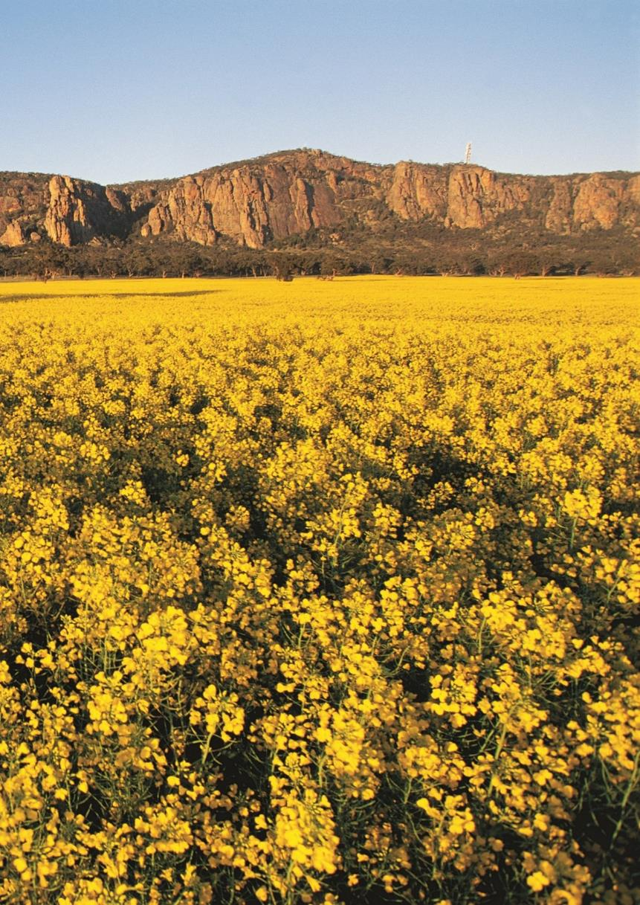

Victorian Agriculture And Climate Change Council
Annual Report
December 2021

Victorian Agriculture and Climate Change Council Members:
- Alexandra Gartmann (Chair) - Former CEO of the Rural Bank, a division of the Bendigo and Adelaide Bank.
- Mark Wootton (Deputy Chair) - beef and wool farmer who is well-known as a pioneer in carbon-neutral farming,
- Caroline Welsh - Director of the Birchip Cropping Group and currently serves as the Deputy Chair of GWMWater
- Fiona Conroy - carbon neutral sheep and cattle producer and partner of Nicon Rural Services.
- Gillian Hayman - Managing Partner at Montrose Dairy and runs her own consultancy business in Gippsland
- Jack Holden - General Manager – Sustainability, Asia Pacific at the Fonterra Group
- Lisa Dwyer - Dairy farmer and currently Non-Executive Director of the Murray Goulburn Cooperative and Australian Livestock Export Corporation.
- Professor Richard Eckard - Professor and Director of the Primary Industries Climate Challenges Centre at the University of Melbourne.
- Tim McCartney – former member until October 2021. Wotjobaluk man and Chair of the First Nations Bushfood and Botanicals Alliance Australia

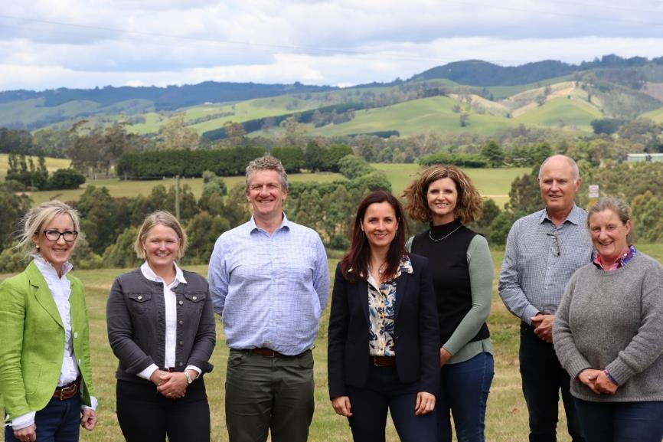
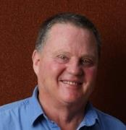

Section 1 - Introduction:
The Victorian Agriculture and Climate Change Council (the Council) is a ministerial advisory council that provides independent and strategic advice to the Minister for Agriculture on how the agriculture sector can prepare for and respond to the impacts and opportunities of climate change.
Climate change is a significant challenge that threatens the productivity and sustainability of the agriculture sector. The Council supports the Victorian Government’s commitment to deliver strong and lasting action on climate change. This includes supporting government to work alongside agriculture industry leaders to build on action already being taken and maximising opportunities for the agriculture sector as Victoria transitions to a resilient, net-zero emissions economy by 2050.
Council members bring a broad cross-section of knowledge, experience and connections to Council discussions, and represent different farm systems, agribusinesses, regions and areas of climate policy expertise.
The Council meets formally up to four times a year and members often attend additional workshops or events throughout the year. The Council’s first business meeting was held in December 2020. Under its Terms of Reference, the Council is required to prepare an annual report to the Minister. This annual report covers the Council’s inaugural year, for the period of December 2020 to December 2021.

Section 2 - 2021 Highlights:
During 2021, the Council provided advice on key Victorian Government policies and programs focused on supporting the agriculture sector to reduce green-house gas emissions and adapt to a changing climate. Highlights include:

Helping to shape government’s approach for building the agriculture sector’s climate resilience
- The Council supported the preparation of the draft Primary Production Adaptation Action Plan and response to feedback received through the public consultation process. The final Adaptation Action Plan was released as part of a whole-of-government package on 9 February 2022.

Supporting the launch and of government’s new agriculture emissions reduction programs
- In May 2021, Council members supported the launch of the Agriculture Sector Emissions Reduction Pledge. Members attended the Minister for Agriculture’s Agriculture and Climate Change Forum and led small group discussions with key stakeholders. Discussion focused on identifying the opportunities for different commodities arising from the Sector Pledge programs.
- The Council supported the development of the Victorian Agriculture and Climate Change Statement – a shared vision and pathway for the agriculture sector’s role in a net-zero emissions economy. This document will be finalised in mid-2022. Council members have helped to shape the approach to stakeholder engagement, drawing on their networks and industry experience. The Council hosted the first roundtable discussion with Gippsland industry representatives in December 2021, with further roundtables in 2022.
- Members provided advice over a series of workshops to inform the design and delivery of the On-farm Action Plan Pilot – a key program to be launched in mid-2022 that will support up to 250 farms to measure, understand and reduce their on-farm emissions with financial support from a $5 million grants fund.

Despite the challenges of working in a largely virtual environment, throughout 2021, the Council also established new stakeholder relationships and progressed various discussions on strategic climate change matters
The Council was established in late 2020, meaning many of the Council’s meetings and engagements took place in a virtual environment. When restrictions allowed, the Council was able to meet face-face on a few occasions and members travelled to Melbourne’s CBD (Wurundjeri Country), Ballarat (Wadawurrung Country) and Gippsland (Gunaikurnai Country).
The Council also:
  - Held a discussion with Professor Mark Howden on the Intergovernmental Panel On Climate Change report on the science behind climate change and implications for agriculture, engaging the sector and shaping policy interventions.
  - Hosted a joint virtual meeting with the Young Farmers Advisory Council and the Minister for Agriculture to understand perspectives and shared priorities on climate change action for the agriculture sector, and identify opportunities to collaborate.
  - Completed a stakeholder mapping exercise to understand the extent of members' existing networks and involvement with climate change programs, and how these can be strategically leveraged through the work program.
  - The Council Chair met with Victorian Farmers Federation (VFF) President to discuss respective climate change priorities and opportunities for collaboration, including insights from VFF’s 2021 climate-related survey.

Section 3 - 2022 Priorities
Throughout 2022, the Council will continue to play a key role in supporting the Victorian Government, industry and agricultural communities to work together to address critical climate change issues, complementing the increasing focus on climate change globally and across the sector.

Advice to support Victorian Government programs
- Continue to support delivery of the Agriculture Sector Emissions Reduction Pledge , including:
  - working in partnership with industry and the Minister for Agriculture to finalise the Victorian Agriculture and Climate Change Statement, to be launched in mid-2022.
  - providing advice on the final design, launch and delivery of the On-Farm Action Plan Pilot
  - helping to establish a ‘network of champions’ to promote on-farm climate action across the sector
  - providing advice on the development of the Agriculture Climate Spatial Tool.
- Support the implementation of the Primary Production Adaptation Action Plan.
- Provide advice on other key government programs, including for example the Carbon Farming Program announced under the Land Use, Land Use Change and Forestry Sector Pledge.

Additional strategic objectives
- Grow the Council’s connections within the agriculture sector, especially as opportunities for face-to-face engagement return.
- Look for opportunities to support initiatives to improve climate change literacy within Victoria’s agriculture community.
