Biosecurity Planning for Service Providers
Good biosecurity is paramount for protecting our economy, environment and community from the negative impacts of pests and diseases.

Protecting Victoria from emergency animal diseases
Did you know you can carry pests and animal diseases on your clothes, boots, equipment, machinery or vehicle tyres?
An emergency animal disease outbreak in Victoria poses a significant threat to our agriculture that would flow-on to financial losses to many rural and regional businesses.
As a council worker, contractor, service and emergency service provider, stock agent, transporter, or anyone who works with livestock, you have an important role to play in keeping our state and country free from foot-and-mouth disease by following strict biosecurity protocols.

What are the risks?
Foot-and-mouth disease is a highly contagious viral disease that spreads rapidly between animals and is considered one of Australia’s greatest biosecurity risks.
In July 2022, an outbreak of foot-and-mouth disease was reported in cattle in Bali, Indonesia and is currently in the majority of Indonesian provinces.
Foot-and-mouth disease is not present in Australia, so it is vital everyone takes responsible and simple actions to prevent it from entering our country.

Have you heard of ‘Come Clean – Go Clean’?
Come Clean – Go Clean is a simple and effective strategy to minimise the spread of animal diseases.
Before you visit a farm
Make sure you are wearing clean clothes and boots and that your vehicle, machinery and equipment is disinfected and free from mud, dirt and manure.
When you leave a farm
Remove mud, dirt and manure from your clothes, boots and equipment before disinfecting them. Where a vehicle washdown station is available, use it to clean your vehicle.
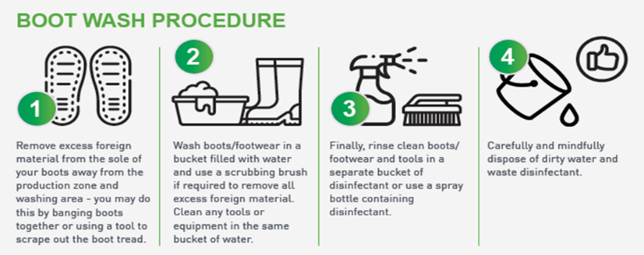
If you have had contact with livestock, change your clothes or coveralls before entering the next farm. Remember to wash your hands with soap and water.

What do you need to consider when visiting a farm?
Before arriving to a farm, it is important you contact the property owner about their biosecurity protocols, including visitor parking areas and washdown bays. If you have been in a country in the last seven (7) days that has foot-and-mouth disease, postpone your visit.
When you arrive at a farm, follow the instructions on the biosecurity signage and stay on marked tracks. If possible, use the property vehicles within the farm and minimise contact with livestock.
If you notice livestock that appear sick or dead, please ensure you advise the farm owner or manager.
Don’t forget: Come Clean – Go Clean.

Carry a biosecurity kit and remember to use it
It is a good idea to always keep a biosecurity kit in your vehicle. Essential items to pack in your biosecurity kit include:

- Hard brush and pan to sweep the floor of your vehicle
- Bucket
- Disinfectant
- Disposable gloves, if available
- Soap
- Garbage bags

More information: www.farmbiosecurity.com.au or agriculture.vic.gov.au/biosecurity

