Wildlife and Small Institutions Animal Ethics Committee
Application for restricted access (V June 2023)
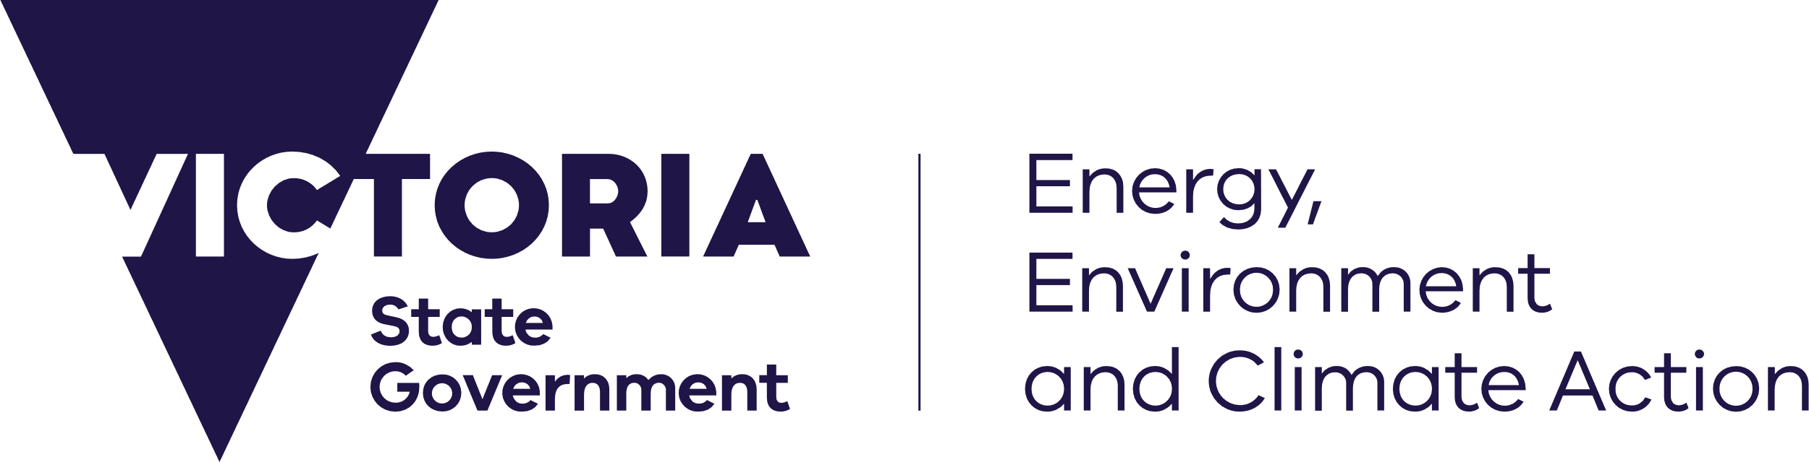
deeca.vic.gov.au

Information for applicants

1. Services provided by the WSIAEC
The Wildlife and Small Institutions Animal Ethics Committee (WSIAEC) is an Animal Ethics Committee for the purposes of the Prevention of Cruelty to Animals Act 1986 (POCTA Act) and sits within the Agriculture Victoria, Department of Energy, Environment and Climate Action (DEECA). WSIAEC provides services to individuals undertaking collection, taking, banding and marking of wildlife for research purposes.
These applicants are exempt from licensing under the POCTA Act, but must hold a research permit issued by the Conservation Regulator within DEECA, in accordance with section 28A of the Wildlife Act 1975.
Permit applicants are required to seek approval from an AEC for proposed research activities prior to submitting an application to DEECA.
For more information on exempt types of animal use please visit the Animal Welfare Victoria website.
The WSIAEC may only approve projects and activities undertaken in the State of Victoria.

2. Eligibility criteria
To be eligible for restricted access to the WSIAEC, applicants must demonstrate that their proposed animal use meets the criteria for exemption from licensing under the POCTA Act. If applying on behalf of an organisation, the applicant must demonstrate that the organisation:
- employs less than 10 persons (full-time equivalent) to carry out project activities; or
- is a not-for-profit organisation where volunteers carry out project activities; or
- is, due to exceptional circumstances, and at the discretion of Agriculture Victoria, deemed appropriate to access the committee.

3. Applicant
The wildlife research permit holder must be the applicant for access to the WSIAEC. If the permit is held on behalf of an organisation (incorporated or otherwise), the application to access the WSIAEC must include the name of the organisation.

4. Service agreement
Applicants are required to enter into a service agreement with Agriculture Victoria for access to the WSIAEC. The agreement defines the terms of service between the wildlife research permit holder and Agriculture Victoria and reflects the exemption from the requirement of a licence under the POCTA Act. Agriculture Victoria will co-sign the agreement when the application for restricted access is approved.

5. Application outcome
Applicants will be advised, in writing, of the outcome of assessment within 30 days of receipt of a complete application.

6. Fees
An annual fee must be paid on submission of the first application for approval for a project or activity and annually on 31 October, for the duration of approval. Failure to pay the annual fee may result in suspension of access to the WSIAEC and all projects and activities must then cease.
One annual fee is payable regardless of the number of projects or activities considered by the WSIAEC.
Each application to the WSIAEC for assessment of projects or activities will incur a fee in accordance with the current fees for service schedule, as updated from time to time. Agriculture Victoria will issue an invoice at the time of submission of an application.
A reduced application fee applies to ‘not for profit’ organisations as defined by the Australian Tax Office (ATO) criteria. The ATO considers an organisation as not for profit where its constituent or governing documents prevent it from distributing profits or assets for the benefit of particular people – both while it is operating and when it winds up.
To be eligible for the reduced fee, applicants must provide evidence of not for profit status.

7. Applications for access where another Animal Ethics Committee (AEC) has previously been used
The WSIAEC will not authorise continuation of animal use in accordance with an application approved by another AEC.
Where the applicant has previously used another AEC for the purposes of a wildlife permit, extensions cannot be granted by WSIAEC and a new application must be submitted.

8. Privacy Statement
The DEECA is committed to protecting personal information provided by you in accordance with the principles of the Victorian privacy laws.
The information you provide will be used for the purposes of the function of the Wildlife and Small Institutions Animal Ethics Committee (WSIAEC) which is administered according to the Prevention of Cruelty to Animals Act 1986 (POCTA) and regulations 2008 and the terms of reference of the WSIAEC.
The information you provide will be made available to members of the WSIAEC, The Minister for Agriculture and DEECA employees administering the POCTA Act and may be disclosed to another government organisation for the purpose of administering or enforcing the Catchment and Land Protection Act 1994, Wildlife Act 1975, POCTA Act or other relevant state, territory or commonwealth legislation.
If all requested information including correspondence and related documents is not received the WSIAEC will be unable to adequately assess or review your application or approved project. This may result in your application not being considered by the WSIAEC or suspension of approval of a project.
You may access the information you have provided to DEECA by contacting DEECA’s WSIAEC Executive Officer, 475 Mickleham Road, Attwood, Victoria 3049.

9 Submission
Send your completed form and supporting documentation to wsi.aec@ecodev.vic.gov.au

Application form

Name of applicant for access to the WSIAEC

Name of any affiliated organisation

Contact details for correspondence with the WSIAEC
Name (if different to above), position in the organisation if relevant, postal address, telephone and email

Provide a brief summary of the animal use proposed by the applicant

For applicants applying on behalf of an organisation, please indicate the criteria for approval:
- Less than 10 persons (approximate full time equivalent) undertaking animal use:
Number of staff:
- Projects and activities to be carried out by volunteers only?
Yes No
- Exceptional circumstances Agriculture Victoria should consider when determining whether to grant access to the WSIAEC.
If yes, provide justification:

Are you applying for ‘not for profit' status?
Yes No
- If yes, please attach a statutory declaration stating the applicant meets the criteria for ‘not for profit’ outlined in section 6.

Applicant declaration
By submitting this application I hereby declare that:
- the above information is true and correct and
- I have signed and attached, to this application, the applicable service agreement.
Date:
Submission of false information may result in termination of the service agreement to access the services of the WSIAEC.

