Low Density Mobile Outdoor Poultry Farm Development Plan

The following template is for Low Density Mobile Outdoor Poultry Farms in Victoria to use in collating the information to accompany a planning permit application. The template has been developed in accordance with the requirements of Section 7 of the Low Density Mobile Outdoor Poultry Farm Planning Permit Guidelines.

The template includes guidance notes/examples to assist applicants in identifying the information to include in each section. This information is presented in a box as shown here.

Example of a guidance note box.

These boxes must be deleted prior to submission.

The inclusion of photographs is encouraged to assist in describing the site, infrastructure or management.

The application should be prepared in conjunction with the Victorian Low Density Mobile Outdoor Poultry Farm Planning Permit Guidelines – Checklist to ensure that all information required by the Low Density Mobile Outdoor Poultry Farm Planning Permit Guidelines has been prepared prior to submitting a planning permit application.

Note: This template is suitable for Victorian poultry farms only that met the criteria to be classified as a Low Density Mobile Outdoor Poultry Farm. For information on preparing planning proposals in other jurisdictions please refer to the National Environmental Management System for the Meat Chicken Industry - Version 2 and the Egg Industry Environmental Guidelines or local council or responsible authority or planning consultants in your State.

Contents

1 Poultry farm planning provisions 4

1.1 Rural Zones Allowed Uses 4

2 Checklists from the Victorian Low Density Mobile Outdoor Poultry Planning Permit Guidelines 5

2.1 LDMO Guidelines Section 5. Threshold requirements for the application 5

2.2 LDMO Guidelines Section 8. Assessment criteria for a low density mobile outdoor poultry farm 5

2.3 LDMO Guidelines Section 7. What information should be submitted with a permit application? 6

3 Description of Proposal 8

4 Name and Contact Details: 8

5 Property Details 8

6 Planning Implications 9

6.1 Planning Zone 9

6.2 Overlay (s) that Apply to the Property 9

6.3 Overlays Impacting Poultry Areas 9

6.4 Distance to receptors 10

6.5 Setbacks from Waterways 10

6.6 Traffic volumes from proposal 10

7 Production System 11

7.1 Production System 11

7.2 Bird Numbers and Composition 11

7.3 Area Available for Birds 12

7.4 Bird Movements 13

8 Poultry Housing, Fencing, Feeding and Water 14

8.1 Poultry Housing 14

8.2 Fencing 14

8.3 Water and Feed Infrastructure 14

9 Feed – Type, Amount and Storage 15

9.1 Type of Feed 15

9.2 Feed Storage 15

10 Nutrient Management Plan 16

10.1 Maintenance of Groundcover 16

10.2 Mobile Infrastructure Relocation and Management of Excess Manure under Housing 17

10.3 No Return Period and Pasture Management 17

10.4 Soil Test Records and Farm Management Details 17

11 Mortalities Management 18

11.1 Mortalities Management 18

11.2 Mass Mortalities Contingency Plan 18

12 Pest Management - Predators, Pests, Rodents and Wild Birds 19

13 Attachments: 20

13.1 Appendix A: Locality Plan 20

13.2 Appendix B: Property Plan 21

# Poultry farm planning provisions

**Poultry farm:** Land used to keep or breed poultry. Included in: Animal production

**Animal Production:** Land used to keep or breed farm animals for the production of livestock, eggs, fibre, meat, milk or other animal products. Included in: Animal husbandry

[53.09 11/04/2019 VC156 POULTRY FARM](https://planning-schemes.api.delwp.vic.gov.au/schemes/vpps/53_09.pdf?_ga=2.47520416.683157069.1606161054-1889765150.1561338401)

VPP 53.09 Poultry farm outlines requirements for poultry farms. It includes exemption from notice and review (53.09-4) for applications that meet the classification of a Class A broiler farm as specified in the Victorian Code for Broiler Farms 2009 plus 2018 amendments and for applications that meet specified criteria relating to low risk systems. These criteria are outlined in 53.09-4 and expanded upon in the [Victorian Low Density Mobile Outdoor Poultry Farm Planning Permit Guidelines](https://agriculture.vic.gov.au/__data/assets/pdf_file/0010/537778/PSAI-poultry-farm-planning-permit-guidelines-2018.pdf)

## Rural Zones Allowed Uses

**Rural living zone:** Poultry farm allowed: section 1 if less than 100 poultry or section 2 as fits under agriculture and is not otherwise mentioned in section 3.

**Green Wedge Zone:** Poultry farm allowed: section 1 if less than 100 poultry or section 2 as fits under Animal Production and is not otherwise mentioned in section 3.

**Green Wedge A Zone:** Poultry farm allowed: section 1 if less than 100 poultry or section 2 as fits under Animal Production and is not otherwise mentioned in section 3.

**Rural Conservation Zone:** Poultry farm allowed: section 1 if less than 100 poultry or section 2 as fits under agriculture and is not otherwise mentioned in section 3.

**Farming Zone:** Poultry farm allowed section 1 if less than 100 poultry or section 2 as fits under Animal Production and is not otherwise mentioned in section 3.

**Rural Activity Zone:** Poultry farm allowed section 1 if less than 100 poultry or section 2 as fits under Animal Production and is not otherwise mentioned in section 3.

# Checklists from the Victorian Low Density Mobile Outdoor Poultry Planning Permit Guidelines

Complete checklists when main body of report is written to ensure you have covered all required information

## LDMO Guidelines Section 5. Threshold requirements for the application

|  |  |  |
| --- | --- | --- |
| **Requirement** | **Requirement met?** | **Refer to report section** |
| **1. Production system:** The farm must be based on a mobile outdoor production system. |  |  |
| **2. Poultry type:** The farm must be a poultry farm for the production of chicken meat or chicken eggs. |  |  |
| **3. Farm capacity:** The farm capacity must be less than 5,000 chickens (eggs) or less than 10,000 chickens (meat). The capacity of a poultry farm is described as the total number of poultry that will be held on the farm. |  |  |
| **4. Outdoor stocking density:** The outdoor stocking density must be less than 1,500 birds/hectare. |  |  |

## LDMO Guidelines Section 8. Assessment criteria for a low density mobile outdoor poultry farm

|  |  |  |
| --- | --- | --- |
| **Requirement** | **Requirement met?** | **Refer to report section** |
| **Objective 1: Low Risk site**  The risk of adverse environmental impacts on soils, waterways and surrounds is minimised by appropriate site selection and through a farm layout that avoids areas of risk. |  |  |
| **Standard 1.1 Land**  The land used for poultry ranging areas are suitable for growing pastures and maintaining ground cover. |  |  |
| **Standard 1.2 Surface waters** |  |  |
| * The poultry paddocks and other farm infrastructure are:   – located above the 1 in 100-year flood level  – not located in areas impacted by a flood zone, flooding overlay or land subject to inundation overlay. |  |  |
| • The poultry farm is not located within a Special Water Supply Catchment Area (refer to Standard 1.2 note and Section 10 of the Guidelines for further information). |  |  |
| • The boundaries of the poultry paddocks are at least 30 m from a waterway declared under the *Water Act 1989*. |  |  |
| **Objective 2 – Environmental protection management**  Adverse impacts on soils, waterways and surrounds are avoided through good management |  |  |
| **Standard 2.1 Ground cover**  • A minimum 50% ground cover is maintained over the poultry range areas at all times (see Appendix A of the Guidelines for consideration of seasonal conditions). |  |  |
| **Standard 2.2 Mobile infrastructure**  • Housing, feeding and water infrastructure are relocated at least every two weeks to ensure nutrient load is evenly spread, ground cover is replenished and birds access fresh range areas. |  |  |
| **Standard 2.3 No return period**  • Poultry do not return to a previously used poultry range area within a 3-month period. |  |  |
| **Standard 2.4 Nutrient Management Plan**  • An NMP that includes strategies and measures to ensure nutrient risks are adequately managed and monitored by:  – maintaining 50% ground cover  – moving mobile infrastructure and managing excess manure under housing (if appropriate)  – implementing a no return period and pasture management  – soil testing, monitoring and farm management |  |  |
| **Objective 3 – Community amenity**  The site location, design and farm management of the low density mobile outdoor poultry farm protects the community from odour, dust and other amenity impacts |  |  |
| **Standard 3.1 Separation Distances**  The nearest poultry paddock boundary and poultry housing meets the separation distances listed in the following table: |  |  |
| Distance to Sensitive Use (m)  ≤ 1,000 poultry > 50 m  > 1,000 poultry > 100 m |  |  |
| Distance to Residential zone (m)  ≤ 1,000 poultry > 200 m  > 1,000 poultry > 400 m |  |  |

## LDMO Guidelines Section 7. What information should be submitted with a permit application?

|  |  |  |
| --- | --- | --- |
| **Requirement** | **Included?** | **Refer to report section** |
| **Property Identification Code** |  |  |
| **A. Property and locality plan** |  |  |
| A property plan showing: |  | Appendix B |
| • property boundaries and dimensions of the site |  |  |
| • paddocks where poultry will be kept |  |  |
| • sheds, including housing used for the raising of young birds prior to them being old enough to range outdoors, or any packing sheds (for egg production if appropriate |  |  |
| • location of any other farm infrastructure such as feed storage areas |  |  |
| • farm bores, dams and other water supply sources and waterways |  |  |
| • mortality management area |  |  |
| • significant slope and other topographic features, remnant vegetation and areas prone to erosion |  |  |
| • areas prone to flooding |  |  |
| • internal and external roads. |  |  |
| A locality plan showing: |  | Appendix A |
| • distances to dwellings in a separate ownership and other sensitive uses (including dwellings under construction or approved by a planning or building permit to be constructed) |  |  |
| • distances to waterways from poultry paddock boundaries |  |  |
| • suitable scale and dimensions |  |  |
| **B. Description of the proposal: a brief written description detailing;** |  |  |
| • proposed number of poultry to be kept (including offspring and the number of poultry to be kept across various production stages) |  |  |
| • the production system including:   * the raising of chicks * the range area and number of poultry paddocks * management, packing and storage of eggs (for egg farms). |  |  |
| • design of the poultry housing, fencing, feeding and water infrastructure |  |  |
| • design and details of housing for the raising of young birds prior to ranging (if applicable) |  |  |
| • the prepared feed for poultry and where it will be stored |  |  |
| • management of dead birds/spent hens |  |  |
| • a Nutrient Management Plan (NMP) that demonstrates how nutrients will be managed and ground cover maintained |  |  |
| • the planning zones and any overlays applying to the land. |  |  |
| • strategies to minimise the risk of predators, pests, rodents and wild birds |  |  |

# Description of Proposal

This is a brief description of the proposal like an executive summary. It may be the same as what is entered into the description of proposal box in the planning permit application form. One or two short paragraphs is the aim.

Example: Low density mobile outdoor poultry farm – Egg farm planning on buying in point of lay pullets with total bird numbers of 850, at 1122 Yolk Rd, Shellbyville

# Name and Contact Details:

|  |  |
| --- | --- |
| Title |  |
| Full name |  |
| Trading name |  |
| Phone number |  |
| Postal address |  |
| Mobile |  |
| Town |  |
| Postcode |  |
| Email address |  |

# Property Details

The property details (except PIC and land area) are available at the top of your property planning report or from your council rates notice <https://mapshare.vic.gov.au/vicplan/>

|  |  |
| --- | --- |
| Property Identification Code (PIC) |  |
| Property Address |  |
| Lot and Plan number (s) |  |
| Local government area |  |
| Council property number |  |
| Total area of property (ha) |  |

# Planning Implications

## Planning Zone

Identify your planning zone and confirm that a poultry farm is a permitted use in the zone.

Eg. The property is located in the farm zone. A poultry farm is a section 2 use (permit required) in the farming zone

Table 1: Planning Zone Requirements

|  |  |
| --- | --- |
| Zone | Poultry Farm |
| Farming Zone | No Permit / Permit |
| Rural Activity Zone | No Permit / Permit |
| Green Wedge Zone | No Permit / Permit |
| Green Wedge A Zone | No Permit / Permit |
| Rural Conservation Zone | No Permit / Permit |
| Rural Living Zone | No Permit / Permit |
| Urban Floodway Zone | Prohibited |
| Urban Growth Zone | No Permit / Permit |
| Industrial Zones | Prohibited |
| Commercial Zones | Prohibited |
| Residential Zones | Prohibited |

* No Permit required for up to 100 poultry

## Overlay (s) that Apply to the Property

List the overlay (s) that apply to your land:

## Overlays Impacting Poultry Areas

If any of these overlays cover (fully or partly) the areas being used for poultry, describe how the overlay(s) will affect the proposal. Read the schedule of each overlay , if applicable, to determine the extent of any controls applying to the land.

## Distance to receptors

Refer to your locality plan in the appendices. State the distance to the nearest neighbour or sensitive use and the distance to the nearest residential zone

Example:

A locality plan showing the property location and distance to receptors is available in appendix 1. It shows the nearest sensitive receptor is a neighbouring house to the North West that is 500 metres from the closest poultry paddock, exceeding the required separation distance of 100 metres.

The closest residential zone is at Euroa in the South. It is 5,300 metres from the closest poultry paddock, exceeding the required separation distance of 400 metres

## Setbacks from Waterways

Refer to your property plan. State the distance from poultry paddocks to waterways and action taken to ensure setbacks are maintained

Example.

Appendix B shows the property plan including paddock layout and setbacks from waterways. All waterways will be fenced to exclude poultry and maintain a minimum setback of 30 metres.

## Traffic volumes from proposal

Provide an estimate of any potential increase in traffic volumes even if it is nil. Councils are required to consider impact of increased traffic on local roads in and land use planning permit application

Example.

Traffic associated with the proposal are low. Feed supplies will be sourced from the nearest town and transported in our farm ute during weekly scheduled trips for groceries and supplies.

Export of product (eggs) will be three times per week by car to our local retailer.

Import and export of birds will be via the farm ute and estimated at one trip per month on average.

# Production System

## Production System

Describe the type of production system e.g.

* LDMO - egg farm with chick rearing
* LDMO - egg farm buy in point of lay pullets
* LDMO - meat chicken farm
* LDMO - other – please describe

## Bird Numbers and Composition

Provide details of bird numbers and composition. Include offspring and the number of poultry to be kept across various production stages.

Total bird numbers

Production stages and numbers

## Area Available for Birds

Provide the total area available for use by the birds.

Provide the total number of paddocks available for use by the birds.

Provide the total area in use by the birds at any one time.

Refer to your property plan in appendix B.

Complete table with paddock ID and size

To determine stocking density, divide the number of birds by the paddock area in ha.

1 ha = 10,000 m2

A zoom in of the paddocks can be added here to show paddock layout and size if you wish

Example.

A property plan showing the layout of available poultry range areas is available in appendix B. It shows the detail of the area and paddock numbers, which is summarized below;

Total area available for birds: ha

Number of paddocks:

Area in use by the entire flock at any point in time: ha

Stocking Density: birds per hectare

Completed paddock/hectares table

|  |  |
| --- | --- |
| Paddock # | Area (ha) |
|  |  |
|  |  |
|  |  |
|  |  |
|  |  |
|  |  |
| Total: |  |

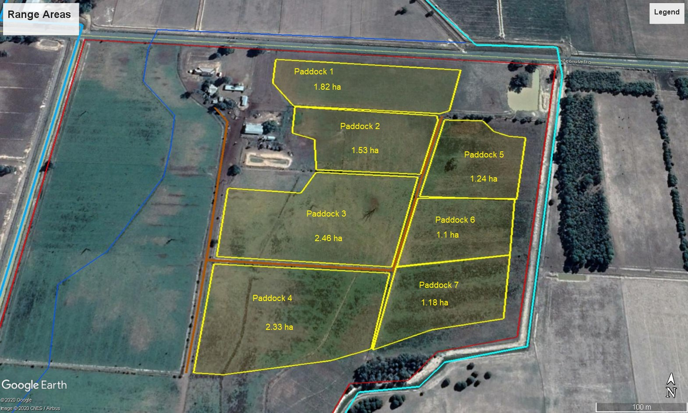

## Bird Movements

Describe the rotation plan for the poultry paddock areas. Include how long the birds are on each paddock, length of time paddock is rested (the ‘resting’ period is the time before birds are returned to the paddock) and any cropping /pasture phase. NB. Low density mobile poultry farms must have a 3-month resting period

Diagrams may be helpful here (conceptual rather than to scale) showing how birds would be moved around the farm

# Poultry Housing, Fencing, Feeding and Water

## Poultry Housing

Describe the poultry housing and how it is managed /moved (including frequency of movement). These movements should include both within and between paddocks. Housing, feeding and water infrastructure must be relocated at least every 2 weeks to ensure nutrient load is evenly spread, groundcover is managed, and birds access fresh range areas.

Photos of the proposed type of poultry shelter are useful in this section

## Fencing

Describe the type of fencing e.g. wooden posts with chicken wire plus six strands of plain wire or electric fencing. If dividing paddocks into cells, describe how temporary fencing is moved.

The inclusion of photographs is recommended.

## Water and Feed Infrastructure

Describe the type of waterers (e.g. nipple drinkers) and feeders (e.g. self- feeder with bin). Feed and water infrastructure should prevent access from waterfowl/wild birds and vermin. It is recommended that feed and water infrastructure be located within housing. Water must come from mains water or be treated prior to use. The inclusion of photographs is recommended.

# Feed – Type, Amount and Storage

## Type of Feed

List the type of feed used e.g. purchased pellets, mash, home-mix or alternative feed (please describe type).

Provide estimated amounts per month

|  |  |
| --- | --- |
| Type of Feed | Amount kg/month or t/month |
|  |  |
|  |  |
|  |  |
|  |  |
|  |  |
|  |  |
|  |  |

## Feed Storage

Describe where and how the feed will be stored and how this area will be managed e.g. stored in covered feed bins, hoppers on self-feeders, silos. Provide storage that is vermin and bird proof and procedures are in place to ensure spilt feed is cleaned up immediately.

The inclusion of photographs is recommended.

# Nutrient Management Plan

A nutrient management plan (NMP) demonstrates how nutrients will be managed and groundcover maintained. The NMP must demonstrate:

1. maintaining 50% ground cover
2. moving mobile infrastructure and managing excess manure under housing (if appropriate).
3. Implementing a no return period and pasture management
4. soil testing, monitoring and farm management

Although it may be repetitive, you need to provide a summary and link back to previous information to demonstrate how you will maintain 50% ground cover etc. Think of the NM P part of the document as a stand-alone document that could be pulled out of the overall document to provide all the information required for the planner to understand how the management practices fit together to demonstrate low risk and sustainable nutrient management on farm in compliance with Standard 2.4 of the Guidelines. Refer to Appendix A, Part 4 of the Guidelines for further information.

## Maintenance of Groundcover

Describe how groundcover will be managed to maintain 50% cover.

Describe how issues with maintaining groundcover will be addressed if they arise.

50% groundcover is estimated as an average cover across a paddock that the poultry are kept in at all times. This is not an estimate of groundcover across the whole farm, or across other poultry paddocks. Management practices that support maintaining 50% groundcover could include:

* Choosing suitable sites
* Careful selection of grass species
* Light stocking densities
* Frequent paddock rotation
* Mobile infrastructure that is frequently relocated – Every 2 weeks
* Appropriate size paddocks based on stocking density and rotation frequency

Consider setting up photograph monitoring points to document paddock groundcover management. Photographing the monitoring points every 2 - 4 weeks will provide evidence of groundcover levels. This will help if there are future complaints or compliance issues relating to dust, run – off, rotation frequency etc.

## Mobile Infrastructure Relocation and Management of Excess Manure under Housing

Describe how the bird housing/shelters and feed and water infrastructure will be moved around and between paddocks. This must include frequency of movement.

For low density mobile outdoor poultry farms, the feeders, waterers and housing/shelters must be relocated at least every 2 weeks to ensure nutrient load is evenly spread, groundcover is replenished and birds access fresh range areas.

Poultry kept in paddocks deposit manure in close proximity to housing or beneath the floor of open shelters. As a result, the soil in these areas of the paddock have higher nutrient levels than other parts of the paddock.

Regularly moving the infrastructure helps to disperse the manure over the paddock area, reducing environmental risk.

Bedding and manure from sheds can be removed and used on other areas.

## No Return Period and Pasture Management

Describe your overall farm paddock /pasture rotation plan including the no return period.

Once poultry have left a paddock (or area of a paddock) they cannot return to the same area for a minimum period of 3 months. This is to allow the pasture to recover and actively grow.

## Soil Test Records and Farm Management Details

Describe the soil monitoring program on the poultry paddocks. This includes a description of the areas to be tested. If there are different soil types, poultry classes or different management (for example different stocking rates), these areas should be tested separately.

Describe how the soil test results will be used to monitor and adjust farm practice.

Soil testing of representative poultry management areas must occur every 2 years. Records of the soil test results must be kept to confirm that soil nutrients are being maintained at suitable levels.

# Mortalities Management

## Mortalities Management

Describe how you will manage dead birds/spent hens. Suitable disposal methods include: composting, rendering, burial and licenced landfill (under arrangement). Burning in open fires is not a suitable option. Practices must prevent groundwater and surface water contamination, odour, spread of disease and vermin breeding. Refer to the National Environmental Management System for the Meat Chicken Industry - Version 2 or the Egg Industry Environmental Guidelines.

## Mass Mortalities Contingency Plan

Provide details of what you would do in the case of a mass mortalities event.

Describe this area below and the process you would follow in the event of a mass mortalities event.

In the event of a disease outbreak, follow any veterinary instruction and the AUSVETPLAN Enterprise Manual Poultry industry (Chickens, Ducks and Turkeys) for guidance on managing a disease outbreak. Contact the emergency disease watch hotline.

For mass mortality events (disease or other event such as heat stress) follow any veterinary advice, council and EPA instruction and AUSVETPLAN Operational Manual: Disposal for managing the mortalities.

Record below the contact details of your vet, the emergency disease watch hotline (1800 675 888.), the council (including afterhours where applicable) and EPA 1300 372 842. Have contact details readily available on site.

# Pest Management - Predators, Pests, Rodents and Wild Birds

Describe how pests such as predators, rodents and wild birds will be managed.

Pests can include dogs and other animals that can kill or injure poultry and rodents, birds and flies that can eat and contaminate feed or water and cause nuisance. All of these pests pose a biosecurity risk.

Care must be taken if using baits/chemicals for pest control, particularly rodenticides which can contaminate product.

# Attachments:

## Appendix A: Locality Plan

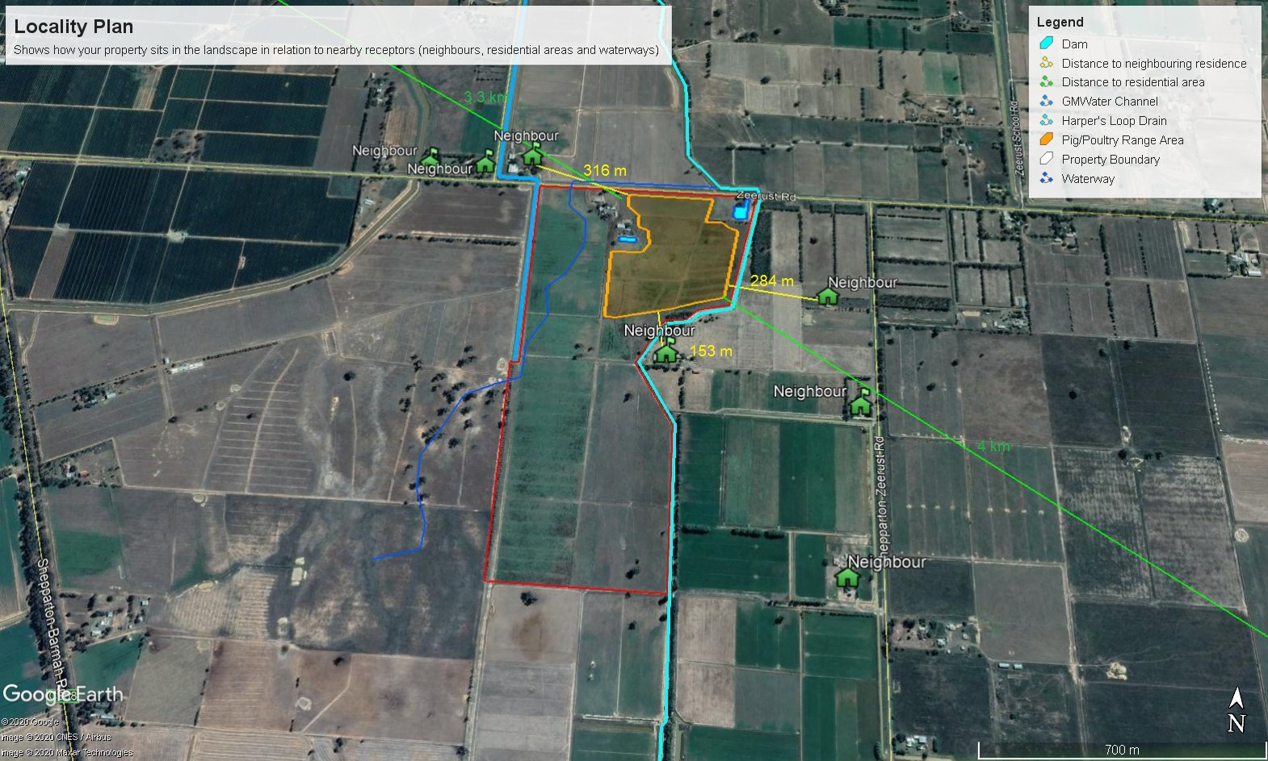

## Appendix B: Property Plan

