Horses and bushfire

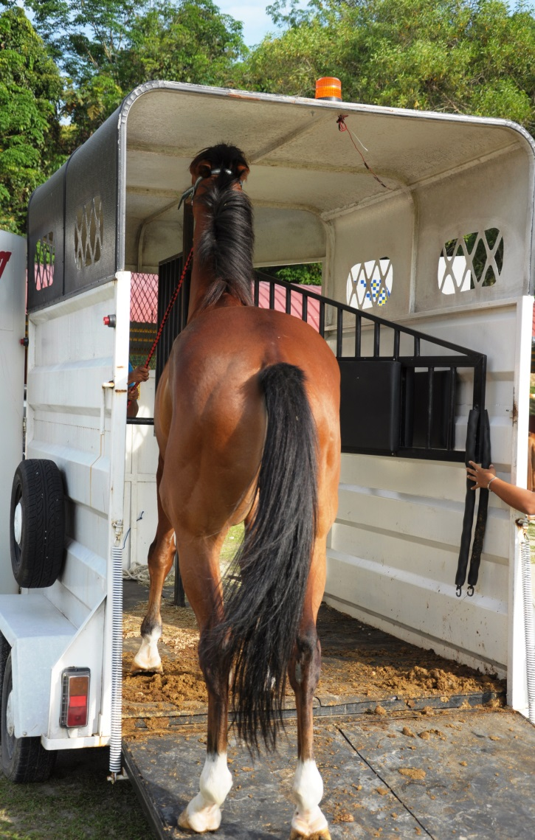
Planning for fire safety
Unfortunately, Victoria is one of the most fire prone areas in Australia. High temperatures and limited summer rainfall produce conditions of very high fire danger in Victoria’s bushland, scrubland and grassland. Strong sudden wind changes, which can cause fires to become erratic in behaviour and uncontrollable, are common.
Bushfire risk exists in most parts of rural Victoria every summer. Bushfires on a catastrophic scale, like Black Saturday 2009, may occur more frequently with the impacts of drought and climate change.
In times of crisis, people worry not only about their family and property but also about their livestock and pets.
There are steps that horse owners can take to prepare themselves and their property before the fire season, to reduce the impact of bushfire. The key is to prepare, act and survive.

Leave early or stay and actively defend?... It’s your decision
The Country Fire Authority (CFA) emphasises to prepare your property, and then decide to leave early before a fire threatens you or your property. If you decide to stay and actively defend your home be aware this is risky and you need to be well-prepared. Ensure you check the CFA website for information on developing your bushfire survival plan and making decisions about what is best for your family. Identify at which level of CFA alert you will action your plan to protect your family, house, property and animals.
Everyone’s situation differs according to the size and nature of their horse enterprise. That is why each and every horse owner needs to develop an individual survival plan, coolly and calmly, before the hot weather arrives. When developing your bushfire survival plan it is important to include your horses and other animals.
Recent emergencies around the world have recognised the bonds between humans and animals, and that these bonds can influence the behaviour of people during an emergency. Without a plan both humans and animals are at greater risk in times of emergency.

Loading horse into trailer

Have a plan
If you live in a high risk area it is essential to develop a bushfire survival plan before the fire season. This may include:
- A plan for early evacuation of horses to a safer district. Horse evacuations present unique problems. Make arrangements well ahead of time for a place to temporarily relocate your horses. Options may include showgrounds, sale yards, parks, racetracks, pony club grounds or placement with family and friends. Decide in advance which horses you will evacuate and make sure they are suitably trained for transport.
- Identifying a ‘safe’ area on the property where horses can be placed if evacuation is not possible or practical. This area should be as large as possible and may be a closely grazed paddock or be created from several paddocks by opening internal gates. Ideally it should have a dam with clear access. An alternative temporary ‘safe’ area might be a large well fenced sand ménage (provided water is available) and that there are no trees or buildings nearby that will burn readily.
- Posting your plan in a clearly visible place together with the telephone number of the local fire brigade and your property’s CFA map reference and PIC number.
- Making sure that everyone who lives, works or agists at your property understands the plan.
- On days of Extreme, Severe or Code Red fire danger rating (FDR), putting your horses in the designated ‘safe’ area or, if you work away from the property or are leaving early, you might do this the night before.
- Having an annual meeting with neighbours, friends or other mutual interest groups to discuss fire contingency plans and establish ahead of time who will check on and help whom and which resources will be shared.
- Setting up a bushfire emergency plan with the landholder if your horses are agisted.
- Leaving horses in well grazed paddocks if they are on ‘weekenders’ in high-risk areas, or moving them to a safer location during the fire season.
Regularly socialise your horse with other horses in a paddock environment if possible, so that they are less stressed when put together with other horses during a fire.

Reduce fire hazards
Reduce fire hazards before the fire season starts:
- remove all fire fuel such as excess grass, sticks, leaf litter etc. for 20 to 30 metres around buildings
- store hay, straw, shavings, scrap wood, fuel supplies and chemicals safely away from important buildings
- clean roof surfaces and gutters regularly
- create firebreaks in strategic locations
- develop a grazing plan to reduce fire risk
- having a well-watered lawn and little (if any) garden vegetation will help protect the house
- post ‘no smoking’ signs in and around the stable, feed storage areas and in vegetated areas as appropriate
- make sure chainsaws and other equipment are fitted with an Australian Standards approved spark arrester
- if you live in a high risk area, invest in a rainwater storage tank, a sprinkler system and a firefighting pump, and consider erecting fireproof fencing, i.e. steel or concrete posts, particularly if you own a stallion
- if your fences are electrified, make sure the boundary fences are ‘horse proof’ as often power is out during a bushfire
- consider slashing paddocks at the start of the bushfire season to prepare a safe, grazed area.
Watch the video on preparing your property for bushfire at https://agriculture.vic.gov.au/farm-management/emergency-management/emergency-animal-welfare/horses-and-livestock-in-emergencies. While this is aimed at small landowners it has good tips for all horse owners. The CFA website also has lots of information on preparing your property.

Prepare an evacuation kit
Equip a plastic rubbish bin (with lid) with the following:
- wire cutters and a sharp knife
- torch, portable radio and fresh batteries
- water bucket
- extra lead rope and head collar
- woollen blanket and towels
- equine first aid items
- whatever else you feel is essential for the first 24 hours
- bottled water.
Store your kit in an easily accessible location and don’t use it if for anything other but emergencies.

Identify your horses
Permanently identified horses (preferably by microchip but brands or a drawing, which includes whorls and white markings will also assist) will be more speedily reunited with their owners if separation occurs during a disaster.
Ensure your personal details are up to date on microchip or brand registers.
Register your horses on your Property Identification Code (PIC) so as a horse owner you can be identified and communicated with in times of emergency.
In an emergency at the very least be prepared to ‘paint’ your name and phone number on the horse itself using livestock grease crayons like the ones used to number horses in endurance rides, or clip similar details on its hair coat or paint its hooves. Neckbands, hip stickers and identification tags on leather head collars can also be useful.

Horse in grassy paddock

Just do it
It has been shown time and time again, if you don’t take the above precautions within the next 24 hours, the chances are very good that you won’t do anything at all to prepare for a fire emergency.

If fire threatens

Decide quickly
If you decide to evacuate with or without your horse/s, this decision must be made very early. Late evacuation is a deadly option. Once the fire is close, visibility will be very poor and travel will be hazardous. Fallen trees, power lines, abandoned cars and even firefighting vehicles can easily block roads. Even quiet horses may panic in a float filled with smoke or when exposed to the noise of sirens.

Wear safe attire
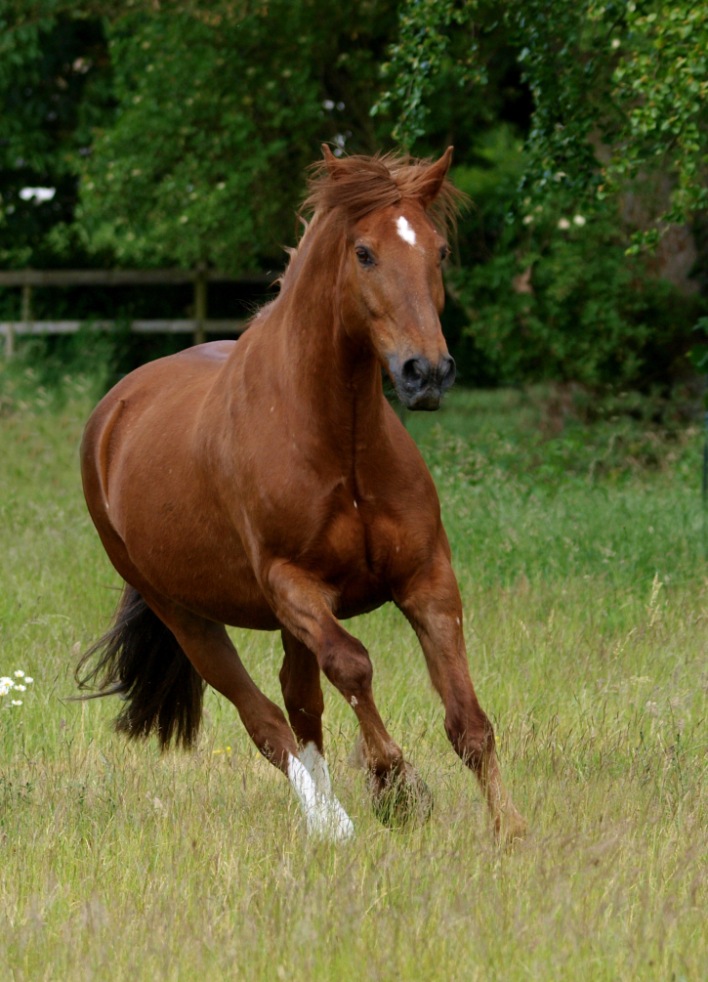
In the event that a fire threatens you, whether you decide to evacuate or stay, the right clothes can help shield you from radiant heat, burning embers and flames:
- wide-brimmed hat to protect your head
- eye protection such as smoke goggles to shield your eyes
- a ‘P2’ type mask or cotton scarf /handkerchief for face protection and to filter smoke
- a long-sleeved, collared shirt and pants made from cotton or some other natural fibre
- tough leather garden gloves – not rubber or synthetic
- sturdy boots and wool or cotton socks.
A word to the wise: condition your horse to your strange appearance ahead of time.

Fire-safe gear for horses
The same principles for fire safe clothing apply to your horse:
- Don’t use synthetic (nylon or plastic) halters or lead ropes. These may melt and cause serious burns to your horse and its handler. Leather halters and cotton lead ropes, while generally not as strong as nylon, will be safer.
- Don’t use nylon fly masks or other synthetic tack or equipment.
- Remove all rugs from horses during bushfires.
- Don’t leave any equipment with metal fittings on horses during fires as these can also cause burns.

When fire strikes
You should plan on the basis that you will receive no official warning that a fire is coming. Don’t expect a fire truck. When fire comes your way, your personal safety and that of the people working with you is paramount, so:
- try to remain calm and alert, think clearly and act decisively
- pay attention to weather conditions and fire behaviour. Watch for a sudden change in wind direction or speed, a dramatic change in air temperature or humidity, or smoke and ash or burning embers dropping around you
- monitor weather forecasts and media broadcasts, especially ABC radio and local community radio stations for emergency information, social media may also provide valuable information such as the CFA fire ready site
- maintain good communications with the people you’re working with; give clear instructions and make sure they are understood
- co-operate with firefighters and other emergency services. Your safety and the safety of other civilians and emergency personnel are their paramount concern.
Ensure you have read the CFA advice on staying and actively defending your property and follow the advice given there.
If your property is closely threatened by a bushfire and you can’t move your horses to a safer district:
- fill troughs, baths, sinks and metal buckets with reserve water for later use
- turn off power and gas and disconnect electrical fences
- remove all equipment from your horse. Rugs burn, plastic headstalls melt and metal buckles may get hot
- move your horses into your previously identified ‘safe’ area
- if you take horses out of stables, close the doors to prevent them running back into their perceived ‘safe’ area
- if you are shifting fractious horses when a fire is very close, a temporary blindfold over the eyes may help
- if hoses are still operational wet tails and manes or drench the horse in water if it has to pass near or through fire. Early veterinary literature based on stable fires suggests that this will protect a horse from serious burns for about half a minute afterwards.
Remember:
- To give your horses plenty of room to move. Past experience of bushfires indicates that horses will suffer minimal burns if given maximum space. They will gallop through flames, or around their edges, and stand on the blackened, previously burnt area and remain there until the fire has passed.
- Don’t shut horses in stables or small yards. Never turn them out on the road. They will be in danger from traffic and the fire. There is also the risk that they may cause a car accident, leaving you legally responsible.
- Don’t stay with horses when the fire approaches. There is little one can do during this time and your safety is paramount. While horses might gain confidence from the nearness of humans and a calming voice, you can’t provide this assurance when smoke is everywhere and the sound of the fire is deafening. Don’t put your own life in additional danger.
Your horse will cope well on its own if it has a chance to move in open space.

After the fire has passed
Deal with spot fires first. As soon as it is safe check your horses for burns and other injuries to see whether veterinary attention is required. It is important that horses are regularly rechecked after the initial assessment to ensure that symptoms that arise a few days or weeks after the fire are adequately treated and the physical environment changed by the fire continues to meet the horses needs i.e. there is still adequate uncontaminated water, shelter, fencing, feed and unburnt cool and soft ground available for the horse.

First aid
Agriculture Victoria animal health staff, RSPCA, local councils and local vets will all be working to assist animals affected by the fires. They will be working under emergency circumstances and access and communications may be disrupted so expect some delay before help arrives. You must therefore be prepared to monitor the progress of your horses and to administer appropriate first aid while you are waiting for professional advice.

Possible problems
Horses commonly suffer facial burns, presumably obtained when they turn and run through the fire front. Other possible injuries include burns to other areas of the body including eyelids, smoke inhalation, hoof damage from standing on hot ground and eye injuries from particulates in the air. It is also important to check for other injuries sustained during the fire such as lacerations from running into fences etc. Along with specific medical care and attention, you should also attend to all other needs of your horse. This includes ensuring it has adequate shade, water and feed.
The nature and extent of the injuries sustained can vary widely between animals, depending on the nature of the fire and the degree of exposure. Some may be more severely burned than others in the same group. Situations which may warrant emergency destruction on humane grounds include:
- severe burns to greater than 50 per cent of the body surface with severe charring of limbs, muscles or facial tissues
- animals suffering from severe smoke or flame inhalation resulting in respiratory distress, as shown by facial burns, laboured breathing, frothing at the mouth and nose, and coughing
- animals which are down and unable to rise due to injuries or burns sustained during the fire.
If an insured horse has to be destroyed, make sure the company is notified as soon as is practicable.

Burns
In the immediate post bushfire period, it is essential to assess your horse for injuries, and obtain veterinary advice and treatment as soon as possible. Skin burns produce severe inflammation, indicated by heat, pain and swelling. Thus first aid must be anti-inflammatory, i.e. cold water delivered by a hose or gently sponging if you still have access to a water supply.

Applying cold water to horse via hose
Once the immediate needs of the horse have been met, attention then turns to long term care and management of your horse’s welfare. Horses with quite severe burns will require intensive treatment that is likely to be time consuming, very costly and painful for the animal. Your veterinarian is best placed to give you advice on how to treat injuries which require ongoing care.
Burn wounds require effective management to reduce scarring where possible and to achieve the best outcomes for your horse. It is difficult to provide generic advice on effective strategies. It very much depends on the individual circumstances of the wound including the degree of the burn, the extent of the burn and the anatomical location of the burn. Veterinary advice must be sought to recommend appropriate long term treatment options.
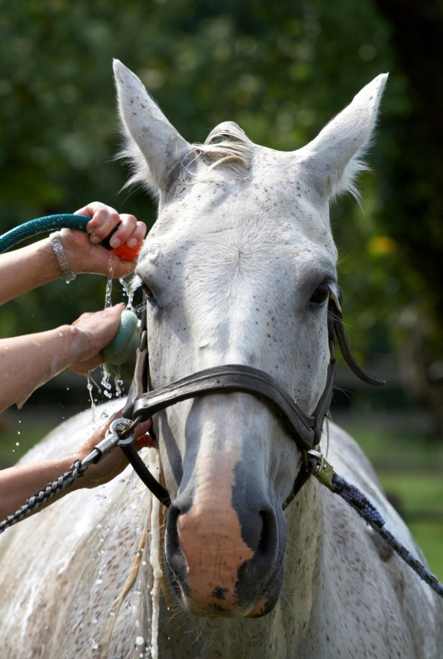
Fly protection is recommended, but do not spray fly repellent onto affected burns areas. It is important to keep your horse comfortable and well-hydrated to assist with its recuperation.

Smoke inhalation
A common cause of death in fires and in the days afterward is complications from smoke inhalation. Particulates from smoke tend to be very small, which allows these to reach the deepest airways within the lung. Severe smoke inhalation can cause delayed lung damage, which may not be immediately obvious. Horses may appear normal after the fire but in 3-4 hours can become anxious with rapid, sometimes laboured breathing and an elevated heart rate. Particulates can also alter the immune system and reduce the ability of the lungs to remove foreign materials, such as pollen and bacteria, to which horses are normally exposed.
If smoke remains in the air, the effects of smoke particulates in the lungs may not be obvious for a number of weeks. Limit exercise when smoke is visible and provide plenty of fresh water. Horses that display signs of reduced lung function, higher than normal body temperature or burns around the eyes, singeing of the mane and forelock, muzzle burns or soot stained discharge from the nose need urgent veterinary treatment.

Hoof damage
An immediate threat to horses left in burnt properties is damage to hooves. Prolonged exposure to hot ground will cause a low grade overheating that can develop into heat induced laminitis. The prognosis for horses suffering this condition will be extremely poor. It is important to get the horse off hot burnt ground as quickly as possible.
If your horse displays signs of lameness in the days after a fire consult a veterinarian immediately for advice on treatment.

Nutrition
The care and management of your horse is likely to be significantly changed as a result of a bushfire, there are many factors to consider to ensure its ongoing needs are met. One important consideration is diet. Bushfires can have a devastating effect on pasture, which is the main source of food for most horses in rural areas.
In non-emergency situations, good quality pastures can provide the food requirements for most horses, except those in work and lactating mares. However, after a bushfire, feed may have to be supplemented to provide the necessary nutritional requirements. This is especially important for horses that may have suffered some degree of burn injuries. Horses with these injuries have increased energy requirements, and in particular, increased protein requirements. Supplementary feeding may be required for up to twelve months after the fire has passed. Temporary relocation of horses to areas unaffected by fire should be considered.
Roughage (fibrous feed such as hay and chaff) should continue to form a significant part of the horse’s diet, to provide sufficient bulk and fibre to enable the digestive system to function normally. Horses need at least 1 per cent of their body weight in roughage daily. Good quality pasture hay is an excellent source of fibre.
It is important to introduce new feeds gradually into a horse’s diet. Quick changes in diet are not recommended. However, in the case of pasture depletion due to bushfires, circumstances may require that horses are introduced to new feeds more quickly than they would under usual conditions. If this is the case, it is recommended that horses are fed small meals more frequently – rather than one or two large meals a day. This will assist with digestion and allow the horse to adapt to the new feed.
It is important to only feed good quality feed and to discard mouldy produce. Horses with burns around their muzzle may require special attention with their feeding as it may be painful for them to eat hay. Feeding chaff and processed feed in this instance may be appropriate.
Produce merchants are able to provide specific advice on the energy content of processed feeds – and this information is available on product labels. It is recommended that horse owners take advice on energy requirements and follow the directions on the feed label.
© The State of Victoria Department Jobs, Precincts and Regions 2016  This work is licensed under a Creative Commons Attribution 3.0 Australia licence. You are free to re-use the work under that licence, on the condition that you credit the State of Victoria as author. The licence does not apply to any images, photographs or branding, including the Victorian Coat of Arms, the Victorian Government logo and the Department Jobs, Precincts and Regions logo. To view a copy of this licence, visit http://creativecommons.org/licenses/by/3.0/au/deed.en  ISBN 978-1-925466-19-5 (print)  ISBN 978-1-925466-20-1 (pdf) | Accessibility  If you would like to receive this publication in an alternative format, please telephone the DJPR Customer Service Centre on 136186, email customer.service@ecodev.vic.gov.au or via the National Relay Service on 133 677 www.relayservice.com.au. This document is also available on the internet at www.agriculture.vic.gov.au  Disclaimer  This publication may be of assistance to you but the State of Victoria and its employees do not guarantee that the publication is without flaw of any kind or is wholly appropriate for your particular purposes and therefore disclaims all liability for any error, loss or other consequence which may arise from you relying on any information in this publication.
It is important that where horses undergo a dramatic change in their diet over a sudden period, that their condition be monitored closely to ensure that they are adapting to the new diet. Colic is a common problem that occurs when diets are changed too quickly. Owners should be aware of the symptoms of colic which include loss of appetite, restlessness and excessive rolling. Owners should contact their vet immediately if they suspect colic. Your vet will also be able to advise on more specific aspects of nutrition and general care for your horse in the aftermath of a bushfire.

Re-entering burned areas
Care must be taken to assess whether a recently burnt area is suitable for horses. There may be hot spots that could flare up without warning or a contaminated water supply. Partially burned structures and trees may be unstable and suddenly fall over. Make sure the fencing is secure and the ground area is no longer warm. Check for ash pit areas where root systems have burned underground, downed power lines and dangerous debris before turning horses out into a burned paddock.

Develop and practice your fire safety plan now
The distress of having a horse burnt in a bushfire can be magnified by the lack of readily available first aid measures. This can be compounded if the fire destroys facilities and prevents any form of communication to seek help.
Good forward planning will protect the safety and well-being of your horses if you live in a high fire risk area.
Carefully consider the needs of your animals when developing or updating your personal bushfire survival plan. Prepare. Act. Survive.

References
- The “Animals in Disasters Independent Study Course” prepared by the Emergency Management Institute, the educational wing of the Federal Emergency Management Agency in the United States of America.
The course is available in two modules:
- Module A: Awareness and Preparedness (IS-010)
- Module B: Community Planning (IS-011)
Copies can be downloaded from: http://www.fema.gov.
- Coghill K (1979) Saving burnt livestock. Department of Agriculture pamphlet. Agdex No 400/29. Victorian Department of Agriculture, Melbourne.
- Good K (1993) Fire safety for horse owners Journal of Equine Veterinary Science 13(5) 249-250
- Duckett WM (1995) Acute care of burn victims Journal of Equine Veterinary Science 15(4) 157-159
- McFarlane D (1995) Smoke inhalation injury in the horse Journal of Equine Veterinary Science 15(4) 159 - 162
- Herbert K and Heath S (1999) Disaster Planning. In The Horse published by The Blood-Horse Inc, Kentucky, June issue, pp 20 – 35.
- Information provided by Dr Graham Tudge and others of the Australian Equine Veterinary Association after the Victorian fires of February 1983 and February 2009.
- CFA fire safety pages www.cfa.vic.gov.au

