final report

Project code: E.PDS.1410
Prepared by: Grace Calder
Agriculture Victoria, Department of Jobs, Precincts and Regions

Andrew Speirs
Meridian Agriculture

Tess McDougall
Agriculture Victoria, Department of Jobs, Precincts and Regions

Date published: June 2019

PUBLISHED BY
Meat and Livestock Australia Limited
Locked Bag 1961
NORTH SYDNEY NSW 2059

Shelter options for increased lamb survival:
Final report

Meat & Livestock Australia acknowledges the matching funds provided by the Australian Government to support the research and development detailed in this publication.
This publication is published by Meat & Livestock Australia Limited ABN 39 081 678 364 (MLA). Care is taken to ensure the accuracy of the information contained in this publication. However MLA cannot accept responsibility for the accuracy or completeness of the information or opinions contained in the publication. You should make your own enquiries before making decisions concerning your interests. Reproduction in whole or in part of this publication is prohibited without prior written consent of MLA.
Abstract
The aim of this project was to demonstrate the establishment and measure benefits of different shelter types for lamb survival. Tall wheat grass (TWG), the leguminous shrub Dorycnium hirstum and constructed shelters including hay bales and corrugated iron structures were utilised as shelter types. Opportunistically, the third and fourth years of the project demonstrated the use of eucalypt plantations. The demonstration was conducted over four years with the Avoca, Casterton and Cavendish Best Wool Best Lamb groups, using eight sites provided by the groups in South West Victoria.
Two paddocks per participating site were selected; shelter was established in one paddock and the second as the unsheltered control. Mobs of twin-bearing merino or composite ewes were allocated to each shelter paddock and ewes in similar condition were allocated to an unsheltered (control) paddock for lambing. Anemometers in the sheltered and control paddocks measured wind speed combined with temperature and rainfall from the Bureau of Meteorology (local to each site) for the lambing period to calculate the chill index.
Establishment of TWG and D. hirstum was challenging throughout the demonstration owing to very dry conditions in 2015 and a late 2016 autumn break followed by an excessively wet spring.
All shelter options were effective at reducing the percentage of time when the chill index was considered high (that is, greater than 1000kJ/m2/h). The plantation provided the greatest reduction of high wind chill with a decrease of 18%, followed by TWG (15.4%), hay bales (14.7%), and corrugated iron shelters (11.5%). D. hirstum provided the smallest reduction in time at high wind chill with a decrease of 7.3%, however, this was influenced by poor establishment and small, slow growing plants.
Lamb survival was calculated as a percentage of lambs marked /foetuses pregnancy scanned. Improvements in lamb survival did not occur across all shelter types. Plantations delivered the biggest improvement, increasing survival by 15.7%, followed by hay bales (5.3%) and TWG (1.8%). The presence of corrugated iron shelters correlated with an overall reduction in lamb survival, of 2.7%. These results were also influenced by the amount of shelter coverage across the paddock as well as sheep breed, feed on offer and lamb birthweight.
Economic analysis of the tall wheat grass shelter in this demonstration found it to be a profitable investment. A breakeven analysis found that an extra 2.9 lambs on the 37 ha tall wheat grass shelter paddock compared to the control paddock is required to justify the tall wheat grass shelter establishment (at a lamb price of $127/hd).
An evaluation of group members showed increases in all parameters measured against knowledge (56%), attitude (39%), skills (43%), aspirations (47%) and adoption (70%).

Executive summary

Climate in South West Victoria dictates that the main lambing season extends from June to September. Optimum lambing time is largely driven by the need to match peak energy demand with a consistent supply of quality pasture. However, this period corresponds with the highest frequency of ‘chill’ days and therefore the most risk to young lambs. Lamb mortality in the high rainfall zone of southern Australia represents a lost income of around $100M per annum to the industry. Research reveals that a 10 per cent increase in weaning percentage can provide a corresponding 10 per cent increase in average gross margin per hectare (EverGraze, 2012). Improved lamb survival in the first 48 hours post-birth is critical to weaning percentages as 70 per cent of lamb mortality (between birth and marking) occurs in this period. Over 80 per cent of lamb deaths are attributed to the Mismothering/Starvation/Exposure (MSE) complex or dystocia. Exposure can be measured by chill index, which is comprised of wind speed, temperature and rainfall. Measurements above 1000kJm2/h have been proven to be high risk for lamb loss.
The aim of this demonstration project was to show the potential economic, social and environmental benefits of increased shelter for lamb survival through the establishment of a variety of shelter options. Hedgerows of tall wheat grass (TWG) and leguminous shrubs, as well as constructed shelters using hay bales and corrugated iron were utilised. Opportunistically, the third and fourth years of the project allowed for an additional shelter option of eucalypt plantations. Additionally, the project set out to build the producers capacity and confidence in establishing and maintaining shelters. It was conducted over four years using eight demonstration sites provided by the Avoca (two sites), Casterton (three sites) and Cavendish (three sites) Best Wool Best Lamb (BWBL) groups in the South West region of Victoria.
Two paddocks per participating site were selected. Shelter was established in one paddock, with the second paddock as the unsheltered control. Mobs of merino or composite ewes scanned in lamb to twins were allocated to each shelter paddock and ewes in similar condition were allocated to a control paddock without shelter for lambing. Anemometers installed at each of the sites in the sheltered and unsheltered (control) paddocks measured wind speed, which was combined with temperatures and rainfall from the Bureau of Meteorology (local to each site) for the lambing period. This data was then used to calculate the chill index.
Establishment of TWG and Dorycnium hirstum was challenging throughout the demonstration owing to very dry conditions in 2015 and a late 2016 autumn break followed by excessively wet spring 2016. The project was continued for an extra year in an attempt to establish and demonstrate these shelter types. Pests (slugs and red-legged earth mites) at some sites further setback establishment in 2017. Shelter constructed from hay bales and corrugated iron were demonstrated each year.
Lambing results were monitored over four years (2015-2018), and lamb survival percentage calculated as number of lambs marked / foetuses pregnancy scanned. Producers also visually monitored welfare of ewes and lambs and use of shelter.
All shelter options evaluated in this demonstration were effective at reducing the percentage of time when the chill index was considered high (that is, greater than 1000kJ/m2/h) when averaged across all sites and years. The plantation provided the greatest reduction of high wind chill with a decrease of 18%, followed by TWG (15.4%), hay bales (14.7%), and corrugated iron shelters (11.5%). D. hirstum provided the smallest reduction in time at high wind chill, with a decrease of 7.3%.
Subsequent improvements in lamb survival did not occur across all shelter types. Plantations delivered the biggest improvement, increasing survival by 15.7%, followed by hay bales (5.3%) and TWG (1.8%); however, the plantations demonstrated with merino ewes, which are more susceptible to wind chill than the composites used at the other sites The presence of corrugated iron shelters correlated with an overall reduction in lamb survival of 2.7%.
Economic analysis of the TWG shelter found it to be a profitable investment, based on a discounted net cash flow over 10 years, compared to the no shelter option. Over the 10 years, the TWG shelter returned an internal rate of return of 46% and a net present value of $5,174. Additionally, breakeven analysis found that to invest in TWG shelter with an expectant life of 10 years, an extra 2.9 lamb survival across the 37 hectares each year, was needed to justify establishment (with lamb valued at $127/head).
While the benefits of shelter were measured at all sites through reduced time at high chill index, improvements in lamb survival were dependent on the type of shelter, its utilisation by ewes with lambs less than 48 hours old, and its coverage over the paddock. Utilising already-existing forms of shelter on farm, such as eucalypt plantations with good understorey, presented a good opportunity to improve lamb survival. D. hirstum was not suitable as an in-paddock shelter to due poor establishment and its initial slow growth reducing the ability to provide shelter within the first two years. It also proved to be palatable to stock despite the high tannin content. The demonstration found that TWG requires close monitoring and management throughout the establishment to prevent slug and red-legged earth mite (RLEM) damage. The corrugated iron shelters and hay bales were effective in reducing the chill index however, it was not practical to provide enough shelters across the paddock to ensure all lambs in the critical 48-hour period post-birth were sufficiently protected. Producer observations suggest that corrugated iron shelters may cause a small increase in mismothering.

Table of contents

1 Background 9
1.1 Impetus for the demonstration project 9
1.2 Demonstration Groups Avoca, Cavendish and Casterton BESTWOOL/BESTLAMB 9
1.2.1 The groups’ interest 9
1.2.2 Group characteristics 10
1.3 Previous research in the value of shelter 10
1.3.1 Chill Index 10
1.3.2 The EverGraze project 11
1.4 Selected shelter options for the demonstration 11
1.4.1 Tall wheat grass (Thinopyrum ponticum cv Tyrell) 11
1.4.2 Dorycnium hirstum 11
1.4.3 Hay bales 11
1.4.4 Corrugated iron shelters 12
1.4.5 Eucalypt plantations 12
2 Project objectives 12
3 Methodology 12
3.1 Demonstration site implementation 14
3.2 Shelter establishment 16
3.2.1 Tall wheat grass 16
3.2.2 Dorycnium hirstum 16
3.2.3 Corrugated iron shelters 16
3.2.4 Straw bale shelters 17
3.2.5 Eucalypt plantations 17
3.3 Chill index 17
3.4 Wind speed data 17
3.5 Lamb survival and monitoring 17
3.6 Economic analysis 18
3.6.1 Assumptions 18
3.7 Extension Activities 19
3.7.1 Knowledge, attitude, skills, aspiration and adoption (KASAA) surveys 19
3.7.2 Planned extension activities 19
4 Results 19
4.1 Establishment 19
4.1.1 Tall wheat grass (TWG) 21
4.1.2 Dorycnium hirstum 21
4.1.3 Corrugated iron shelters 22
4.1.4 Hay bales 23
4.1.5 Eucalypt plantations 24
4.2 Chill index and lamb survival 25
4.2.1 Tall wheat grass hedgerows 26
4.2.2 Dorycnium hirstum 27
4.2.3 Corrugated iron shelters 28
4.2.4 Hay bales 29
4.2.5 Eucalypt plantation 31
4.3 Economic Analysis 32
4.3.1 Breakeven analysis 32
4.3.2 Discounted net cash flow analysis 32
4.3.3 Sensitivity analysis 32
4.4 Extension activities 33
4.4.1 Group attendance/field day attendance 33
4.5 Knowledge, Attitudes, Skills, Aspiration and Adoption (KASAA) 34
4.5.1 Knowledge 34
4.5.2 Attitude 35
4.5.3 Skills 36
4.5.4 Aspirations 36
4.5.5 Adoption 37
5 Discussion 38
5.1 Chill Index and Lamb Survival 38
5.1.1 Tall wheat grass 38
5.1.2 Dorycnium hirstum 38
5.1.3 Corrugated iron shelters 39
5.1.4 Hay bales 39
5.1.5 Eucalypt plantation 40
5.2 Using shelter to improve lamb survival 40
5.2.1 Producer feedback 40
5.2.1.1 Challenges in managing shelters 41
5.2.1.2 Commitment to later years of the demonstration 41
5.3 Economic analysis 41
5.4 Challenges in the demonstration 41
5.4.1 Establishment of TWG and Dorycnium hirstum hedgerows 41
5.4.2 Damage to logging equipment by lambs 42
5.4.3 Producer commitment 42
5.5 Extending the results to others 42
5.5.1 Participating BWBL group members 42
5.5.2 Other BWBL group members 42
5.5.3 Broader industry and the general public 43
5.5.4 Change in KASAA 43
5.5.4.1 Knowledge 43
5.5.4.2 Attitude 43
5.5.4.3 Skills 44
5.5.4.4 Aspirations 44
5.5.4.5 Adoption 44
5.6 Achievement of project objectives 44
5.6.1 To demonstrate integration, establishment and management of a range of hedgerows and intra-paddock shelter options in a whole farm system to increase lambing percentages compared to paddocks without shelter. 44
5.6.2 Ascertain which hedgerow species performs best in terms of establishment, persistence over the demonstration period, and providing the most effective shelter. 45
5.6.3 Conduct a cost benefit for each shelter type to demonstrate the value of shelter in increased lamb survival. 45
5.6.4 Through on farm trials and annual field days demonstrate the value of shelter to BWBL members and the wider farming community. 45
5.6.5 Develop technical notes on the establishment and management of inter-paddock shelter. 45
6 Conclusions/recommendations 45
6.1 Implications to the Red Meat Industry 45
6.1.1 Tall wheat grass 46
6.1.2 Dorycnium hirstum 46
6.1.3 Corrugated Iron and Hay Bale Shelters 46
6.1.4 Eucalypt plantations 46
6.2 Achieving full value from the project findings 47
7 Bibliography 47
8 Appendix 48
8.1 Appendix A: Economic analysis of Tall Wheat Grass (TWG) shelter compared to no shelter 48
8.2 Appendix B: Knowledge, Attitudes, Skills, Aspirations and Adoption (KASAA) Survey Questions 48
8.3 Appendix C: General qualitative evaluation questions and responses 49
8.4 Appendix D: Chill index line graphs and percentage time histograms 53
8.4.1 Year 1 (2015) 53
8.4.2 Year 2 (2016) 56
8.4.3 Year 3 (2017) 59
8.4.4 Year 4 (2018) 65

Background

Impetus for the demonstration project
Lamb mortality in the high rainfall zone of southern Australia represents a lost income of around $100M per annum to the industry. Research reveals that a 10% increase in weaning percentage can provide a corresponding 10% increase in average gross margin per hectare (EverGraze, 2012).
Improved lamb survival in the first 48 hours post-birth is critical to weaning percentages as 70% of lamb mortality (between birth and marking) occurs in this period (EverGraze, 2012). Furthermore, recent research indicates that better survival can be expected from crossbred twin-born lambs than merino single-born lambs at a given birthweight, as shown in Figure 1 (Hocking Edwards et al., 2019).
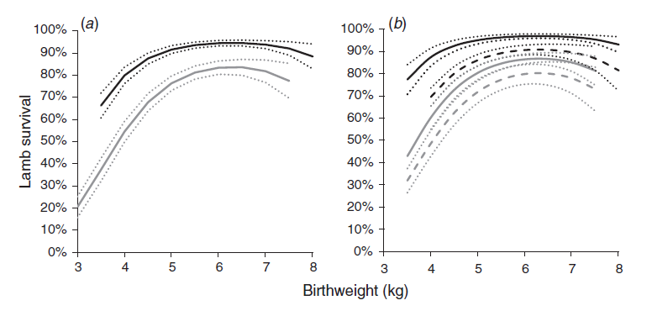
Fig. 1: Predicted relationship between birthweight and survival of lambs from (a) BLM (black) and Merino (grey) dams, that were (b) single (solid lines) or multiple (dashed lines) born. Dotted lines are standard errors of the mean. Source: Hocking Edwards et al., 2019.
Over 80% of lamb deaths are attributed to the Mismothering/Starvation/Exposure (MSE) complex or dystocia (EverGraze, 2012). Exposure can be measured by chill index, which is comprised of wind speed, temperature and rainfall. Measurements above 1000kJ/m2/hr have been proven to be high risk for lamb loss (Donelly, 1984).
The social and economic impacts of high lamb mortality rates are significant, and this project sought to provide land managers with a range of options to reduce this impact.

Demonstration Groups Avoca, Cavendish and Casterton BESTWOOL/BESTLAMB

The groups’ interest
This producer demonstration project was run with the Casterton, Cavendish and Avoca BESTWOOL/BESTLAMB (BWBL) groups from 2015 – 2018, funded by Meat and Livestock Australia and Agriculture Victoria. All three participating BWBL groups were formed to focus on pasture-based sheep production systems.
Prior to the demonstration commencing, most producers across the three applicant BWBL groups had undertaken sections of “Making more from Sheep” modules, such as “Turning pasture into product”, “Wean more lambs” and “Healthy and contented sheep”. Many of the producers in these groups were scanning ewes prior to lambing and knew their production potential given number of foetuses; hence lamb survival was a major focus.
The Cavendish and Avoca groups had also completed a Top Paddock pilot program which focused on measuring lamb numbers and lamb growth rates. The group identified lamb survival as a key topic during a review of the group’s achievements and priorities. The Casterton and Avoca groups also identified lamb survival as a key production and animal welfare issue. Furthermore, two producers in the Casterton group had established hedgerows on their properties for improved lamb survival.
Climate in South West Victoria dictates that the main lambing season extends from June to September. Optimum lambing time is largely driven by the need to match peak energy demand with a consistent supply of quality pasture. However, this period corresponds with the highest frequency of ‘chill’ days and is at most risk to young lambs at the participating BWBL groups.

Group characteristics
Table 1: Group characteristics
 | Largest | Smallest | Total
Flock size (DSE) | 16,000 | 1,100 | 110,000
Area (ha) | 3,500 | 220

Previous research in the value of shelter

Chill Index
Previous research by Alexander (1962) found that newborn lambs can maintain a normal rectal temperature at ambient temperatures as low as -5°C by increasing their normal metabolic rate to at least two or three times their basal rate. However, Alexander (1962) also it was found that lambs born in wintry conditions in an exposed position, may be subjected to a higher heat loss than predicted from ambient temperature alone. The insulation of the air and the fleece will be reduced by air movement, and water evaporating from the very wet coat of the newly born lamb will absorb heat from the lamb (Alexander, G. 1962).
Adverse weather conditions such as wind, precipitation and low temperature either alone or in combination (chill index) can increase the level of newborn lamb mortality for short periods during lambing due to increased heat loss. The provision of shelter reduces wind speed and therefore chill index and has been shown to effectively reduce lamb mortality (Broster et al., 2012). It has been shown that mortality rates increase rapidly at chill values of over 1000 kJ/m²/hour (Donnelly J. 1984). This figure is key a key indicator used by the Bureau of Meteorology in issuing Sheep Grazier Alerts. Data from the Hamilton EverGraze site indicates that June to September typically contain 10 – 13 chill days each.

The EverGraze project
The EverGraze project’s Hamilton site found that using “maternity ward” paddocks with TWG hedgerows reduced the number of high chill days for lambing mobs to 3 – 4 per month over the lambing period. This significantly reduced the risk of lamb mortality for lambs of average birth weight, regardless of whether they were born as singles, twins or triplets. Survival at the Hamilton site increased by 30% when TWG hedgerows were used for shelter (Morant et al., 2013).
The theory applied to other regions with high chill index. A similar trend was found at the Wagga Wagga EverGraze Proof Site with lamb survival increasing by 10% where shelter was provided by shrubs. The effect was not as large as at Hamilton due to a generally lower chill index at the site.
EverGraze research demonstrated that perennial pastures and shrubs can improve lamb survival through provision of high-quality forage and shelter. EverGraze research drew together the science behind lamb survival and provided recommendations to address lamb issues on farm (King et al., 2012).
Despite the gains demonstrated using hedgerows at the Hamilton EverGraze site there had been little evidence of adoption of the practice. Dr Malcolm McCaskill (DJPR, Hamilton) was part of the EverGraze research and explained at the initial meeting with producers that “the EverGraze project had taken the shelter message as far as possible through conventional research and extension. Despite what we calculate to be high returns from investment in shelter, we are only aware of a few cases of adoption. This project will fill a gap we were unable to fill in EverGraze by demonstrating how it can be done at a larger scale on commercial properties”.

Selected shelter options for the demonstration

Tall wheat grass (Thinopyrum ponticum cv Tyrell)
EverGraze research found that grass hedges have several advantages over shrub and tree belts. They are relatively inexpensive and easy to establish and can provide effective shelter the year after sowing. The best protection is close to the ground where it is most effective for small lambs, whereas shrubs often tunnel wind below the canopy. Additionally, if the hedges are not required in the future, they can be easily removed (McCaskill and Saul, 2008). Recommended species are over 1m tall and are sufficiently hardy enough to remain upright after animals move through them.

Dorycnium hirstum
D. hirstum is an early spring-growing deep rooted, perennial legume which develops to approximately 1m tall and 1m in diameter. It occurs naturally across the Mediterranean basin and West Asia (Nichols et al., 2012). Lane et al. (2004) considered D. hirstum to have potential to provide forage in drought prone areas and shelter for lambing ewes.

Hay bales
Previous studies by Pollard and Littlejohn (1999) used hay bales to examine sheltering behaviour during lambing in southern New Zealand, as large square and round bales present a cheap, accessible, easy to use option for lamb shelter. In this work there was no difference in lamb mortality between unsheltered and sheltered treatments, however, they observed frequent utilisation of hay bales during periods of wet and windy weather.

Corrugated iron shelters
Data exists on the use of constructed shelters made from corrugated iron as a viable option to improve animal welfare outcomes, including the survival of newly-born lambs, in extreme cold (Agriculture Victoria, n.d.). It recommends shelters be well dispersed to encourage use by ewes isolated from the mob at lambing. Inclusion of this shelter type was recommended by project funders.

Eucalypt plantations
Eucalypt plantations were selected for the demonstration because they are common in the local landscape. BWBL group producers had observed better lambing performance in paddocks sheltered with trees suggesting they were effective in limiting impacts of exposure to vulnerable sheep, such as those freshly shorn, or neonatal lambs.

Project objectives
The project aimed to demonstrate the economic, social and environmental benefits of increased shelter for lamb survival through the establishment of hedgerows of tall wheat grass and leguminous shrubs, as well as constructed shelters using hay bales and corrugated iron. Opportunistically, the third and fourth years of the project also demonstrated using eucalypt plantations. In addition to the benefits of increased shelter, the project set out to demonstrate how to establish and maintain the shelters. Specifically, the project identified five key objectives:
- To demonstrate integration, establishment and management of hedgerows and intra-paddock shelter options in a whole farm system to increase lambing percentages compared to paddocks without shelter.
- Ascertain which hedgerow species performs best in terms of establishment, persistence over the demonstration period, and providing the most effective shelter.
- Conduct a cost benefit analysis for each shelter type to demonstrate the value of shelter in increased lamb survival.
- Through on farm demonstrations and annual field days, show the value of shelter to BWBL members and the wider farming community.
- Develop technical notes on the establishment and management of inter-paddock shelter.

Methodology
Meetings were held with participating producer groups (Casterton CMC BWBL, Cavendish BWBL and Avoca BWBL) to discuss the project and project outcomes and seek input from members about the finer details of the demonstration site implementation (widths of hedgerows, direction of shelter in paddocks, spacing between rows, number of rows per paddock and management of hedgerows.)
Based on research by EverGraze (2012), Anderson (1962), Donelly (1984), Pollard and Littlejohn (1999) as well as producer and funder feedback, the project team proceeded with the following forms of shelter: tall wheat grass, D. hirstum (a leguminous shrub), corrugated iron structures, large hay bale structures and eucalypt plantations.
Rainfall data
The closest meteorological stations to the Avoca, Cavendish and Casterton sites were Stawell, Hamilton and Casterton, respectively. Rainfall for the four years of the demonstration and the long-term average (LTA) are shown in Figures 2, 3 and 4. These stations also provided data used to calculate chill index.

Fig. 2: Monthly rainfall data for Stawell 2015-2018 and long-term average

Fig. 3: Monthly rainfall data for Hamilton 2015-2018 and long-term average

Fig. 4: Monthly rainfall data for Casterton 2015-2018 and long-term average

Demonstration site implementation
Eight producer sites were selected across Western Victoria at Casterton, Cavendish and Avoca, with two producer sites being selected from the Avoca BWBL group and three producer sites being selected from each of the Casterton and Cavendish BWBL groups.
Table 2 summarises the shelter type used for each year at each location, and whether it was successfully established to be available for monitoring chill index and lamb survival.
Table 2: Demonstration Sites
BWBL Group | Year | Site | Shelter type | Establishment of site for monitoring
Avoca | 2015 | Dobie | Square hay bales | Successful
 |  |  | D. hirstum | Postponed
 |  | Amphitheatre | D. hirstum | Postponed
 |  |  | Tall wheat grass | Postponed
 | 2016 | Dobie | L-shape corrugated iron shelters | Successful
 |  |  | D. hirstum | Postponed
 |  | Amphitheatre | D. hirstum | Postponed
 |  |  | Tall wheat grass | failed
 | 2017 | Amphitheatre | Tall wheat grass | Failed
 |  |  | D. hirstum | Failed
 |  | Dobie | D. hirstum | Failed
 | 2018 | Dobie | T-shape corrugated iron shelters | Successful
Casterton | 2015 | Wando Bridge | T-shape corrugated iron shelters | Successful
 |  | Warrock | D. hirstum | Postponed
 | 2016 | Wando Bridge | Corrugated iron shelters | Successful
 |  |  | D. hirstum | Postponed
 | 2017 | Wando Bridge | Square hay bales | Successful
 |  |  | Tall wheat grass | Failed
 |  | Warrock | Tall wheat grass | Previously established
 |  | Casterton | D. hirstum | Failed
 | 2018 | Wando Bridge | Square hay bales | Successful
Cavendish | 2015 | Mooralla | Corrugated iron shelters | Successful
 |  | Bulart | D. hirstum | Postponed
 |  | Gatum 1 | D. hirstum | Postponed
 |  | Gatum 2 | Tall wheat grass | Postponed
 | 2016 | Bulart | Y-shape corrugated iron shelters | Successful
 |  |  | D. hirstum | Postponed
 |  | Gatum 1 | D. hirstum | Postponed
 |  | Gatum 2 | D. hirstum | Postponed
 |  |  | Tall wheat grass | Postponed
 | 2017 | Gatum 1 | D. hirstum | Successful in creek line, failed in paddock
 |  |  | Round hay bales | Successful
 |  |  | Eucalypt plantation | Previously established
 |  | Gatum 2 | Tall wheat grass | Failed
 | 2018 | Gatum 1 | Round hay bales | Successful
 |  |  | Eucalypt plantation | Previously established

Two paddocks per participating site were selected. Where possible, each of the 18 paddocks were approximately 14 ha in size and had similar aspect and improved pastures. Pastures were managed to target Lifetime Ewe Management principles for feed on offer levels. Shelter was established in one paddock, with either, leguminous shrubs (D. hirstum), corrugated iron shelters or hay bales. The second paddock was the unsheltered control. At the Gatum 1 site, the unsheltered control was the same paddock for each of the treatments.
Mobs of merino or composite ewes (average n =102 ewes, range =33 to 262 ewes) scanned in lamb to twins were allocated to each shelter paddock and ewes in similar condition were allocated to a control paddock without shelter for lambing. Ewes were condition scored and only ewes of condition score 3+ were allocated to the demonstration paddocks to ensure that poor condition score was not a factor in lamb survival. Vermin control was carried out at each site by the producers prior to lambing by baiting or hunting.
Lamb survival was calculated as a percentage of lambs marked / foetuses pregnancy scanned, in line with EverGraze (Morant et al 2013). For example. 150 lambs marked in a mob of 100 twin bearing ewes (200 foetuses scanned) the survival of twin lambs is 150/200 x 100 = 75%.

Shelter establishment

Tall wheat grass
Sowing of TWG was postponed in autumn and spring 2015 owing to very dry conditions (Figures 3-5). The late 2016 autumn break at Avoca and Cavendish followed by the excessively wet spring 2016 caused a further delay to 2017.
In autumn 2017 pre-sowing, rows of pasture were sprayed out with Roundup at 2-3lt/ha plus Kamba 500 at 250ml/ha for broad leaf control, and Le-Mat for red-legged earth mite. TWG seed was sown at 20kg/ha in rows 1-1.2m wide, spaced at 18-20m apart across the paddock (slight variations between sites depended on specific boom spray width and machinery used for pasture management at each site). 80kg/ha of MAP was applied at sowing. Slug bait was spread either the day of sowing or the day immediately following.
The 2017 TWG plantings failed and consequently only a single year of TWG data was collected using a site that had previously been established as part of the EverGraze project in 2010. This site utilised 1.5m rows at 20m spacing’s.

Dorycnium hirstum
Below average rainfall and low soil moisture availability in autumn and spring 2015 (Figures 3-5) caused establishment of D. hirstum to be postponed. The decision was made to establish seedlings of D. hirstum rather than direct seeding to allow the plants to grow while paddock conditions were unfavourable. Seedlings were grown as tubestock at Arborline Nursery, Hamilton in 2016 and were due to be planted in autumn spring 2016, however the excessively wet spring 2016 (Figures 3-5) caused a further delay to autumn 2017.
D. hirstum was inoculated with Rhizobium, and then planted at 50cm spacing’s in a line sprayed out at spot spray rates (3 lt/ha of 450g glyphospate active) in autumn 2017. No bait or fertiliser was applied.
Further issues with D. hirstum were experienced as spring planted seedlings dried out and died over the summer period at two sites and sheep ate and damaged plants at two sites.
Only one year at one site of chill index data and no survival information was available for the D. hirstum in the fenced-off creek line site.

Corrugated iron shelters
Demonstrated in 2015, 2016 and 2018, these shelters were constructed from several corrugated iron sheets arranged in a Y-, T- or L-shaped formation secured in place using star pickets. There were between 3 and 5 of these shelters spread across the sheltered paddock at each site, established in the 1-2 weeks prior to the start of lambing.

Straw bale shelters
Between three and six round or square hay bales were arranged in an L-shape and utilised in 2015, 2016 and 2018 for the demonstration, dependent on the on-farm availability.

Eucalypt plantations
Two established eucalypt plantations were utilised in 2017 and 2018 on the Gatum 1 site to accommodate producer interest and in recognition that established tree breaks, including plantations, are a common feature on farms in the local area. The plantation in 2017 had a low understorey as it was an unsown area originally affected by salinity, and the 2018 plantation had a grassy understorey approximately 1.2-1.5m tall. Neither plantation had previously been grazed.

Chill index
Rainfall and temperature data were sourced from the Bureau of Meteorology (BoM) and analysed with wind speed recorded at the site to calculate chill index. Chill index was calculated for each site for the period of lambing using the following equation, which is also used by the Australian BoM to issue sheep graziers alerts (Broster et al., 2012). This formula calculates the potential heat loss (⁰C) in kJ/m².hr using mean daily wind velocity (v; m/sec), the mean daily temperature (T; ⁰C) and daily rainfall (x; mm) as shown below:
Equation 1: Chill Index
$$C=\left(11.7+3.1v^{0.5}\right)\left(40-T\right)+481 (481\left(1{-e}^{-0.04x}\right))$$
Data loggers were installed at each of the sites in the sheltered and unsheltered paddocks and measured wind speed at 15 minute intervals throughout the lambing period. Data on hourly temperature and rainfall for each site was gathered from the BoM for the lambing period to calculate the chill index.

Wind speed data
Wind speed data was collected in each paddock (sheltered and unsheltered) using anemometers, attached 20cm above ground to replicate average neonatal lamb height. The anemometers were protected from access by lambs using a pasture cage.

Lamb survival and monitoring

Lambing results were monitored over four years (2015-2018), and lamb survival percentage calculated as number of lambs marked / number of foetuses pregnancy scanned). Producers also visually monitored welfare of ewes and lambs and use of shelter as part of their usual farm operations, with demonstration staff attending regularly during lambing (1-3 weeks between visits) to download wind speed data from loggers and visually assess utilisation of shelter (by presence of lambs, and condition of pasture around shelter).

Economic analysis
Economic analysis determined the net present value (NPV) of the investment being the difference between the present value of the future cash flows and the cost of the investment, where the NPV is positive the investment should be accepted. The method also calculated the internal rate of return (IRR) and where the rate exceeds the required return or cost of capital the investment should be accepted.
The analysis identified the additional benefits and costs relative to the status quo (no shelter option). The economic analysis looks at TWG shelter establishment only, as it had more consistent lamb survival results than the other shelter types.
The additional benefits evaluated are:
- Increased survival of lambs. There was 1.8% increase in lamb survival (based on lambs marked /foetuses scanned), which was equivalent to 3.6% increase lambs marked/ ewes pregnant, or 9.6 lambs in the 262 ewe mob. Additional lambs (increased marking percentage) are valued at $127/head based on the 2017/18 Livestock Farm Monitor Project (Table 3).

The additional costs evaluated are:
- Establishing and maintaining a TWG shelter (Table 4)

Assumptions
The assumptions of the TWG shelter demonstration are outlined in Tables 3 and 4 below. The analysis will focus on the benefits of increased lamb survival and breakeven compared to the costs of TWG shelter.

Table 3: Tall Wheat Grass establishment assumptions – Additional BENEFITS
Additional benefits | Increased lamb survival on the 37 ha compared to no shelter (number) p.a. | Total benefit (assume lamb value as $127/hd)
TWE shelter – 10-year analysis | 9.6 | $1,215
Breakeven analysis | 2.9 | $366

Table 4: Tall Wheat Grass establishment assumptions – Additional COSTS
Additional costs | Metric | Comment
Hedge rows | 7% | Proportion of the paddock sown to TWG shelter
TWG Establishment | $595/ha | Costs to establish TWE hedge rows for shelter on a per hectare basis. Includes seed, sowing, fertiliser, herbicide and insecticide costs
Pasture establishment | $1,541 | Total cost of TWE shelter for the 37 hectares
Annual urea application | $4.20 | Annual urea application cost $60/ha or $4.20 across the 37-hectare paddock
Cost of capital  (Discount rate) | 7% | Used to estimate the amount the invested funds could earn in the most profitable alternative use
Time to establish | 1 year | Full production benefit realised in year 2
Expected life of the pasture (salvage value) | 15 years | At the end of 10 years the TWG shelter is expected to be 1/3 of the initial value.

Extension Activities

Knowledge, attitude, skills, aspiration and adoption (KASAA) surveys
A survey was conducted prior to the establishment of the demonstration sites to gauge the baseline KASAA levels. The survey was undertaken again in 2019 at the completion of the project. The final survey also included a short general qualitative evaluation of the demonstration. Questions asked of participants in the KASAA surveys, including the general qualitative evaluation, can be found in the appendices.

Planned extension activities
An engagement activity (e.g. discussion at group meeting, or a field day) and a results activity (e.g. group meeting to discuss results) was planned for each year of the demonstration.

Results

Establishment
Table 5 shows the establishment results at all sites in the demonstration. The results indicate the considerable difficulties encountered when attempting to establish TWG and D. hirstum, caused by dry seasonal conditions and pests.
Table 5: Establishment result
BWBL Group | Year | Site | Shelter type | Establishment result
Avoca | 2015 | Dobie | Square hay bales | Successful
 |  |  | D. hirstum | Postponed due to dry seasonal conditions
 |  | Amphitheatre | D. hirstum | Postponed due to dry seasonal conditions
 |  |  | Tall wheat grass | Postponed due to dry seasonal conditions
 | 2016 | Dobie | L-shape corrugated iron shelters | Successful
 |  |  | D. hirstum | Postponed due to dry seasonal conditions
 |  | Amphitheatre | D. hirstum | Postponed due to dry seasonal conditions
 |  |  | Tall wheat grass | Postponed due to dry seasonal conditions
 | 2017 | Amphitheatre | Tall wheat grass | Failed due to RLEM post sowing, grazed too early
 |  |  | D. hirstum | Failed due to dry summer
 |  | Dobie | D. hirstum | Failed due to dry summer
 | 2018 | Dobie | T-shape corrugated iron shelters | Failed due to dry summer
Casterton | 2015 | Wando Bridge | T-shape corrugated iron shelters | Successful
 |  | Warrock | D. hirstum | Postponed due to dry seasonal conditions
 | 2016 | Wando Bridge | Corrugated iron shelters | Successful
 |  |  | D. hirstum | Postponed due to dry seasonal conditions
 | 2017 | Wando Bridge | Square hay bales | Successful
 |  |  | Tall wheat grass | Failed due to slugs from inter-row pasture
 |  | Warrock | Tall wheat grass | Previously established
 |  | Casterton | D. hirstum | Failed due to grazing
 | 2018 | Wando Bridge | Square hay bales | Successful
Cavendish | 2015 | Mooralla | Corrugated iron shelters | Successful
 |  | Bulart | D. hirstum | Postponed due to dry seasonal conditions
 |  | Gatum 1 | D. hirstum | Postponed due to dry seasonal conditions
 |  | Gatum 2 | Tall wheat grass | Postponed due to dry seasonal conditions
 | 2016 | Bulart | Y-shape corrugated iron shelters | Successful
 |  |  | D. hirstum | Postponed due to dry seasonal conditions
 |  | Gatum 1 | D. hirstum | Postponed due to dry seasonal conditions
 |  | Gatum 2 | D. hirstum | Postponed due to dry seasonal conditions
 |  |  | Tall wheat grass | Postponed due to dry seasonal conditions
 | 2017 | Gatum 1 | D. hirstum | Successful in creek line, failed in paddock due to grazing
 |  |  | Round hay bales | Successful
 |  |  | Eucalypt plantation | Previously established
 |  | Gatum 2 | Tall wheat grass | Poor emergence, slugs
 | 2018 | Gatum 1 | Round hay bales | Successful
 |  |  | Eucalypt plantation | Previously established

Tall wheat grass (TWG)
Sowing of TWG was postponed at four sites due to dry conditions. Sowing failed once due to slugs.
Figure 5 shows the previously established TWG site at Warrock that was used for monitoring chill index and lamb survival, given the failure to establish at all other sites.
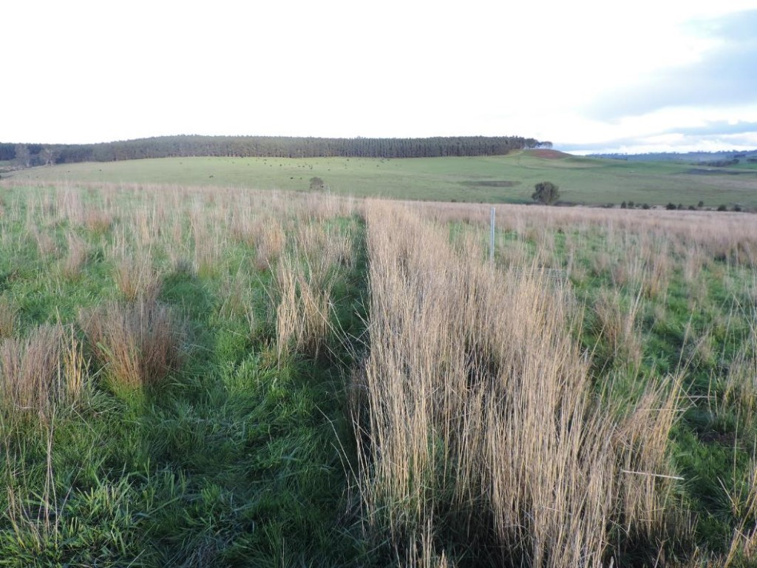
Fig. 5: Tall wheat grass at the Warrock site in 2017

Dorycnium hirstum
Sowing of D. hirstum was postponed over 2015 and 2016 11 times (Table 5) due to dry conditions followed by an excessively wet spring 2016 (Figures 2-4). Seedlings were planted in 2017 across four sites and subsequently failed at two sites owing to grazing by sheep and twice by dry conditions. Establishment was successful at the Gatum 1 creek line, which was fenced preventing grazing.
Figure 6 shows D. hirstum establishment at Casterton, prior to grazing. When ewes were given access to the paddock, plants were grazed to ground level, contrary to advice provided to the project team that the plant had poor palatability.
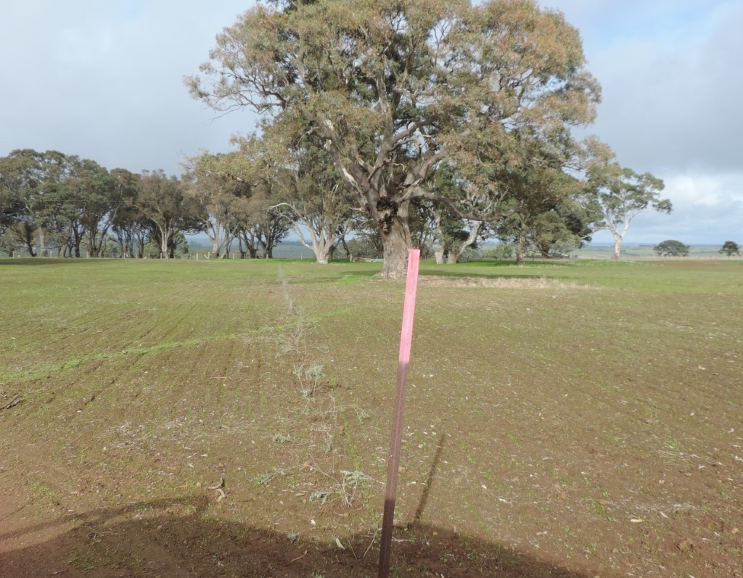
Fig. 6: Dorycnium hirstum establishment at Casterton, prior to grazing.

Corrugated iron shelters
Figures 7-9 show the corrugated iron shelters established in a T-, Y- and L-shape at Wando Bridge, Bulart and Dobie, respectively in 2016 with wind metres in situ. One L-shaped, two T-shaped and one Y-shaped shelter sites were established over the course of the demonstration.
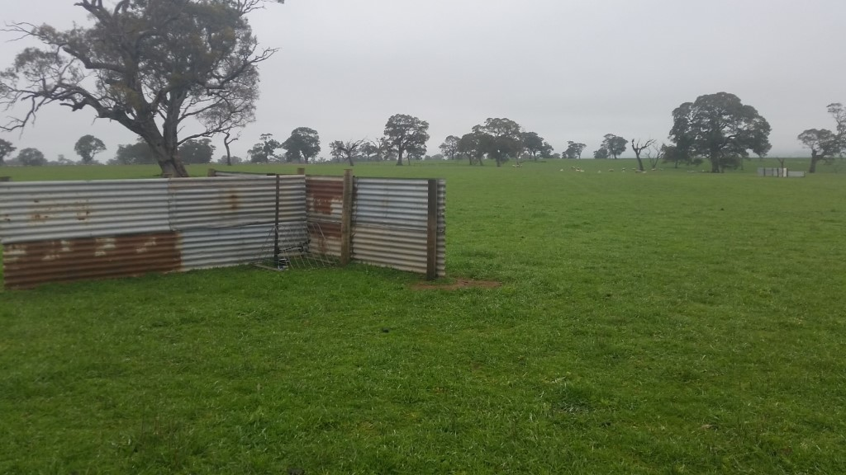
Fig. 7: Corrugated iron shelter (T-Shaped) at Wando Bridge in 2016
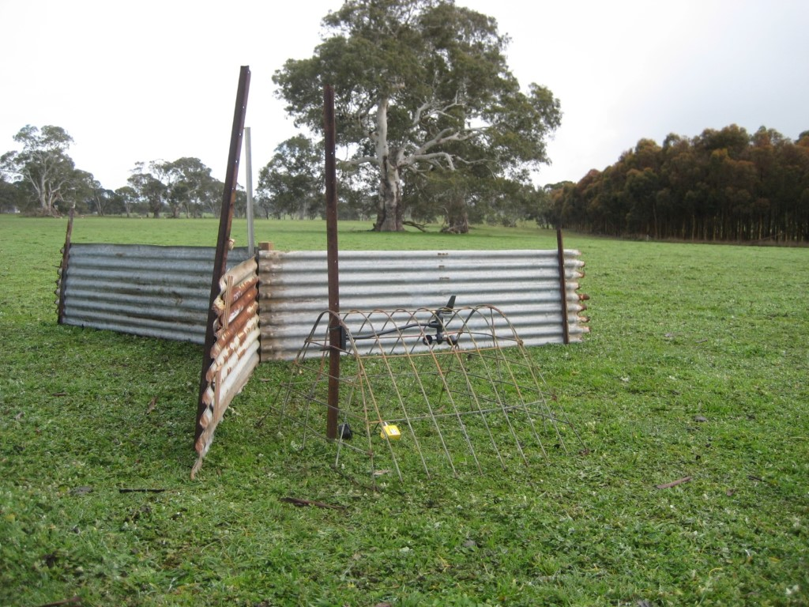
Fig. 8: Corrugated iron shelter (Y-Shaped) established at Bulart in 2016
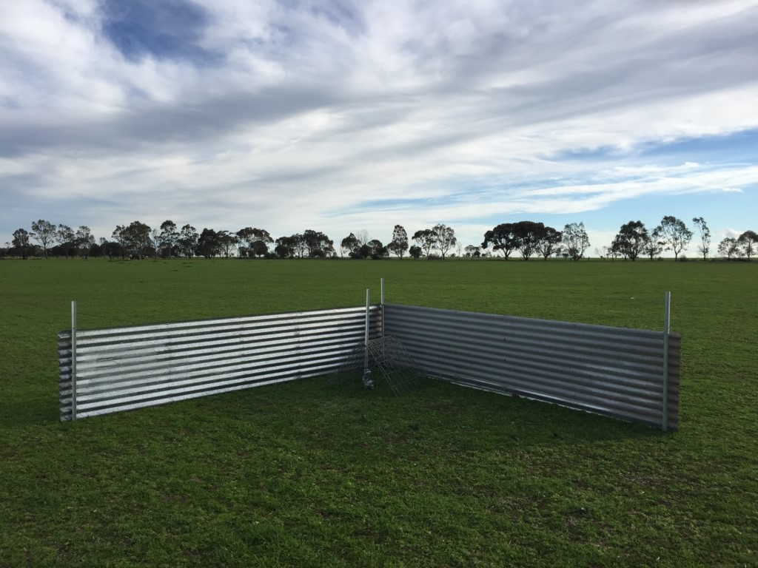
Fig. 9: Corrugated iron shelter (L-Shaped) established at Dobie in 2016

Hay bales
Three square and two round hay bale sites were established during the demonstration (Table 5). Figures 10 and 11 show the square and round hay bale structures established at the Wando Bridge and Gatum 1 sites, respectively, in 2017. The wind metres are pictured in situ.
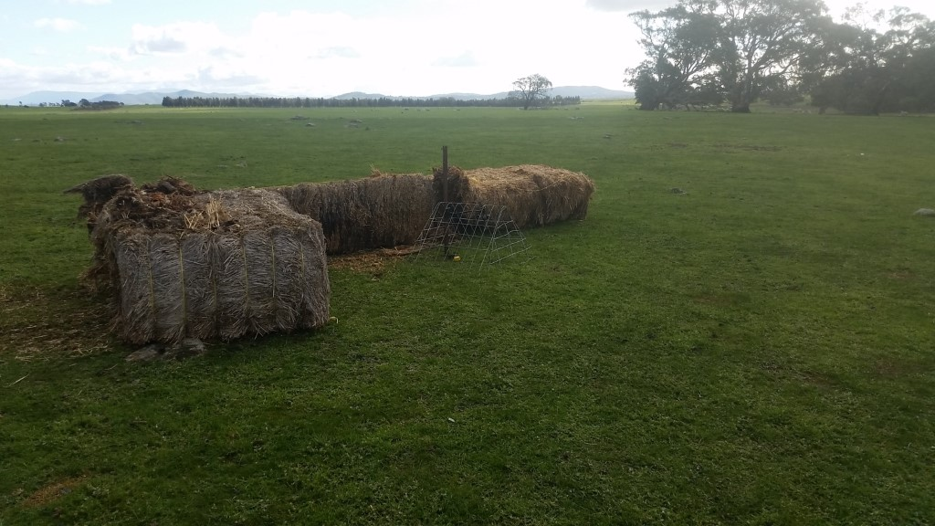
Fig. 10: Square hay bale shelter at Wando Bridge in 2017
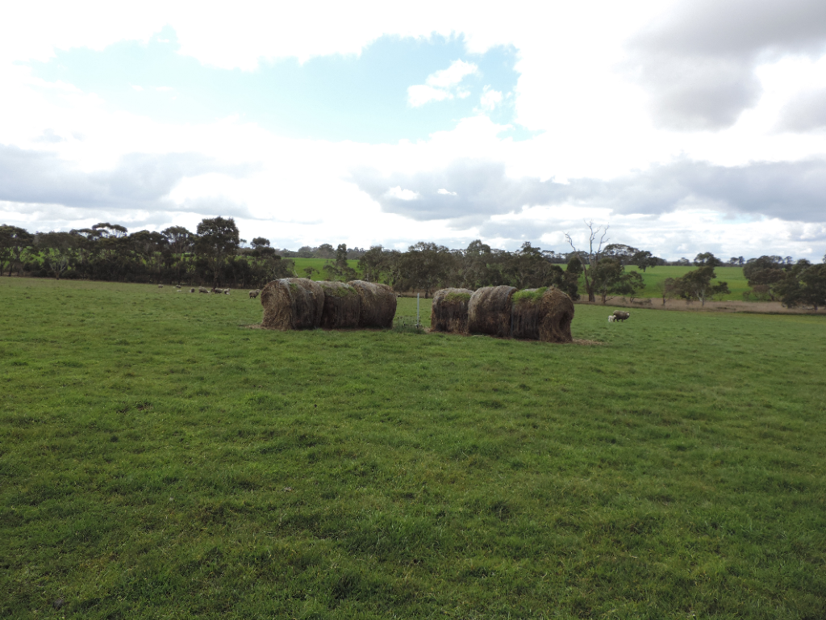
Fig. 11: Round hay bale shelter at Gatum 1 site in 2017

Eucalypt plantations
Two separate pre-existing eucalypt sites were used throughout the demonstration in 2017 and 2018 (Table 5). Figure 12 shows the eucalypt plantation at Gatum 1 site in 2017, including the wind metre in position. Notable differences between the two eucalypt sites were the presence (or absence) of an understory grass canopy.
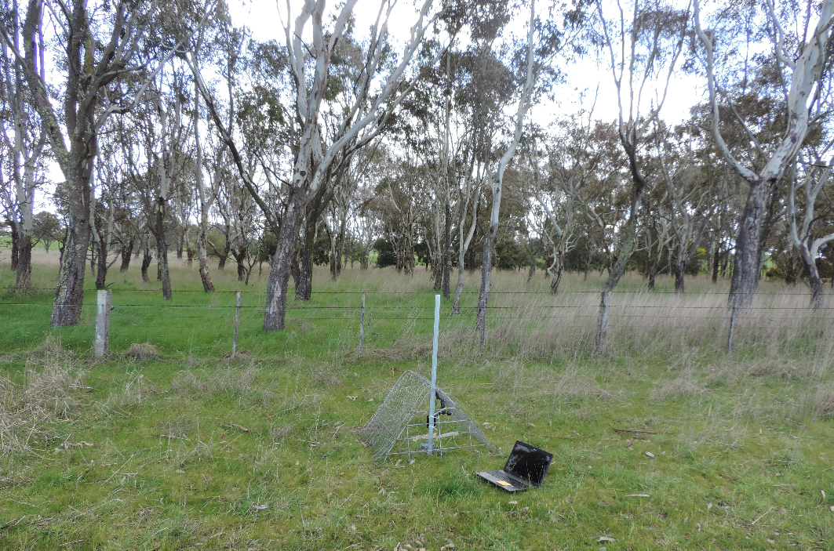
Fig. 12: Eucalypt plantation at Gatum 1 site in 2017

Chill index and lamb survival
All shelter options evaluated in this demonstration reduced the percentage of time when the chill index was considered high (> 1000kJ/m2/h) compared to unsheltered area (Figure 13). Averaged over all sites and years for each shelter type, the plantation provided the greatest reduction of high wind chill with a decrease of 18%, followed by TWG (15.4%), hay bales (14.7%), and corrugated iron shelters (11.5%). D. hirstum provided the smallest reduction in time at high wind chill, with a decrease of 7.3%.
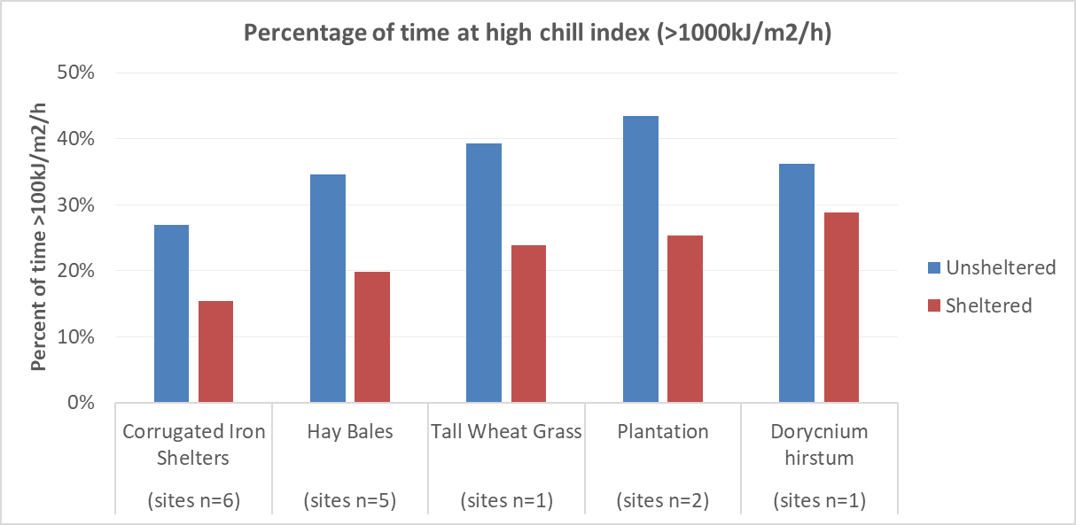
Fig. 13: Average percentage of time at high chill index (>1000kJ/m2/h) across all sites and years of the demonstration, where sites (n=x) is the number of sites with necessary information available to calculate the average
Averaged over all sites and years, improvements in lamb survival (measured at marking) did not occur across all shelter types (Figure 14). Plantations delivered the biggest improvement, increasing survival by 15.7% on foetuses scanned (a 31.4% increase per ewes pregnant) compared to the unsheltered equivalent, followed by hay bales (5.3% increase on foetuses scanned; 10.6% increase per ewes pregnant) and TWG (1.8% increase on foetuses scanned or 3.6% increase per ewes pregnant). The presence of corrugated iron shelters correlated with an overall reduction in lamb survival of 2.7% on foetuses scanned or 5.4% per ewes pregnant. No survival data was available for the D. hirstum. Individual site-by-site data (chill index line graphs and histograms of time at various chill index ranges) is provided in Appendix D.
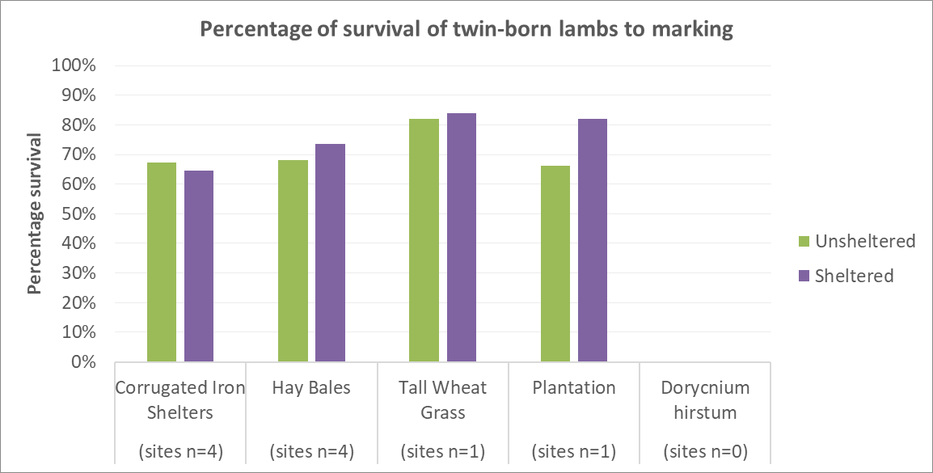
Fig. 14: Average percentage of survival of twin-born lambs to marking across all sites and years of the demonstration, where sites (n=x) is the number of sites with necessary information available to calculate the average.

Tall wheat grass hedgerows
Figure 15 shows a reduction in time at high chill index of 15.4% compared to the unsheltered sites. This led to a minor increase in lamb survival (1.8% of foetuses scanned or 3.6% per ewe pregnant) compared to the unsheltered site. This result was for one site of pre-established TWG stocked with composite lambs.
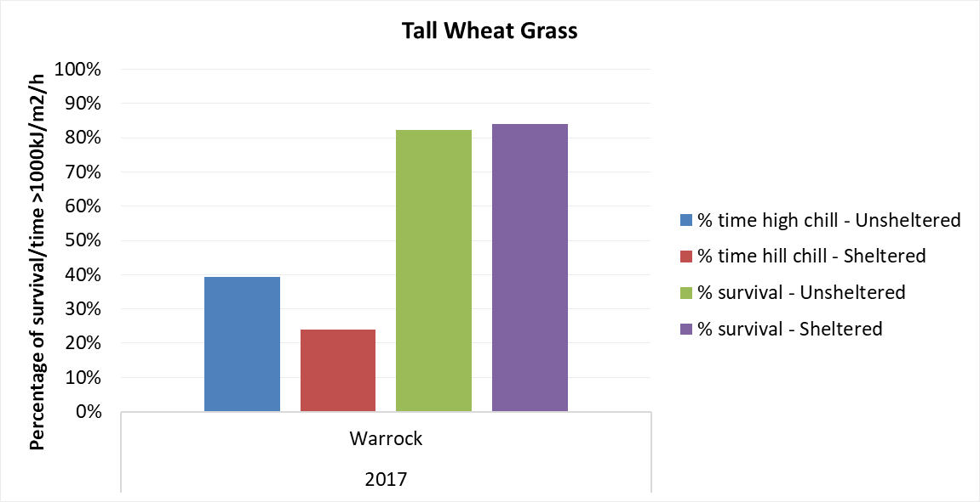
Fig. 15: Sheltered and unsheltered results for percentage of time at high chill index (>1000kJ/m2/h) and percentage of lamb survival (lambs marked/ foetuses pregnancy scanned) at all sites of tall wheat grass in the demonstration.
Table 6 shows a reduction of 13 days (34 in unsheltered compared to 21 in the sheltered) in the lambing period where the chill index was considered high (>1000kJ/m2/h), as well as the reduction in total time by 15.4%.

Table 6: Number of days and percentage of time in lambing period at high chill index (>1000kJ/m2/h) for tall wheat grass sites
Year | Site | Lambing period | Days in lambing period >1000kJ/m2/h |  | Time in lambing period >1000kJ/m2/h (%)
 |  |  | Unsheltered | Sheltered | Unsheltered | Sheltered
2017 | Warrock | 14 July to 25 August | 34 | 21 | 39.3 | 23.9

Dorycnium hirstum
Chill index was measured at the one successfully established site in a creek line at Gatum 1. Figure 16 shows the reduction in time at high chill index compared to the unsheltered treatment, which was the smallest of all shelter types (7.3% reduction), reflecting the poor establishment and small stature of the slow growing plants. No lambing data was available at this site.
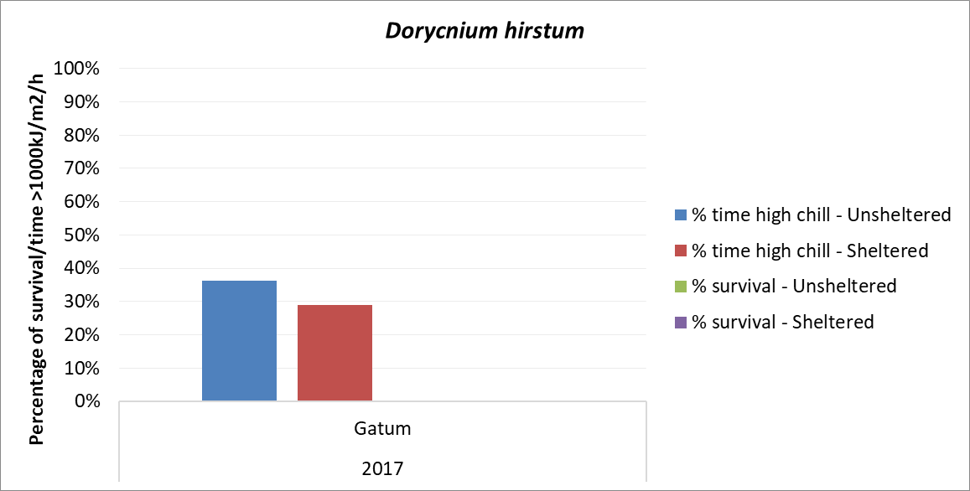
1
Fig. 16: Sheltered and unsheltered results for percentage of time at high chill index (>1000kJ/m2/h) at all sites of D. hirstum in the demonstration. Note that percentage of lamb survival results are not available given the sheltered paddock was not suitable at that time for grazing with lambing ewes.
Table 7 shows no reduction in number of days in the lambing period where the chill index was considered high (>1000kJ/m2/h), but the reduction in total time by 7.3% indicates that on the days where high chill index occurred, it was for shorter periods in the sheltered paddock compared to the unsheltered paddock.
Table 7: Number of days and percentage of time in lambing period at high chill index (>1000kJ/m2/h) for D. hirstum sites
Year | Site | Lambing period | Days in lambing period >1000kJ/m2/h |  | % time of lambing period >1000kJ/m2/h
 |  |  | Unsheltered | Sheltered | Unsheltered | Sheltered
2017 | Gatum 1 | 5 August to 2 September | 15 | 15 | 36.2 | 28.8

Corrugated iron shelters
As shown in Figure 17, at all sites in 2015 and 2016 the corrugated iron shelters reduced the percentage of time at high chill index, but this was not the case in 2018. The presence of corrugated iron shelters did not correspond with an improvement in lamb survival across the demonstration project and in fact, lamb survival was lower at all corrugated iron sites except Wando Bridge in 2016, giving weight to our observation that the ewes were not using these shelters in the first 48 hours post lambing.
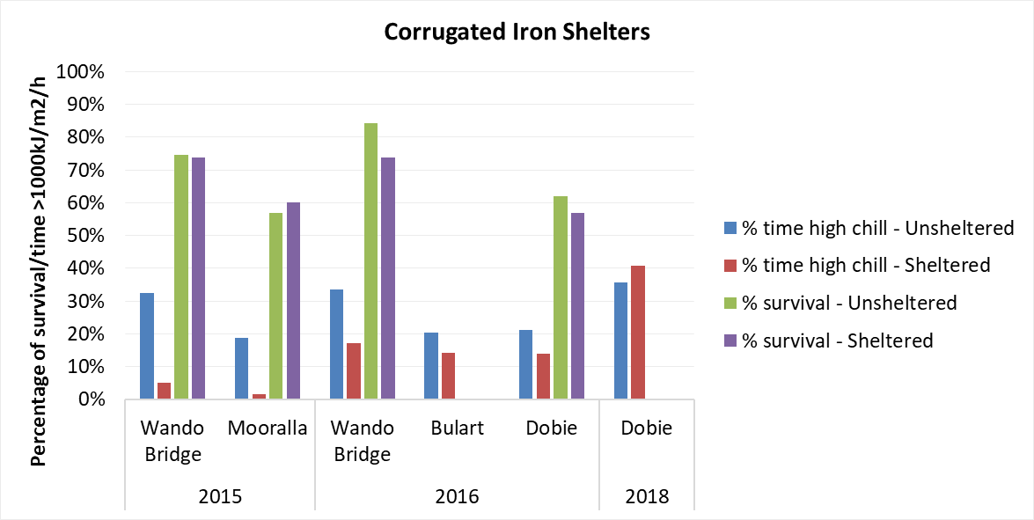
Fig. 17: Sheltered and unsheltered results for percentage of time at high chill index (>1000kJ/m2/h) and percentage of lamb survival/ foetuses pregnancy scanned) at all sites of corrugated iron shelters in the demonstration.
Table 8 shows a reduction the corrugated iron sheltered paddocks in both the number of days in the lambing period where the chill index was considered high (>1000kJ/m2/h) and the percentage of total time in the lambing period at all sites (compared to unsheltered treatments), except at Dobie in 2018, where the opposite was seen. The 2018 exception is an unexplained anomaly.
Table 8: Number of days and percentage of time in lambing period at high chill index (>1000kJ/m2/h) for corrugated iron shelter sites
Year | Site | Lambing period | Days in lambing period >1000kJ/m2/h |  | % time of lambing period >1000kJ/m2/h
 |  |  | Unsheltered | Sheltered | Unsheltered | Sheltered
2015 | Wando Bridge | 22 June to 31 August | 44 | 6 | 33 | 5
2015 | Mooralla | 13 August to 15 September | 12 | 2 | 20 | 2
2016 | Wando Bridge | 17 June to 27 July | 21 | 15 | 33 | 17
2016 | Bulart | 11 August to 20 September | 15 | 12 | 20 | 14
2016 | Dobie | 23 August to 25 September | 14 | 8 | 21 | 14
2018 | Dobie | 8 July to 19 August | 25 | 31 | 35.6 | 40.7

Hay bales
At all sites across the demonstration project the presence of hay bales reduced the percentage of time at high chill index, though to varying degrees, from 1% at Gatum 1 in 2017 to 23% at Wando Bridge in 2017 (Figure 18). However, the presence of hay bales in the lambing paddock made only a small improvement of 5% in lamb survival compared to unsheltered paddocks.

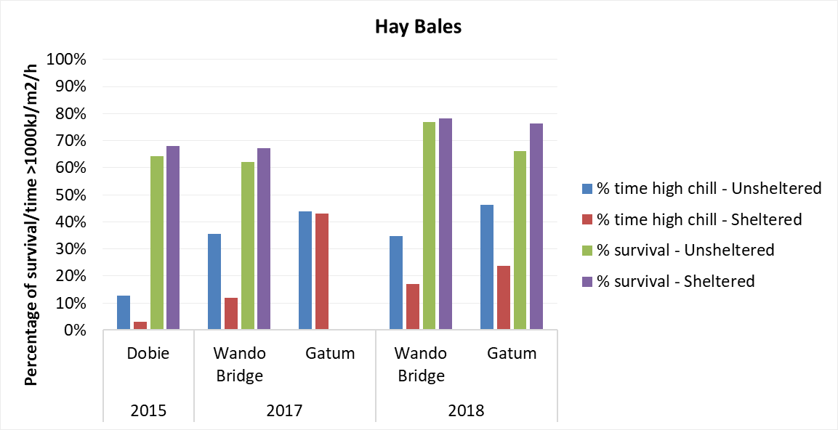
1
1
Fig. 18: Sheltered and unsheltered results for percentage of time at high chill index (>1000kJ/m2/h) and percentage of lamb survival (lambs marked/ foetuses pregnancy scanned) at all sites of hay bales in the demonstration.
There was a reduction in both number of days and the percentage of time where the chill index was considered high (>1000kJ/m2/h) in hay bale sheltered paddocks, compared to unsheltered paddocks during lambing (Table 9). This was seen at all sites, except at Gatum (2017), which achieved a similar result in sheltered and unsheltered treatments.
Table 9: Number of days and percentage of time in lambing period at high chill index (>1000kJ/m2/h) for hay bale shelter sites
Year | Site | Lambing period | Days in lambing period >1000kJ/m2/h |  | % time of lambing period >1000kJ/m2/h
 |  |  | Unsheltered | Sheltered | Unsheltered | Sheltered
2015 | Dobie | 23 August to 25 September | 9 | 3 | 12.7 | 3.1
2017 | Wando Bridge | 14 July to 25 August | 30 | 12 | 35 | 12
2017 | Gatum 1 | 5 August to 2 September | 18 | 18 | 43.8 | 43
2018 | Wando Bridge | 14 July to 25 August | 32 | 17 | 34.6 | 17.1
2018 | Gatum 1 | 20 July to 31 August | 39 | 18 | 46.2 | 23.9

Eucalypt plantation
Overall, the eucalypt plantation provided the biggest reduction in time at high chill index (compared to the unsheltered treatment) across all demonstration sites (18%), averaged over 2017 and 2018. A reduction of 10% was achieved in 2017 and 26% in 2018 (Appendix D), which was attributed to the denser understorey at the 2018 site.
The eucalypt plantation at Gatum 1 provided the highest improvement to lamb survival (66% in the unsheltered paddock to 82% in the sheltered plantation paddock) (Figure 19). This was based on only a single year of data from 2018. Unfortunately, the producer did not use the 2017 sheltered paddock for lambing.
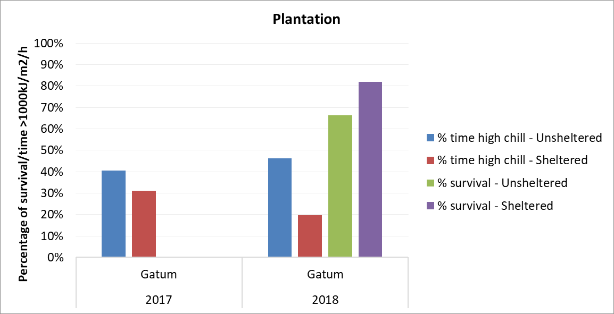
1
1
Fig. 19: Sheltered and unsheltered results for percentage of time at high chill index (>1000kJ/m2/h) and percentage of lamb survival (lambs marked/ foetuses pregnancy scanned) at all sites of eucalypt plantation in the demonstration.
Table 10 shows a reduction in both the number of days in the lambing period where the chill index was high (>1000kJ/m2/h) and the percentage of total time in the lambing period at high chill index in the sheltered paddock (plantation) compared to the unsheltered paddock.
Table 10: Number of days and percentage of time in lambing period at high chill index (>1000kJ/m2/h) for eucalypt plantation sites
Year | Site | Lambing period | Days in lambing period >1000kJ/m2/h |  | % time of lambing period >1000kJ/m2/h
 |  |  | Unsheltered | Sheltered | Unsheltered | Sheltered
2017 | Gatum 1 | 5 August to 2 September | 18 | 12 | 40.5 | 31
2018 | Gatum 1 | 20 July to 31 August | 39 | 24 | 46.2 | 19.6

Economic Analysis
Economic analysis was undertaken using the demonstration wind chill reduction and lamb survival results. The economic analysis looked at TWG shelter establishment only, as it had more consistent lamb survival results than the other shelter types. The D. hirstum failed to establish adequately to give a true representation of its benefits, and there was large variation in the results from the structural shelters, particularly the corrugated iron. The plantations were well established- 15 years or more in age- and it would be a worthwhile project (beyond the scope of this demonstration) to conduct a thorough benefit:cost on plantation shelter over time, accounting for the reduced production area and potential productivity gains.

Breakeven analysis
An estimate of the benefits required for this investment to breakeven (net present value equal to $0) provides insights into what needs to be achieved for the investment to have returns to pay for itself. The breakeven analysis found that survival of an extra 2.9 lambs across the 37 ha paddock each year was required to breakeven (with a TWG shelter life of 10 years and a lamb price of $127/hd – Livestock Farm Monitor Project 2017). The project achieved 9.6 extra lambs in the TWG sheltered paddocks than the unsheltered paddock (an increase of 1.8%).
This result was lower than the 30% increase in lamb survival achieved at the Hamilton EverGraze site, however the composite lambs in the demonstration have better survival rates than merino lambs (used in EverGraze).

Discounted net cash flow analysis
TWG shelter was a profitable investment, based on a discounted net cash flow over 10 years, compared to no shelter (Appendix A). Over the 10 years, the TWG shelter provided an internal rate of return of 46% and a net present value of $5,174. This suggests that the investment will make returns to cover the cost of interest payments (assuming interest rates of 5%) and the costs and benefits balance out to be positive.
The analysis does not allow for an increase in variable costs (e.g. fertiliser, supplementary feeding costs) to account for increased lamb survival. However, it is assumed the benefits from TWG shelter would outweigh these costs.

Sensitivity analysis
Fluctuations in lamb market price and survival numbers increase the likelihood of a negative net present value (NPV) for the shelter. Where a negative NPV occurs, consideration should also be given to the increased animal welfare benefits from providing shelter.
The analysis in Table 11 identifies the NPV of TWG shelter establishment based on changing lamb survival and dollars received per head over 10 years. The table shows a negative NPV would occur only where the market price was less than $100 per head and extra lamb survival was less than five lambs.
Five increases in lamb survival were considered in the sensitivity NPV (Table 11). The NPV indicates that the investment in the TWG shelter establishment should be accepted, based on the results of this demonstration the range of lamb number was included because each years wind chill varies giving people a range of improved numbers to consider.

Table 11: Sensitivity analysis of Net Present Value from changing the number of lambs and lamb value per head. The grey cells show the results from the EPDS
$/hd | Increased number of lambs
 | 3 | 5 | 9.6 | 20 | 30
50 | -$1,313 | -$704 | $697 | $3,863 | $6,907
100 | -$399 | $818 | $3,619 | $9,952 | $16,041
127 | $94 | $1,640 | $5,198 | $13,240 | $20,973
150 | $514 | $2,341 | $6,542 | $16,041 | $25,174
175 | $971 | $3,102 | $8,003 | $19,085 | $29,741

Extension activities

Group attendance/field day attendance
Table 12 shows the number of participants and types of extension activities delivered throughout the demonstration.
Table 12: Extension events run throughout the duration of the demonstration, activities delivered and number of participants attending.
Extension event | Activity | Number of participants
Casterton BWBL group meeting 13 April 2015 | Malcom McCaskill, Soils and Climate Scientist at Agriculture Victoria, spoke about the research work into perennial grass hedges for lamb shelter carried as part of the EverGraze Project at the Hamilton Research Centre. Also detailed how chill index is calculated, its effect on lamb mortality and how having intra-paddock shelter options reduce wind speed and overall chill index exposure to lambs. Project sites selected. | 16
Cavendish BWBL group meeting 20 April 2015 | As per Casterton BWBL group meeting on 13 April. | 14
Avoca BWBL group member discussions May 2015 | Andrew Speirs conveyed information delivered at Casterton and Cavendish group meetings to Avoca members individually, as the group was not available to meet. | 6
Casterton BWBL group meeting 8 September 2015 | Presentation of initial Year 1 results, viewing corrugated iron shelters in situ at Wando Bridge site. | 15
Wando Bridge field day 26 October 2016 | Presentation and discussion of Year 2 results | 12
Casterton, Cavendish and Avoca BWBL group meetings October 2016 | Presentation and discussion of Year 2 results | N/A
Warrock Field Day 1 May 2018 | Presentation and discussion of Year 3 results, inspection of TWG hedgerows | 4
Gatum 1 Field Day 27 April 2018 | Presentation and discussion of Year 3 results, inspection of D. hirstum and TWG hedgerows | 8
Final Results Webinar 4th March 2019 | Presentation of demo results for years 1 to 4 and key learnings from the project. | 6

Knowledge, Attitudes, Skills, Aspiration and Adoption (KASAA)
A survey was undertaken with producers in the three BWBL groups before and after the demonstration to observe how their knowledge, attitude, skills, aspirations and adoption (KASAA) changed because of their participation. The three parameters included:
- Establishment and use of permanent hedgerows using TWG or other suitable species (e.g. leguminous shrubs).
- Allocation of existing shelter (e.g. small sheltered paddocks, plantations and existing vegetation) to lambing ewes as a key component of lambing management.
- Measuring and monitoring reproductive performance (e.g. pregnancy, scanning and monitoring lamb mortality).
Figure 20 shows KASAA results averaged across all parameters. The key result here is that producers indicated an increase in adoption of all parameters (70%).
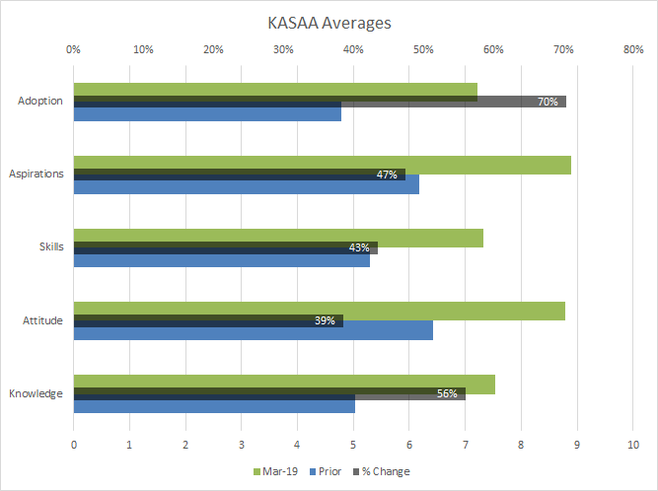
Fig. 20: Average across the objectives

Knowledge
Figure 21 shows participants’ increase in knowledge over the demonstration period. Of note is the large increase (96%) in the knowledge around establishing and managing permanent shelter belts such as TWG for lambing ewes.
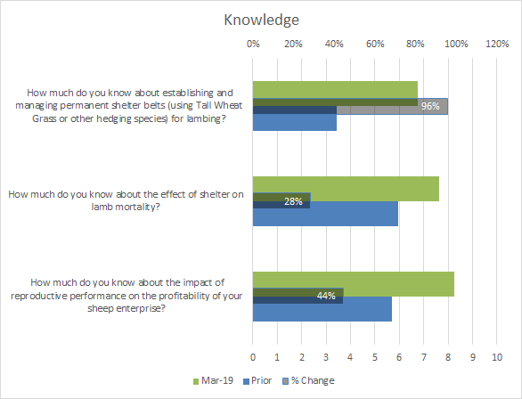
Fig. 21: Participants change in Knowledge

Attitude
Figure 22 shows the participants’ change in attitude. Of note here is the attitude towards establishing permanent hedgerows which increased by 53% during the demonstration.
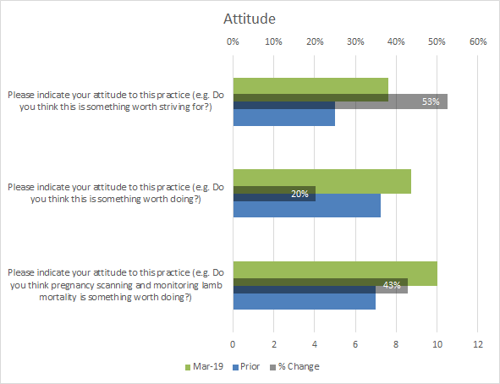
Fig. 22: Participants change in Attitude

Skills
Figure 23 shows the change in the participants’ skills during the demonstration while there was an increase in skills for all objectives, there was a significant change in skills for objective 1, establishing permanent hedgerows such as TWG (73%).
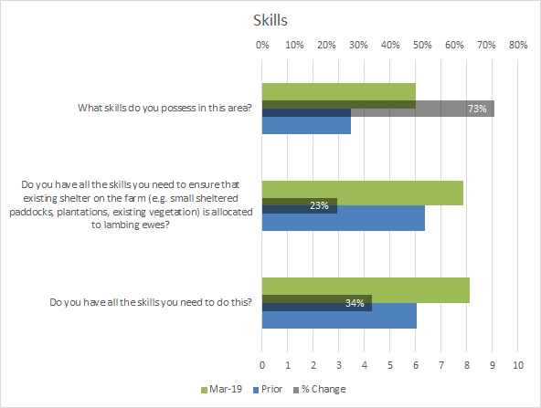
Fig. 23: Participants’ change in Skills

Aspirations
Figure 24 shows the participants’ change in aspirations over the period of the demonstration. Notable, is the participants’ change in motivation to incorporate permanent hedgerows as a component of their lambing management (69% increase).
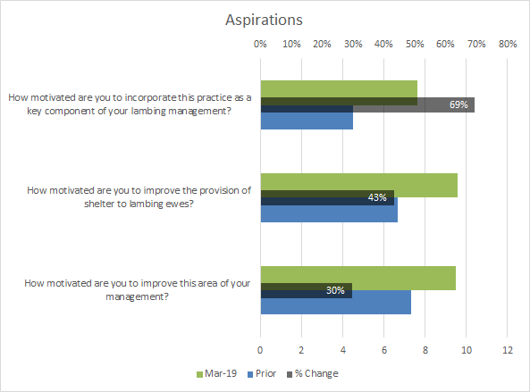
Fig. 24: Participants’ change in Aspirations

Adoption
Figure 25 shows the participants’ change in adoption during the period of the demonstration. Producers indicated adoption of parameter 1 (establishment of TWG or other permanent hedgerows), with an increase of 138%.

Fig. 25: Participants change in Adoption

Discussion

Chill Index and Lamb Survival

Tall wheat grass
Tall wheat grass establishment was not well demonstrated in this project owing to seasonal conditions and slug and RLEM damage. This occurred despite slug baiting at sowing and reflects a lack of monitoring and management. The project demonstrated that good, dense establishment is crucial to the performance of the shelter and that this is reliant on frequently checking newly sown areas and responding to problems encountered. Slug damage from second hatchings caused much of the losses and with many competing needs in farm they were missed by the farmer. Once established and with time to adequately develop, TWG is known to reduce in palatability and pests become less problematic once past the first 12 weeks.
It is likely that the required level of monitoring and management was overlooked as a consequence of TWG establishment having a lower priority than other more pressing farm jobs, such as pasture establishment. This can also occur on demonstrations when there may be different expectations of workloads.
TWG performance was effectively demonstrated using existing hedgerows and successfully reduced wind chill by 13 days (from 34 to 21 days) compared to the unsheltered control over lambing. The result was not as significant as EverGraze research, which managed a reduction in high chill index days to 3-4 days per month and an increased lamb survival of 30%. It is possible that the EverGraze sites had higher coverage of TWG. It is also likely that set up and monitoring on the research trial was more extensive than was possible on this demonstration.
The result can also be attributed to the already high birth weights of the twin lambs in those paddocks, given the significant amount of available feed on offer (in excess of 2000 kg/DM/ha) and importantly, the composite breed type. This is consistent with the recent research of Hocking Edwards et al. (2019) which indicates that better survival can be expected from crossbred twin-born lambs versus merino single-born lambs at the same birthweight. The EverGraze result of a 30% increase in lamb survival with TWG used merino ewes.
TWG requires careful management to ensure seed is harvested through spring and summer by grazing to prevent plant spread throughout pastures, it has been known to spread along waterways. Application of nitrogen is recommended to optimize growth given the absence of a legume. It is possible that these management factors as well as the requirements at establishment may limit producers’ interest in sowing TWG.

Dorycnium hirstum
Establishment of 2017 D. hirstum presented challenges throughout the demonstration. Sowing was postponed throughout 2015 and 2016 (11 times in total) owing to dry conditions followed by excessively wet conditions. Attempts to plant seedlings grown in the nursery also had limited success because of dry conditions, and grazing by sheep. The D. hirstum that established at one site was very slow to develop.
D. hirstum plants were not unpalatable as indicated by Tas Global Seeds and Tasmania Institute of Agriculture (TIA) during the design project and unfortunately two established sites were unfenced and grazed to the ground.
Earlier supporting research by Bell et al. (2006) identified major limitations of D. hirstum as a forage species being accumulation of woody stems and poor digestibility of edible components if left ungrazed. They suggest once biomass is established it may not be acceptable to livestock with dry matter digestibility of the shoot often < 55%, possibly due to high concentrations of condensed tannins.
All plants exposed to grazing were eaten to ground level by sheep, despite the availability of pasture. Once fully developed, D. hirstum may be unpalatable and dense enough to reduce time at high chill index. However, its slow establishment and lack of hardiness in young plants made it a poor shelter option in this demonstration anda key outcome is that it shouldn’t be recommended as an open sown shelter. It would need to be fenced as a plantation to have any hope of success.

Corrugated iron shelters
These shelters were relatively simple to establish (irrespective of seasonal conditions). However, the presence of corrugated iron shelters in the lambing paddocks did not correspond with an improvement in lamb survival. The shelters were poorly utilised by both ewes and at-risk lambs (within first 48 hours of life), though older lambs were commonly seen using shelters.
Up to 4 shelters were constructed in each paddock, which may not have been sufficient coverage to benefit lamb survival. It was hoped that lambing ewes would seek the shelters, however this was not the case and it is likely that considerably more time and resources (corrugated iron sheets, star pickets) would be required to establish adequate shelter making this option unattractive. The shelters maintained their condition throughout lambing period, and some producers left them in situ between lambing’s, however most removed them to make it easier for pasture management.
To provide benefit, there would need to be sufficient shelters across the paddock to ensure that wherever the ewes were grazing, her lambs would be within protective distance of a shelter. The principle for TWG to be effective is to establish hedge rows every 20 m across the paddock. This is not practical for corrugated iron shelters and given they obstruct vision and sound there is increased risk of mis-mothering as lambs and mothers become separated.

Hay bales
Similar to corrugated iron shelters, the hay bale shelters were relatively simple to establish, again only a small number (3 or 4) were constructed in each shelter paddock. Generally, the shelters maintained condition throughout lambing period, particularly where old, lower quality bales were used, however newer good quality bales were consumed and damaged by sheep.
Equivalent to the corrugated iron shelters, poor utilisation by both ewes and at-risk lambs (within first 48 hours of life) was observed at the hay bale sites, so the overall 5% improvement across the four years of the demonstration is a surprising result. The hay bale shelters were effective in reducing the amount of time at high risk for neonatal lamb survival, however the number of shelters (i.e. their coverage across the paddock) and their resulting utilisation does not clearly explain the increase in survival.
As with corrugated iron shelters, there would need to be sufficient hay bale shelters across the paddock to ensure benefits in lamb survival such that wherever the ewes were grazing, her lambs would be within protective distance of a shelter; again big numbers of bales are required.

Eucalypt plantation
While not originally intended for demonstration in this project, the improvements in lamb survival seen at the 2018 Gatum 1 site highlights the potential to utilise established tree lines and plantations to reduce wind chill and improve lamb marking rate.
The reduction in time at high chill index across the eucalypt plantation demonstration sites was partly driven by the density of understorey across the paddock slowing the wind at ground (lamb) level. In 2017, the plantation had a minimal amount of pasture or small shrubs compared with 2018, which is reflected in the difference in percentage time at high chill (26% in 2017 and 10% in 2018). The reduction in high chill index time occurred when there was a large amount of perennial grass (mainly phalaris) in the plantation. The phalaris gave a tall (70cm), dense pasture wind break at the appropriate height for detection by the anemometer and for protection of the neonatal lamb.
The reduction in time at high wind chill was similar to what was observed in the TWG sites (Figure 13), however the improvements in lamb survival were higher from eucalypt plantation shelter than TWG shelter. It is likely that breed played a part in this result, given composites were used at the TWG site and merinos were used at the plantation site.
The outcomes suggest that ewes whose offspring are particularly at risk of high chill (e.g. twin-bearing ewes and merinos) will benefit from eucalypt plantations (as they would from TWG) that have a dense understorey that will slow the wind speed and protect the lamb.

Using shelter to improve lamb survival
The effect of shelters were measured at all sites through reduced time at high chill index, however improvements in lamb survival were dependent on the type of shelter, its utilisation by ewes with lambs less than 48 hours old, and its coverage over the paddock. Utilising already-existing forms of shelter on farm, such as eucalypt plantations with good understorey, presents a good opportunity to improve lamb survival at minimal cost to the producer however it takes longer to establish than TWG if the TWG established effectively.

Producer feedback
Throughout the demonstration it was clear that producer sentiment toward the benefits of shelter for lamb survival improved. The establishment of shelter in specific lambing paddocks rather than across the entire farm, was considered more achievable, animal considerations were becoming more prominent and the high the price of lamb made the strategy economical.

Challenges in managing shelters
Some producers had (and still have) concerns about the potential integration of hedgerows and constructed shelters into the farming system, particularly TWG, and indicated they prefer more common alternatives such as phalaris or trees. Producers expressed concerns about managing hedgerows after establishment to prevent spread and preserve the quality of the pasture base. Producers who hosted constructed shelter sites (hay bales and corrugated iron shelters) commented that the shelters were inconvenient to work around when managing pastures (e.g. spreading fertiliser, spraying) and one producer felt they looked “untidy”. While this could be addressed by having the shelters in place during the lambing period only, and then removing them, it significantly increases the labour associated – ideally, shelters are more convenient if they are “set and forget”.

Commitment to later years of the demonstration
In Year 3 we began to see a decline in producer commitment to carrying out the ongoing requirements of the demonstration, which seemed to be driven by a belief that the demonstration had already achieved its outcomes. Some producers, having seen the data from the first two years of the demonstration, were not willing to host some types of shelter on their properties. This was particularly the case with the iron and straw bale shelters as they felt such shelters were not effective. For example, it was perceived that if ewes are not feeling the cold and not seeking protection from corrugated iron shelters, there would be limited benefit to the neonatal lambs, as they do not routinely stray from the ewe to seek shelter. Anecdotal evidence from the producers involved in the first two years of the demonstration suggested that it was more commonly older lambs accessing the shelter as a nursery, to socialise with other lambs of similar age. These older lambs were considerably less at risk from exposure, in comparison to the young neonates (<48 hours old). Producers expressed concerns that the shelters may actually be counter-productive by causing lamb loss (lambs playing in or nibbling away at straw bale shelters, and being crushed when the bales collapse on top of them; young lambs sleeping close to the shelters while their mothers graze nearby, waking up once mother has moved on (often to the other side of the shelter, out of view) and not being able to mother-up within a suitable timeframe. Those that were willing to host such types of shelter did so mostly due to feeling under obligation by the demonstration.

Economic analysis
Economic analysis of the TWG hedgerows as a shelter option indicated investment was worthwhile to increase lamb survival, however the result proved less profitable than was achieved by EverGraze researchers (EverGraze 2012). Nevertheless, a 1.8% increase in lamb survival (measured as lambs marked/ foetuses scanned) from a mob of twin bearing ewes (or 3.6% increase per ewes pregnant) can lead to substantial financial benefit, particularly with high lamb prices.

Challenges in the demonstration

Establishment of TWG and Dorycnium hirstum hedgerows
The project encountered a number of challenges, particularly around establishment activities for TWG and D. hirstum hedgerows, due to the lack of rainfall and unfavourable sowing conditions. To give the plants the best start it was decided that the D. hirstum would be grown out to seedlings in tubes prior to being planted as hedgerows, this was additional to the budget/plan. The delay in establishing these hedges meant that data was not available until lambing 2017.

Damage to logging equipment by lambs
Lambs chewed cables between the wind meter and the data logger at two sites causing some wind data at the end of the lambing period to be lost. This was addressed by ensuring the leads were out of reach from the lambs (pasture cages were used from the start) using pasture cages and despite this effort some smaller lambs were still able to squeeze their heads in between the bars of the cage and nibble the cords. Pasture cages were covered in chicken wire to minimise lamb accessibility.

Producer commitment
Commitment to establishing TWG and D. hirstum may have diminished after several delays in establishment caused by unsuitable seasonal conditions. When conditions were finally appropriate to sowing hedgerows, a lack of monitoring led to damage by RLEM and slugs at some sites especially for the TWG. This may also have been caused by confusion about responsibilities or higher priority jobs on-farm. Furthermore, as explained above, producer commitment to the demonstration began to wane in the later years.
There is no easy answer when it comes to running demonstrations as producers will always encounter work demands that take precedent over external projects. However, their involvement as hosts indicates a degree of commitment. Demonstrations are designed not only to collect information about a topic, but to allow producers to see it first hand and learn from the experience and that was achieved.
The project team has learnt from their experiences in this demonstration and would make changes, such as more frequent checking in with producer hosts and provisions of paddock diaries if undertaking a similar project in the future.

Extending the results to others

Participating BWBL group members
The results and outcomes of this demonstration were presented to group members of the participating Casterton, Cavendish and Avoca BWBL groups through a range of extension activities (meetings, field days, webinars) as detailed in section 4.3.1. The group members were also supplied with a demonstration summary at the conclusion of the project.

The groups have seen the problems associated with the establishment of TWG and failure of the D. hirstum to survive in a pasture situation, along with the animals not using the man-made shelters at critical times (<48 hours post lambing) and haven't progressed with them.

Other BWBL group members
Other BWBL groups in the South West Victoria region expressed interest in seeing sites and results throughout the demonstration project, attended the field days and results meetings held in addition to the participating group members. The South West Prime Lamb BWBL Group attended the 2018 Gatum 1 field day as one of their planned group meetings.

Broader industry and the general public
On July 5, 2016 Andrew Speirs was interviewed by ABC Rural about the demonstration at the Wando Bridge site. The interview and accompanying article conveyed the purpose and importance of the EPDS, the options for providing shelter and the challenges associated with encouraging ewes to utilise the shelter during lambing. Meridian Agriculture, Meat and Livestock Australia, and the Agriculture Victoria Best Wool Best Lamb program were acknowledged as joint project partners. The material can be viewed at http://www.abc.net.au/news/2016-07-05/trial-studies-wind-shelters-for-newborn-lambs/7566158. After the radio interview and media published on ABC Rural, Andrew received several phone calls as to how farmers could establish shelter and the discussion around wind chill and the fact something can be done about lamb losses, it doesn’t need to be accepted.
Information displays on the project, including displaying anemometers, physical demonstrations of the three types of shelter, lamb survival and hedgerow research conducted at the Agriculture Victoria Hamilton Research Centre and some initial first year findings were on display in the Agriculture Victoria site and the Meridian stand at Sheepvention in Hamilton, 1st and 2nd August 2016. These displays were a strong discussion point with many sheep producers.

Change in KASAA
The KASAA evaluation considered three parameters with each measured prior to and at the conclusion of the demonstration.
- Establishment and use of permanent hedgerows using TWG or other suitable species (e.g. leguminous shrubs).
- Allocation of existing shelter (E.g. small sheltered paddocks, plantations, existing vegetation) to lambing ewes as a key component of lambing management
- Measuring and monitoring reproductive performance (e.g. pregnancy scanning, monitoring lamb mortality).
The findings of the KASAA evaluation are described below under each of their measures.

Knowledge
Comments from producers indicate that the group has learnt the importance of shelter at lambing and is having a positive impact on their farming business. Their knowledge about the effect of shelter and paddock selection on lamb mortality and the impact of reproductive performance on profitability also increased markedly.

Attitude
Participants indicate that they are highly positive in their attitude towards pregnancy scanning and the monitoring of lamb mortality and believe that the recording of this data is worth their while (43%). Comments made indicated that this data would help them to offer adequate feed to ewes, that this practice was ‘crucial’ to their farm business, that they can use the data to become more profitable by getting better twin survivability and in turn increasing animal welfare. The attitude to allocating paddocks with shelter available increased throughout the demonstration period overall showing a 20% change in attitude. The average change in attitude during the period was 39%.

Skills
Participants gained valuable skills in the establishment of permanent hedgerows for their lambing ewes with a 73% change in their confidence to be able to access pregnancy scanning and monitor lamb mortality. There was also growth in the skills for measuring the reproductive performance of ewes (34%) and a 23% increase in skills needed to ensure that they used their existing shelter more effectively for lambing ewes. The average change in skills throughout the project period was 43%. A shift in confidence was observed from an average of 5.3 to 7.3 (out of 10) with numerous participants gauging their skills after the demonstration at 10 for measuring reproductive performance.

Aspirations
The motivation to improve the provision of existing shelter to lambing ewes increased by 43%. The motivation to establish and use hedgerows of TWG or other suitable species increased by 69% with participants indicating that they were trialling other species such as phalaris to act as shelter for lambing. There was only a small change in motivation to include pregnancy scanning and the monitoring of lamb mortality into their lambing management (30%) as it is an established practice in a majority of the farms. The average increase in aspirations during the demonstration was 47%.

Adoption
The adoption of the establishment of permanent hedgerows showed a large percentage change (138%) and while the percentage change is high, the confidence to adopt is still low <5 (range 1-10). The percentage change in adoption of measuring reproductive performance was 49% over the demonstration with the biggest adoption happening in the first part of the study 2015-17, this trend is shown across all graphs. Participants indicate that the splitting of twins, multiples has allowed them to appropriately allocate shelter to lambing ewes. The average change in adoption for the demonstration was 70% but this is skewed by the large percentage change in the establishment of hedgerows. Comments made by producers include; they can see and understand the benefit of establishing permanent hedgerows. Some indicated they had adopted these practices in some manner using species such as Phalaris, others indicate that it could be impractical for their farming business, mostly due to cost. Comments indicate that people have adopted changes in allocating lambing paddocks such as using small mob sizes, smaller paddocks, more feed availability and the allocation of the most sheltered paddocks to twin bearing ewes.

Achievement of project objectives

To demonstrate integration, establishment and management of a range of hedgerows and intra-paddock shelter options in a whole farm system to increase lambing percentages compared to paddocks without shelter.
Two different hedgerow species (TWG and D. hirstum) and four different types of intra paddock structures (Y-, T- and L-shaped corrugated iron shelters as well as hay bale shelters) were established as shelter options that could be utilised in lambing paddocks. These paddocks containing the various shelter options, as well as an existing eucalypt plantation, were evaluated for chill index and lamb survival, in comparison to unsheltered paddocks. Chill index and lamb survival data for the sheltered and unsheltered paddocks in this demonstration is contained in the results section of this report.

Ascertain which hedgerow species performs best in terms of establishment, persistence over the demonstration period, and providing the most effective shelter.
Establishment and persistence of each shelter type, as well as chill index and lamb survival data for the sheltered and unsheltered paddocks was ascertained and results are contained in the results section of this report. With careful establishment and management, TWG, along with eucalypt plantations perform best out of the options considered in this report.

Conduct a cost benefit for each shelter type to demonstrate the value of shelter in increased lamb survival.
Given the challenges of establishing the D. hirstum hedgerows, and the integration, utilisation and impact of the hay bale and corrugated iron shelters on lamb survival, the TWG was deemed to have the best adoption potential, and economic analysis was focused accordingly. The outcomes of this analysis are highlighted in the results section of this report. Adoption is recommended based on a positive net present value and internal rate of return.

Through on farm trials and annual field days demonstrate the value of shelter to BWBL members and the wider farming community.
The four years of this project included sites suitable for shelter performance analysis on six farms, and annual results meetings or field days with groups. In addition, key outcomes of the demonstration were circulated to the wider farming community through presence at regional field days (SheepVention), radio interviews and media articles, social media and web conferencing technology.

Develop technical notes on the establishment and management of inter-paddock shelter.
A factsheet was developed about the demonstration and project findings. The factsheet was distributed to participating BWBL groups and will appear on the Agriculture Victoria website. A copy of the factsheet is provided in the appendix.

Conclusions/recommendations
Demonstrating the establishment of hedgerow shelters was extremely challenging given the difficult seasonal conditions of the first two years of the project. Nevertheless, five different types of shelter were demonstrated and their use in the farming system was assessed by producers. One producer explained “This has been a worthwhile project resulting in some good information, I think it still has further to go”.

Despite challenges encountered, the demonstration was successful in increasing knowledge and awareness of the benefits of shelter. Importantly, the project also raised awareness of appropriate paddock allocation at lambing, which may be an opportunity for further activity with the participating BWBL groups.

Implications to the Red Meat Industry
Throughout the demonstration it became apparent that producers have their own biases towards shelter types and ideas of what works for them. One producer decided to stick with corrugated iron shelters suggesting it worked for them, whilst others suggested they would definitely not continue with corrugated iron shelters. Others had preconceptions around TWG and preferred to use phalaris.
The discussion around providing shelter (regardless of what type) is important for increasing lamb survival and managing animal welfare issues. High lamb prices and placing a value on increased lamb welfare) is also helpful.

Tall wheat grass
Tall wheat grass hedgerows are effective when sown in 1m-wide rows, planted at 10 –20m spacing’s across a paddock at right angles to the main prevailing wind. Stock actively utilise the TWG hedgerows which is valuable, however, the establishment can be difficult and monitoring is required to prevent slug and RLEM damage. TWG also requires management throughout its life, by strategic grazing to remove seed heads and prevent its spread. Despite proven benefits as a shelter option for lambing ewes, some producers were concerned about management requirements to prevent its spread.

Dorycnium hirstum
The project demonstrated that D. hirstum, a perennial leguminous shrub, was not suitable as an in-paddock shelter due to two main factors:

- It is a slow growing shrub reducing its ability to provide shelter within the first two years.
- It is more palatable to stock than described by the TIA, particularly when young, as stock actively grazed the shrub and were not deterred by the high tannin content.

Therefore, in this environment, consideration to plant alternative less palatable species is recommended.

Corrugated Iron and Hay Bale Shelters
The corrugated iron shelters and hay bales were effective in reducing the chill index however it was not practical to provide enough shelters across the paddock to ensure all lambs in the critical 48-hour period post-birth are sufficiently protected. There were also concerns from producers that these shelters may increase mismothering as ewes may struggle to find a sheltering lamb, especially if high number of shelters were provided.

Eucalypt plantations
The eucalypt plantation was effective in reducing the chill index and improved lamb survival, in comparison to the unsheltered paddock. Plantations generally offer shelter only along paddock boundaries, so smaller paddocks surrounded by plantations are likely to achieve lower chill index and higher lamb survival. Many producers in south west Victoria have established eucalypt plantations on their properties, so identifying well sheltered paddocks for lambing is achievable. Anecdotally, some producers are seeing the benefits of lambing within plantation blocks, however feed on offer needs to be considered.

Achieving full value from the project findings
To achieve full value from the data obtained from this project it is recommended that the project summary factsheet is made available to producers with an interest in improving shelter, weaning percentages or animal welfare outcomes.

Bibliography
Agriculture Victoria (2004) Sheep shelter guidelines, http://agriculture.vic.gov.au/agriculture/livestock/sheep/handling-and-management/sheep-shelter-guidelines (verified 11 April 2019).
Alexander G (1962) Temperature regulation in the newborn lamb IV. The effect of wind and evaporation of water from the coat on metabolic rate and temperature, Australian Journal of Agricultural Research 13, 82-99.
Bell L., Ryan M. Ewing M. (2006) Hairy canary clover: a case study for integrating semi-herbaceous forage plants into agricultural systems. In N. C. Turner, T. Acuna, & R. C. Johnson (Eds.), Ground breaking stuff: Proceedings of the 13th Australian Agronomy Conference (Perth, Western Australia ed., Vol. n/a, pp. 4 pp). Perth, Western Australia: Regional Institute Ltd.

Broster JC, Robertson SM, Dehaan RL, King BJ, Friend MA (2012) Evaluating seasonal risk and the potential for widespread reductions to reduce chill index at six locations using GrassGro, Animal Production Science 52, 921-928.
Donnelly J (1984) The productivity of breeding ewes grazing on lucerne or grass and clover pastures on the tablelands of Southern Australia. III Lamb mortality and weaning percentage. Australian Journal of Agricultural Research 35, 709-721.
Hocking Edwards JE, Winslow E, Behrendt R, Gordon DJ, Kearney GA and Thompson AN (2018) Crossbred ewes gain more weight and are fatter than Merino ewes when managed together but similar coefficients predict lamb birthweight and survival. Animal Production Science 59, 767-777.
King B, Friend M, Behrendt R, Morant A (2012) Improving survival of lambs. EverGraze Exchange. https://www.evergraze.com.au/wp-content/uploads/2013/06/Evergraze-Exchange-Improving-survial-of-lambs-3.pdf. (verified 11 April 2019)
Lane P, Davies S, Hall E, Moore G (2004) D. hirstum species as alternative forage plants, Rural Industries Research and Development Corporation, Barton, ACT.
McCaskill M, Saul G (2008) Perennial grass hedgerows provide shelter at lambing. EverGraze Actions. https://www.evergraze.com.au/wp-content/uploads/2013/06/EverGraze-Action-hedges-A4.pdf. (verified 11 April 2019)
Morant A, Robertson S, McCaskill M, Behrendt R, King B, Broster J, Friend M, Sargeant K (2013) EverGraze Website https://www.evergraze.com.au/library-content/hamilton-key-message-shelter-improves-lamb-survival/#. (verified 11 April 2019)
Nichols P, Revell C, Humphries A, Howie J, Hall E, Sandral G, Ghamkhar K, Harris C (2012) Temperate pasture legumes in Australia - their history, current use, and future prospects, Crop & Pasture Science 63, 691-725.
Pollard JC, Littlejohn RP (1999) Shelter for lambing in southern New Zealand. II. Sheltering behaviour and effects on productivity, New Zealand Journal of Agricultural Research 42, 171-177.

Appendix

Appendix A: Economic analysis of Tall Wheat Grass (TWG) shelter compared to no shelter
Year |  | 1 | 2 | 3 | 4 | 5 | 6 | 7 | 8 | 9 | 10
Additional benefits
Increase in lamb survival (number of lambs) |  | 0.0 | 9.6 | 9.6 | 9.6 | 9.6 | 9.6 | 9.6 | 9.6 | 9.6 | 9.6
Value of increase in lamb survival |  | $0 | $1,215 | $1,215 | $1,215 | $1,215 | $1,215 | $1,215 | $1,215 | $1,215 | $1,215
Additional costs
Annual cost of urea |  | $0 | $155 | $155 | $155 | $155 | $155 | $155 | $155 | $155 | $155
Pasture Establishment Costs | -$1,541
Salvage value |  |  |  |  |  |  |  |  |  |  | $514
Net cash flow (for DCF) | -$1,541 | $0 | $1,060 | $1,060 | $1,060 | $1,060 | $1,060 | $1,060 | $1,060 | $1,060 | $1,574
Discount rate | 7%
NPV | $5,174 |  | $140 | /ha | $13 | /DSE
IRR | 46%

Appendix B: Knowledge, Attitudes, Skills, Aspirations and Adoption (KASAA) Survey Questions
Objective 1: Measuring and monitoring reproductive performance (e.g. pregnancy scanning, monitoring lamb mortality)
- How much do you know about the impact of reproductive performance on the profitability of your sheep enterprise?
- Please indicate your attitude to this practice (e.g. Do you think pregnancy scanning and monitoring lamb mortality is something worth doing?)
- Do you have all the skills you need to do this?
- How motivated are you to improve this area of your management?
- To what extent are you putting this into practice already?
Objective 2: Allocation of existing shelter (e.g. small sheltered paddocks, plantations, existing vegetation) to lambing ewes as a key component of lambing management
- How much do you know about the effect of shelter on lamb mortality?
- Please indicate your attitude to this practice (e.g. Do you think this is something worth doing?) Do you have all the skills you need to ensure that existing shelter on the farm (e.g. small sheltered paddocks, plantations, existing vegetation) is allocated to lambing ewes?
- How motivated are you to improve the provision of shelter to lambing ewes?
- To what extent are you ensuring that lambing ewes are given all the shelter they need?
Objective 3: Establishment and use of permanent hedgerows using tall wheat grass or other suitable species (e.g. Leguminous shrubs)
- How much do you know about establishing and managing permanent shelter belts (using tall wheat grass or other hedging species) for lambing?
- Please indicate your attitude to this practice (e.g. Do you think this is something worth striving for?)
- What skills do you possess in this area?
- How motivated are you to incorporate this practice as a key component of your lambing management?
- To what extent are you putting this into practice already?

Appendix C: General qualitative evaluation questions and responses
What specific benefits can you see for your sheep enterprise arising from monitoring pregnancy status after joining and lamb mortality?
‘Definitely improved feeding determined by singles, multiples and remove dry’
‘Huge bearing on productivity of enterprise. Scan all ewes for twins, singles and dry. Manage twins in better paddocks & smaller mobs for good %.’
‘Scan all ewes but not monitoring deaths. Manage them better (Feed allocation) so in better condition for lambing, better growth rates in lambs’
‘Know what the losses are to work towards greater survivability.’
‘Scanning for many years - by separation of multiples (= increased survival). Monitoring lamb mortality this year to understand reason for lamb losses to improve management & increase productivity.’
‘No longer scanning as son scans all his ewes & they don't get different lambing %. Feed all ewes as though carrying twins. Tries to minimise stock handling, concerned that extra handling causes stress (=abortion). When he has scanned, has only had about 3% dry.’
‘Allocation of feed. This year concerned with over-feeding & problems with large lambs at lambing. Wind breaks to provide shelter for lambing ewes to reduce deaths & increase % rates.’
‘Wet/Dried ewes for 35 years. Increased profitability dramatically by removing dry ewes.’
‘Hopefully get increased lambing % (= increased profitability), however weather can affect this detrimentally regardless of shelter.’
‘Better twin survival.’

‘Whilst the benefits are there, Geoff has gone from doing little to everything & now less again. Can't see sufficient benefit for the input required. Wants 20% benefit for 80% return. Feeds all ewes as multiples, less work, no small mobs. Only scans once for ewe's life and finds that if he removes dry ewes at 18 months, they then produce lambs for life.’
‘Less trouble lambing. Better allocation of feed to singles, twins, etc.’
‘Allocating feed better. Hopefully higher lambing %, increased profitability, more lambs/less ewes.’
‘Nutritional benefits for healthy lambs on ground during first 48 hours. Feed more to multiples, less to singles.’
‘Sees more benefit in wet/dry. Nutrition needs determined for ewes based on single/twin, etc.’
‘Multiple births looked after better.’
‘% lambs increase. Absolutely crucial to monitor.’
‘Better profit, less deaths’
‘Healthier ewes, more lambs on the ground & better profits’
‘1. Profitability; 2. Improved welfare; 3. Better market access - believes buyers will give priority to farmers implementing higher welfare to animals.’
‘moved survival over 10 years 65-85%’
‘Ewe health and higher marking %’
‘greater ewe survival better feed allocation resulting a better animal welfare outcomes’
What specific benefits can you see for your sheep enterprise arising from allocating shelter to lambing ewes?
‘Increased lambs at marking, increased survival’
‘Huge bearing on survival of lambs in mobs, especially twins, and better growth rates.’
‘Better survival rate. Less ewe mortality.’
‘From mid-north SA previously (diff. environment, shelter not available). Has learnt the importance since moving to Victoria and joining BWBL. Has monitored and knows that lamb survival rates increase when they have shelter, particularly in multiple bearing ewes.’
‘Higher lamb numbers at weaning.’
‘Allocates mobs to paddocks based on amount of feed and condition of ewes - not on a shelter basis.’
‘Percentage rates better in paddocks with good shelter for lambing ewes.’
‘More lambs / more profit. Better options - cull heavier to improve flock.’
‘Splitting up multiples / twins / singles, with purchase of land with existing shelter. Has been better able to allocate and utilise for added benefit that shelter gives to lambing ewes.’
‘Higher lambing %, greater profit margin.’
‘Give the ewes with the most need the available shelter. Increase survivability x99%.’
‘Less mortality - higher lambing %. Less stress on ewes and good husbandry practice.’
‘Higher survival in multiples in cold weather.’
‘Higher % of lambs. More lambs - less ewes and better quality.’
‘Greater growth rates, allowing turn off in shorter time.’
‘Higher lamb survival.’
‘Mortality rates down.’
‘Lamb survival increases.’
‘At what cost?’
‘Profit up and deaths down - same as other.’
‘Better lambing % (lamb survival)’
‘Profitability largely, and also welfare & markets.’
‘20% increase in twins’
‘improving twin survival’
What specific benefits can you see for your sheep enterprise arising establishing and using permanent hedgerows for shelter?
‘Increased survival rates’
‘Increased survival rates’
‘Not convinced it would work. If it did, it would be beneficial.’
‘Have attempted to grow, but failure in germination. Aim to is provide to all twin lambing ewes for greater lamb survival, lower energy requirements and there for increased productivity.’
‘Establishment is a problem as well as keeping kangaroos from eating anything that does persist.’
‘Can see advantage but considers impractical for his farming operation. Believes it would be more suited to small hobby farms.’
‘Can see benefits but not prepared to do it. His paddocks already have phalaris offering shelter.’
‘Phalaris trials of hedgerows in one paddock. Have planted tree plantations in other paddocks - effective in reducing deaths.’
‘Yes benefits, but practicality of establishing outweigh. Other ways - utilise what is available, i.e. crops. Shut up paddocks to increase grass length for shelter.’
‘Currently undertaking trials in 3 paddocks & will assess viability at end of trials.’
‘More lambs = more profits and selection pressure’
‘Get better lamb survival rates. Wind protection for ewes post shearing.’
‘Improved survival of lambs. Will be implemented further with paddock improvements.’
‘Participated in Currie trial & sees the benefits for higher %'s. Issue with foxes, however. He does not intend putting into practice, believes issue with TWG being a noxious weed.’
‘Increased lamb %. Seed spread throughout pastures is of major concern and limits their use. Rated self at 10 for establishing hedgerows & 5 for managing (sheep eat them).’
‘Increased lambing etc - same. Better species and management practices to utilise on farm. However, it needs to fit in with other management practises i.e. Stock rotations, pasture availability and quality.’
‘Higher % survival rate at birth & ability to turn off quicker.’
‘Better lamb survival - increased profitability.’
‘None, utilising shelter already there.’
‘Need to see data before trialling, not yet convinced beneficial.’
‘at what cost?’
‘Corrugated iron shelters successful on his farm. Less chill factor. Would be most benefit but can be achieved by other methods.’
‘Better lambing % (lamb survival)’
‘Currently trialling phalaris growing rank - high cry standing grass. Has concerns with planting what he considers to be a noxious weed for hedging.’
‘At what cost consider No. of sheep big job. >5000 twin bearing ewes need to consider property characteristics very open’
‘Not sure, but possibly has potential.’
‘seasonal conditions haven't really allowed establishment. After first failure’
What changes have you made as a result of this demonstration? (e.g. to your farm layout, lambing paddock selection, ewe/lamb management)? If none do you intend to make any changes? (please list)
‘Trying to grow more permanent shelter belts but this will take time.’
‘Modified paddock sizes (reduced) to make use of existing shelter’
‘Prioritising twin bearing mobs, establishing permanent pasture varieties in creek lines as shelters, constructing temporary shelters that can be removed when not required’
‘Small mobs, small paddocks and better feed’
‘making sure there is more grass (taller) in paddocks where twin bearing ewes will lamb’
‘Small mobs, small paddocks and better feed’
‘smaller mobs and best shelter to twins’
Any other comments you would like to make about the demonstration?
‘The theory is great but can be difficult to manage.’
‘This has been a worthwhile project resulting in some good information, I think it still has further to go through. I'm not convinced that the haybales and tin structures are the best methods for lamb shelters, I found more dead lambs around these structures than in other areas.’

Appendix D: Chill index line graphs and percentage time histograms

Year 1 (2015)
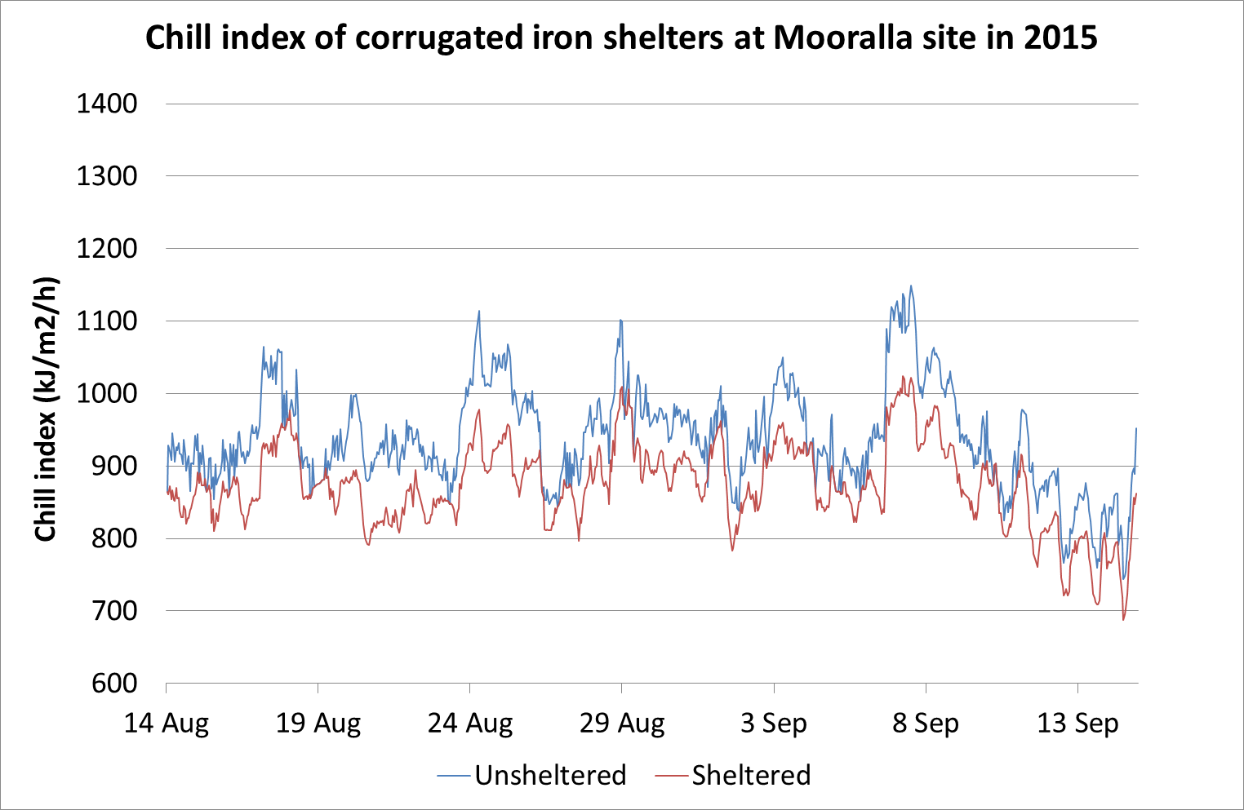
Fig. D1: Line graph of chill index (kJ/m2/h) measured adjacent to corrugated iron shelters (sheltered red line) and in the open (unsheltered blue line) at the Mooralla site in 2015.
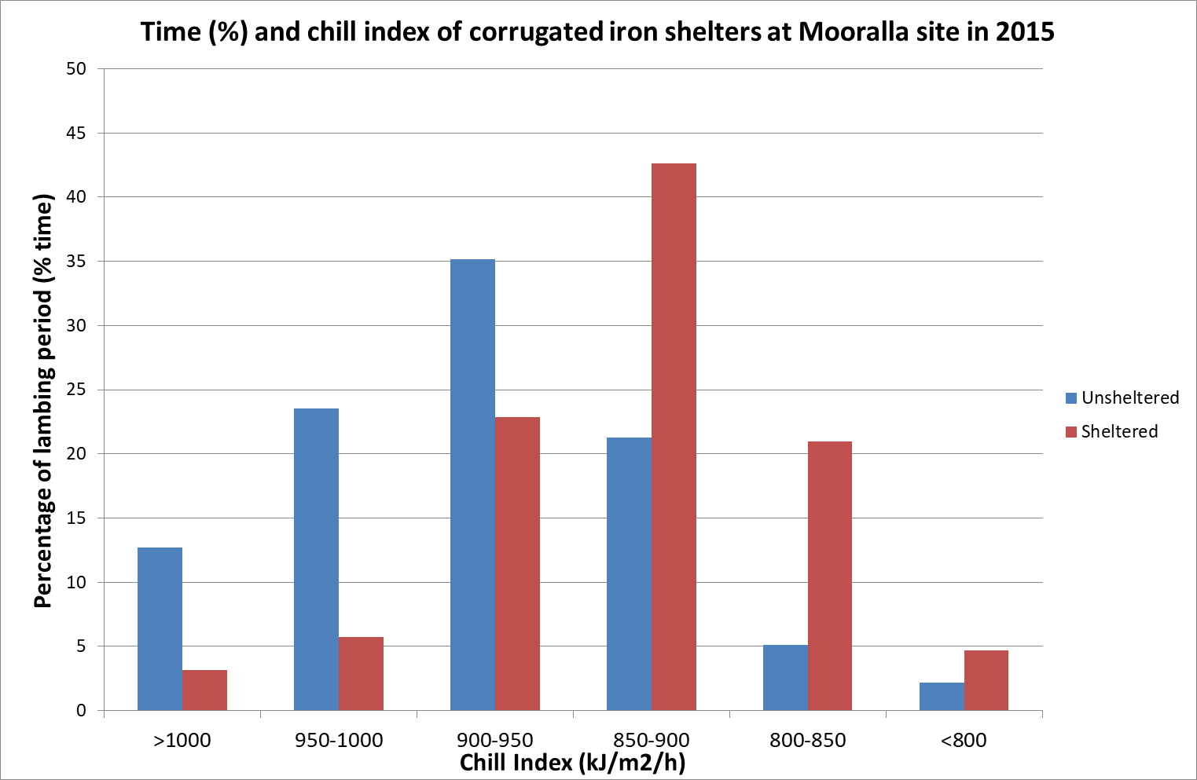
Fig. D2: Histogram of the percentage of time during the lambing period where chill index (kJ/m2/h) was within a given range adjacent to the corrugated iron shelters (sheltered red columns) and in the open (unsheltered blue columns) at the Mooralla site in 2015.
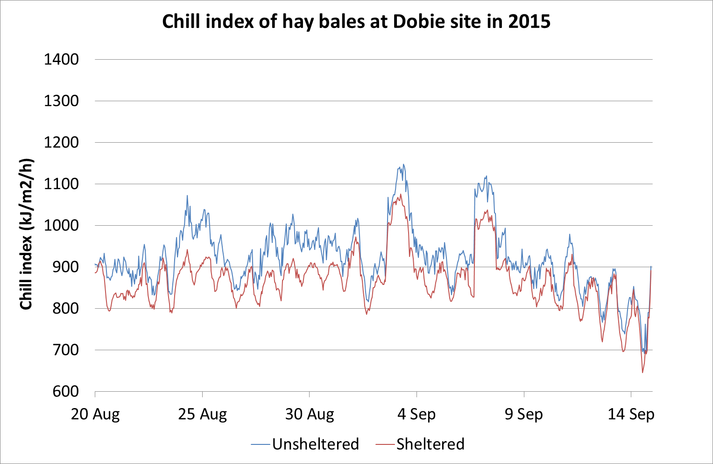
Fig. D3: Line graph of chill index (kJ/m2/h) measured adjacent to hay bales (sheltered red line) and in the open (unsheltered blue line) at the Dobie site in 2015.

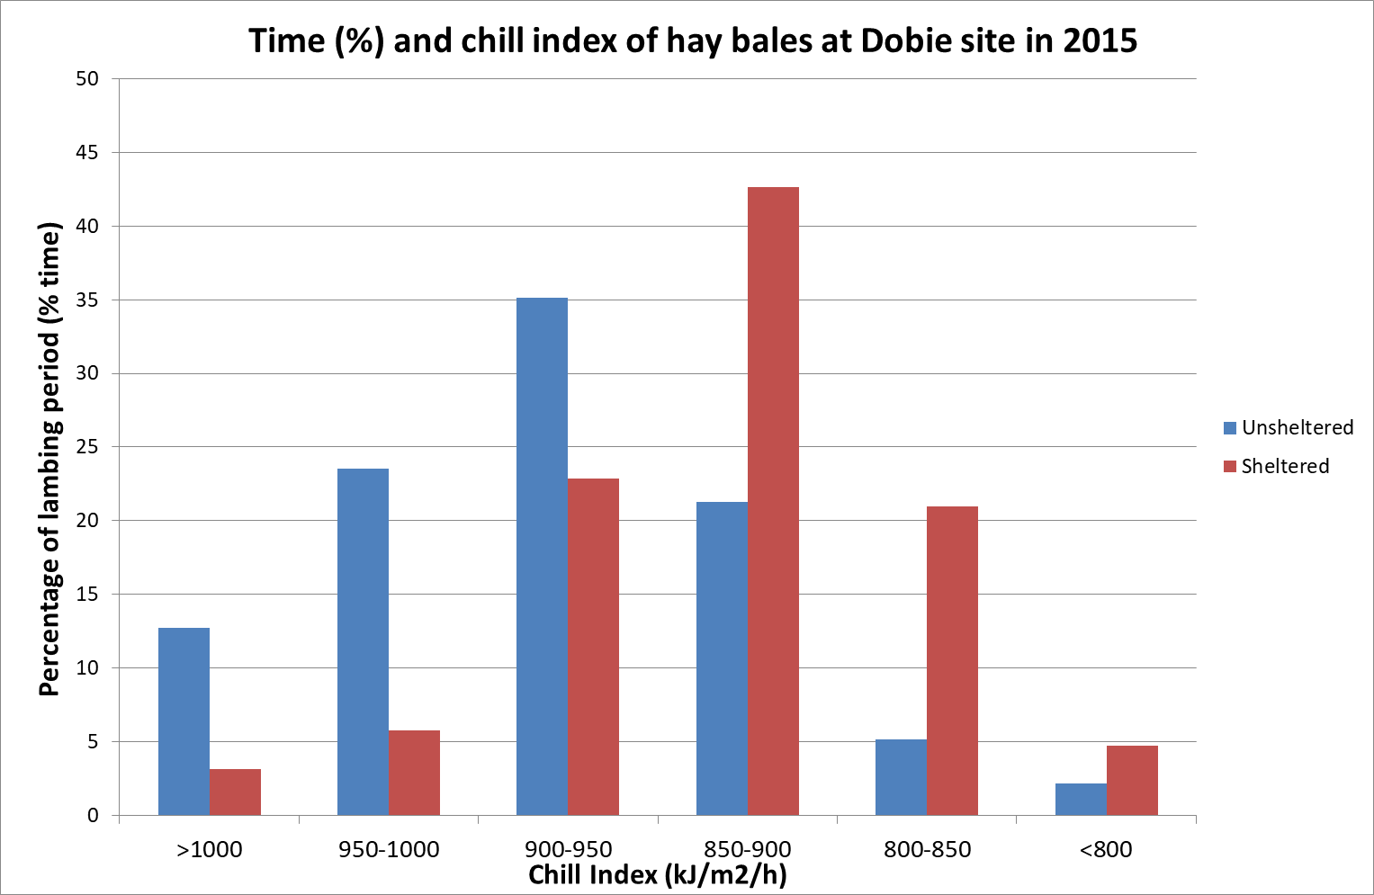
Fig. D4: Histogram of the percentage of time during the lambing period where chill index (kJ/m2/h) was within a given range adjacent to the hay bales (sheltered red columns) and in the open (unsheltered blue columns) at the Dobie site in 2015.
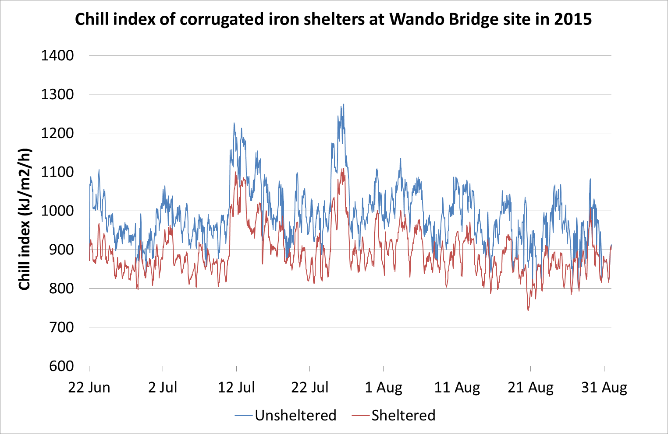
Fig. D5: Line graph of chill index (kJ/m2/h) measured adjacent to corrugated iron shelters (sheltered red line) and in the open (unsheltered blue line) at the Wando Bridge site in 2015.
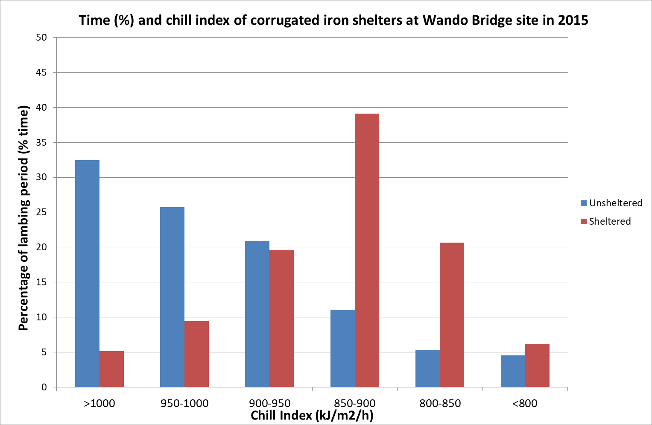
Fig. D6: Histogram of the percentage of time during the lambing period where chill index (kJ/m2/h) was within a given range adjacent to the corrugated iron shelters (sheltered red columns) and in the open (unsheltered blue columns) at the Wando Bridge site in 2015.

Year 2 (2016)
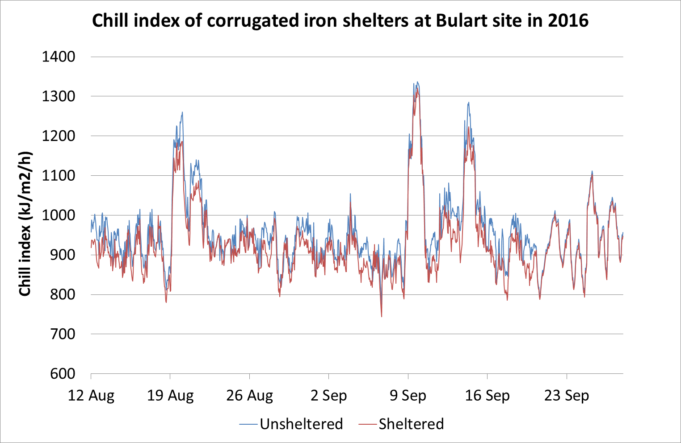
Fig. D7: Line graph of chill index (kJ/m2/h) measured adjacent to corrugated iron shelters (sheltered red line) and in the open (unsheltered blue line) at the Bulart site in 2016.
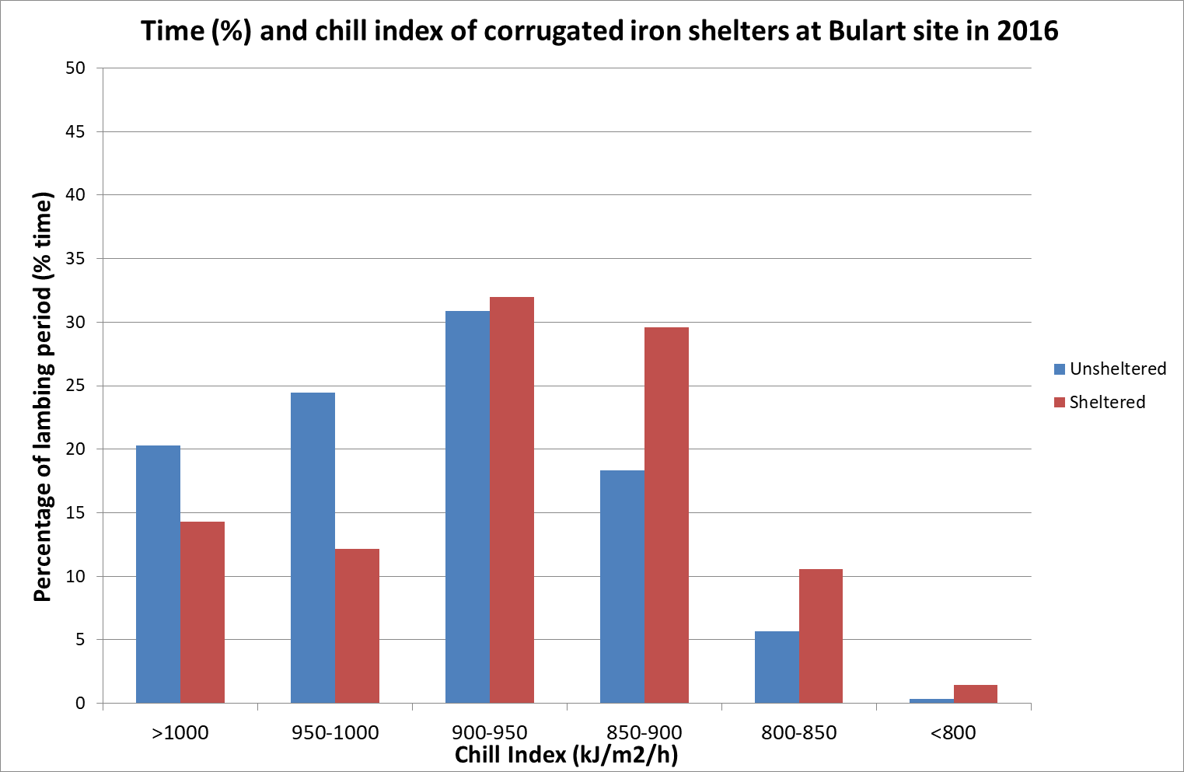
Fig. D8: Histogram of the percentage of time during the lambing period where chill index (kJ/m2/h) was within a given range adjacent to the corrugated iron shelters (sheltered red columns) and in the open (unsheltered blue columns) at the Bulart site in 2016.
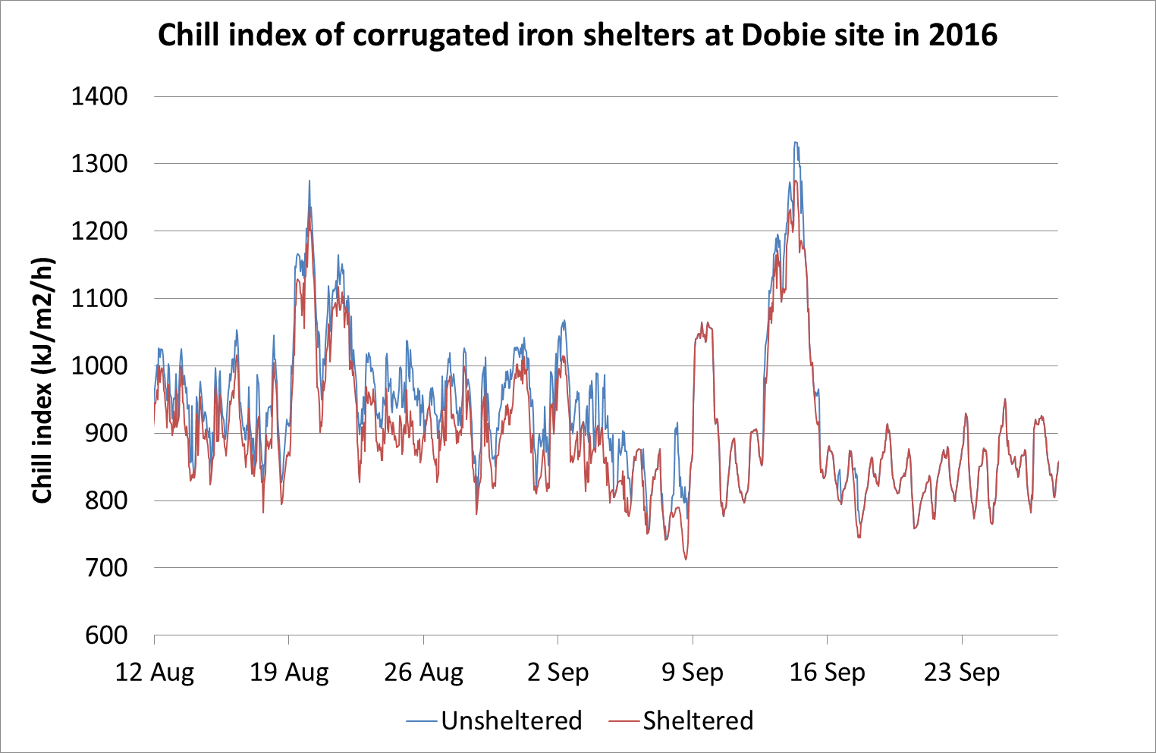
Fig. D9: Line graph of chill index (kJ/m2/h) measured adjacent to corrugated iron shelters (sheltered red line) and in the open (unsheltered blue line) at the Dobie site in 2016.
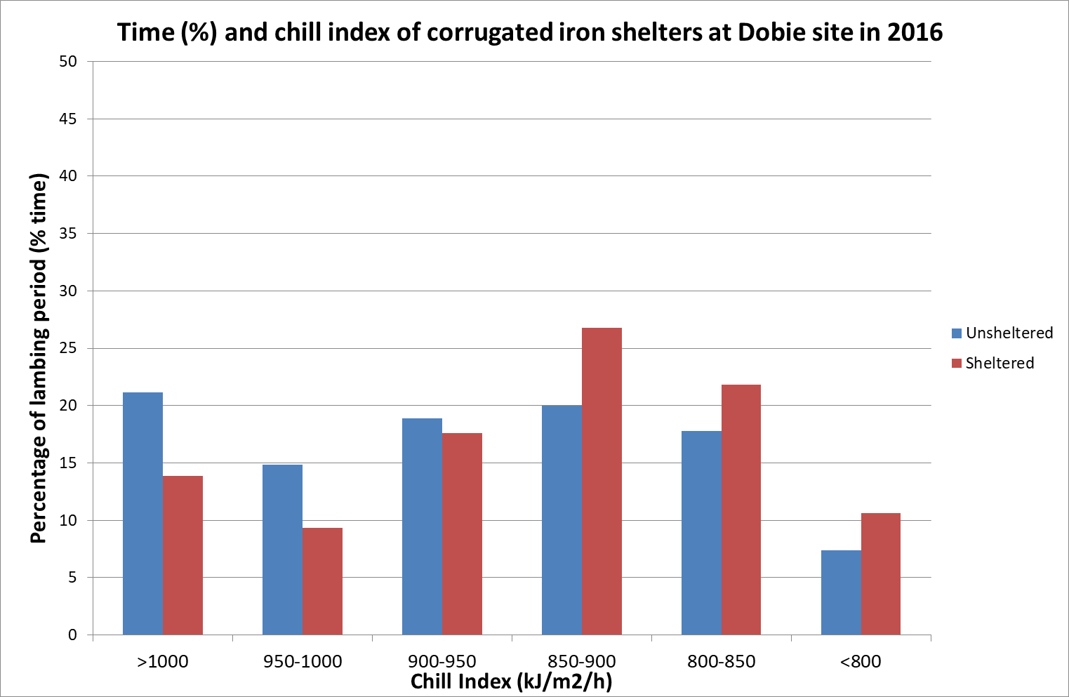
Fig. D10: Histogram of the percentage of time during the lambing period where chill index (kJ/m2/h) was within a given range adjacent to the corrugated iron shelters (sheltered red columns) and in the open (unsheltered blue columns) at the Dobie site in 2016.
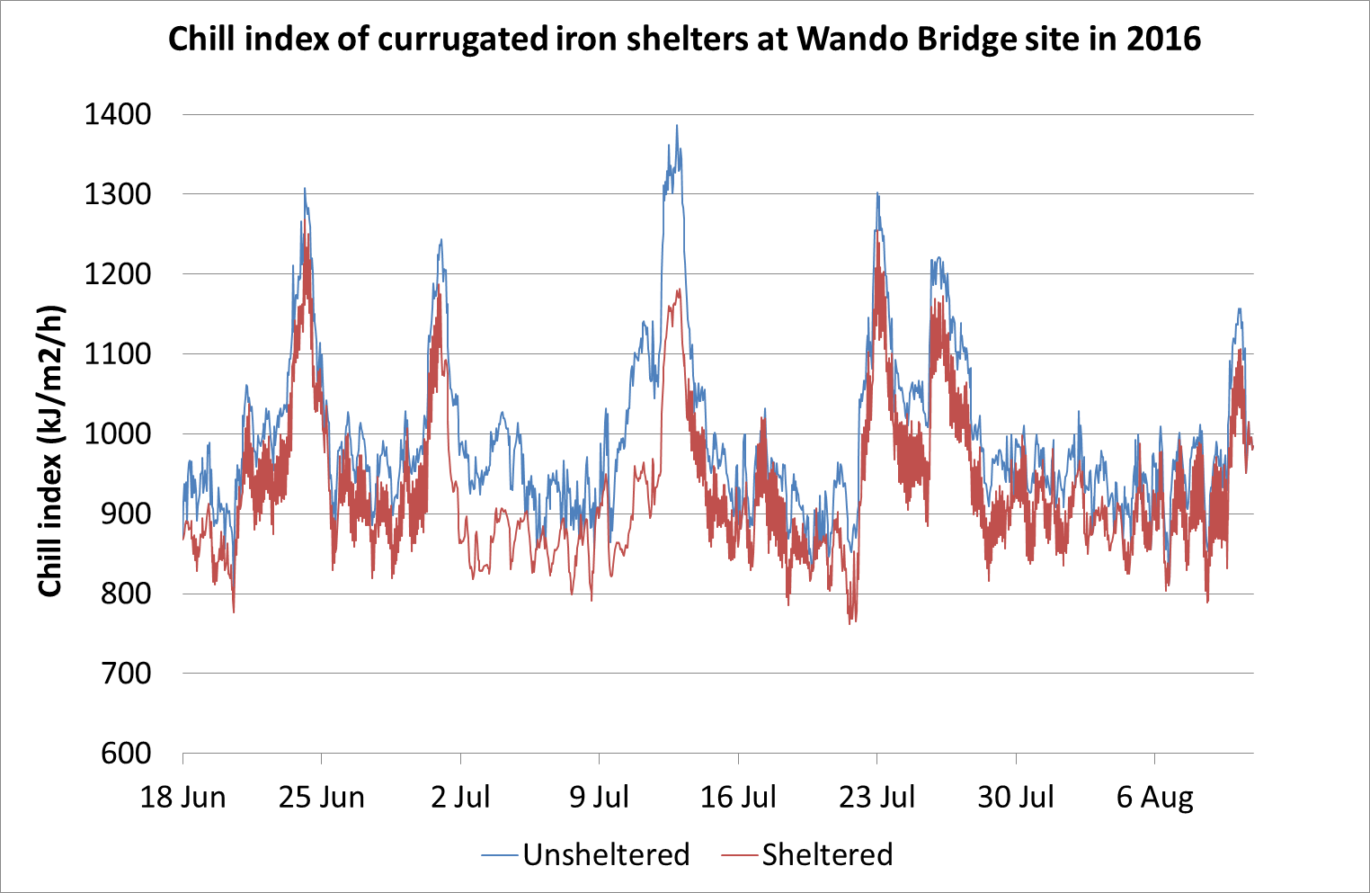
Fig. D11: Line graph of chill index (kJ/m2/h) measured adjacent to corrugated iron shelters (sheltered red line) and in the open (unsheltered blue line) at the Wando Bridge site in 2016.
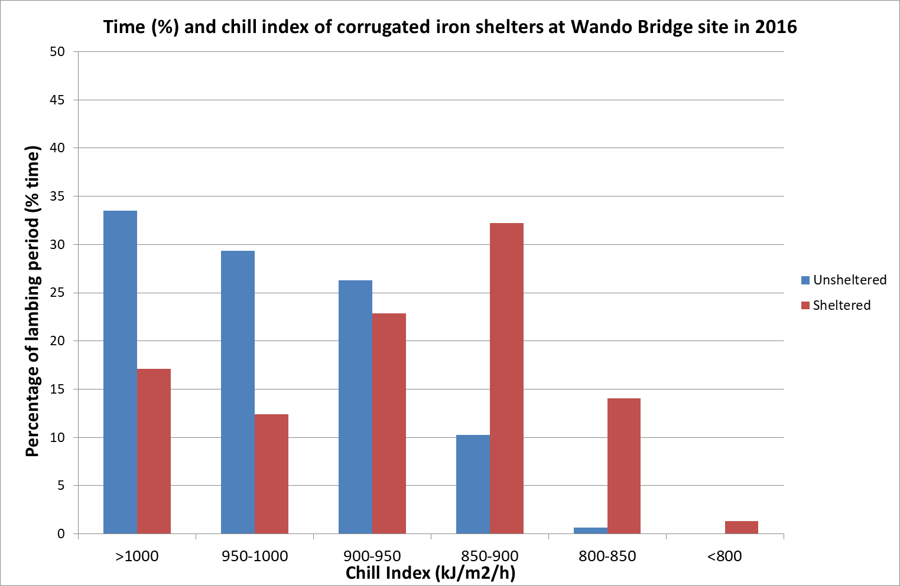
Fig. D12: Histogram of the percentage of time during the lambing period where chill index (kJ/m2/h) was within a given range adjacent to the corrugated iron shelters (sheltered red columns) and in the open (unsheltered blue columns) at the Wando Bridge site in 2016.

Year 3 (2017)
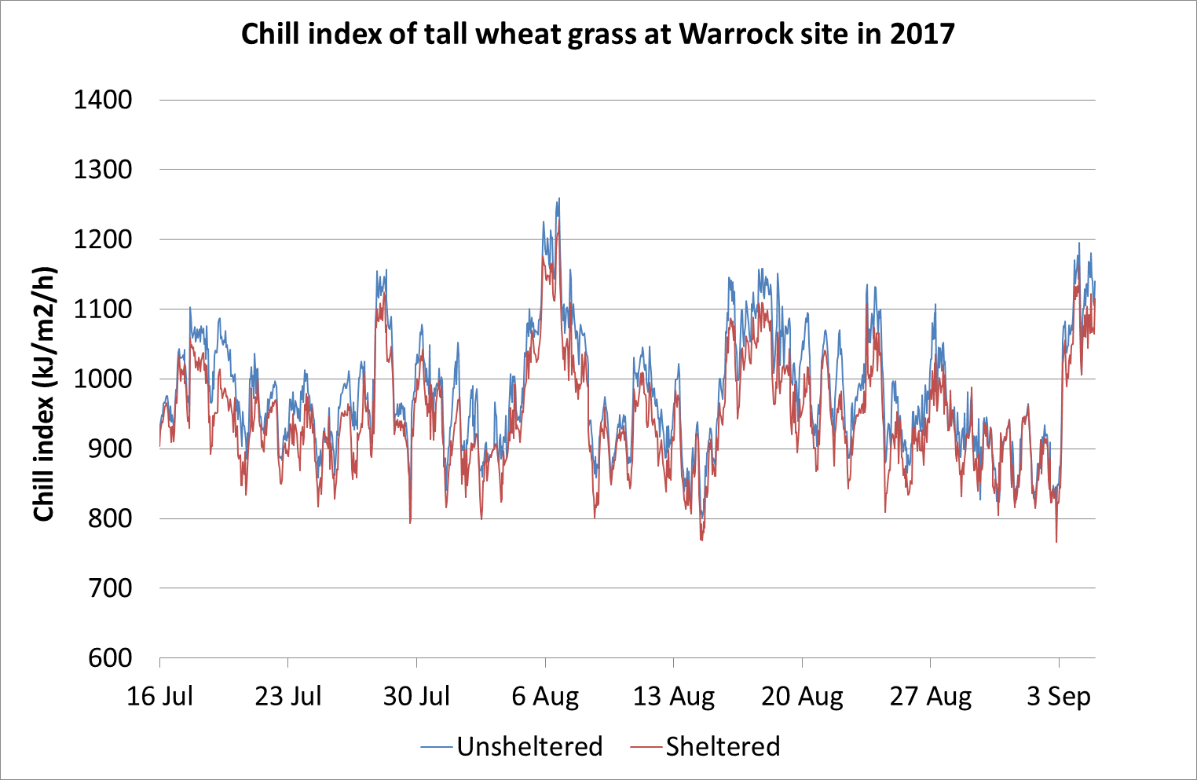
Fig. D13: Line graph of chill index (kJ/m2/h) measured adjacent to tall wheat grass hedgerows (sheltered red line) and in the open (unsheltered blue line) at the Warrock site in 2017.
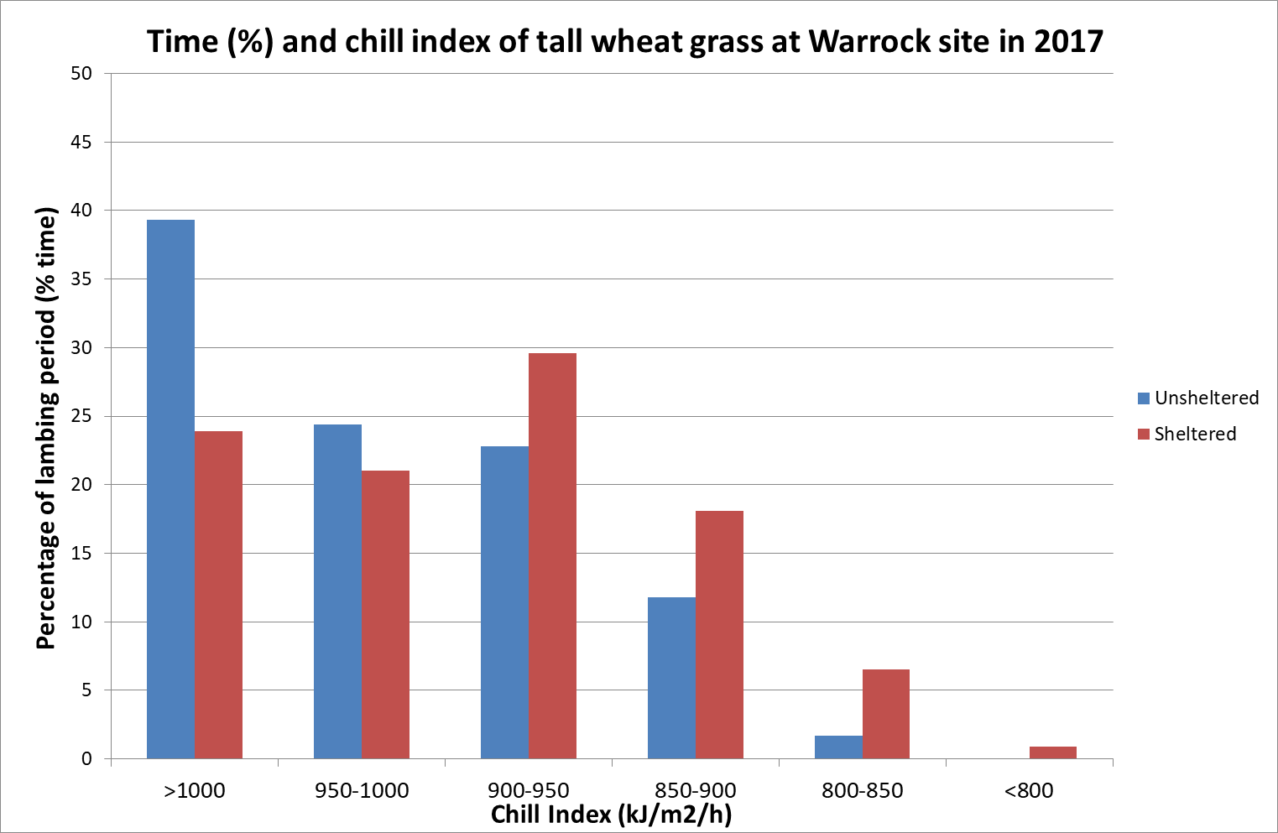
Fig. D14: Histogram of the percentage of time during the lambing period where chill index (kJ/m2/h) was within a given range adjacent to the tall wheat grass (sheltered red columns) and in the open (unsheltered blue columns) at the Warrock site in 2017.
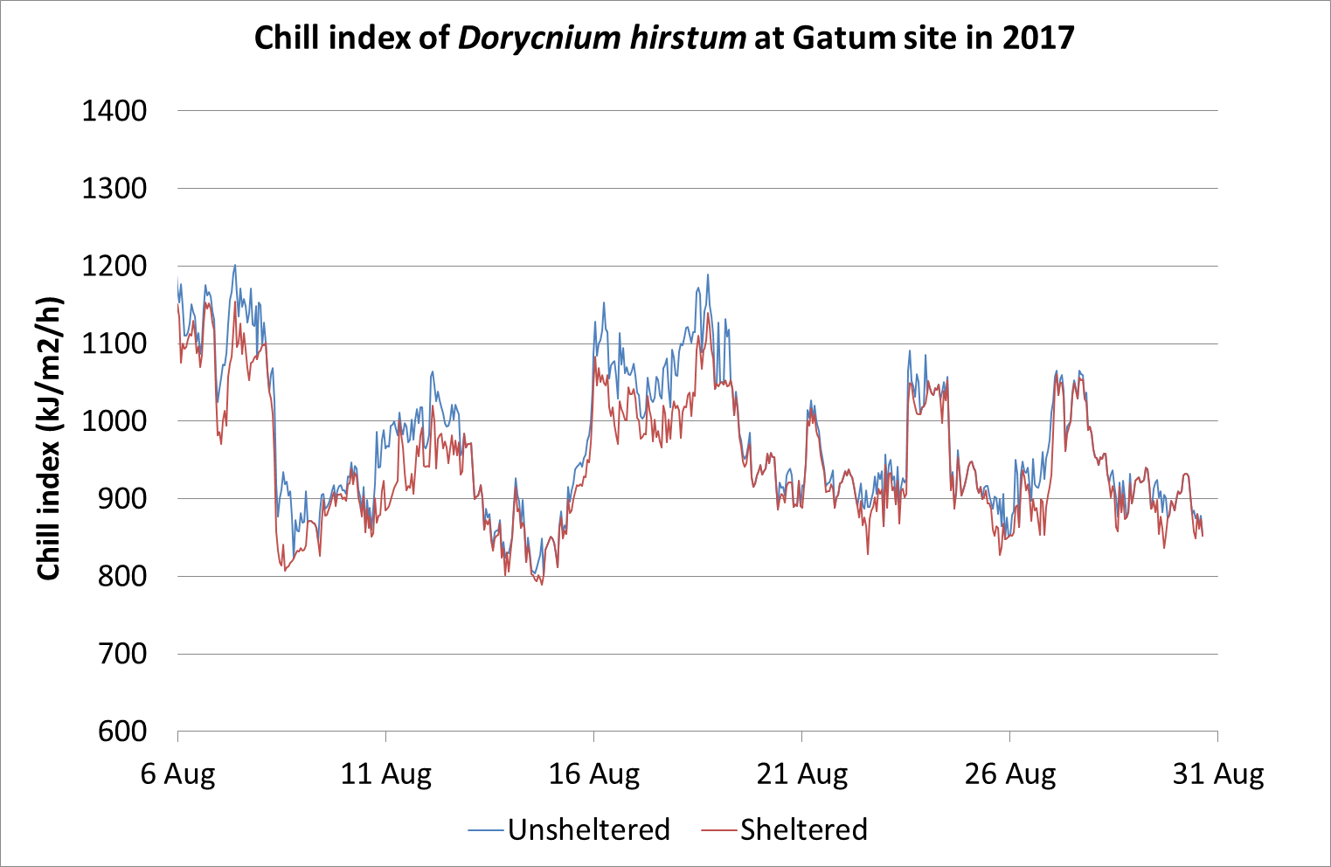
Fig. D15: Line graph of chill index (kJ/m2/h) measured adjacent to D. hirstum hedgerows (sheltered red line) and in the open (unsheltered blue line) at the Gatum 1 site in 2017.
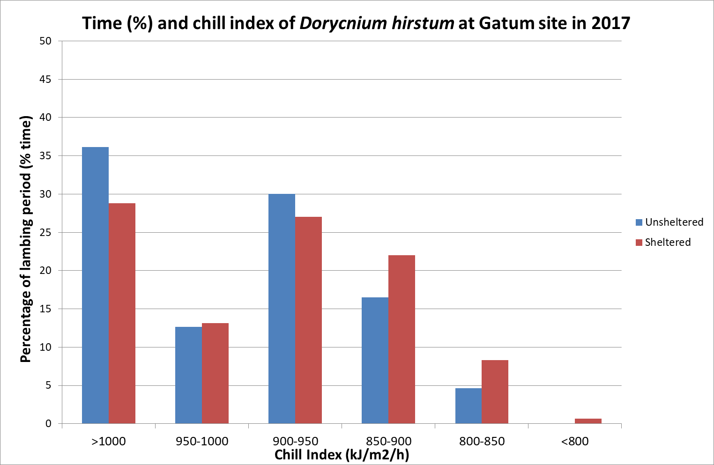
Fig. D16: Histogram of the percentage of time during the lambing period where chill index (kJ/m2/h) was within a given range adjacent to the D. hirstum hedgerows (sheltered red columns) and in the open (unsheltered blue columns) at the Gatum 1 site in 2017.
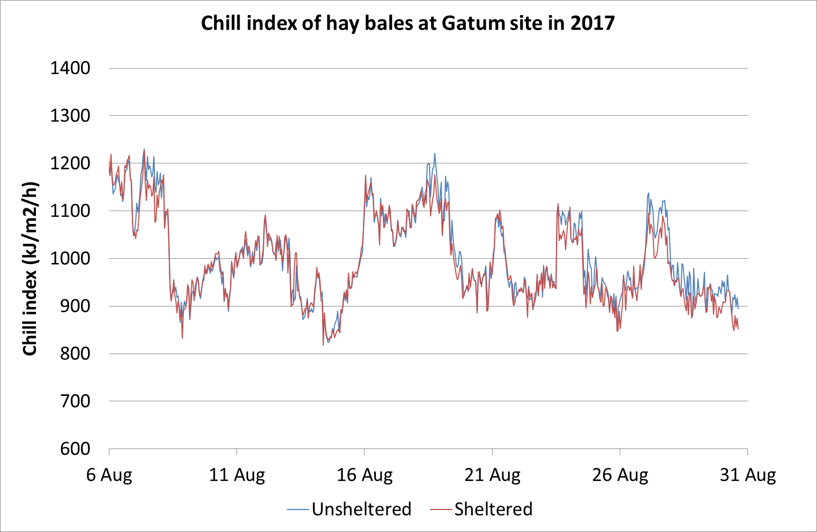
Fig. D17: Line graph of chill index (kJ/m2/h) measured adjacent to hay bales (sheltered red line) and in the open (unsheltered blue line) at the Gatum 1 site in 2017.
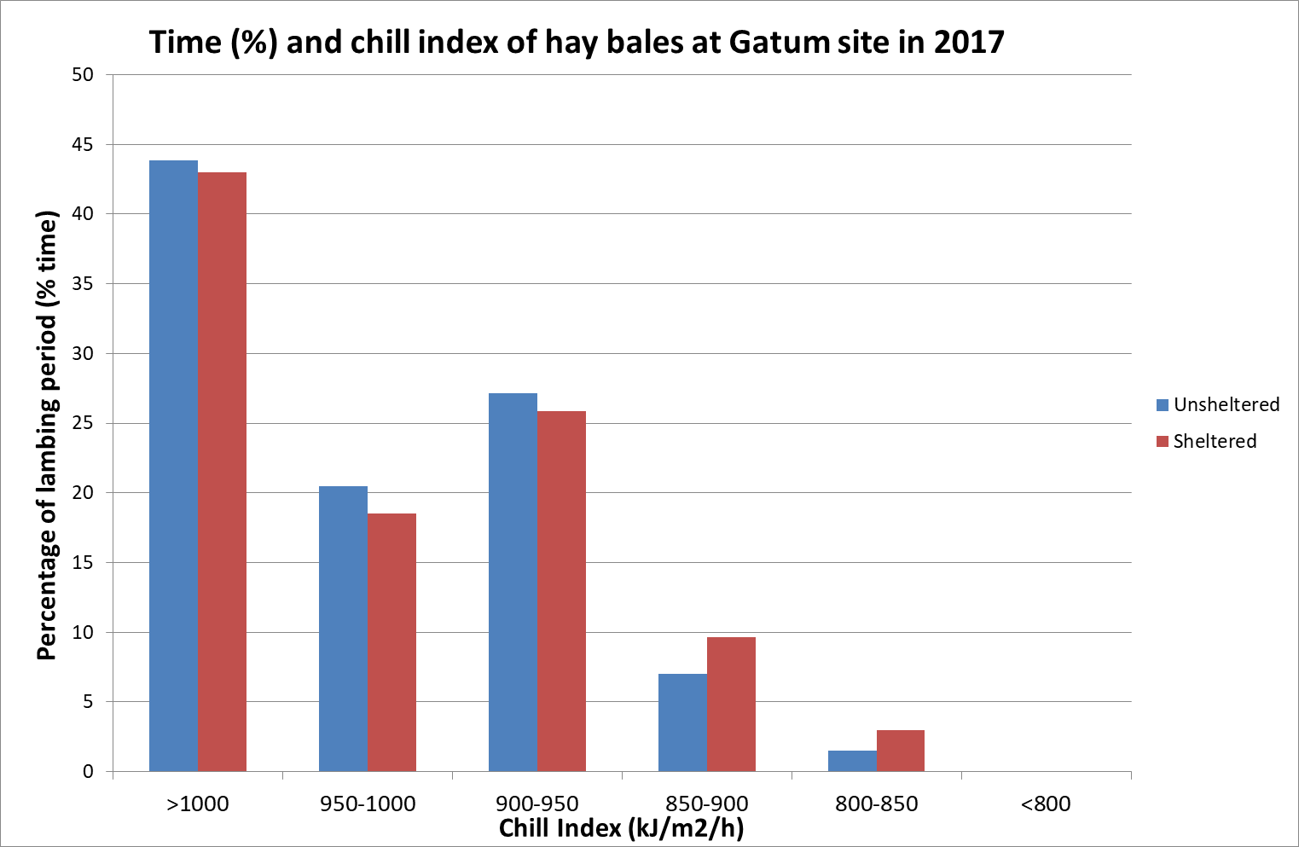
Fig. D18: Histogram of the percentage of time during the lambing period where chill index (kJ/m2/h) was within a given range adjacent to the hay bales (sheltered red columns) and in the open (unsheltered blue columns) at the Gatum 1 site in 2017.
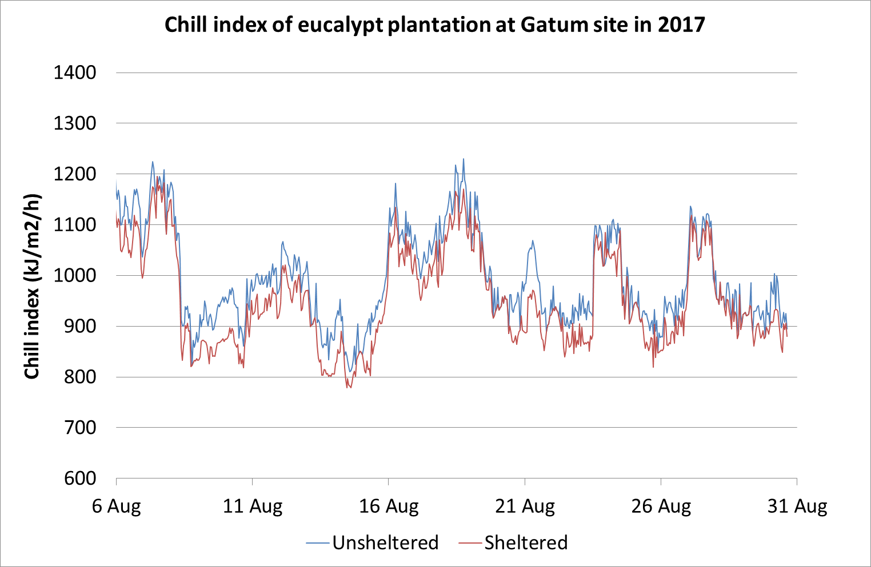
Fig. D19: Line graph of chill index (kJ/m2/h) measured adjacent to eucalypt plantation (sheltered red line) and in the open (unsheltered blue line) at the Gatum 1 site in 2017.
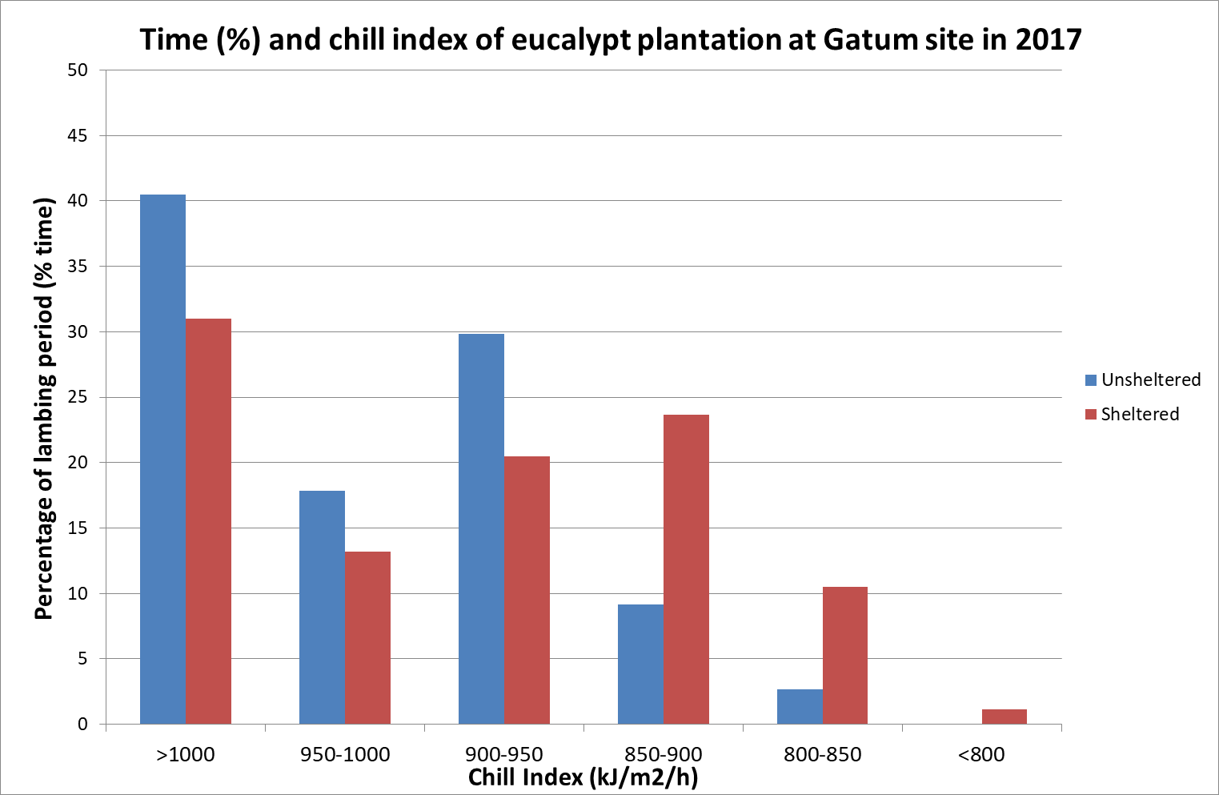
Fig. D20: Histogram of the percentage of time during the lambing period where chill index (kJ/m2/h) was within a given range adjacent to the eucalypt plantation (sheltered red columns) and in the open (unsheltered blue columns) at the Gatum 1 site in 2017.
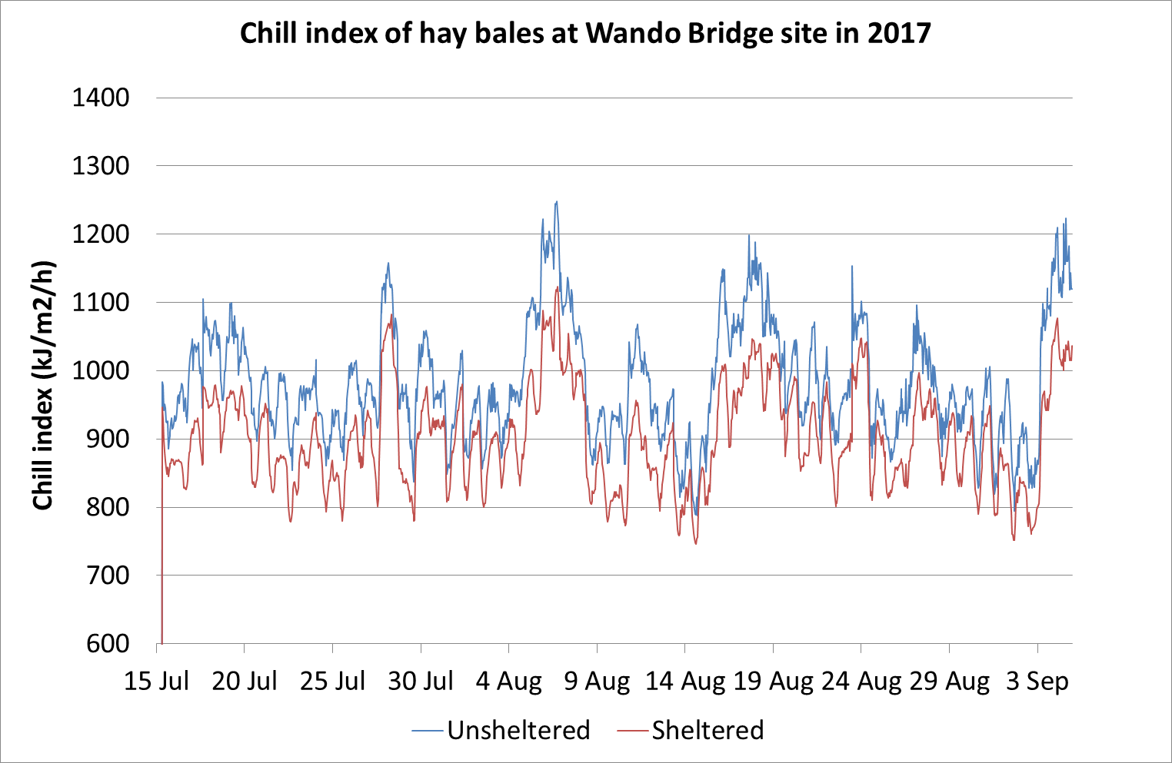
Fig. D21: Line graph of chill index (kJ/m2/h) measured adjacent to hay bales (sheltered red line) and in the open (unsheltered blue line) at the Wando Bridge site in 2017.
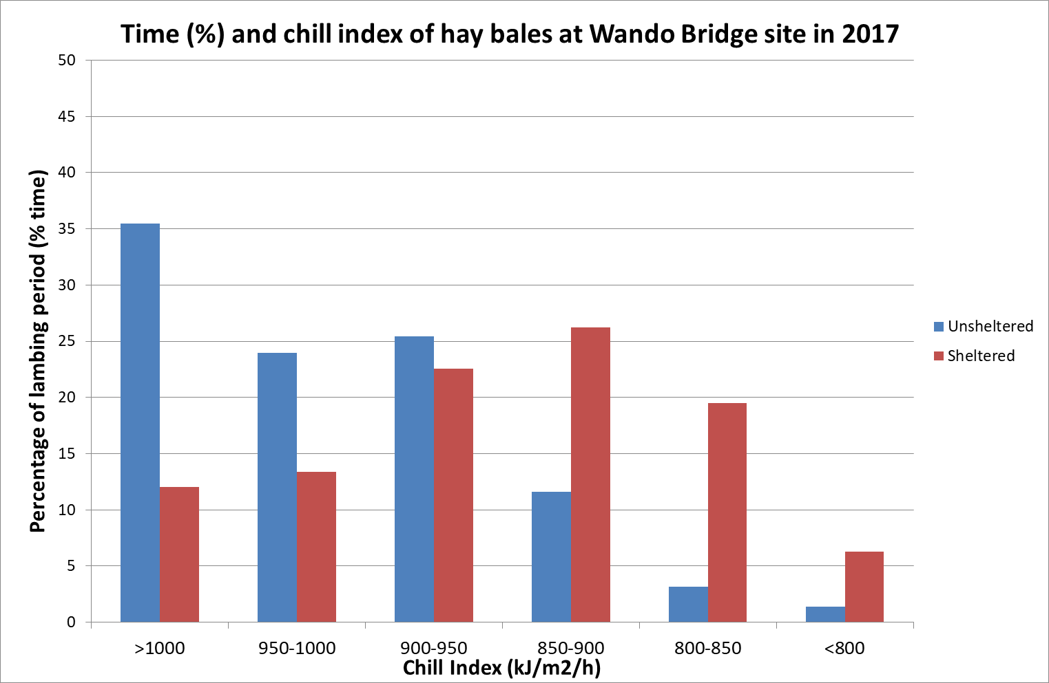
Fig. D22: Histogram of the percentage of time during the lambing period where chill index (kJ/m2/h) was within a given range adjacent to the hay bales (sheltered red columns) and in the open (unsheltered blue columns) at the Wando Bridge site in 2017.

Year 4 (2018)
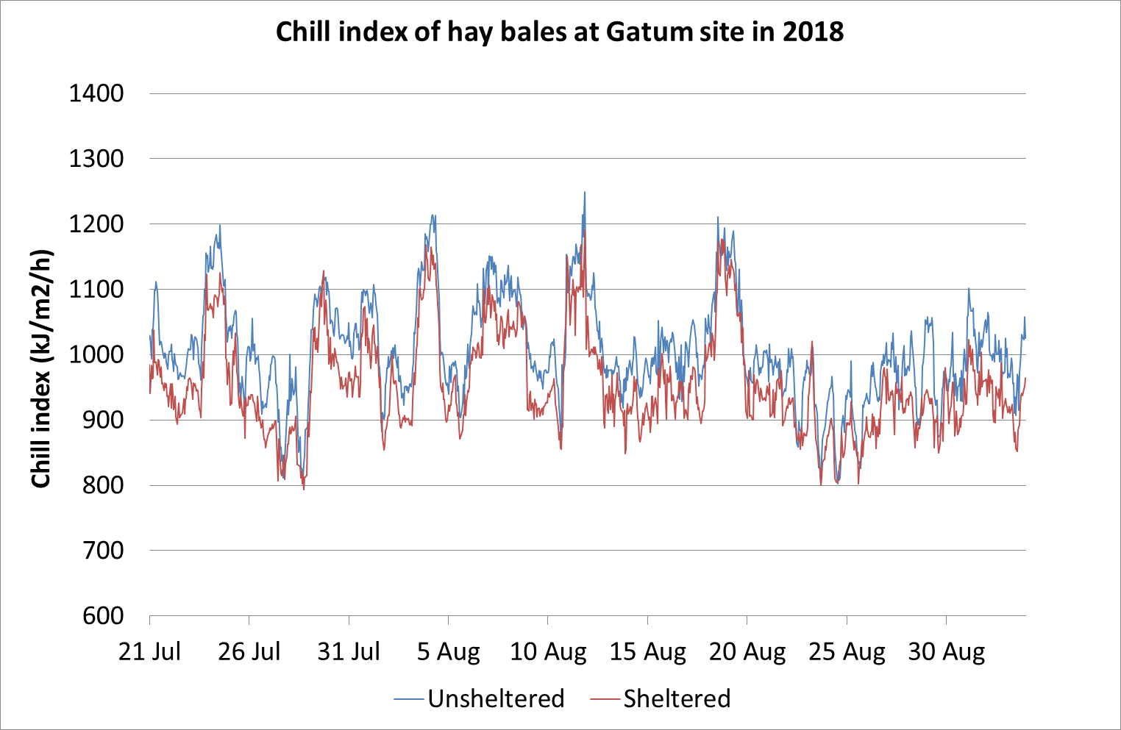
Fig. D23: Line graph of chill index (kJ/m2/h) measured adjacent to hay bales (sheltered red line) and in the open (unsheltered blue line) at the Gatum 1 site in 2018.
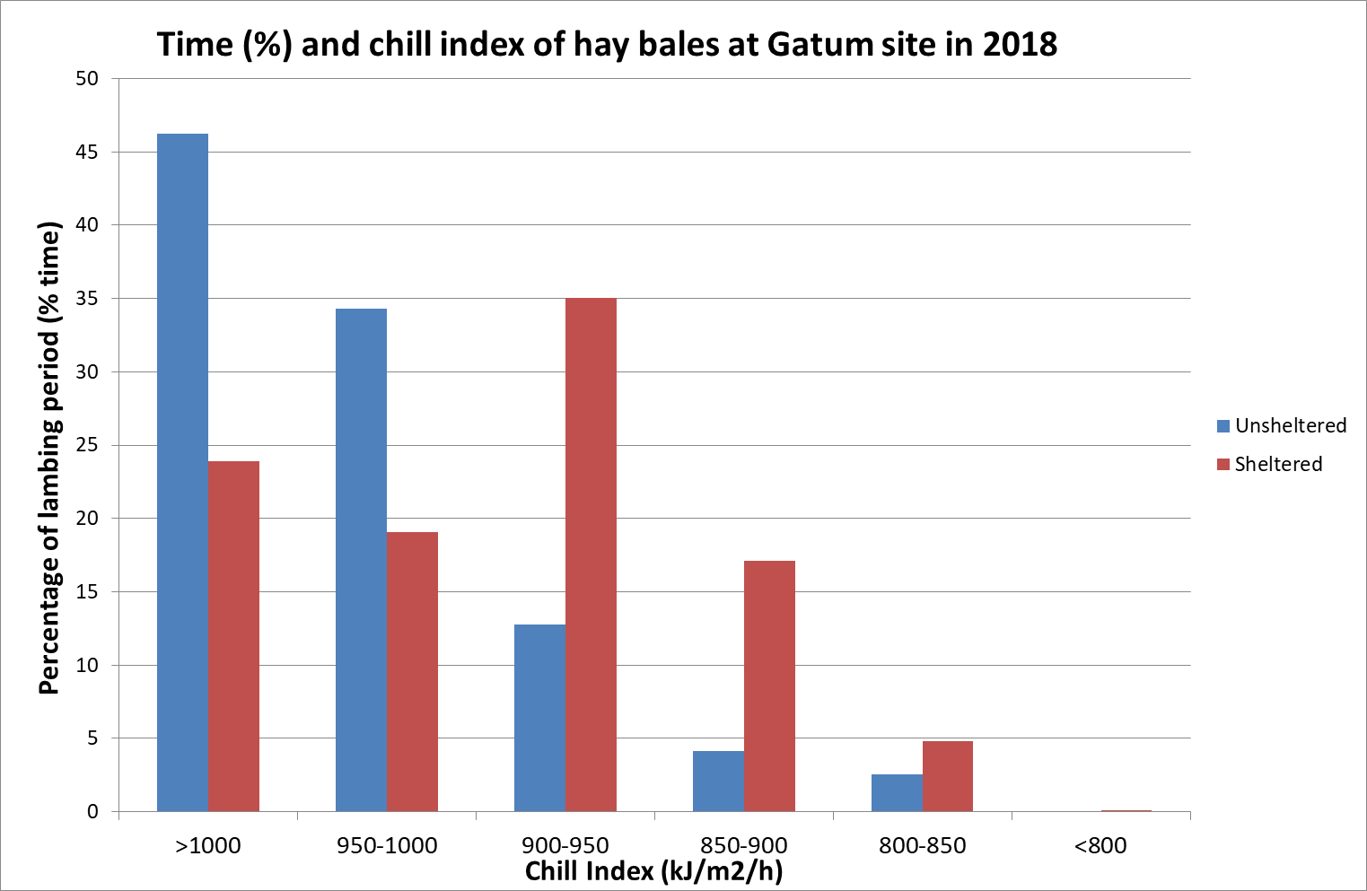
Fig. D24: Histogram of the percentage of time during the lambing period where chill index (kJ/m2/h) was within a given range adjacent to the hay bales (sheltered red columns) and in the open (unsheltered blue columns) at the Gatum 1 site in 2018.
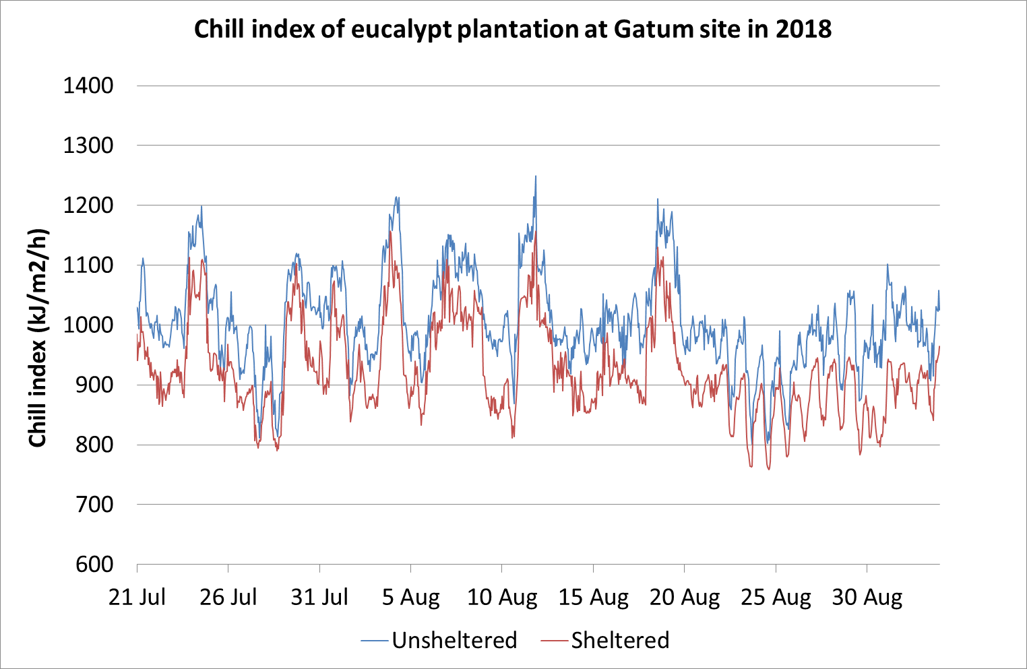
Fig. D25: Line graph of chill index (kJ/m2/h) measured adjacent to eucalypt plantation (sheltered red line) and in the open (unsheltered blue line) at the Gatum 1 site in 2018.
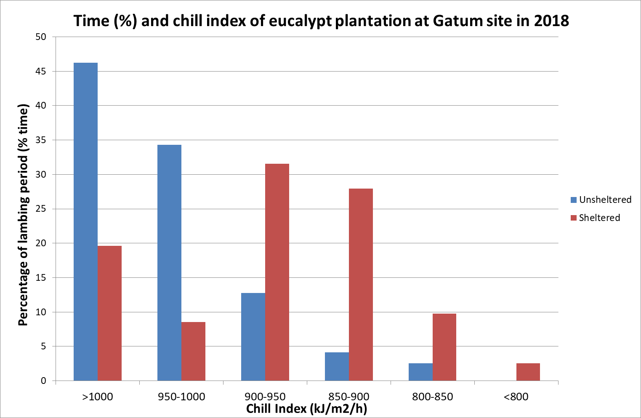
Fig. D26: Histogram of the percentage of time during the lambing period where chill index (kJ/m2/h) was within a given range adjacent to the eucalypt plantation (sheltered red columns) and in the open (unsheltered blue columns) at the Gatum 1 site in 2018.
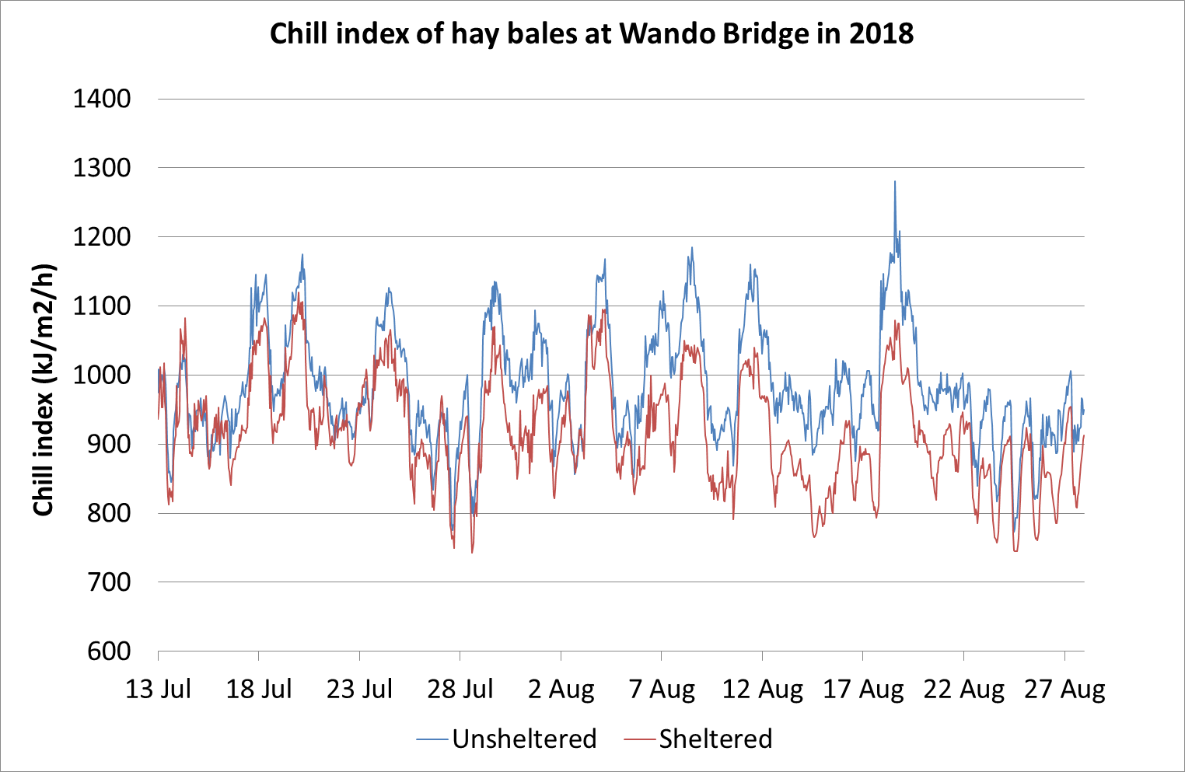
Fig. D27: Line graph of chill index (kJ/m2/h) measured adjacent to hay bales (sheltered red line) and in the open (unsheltered blue line) at the Wando Bridge site in 2018.
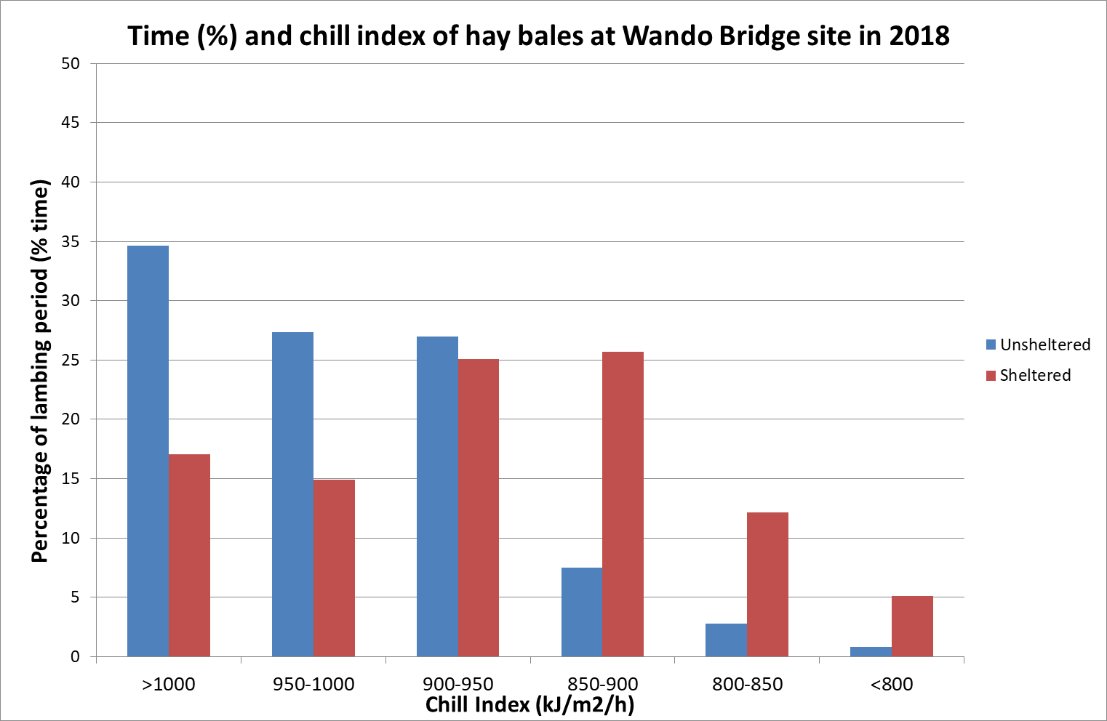
Fig. D28: Histogram of the percentage of time during the lambing period where chill index (kJ/m2/h) was within a given range adjacent to the hay bales (sheltered red columns) and in the open (unsheltered blue columns) at the Wando Bridge site in 2018.
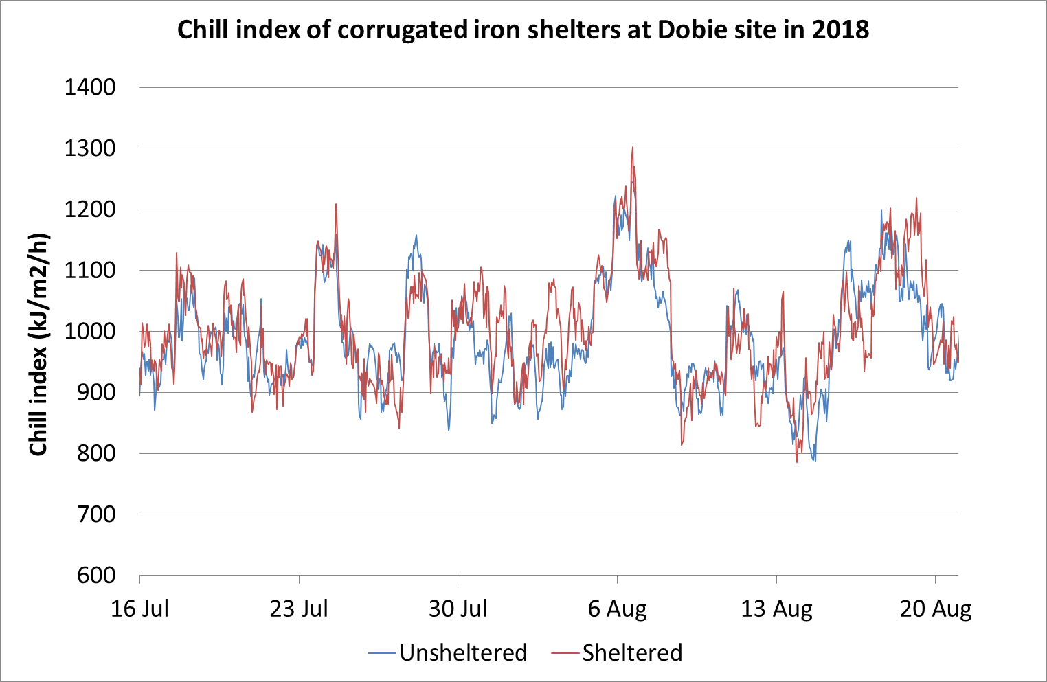
Fig. D29: Line graph of chill index (kJ/m2/h) measured adjacent to corrugated iron shelters (sheltered red line) and in the open (unsheltered blue line) at the Dobie site in 2018.
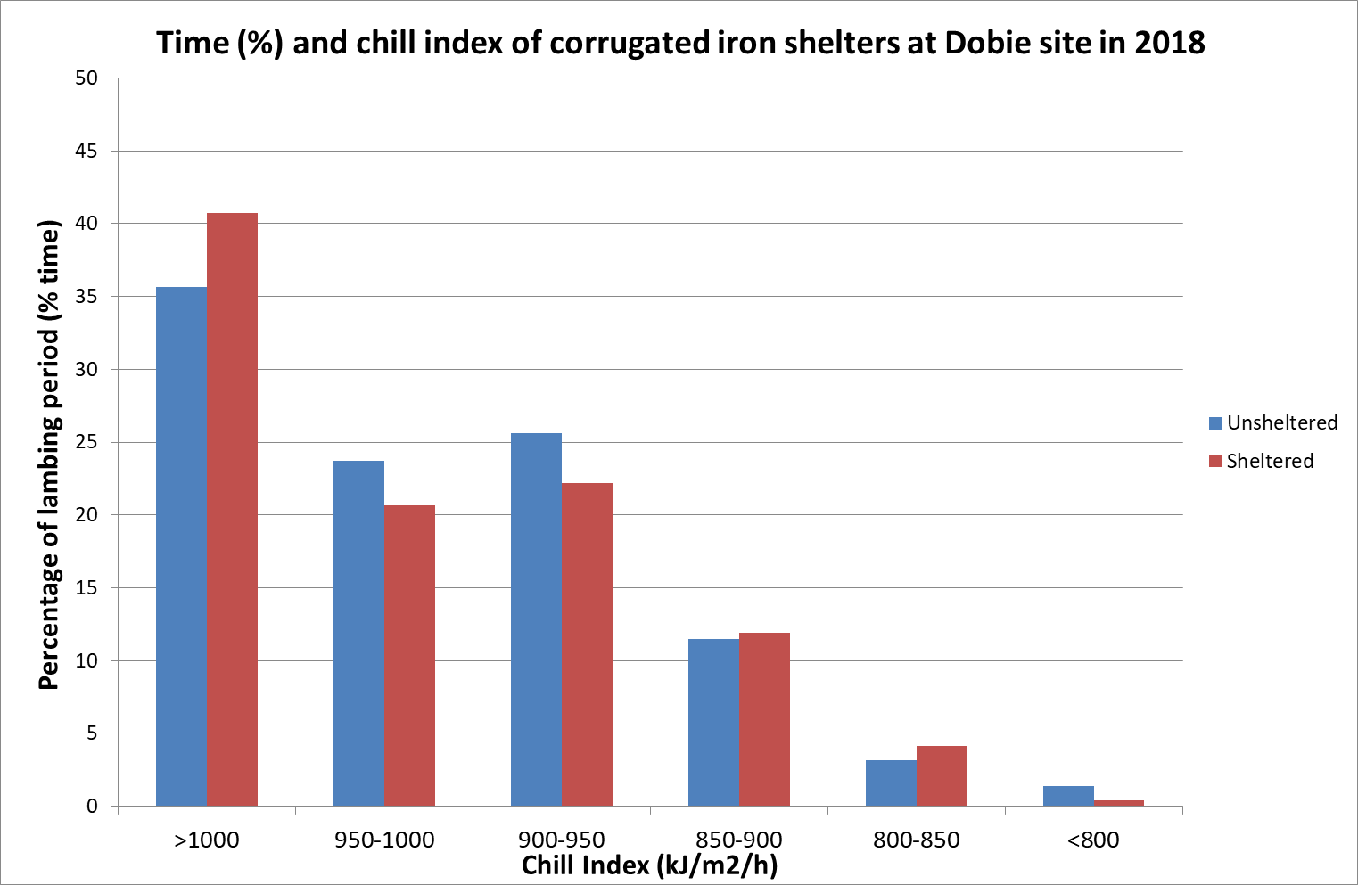
Fig. D30: Histogram of the percentage of time during the lambing period where chill index (kJ/m2/h) was within a given range adjacent to the corrugated iron shelters (sheltered red columns) and in the open (unsheltered blue columns) at the Dobie site in 2018.

