final report

Project code: E.PDS.1410/L.PDS.1803
Prepared by: (1) Rob Shea (2) Rachael Campbell
- Perennial Pasture Systems (2) Agriculture Victoria

Reviewed by: Jane Court; Agriculture Victoria

Date published: April 2019

PUBLISHED BY
Meat and Livestock Australia Limited
Locked Bag 1961
NORTH SYDNEY NSW 2059

Innovative Use of Gibberellic Acid (GA)
Meat & Livestock Australia acknowledges the matching funds provided by the Australian Government to support the research and development detailed in this publication.
This publication is published by Meat & Livestock Australia Limited ABN 39 081 678 364 (MLA). Care is taken to ensure the accuracy of the information contained in this publication. However MLA cannot accept responsibility for the accuracy or completeness of the information or opinions contained in the publication. You should make your own enquiries before making decisions concerning your interests. Reproduction in whole or in part of this publication is prohibited without prior written consent of MLA.

Executive summary

Gibberellic Acid (GA) is made naturally in plant roots and stimulates shoot and cell elongation, promoting plant growth during spring. The application of manufactured GA in winter aims to stimulate plant growth and therefore increase winter feed availability.

In recent years the use of GA has been implemented on many farms, however much of the current data on its effectiveness has been confined to ryegrass-based pastures in high rainfall regions. The Perennial Pasture Systems (PPS) group felt that there was a need to evaluate its performance in the lower rainfall regions which have phalaris as the perennial species base in productive pastures.

A demonstration was designed to evaluate the extra winter feed growth produced using GA in comparison to Nil and nitrogen treatments in phalaris based pastures in the Upper Wimmera/Central region of Victoria.

The response to nitrogen was low as agronomic advice predicted. This is due to low winter temperatures and reduced production responses over this period.

The individual phalaris plants responded to the GA treatments and increased the amount of pasture dry matter (DM) grown, but the responses at most sites were not as substantial as was anticipated.
The density of phalaris, even in a good phalaris/sub clover pasture, appears to be a limiting factor in the response to the GA applications in the demonstration. PPS estimates that phalaris needs to make up at least 40% of the total pasture composition to make GA application worthwhile.

The economic analysis concluded that GA applications to phalaris based pastures may be worthwhile to provide extra winter feed but the variables in pasture composition and pre-existing pasture mass need to be taken into consideration. It is to be noted the increasingly unreliable autumn breaks in the Upper Wimmera/Central region of Victoria can mean that the pre-requisites for effective GA use are not met, as it is recommended that pastures have 1,000kg DM/ha of green matter and non-limiting soil moisture for plant growth.

The three-year demonstration resulted in 133 kg DM/ha increase in pasture grown after GA application averaged over the sites, a net benefit of $2.97/ha based on the long-term average feed barley prices and $12.91/ha based on October 2018 prices. With a GA treatment cost of $22.43/ha, this would be a worthy feed option compared to grain feeding at October 2018 grain prices of $35.19/ha. A sensitivity analysis concluded that to break even on GA treatment cost, an extra 117kg DM/ha would need to be produced based on long-term average feed barley prices, or an extra 84kg DM/ha based on October 2018 prices, to justify the GA application.

Results indicate the greatest benefit of GA would be opportunistic rather than strategic in lower rainfall regions on phalaris pastures due to vastly different yearly growth patterns as a result of variable autumn breaks and subsequent pasture availability on farm. This affects the ability to meet the optimal pasture requirements for GA application to produce more winter feed, including the recommended period of destocking.

A second demonstration was implemented to evaluate the effect of GA on annual grass weeds. This concept arose from observations made on a PPS member property in 2014, after GA application on a pasture infested with silver grass.

This demonstration aimed to explore the hypothesis that GA applications have the potential to reduce annual grass weeds through increased growth and palatability followed by grazing heavily enough to affect their recovery.

Treatments on five sites were implemented in each year from 2016 to 2018, to assess the effect of GA treatment and grazing on barley grass (Hordeum leporinim), soft brome grass (Bromus mollis), annual ryegrass (Lolium rigidum) and the main target species silver grass (Vulpia spp.) using replicated Nil and GA treatments followed by grazing with sheep. Several variations of treatment and timings were completed over the three years.

The annual weed reduction demonstration sites failed to replicate the effect seen on silver grass in 2014. It also failed to produce any meaningful reduction in the other targeted annual grasses; barley grass and annual ryegrass.

Table of contents
1 Background 5
1.1 The Perennial Pasture Systems Group (PPS) 5
1.2 Gibberellic Acid (GA) Demonstration 5
2 Project Objectives 6
3 Methodology 7
3.1 Project oversight and design 7
3.2 Phalaris based pasture production demonstration 7
3.3 Annual weed reduction demonstration 8
3.4 Demonstration Site Locations 9
4 Results 11
4.1 Phalaris based pasture production demonstration 11
4.1.1 Dry Matter measurements 11
4.1.2 Pasture Composition 15
4.1.3 Pasture Quality 17
4.2 Annual weed reduction demonstration 20
4.2.1 2016 site results 20
4.2.2 2017 site results 25
4.2.3 2018 site results 32
5 Discussion 35
5.1 Phalaris based pasture production demonstration 35
5.1.1 Dry Matter Production 35
5.1.2 Pasture Composition 39
5.1.3 Pasture Quality 40
5.1.4 Dry winter use 40
5.1.5 Effect on spring growth 40
5.2 Economic analysis 41
5.3 Annual weed reduction demonstration 43
5.4 Adoption 43

6 Conclusions/recommendations 44
6.1 Phalaris based pasture production demonstration 44
6.2 Annual weed reduction demonstration 45
7 Bibliography 46
8 Acknowledgements 46
9 Appendices 47

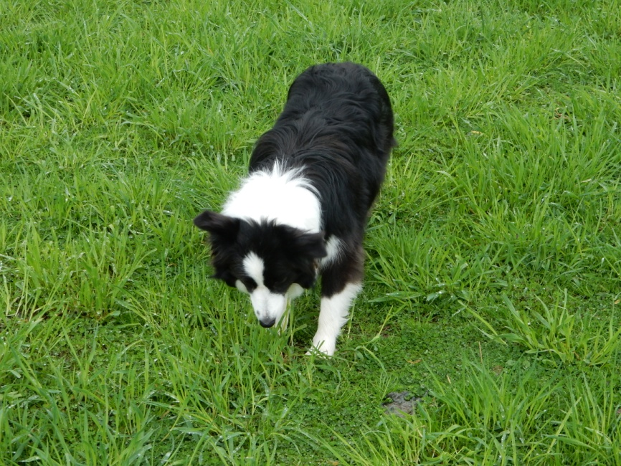

Fig. 1: Phalaris pasture at Marenda, Mt Dryden prior to GA treatment 2016.

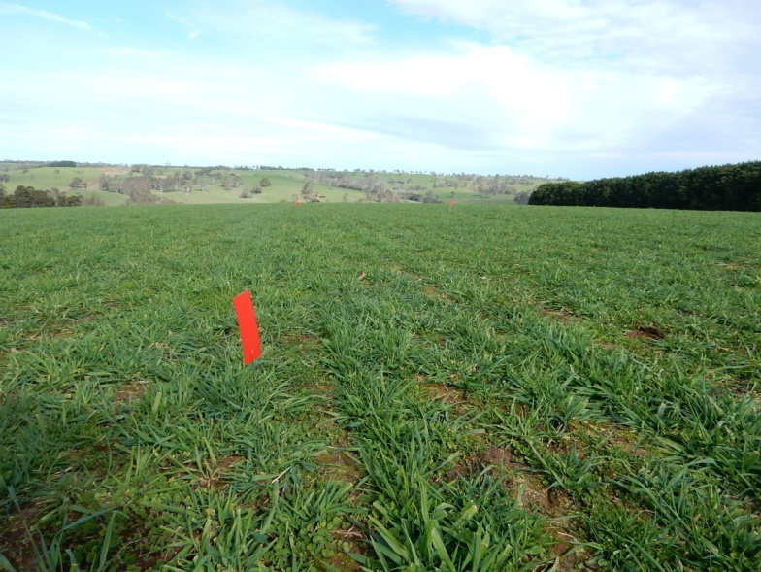

Fig.2: Nil treatment at Cuyuac, Nareen 2018.

Background

The Perennial Pasture Systems Group (PPS)
The Perennial Pasture Systems (PPS) group was formed in mid-2007 at a meeting in Hall’s Gap, reacting to concerns about the lack of research and extension into productive pastures in the Upper Wimmera and Central Highlands region of Victoria.
Since its inception in 2007, 170 farm businesses across the Southern Wimmera and Central Victoria have joined PPS. Farm amalgamations and farmer retirements result in fluctuations in membership and current membership is 130 farm businesses.
Members are involved in prime lamb, mutton, wool and beef production. PPS also has 35 members involved in agribusiness and agronomic services. The total area farmed by producers who have joined PPS is 192,200 ha and they manage approximately 1,250,000 Dry Sheep Equivalents (DSE), made up of 710,000 sheep and 27,800 cattle; cropping and export hay operations are also conducted on many of the farms. The smallest farm in the group is 20 hectares and the largest is 8,200 hectares. The average farm size is 1,101 ha and an average of 7,010 DSE is managed by group member enterprises.

The aim of the group is to push the boundaries of perennial pasture research in the Upper Wimmera and Central Highlands region of Victoria, and to provide information on productive pasture management to PPS members.

The PPS group have actively engaged producers in multiple research projects since 2007 including the PPS/MLA Producer Demonstration Site (PDS) pasture variety trials which are full scale variety comparisons, two EverGraze supporting sites at Mooney’s Gap and Tottington, a Producer Research Site (PRS) on phalaris persistence as well as demonstrations including cocksfoot cultivar comparison, subsoil amelioration and a variable rate liming project.
The PPS/MLA PDS sites and the PPS/EverGraze Supporting Sites have had a focus on pasture persistence and although they have officially been completed, they will be monitored and measured by PPS for several years to come.

For the Enhanced Producer Demonstration Site (EPDS) GA demonstration project, an advisory group of three PPS producers (Simon Brady, Jodie Greene and Dennis Harrington) and the group co-ordinators oversaw the planning and implementation of the project and reported back to the wider group. Ten PPS member farms participated directly in the project, hosting sites for the GA demonstrations.

Gibberellic Acid (GA) Demonstration
The Perennial Pasture Systems (PPS) group was successful in an application to the Agriculture Victoria and MLA funded EDPS program in 2015 to commence a gibberellic acid (GA) demonstration.

The project, titled “Innovative use of Gibberellic Acid” was a three-year, two-part demonstration of the potential benefits of GA in the PPS member region and beyond.

The use of GA to promote winter growth in perennial grasses was well documented by CSIRO in the 1950’s and 1960’s, but due to its cost it was not taken up by the grazing industry as nitrogen fertilizer was a much cheaper alternative. In recent years the cost of GA has reduced, and it has now become a useful tool in perennial grass management.

Although GA has re-emerged as a pasture management option, information on its use tends to be of a very general nature and PPS believed that there needed to be more specific guidelines for its use in the Central West region of Victoria.

As far as PPS is aware the only Victorian trial information available is from South West Victoria which is a much more favourable environment for pasture production. Most trial and demonstration results focus on the use of GA on ryegrass-based pastures and group members felt that there was a need to demonstrate its use on phalaris based pastures in the drier central region of Victoria. PPS in conjunction with Agriculture Victoria therefore aimed to run these demonstrations to help produce a set of guidelines for GA use in less favourable environments as well as looking at both physical and economic aspects of its use.

The project also aimed to demonstrate the potential use of GA as a non-toxic annual weed control measure in addition to the best practice GA use on phalaris for our region. It aimed to measure any impact of GA applications on annual weeds arising from observations on a member’s pasture where silver grass (Vulpia spp.) appeared to have been reduced following GA applications and heavy grazing. On an adjacent unsprayed and ungrazed area, the silver grass grew strongly into the spring.

Gibberellic Acid (GA)
GA is made naturally in plant roots and stimulates shoot and cell elongation promoting plant growth during spring. The application of manufactured GA, which is sold commercially in granular and liquid form as “ProGibb™” and “Gala™”, in winter stimulates plant growth to increase winter feed availability. Research shows the best responses occur when there is adequate soil moisture and air temperatures between 5 – 15° Celsius and the pasture is left ungrazed for 21 days post-treatment.

Often after GA application short term yellowing of the plants occurs, however this has no long-term effects on the plant.
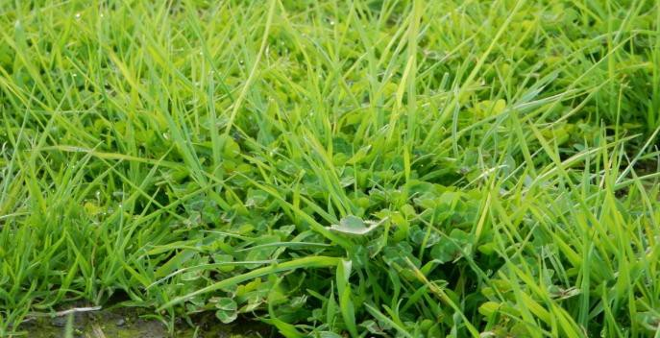

Fig. 3: GA treated phalaris at Marenda, Mt Dryden showing the short-term yellowing of the leaves.

Project Objectives
Phalaris based pasture production demonstration:

- To assess the additional winter feed gains that can be made in the region by using GA and the cost/benefit of its use.
- To develop best practice guidelines for the use of GA in the region, to increase the uptake of the technique and increase winter feed availability in a cost-effective way.

- To have half of PPS member farms using GA to increase winter feed production by the end of the project.

- To have all PPS members aware of the potential use of GA to increase winter feed production.

Annual weed reduction demonstration:
To assess the effectiveness of GA as a control measure for annual grass weeds.

Methodology

Project oversight and design
As with all PPS projects, an advisory group of PPS members was appointed to oversee the project and assist the PPS project manager in the implementation and management of the project.
PPS GA Advisory Group;
Simon Brady “Jallukar Park” Rhymney
Jodie Greene “Millbanks” Elmhurst
Dennis Harrington “Tirranna” Mt Cole Creek
Project data collection, recording, analysis and reporting were carried out by PPS Project Manager; Rob Shea and Agriculture Victoria Extension Officer; Rachael Campbell.
The project design, technical advice and dry matter assessments were provided by Andrew Speirs and Jade Chan; Meridian Agriculture, Casterton.

Phalaris based pasture production demonstration
In each year of the project, five sites were selected for each demonstration and the treatments were as follows;

2016
(1) Nil
(2) Gibberellic Acid (GA) only – optimum timing mid to late June, rate 10 g ProGibb™/ha or liquid equivalent.
(3) Nitrogen (N) only @ 50 kg N/ha liquid or granular.
(4) GA (rate 10 g ProGibb™/ha or liquid equivalent) + N treatment (@ 50 kg N/Ha liquid or granular), a method which is commonly used by dairy farmers

Three replicates were implemented in a randomised design at boom spray width (dependent on the size of the host farmer’s equipment).
Dry Matter (DM) cuts from the treatments were taken approximately 21 days after the GA application and dried and weighed to provide DM results. DM samples were tested for pasture quality through the FeedTest laboratory. Total Nitrogen tests were conducted on the FeedTest samples.
Tissue tests were conducted at one site in spring to ascertain if there were any differences between GA and Nil treatments.

2017
The N treatments were removed from the demonstration in 2017 on the recommendation of the project advisory group. The mid-winter cooler temperatures slow the response from nitrogen applications. Therefore, the sampling at 21 days to assess extra dry matter produced by the treatment would have been too soon to see a nitrogen response. They were included in 2016 for demonstration purposes and the results confirmed the slower response in mid-winter.
Cuts were taken from treatment sites and dried and weighed for DM measurements. DM samples were tested for pasture quality through the FeedTest laboratory.

2018
No N treatments were applied in 2018. No FeedTests were taken in 2018 as the previous two years had shown little difference between the treatments.
Along with the standard treatments the Cuyuac site had replicates with a higher rate of GA added (Pro Gibb™ 20 g/ha) included for comparison.

One of the host farmers, PPS member Mal Nicholson put forward the proposition that GA may be used as a tool to promote growth in late winter in phalaris pastures in years of predicted below average rainfall. Many of the shallow soils, north of the Great Diving Range in central Victoria, dry out quickly when spring rainfall is well below average.

In 2018 below average spring rainfall was predicted by the Bureau of Meteorology and the method was tested at the Overdale site. In these situations, phalaris growth was limited by the winter soil temperature and then by low soil moisture availability. The proposition is that GA can maximise the growth of phalaris in these situations and help the producer to gain extra feed and get a return on the improved pasture investment. The application of GA at this site was postponed until August 2nd.

The method of dry matter measurement was refined to improve the accuracy of the results. Measurement sites were mowed to a height of 4cm prior to treatment and pegged to identify treatments areas. These were mown post-treatment to a height of 4cm to collect samples to be dried and weighed for DM measurement.
The original demonstration design is available as Appendix H.

Annual weed reduction demonstration
The sites selected for this demonstration had a high level of annual weeds, including silver grass (Vulpia spp.). The following treatments were implemented over the three years in an attempt to repeat the effect observed on Silver Grass (Vulpia spp.) in 2014.
Replicates were implemented at boom spray width dependent on the size of the host farmer’s equipment.

GA applications:
1. Nil
2. Gibberellic Acid at 10 g of ProGibb™/ha on multiple sites.
3. GA applications of 10 g/ha ProGibb™/ha at different intervals prior to grazing.
4. Use of higher rates of GA.

Timing:
GA was applied once air temperature was below 15°C, green pasture availability at 1000 kg DM/ha and water was non-limiting.
Pasture composition was visually assessed after seed set in spring to evaluate any difference between GA and Nil treatments.

Demonstration Site Locations
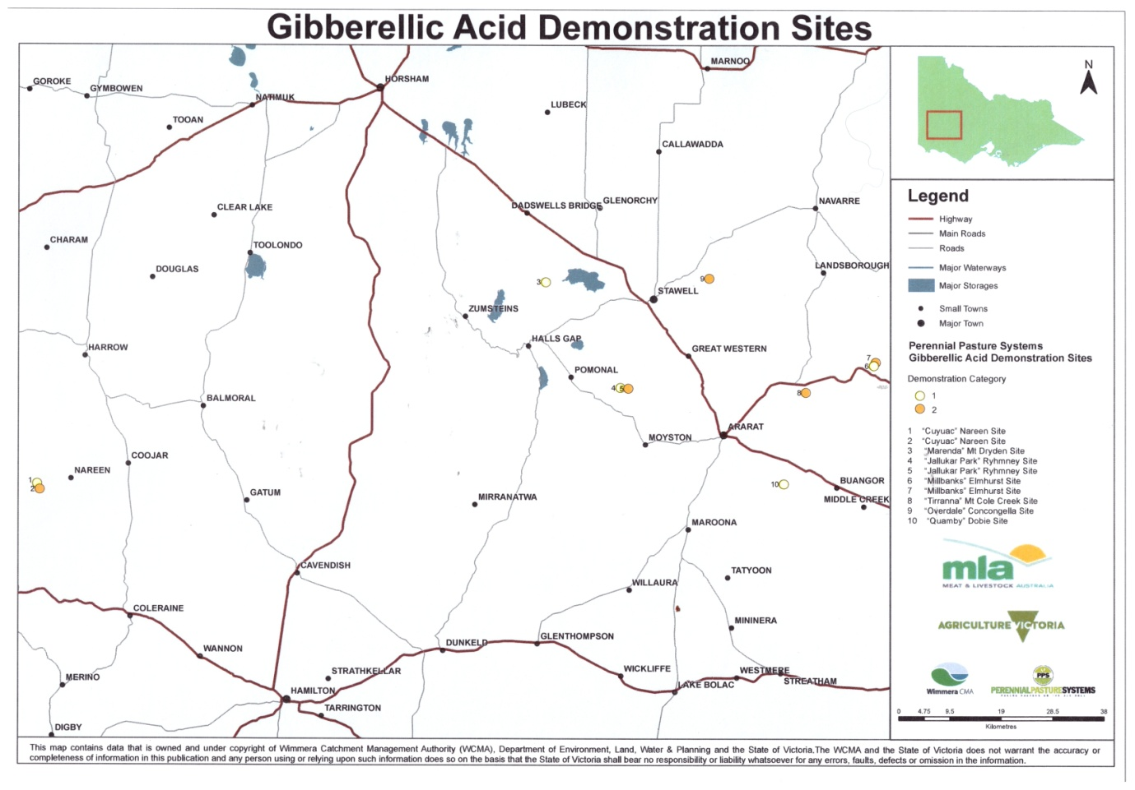

Fig. 4: 2016 demonstration site locations

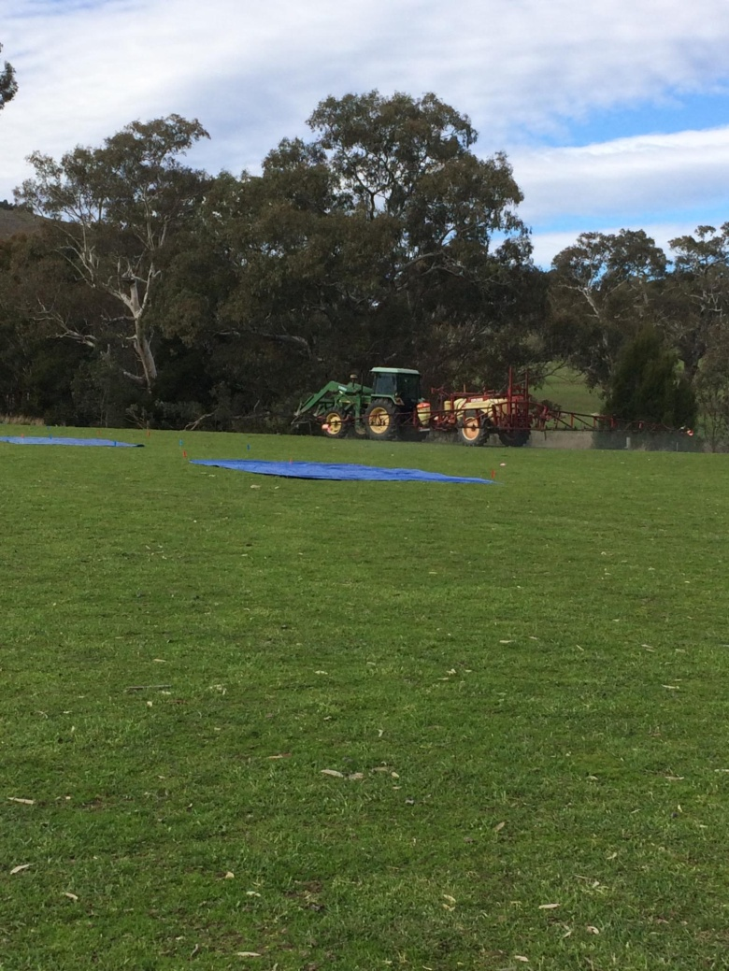
Fig. 5: GA application at Millbanks 2018

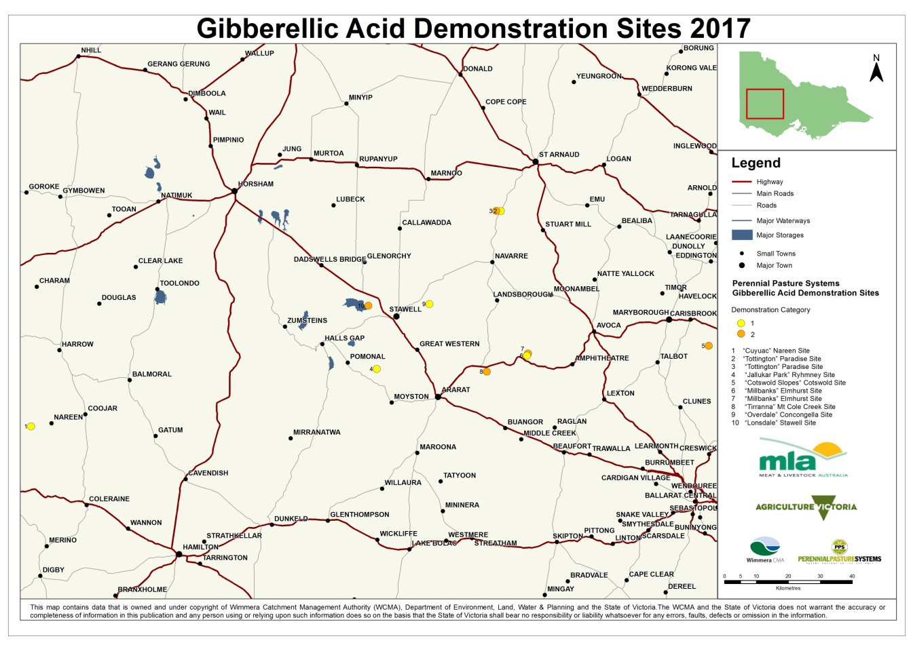

Fig. 6: 2017 demonstration site locations

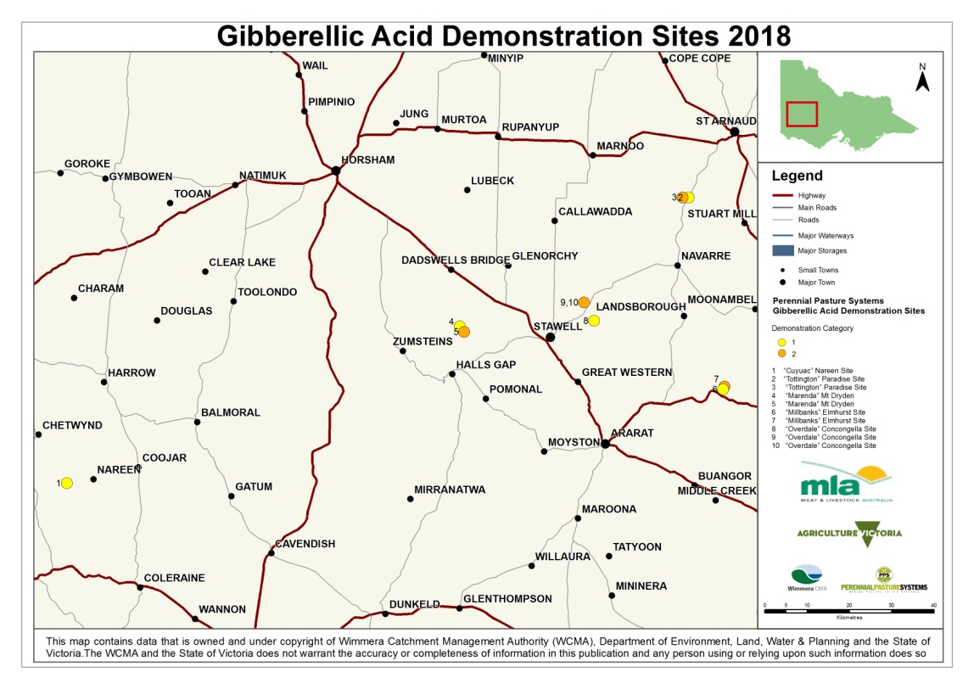

Fig. 7: 2018 demonstration site locations

Results
The results are reported as averages across replicates at each site for every year measured. Individual paddock dry matter results are outlined in Appendix F.

Phalaris based pasture production demonstration

4.1.1 Dry Matter measurements
The paddocks were destocked pre-application and pasture cuts were conducted 20 – 22 days after treatment. Samples were dried and dry matter (DM) determined.
The paddock sampling was refined during the project to increase the accuracy of the results; this may have created minor differences when comparing different year’s results.

2016
Table 1: DM and phalaris content, prior to treatments in 2016.
Demonstration site | Green pasture availability at treatment  (kg DM/ha) | Estimated Phalaris content  (%)
Cuyuac | 1100 | 39
Jallukar Park | 1400 | 53
Marenda | 800 | 20
Millbanks | 900 | 37
Quamby | 500 | 35
Average | 940

Figure 8 shows the dry matter increase between the treatments when compared to the Nil treatments in 2016. At all sites, except Jallukar Park, the GA only treatment produced the most additional dry matter. The Jallukar Park site was the only site to show a response to GA plus N.

Fig. 8: average Kg DM/Ha increase in GA, N & GA+N replicates

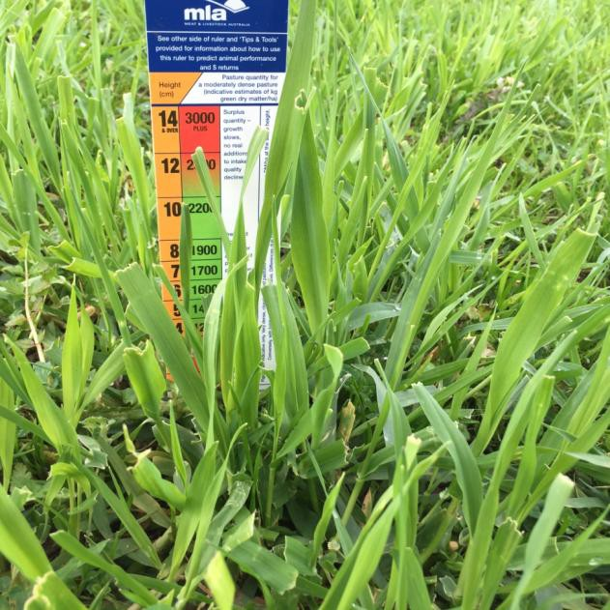
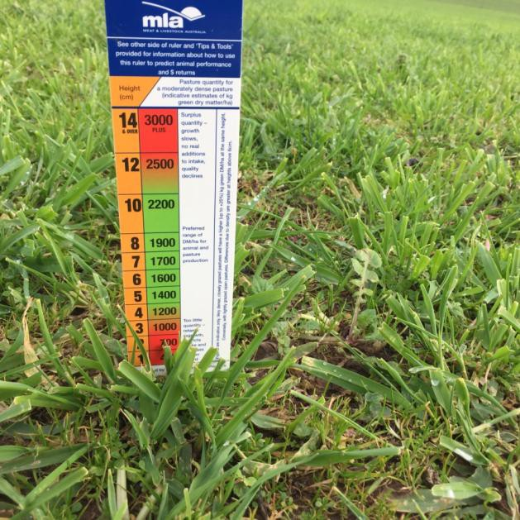

Fig. 9: Untreated replicate at Cuyuac Fig. 10: GA replicate at Cuyuac, eight days after treatment

2017
Growing conditions in 2017 were very favourable and DM harvested was much higher than in 2016 for both the GA and Nil replicates as illustrated in Table 2 and Figure 11.

Table 2: Dry Matter and phalaris prior to treatments in 2017
Demonstration site | Green pasture availability at treatment  (kg DM/ha) | Estimated Phalaris content  (%)
Cuyuac | 1400 | 32
Jallukar Park | 1400 | 57
Millbanks | 1100 | 50
Overdale | 1700 | 57
Tottington | 1400 | 35
Average | 1400

Fig. 11: Average additional Dry Matter produced (kg DM/Ha) from GA application, compared to Nil in 2017

The replicates were mown and the extra pasture grown, compared to 2016, reflects the good growing season experienced in 2017 (Figure 11).
2018
A late autumn break reduced the amount of dry matter and leaf area of the phalaris plants at the time of application (Table 3).

Table 3: DM and phalaris content of reps (incl. bare ground) prior to treatments
Demonstration site | Green pasture availability at treatment  (kg DM/ha) | Estimated Phalaris content  (%)
Cuyuac | 1100 | 50
Marenda | 900 | 20
Millbanks | 900 | 35
Overdale | 1100 | 30
Tottington | 1200 | 30
Average | 1020

Figure 12, on page 14, shows the additional dry matter produced by the GA treatments compared to Nil treatment for each of the five sites. The application of GA at the Overdale site was later (August 2nd) than at the other sites to test the proposition that GA may be used as a tool to promote growth in late winter in phalaris pastures during years of predicted below average rainfall.

Fig. 12: Average additional Dry Matter produced (kg DM/Ha) from GA application compared to Nil in 2018, across all sites.
The site at “Overdale” east of Stawell had the GA applied later in winter (August 2nd) after the BOM prediction of lower than average spring rainfall.
The rainfall prediction was accurate with only 7.6 mm recorded at nearby Stawell in September and the available soil moisture declined as evidenced by the recordings in the PPS soil moisture probe network which has two sites near Stawell.

Figure 13, below, shows the additional pasture grown at the Overdale site in the 21 days post-treatment. Pasture cages were placed in the paddock to measure the rest of the spring growth. Extra pasture was grown in the GA treatment over both periods averaging an extra 52 kg DM/ha in August and an extra 60 kg DM/ha in spring.

October DM
August DM

Fig. 13: Average additional Dry Matter produced (kg DM/Ha) in August and November from GA application compared to Nil in 2018, at Overdale, Concongella.

4.1.2 Pasture Composition
Visual pasture composition counts were undertaken in spring in each year of the demonstration. No significant differences in the percentage of phalaris (Figures 14, 16 and 18) or sub clover (Figures 15, 17 and 19) were measured at any of the sites due to the treatments.
The results were confirmed by a second measurement using the pasture stick technique.

2016

Fig. 14: Proportion of phalaris in the pasture for each site and treatment, 2016.

Fig. 15: Proportion of sub clover in the pasture for each site and treatment, 2016.

2017

Fig. 16: Proportion of phalaris in the pasture for each site and treatment, 2017.

Fig. 17: Proportion of sub clover in the pasture for each site and treatment, 2017.

2018

Fig. 18: Proportion of phalaris in the pasture for the three measured sites, 2018.

Fig. 19: Proportion of sub clover in the pasture for the three measured sites, 2018.

Pasture Quality
2016
Pasture quality tests of energy (as digestibility of Dry Matter and Megajoules per kg of Dry Matter), protein (as % Crude Protein) and Fibre (as Neutral Detergent Fibre) were undertaken on samples collected at four sites when the DM cuts were taken in July. The sample results from the Feed Test laboratory are provided in Tables 4 to 7 for each site.
They showed no feed quality penalty with the GA treatments; all the GA, N and GA + N had a higher ME values than the Nil reps except for the N treatment at Jallukar Park.

Table 4: FeedTest results for treatments at Cuyuac, Nareen in 2016
CUYUAC | Nil | N (urea) | GA | GA + N
Crude Protein (%) | 30.1 | 30.0 | 27.6 | 27.5
Neutral Detergent Fibre (NDF) | 49.6 | 51.2 | 52.1 | 52.2
Digestibility (DMD) (% of dry matter) | 66.4 | 67.6 | 67.8 | 66.8
Energy (MJ/kg DM) | 9.8 | 10.0 | 10.1 | 9.9

Table 5: FeedTest results for treatments at Jallukar Park, Rhymney in 2016
JALLUKAR PARK | Nil | N (urea) | GA | GA + N
Crude Protein (%) | 25.0 | 28.3 | 30.6 | 23.6
Neutral Detergent Fibre (NDF) | 47.7 | 45.0 | 45.1 | 47.5
Digestibility (DMD) (% of dry matter) | 66.5 | 73.5 | 70.2 | 70.7
Energy (MJ/kg DM) | 9.8 | 11.0 | 10.5 | 10.5

Table 6: FeedTest results for treatments at Marenda, Mt Dryden in 2016
MARENDA | Nil | N (urea) | GA | GA + N
Crude Protein (%) | 30.5 | 30.2 | 30.5 | 30.0
Neutral Detergent Fibre (NDF) | 46.7 | 47.0 | 45.7 | 45.9
Digestibility (DMD) (% of dry matter) | 68.3 | 65.8 | 70.4 | 70.1
Energy (MJ/kg DM) | 10.1 | 9.7 | 10.5 | 10.4

Table 7: FeedTest results for treatments at Millbanks, Elmhurst in 2016
MILLBANKS | Nil | N (urea) | GA | GA + N
Crude Protein (%) | 30.2 | 31.5 | 29.7 | 30.9
Neutral Detergent Fibre (NDF) | 50.3 | 48.4 | 49.7 | 49.2
Digestibility (DMD) (% of dry matter) | 58.3 | 64.4 | 67.0 | 66.5
Energy (MJ/kg DM) | 8.4 | 9.5 | 9.9 | 9.8

Total Nitrogen
The Feed Test samples taken in July were tested for total nitrogen; (Table 8). The standard for adequate nitrogen in ryegrass is 3.5 to 5.0 and all sites and treatments were within this range and no trend was observed due to treatment.

Table 8: Total Nitrogen % test results, 2016
 | Nil | Urea | GA | GA + Urea
Millbanks | 4.35 | 4.25 | 4.56 | 4.58
Jallukar Park | 3.59 | 4.42 | 4.21 | 3.67
Cuyuac | 4.62 | 4.89 | 4.30 | 4.64
Marenda | 4.79 | 4.9 | 4.74 | 4.96

Plant Tissue tests
Plant tissue tests were also conducted on phalaris samples collected from the GA and Nil treatments at Millbanks in late October. The results and analysis from the Feed Test laboratory are shown in Table 9. These showed little difference in the major nutrients, but a few differences in the trace elements; note that these are not replicated.

Table 9: Plant Tissue tests, Millbanks site, late October 2016
ANALYSIS | NIL | GA
Total Nitrogen % (Dumas) | 3.3 Marginal | 3.5 Marginal
Phosphorus % | 0.37 Sufficient | 0.32 Sufficient
Potassium % | 3.30 Sufficient | 3.10 Sufficient
Sulphur % | 0.42 Sufficient | 0.33 Sufficient
Cobalt (mg/kg) | 0.09 High | 0.31 High
Molybdenum (mg/kg) | 0.770 Sufficient | 0.530 Sufficient
Selenium (mg/kg) | 0.078 Sufficient | 0.030 Marginal

2017
Pasture feed quality tests were carried out on pasture samples collected at three sites when the DM cuts were taken in July (Tables 10-12). The crude protein levels were lower in the GA treatments but were still above the level required for animal production.

Table 10: FeedTest results for treatments at Jallukar Park, Rhymney, 2017
JALLUKAR PARK | Nil | GA
Crude Protein % | 30.9 | 27.5
Neutral Detergent Fibre % (NDF) | 40.4 | 40.4
Digestibility (DMD) (% of dry matter) | 82.4 | 83.3
Energy (MJ/kg DM) | 12.6 | 12.7

Table 11: FeedTest results for treatments at Millbanks, Elmhurst, 2017
MILLBANKS | Nil | GA
Crude Protein % | 32.2 | 28.7
Neutral Detergent Fibre % (NDF) | 38.5 | 41.6
Digestibility (DMD) (% of dry matter) | 86.4 | 83.2
Energy (MJ/kg DM) | 13.2 | 12.7

Table 12: FeedTest results for treatments at Overdale, Concongella, 2017
OVERDALE | Nil | GA
Crude Protein % | 27.5 | 18.8
Neutral Detergent Fibre % (NDF) | 38.8 | 41.3
Digestibility (DMD) (% of dry matter) | 82.9 | 81.9
Energy (MJ/kg DM) | 12.6 | 12.5

Spring Pasture Quality Test
A feed test was conducted on phalaris plant samples taken from a GA replicate and a Nil replicate at Cuyuac; Nareen in spring on November 9th. Results showed little difference between the samples which suggests that there is no feed quality reduction in using GA during winter (Table 13).

Table 13: FeedTest results for treatments at Cuyuac, Nareen November 2017
 | NIL | GA
Crude Protein (% of dry matter) | 23.1 | 22.3
Neutral Detergent Fibre (% of dry matter) | 43.3 | 42.7
Digestibility (DMD) (% of dry matter) | 79.4 | 77.6
Metabolisable Energy (MJ/kg DM) | 12.0 | 11.7

Figures 20 and 21 show the FeedTest results for energy (as MJ/kg DM) for each treatment at each site for July 2016 and 2017 respectively.

Fig. 20: Feed Tests results for energy as MJ/kg DM) for treatments at each site, 2016

Fig. 21: Feed Tests results for energy as MJ/kg DM) for treatments at each site, 2017.
No samples were taken for feed tests analysis in 2018.

Annual weed reduction demonstration

2016 site results
Cuyuac: Nareen
The treatment at Cuyuac focused on managing annual ryegrass and was set up with three GA replicates and three Nil replicates in a farm laneway. The site received intermittent periods of heavy grazing. No major differences were recorded between the GA and Nil treatments.

Fig. 22: Pasture composition pre-treatment at Cuyuac; June 2016

Fig. 23: Pasture composition at Cuyuac; spring 2016

Jallukar Park: Rhymney
The pasture was an old Australian phalaris stand with a variety of annual weeds in the paddock as illustrated in Figure 24.

Fig. 24: Pasture composition pre-treatment at Jallukar Park; June 2016

Fig. 25: Pasture composition at Jallukar Park; spring 2016

The pasture had three replicates of GA applied on June 25th and was set stocked with ewes, which exerted moderate grazing pressure on the pasture. The initial plan to use the paddock as part of a rotational grazing plan was altered when higher than expected winter and spring growth allowed the ewes to remain in the paddock with more than sufficient feed to meet their requirements for an extended period.
The pasture was assessed prior to treatment on June 20th using the pasture stick method, a spring assessment of both the GA and Nil treatment was completed on October 20th and a visual assessment was also completed. Both methods showed a slight reduction in silver grass (Vulpia spp.) in the GA treated replicates (Figure 25), but it was not considered a sufficient result to be of a consequence to the pasture quality.

Host farmer observations; (Simon Brady)
“The much greater than average winter feed growth meant that we were unable to put the grazing pressure on the paddock that we had planned. There didn’t look to be much difference between the GA and Nil areas, so it was interesting to see the pasture assessments showing a small reduction in silver grass”.

Millbanks: Elmhurst
The annual weed reduction demonstration paddock at Millbanks was the pasture established in 2009 as part of the PPS pasture variety site project funded by the MLA PDS program. It was a Holdfast GT phalaris and sub clover pasture which has proven to be a highly productive pasture since establishment. The pasture had an increase in barley grass in recent years and it was included in the annual weed reduction demonstration to measure any effect that GA application combined with heavy grazing had on the barley grass. The pasture had three replicates of GA applied on June 29th and was stocked with ewes and lambs through late winter and early spring. The results did not show any reduction in annual weed species from the use of GA.

Fig. 26: Millbanks Pasture composition at Millbanks pre-treatment, June 2016

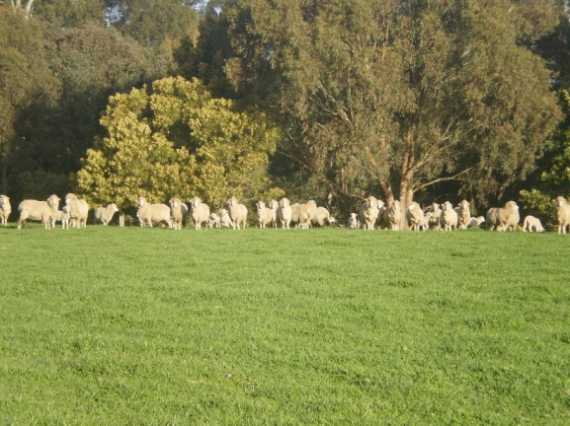

Fig. 27: Picture at Millbanks site 2016

Fig. 28: Pasture composition at Millbanks; spring 2016

Overdale: Concongella
The pasture at Overdale was a 20-year-old Australian phalaris paddock which received a successful onion grass (Romulea rosea) eradication treatment in 2015. The results of this demonstration did not show any meaningful difference in annual weeds between the GA and Nil treatments (Figure 29).

Fig. 29: Pasture composition at Overdale; pre-treatment; June 2016

Fig. 30: Pasture composition at Overdale; spring 2016

Host farmer observations; (Mal Nicholson)
“While we don’t seem to have had much effect on the annual grasses, applying GA to the old phalaris got us a lot more feed, the paddock was grazed with ewes and lambs and the lambs from the paddock averaged 4kg heavier than those from the rest of the farm”.

Tirranna: Mt Cole Creek
The Tirranna pasture was an old phalaris stand with a heavy infestation of silver grass (Vulpia spp.), it was sprayed on June 21st and while site host, Dennis Harrington noted that the sheep initially appeared to favour the GA treated areas, there was no noticeable reduction in silver grass by the spring.

Fig. 31: Pasture composition at Tirranna; pre-treatment; June 2016

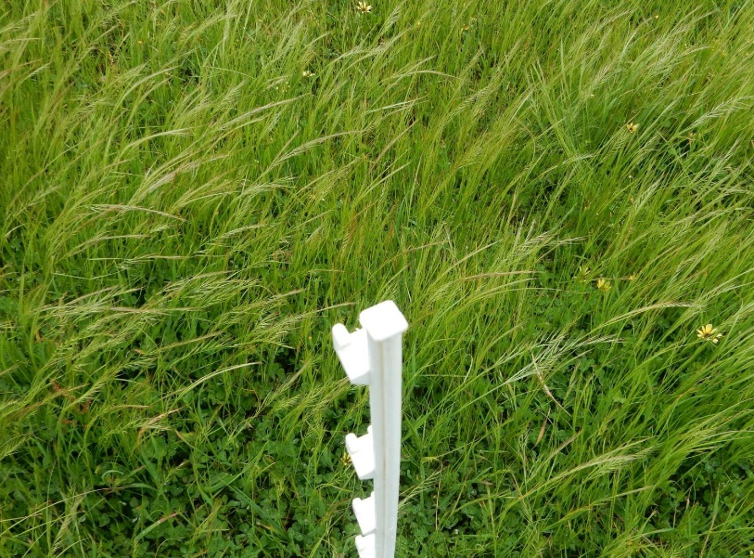Fig. 32: Pasture composition at Tirranna; Spring 2016.
NIL
GA

Fig. 33: Picture of the Annual weed reduction demonstration site at Tirranna, 2016

2017 site results
In 2017 the ‘Annual weed reduction demonstration’ included different GA application rates, varied timing between applications and grazing as well as a comparison between areas of a paddock where hay was cut in the year prior and a section of the paddock not cut for hay.

Cotswold Slopes; Carisbrook
The pasture was an old Australian phalaris stand with a variety of annual weeds in the paddock. The project management team and the host farmer David Dowie designed a two-part demonstration with three treatments on each. Part of the paddock was cut for hay in 2016 to try to reduce annual grass seed set. The rest of the pasture was not cut. Three rates of GA were used on each section of the paddock; ProGibb™ was applied at 10 ml/ha, 20 ml/ha and 30 ml/ha.

Fig. 34: Pasture composition at Cotswold Slopes; pre-treatment June 2017

The pasture was sprayed with GA on the 29th of June with a pasture availability of 900 Kg DM/Ha and was heavily grazed directly post-treatment. The pasture was assessed on October 12th and minor differences in annual weed content were found between treatments (Figures 35 and 36). Both the assessors considered that paddock bias was the most likely explanation and the differences were too low to make any conclusions on any effect of the GA treatments. Regardless of the cause, the reduction was too low to have any positive impact on annual weed reduction in the pasture.

Host farmer observations (David Dowie)
“We really didn’t see any difference in the treatments throughout winter and spring; the sheep didn’t appear to preferentially graze any particular section of the paddock”.

Fig. 35: Pasture Composition in 2017 at Cotswold Slopes in the section not cut for hay in 2016

Fig. 36: Pasture Composition at Cotswold Slopes in section cut for hay post treatment, 2016

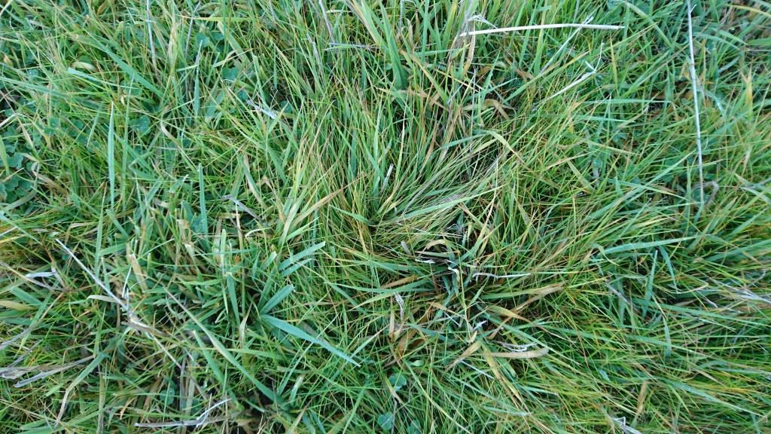

Fig. 37: Pasture at Cotswold Slopes prior to treatment
Lonsdale; Stawell
The pasture at Matt Kindred’s Lake Lonsdale property was an Uplands cocksfoot pasture that was being measured in the PPS Cocksfoot Comparison Project. It was sown in 2009 and there was still a strong stand of Uplands in the paddock. In 2016 and 2017 the paddock developed a substantial infestation of silver grass (Vulpia spp.) as shown in Figure 38.

Fig. 38: Pasture composition at Lonsdale; pre-treatment June 2017

A section of the pasture was treated with GA in June at the standard 10 g/ha when the paddock had a pasture mass of 1400 g DM/ha. No post treatment effect was observed on the pasture composition.

Fig. 39: Pasture composition at Lonsdale, post treatment, 2017

Host farmer observations; Matt Kindred
“The GA had no effect on the silver grass where I sprayed the demonstration strip. I spray topped the paddock in October, hope that does the job”.

Millbanks: Elmhurst
The annual weed reduction demonstration paddock at Millbanks was a pasture established in 2009 as part of the PPS pasture variety site project funded by the MLA PDS program. It was a Holdfast GT phalaris and sub clover pasture which has proven to be a highly productive pasture since establishment. Barley grass has increased in the pasture in recent years and it was included in the annual weed reduction demonstration to measure any effect that GA application combined with heavy grazing had on the barley grass. GA was applied on a section of the pasture on June 29th and was stocked with ewes and lambs through late winter and early spring.

Fig. 40: Pasture composition at Millbanks; pre-treatment June 2017

The treatment had no positive effect on annual grass reduction as shown in Figure 41.

Fig. 41: Pasture composition at Millbanks post treatment, 2017

Tirranna: Mt Cole Creek
The Tirranna pasture was an old Australian phalaris stand with a heavy infestation of silver grass (Vulpia spp.). GA was applied to different sections of the paddock at weekly intervals with the aim to implement varying grazing intervals post-treatment. ProGibb™ was applied at 20 g GA/ha on July 2nd and a different section was sprayed weekly for three weeks. The pasture was grazed in August. No major differences were identified in any of the treatments when compared with the Nil treatments (Figure 43).

Fig. 42: Pasture composition at Tirranna; pre-treatment June 2017

Fig. 43: Pasture composition at Tirranna post-treatment, 2017

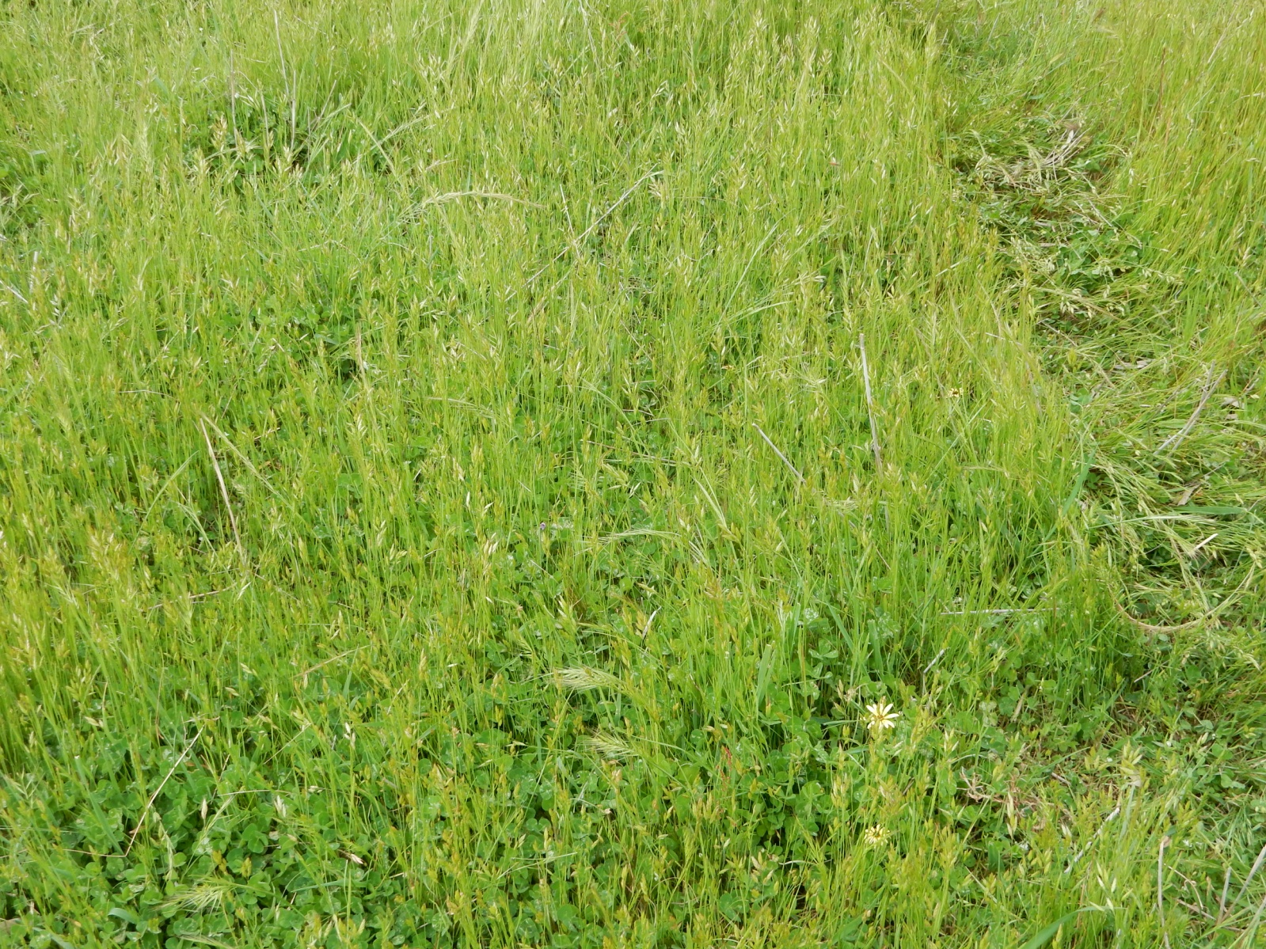
Fig. 44: Pasture at Tirranna post-treatment, still showing a large infestation of silver grass. Tottington; Paradise

The Tottington site was situated in a small area near the Avon River. The pasture had some perennials grasses (phalaris, cocksfoot and kikuyu) as only 4% of the total composition (as shown in Figure 45). Two rates of GA were used; 10 g/ha and 20 g/ha of ProGibb™.

Fig. 45: Pasture composition at Tottington; pre-treatment June 2017

The spring pasture assessment showed little difference between the treatments (Figure 46).

Fig. 46: Pasture composition at Tottington, post-treatment, 2017

4.2.3 2018 site results
In 2018, it was decided to target barley grass (Hordeum leprorinum) at three of the phalaris based pasture production demonstration sites which had barley grass infestation in the phalaris stand (Marenda, Millbanks and Tottington). Two additional treatments were also implemented at the Overdale site targeting various annual weeds. Pasture composition was assessed after seed set in spring to evaluate any difference between GA and Nil treatments.

Fig. 47: Pasture composition at Marenda, Mt Dryden; pre-treatment 2018

Fig. 48: Pasture composition at Marenda, Mt Dryden; post-treatment, 2018

Fig. 49: Pasture composition at Millbanks, Elmhurst; pre-treatment 2018

Fig. 50: Pasture composition at Millbanks, Elmhurst; post-treatment, 2018

Fig. 51: Pasture composition at Tottington, Paradise; pre-treatment 2018

Fig. 52: Pasture composition at Tottington, Paradise; post-treatment 2018
The paddock at Overdale was a six-year-old phalaris based pasture with mixed cultivars; Holdfast, Landmaster and Holdfast GT. A single GA treatment (10 g/ha) was applied to the main part of the paddock and a double (20 g/ha) GA application was applied to a gully area.

Fig. 53: Pasture composition at Overdale, Concongella; pre-treatment, 2018

Fig. 54 Pasture composition at Overdale Gully, Concongella; pre-treatment, 2018

There was no noticeable difference in the pasture composition in late spring between the GA and double GA treatments suggesting that there was no effect on the target weeds i.e. brome and barley grass.

The paddock was heavily grazed after the GA treatment and the farmer observed there was a noticeable effect on the corkscrew (Erodium spp.) in the paddock. The sheep appeared to find it palatable in late August around a month after the GA application, which restricted the number of plants that were able to produce a seed head. A spring pasture assessment found little difference between the GA and Nil treatments (Figure 54 and 55).
The corkscrew assessment was in a different area of the paddock to the annual weed assessment.

Fig 55: Number of Corkscrew (Erodium spp.) seedlings as plants/m² at Overdale, Concongella; post-treatment, 2018

Discussion

Phalaris based pasture production demonstration

Dry Matter Production
The increase in dry matter production from applying GA in winter was variable between sites and between years. In some cases, the extra feed was considered by the farmers involved as worthwhile and in other cases, the response was minimal.

The highest response to GA application occurred in 2017, but this year had adequate winter pasture availability due to an early autumn break and hence the benefit of extra winter feed was not as useful as in other years.

Differences between sites and years in the proportion of phalaris in the pasture pre-treatment may also have contributed to the variation in responses. Figure 56 indicates that more pasture is grown after GA treatment as the proportion of phalaris in the pasture increases, which is logical if this is the main grass species in the paddock that is responding, but it indicated that the percentage of phalaris required for an adequate response is higher than was anticipated at the commencement of the project. Factors such as DM at treatment, leaf area and cultivar appear to have greater influence on the results than expected.

Fig. 56: The relationship between the percentage of phalaris in the pasture and the DM response to GA at all sites and for each year tested

Fig. 57: Summary of the additional pasture grown (DM) after GA treatments compared to Nil

2016
Whilst above average rainfall was recorded in the region for 2016, the autumn break did not occur until the second week of May. (Figure 58).

Fig. 58: Monthly Rainfall for Stawell; 2016 and long-term average (1981-2010)

The average pasture availability across all sites was 940 kg DM/ha at the time of the GA treatment in 2016. The recommended pasture availability for GA application is 1,000 kg DM/ha at the time of the GA and N applications.
The increase in DM from the GA treatments was fairly low ranging from 68 – 189 kg DM/ha

Nitrogen Fertiliser Response
Nitrogen was applied to the sites in 2016 as part of the demonstration in either liquid form or Urea at an equivalent of 50 kg N/Ha. Nitrogen fertiliser does not produce substantial additional dry matter when the soil temperature is below 4°C (More Profit from Nitrogen factsheet) and therefore does not produce much extra winter feed in Central Victorian pastures. Previous trials have found in winter that 1 kg/ha of nitrogen applied only provides a response of 5 to 1 and can take up to 45 days to produce a useful response (A. Spiers, pers. comm.) It was included in the demonstration in 2016 as the addition of nitrogen fertiliser with GA applications is standard practice in dairy ryegrass pastures in southern Victoria.
The stand-alone N treatment showed that it did not produce useful extra pasture feed when used in mid-winter in all treatments except the GA + N replicates at Jallukar Park, which is most likely an anomaly as indicated by the other site results.

The N treatments were not included in the subsequent years of the demonstration due to the lack of responses found here and in previous trials and because GA response was the main objective of the trial.

Host farmer comments;
Ben & Jodie Greene – Millbanks, Elmhurst
“We have used GA in the past and consider it a useful tool in winter pasture management, but it isn’t the complete answer to winter feed requirements. It is hard to find paddocks in tough winters to take out for the three-week period to allow the GA to take full effect so that needs to be considered when planning feed requirements.

Simon Brady – Jallukar Park, Rhymney
“I have been using GA for a few years now and it is part of our winter pasture management. We had good late autumn rains this year, so we had more feed going into winter and the paddock where we did the demonstration had more growth than in a normal year prior to the GA. We had a great result and it was still responding to the GA after the measurement date, so we grew even more feed than what was recorded in the dry matter results”.

Andrew Edgar – Cuyuac, Nareen
The paddock grew a lot of feed and carried a large number of ewes through the lambing period in what was a cold, wet winter. We use GA regularly and regard it as a useful tool in our pasture management. We also use nitrogen on pastures in early winter when conditions are suitable and produce more additional feed than with GA applications”.

Charlie & Rich de Fegely – Quamby, Dobie
“Even though we had good late autumn rains, the feed didn’t get away quickly on our heavy basalt soils and things did get a bit tight in mid-July. We applied GA to the rest of the paddock where the demonstration site was and even though we didn’t grow a lot of extra feed, it was sufficient to get a week’s grazing and allow a couple of other pastures to get a GA application and continue with our planned paddock rotation. The kg DM/ha in the paddock at application was below what we would normally be planning for, but the GA was still a help”.

2017
An early autumn break produced good pasture growth which continued throughout the growing season.

Fig. 59: Stawell Rainfall 2017

The sites had an average of 1400 kg DM/Ha at the time of the GA treatment; 2017 produced the highest gain in DM through the use of GA in the three years of the demonstration. There was a large variation in the results with DM increase ranging from 102 kg DM/Ha to 365 kg DM/Ha. In most cases the extra feed grown was surplus to the winter requirements on the host farm.

Host farmer comments
Simon Brady - Jallukar Park, Rhymney
“We have had two years of great pasture growth; unusually things have been quite wet here. I probably didn’t need the extra feed from the GA this year but wanted to continue seeing the results of the project”.

Mal Nicholson & Sue Holden – Overdale, Concongella.
“It got very dry in June, which may have affected the pasture growth, it looked like a fair difference between the GA and the Nil, but the overall DM results are a bit on the low side”.

Tom & Jenny Small – Tottington, Paradise.
“We were later than the other sites in applying the GA; not by choice as our whole family got caught by the flu outbreak. Like Mal, I was a bit disappointed by the low overall DM in both the GA and Nil plots”.

Ben & Jodie Greene - Millbanks, Elmhurst
“I was rather disappointed with the result when a low Nil result was taken out of the equation. I am looking forward to next year’s results to see how they line up”.

2018
2018 had below average rainfall in all months at the time of the final report preparation (Jan – Nov) and the autumn break was in mid-May.

Fig. 60: Stawell Rainfall 2018

The increases in DM from the GA applications were low (range 38 – 100 kg DM/Ha); two of the demonstration paddocks were below the recommended 1,000 kg DM/Ha at the time of application. The density of the phalaris in the paddocks was less than optimum and this also contributed to the low DM increases.

Host farmer comments
Ben & Jodie Green – Millbanks, Elmhurst.
“If we are going to lock up a paddock in our system for 3 weeks (GA or not), you are going to grow feed. At this time of year there is a cost of that and needs to be considered against the cost of the GA treatment.”

Mal Nicholson & Sue Holden – Overdale, Concongella.
Mal would use GA again. “It has its place, but wouldn’t use over the whole farm, would use as a tool.”
“Might use GA late again, as per the demonstration at our farm this year, if the year warrants it.”

Andrew Edgar – Cuyuac, Nareen.
I would not use GA by itself again. “I’m glad I did the demonstration; however, it seems to slow the growth down in early spring and therefore the benefit doesn’t warrant it. I plan to use urea in the future instead. Late August/early spring is a critical point, so not good when GA paddocks are behind at this point.”

5.1.2 Pasture Composition
The pasture composition counts showed no noticeable effect on pasture composition where GA was applied compared to the Nil treatments, when assessed in the spring of each year of the demonstration. This would suggest that there is no adverse response to using GA in phalaris based pastures.
This was reinforced by a case study on a dairy farm near Casterton which has used GA on a long-term basis. The case study is included as Appendix G to the final report.

5.1.3 Pasture Quality
Crude Protein
There were variable differences in crude protein levels resulting from GA in 2016. The Cuyuac site had a crude protein result 2.5% lower in the GA treatment, whilst the Jallukar Park site had a crude protein 5% higher in the GA treatment. The other two sites showed only small differences. As no consistent result was seen, no conclusion can be drawn on the differences between treatments.
In 2017 all four sites had a lower crude protein in GA treatments, although caution needs to be used as one crude protein result (Overdale) seems to be an outlier in the results.
Despite any differences in the crude protein across the treatments, all results are more than adequate for lactating ewe requirements which is the main target livestock group for any extra feed growth generated from GA application.
(Making More From Sheep, Tool 11.1)

Energy
For the four 2016 samples, the metabolizable energy (ME) was lower for the Nil treatments. In contrast, in 2017 the Nil treatment at one of the three farms had a higher ME and the other two farms had about the same ME for both the Nil and GA treatments.
Overall, the feed quality and plant tests showed no consistent differences between sites when the GA and Nil treatments were compared. This suggests that any differences which did occur were due to other factors rather than the GA application.

5.1.4 Dry winter Use
Measurements at Overdale in 2018 showed an average increase of 112 Kg DM/Ha in the GA replicates, which indicates that the method could be of value in these seasons. It is important to note that grazing of the pasture should cease when the pasture dry matter falls to 800 Kg DM/Ha to maintain ground cover and aid phalaris persistence.

5.1.5 Effect on spring growth
Except for the Overdale site in 2018, the project management team did not carry out any spring growth measurements. However, research has shown that there is often an initial increase in growth from GA, followed by a phase of reduced growth, suggesting a depletion of reserves (Williams and Arnold 1963). Host farmer, Andrew Edgar commented that he found this on his farm.
It should be noted the project objective was to assess the winter pasture growth benefits of GA and not spring.

Economic analysis
Georgie Thomson, Agriculture Victoria; Geelong provided an economic analysis of the project

Benefit Cost Analysis:
The following uses a partial budget economic analysis and identifies the additional benefits and costs of applying GA relative to the status quo (feeding grain to match equivalent kilograms (kg) dry matter (dm) per hectare (ha) grown).

The benefit cost presented is based on a per hectare basis. The economic analysis does not look at changes to profits for the whole farm system. There is the option of buying feed barley or spraying Gibberellic Acid (GA), no capital or pasture development is involved in this analysis as treatment was on established pastures.
The additional costs included were:
- Boom spray application costs valued at contract rates
- GA treatment

The additional cost of resting the pasture for 21 days was not included as it was assumed the rest period could fit within the grazing rotation.

The additional benefit from applying GA was the additional pasture availability for livestock grazing during winter. The annual increase in pasture availability was averaged over the three-year period.

Assumptions:
The analysis focussed on the increase of pasture grown, as kg DM/ha, following GA treatment compared to substituting additional pasture grown with feed barley. The assumptions used for the costs of GA application, feed grown in response to GA; feed costs and equivalent feed barley required to replace the extra feed grown, are outlined in Table 14. The energy value of the pasture in winter was assumed to be 10.1 megajoules (MJ)/kg DM and feed barley to have an energy value of 13 MJ/kg DM. Therefore, a quantity adjustment of 23% is required to reduce the quantity of feed barley required to equal the MJ/kg DM that otherwise was on offer in pasture. Pasture has been valued based on the long-term average of $248/t and increased price of $345/t in October 2018 for feed barley.

Table 14: GA Treatment Assumptions
 | Additional Benefits | Additional Costs | Break Even
Increase in kg DM/ha | 133kg
Grain substitution quantity adjustment for pasture @ 23% kg dm/ha | 102kg
Value of pasture
Feed Barley $248/t | $25.40/ha
Feed Barley $345/t | $35.34/ha
GA Treatment
Rate 10 g/ha |  | $7.43
Application cost |  | $15.00
Total |  | $22.43
Net Benefit
Feed Barley @ $248/t | $2.97 |  | 117 kg DM/ha
Feed Barley @ $345/t | $12.91 |  | 84 kg DM/ha

Sensitivity Analysis
The analysis in Table 15 identifies the net benefit of GA treatment based on kg DM/ha produced compared with feed barley prices. For example, where an extra 200 kg DM/ha of pasture is produced from GA application, there will be a net benefit of $8.40 compared to feeding barley at $200/t, or where only 50 kg DM/ha additional pasture is produced, GA treatment will cost (or run at a loss of) $9/ha when barley prices are $350/t.

Table 15: Sensitivity analysis GA Treatment Cost Benefit Analysis
 |  | Pasture Growth Kg DM/ha
 |  | 0 | 50 | 100 | 150 | 200
Feed Barley Price  $/t | 150 | -$22.40 | -$16.70 | -$10.9 | -$5.1 | $0.7
 | 200 | -$22.40 | -$14.70 | -$7.0 | $0.7 | $8.4
 | 250 | -$22.40 | -$12.80 | -$3.20 | $6.4 | $16.1
 | 300 | -$22.40 | -$10.9 | $0.7 | $12.2 | $23.8
 | 350 | -$22.40 | -$9.0 | $4.5 | $18.0 | $31.5

Key Decision Drivers:
Generally, the analysis indicates that winter pasture response to GA needs to be at least 150 kg DM/ha for most barley price scenarios or 100 kg DM/ha extra when barley prices are very high (i.e. above $300/t). More precisely the analysis estimated that the break even on GA treatment cost, 117kg DM/ha would need to be produced based on long-term average feed barley prices or 84kg DM/ha based on Oct 18 prices.
The proportion of phalaris in the pasture, soil moisture and timing of the autumn break will affect how likely this is to occur.

GA treatment would be worthwhile if implemented as part of a rotational grazing system to optimise the increase in kg DM/ha with pastures destocked for 21 days post-treatment. However, treatment of GA should be strategic to take advantage of seasonal conditions, adequate soil moisture and when grain prices are high.

The three-year demonstration resulted in 133 kg DM/ha or net benefit of $2.97/ha based on the long-term average feed barley prices and $12.91/ha based on Oct 18 prices.

With a GA treatment cost of $22.43/ha this would be a worthy feed option compared to grain feeding at Oct 2018 grain prices of $35.19/ha.

Where variables discussed justify GA treatment consideration should also be given to the increase in cost of labour required for supplementary feeding.

Annual weed reduction demonstration
The annual weed reduction demonstration sites failed to replicate the effect seen on silver grass at Overdale in 2014. It also failed to produce any meaningful reduction in the other targeted annual grasses; barley grass and annual ryegrass.

There are four possible explanations for the failure of the treatment to produce the desired results in relation to the observed effects on silver grass.
- The timing of the GA treatment may not have been at the time when the silver grass was vulnerable to being “grazed out” after a period of induced growth.
(2) The GA treatment may have had a growth and/or palpability effect on the silver grass but there was insufficient grazing pressure able to be applied to affect the annual weeds.
(3) The interval between the GA treatment and grazing pressure may not have been the ideal time to impact the silver grass.
(4) GA and grazing does not influence annual weed grasses in perennial pastures.

As there was no difference in annual weeds at any of the sites over the three years, despite introducing new treatments with variations of GA rates and timing of sprays; the conclusion is that the demonstration has addressed the first three possibilities. Therefore, point four is the likely explanation – it doesn’t work!

The 2018 GA demonstration paddock at “Overdale” Concongella had an infestation of Corkscrew (Erodium spp.) estimated to make up 15% of the total pasture composition. Observations after GA treatment showed that that corkscrew plants “stood up” and were very accessible to the sheep which started to graze the pasture three weeks after treatment. The paddock was heavily grazed and many of the corkscrew seed heads appeared to have been consumed. Cages were placed on the GA and Nil replicates and assessment of the number of plants that produced seed heads in November showed little difference between the GA and Nil treatments. This response has also been observed on capeweed (Arctotheca calendula) by PPS members.

PPS will continue to assess the observed corkscrew and capeweed responses as part of the PPS project ‘Annual Grass control strategies in perennial pastures’ which is part of the MLA/ Agriculture Victoria EPDS program. PPS will also implement a site within the project to further test the response to GA on corkscrew in an infested pasture.

Adoption
One of the objectives of the demonstrations was to develop best practice guidelines for the use of GA in the region which would increase the uptake of the technique, thereby increasing available winter feed and improving animal nutrition and production.

The findings of the demonstration have been summarised and included along with technical information and recommendations for effective use of GA in phalaris based pastures as guidelines for use in the drier central region of Victoria (Appendix A).

A second objective was to have half of PPS member farms using GA to increase winter feed production by the end of the project.

While the use of GA on phalaris has increased growth in the phalaris plants, the overall increase in total pasture DM produced in most of the demonstration sites suggested that its use is most effective in pastures with at least 40% phalaris. This has reduced the adoption in older stands of phalaris where the plant density is below this.
This objective has not been met; however, PPS members are now aware of the benefits and limitations of the effective use of GA.

The third objective was to have all PPS members aware of the potential use of GA to increase winter feed production.

The extension of the demonstration results has made all PPS members aware of the possible benefits of GA to increase winter feed availability. Appendix B outlines all the extension activities conducted to share and discuss results with PPS members. The final report and best practice guidelines will be distributed to all PPS members, which will provide information to help them make informed decisions on GA use prior to the winter period of 2019.
Appendix C includes the feedback from host producers about what they learnt throughout the demonstration, their insights about using GA and their thoughts about being involved in the demonstration. Most people interviewed said they would use GA again, however for strategic purposes rather than as a blanket application. Everyone interviewed agreed that the GA was easy to use.
Appendix D shows the results of the pre and post Knowledge, Attitude, Skills, Aspirations and Adoption (KASAA) survey. This indicates the shift in KASAA around the use of GA, brought about by the demonstration. The biggest change was in participants’ knowledge of GA and its impact, use for growing feed and use for managing annual grasses (70-100% increase). There was also a shift in attitude, skills, aspirations and adoption (ranging from 25-58% increase).
CSIRO’s Adoption and Diffusion Outcome Prediction Tool (ADOPT) model was used at the results evening to predict the likely adoption of GA based on the demonstration results. The full report can be found in Appendix E. The model found the predicted peak level of adoption was 47% and it was predicted that it would take 17 years to peak adoption is reached.

Conclusions/recommendations

Phalaris based pasture production demonstration
In October 2018, the management team presented the results to a focus group of PPS members and these conclusions and recommendations incorporate the feedback from the participants.

PPS considers the use of GA as opportunistic rather than strategic in lower rainfall regions on phalaris based pastures due to vastly different yearly growth patterns as a result of variable autumn breaks and subsequent pasture availability on farm. This affects the ability to fit in GA treatments and the recommended period of destocking into the farm rotation. Seasonal conditions, soil moisture, available feed on offer and the cost of grain if supplementary feeding should be considered when deciding on possible GA applications.

The three-year demonstration resulted in 133 kg DM/ha increase in pasture grown after GA application averaged over the sites, or a net benefit of $2.97/ha based on the long-term average feed barley prices and $12.91/ha based on October 2018 prices. With a GA treatment cost of $22.43/ha this would be a worthy feed option compared to grain feeding at October 2018 grain prices of $35.19/ha

A sensitivity analysis concluded that to break even on GA treatment cost, 117kg DM/ha would need to be produced based on long-term average feed barley prices or 84kg DM/ha based on Oct 18 prices.

GA applications on phalaris pastures in Central Victorian sites did increase winter pasture production but many phalaris based pastures do not have sufficient phalaris plant density to produce economic amounts of extra dry matter. PPS estimates that phalaris needs to make up at least 40% of the total pasture composition to make a GA application worthwhile. Even highly productive phalaris and sub clover-based pastures may contain less than 40% phalaris.

GA applications do not appear to have any negative medium or long-term effects on pasture quality or composition.
The project conducted a case study on a farm with a history of long-term GA use which confirmed this; it is in Appendix G of the final report.

Previous trials have shown that due to the erect form of the extra feed grown with GA applications, an estimated 90 to 100% of it can be utilised by stock compared to <70% utilisation of feed grown without treatment (A Speirs; pers. comm.).

The use of GA later in winter in dry years to enable maximum growth of phalaris before soil moisture becomes limiting appears to be a potential tool where winter dormant forms of phalaris e.g. Australian, are the perennial species. However, in a tight year, or year of poor autumn/winter pasture growth, GA often needs to be applied at the point of lambing and it is hard to identify paddocks, especially those with > 1,000Kg DM/Ha, that GA can be applied, and the paddock destocked for the recommended three-week period.

In good years where winter pasture feed is not limiting, the application of GA may have a higher response than in dry years but is less likely to be of net value if the extra feed cannot be utilised. However, increasing stocking rates through animal type or reproduction for example, may lift requirements for winter feed. After observations made in New Zealand during the 2015 PPS Annual Study Tour, many members are aiming for 1700 kg DM/Ha in phalaris based pastures for lambing. GA applications could assist in this process.

GA needs to be applied under the following best practice conditions for maximum benefit (A Speirs; pers. comm.).
Timing: -
Air temperature is below 15°C
Pasture with at least 1,000 kg DM/ha of green matter.
Available water is non-limiting (pasture growing well).

Paddock requirements: -
Strong perennial phalaris based pasture.
Ensure that soil fertility is non-limiting.

The demonstration indicates that further demonstration or trial work is needed to strengthen the recommendations for GA use on phalaris based pastures to assist producers to make positive economic decisions on GA usage.

More research is needed to assess production and economic gains in sheep and beef cattle systems in Southern Australia to assist producers make decisions regarding the use of GA on perennial grass-based pastures.

Annual weed reduction demonstration
The three years of the annual weed demonstration indicated that GA applications and follow up grazing did not suppress annual grasses such as barley grass (Hordeum leporinim), soft brome grass (Bromus mollis) and the main target species silver grass (Vulpia spp.) or have any impact on pasture composition.

It may have had an effect on Corkscrew (Erodium spp.) and capeweed (Arctotheca calendula). PPS will continue to study the effect seen in this demonstration in 2018 in the group’s Annual Grass control strategies in perennial pastures project which is part of the Agriculture Victoria/MLA EPDS program.

Bibliography
Australian Wool Innovation, Meat & Livestock Australia, date N/A, Making More From Sheep, Tool 11.1 Energy and protein requirements of sheep.
Conboy C. and Speirs A. (2009) Gibberellic Acid on Phalaris Trial Quamby, Dobie; Unpublished
Lamp C. And Collet F. (1976) A field guide to weeds in Australia. Inkata Press P/L
More Profit from Nitrogen Project, Best Management Practices for Nitrogen (N) Use on Dairy Pastures, viewed 20 November 2018, http://www.dairyingfortomorrow.com.au/wp-content/uploads/BMPs-for-N-use-on-dairy-pastures-MPfN-2018-.pdf
Sumitomo Product Information, ProGibb SG product information, viewed 5 November, 2018, www.sumitomo-chem.com.au
Vicchem Product Information, Gala product information, viewed 5 November, 2018, www.vicchem.com
Williams C.J. and Arnold G.W. (1963) Winter growth stimulation by gibberellins in differentially grazed pastures of Phalaris tuberosa. CSIRO
8 Acknowledgements
PPS wishes to acknowledge the following people for their assistance with the PPS GA demonstration project.

PPS Project Advisory Group:
Simon Brady, Jodie Greene, Dennis Harrington

Host Properties:
Cotswold Slopes; Cotswold Cuyuac; Nareen Jallukar Park; Rhymney Lonsdale Pastoral; Stawell Marenda; Mt Dryden Millbanks; Elmhurst
Overdale; Concongella Quamby; Dobie Tirranna; Mt Cole Creek
Tottington; Paradise

Project management:
Rob Shea; PPS Project Manager & Rachael Campbell; Agriculture Victoria, Ballarat

Project economic review
Georgie Thomson; Agriculture Victoria

Site selection assistance:
Tim Leeming

Project design and advice:
Andrew Speirs; Meridian Agriculture, Casterton

Mapping;
Paul Skeen & Wimmera CMA – GIS Team

Project measurement assistance:
Lisa McDonald, Peter Flavel, Daryl Kirkwood, Bec McLellan, Jade Chan; Meridian Agriculture, Casterton

Final report review
Jane Court; Agriculture Victoria, Bendigo

Project coordination assistance:
Martin Dunstan, Gervaise Gaunt & Bindi Hunter; Agriculture Victoria, Renelle Jeffery: MLA

9 Appendices

Note appendices can be obtained by contacting MLA at reports@mla.com.au
Appendix A - Best Practice Guidelines Factsheet 2
Appendix B – Extension Activities 3
Appendix C: Summary of survey responses from participants: 4
Appendix D: Knowledge, Attitude Skills, Aspiration and Adoption Survey (pre and post) 7
Appendix E –The Adoption and Diffusion Outcome Prediction Tool 9
Appendix E PPS GA Demonstration; Individual Paddock DM results 17
Appendix F – Long term use of GA; case study 22
Appendix G – GA demonstration design ………………………………………………………………………………..23

DISCLAIMER
This publication has been prepared in good faith on the basis of information available at the date of publication.
Readers are responsible for assessing the relevance and accuracy of the content of this publication. PPS will not be liable for any loss, damage, cost or expense incurred or arising by reason of any person using or relying on the information included in this publication.

