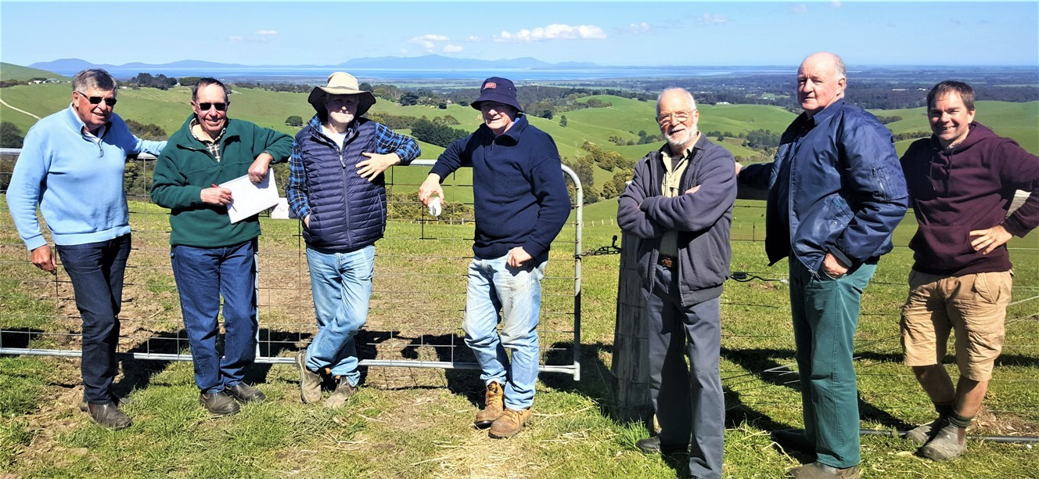
Some of the Buffalo BetterBeef Group, at David and Linda Hall’s property, view to Wilson’s Prom, September 2019
Coordinator – Malcolm Cock, Farm Dynamics
Group – Buffalo
- 14 businesses, with approximately 100 to 1800 head cattle at 20 to 30 dse/ha, with average rainfall of 1000 ml per annum.
Enterprise mix
- Breeding and finishing pasture-fed cattle. Some sheep and prime lamb businesses.
Main areas of risk in a farming business
Buffalo BetterBeef Group Coordinator Malcolm Cock brought the topic of ‘risk management’ into focus for the group. He said that as farmers we work in a high-risk business yet very few producers have a business plan that includes a comprehensive risk management section incorporating health (including mental health) and safety. As a result, the Buffalo group have made risk management a priority, resulting in some changes to their approach and practices.
The seven main areas of risk in a farming business are:
- Workplace health and safety – family, staff, contractors and visitors
- Partner relationships – spouse, wider family, or business partner
- Business management practices – affecting people, production and profit
- Market access and commodity – price fluctuations
- Weather and climate – variability, enterprise suitability
- Biosecurity – pests, plant and animal disease
- Financial – cashflow, income, costs, off-farm income and capital gains tax.

Malcolm said the two areas of risk most often considered by farmers are market prices and weather/climate, due to the significant impact they can have on a business. “While we as managers have little control over these factors, with good proactive management we can mitigate the consequences. However, the top two risks – workplace health and safety and partner relationships – often receive far less attention yet the consequences to people and the business can be severe and are likely to occur more often.”
In a group session on farm safety, a representative from WorkSafe Victoria was invited to discuss this topic and demonstrate a farm safety audit. Following that session, Malcolm said members carried out safety audits on their farms, with some seeking the assistance of a WorkSafe representative.
“They don’t come in with a big stick or to criticise, they are there to help, such as noting the need for a guard on a PTO shaft. Things get more serious however, when an accident has happened which could have been prevented with a few measures in place.”
Quad bike safety was raised in the session and a few of the members later applied for the safety rebate (applications are now closed). One group member, David Hall, had already fitted operator protection devices to his three quad bikes. This proved to be a worthwhile investment when David later experienced a quad bike roll over himself. He was very grateful he had them in place.
According to WorkSafe assessing risk is not just for, and about the farmers themselves, it also includes family members, staff and contractors. Worksafe also recommends inducting all contractors onto the farm. A checklist to assist farmers to do this was a suggested method. Group member David Hall has a sign at his main gate requiring all visitors and contractors to report to the house for further checks and safety protocols.
Another member, Rob Liley, said “In rural businesses we are exposed to a variety of safety risks, from infections such as brucellosis through to how you get out of a tractor.” While he maintains individual common sense is crucial, he makes sure incoming visitors follow farm safety and biosecurity measures. Additionally, for contractors, Rob provides a farm plan, noting high-risk areas such as steep ground. All the paddocks are clearly named on the gates. “It does help to educate people when they come onto the place, and these BetterBeef group sessions help awaken you to looking at new things,” Rob said.
The WorkSafe website has an ‘agriculture’ area, with many useful resources for farmers.
- www.worksafe.vic.gov.au/agriculture
In February 2020, a Buffalo BetterBeef workshop was held for the general farming community, focussing on farmer health and safety. Positive feedback was received from attendees. Representatives from the National Centre for Farmer Health presented on maintaining physical and mental health, accounting for how our bodies and minds change over time and circumstances. “As farmers many of our tasks are familiar and automatic and we don’t often notice the changes, unless ill health or accidents force us to,” Malcolm said.
The Buffalo group often discuss farm activities and decisions and their associated risks. A risk matrix can help rate and consider the likelihood of something happening, and then the consequences if it does. Examples of where the matrix can be been applied for health and safety are stock yard design or purchasing a quad bike compared with an ATV.
Malcolm said: “If we are aware of the risks and consequences, we are more likely to make better informed decisions and act on them.”
“Applying risk management principles in a farming business includes recognising what’s in our comfort zone, and whether we are proactive or resistant to change. It’s about identifying the source of the risk and then putting strategies in place to limit the likelihood of it happening or minimising the consequences. Good risk management plans are a positive tool for farm business success, and far better than keeping our head in the sand.”

