Careers in STEM
  - (Science, Technology, Engineering and Mathematics)
  - Find solutions to real-world challenges while also finding self-fulfilment through a meaningful and future-shaping career.
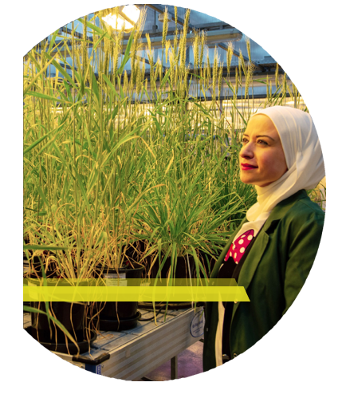

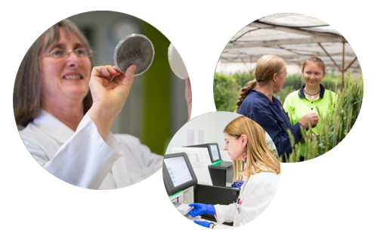

STEM
Science, technology, engineering and mathematics are high-demand skills that are essential to the future wellbeing of Victoria and the broader global community and environment.
The job market is transforming rapidly, and demand for STEM skills and knowledge is increasing. It is projected that 75 per cent of emerging jobs will require skills in STEM. A career in STEM means providing solutions to current and future challenges, while also empowering individuals through meaningful and future-shaping careers.
Within the field of agriculture, STEM skills are fundamentally important as we face a diverse range of challenges like climate change, food security, sustainable production and biosecurity in the years to come. A STEM career in agriculture might involve aiding in national biosecurity, or developing more drought-tolerant crops for the future.
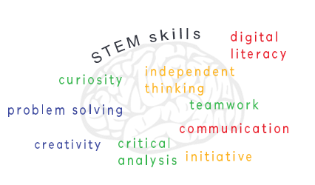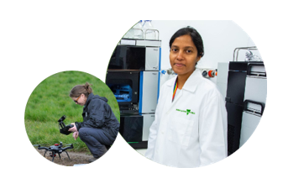

A career at Agriculture Victoria:
Research and innovation
Agriculture Victoria’s research and innovation team at Agriculture Victoria Research offers career opportunities across a range of STEM skills and levels with work outcomes providing solutions to the most essential challenges agriculture is facing now and into the future.
Our scientists and staff are integral to meeting the challenges of climate change and food security within the industries of grains, dairy, horticulture, red meat, biosecurity and emerging new industries.
Based at state-of-the-art facilities across Victoria, we are diverse in skill sets and backgrounds with speaking staff drawn from more than 35 countries, collectively more than 50 languages. We are proud of our representation of women in STEM with a staff gender ratio of 50:50. We are committed to maintaining and building diversity in our workforce, while also providing flexible work arrangements to support staff in all stages of life.
Agriculture Victoria Research is proud to be at the forefront of innovation that has real impact locally and across the globe.
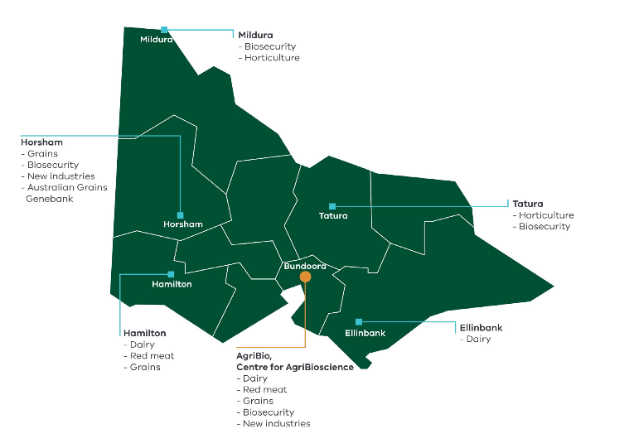
Above map: Agriculture Victoria Research sites in Victoria and their focus industries
- AgriBio, Centre for AgriBioscience, Bundoora (Dairy, Red meat, Grains, Biosecurity, New industries)
- Horsham (Grains, Biosecurity, New industries, Australian Grains Genebank)
- Hamilton (Dairy, Red meat, Grains)
- Ellinbank (Dairy)
- Tatura (Horticulture, Biosecurity)
- Mildura (Biosecurity, Horticulture)
  - Make a difference
Agriculture Victoria Research works closely with industry leaders to maintain and enhance Australia’s food system.
Head of Agriculture Victoria Research, Professor German Spangenberg highlights, ‘I am proud of the diverse workforce at Agriculture Victoria Research that has made possible the achievement of real outcomes for the state of Victoria and beyond’.

STEM career snapshots
  - Dr Sally Norton, National Leader, Australian Grains Genebank, Horsham
Dr Sally Norton is the Leader of the Australian Grains Genebank, the national program that stores seeds for historical and current varieties of grain crops grown by Australian (and some international) farmers. Importantly, these seeds will be the parents of varieties that will be grown into the future.
“I love what I do – I love the huge diversity of seeds that exist around the world, and I really love that I have the privilege of working in an area that makes a real difference in global food security. I am proud to have developed the Australian Grains Genebank from the ground up into a now highly respected and recognised national and international program. I work with a great bunch of people who have different perspectives and personalities, which make working together very rewarding. I really enjoy encouraging and watching my team develop and take the initiative to improve what we do. While pursuing my career goals, I have also had the flexibility to be involved in my kids’ school activities, as well as taking some time out for myself.”
  - Career Pathway
- Bachelor of Agricultural Science, La Trobe University, Melbourne
- PhD, Southern Cross University, Melbourne
- Scientist and Curator, Australian Tropical Crops and Forages Collection, Queensland
- National Leader, Australian Grains Genebank, Horsham
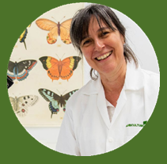
  - Dr Isabel Valenzuela-Gonzalez, Research Scientist, Microbial Science, Pest & Diseases, AgriBio
Dr Isabel Valenzuela-Gonzalez is an entomologist or in her words a ‘bug woman’. She conducts research to strengthen Agriculture Victoria’s diagnostic capability for detecting and managing insect pests. Her work greatly benefits farmers and the future of food security in Victoria and across Australia.
“I was born to work with insects. With many million different species on Earth, I will never get bored. I love my work and have been able to contribute to national biosecurity initiatives such as honey bee protection. This work has also taken me to many places. I grew up on a self-sustaining farm in Spain; I have worked with bumble bees in the Netherlands, and I now work in Victoria where I also own and operate a hobby farm in the Wimmera. I also spent time in Papua New Guinea, where I worked with the confectionery company, Mars, to collect and identify moths that caused significant damage to cocoa plantations throughout South-East Asia.”
  - Career Pathway
- Bachelor of Biological Sciences, University of Alicante, Spain
- PhD research placement, Koppert BV, Netherlands
- Technical Assistant, Entomology Diagnostics, Department of Primary Industries, Melbourne
- PhD: A molecular analysis of aphids in South Eastern Australia, The University of Melbourne
- PhD placement, Mars, Papua New Guinea
- Research Scientist, Agriculture Victoria, AgriBio

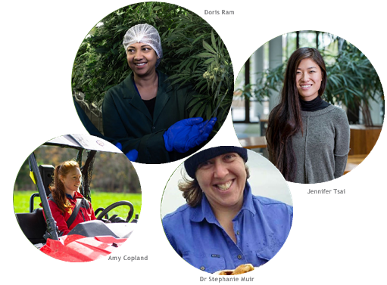

Diversity of careers
A career in STEM at Agriculture Victoria Research is diverse in opportunity, from field and laboratory research to educating secondary students to graphic design for communicating science to a range of audiences.
  - Dr Stephanie Muir, Research Scientist, Red Meat, Hamilton
Dr Stephanie Muir supports the development of sustainable and profitable sheep feeding and production systems.
“In a given week I could be preparing manuscripts, training sheep to use the automated feeders, assisting with the delivery of newborn lambs, collating and examining data or presenting the results of our research to conferences or producers. I enjoy the variety of my role, in particular learning how to apply different technologies to solve research problems.”
  - Doris Ram, Research Scientist, Medicinal Cannabis, Melbourne
Doris Ram supports the State of Victoria’s emerging medicinal cannabis industry while wearing a number of hats in the process.
“I work across cultivation, production, manufacture, and quality control testing of the plant extracts. Coming from an animal research background, this project has given me a unique opportunity to learn and upskill. It is incredibly exciting to be at the forefront of medicinal cannabis research in Australia.”
  - Jennifer Tsai, Communications Officer, Digital and Design, AgriBio
Jennifer Tsai designs and builds accessible communication tools that bridge scientists to a variety of stakeholders including farmers, businesses and consumers.
“I was planning for a career in the field of biology, however made a last-minute decision to pursue a Business and Communications degree instead. Some years later, it makes perfect sense that I am now in a career that marries the two. A peer-reviewed research paper is not always the right vehicle to garner attention, understanding or support of research. I use a combination of design and web skills to create collateral that ensures research is communicated effectively to its specific science and non-science audiences. I love that my work allows me a bird’s-eye view of the array of impactful research projects Agriculture Victoria is undertaking.”
  - Amy Copland, Technical Assistant, Dairy, Ellinbank
Amy Copland betters productivity and profitability outcomes for dairy farmers.
“Using a range of technologies including sonar, LIDAR, satellite, and sensors on drones, I predict pasture yield and quality that has real impact for farmers. I also help with other projects running at Ellinbank, which can involve feeding and looking after cows, setting up fences, assisting in the dairy, processing pasture cuts and recording various experimental data. It is very satisfying to contribute to ground- breaking dairy research. No day is the same; there is always something to learn and our work atmosphere is supportive and fun.”

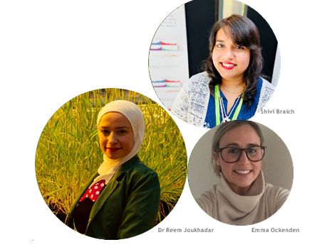

Pathways to STEM careers
  - Shivi Braich, PhD student, Medicinal Cannabis, Melbourne
“I come from a farm and rural background and I have always been passionate about science. Therefore, a career in agriculture science provides me with the perfect opportunity to combine my family tradition with something that I find interesting. Agriculture Victoria Research has provided me with the perfect platform to be recognised as an emerging scientist.”
  - Emma Ockenden, PhD Student, Calf Nutrition, Ellinbank
“I have always had an interest in animal science and the dairy industry. Having the mix of field work with the calves, and office time, really appealed to me. Working in STEM provides a wide range of opportunities across a number of disciplines.”
  - Dr Reem Joukhadar, Research Scientist (PhD graduate), Wheat Cultivars, AgriBio
“I generally do not like routine in life and I found working in science is full of excitement and novelty. Since I was I child, I used to read about new scientific discoveries every day and I dreamt of being part of making our world a better place with science.”
  - Facilitating the future
Kendra Whiteman is the Visitor and Student Coordinator at Agriculture Victoria Research. Kendra provides guidance to new and current PhD students, ensuring they have the support needed to reach their career aspirations.
Each year Kendra helps students achieve their study goals through networking opportunities, workshops, seminars, and work placements on offer via internal and university-wide professional development programs.
“I have been fortunate to have been in this role long enough to have assisted, in some small way, with the career choices of some of our most successful placement students. Watching them transition and flourish as PhD candidates in agricultural science has been most rewarding.”
If you have inquiries about PhD opportunities, please email:
kendra.whiteman@agriculture.vic.gov.au

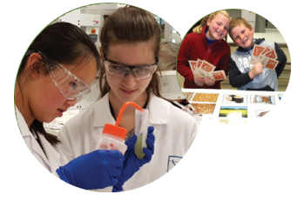

Inspiring young minds: Get into Genes
Get into Genes is a long-standing education program that delivers STEM-based workshops to primary and secondary students.
The program comprises the following workshops:
- Get into Genes
- Get into Grains
- Get into Gums
- Get into Issues and
- Get into Digital Agriculture.
These workshops are designed to increase the engagement of schools and the broader community with STEM, and provide a taste of real-life research undertaken throughout Agriculture Victoria.
The program also provides opportunities for PhD students to deliver Get into Genes workshops, developing critical employability competencies such as teamwork and STEM communication skills.
  - Getting into it
Anna-Leisa Vietz is the Community Education Manager at Agriculture Victoria Research and manages the Get into Genes program. With her team she coordinates, facilitates and develops workshops that meet the emerging needs of the Victorian education community while also showcasing career opportunities and pathways in agricultural research.
Anna-Leisa is a strong advocate for equity and diversity in STEM.
“Get into Genes is an important tool for encouraging young, Under- represented groups, including female-identifying students, to consider further education and careers in STEM. Our workshops provide students with fun activities that showcase STEM careers and role models, while facilitating a sense of both challenge and success. The program is free, making it accessible to a broad section of the community and more than 60 per cent of students that undertake workshops are female-identifying. Through our program, we hope to overcome some of the barriers of systemic inequality that are shown to be prevalent, particularly at higher level STEM careers for women.”
If you are interested in learning more about the Get into Genes program please email:
anna-leisa.vietz@agriculture.vic.gov.au

  - Accessibility
If you would like to receive this publication in an accessible format, please telephone our Customer Service Centre on 1300 502 656, email info@agriculture.vic.gov.au or via the National Relay Service on 133 677, www.relayservice.com.au.
  - Disclaimer
This publication may be of assistance to you, but the State of Victoria and its employees do not guarantee that the publication is without flaw of any kind or is wholly appropriate for your particular purposes and therefore disclaims all liability for any error, loss or other consequence which may arise from you relying on any information in this publication.

