Engaging contractors for ground-based use of agricultural chemicals
  - A guide for land managers on responsible chemical use

Contractors play an important role in the use of agricultural chemicals in primary production and land management. Good contractors can save a land manager time and money and bring a level of expertise to the job.
This guide outlines responsibilities and provides tips for land managers to assist in the safe and appropriate ground-based use of agricultural chemicals, which includes spraying and pest animal control (i.e. pest animal baiting and warren fumigation). For those interested in the aerial application of agricultural chemicals please read Agriculture Victoria’s guide ‘Aerial spraying of agricultural chemicals’.
Land managers should explore all control methods available to them. This guide assumes that land managers have appropriately assessed their chemical use method for pest/disease control as part of their integrated pest management plan.

Planning
The use of chemicals requires careful management and preparation. The inappropriate or unsafe use of any chemical can be harmful to human health, the environment and livelihoods. Before engaging a contractor, consider the potential risks involved in the use of agricultural chemicals. Risks may include (but are not restricted to):
- potential damage to any assets or sensitive areas both on-site and on adjacent land from spray drift.
- poisoning of non-target species when using pest animal bait products.
- chemical residues in harvested produce that are above the Maximum Residue Limit.
Assets/sensitive areas include (but are not restricted to) crops, livestock, native vegetation, wildlife, domestic pests, aquatic areas, houses and other areas where people congregate i.e. schools).
People sometimes turn immediately to using a chemical to deal with a pest or disease without considering
other non-chemical control options e.g. ripping rabbit warrens, using beneficial insects to predate upon the harmful insects. Make sure to fully explore all options before settling on using an agricultural chemical.
After assessing all the risks, if you then determine that the use of chemicals is appropriate, work with the contractor to manage these risks. If the risks cannot be managed, then you must explore other control methods.
Providing a map to the contractor and/or diagrams relating to the ‘target area’ and its surroundings is a sound risk management practice. Maps should clearly outline the target and location of any nearby assets or sensitive areas. It is a legal requirement for any maps or diagrams provided to be accurate.
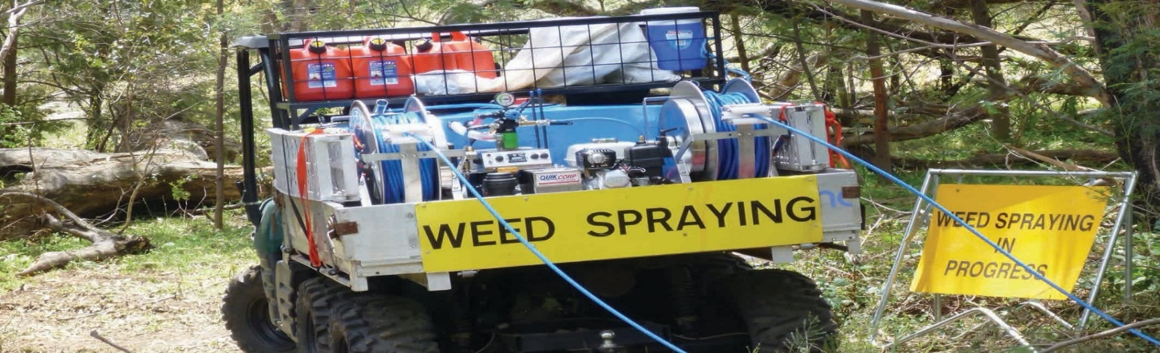

Engage a licenced contractor
People that use agricultural chemicals on another person’s land or produce for a fee or reward must be licenced, a prerequisite of which is the completion of appropriate training.
An Agriculture Victoria issued Commercial Operator Licence (‘COL’) is required by people or businesses that use agricultural chemicals for agriculture or horticultural purposes such as forestry, post-harvest treatments and the control of weeds, insects and diseases. A COL is required regardless of the chemical type or how it is applied. For example, contractors or arborists who only use glyphosate to paste onto cut limbs or inject into tree stumps are required to hold a COL.
If a business offers vertebrate pest control such as bait use or rabbit burrow fumigation their COL must also be endorsed with ‘Vermin (Pest Animal) Destroyers and Avicides’.
If the business is offering to use pest animal bait products that contain 1080 (sodium fluoroacetate) or PAPP to control a pest animal, the employees must each hold evidence of having completed the Course Minimising Risks in the Use of 1080 and PAPP Pest Animal Bait Products for Vertebrate Pest Control (21835VIC). This is in addition to the business holding a Vermin (Pest Animal) Destroyers and Avicides COL.
When engaging a contractor to use agricultural chemicals on your behalf you should always check that they hold the appropriately endorsed Commercial Operators Licence issued by Agriculture Victoria or a Pest Control Licence issued by the Department of Health and Human Services (‘DHHS’).
If a contractor chooses to sub-contract agricultural chemical use work to a third party, the sub-contractor is also required to hold the appropriately endorsed COL for the work they are being engaged to undertake. They cannot operate under the COL of another business.

Agricultural Chemical User Permits vs COLs
Agricultural Chemical User Permits (‘ACUPs’) are required by individuals who apply certain restricted chemical products on their own land or produce, or on land their employer manages (i.e. council workers, orchard workers). While ACUPs provide evidence that a person has been trained in the safe use of agricultural chemicals, they cannot be used in place of a COL.
Many businesses will require that their employees hold ACUPs, however the business offering the commercial agricultural chemical use service must itself hold a COL. COLs can either be issued to small businesses where the licence holder has operational responsibility for spraying or large businesses where the licence holder has no direct involvement in spraying. In the case of large businesses all employees that use chemicals must be listed on the licence and have completed the prerequisite training, whereas employees of small businesses do not need to be listed on the licence as the licence holder (i.e. business owner) can take responsibility for the actions of their employees.

Notification
Notification is legally required when chemicals are sprayed by mister (definition of mister includes orchard sprayers, air blast sprayers or any other equipment that produces a fine to very fine droplet) or aircraft within 200 metres of a school, hospital, aged care facility or children’s service centre. People who use 1080 or PAPP pest animal bait products are also required to provide written notification to adjoining neighbours as defined in the ‘Directions for the Use of 1080 and PAPP Pest Animal Baits in Victoria’.
The chemical user is responsible for ensuring the required notification takes place and that records of notification are made and kept.
Depending on the situation and risks, land managers may wish to take additional steps to notify neighbouring landowners or persons who use the area where chemicals are proposed to be use (such as members of the public who use parks and gardens). While it may not be a legal requirement to take additional steps to notify these people, it forms an important part of risk management and managing the enforceable re-entry periods on some product labels.
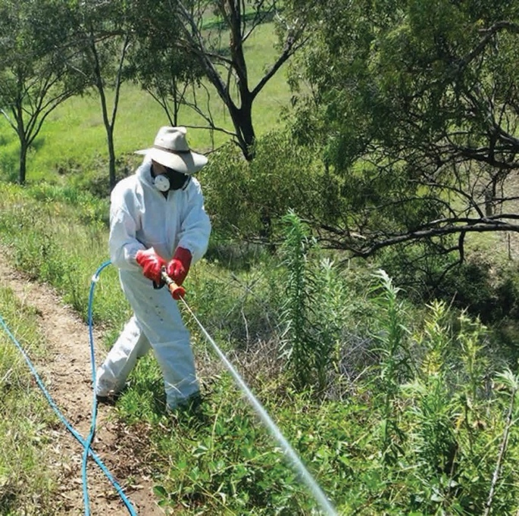

Re-entry periods
The users of agricultural chemicals are responsible for ensuring that all prohibitive statements on a product label are being complied with (i.e. ensuring that people do not breach “DO NOT” statements). Re-entry periods are written on product labels in the format of “DO NOT enter treated area for…”
Re-entry periods are the minimum time that must be allowed to elapse from when you apply the chemical until it is safe for a person to go back into the treated area.
If people want to go back into the treated area before the re-entry period has passed, they must wear the safety equipment that is listed on the product label.
Re-entry periods will differ from product to product so chemical users should always read the full product label and ensure that they are complying with these statements.

Record keeping
Keeping specified records is required by law for users of all agricultural chemicals in Victoria. Records must be made within 48 hours of use and kept for two years by the chemical user.
It is best practice for the contractor to provide their records to the land manager upon request, however the contractor must also maintain their own records of chemical use.

Provision of additional information to land managers
Depending upon what chemical has been used there may be ongoing risks that the land manager will need to manage. This includes withholding periods (WHP) that must be adhered to and plant back periods.
A WHP is the minimum period of time that must elapse between when you apply the chemical and the ‘use’
of the produce to which the chemical was applied (i.e. harvest, sale, grazing, cut for stock food, feed to animals, use of recreation etc.).
Some herbicides also have lengthy plant back periods that should be allowed to expire before sensitive crops are sown in the treated land. It is important that land managers discuss in detail any of these issues, along with re-entry periods, with the contractor to ensure that they can adequately manage these risks.

Take action if spray drift has occurred
If spray drift damage has occurred to crops, land, livestock, native vegetation, or aquatic areas, report it immediately by calling the Agriculture Victoria Customer Contact Centre on 1300 502 656 and asking to speak to your local Chemical Standards Officer.

Public health issues
Individuals with health concerns relating to spray drift should contact the Environmental Health Officer at their local council. It is also essential to contact a doctor if health issues are encountered.

Environmental issues
For enquiries relating to the pollution or contamination of land or water, contact the EPA on 1300 372 842.

Occupational Health and Safety
For enquiries relating to workplace occupational health and safety issues, contact WorkSafe on 1800 136 089.
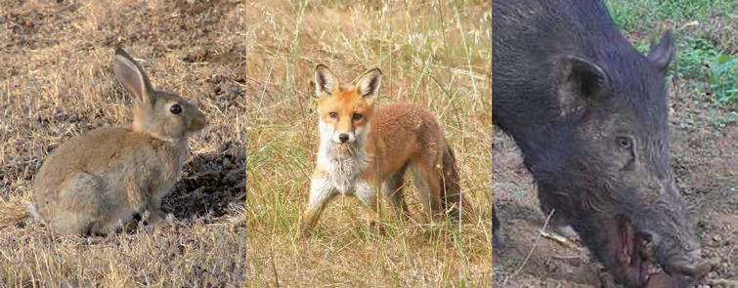

Authorised and published by Agriculture Victoria, 1 Spring Street, Melbourne. March 2022
© The State of Victoria 2022. This publication is copyright. No part may be reproduced by any process except in accordance with the provisions of the Copyright Act 1968.
Disclaimer
This publication may be of assistance to you but the State of Victoria and its employees do not guarantee that the publication is without flaw of any kind or is wholly appropriate for your particular purposes and therefore disclaims all liability for any error, loss or other consequence which may arise from you relying on any information in this publication.
For more information about Agriculture Victoria go to www.agriculture.vic.gov.au or call the Customer Service Centre on 1300 502 656.
www.agriculture.vic.gov.au

