Looking back at BetterBeef group profiles for 2020.
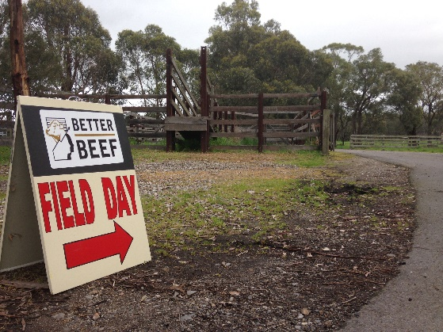
In BetterBeef we have 24 producer groups around Victoria made up of 370 producer members and led by 13 coordinators, from Agriculture Victoria and the private sector.
This year has been a challenging one for all the BetterBeef groups. Due to coronavirus (COVID-19) restrictions, groups have not been able to meet face-to-face since April.
Groups quickly moved to online meetings using platforms such as Zoom. For many this was a new and even strange experience. However, after a steep learning curve, most members embraced the technology, overcame tech and internet connection hurdles and replaced on-farm meetings with on-line meetings and virtual farm tours.
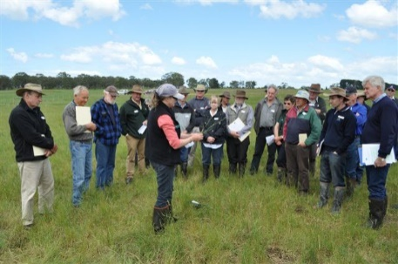
The aim of the group network is to facilitate discussion and exchange of information between producers and with their coordinator, tackle seasonal challenges and decision making in farming, and support adoption of productive and profitable farming practices.
A strong theme through all the group profiles is the support provided to members not only with day-to-day farming decisions and longer-term strategies, but also the social connection and support. The social support has been particularly critical following events such as drought and fire.
A summary of each profile is provided below. To access the full profile visit the Agriculture Victoria website.
February 2020 Tallangatta group: Grazing management to increase pasture production
In February, the profile of Phil Shannon’s Tallangatta group based in the Upper Murray region was focused on increasing pasture production through improved grazing management and the benefits of conserving more home-grown feed. For members Des and Christine Varker at Chiltern, this meant greater investment in ‘wire and water’; increasing the number of paddocks in order to establish an effective rotational grazing program. The Varkers also implemented a more rigorous soil testing regime to monitor soil pH, phosphorus and aluminium levels for targeted and strategic application of fertiliser and lime.
March 2020 Macarthur group: More profitable weaner feeding systems
James Whale’s group at Macarthur in SW Victoria finds great value in collecting and discussing feed test data and weaner growth rates for more profitable management decisions. By collecting and using this data, the group found there were opportunities to feed weaners more economically by improved feeding strategies to achieve target weights at a lower cost.
April 2020 Mirboo North/Boolarra group: Silage versus Hay
John Bowman from Agriculture Victoria coordinates the Mirboo North group in South Gippsland. This group was evaluating the merits of making hay versus silage. After looking at the cost of production, feed value (MJ), and the benefits of being able to graze the paddock after baling, the group agreed the best course of action was to cut silage.

May 2020 High Country group: Farming from a different perspective
Dr John Webb-Ware of the Mackinnon Project (University of Melbourne) has been coordinating the High Country group (Merton and district) for many years. Many members have come into beef farming later in life, so this group provides support and guidance to many for whom beef farming is a new or novel way of life. During meetings the group learn about pasture assessment, stocking rates, genetics and animal health. The group also have a firm focus on farm safety. This is a dynamic group with members always open to reviewing their farming practices.
July 2020 Buffalo group: Risk Management – farm safety
Farming consultant Malcolm Cock coordinates the Buffalo group based in South Gippsland. Mal often challenges the group on their risk management. For this month’s profile, Malcolm discusses the meeting where a speaker from Worksafe talked about farm safety, particularly quad bikes and the value of operator protection devices. In this profile, Mal also highlights the value of having a farm safety plan which is particularly helpful for contractors who need to be aware of where the hazards are like steeper country.
September 2020 Upper Murray group: Triumph through adversity and moving forward.
Chris Mirams, a consultant from Albury NSW is the coordinator of the Upper Murray group. Many members from this group were impacted by the fires in the summer 2019/20. Therefore the group has been incredibly valuable for not only technical support for fire recovery, but socially as well. Despite the heartbreak and frustration the fires caused, members remain positive and are looking ahead to the future. Some members have implemented an AI program for heifers, pasture improvement, and changing the time of calving to better match feed supply with demand.
October 2020 West Gippsland group: Data-driven decision making; feed budgets
Another group that regularly practices data-based decision making is the West Gippsland group coordinated by Fiona Baker from Agriculture Victoria. Group sessions often involve the use of budgets to estimate feed requirements and stocking rates for the season ahead. Doing feed budgets allows the group to consider management strategies needed under different scenarios which could include variations to predicted pasture growth rates, sale date options and target weights. In this profile we read how one member avoided dark-cutting penalties in steers by choosing the right silage in the lead-up to sale and processing.
November 2020 Phillip Island group: Competing with tourists and Cape Barren Geese
The final profile for 2020 is from the Phillip Island group coordinated by consultant John Gallienne. Members of this group farm in an area popular with tourists and as such, their farms are being gradually subjected to ever increasing pressures of urban encroachment and infrastructure growth required to support the growing tourism industry on the island. Another pressure discussed in this profile is from local wildlife, Cape Barren Geese (CBG). These birds consume about the equivalent of one sheep (i.e. 1 DSE) and there are around 3000 of them on the island. This means farmers on the island must consider this additional grazing pressure when doing their feed budgets and working out stocking rates.

ACCESSIBILITY
If you would like to receive this publication in an accessible format, please email the Beef Sheep Network on beef.sheepnetworks@agriculture.vic.gov.au
This document is also available in Word format at https://agriculture.vic.gov.au/support-and-resources/newsletters/newsflash

