Agriculture Victoria

Food to Market Grants Program
Program Guidelines
March 2021

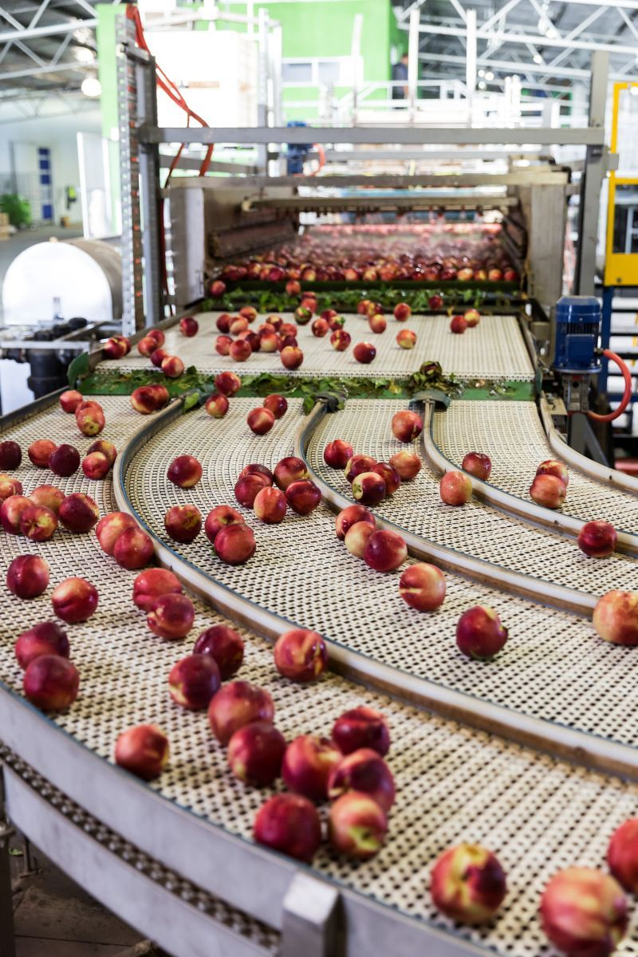

Background
The Food to Market Program is a $15 million commitment by the Victoria Government to encourage food producers and their supply chain partners to add value to food grown and processed in Victoria. The program was announced as part of the Strategy for Agriculture in Victoria – a 10-year plan for growing and supporting the Victorian agriculture sector.
The Food to Market Program supports investment into the Victorian agri-food supply chains to create new job opportunities in food manufacturing, grow exports and build the resilience of the sector.
The Food to Market Grant Program is now open.
Eligible businesses can apply for grant funding of $50,000 to $1 million for activities supporting the objectives of the Food to Market Program. Grant funding is on a co-contribution basis, with projects funded up to 50 per cent of total eligible project costs.
Additional information about the Food to Market Program is available on our website at agriculture.vic.gov.au/support-and-resources/funds-grants-programs/food-to-market-grant-program
For any further queries please email a Food to Market representative at foodtomarket@agriculture.vic.gov.au

Program Objectives
The Food to Market Program will assist the Victorian agri-food sector respond to the challenges and capitalise on the opportunities from recent changes in the market following COVID-19.
Key objectives of this program include to:
- increase supply chain efficiency and productivity;
- grow existing export markets and access new export markets;
- close critical gaps in domestic production and supply chains;
- increase value add to Victorian production; and
- increase collaborative and shared resources along the domestic supply chain.
Key outcomes of the Program are to increase the Victoria agri-food sector’s productive capacity, exports and productivity and support new and retained sustainable jobs. The Program will deliver supply chains that are more resistant to disruptions and that are more collaborative.

Food to Market Grants Program
Eligible businesses can apply for grant funding of $50,000 up to $1 million.
Grant funding is on a co-contribution basis, with projects funded up to 50 per cent
of total eligible project costs.

Who can apply?
Eligible applicants may include private sector businesses, industry associations, marketing co-operatives and local government authorities.
Applicants must be able to demonstrate a connection to the Victorian agri-food supply chain.
Applicants must also satisfy the following criteria:
- have a business operation located in Victoria;
- have a current Australian Business Number (ABN), (prior to 31 March 2021); and
- directly employ staff.

Projects eligible for funding
A wide range of projects that support the objectives of the Program will be considered for funding.
Examples of projects that may be considered include those that:
- address a supply chain issue that presents barriers to domestic processing capability;
- take up new technology and innovation
- grow export markets including access to new markets for existing or new products;
- improve supply chain productivity and cost competitiveness;
- improve data collection and analysis for improved decision making along supply chains;
- provide import replacement or onshore supply chains; and
- design and implement new systems that improve supply-chain networks and partnerships.

To be eligible for funding applicants must demonstrate that:
- projects align with Program Objectives; and
- benefits to be delivered by the project will extend to other agri-food participants along the supply chain, or to the
agri-food sector or supply chain more broadly.

Eligible Project Costs
Project costs eligible for funding include (but are not limited to):
- investment in plant and equipment;
- research and development for pilot projects or new product development;
- market promotion;
- business and marketing plans or feasibility study development; and
- website development and network costs.

Costs not eligible
Project costs not eligible for funding include (but are not limited to):
- costs incurred for projects that have been completed or commenced before receiving funding approval;
- ongoing operating expenses or other ‘business as usual’ expenses (including utility costs; advertising and social media; operational wage-related costs; online costs);
- fees associated with permits for planning;
- ongoing or routine maintenance costs; and
- the purchase, lease or acquisition of land.

Program Dates
The Food to Market grant program is proposed to be open until 30 June 2022 or until funding is expended, whichever is earliest. Please see the Agriculture Victoria website at agriculture.vic.gov.au/support-and-resources/funds-grants-programs/food-to-market-grant-program for updated advice on program close date.

Application and Assessment Process
Applications for the Food to Market Grants Program open on 31 March 2021. An Expression of Interest may be submitted at any time until the close of the Program.

Application Process
To ensure the suitability of projects, all applicants will need to undertake the following process.

Step 1: Prior to application
Prior to submitting an expression of interest form, applicants are advised to read the program guidelines in full in order to establish eligibility.

Step 2: Expression of Interest
Complete a short expression of interest form accessed at the Agriculture Victoria website found at: agriculture.vic.gov.au/support-and-resources/funds-grants-programs/food-to-market-grant-program. The expression of interest form will ask for a brief outline of the project, project deliverables, project timelines, project cost and funding requested.
A DJPR staff member will then contact you to discuss your expression of interest.
Applicants that meet applicant eligibility criteria and projects that align with the Program Objectives and meet project eligibility criteria will be invited to formally apply for funding. A link will be provided to complete an on-line application form.
Applicants should note that projects may not proceed to the formal application and assessment process if the project does not meet the Program Objectives.

Step 3: Prepare an application
The second step will consist of a formal application process, which will be administered as follows:
- Invited applicants will be asked to complete an on-line application form including information that describes the project and addresses the Assessment Criteria set out below, including information on the project objectives, benefits, outcomes, feasibility and delivery, and the need for Victorian Government funding.
- Supporting documentation may be required depending on the size of the project and level of requested funding. Applicants will be advised of any request for supporting documentation.
- Three years of consecutive financial reports need to be included with the application to allow for completion of a Financial Risk Assessment.

Step 4: Assessment process
All eligible applications will be evaluated by an assessment panel who will make recommendations to the Minister for Agriculture for final consideration.
The assessment panel will review the applications against the following criteria:

Program Objectives:
How well does the proposed project meet one or more of the objectives (listed in Program Objectives section) of the Food to Market Program and is the funding request a value for money investment by the Victorian Government.
Applicants will be asked to describe their proposed project and how it relates to the Program Objectives.

Project benefits:
How well does the proposed project demonstrate broader agri-food supply chain benefits beyond any direct project benefits to the applicant.
Applicants will be asked to demonstrate how proposed project benefits will extend to other agri-food participants along the supply chain, or how the proposed project will deliver benefits aligned with Program Objectives to the agri-food sector or supply chain more broadly.

Feasibility and delivery:
How well does the application show that the project can be delivered on time and within budget.
Applicants will be asked for an outline of a project plan, including budget and timelines. Larger proposed projects may be required to provide a detailed business case.

Need for Victorian Government funding:
How well does the application make a case for government assistance.
Applicants will be asked to address how Victorian Government funding will support them to, for instance:
- deliver the outcomes from the proposed project more quickly;
- reach more beneficiaries; or
- deliver a project that might otherwise not have sufficient funding to proceed.

Step 5: Due diligence
Applicants will be required to submit their past three years Australian Taxation Office financial reports (balance sheet and profit & loss statements).
Where the latest financial report is more than six months old, up-to-date management or interim accounts (profit & loss and balance sheet) will be requested.
The documents are required for completion of a Financial Risk Assessment.

Step 6: Application outcome and funding agreement

Application outcome
An applicant should expect to learn the outcome of their application for a Food to Market Grants Program grant in approximately 12 weeks from the time of submitting an application.
All applicants will be notified of the outcome of their application. If requested, feedback can be provided to the unsuccessful applicants by DJPR.

Funding agreement
Applicants who are successful will be issued with a letter of offer of funding.
The applicant accepts the letter of offer which is a non-binding legal agreement until the execution of the formal grant agreement between both parties. The grant agreement will be provided by the department and will set out the terms and conditions upon which the government provides the grant.
Details of the project should remain confidential until the project is formally announced by the Victorian Government.

Condition of Applying
These guidelines and any discussions you may have with a representative of the Department of Jobs, Precincts and Regions (DJPR) are for information only and do not constitute advice.
Applicants should seek independent advice before making an application or entering into a grant agreement.
Applications are at the cost of the applicant.
The department makes no representation that a grant of funds will be made to any applicant and reserves the right to make no funds available under the Food to Market Grants Program.

Compliance and Governance

Information Only
The department reserves the right to make changes to these guidelines as required. Any changes to the guidelines will not affect the eligibility of the applicants and applications made prior to the date of publication of any update.

Conditions of Funding
Successful applicants will be required to enter into a grant agreement with the department detailing all funding obligations and conditions.
Grant agreements are legally enforceable documents that clearly set out the obligations of both parties. The grant agreement aims to protect the Victorian Government’s interests and ensure the efficient and effective use of public money.
Grant agreements can be signed by an authorised person to bind the organisation and will:
- describe the purpose for which the funding must be used
- set out any requirements or conditions that must be met prior to the payment of a grant instalment
- outline agreed milestones and project outcomes that must be achieved before payment of a grant instalment.
Once the grant agreement has been signed, the applicant will be required to actively manage and deliver the project and provide accurate progress reports to the department. During a project, the department may conduct site visits as necessary.
Successful applicants must execute a grant agreement and commence the project within the timeframe agreed with the department.
If a project does not commence within this timeframe the grant will be reviewed by the department.

Publicity
Grant recipients may be asked to assist the department in promotion of the Food to Market Program. This may include involvement in media releases, case studies or promotional events and activities.
Recipients must not make any public announcement or issue any press release regarding the receipt of a grant without prior written approval from the department.
The department may include the name of the recipient and/or grant amount in any publicity material and in the department’s annual report. If requested by the department, the recipient must ensure that the State’s support for the grant is acknowledged on all promotional materials and appropriate signage, consistent with the Guidelines for Victorian Government Advertising and Communications (available at dpc.vic.gov.au) or as otherwise specified by the department.

Privacy Statement
Any personal information provided by the applicant in an application will be collected by the department for the purpose of program administration. This information may be provided to other Victorian Government bodies for the purposes of assessing applications. If confidential personal information about third parties is included in an application, applicants are required to ensure that the third party is aware of the contents of this Privacy Statement.
Any personal information collected, held, managed, used, disclosed or transferred will be held in accordance with the provisions of the Privacy and Data Protection Act 2014 (Vic) and other applicable laws.
The Department of Jobs, Precincts and Regions is committed to protecting the privacy of personal information. The department’s Privacy Policy can be found online at djpr.vic.gov.au/privacy. Enquiries about access to information should be directed to Agriculture Victoria by phone on 136 186 or to the Department’s Privacy Unit by email privacy@ecodev.vic.gov.au.

Program Support
Applicants requiring further information should contact a Food to Market representative at foodtomarket@agriculture.vic.gov.au for further details.
Additional information about the Food to Market Program is available on our website at agriculture.vic.gov.au/support-and-resources/funds-grants-programs/food-to-market-grant-program

Step-by Step Application Guide
- Read the Program Guidelines to establish eligibility
- Complete Expression of Interest Form found at https://agriculture.vic.gov.au/support-and-resources/funds-grants-
programs/food-to-market-grant-program
- Applicant will be advised of the Expression of Interest Outcome (successful/unsuccessful)
- Successful applicants will receive a formal invitation to apply and an on-line application form to complete and submit to the department
- Applicant will receive a letter confirming the outcome of the application (successful/unsuccessful)
- Successful applicants will receive a letter of offer, valid for 30 days
- The department issues a grant agreement outlining the scope of the project, milestone and activity deliverable dates
- Project commences
- Payments are made on evidence of the project milestones being met and completed
- Post Completion Evaluation Report

Published by the Department of Jobs, Precincts and Regions
1 Spring Street Melbourne Victoria 3000
Telephone: (03) 9651 9999
Email: foodtomarket@agriculture.vic.gov.au
© Copyright State of Victoria, Department of Jobs, Precincts and Regions 2021
E: foodtomarket@agriculture.vic.gov.au
W: agriculture.vic.gov.au

https://agriculture.vic.gov.au/about/our-role/agriculture-strategy

