84Y Agreements Guidance
Domestic Animals Act 1994
This document provides guidance for:
- councils
- shelters and pounds
- veterinary clinics
- community foster care networks and/or any other person or organisation utilising 84Y agreements under the Domestic Animals Act 1994.

This guidance document is valid from October 2021.

Note: the information provided in this document is not legal advice; it is provided is to assist you with implementing the Domestic Animals Act 1994. Organisations entering an 84Y agreement may wish to seek independent legal advice.

Table of Contents
Table of Contents 1
What is an 84Y agreement? 2
Why are 84Y agreements used? What are the benefits? 2
Who can access an 84Y agreement? 2
Agreements with registered shelters (domestic animal business) 3
Agreements with veterinary practices 3
Agreements with CFCNs or any other person or organisation 4
What should be included in an 84Y agreement? 4
Can section 84Y agreements be informal? 5
How long does an 84Y agreement need to be? 6
What happens if a person or organisation undertakes the duties without an 84Y agreement? 6
Responsibility of a person or organisation with a section 84Y agreement to serve notice of seizure 6
Additional requirements 6
Sample 84Y agreement template 7
Diagram: The role of 84Y agreements in managing and reuniting pets 8

What is an 84Y agreement?
In Victoria, dogs and cats can be captured and held by local councils for a range of reasons under the Domestic Animals Act 1994 (the Act). For instance, a dog may have escaped confinement and be roaming in the community, presenting a potential danger to itself or others. Any person who captures a roaming animal under section 84 of the Act, must provide the animal to a council authorised officer, or to a person or organisation with an 84Y agreement. This is to ensure the animal has the best chance of being reunited with its owner, as well as managing any immediate animal welfare needs.

Section 84Y of the Act enables local councils to make written agreements with a ‘person or body’, namely shelters, veterinary practices, Community Foster Care Networks (CFCN) and foster carers, to support the capture, holding, rehoming or disposal of dogs and cats. That is, 84Y agreements allow certain people and organisations other than local councils to receive and manage lost pets and/or stray animals.
Councils can tailor agreements to suit their operational and local community needs. Different types of section 84Y agreements exist to cover a range of situations, and agreements can include some or all of the activities outlined under section 84Y of the Act.

Why are 84Y agreements used? What are the benefits?
The welfare and management of cats and dogs in local council municipalities can improve by enabling appropriately skilled individuals or organisations to receive and manage lost pets and/or stray animals. Describing and agreeing to the appropriate animal care and holding services associated with this in an 84Y agreement allows councils to better apply their resources and personnel.
The benefits of 84Y agreements include:
- reduced burden on councils to manage lost or stray animals in their community
- increased number of animal management facilities or services within a council area, meaning more places for:
  - cats and dogs to be cared for
  - the public to access when delivering up lost animals
  - adoptions to take place
- increased care options for animals, potentially reducing euthanasia rates and increasing the possibility of adoption.

Who can access an 84Y agreement?
Councils can set up an 84Y agreement with a registered shelter, veterinary clinic, CFCN or foster carer to receive and manage lost pets and/or stray animals. For example:
- Councils without their own pound facility can have an 84Y agreement with a person or organisation who provides this service. The person or organisation providing the service must be registered as a domestic animal business (DAB).
- Councils owning a pound facility can have an 84Y agreement with a person or organisation to operate the pound on its behalf.
- Councils that operate their own pound facility can have 84Y agreements with CFCNs for the purpose of rehoming animals.
- Councils can have an 84Y agreement with a local veterinary practice so that they may reunite owners with lost pets handed in at their clinic.
To recognise the various rehoming pathways available, an 84Y agreement may authorise a person or organisation to give a dog or cat to:
- a CFCN for rehoming (under clause 84Y(ca)), on the condition that the dog or cat is desexed and microchipped before ownership is transferred to the CFCN, or
- an animal shelter (under clause 84Y(cb)).
84Y agreements are exclusively held between a person or organisation and the local council. Any other written contracts between the agreement holder and another person or organisation, such as a CFCN or foster carer, is separate and in addition to an 84Y agreement.
If council is not satisfied with the activities being performed under an 84Y agreement, they can end the agreement.

Agreements with registered shelters (domestic animal business)
A council can have an agreement with a registered shelter for the purposes of:
- capturing dogs or cats under section 84 of the Act
- retaining or holding dogs or cats (until reunited or rehomed)
- selling or destroying any dogs or cats that have been captured under section 84.

The shelter can charge a fee for any of the above services. If the 84Y(ca) clause is included in the agreement, then the shelter may give desexed dogs or cats that have been captured to a CFCN for rehoming.
All dogs or cats at a registered shelter must be housed and cared for in a way that complies with the Act and the Code of Practice for the Management of Dogs and Cats in Shelters and Pounds (the Code of Practice). Where a shelter is operating as a pound on behalf of a council, they must fulfil all obligations of a pound under the Act. For instance, under section 33A of the Act, they must accept surrendered animals.

Agreements with veterinary practices
Just like shelters, a council can have an 84Y agreement with a local veterinary practice for the purposes of:
- capturing dogs or cats under section 84 of the Act
- retaining or holding dogs or cats (until reunited or rehomed)
- selling or destroying any dogs or cats that have been captured under section 84.

The veterinary practice can charge a fee for any of the above services.
If there is an 84Y(ca) clause in the agreement, the veterinary practice can give desexed dogs or cats to a CFCN for rehoming. Alternatively, a veterinary practice can give captured dogs or cats to an animal shelter under clause 84Y(cb) if that option is in the agreement. If an animal is given to an animal shelter, it is the responsibility of the animal shelter to desex and microchip the animals prior to rehoming, as per the Code of Practice.
Veterinary practices with an 84Y(c) clause in the agreement may sell any dog or cat that has been captured and is unable to be reunited with its owner. In these instances, the veterinary practice is to desex and microchip the animal prior to it being rehomed, in line with expectations set out for council pounds in the Code of Practice.
If a veterinary practice has an 84Y agreement with council and is not a registered DAB, it will need to self-enrol on the Pet Exchange Register (PER) to obtain a source number before microchipping and/or advertising a dog or cat for sale/rehoming. Registration for a source number may be completed here: https://per.animalwelfare.vic.gov.au/.

In some cases, a council’s section 84Y agreement with a veterinary practice is only for the purpose of returning a lost dog or cat to its owner. In this case, the council might limit the agreement to subsections (a) and/or (b) of 84Y, allowing the veterinary practice to accept a dog or cat delivered to them, and/or keep the animal for the purpose of trying to reunite it with its owner. A veterinary practitioner may register an animal if they are appointed by the council as an agent for registration under section 12 of the Act. If this is not the case, the 84Y agreement will need to include the requirement for a veterinary practice to refer the registration to council.

Agreements with CFCNs or any other person or organisation

Section 84Y agreements between a local council and a CFCN usually focus on the 84Y(c) clause for selling and/or rehoming a dog or cat that has been captured. Where a dog or cat comes directly to a CFCN from a local council under an 84Y agreement, it should be desexed and microchipped prior to ownership transferring to the CFCN, as per the Code of Practice.
In addition to an 84Y agreement, pounds or shelters can make separate agreements with CFCNs or foster carers under the Code of Practice. Under a foster care agreement, the CFCN or foster carer provides temporary care for a dog or cat and the animal must be returned to the pound or shelter for microchipping, desexing and rehoming. Council may use an 84Y agreement to address certain animal care and management requirements. Any agreement with a CFCN must have provisions in place to ensure the animal is desexed and microchipped prior to permanent rehoming.
If a CFCN has an 84Y agreement with council and is not a registered DAB, it will need to self-enrol on the Pet Exchange Register (PER) to obtain a source number before microchipping and/or advertising a dog or cat for sale/rehoming. Registration for a source number may be completed here: https://per.animalwelfare.vic.gov.au/.

What should be included in an 84Y agreement?
The below sections provide recommendations for what should be included in an 84Y agreement. This does not include all possible considerations for an agreement, and councils may wish to include additional provisions to ensure the agreement meets their needs.

For example, a council might like to consider including a clause stating that where the agreement holder is unable to hold animals for the entire statutory period, they may give the animals to a council authorised officer for the remainder of the statutory period (noting the statutory period must always be observed in full). For reference, the obligatory holding time (‘statutory period’) is eight days if the animal has been captured under section 84, or 14 days if the animal has been abandoned.

Term of the agreement
- How long is the agreement going to be in place?
- When will it start and when will it finish?

Legislative basis of the agreement
- Which clauses under section 84Y will the person or organisation be permitted to take on?
- Will they be permitted to release the animals into the care of a CFCN for rehoming?

Who is responsible for costs incurred in caring for animals?
- Will the agreement allow the person or organisation to charge a fee for their services? Who may they charge and for what aspects of care?
- The agreement should define which party is responsible for the cost of caring for the captured animal, including costs relating to transport, management, veterinary care or treatment provided (e.g., microchipping, vaccinating, worming), as well as destruction, where required.
- It should also outline the process and who is responsible for the cost of life preserving treatment if the owner cannot be identified/contacted.

If an owner does not collect an animal, what happens to the animal after the statutory period has lapsed?
- Where an owner does not come to collect their pet after the statutory period has lapsed, should the animal be given to a council authorised officer?
- Does the local council collect the animal?
- Alternatively, can the person or organisation rehome or otherwise move the animal on (to a CFCN or animal shelter), e.g., under an 84Y(c), (ca) or (cb) clause?

Animals being sold or destroyed
- Animals being sold or destroyed by the person or organisation must be sold or destroyed as per the Code of Practice requirements.
- Animals being sold will need to be assessed as suitable for rehoming, considering health and behavioural factors, such as temperament and sociability.
- All animals being sold by an establishment will need to be microchipped, vaccinated, desexed and wormed prior to rehoming.
- The person or organisation rehoming the animal will need to notify the relevant local council of the sale (refer to s13 of the Act).

Record Keeping
- Does the council require the agreement holder to notify them and maintain records of animals captured and held, including their fate, i.e. whether they have been rehomed or destroyed? If this is councils’ expectation, then appropriate provisions should be included in the agreement.

Registration of animals
- Any dog or cat three months of age and older must be registered with the relevant local council. If a dog or cat moves either permanently or temporarily for housing in another council area, the owner of the animal (or person responsible, in the case of fostering) must register that dog or cat with the new council.
- Section 12 of the Act allows for a council to have a registered veterinary practitioner or domestic animal business complete the registration of the animal. If the registration application is not complete (inclusive of the required fee), the application must be referred to council.

Can section 84Y agreements be informal?
There is no requirement for an 84Y agreement to be a formal contract. However, the Act does require the agreements to be made in writing. Agreements cannot be verbal, or handshake based. Anyone engaged in establishing an 84Y agreement must have appropriate authorisation to do so.

How long does an 84Y agreement need to be?
Section 84Y agreements vary in the level of detail included. It is up to the parties to determine how much detail they want to include in their agreement.

Can 84Y agreements be made with cross-border facilities?
The DA Act permits cross-border 84Y agreements to be made where appropriate. Where councils located in border towns seek to establish 84Y agreements with cross-border facilities, they will need to include provisions to ensure that the interstate facility undertakes the agreed activities in accordance with Part 7A of the DA Act, as required under section 84Y. Councils may also need to include additional provisions to ensure that their broader legislative obligations, for instance those related to record-keeping and reporting, continue to be met. This may be achieved by reproducing or referencing the relevant DA Act provisions within the agreement.
Additionally, given the DA Act does not apply to interstate pounds, any cross-border 84Y agreement should include provisions for managing a breach of the agreement. This may include, for example, provisions relating to contractual indemnities, dispute resolution, breach of contract, and contract termination. Given the increased complexity of cross-border 84Y agreements, it is strongly recommended that councils seek independent legal advice when developing such agreements.

What happens if a person or organisation undertakes the duties without an 84Y agreement?
If a veterinary practice, animal shelter, person or organisation does not have an 84Y agreement with council to retain custody of any captured dog or cat, they must not accept the animal. Instead, it must be delivered to a council authorised officer of the area in which the animal was captured, as soon as possible.

Failure to comply with this requirement could lead to an offence under section 84D of the Act and a fine of up to 5 penalty units. The value of a penalty unit changes annually and is set by the Department of Treasury and Finance. Further information, including the current value of a penalty unit, is available here: https://www.dtf.vic.gov.au/financial-management-government/indexation-fees-and-penalties.

Responsibility of a person or organisation with a section 84Y agreement to serve notice of seizure
Any person or organisation with an 84Y agreement is responsible for attempting to identify and contact the owner of any animal delivered to them. This can be done through inspection of an identification tag, if one is present, or by scanning the animal for a microchip. Once details of the owner are obtained, the agreement holder must serve a ‘notice of seizure’ on the owner within 4 days of the animal being captured. Further details on what must be included in a ‘notice of seizure’ may be found under section 84I of the Act.

Additional requirements
When operating under a section 84Y agreement, all parties must comply with the legislative requirements of the Act, associated regulations and Code of Practice.

Sample 84Y agreement template
A sample 84Y agreement template is available to council officers via the Domestic Animals Resources and Tools (DART) website. Councils can tailor this template to meet their needs.

For more information
Visit http://www.animalwelfare.vic.gov.au or
email pet.welfare@ecodev.vic.gov.au or
call 136 186.

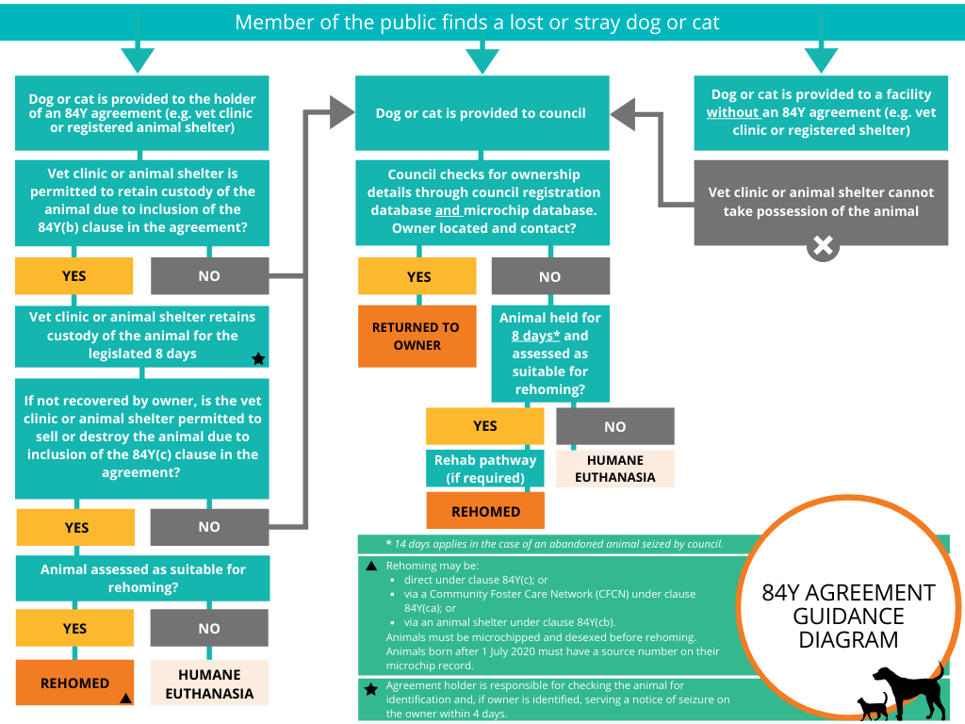
Diagram: The role of 84Y agreements in managing and reuniting pets

Process when the dog or cat is provided to the holder of an 84Y agreement (e.g. vet clinic or registered animal shelter)
- Member of the public finds a lost or stray dog or cat.
- The dog or cat is provided to the holder of an 84Y agreement (e.g. vet clinic or registered animal shelter).
- Vet clinic or animal shelter is permitted to retain custody of the animal due to inclusion of the 84Y(b) clause in the agreement?
- If no, the dog or cat is provided to council (follow process of when a dog or cat is provided to council).
- If yes, vet clinic or animal shelter retains custody of the animal for the legislated 8 days.[1]
- If not recovered by owner, is the vet or animal shelter permitted to sell or destroy the animal due to inclusion of the 84(c) clause in the agreement?
- If no, the dog or cat is provided to council (follow process of when a dog or cat is provided to council).
- If yes, the animal is assessed for rehoming.
- Is the animal assessed as suitable for rehoming?
- If no, humane euthanasia.
- If yes, rehome.[2]

Process when the dog or cat is provided to council
- Member of the public finds a lost or stray dog or cat.
- The dog or cat is provided to council.
- Council checks for ownership details through council registration database and microchip database. Owner located and contacted?
- If yes, they are returned to owner.
- If no, the animal is held for 8 days[3] and assessed as suitable for rehoming.
- Is the animal assessed as suitable for rehoming?
- If no, humane euthanasia.
- If yes, rehome. Optional rehab pathway if required.

Process when a dog or cat is provided to a facility without an 84Y agreement (e.g. vet clinic or registered animal shelter)
- Member of the public finds a lost or stray dog or cat.
- The dog or cat is provided to a facility without an 84Y agreement (e.g. vet clinic or registered animal shelter).
- Vet clinic or animal shelter cannot take possession of the animal and the animal is provided to council (follow process of when a dog or cat is provided to council).

[1] Agreement holder is responsible for checking the animal for identification and, if owner is identified, serving a notice of seizure on the owner within 4 days.
[2] Rehoming may be direct under the clause 84Y(c) or via a Community Foster Care Network (CFCN) under clause 84Y(ca) or via an animal shelter under clause 84Y(cb). Animals must be microchipped and desexed before rehoming. Animals born after 1 July 2020 must have a source number on their microchip record.
[3] 14 days applies in the case of an abandoned animal seized by council.

