Livestock Farm Monitor Project

Victoria │ Annual Report

2021–22

Further information regarding the Livestock Farm Monitor Project (LFMP) may be obtained from:
Sam Henty
Agriculture Victoria
PO Box 3100, Bendigo, Victoria 3400
sam.henty@agriculture.vic.gov.au
Authorised and published by the Victorian Government, Department of Jobs, Precincts and Regions (DJPR) 2022. © The State of Victoria Department of Jobs, Precincts and Regions 2022.
This publication is copyright. No part may be reproduced by any process except in accordance with the provisions of the Copyright Act 1968.
For more information contact the Agriculture Victoria Customer Service Centre on 136 186.

Disclaimer
This publication may be of assistance to you, but the State of Victoria and its employees do not guarantee that the publication is without flaw of any kind or is wholly appropriate for your particular purposes and therefore disclaims all liability for any error, loss or other consequence which may arise from you relying on any information in this publication.
Accessibility
If you would like to receive this publication in an accessible format, such as large print or audio, please telephone 136 186.
Deaf, hearing impaired or speech impaired? Call us via the National Relay Service on 133 677 or visit www. relayservice.com.au
This document is also available on the Agriculture Victoria website.

In 2021–22, the Livestock Farm Monitor Project (LFMP) provided 124 Victorian sheep, beef and mixed farming, including cropping, farmers with detailed financial and production performance information. Agriculture Victoria collated the individual business performance information of all surveyed farms to provide insights in this report.
The LFMP is Agriculture Victoria’s primary source of farm-level information for sheep and beef production practices, resource use, and economic data.
The results of this annual survey provide farm-level data to inform Agriculture Victoria’s decisions that impact at a farm level and to inform the direction of future policy design, research themes and service delivery programs.
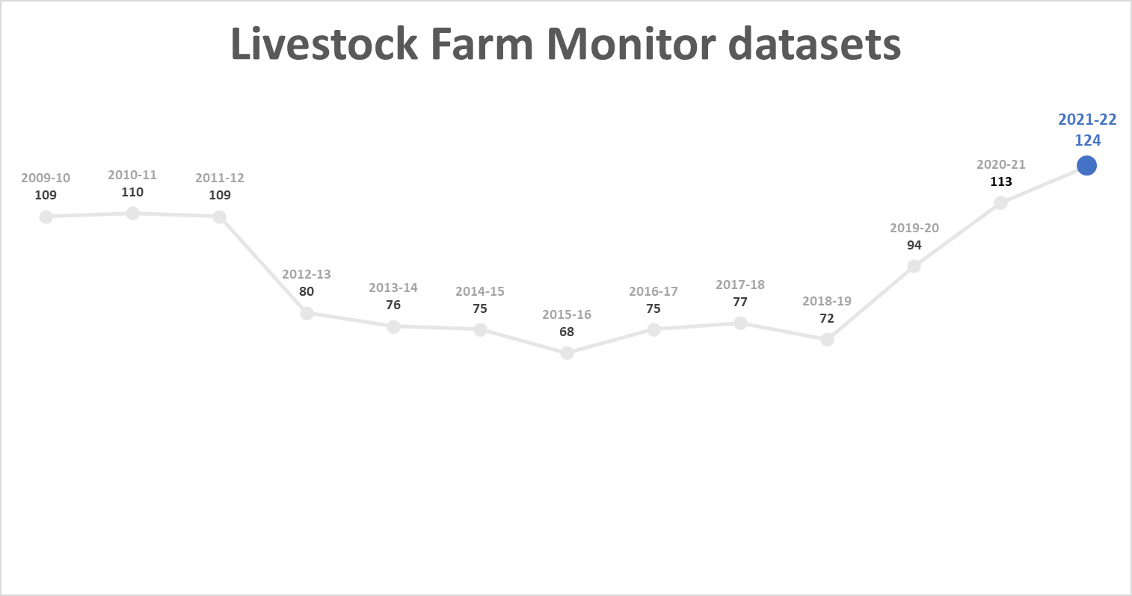
Figure 1. Number of participating businesses in the LFMP since 2009–10
Farmers who participate in the project increase their understanding of their farm business, which builds resilience and improves their ability to adapt to change.
Results published in this report are not statistically representative of an industry or a region.
Agriculture Victoria staff are grateful for the cooperation of the farmers who contributed their data to this project.
The theory and methods used to generate the profitability data in this report can be found in the references.
This report has been funded by Agriculture Victoria.

State summary
Key points
- Strong red meat prices and improved wool prices resulted in the highest average farm incomes in 18 years for each region.
- Reduced rates of fertiliser application on pasture partially offset the high cost of fertiliser.
- Earnings before interest and tax in each region was above the ten year average with Northern Victoria and South West Victoria regions recording their highest in 18 years.
- The continued rise in farmland value strengthened business equity levels and constrained return on assets.
- More than two-thirds of participants used the high farm cashflows, and other incentives, to invest in plant and equipment.
- Larger farm businesses tended to have a higher return on assets than smaller farms.

Financial parameter bars: | Gippsland 10-yr average | 21–22 Gippsland | Northern Victoria 10-yr average | 21–22 Northern Victoria | South West Victoria 10-yr average | 21–22 South West Victoria
Gross farm income ($/ha) | $1,035 | $1,419 | $750 | $1,125 | $1,064 | $1,473
Variable costs ($/ha) | $390 | $462 | $276 | $348 | $406 | $552
Overhead costs ($/ha) | $472 | $572 | $320 | $397 | $313 | $379
Earnings before interest and tax (EBIT) ($/ha) | $172 | $385 | $154 | $380 | $345 | $542
Return on assets (%) | 1.6% | 2.3% | 1.9% | 2.2% | 3.6% | 3.0%
Return on equity (%) | 1.4% | 2.1% | 1.3% | 3.0% | 4.4% | 3.8%
Physical parameter bars:
Effective area (ha) | 783 | 598 | 920 | 765 | 1,163 | 1,449
Stocking rate (DSE/ha) | 14.1 | 16.2 | 7.4 | 12.6 | 12.3 | 17.1
Sheep (head) | 2,894 | 1,284 | 3,488 | 2,444 | 6,751 | 8,001
Cattle (head) | 526 | 510 | 376 | 386 | 280 | 329

Business profit and returns
Statewide average profitability was strong in 2021-22 as 90 per cent of surveyed businesses recorded positive returns. Farm businesses in South West Victoria and Northern Victoria achieved their highest average earnings before interest and tax (EBIT) in 18 years, while businesses in Gippsland recorded their second highest profits (Figure 2).
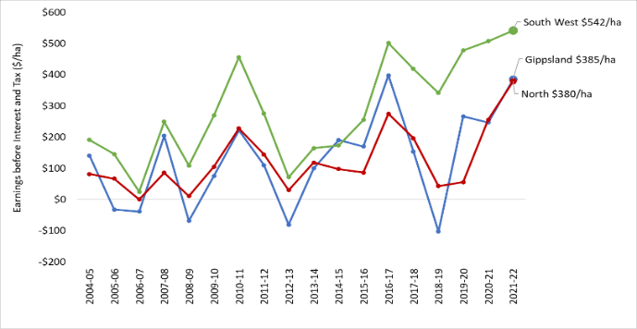
Figure 2. Regional profitability over time
In 2021–22, the return on assets were above the 10-year average in all regions. Surveyed farms located in South West Victoria recorded the highest average returns for the state (Figure 3), while farms in Northern Victoria had the largest annual percentage increases. Regardless of the average, each region had participant farms that recorded high returns and negative returns (Appendix B1, C1, D1).
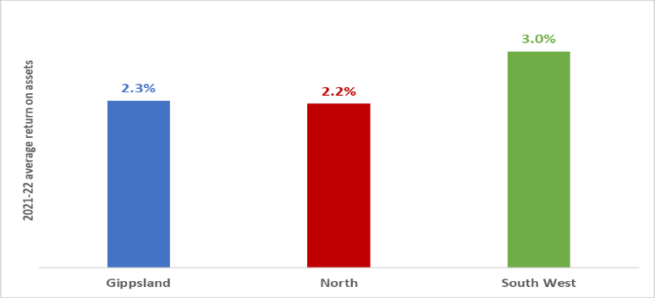
Figure 3. 2021–22 regional return on assets

Scale
When the LFMP dataset was separated by business scale based on total cash income, there were farms with good returns across all farm sizes. Figure 4 shows larger farms tended to have higher average return on assets than smaller farms. Larger farms can reduce their costs through scale by spreading overhead (fixed) costs over more output. Surveyed farms with cash income less than $428,000 had the lowest average return on assets.

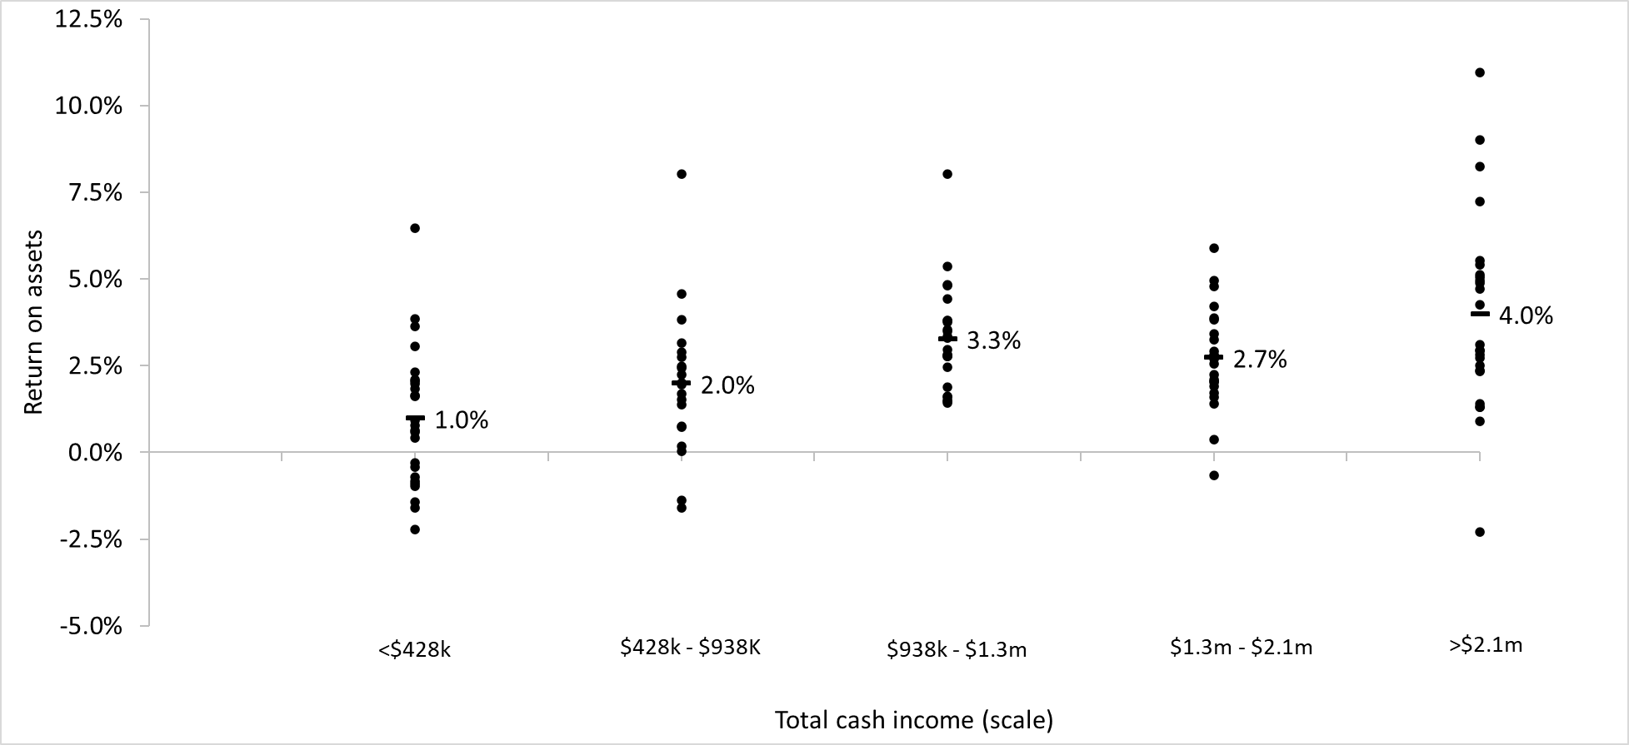
Figure 4. 2021–22 farm scale and return on assets

Capital expenditure
High cashflows for many LFMP farmers in 2021–22 resulted in high rates of expenditure on capital additions. The most popular capital addition in each region was plant and equipment (P&E) (Figure 5). This was attributable to a combination of replacing old P&E for new and the incentives of low-interest rates and access to pandemic tax concessions.
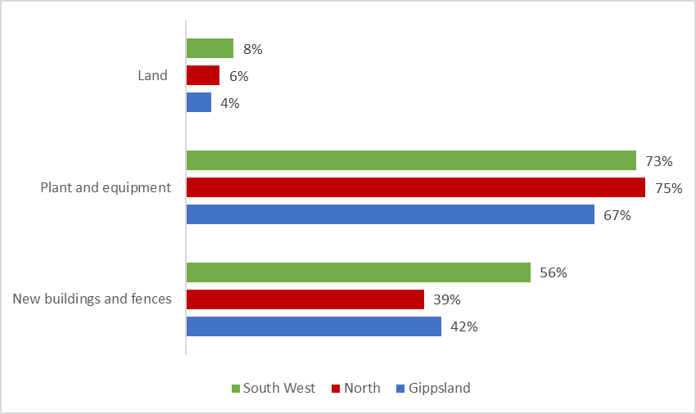
Figure 5. The proportion of farms that made capital additions

Debt
Increased cashflows in 2021– 22 also allowed a high proportion of surveyed farms to reduce debt (Figure 6). However, a large proportion of farms increased their debt over the 12 months, particularly in Northern Victoria and South West Victoria. This was mostly for capital improvements as managers chose to invest in land, P&E, new fences and other on-farm improvements.
Debt was part of the business structures for a substantial proportion of surveyed farms. The use of debt increases the obligatory costs of farm businesses as principal and interest repayments must be paid in good and poor years. For this reason, farm management strategies employed throughout the year can be influenced by the level of debt held by the business.
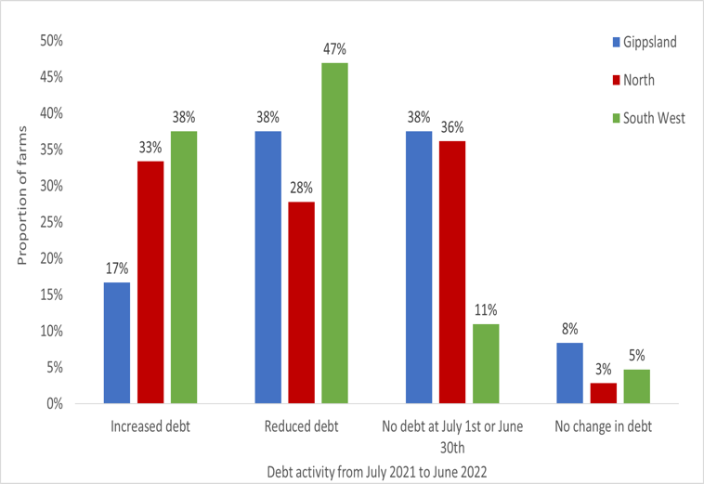
Figure 6. Debt activity from 1 July 2021 to 30 June 2022

Comparing the risk and return of Livestock Farm Monitor farms with off-farm investments
A commonly asked question is how did LFMP farms perform over the last five years? A common response is compared to what? In answering this question, the criteria of performance must assess the size of returns and the variability in return (risk) associated with it. This section also looks at which LFMP region came out on top and why.
Figure 7 shows the average LFMP return on assets over the last five years, in comparison with returns from alternative off-farm investments that have similar risk, such as shares in the stock market, and others with less risk, such as bonds and cash. The risk was measured by the standard deviation in return on assets across the time period 2017–19 to 2021–22.
Investment types whose performance falls toward the right-hand side of Figure 7 are considered ‘riskier’ than those indicated by points toward the left-hand side. Less volatility was experienced by farms across all regions than all other asset classes except cash. The time period represented in Figure 7 includes the COVID-19 pandemic, which caused large amounts of volatility in share markets and property markets resulting in more volatile returns than agriculture-related asset classes.
South West Victoria farms had the highest average returns of farms in the other LFMP regions with equivalent risk. This result was influenced by south west farms mostly escaping the negative impact of dry seasonal conditions experienced by Northern Victoria and Gippsland businesses through 2018–19 and 2019–20. However, farms in Northern Victoria and Gippsland had higher returns than Australian bonds investment over the same time and experienced less volatility.
Growth in farmland capital value has been excluded from this analysis and can be another source of returns for farmland owners.
The analysis shows the relationship between risk and return for the different investments. Investments with higher returns were associated with higher risk, but investments with similar returns exhibit different risk too.
Managing the volatility in a business over time is a characteristic of good farm managers. They will structure their business so the risk-return mix suits their business goals and objectives.
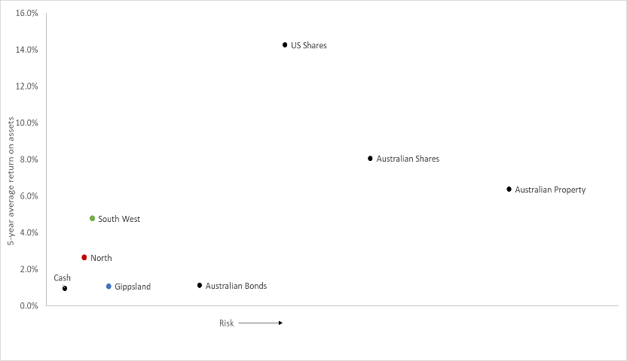
Figure 7. Return versus risk: Average and standard deviation of annual returns from various investments (2017–18 to 2021–22).

Gippsland

Price recieved
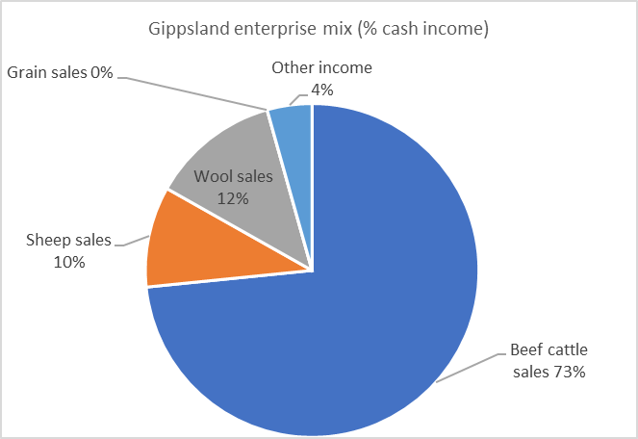
Figure 8. Gippsland enterprise mix (proportion of cash income)
Beef was the dominant enterprise of the Gippsland region (Figure 8). Many participant farms were well-placed to take advantage of the strong beef prices. As a result, regional gross farm income was the highest recorded in 18 years (Appendix D12). High beef prices offset the decreased beef production which dropped below the regional three-year average.

Fertiliser:

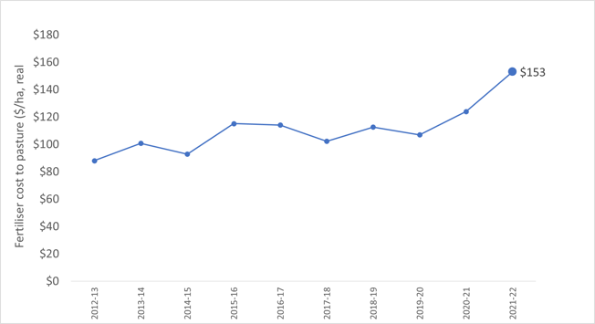
Figure 9. Average cost of fertiliser applied to pasture over time
Consistent with the trend observed in the other regions, fertiliser was the largest cost item on Gippsland farms. Gippsland was subject to the significant unit price increase of all fertiliser experienced across the state. Additional freight costs to the region meant that Gippsland farmers paid more per unit of fertiliser than their northern and south west counterparts.
Decreases in regional phosphorus and nitrogen application rates helped offset the high fertiliser prices. High fertiliser prices and very wet conditions resulted in the largest proportion of farms not applying any fertiliser in four years (Figure 10). Despite the decreased application rate, expenditure on fertiliser was the highest recorded in the past decade (Figure 10).
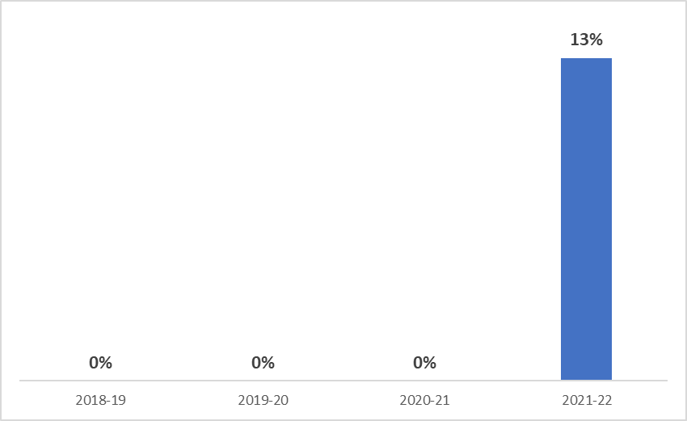
Figure 10. Proportion of farms that applied zero fertiliser (2018–19 to 2021–22)

Gross margins
Beef gross margins were 19 per cent above the three-year average in 2021–22 due to high income and low average variable costs.
The shrinking size of the Gippsland sheep flock was highlighted with below average stocking rates and sales quantity in 2021–22. This contributed to a 28 per cent reduction in prime lamb gross margin compared to the three-year average.

Calving and lambing pattern
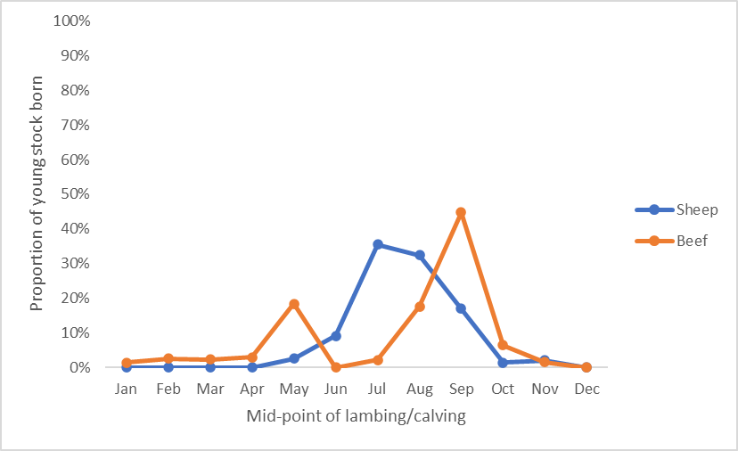

Figure 11. 2021–22 calving and lambing pattern
July and August were the peak months for lambing in sheep enterprises while September was the peak month for calving in beef enterprises. Consequently, spring 2021 represented the months of highest feed demand. On average Gippsland farms received 145 per cent of their long-term average spring rainfall (Appendix C2) which left some soils saturated, particularly in South and West Gippsland. Wet conditions provided a challenge to harvest pasture for conservation. Despite the wet conditions, average quantities of fodder harvested increased compared to the previous year. Hay and silage making costs and feed inventories increased as a result.
Grazed pasture made up a larger component of the average animal diet in 2021–22. The good pasture production also reduced supplementary feeding requirements thereby helping to minimise exposure to higher feed prices.

Assets
Rising farmland and cattle prices resulted in Gippsland participants managing the highest value of total assets per hectare of the LFMP regions. Increases in land prices offset the higher debt levels leading to an average annual addition to farmers’ wealth (equity) of $3,044/ha.

Return on assets
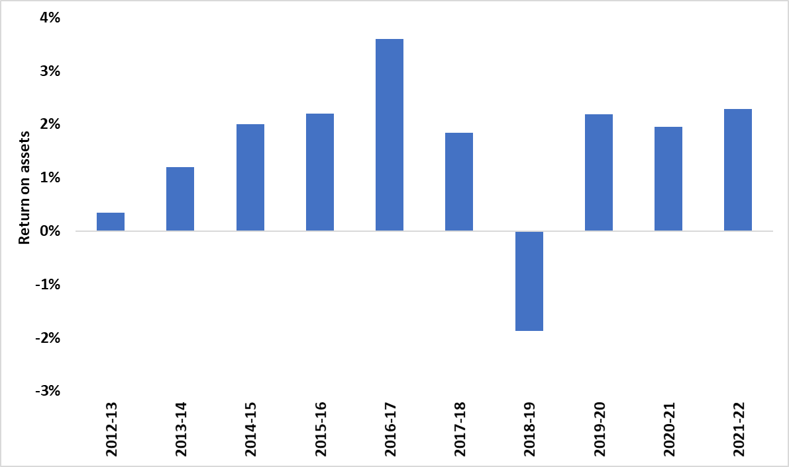
Figure 12. Average Gippsland return on assets over time
Increases in farm profits matched the increase in the value of total assets managed. Therefore 2021–22 average return on assets for Gippsland farms remained higher than the 10-year average and was the second highest recorded in the last decade (Figure 12).

Gippsland regional summary
- Beef sales made up 73 per cent of cash income for LFMP farms in Gippsland
- Highest average price received for beef cattle in 18 years
- Highest average gross farm income recorded in 18 years
- Highest return on assets since 2016–17
- Average annual increase to equity (net worth) of $3,044/ha

Regional summary
 | 3-yr average  Gippsland | Gippsland 2021–22
Beef income ($/ha) | $1,250 | $1,348
Prime lamb income ($/ha) | $1,154 | $930
Wool sheep income ($/ha) | $711 | $717
Beef variable costs ($/ha) | $510 | $470
Prime lamb variable costs ($/ha) | $417 | $399
Wool sheep variable costs ($/ha) | $280 | $278
Total assets managed ($/ha) | $16,385 | $19,602
Total debt ($/ha) | $1,395 | $1,865
Annual increase in equity ($/ha) | $1,827 | $3,044
Beef sold (kg lwt/ha) | 365 | 288
Lamb sold (kg cwt/ha) | 114 | 89
Wool sheep wool cut (kg Gr./ha) | 38 | 37
Labour use (FTE/farm) | 1.9 | 1.9
Labour use efficiency (ha/FTE) | 310 | 299
Labour use efficiency (DSE/FTE) | 4,761 | 4,772
Labour use efficiency (cash income/FTE) | $396,251 | $427,409
Nitrogen applied to pasture (kg/ha) | 14 | 11
Phosphorus applied to pasture (kg/ha) | 12 | 11
Potassium applied to pasture (kg/ha) | 12 | 15
Sulfur applied to pasture (kg/ha) | 11 | 11
Beef stocking rate (DSE/ha) | 17.6 | 17.0
Prime lamb stocking rate (DSE/ha) | 16.3 | 14.3
Wool sheep stocking rate (DSE/ha) | 10.8 | 10.7

Northern Victoria

Price recieved
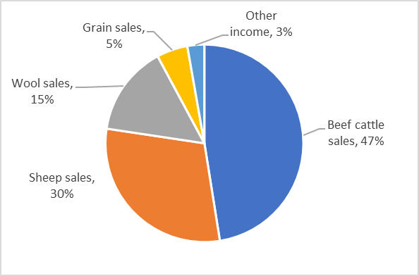
Figure 13. Northern Victoria enterprise mix (proportion of cash income)
The combination of exceptional seasonal conditions and high commodity prices led to the highest average gross farm income recorded by the project in Northern Victoria (Appendix C12). Beef cattle were the major enterprise on northern farms and many were well placed to take advantage of the high beef prices. The average beef price received by northern farmers increased 29 per cent in 2021–22 compared to the previous year.
Fertiliser:
Contrary to the trend across the state, there was a decrease in average expenditure on fertiliser applied to pasture in Northern Victoria (Figure 14). Phosphorus and nitrogen application rates decreased to below the three-year average as farm managers attemped to offset the high fertiliser price by decreasing fertiliser application rates.
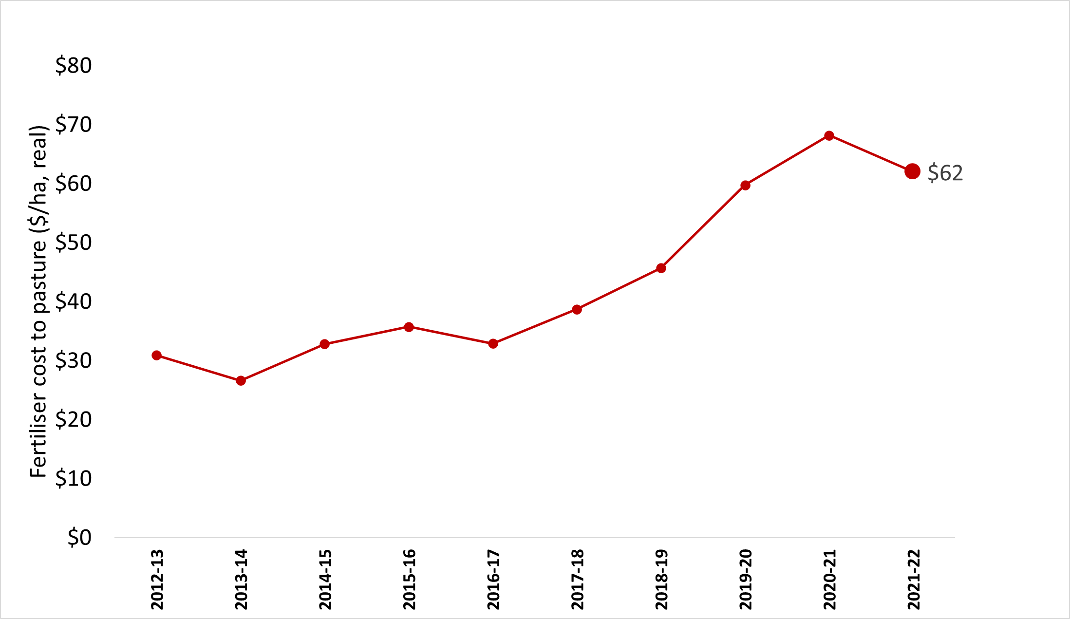
Figure 14. Average cost of fertiliser applied to pasture over time
In response to the high fertiliser price and lower availability in 2021–22, 19 per cent of northern participants did not apply any fertiliser (Figure 15). A similar proportion of farms applied zero fertiliser in 2018–19, however, in that year, it was attributable to dry seasonal conditions.
A combination of lower nutrient application rates and a higher proportion of businesses not applying any fertiliser in 2021–22 led to a decrease in the average fertiliser expense.
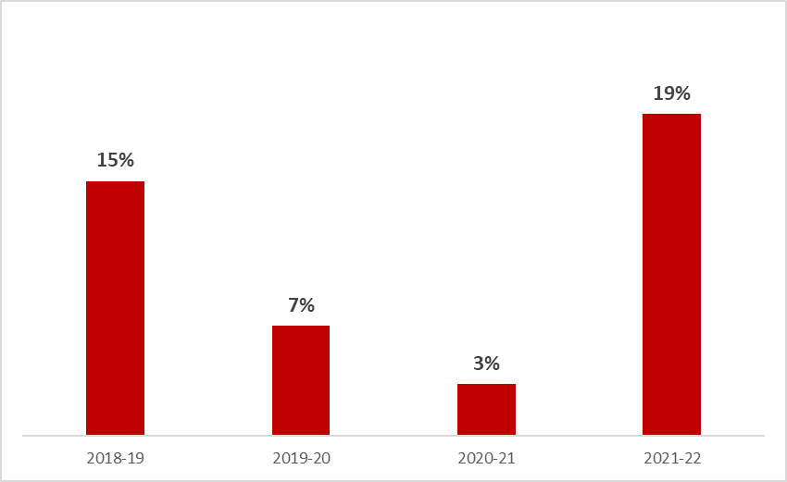
Figure 15. Proportion of farms that applied zero fertiliser (2018–19 to 2021–22)

Gross margins
High prices received for beef, lamb and wool in 2021–22 offset increases in fertiliser and labour input prices. As a result, gross margins were all above the three-year average in 2021–22.

Calving and lambing pattern
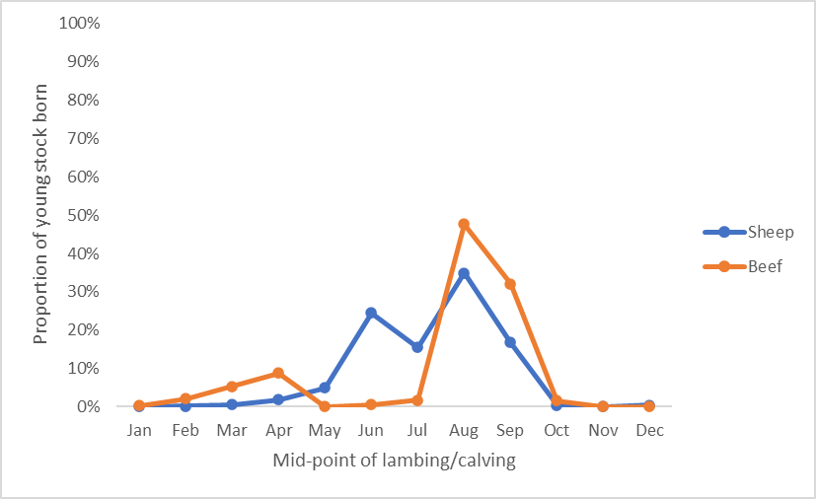
Figure 16. 2021–22 calving and lambing pattern
Most northern participants received higher than average annual rainfall in 2021–21 and over half of the farms received more than 130 per cent of long-term average spring rainfall (Appendix C2).
In Northern Victoria, the peak lambing period was from June to September (Figure 16). The distribution of calving times remained tight with 80 per cent of calving occurring in August and September (Figure 16).

Assets
Large increases in farmland values across Northern Victoria boosted the value of total farm assets and offset the high proportion of businesses that took on more debt in 2021–22 (Figure 6). This resulted in an average annual addition to farmers’ wealth (equity) of $1,792/ha.

Return on assets
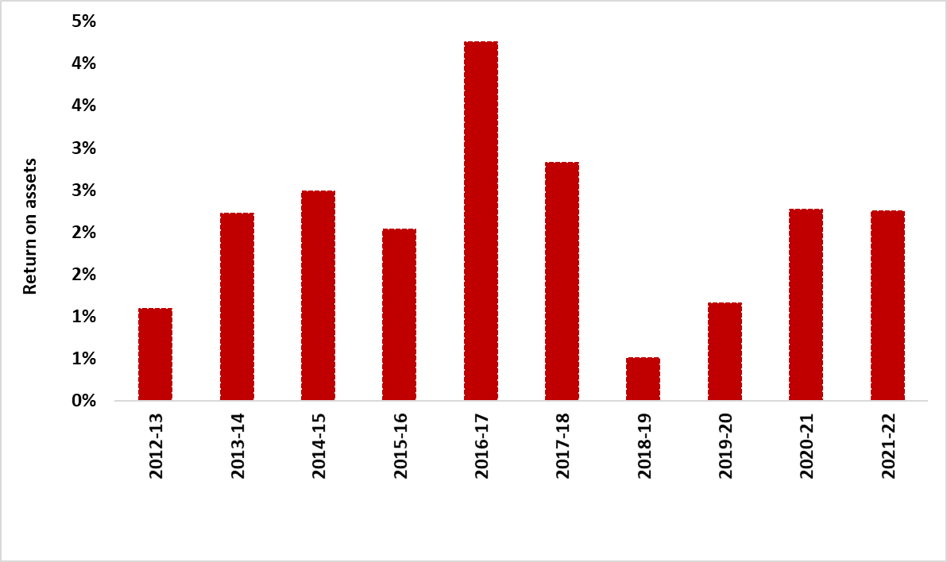
Figure 17. Average return on assets over time
Northern Victoria participants recorded strong performance in 2021–22. Return on assets was above the 10-year regional average despite a slight decrease from the previous year. Average EBIT on northern farms increased 53 per cent year-on-year to the highest recorded value in 18 years of the project.
The continued and rapid increase in the value of total assets managed was the reason for the difference in the trends of these performance measures. As the return on assets did not include the additional return from capital appreciation this measure is constrained by higher asset values.

Northern Victoria regional summary
- Highest average EBIT recorded in 18 years
- Highest return on assets since 2017–18 as continued and rapid rise in farmland constrained returns in 2021–22
- Highest average gross farm income recorded in 18 years
- Reduced fertiliser usage, application rates and expenditure
- Average annual increase to equity (net worth) of $1,792/ha

Regional summary
 | 3-yr average | Northern Victoria 2021–22
Beef income ($/ha) | $922 | $1,241
Prime lamb income ($/ha) | $978 | $942
Wool sheep income ($/ha) | $759 | $897
Beef variable costs ($/ha) | $476 | $416
Prime lamb variable costs ($/ha) | $331 | $368
Wool sheep variable costs ($/ha) | $275 | $321
Total assets managed ($/ha) | $13,166 | $17,094
Total debt ($/ha) | $818 | $886
Annual increase in equity ($/ha) | $1,220 | $1,792
Beef sold (kg lwt/ha) | 270 | 282
Lamb sold (kg cwt/ha) | 153 | 121
Wool sheep wool cut (kg Gr./ha) | 33 | 35
Labour use (FTE/farm) | 2.0 | 1.9
Labour use efficiency (ha/FTE) | 428 | 417
Labour use efficiency (DSE/FTE) | 4,612 | 4,917
Labour use efficiency (cash income/FTE) | $424,536 | $513,030
Nitrogen applied to pasture (kg/ha) | 7 | 5
Phosphorus applied to pasture (kg/ha) | 11 | 7
Potassium applied to pasture (kg/ha) | 2 | 3
Sulfur applied to pasture (kg/ha) | 8 | 9
Beef stocking rate (DSE/ha) | 12.6 | 13.9
Prime lamb stocking rate (DSE/ha) | 11.2 | 11.2
Wool sheep stocking rate (DSE/ha) | 10.6 | 11.5

South West Victoria

Price recieved
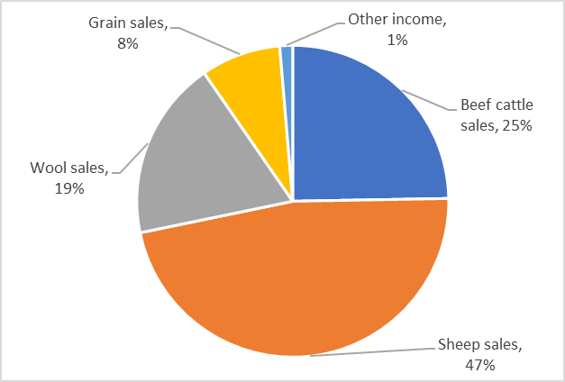
Figure 18. South West Victoria enterprise mix (proportion of cash income)
Sheep enterprises were the dominant enterprises in the south west (Figure 18). Prime lamb and wool sheep products made up 66 per cent of cash income (47 per cent sheep sales and 19 per cent wool sales). In 2021–22, lamb price was the highest in 18 years and fine wool price recieved was the second highest. This boosted average gross farm income to the highest levels recorded in 18 years (Appendix B12).

Fertiliser:
High fertiliser prices increased fertiliser expenditure by 20 per cent year-on-year and was the highest outlay in the last decade (Figure 19). The increase in expenditure was in spite of decreases in regional phosphorus, nitrogen and potassium application rates.
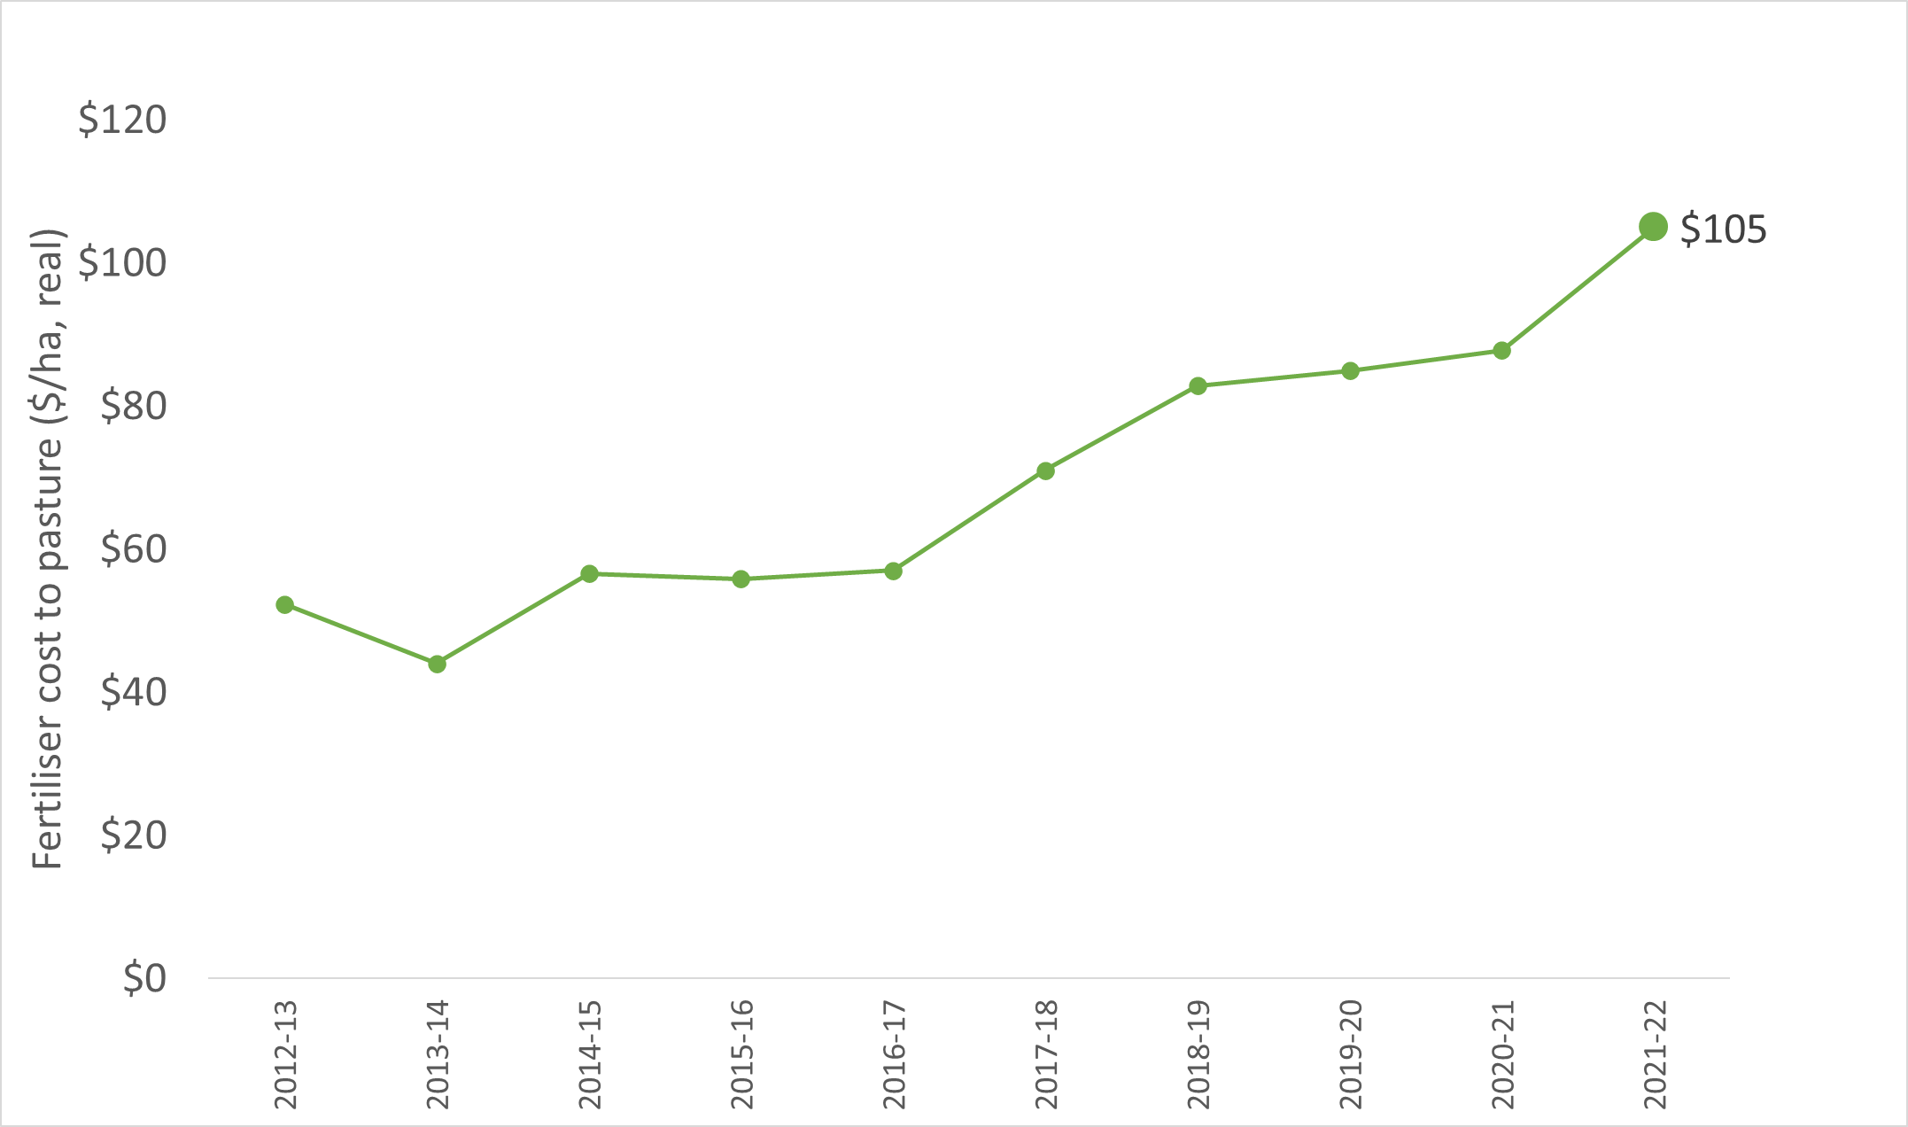
Figure 19. Average cost of fertiliser applied to pasture over time
The proportion of south west participants who did not apply any fertiliser in 2021–22 remained low (Figure 20) and equal to the three previous years. This result is a diversion from the trend observed in the other LFMP regions.
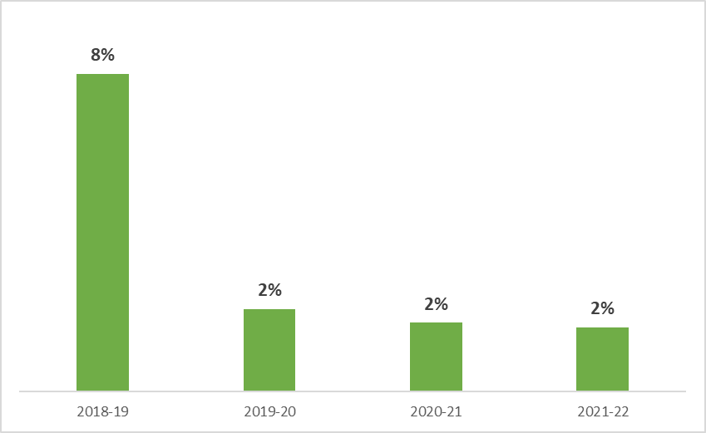
Figure 20. Proportion of farms that applied zero fertiliser (2018–19 to 2021–22)

Gross margins
Beef and prime lamb gross margins increased in 2021–22 to be above the three-year average while wool sheep gross margins decreased slightly. Average variable costs in the south west were the highest in 18 years (Appendix B12) due to the increased cost of fertilisers and labour. South West Victoria farm businesses were more reliant on contract labour for shearing and crutching operations than Gippsland and Northern Victoria businesses and therefore highly exposed to the changes in costs and availability.

Calving and lambing pattern
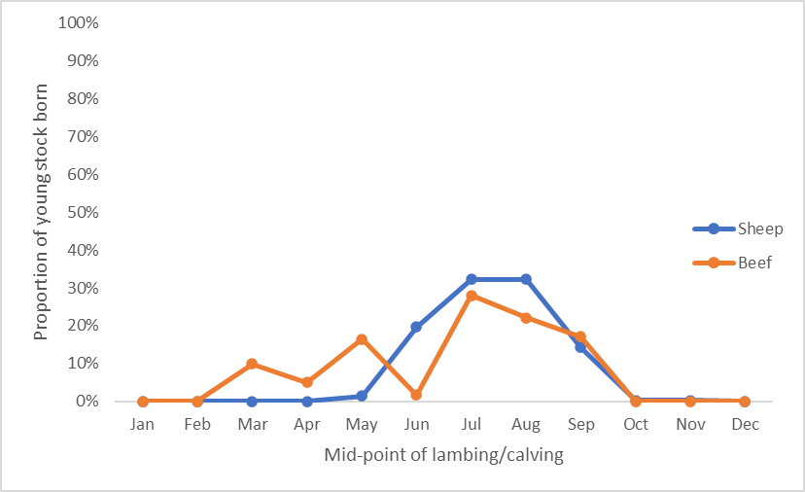
Figure 21. 2021–22 calving and lambing pattern
The distribution of lambing dates on surveyed farms in the south west (Figure 21) can be explained by the large proportion of self-replacing prime lamb enterprises. Lambing in prime lamb enterprises tended to peak in mid-winter as producers attempted to use the high pasture growth in spring. Meeting the feed demand of lactating ewes and target weights of lambs to be sold in early summer with pasture. South West Victoria farms had a higher proportion of autumn calving beef cows than other regions.
South west participants received average annual and spring rainfall in 2021–22 (Appendix C2). Many capitalised on favourable seasonal conditions to increase homegrown fodder production on average. This helped reduce the amount of supplementary feeding that occurred in 2021–22 (Appendix B2) which had the added benefit of minimising the exposure to rising fodder and grain prices in the supplementary feed market.
Pasture utilisation rates decreased across the region and corresponded with a decrease in stocking and supplementary feeding rates. As a result, grazed pasture made up a greater proportion of sheep diets than in 2020–21.

Assets
Farmland and livestock values continued to rise across South West Victoria. The subsequent increase in the value of total farm assets offset the increased debt levels and resulted in an average annual addition to farmers’ wealth (equity) of $2,526/ha.

Return on assets
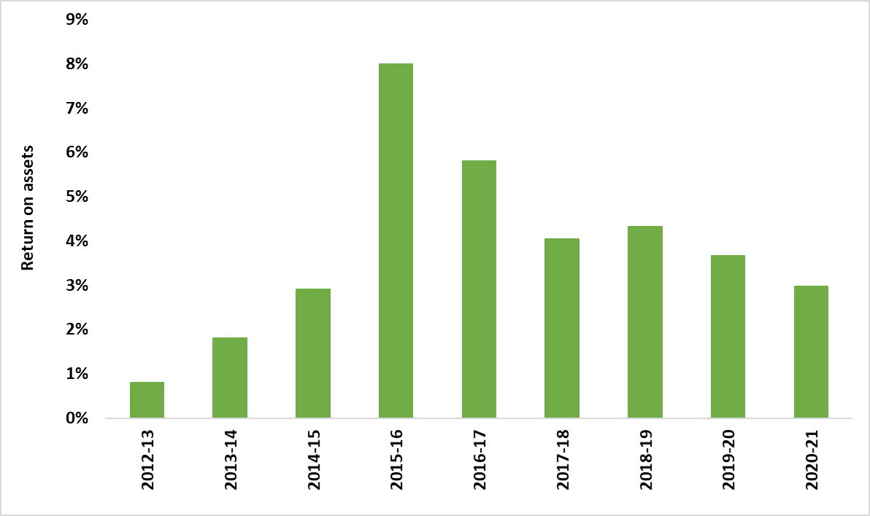
Figure 22. Average return on assets over time
Return on assets decreased for the second consecutive year to 3.0 per cent in 2021–22, the lowest level recorded since 2014–15. Average EBIT on south west farms increased to the highest level recorded value in 18 years.

South West Victoria regional summary
- Highest average EBIT recorded in 18 years
- Highest average variable costs in 18 years
- Highest average gross farm income in 18 years
- Lowest return on assets since 2014–15
- Average annual increase to equity (net worth) of $2,526/ha

Regional summary
 | 3-yr average | South West Victoria 2021– 22
Beef income ($/ha) | $1,350 | $1,496
Prime lamb income ($/ha) | $1,383 | $1,419
Wool sheep income ($/ha) | $1,119 | $1,099
Beef variable costs ($/ha) | $563 | $570
Prime lamb variable costs ($/ha) | $507 | $505
Wool sheep variable costs ($/ha) | $477 | $480
Total assets managed ($/ha) | $14,343 | $18,277
Total debt ($/ha) | $1,600 | $1,816
Annual increase in equity ($/ha) | $2,065 | $2,566
Beef sold (kg lwt/ha) | 668 | 566
Lamb sold (kg cwt/ha) | 118 | 117
Wool sheep wool cut (kg Gr./ha) | 49 | 48
Labour use (FTE/farm) | 3.2 | 3.5
Labour use efficiency (ha/FTE) | 396 | 403
Labour use efficiency (DSE/FTE) | 6,086 | 6,133
Labour use efficiency (cash income/FTE) | $546,068 | $604,755
Nitrogen applied to pasture (kg/ha) | 13 | 8
Phosphorus applied to pasture (kg/ha) | 14 | 13
Potassium applied to pasture (kg/ha) | 14 | 10
Sulfur applied to pasture (kg/ha) | 12 | 13
Beef stocking rate (DSE/ha) | 17.9 | 17.2
Prime lamb stocking rate (DSE/ha) | 18.4 | 18.4
Wool sheep stocking rate (DSE/ha) | 15.5 | 14.6

Glossary
Appreciation
An increase in the value of an asset in the marketplace. Often only applicable to land value.
Asset
Anything managed by the farm, whether it is owned or not. Assets include owned land and buildings, leased land, plant and machinery, fixtures and fittings, trading stock, farm investments (i.e., Farm Management Deposits), debtors and cash.
Average
The sum of a collection of numbers divided by the count of numbers in the collection.

Cash Income
The sum of all cash income related to the operation of the farm/enterprise.

Cash overheads
All fixed costs have a cash cost to the business. Includes all overhead costs except imputed labour costs and depreciation.
Casual labour
A casual employee is an employee engaged casually and paid by the hour. Casual loading is paid instead of annual leave, a notice of termination, redundancy benefits and other attributes of permanent labour.
Contract labour
A contractor controls the work to be done and how it is to be performed. They can employ their own staff and can subcontract or delegate.
Concentrate
Category of feed that includes grains, oilseeds, and pellets.
Depreciation
Decrease in value over time of capital asset, usually as a result of using the asset. Depreciation is a non-cash cost of the business but reduces the book value of the asset and is therefore a cost.
Dry sheep equivalent (DSE)
The standard unit used to compare the metabolisble energy (ME) requirements of different classes of stock for feed budgeting purposes.
Earnings before interest and tax (EBIT)
Also known as ‘Operating Profit’ or ‘Profit’ is the return on all the capital used in the business before accounting for finance costs. Calculated as gross farm income minus total variable and total overhead costs.
Effective area
Total hectares managed minus the area of land which is of little or no value for livestock or crop production.
Equity
Total assets minus total liabilities. Equal to the total value of capital invested in the farm business by the owner/operator(s).
Equity %
Total equity as a percentage of the total assets owned.
The proportion of the total assets owned by the business.
Feed inventory change
An estimate of the feed on hand at the start and end of the financial year.
Full time equivalent (FTE)
Standardised labour unit. Equal to 1,920 hours a year.
Calculated as 48 hours a week for 40 weeks a year.
Grazed area
Pasture area plus an estimate of annual cropping area grazed. If a farm has multiple livestock enterprises, the grazed area is apportioned based on the total annual ME demand of each enterprise.
Grazed pasture utilised
Calculated using the back-calculation approach. Grazed feed is calculated as the difference between the total metabolisable energy required by livestock over the year and the amount of metabolisable energy consumed from other sources (hay, silage, grain, and concentrates).
The total metabolisable energy required by livestock is a factor of age, weight, growth rate, pregnancy and lactation requirements and the number of animals.
Gross farm income
The total income, cash, and non-cash, received from a farm or enterprise before any expenses are paid.
Gross margin
Gross farm income minus total variable costs.
Imputed
An estimated amount is introduced into economic management analysis to allow reasonable comparisons between years and between other businesses.
Interest and lease costs
Total interest plus total lease costs paid. Also known as ‘finance costs’.
Liability
Money owed to someone else, e.g. family or a financial institution.
Livestock trading profit
An estimate of the annual contribution to gross farm income by accounting for the changes in the number and value of livestock during the year. It is calculated as the trading income from sales minus purchases, plus changes in the value and number of livestock on hand at the start and end of the year, and accounting for births and deaths. An increase in livestock trading indicates there was an appreciation in the value of livestock per head or an increase in livestock numbers over the year.
Metabolisable energy (MJ ME)
The energy available for use by the animal. It is the energy used for maintenance of body systems, activity, milk production, pregnancy and weight gain. Metabolisable is net of energy lost in the form of urine and methane gas released by rumen and hind-gut microbes.
Net farm income
Earnings before interest and tax (EBIT) minus interest and lease costs. The amount of profit available for capital investment, loan principal repayments and tax.
Nominal terms
Dollar values or interest rates that include an inflation component.
Livestock costs
All expenses relating to assisting with herd and flock management. Includes animal health costs and shearing contractors.
Livestock marketing costs
All costs associated with buying and selling livestock including freight and cartage.
Operating costs
Overhead and variable costs, i.e. the costs associated with the annual operation of the farm.
Overhead costs
All fixed costs incurred by the farm business that do not vary with the level of production. These include cash overhead costs such as permanent labour and noncash costs such as owner-operator labour, family labour and depreciation of plant and equipment. It excludes interest, lease costs, capital expenditure, principal repayments, drawings, and tax.
Owner/Operator labour
Staff members (such as family) that take income from business drawings rather than wages. The operators’ labour and management are an input to make a profit and so these must be costed and deducted to estimate the true profit and return to the capital in the business.
Pasture costs
All costs associated with growing pasture including fertiliser, seed and chemicals.
Permanent labour
Farm staff who have an ongoing expectation of work, generally work standard or set hours, are entitled to paid leave and notice of termination.
Profit (s)
See Earnings before interest and tax (EBIT).
Real terms
Dollar values or interest rates that have no inflation component.
Return on equity (ROE)
Net farm income divided by the value of total equity.
Return on assets (ROA)
Earnings before interest and tax divided by the value of total assets under management, including owned and leased land.
Standard deviation
The standard deviation is a measure of how widely values are dispersed from the average value.

Variable costs
Variable costs (sometimes called direct costs) vary directly as the output of an enterprise varies.

List of abbreviations
CWT | Carcass weight
DJPR | Department of Jobs, Precincts and Regions, Victoria
DSE | Dry sheep equivalent
EBIT | Earnings before interest and tax
GM | Gross margin
ha | Hectare(s)
kg | Kilograms
Kg Gr. or  Gr. kg | Kilograms of greasy wool
LFMP | Livestock Farm Monitor Project
LWT | Live weight
ME or  MJ ME | Megajoules of Metabolisable energy
ML | Megalitre
mm | Millimetres
NFI | Net Farm Income
ROA | Return on Assets
ROE | Return on Equity
t | Tonne = 1,000 kg
tDM | Dry matter of feed stuffs measured in tonnes
yrs | Years old

References
Kay RD, Edwards WM, Duffy PA 'Farm Management' (Mcgraw-Hill Companies)
Malcolm B, Makeham J, Wright V 'The Farming Game - Agricultural Management and Marketing.' (Cambridge University Press: Melbourne)
Nuthall P ‘Farm Business Management: Analysis of Farming Systems ‘ (CAB international)

