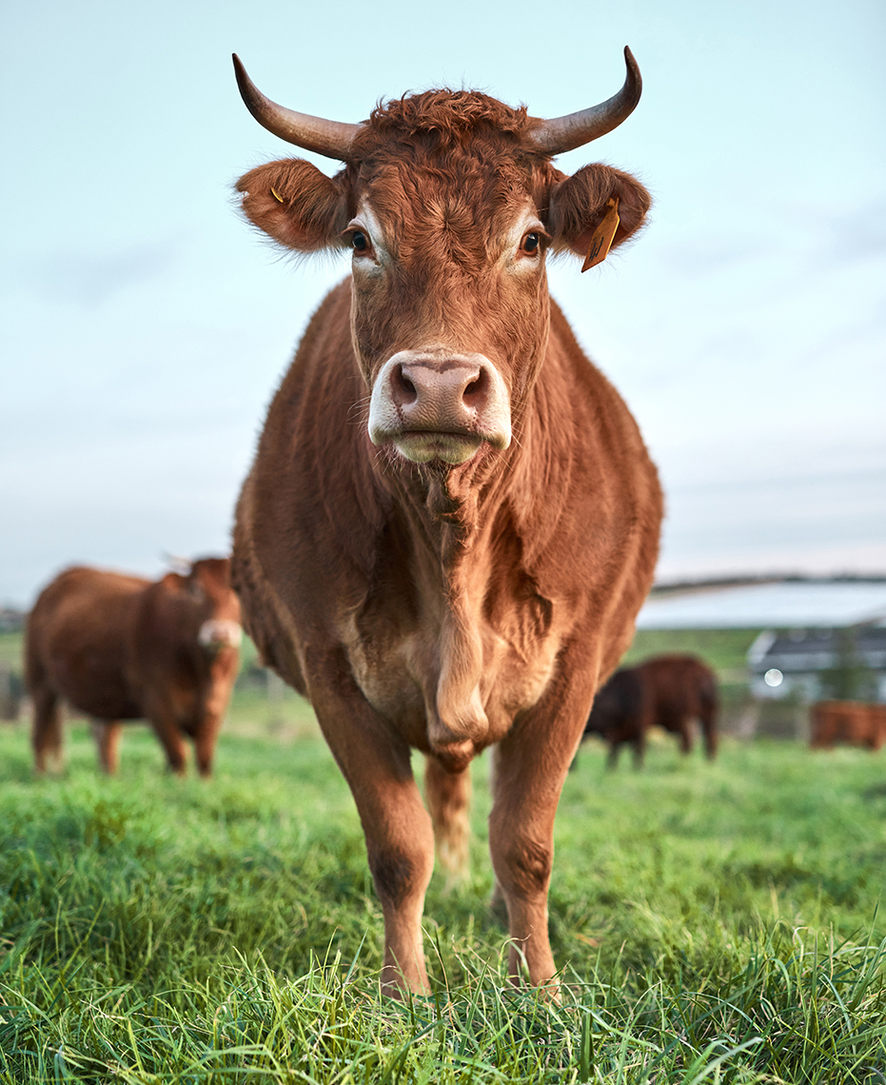
Municipal Emergency Animal Welfare Sub-Plan

This template is provided to assist Municipal Emergency Management Planning Committees (MEMPC) in the development of plans to address animal welfare issues arising from an emergency within a municipality. It has been structured to ensure consistency with the Victorian Emergency Animal Welfare Plan and builds on the efforts of MEMP committees and councils who have already made in-roads in this area.
Not all sections of the template will be relevant to every municipality.
MEMP committees may also identify additional planning requirements or prefer to incorporate relevant information into Municipal Emergency Management Plans.
For further information to assist the development of municipal emergency animal welfare plans, refer to the Victorian Emergency Animal Welfare Plan or Guidelines for the management of animals at Emergency Relief Centres, which is found at: https://agriculture.vic.gov.au/farm-management/emergency-management/emergency-animal-welfare/managing-animals-at-relief-centres#h2-2

Accessibility
If you would like to receive this publication in an accessible format, please telephone the Department of Jobs, Precincts and Regions on 136186.

Contents
Acronyms………………………………………………………………………………………………………………………………………….….5
Glossary………………………………………………………………………………………………………………………………………………..5
Purpose………………………………………………………………………………………………………………………………………………...5
Scope……………………………………………………………………………………………………………………………………………………..5
Audit……………………………………………………………………………………………………………………………………………………….5
Plan development, endorsement, testing and review……………………………………………………………………………………………………………………………………………….……5
Aim and objectives…………………………………………………………………………………………………………………………...6
Plan Activation……...……………………………………………………………………………………………………………………………6
Business continuity …………………………………………………………………………………….……………………………………6
Roles and responsibilities……..……………………………………………….……………………………………………………….7
Operational arrangements…………………….……………………………….……………………………………………………..7
Emergency animal welfare services…………………………………………….…………………………….……………………………………………………………………..8
Information sharing…………………………………………………………….……………………………………………………………11
Process for requesting additional resources………………………………………………………………………..…………………………………………………………………….11
Financial measures………………………………………………………….……………………………………………………………….11
Appendix 1 Contact information…………………………………………………………………………………………………12
Appendix 2 Emergency relief centres and animal welfare processes……………………………………………………………………..…………………………………………………………………...…13
Appendix 3 Job cards………………………………………………………………………………..……………………………………13
Appendix 4 Emergency animal welfare resources within the municipal district………………………………………………………………………………………………….…………………………………………….….13
Appendix 5 Standard operating procedures / Safe work procedures…………………………………………………………………………………………….…………………………………………….13
Appendix 6 Templates…………………………………………………………………………………………………………………….13
Appendix 7 Memorandum of understanding………………………………………………………………………………………………………………………………….…13

Acronyms
Refer to the Victorian Emergency Animal Welfare Plan.
https://agriculture.vic.gov.au/farm-management/emergency-management/emergency-animal-welfare/victorian-emergency-animal-welfare-plan

Glossary
Refer to the Victorian Emergency Animal Welfare Plan.
https://agriculture.vic.gov.au/farm-management/emergency-management/emergency-animal-welfare/victorian-emergency-animal-welfare-plan

1. Purpose

This Municipal Emergency Animal Plan has been produced pursuant to Section 20 (1) of the Emergency Management Act 1986 and assists in the management of animal welfare during an emergency. The Plan has been developed with reference given to the Victorian Emergency Animal Welfare Plan.

2. Scope

- Describe emergency risks relevant to the municipality.
- Include relevant animal population data relevant to the municipality (companion animals, livestock, and wildlife) to understand the potential scope of services needed.
- List animal welfare support services relevant to the municipality that will be addressed in the Plan.
Example:
Drought, flood, fire, and emergency animal disease have been identified in Municipal Emergency Management Plan’s risk register as having a high or moderate risk that could affect the welfare of companion animals and livestock within the municipality. Consequently, this plan has been developed to guide local emergency animal welfare arrangements for these risks with emphasis given to:
- Identification of affected animals
- Management of evacuated animals at Emergency Relief Centres
- MANAGEMENT OF STRAY OR ROAMING ANIMALS
- Animal welfare assessment
- Veterinary treatment and triage
- Humane destruction or salvage slaughter
- Carcass disposal
- Provision of emergency pet food, livestock fodder and water
- Coordination of donations and offers of assistance

3. Audit

This Municipal Emergency Animal Welfare Plan is a sub-plan of the Municipal Emergency
Management Plan prepared under Section 20 (1) of the Emergency Management Act 1986 and as such is subject to the audit provisions as detailed in Section 20A of the Emergency Management Act 1986.

- Plan development, endorsement, testing and review

- Describe the process used to develop and endorse the Plan.
- Describe arrangements for the testing and review of the Plan.
- Include relevant committees and their membership.

- Aim and objectives

- Describe what the plan aims to achieve
Example:

The aim of the Municipal Emergency Animal Welfare Plan is to define agreed arrangements for the management of emergency animal welfare within the Municipality including:
- Roles and responsibilities of key agencies and stakeholders
- Operational interactions between key agencies and stakeholders
- Resources (personnel. facilities, equipment, services) to be used in the delivery of animal welfare services

The overarching objective of the Plan is to:
- contribute to enhanced public safety and community resilience within the municipality through effective planning and management of animals in emergencies: and
- ensure animals within the municipality are better considered and protected from suffering during and immediately following emergencies.

- Plan Activation

- Who within council is responsible for activating the plan?
- What might be the triggers to activating arrangements in the plan?
- Who will oversee the implementation of the plan?
Example:
The Municipal Emergency Resource officer will activate the Plan following advice from the Municipal Emergency Response Coordinator (Victoria Police) or the Department of Primary Industries. Triggers for plan activation may include:
- opening of a Municipal Emergency Relief Centre;
- carcass disposal need; and /or
- donated fodder or stock water supply need

In large-scale emergencies, the Manager Local Laws will oversee the implementation of the plan in consultation with the Agriculture Victoria MECC Liaison or Agriculture Victoria Animal Welfare Liaison Officer assigned to the emergency.

- Business Continuity

- What will be the priority given to emergency animal welfare services versus normal animal welfare services in the event of an emergency.
- This may include a description of priorities against small, medium, or large scale and complex events.

8. Roles and Responsibilities

Municipal staff involved in Animal Welfare activities
- List key roles within the municipality and an overarching role description
- Insert an organization chart that shows reporting relationships and links to the Municipal Emergency Coordination Centre
- Describe briefing and handover standards
- Develop job cards outlining pre-requisite training and PPE (Job Cards may be inserted as an Appendix).
- Identify staff member to provide ratepayer information to State response agencies.

Other agencies
- List key roles and responsibilities of relevant agencies and organizations
(Refer to the Victorian Emergency Animal Welfare Plan for guidance)

- Operational Arrangements

- Describe key animal welfare interactions in the preparedness, prevention, response/relief, and recovery phases

Example:

Preparedness:
- Animal welfare support services will be represented by council and Agriculture Victoria at the Municipal Emergency Management Planning Committee OR Municipal Emergency Animal Welfare Sub Committee.
- Emergency animal welfare services will be built into at least one exercise per year.
  - Council officers will undertake the necessary training to ensure the following minimum number of staff have and maintain the specified accreditations: POCTA Act authorisation (x number of local laws officers)
  - First Aid (all council laws officers)
  - Firearms (x number of local laws officers)
  - Basic Wildlife Awareness (z number of local laws officers)
- Council will ensure information in this plan is reviewed and updated annually.

Prevention:
- The MEMPC will encourage emergency animal welfare planning to residents of, and visitors to, the municipal district by promoting information sources through various means including the council website.

Response / Relief:
- In the event of an emergency impacting animals, an appointed Agriculture Victoria MECC Liaison Officer or Agriculture Victoria Animal Welfare Liaison Officer will interact with the MERO or their delegate to ensure animal welfare arrangements are in place that allow effective scoping, management and referral of animal welfare needs as well as distribution of relevant public information.
- In situations where a MECC has not been established, interaction will occur between the Council contact and the Agriculture Victoria Animal Welfare contact listed in this Plan.
Recovery:
- Longer-term animal welfare needs will be documented and addressed through Municipal Recovery Plans.

- Emergency animal welfare services

- List the emergency animal welfare services likely to be required in the municipal district
- Provide a description of relevant activities, relevant municipal policies, and implementation arrangements.
- Describe arrangements to be used for recording reports of animals requiring emergency welfare in the municipal district, or another municipal district being supported by the council, and coordinating services for those animals. This might include injured wildlife, uncontained or injured livestock, or uncontained companion animals.

Example:

10.0 Animal Welfare Services

10.1 Identification of affected animals
In the event of an emergency, information on registered animal populations can assist scope the effort required to address animal welfare issues. Animal registers can also help identify stray or roaming animals, or those presenting at relief centres.

Eg:
Council will work with Agriculture Victoria in the identification of impacted livestock and companion animals (council) populations through the Agriculture Victoria Liaison Officer at the Municipal Emergency Coordination Centre or an Agriculture Victoria Animal Welfare Liaison Officer. In smaller scale incidents where these roles have not been activated, Council and/or DELWP/Parks Victoria will work with the Agriculture Victoria Animal Welfare Officer listed in this Plan.

10.2 Management of displaced animals

Managing animals presenting at emergency relief centres
Local government is responsible for the coordination of the provision and operation of emergency relief centres.

Eg:
Council’s policy on managing evacuated animals that present at emergency relief centres is:
- Advertise suitable alternative and short-term accommodation options to encourage owners to plan.
- Provide short-term accommodation at XYZ emergency relief centre OR direct owners to temporary boarding facilities.

Emergency containment of displaced (un-confined animals)
Unconfined animals can pose a danger and require emergency containment or impoundment.

Eg.
Reports of unconfined animals that pose a hazard will be dealt with by:
- Describe process for dealing with unconfined animals (e.g., who deals with reports in first instance, what sites will be used to house displaced animals, how will owners be notified, how might unconfined animals be confined to a property)

10.3 Animal welfare needs assessment (including veterinary treatment, humane destruction, salvage slaughter, fodder, water, and carcass disposal)

DELWP will assess the needs of wildlife, in partnership with Parks Victoria and registered wildlife groups.

Agriculture Victoria will assess livestock and companion animal welfare support needs on private property.
Eg:
- Livestock and companion animal welfare assessment needs on private property will be reported to Agriculture Victoria for action through the Agriculture Victoria Liaison Officer at the Municipal Emergency Coordination Centre or Incident Control Centre, or the Agriculture Victoria Animal Welfare Liaison Officer. In smaller scale incidents where these roles have not been activated, reports can be sent to the Agriculture Victoria Animal Welfare Officer listed in this Plan. Agriculture Victoria will liaise with both council officers and RSPCA to ensure a coordinated and appropriate response.
- Wildlife welfare assessment needs will be reported to the Incident Controller or Planning Officer in the Incident Management Team, or Wildlife Welfare Officer if in place. In smaller scale incidents where these roles have not been activated, reports will be sent, or the DELWP/Parks Victoria contact listed in this plan.
- Describe council’s approach to involvement in animal assessment and destruction activities. This will depend on capacity, authorisation under the Prevention of Cruelty to Animals Act and having appropriate skills, personal protective and other equipment, and licenses (e.g., Basic Wildfire Awareness, firearms.)

10.4 Veterinary Treatment
While the treatment of animals will ideally be organised by owners in conjunction with their private veterinarian, local practices may be overwhelmed or inaccessible in a large-scale emergency.
Eg:
- Describe council’s policy and any procedures for the establishment of triage sites, including possible triggers.
- Where might they be?
- List organizations that will support triage sites, including any relevant MOUs.

10.5 Coordination of carcass disposal
Local government is responsible for the coordination of clean-up activities including disposal of dead animals.
Eg:
Agriculture Victoria will provide any information it has on carcass disposal needs (number and type of animals and location) to assist council. For biosecurity purposes, it is preferable to dispose of carcasses on the affected property. Where this is not practically possible, council will call upon the following options:
- List sites

10.6 Emergency Fodder
In large-scale emergencies, fodder may be donated for distribution to affected animal owners.
Eg:
Agriculture Victoria will work with the VFF or local government in the establishment of distribution sites and draw on the following groups to assist
- List groups
Suitable sites within the municipality include:
- List sites

10.7 Emergency Water
In the event emergency water supplies are needed for livestock (due to contamination of private supplies), water may be collected by owners from the following sites:
Eg:
- Go to: http://www.ourwater.vic.gov.au/saving/farms/emergency-supply/types
- List sites and operating hours
- Identify groups who may be able to assist in the transport of water if an owner is not able to make arrangements

10.8 Donations
In large-scale emergencies, donations of money or other material aid for animals may be made. Council’s position on donations for impacted animals is:
Eg:
- Describe preferred approach eg.
  - Direct donations to established animal welfare organizations
  - Describe preferred donations (eg. cash, blankets, first aid materials, pet food)

10.9 Offers of volunteer assistance
In large-scale emergencies, offers of volunteer assistance may be made to council.
Eg:
Council’s position on the use of volunteers to assist in the management of impacted animals is:
- Describe preferred approach to any use of volunteers by council

Volunteers will be used in the delivery of the following activities:
- List activities
- List pre-requisite skills/capability/authorisation

10.10 Recording reports of animals requiring emergency welfare support
Reports received at the Municipal Emergency Coordination Centre of animals requiring services provided by another agency/organization will be recorded in X and referred to the relevant agency/organization within 24 hours of receipt.

Referrals received at the Municipal Emergency Coordination Centre of animals requiring services provided by the council will be recorded in Y with action initiated within 24 hours of receipt.

- Information sharing

- Describe relevant agency / organization policies on the disclosure of individual property owner details for the purposes of delivering animal welfare relief services.
- Describe requirements for the disclosure of information to ensure principles within the Privacy Act are met.

Example:

To ensure comprehensive assessment of animals impacted by an emergency, animal owner/carer details may need to be provided to animal welfare support agencies or organizations. This enables the delivery of urgent services to affected individuals and their animals. Council agrees to manage and share information in accordance with the principles of the Information Privacy Act 2000, their own privacy policies and guidelines provided by the Office of the Victorian Privacy Commissioner (Info Sheet 02.10). Where information is disclosed, council will attach a written note to the relevant file as to why the information was released and to whom.
- Process for requesting additional resources

- Describe triggers and process for requesting additional resources
- Refer to agreements made with neighboring municipalities

Example:

- Council will draw on resources from the following municipalities / organizations in the delivery of animal welfare services:
  - List here
- Requests for supplementary resources will be consistent with principles described in the State Emergency Response Plan / Municipal Emergency Response Plan.
- Additional resources to enable the effective delivery of animal welfare services will be discussed with the Agriculture Victoria MECC Liaison Officer or Agriculture Victoria Animal Welfare Liaison Officer.

- Financial measures / Budget

- What aspects of this plan would be reasonably covered by council resources?
- What aspects of this plan would be subject to reimbursement, and what information would be required to assist that process (i.e., records)?

Appendices (Examples)

Appendix 1- Contact information

Service | Organisation / Business Name | Contact Name/Role | Phone/email | Address
Municipal Emergency Animal Welfare Team
Animal Welfare Unit Team Leader
Deputy Animal Welfare Team Leader
Team Member
Team Member
Identification of affected animals
Livestock identification | Agriculture Victoria (NLIS)
Pet identification | Microchip registers
Management of displaced animals
Shelters

Pounds
Boarding establishments
Animal transport providers
Cage hire / traps
Animal welfare assessment
Livestock and companion animal impacts | Agriculture Victoria
Wildlife impacts | DELWP or Parks Victoria
Animal destruction
Livestock and companion animal | Agriculture Victoria
 | Other (list)
Wildlife impacts | DELWP or Parks Victoria
 | Other (list)
Veterinary Treatment / Triage
Veterinary Practices
Wildlife Carers
Volunteer vets / vet nurses | Australian Veterinary Association
Triage support | RSPCA
 | Other (list)
Carcass Disposal
Transport
Landfill Sites
Knackeries
Approvals | EPA
Water supplies
Water Authority
Donated fodder supplies
Victorian Farmers Federation
Animal welfare groups
Neighboring Local Government Contacts
Other
Pest Removers

Appendix 2 - Emergency Relief Centres and Animal Welfare Processes
- Site Map of Centres and associated holding / housing facilities
- Procedures for the management of dangerous, unvaccinated animals or assistance animals
- Admissions flow charts
- Checklist for items required in the management of animals at Emergency Relief Centres
- Templates for record keeping

Appendix 3 – Job Cards
- Municipal Animal Welfare Team Leader – role overview, duties, reporting arrangements
- Municipal Animal Welfare Deputy Team Leader
- Municipal Animal Welfare Team Members

Appendix 4 –Emergency Animal Welfare Resources within the Municipal District
- List the resources owned or under the direct control of the council that are relevant to emergency animal welfare (e.g., vehicles of the council, or its contractors, that can transport animals or water for livestock; personnel with animal training; cages, fencing, food bowls, animal welfare trailer).

Appendix 5 – Standard Operating Procedures / Safe Work Procedures
- List all relevant SOP’s, safety instructions etc.

Appendix 6 – Templates
- Briefing / Debriefing
- Record of animals requiring emergency welfare support

Appendix 7 – Memorandum of Understanding
- Describe or include any MOUs with neighboring shires, organization’s, etc.

