My Plan on a Page
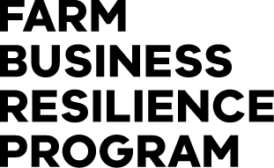
Name:
SWOT analysis of:

The analysis of your Strengths, Weaknesses, Opportunities and Threats (SWOT) can be a useful decision making tool for both small and large scale farm business decisions.
Strengths | Weaknesses

Opportunities | Threats

Questions | Strategies to build on
Ways to build strengths
Ways to take advantage of opportunities
Ways to reduce the effects of weaknesses
Ways to reduce the effects of threats

Number | Goal title/topic | 1 year | 5 years | 10 years
1
2

The Farm Business Resilience Program is supporting farmers to build stronger, more productive agricultural businesses. Visit: agriculture.vic.gov.au/FBRP
The Farm Business Resilience Program is jointly funded through the Australian Government’s Future Drought Fund and the Victorian Government’s Future Agriculture Skills Capacity Fund.

