Approximately 50 per cent (50 million hectares) of the agricultural lands in Australia are considered acidic, with a large proportion located in high rainfall regions of south eastern Australia including Victoria (NLWARA, 2001). Soil acidification is a natural process; however, it has been accelerated under high productive farming systems such as horticulture, dairying and grazing industries.
Soil acidity interferes with various soil processes such as nutrient availability, substance toxicity, and microbial activity. As a result, soil acidity can influence the pasture production and pasture suitability of lands that are continually subjected to soil acidification processes. In addition, acidity has the potential to create major off-site environmental issues affecting wider communities unless it is alleviated through adaptation of sustainable farming practices.
Recently completed ‘Grazfert’ and ‘Topsoils’ projects involving grazing industries in South Eastern Victoria have found that the surface soils (i.e. 0 -10 cm depth) of over 60 per cent of grazing land is acidic with pH (CaCl₂) of below 5.0. When soil pH is below 5 it would be recommended that remedial actions need to be adopted without delay.
Acidification is a slow process and the visible symptoms are not clear-cut and can be confusing because of their variability on soil type, vegetation, climatic factors and fertilizer regimes. Untreated surface soil acidity can move down the soil profile to the sub soil layers making treating acidity difficult and significantly more expensive.
If grazing land has not been treated for acidity recently, and it exhibits one or more of the following visible symptoms, it could be the result of the increasing acidity in soil:
- Poor plant vigour, uneven growth, reduced growth and production
- Poor establishment of pasture species and stunted root growth
- Deprived nodulation of legumes
- Persistence of acid tolerant weeds (e.g. sorrel)
- Increased incidence of diseases in the pastures.
The effects that soil pH has on plants and soil organisms is caused by the alteration of chemical reactions within the soil as a result of the increase in the pH of the soil
When soil acidity is increased, soil will have more H⁺ ions. However, H⁺ ions are not the main cause of adverse effects on plants. Increasing concentration and mobility of various elements and their chemical reactions involving crucial nutrients cause the most damaging effects in acidic soils. The most obvious effect comes as a result of the reaction of aluminum (as Al ³⁺) with important nutrients such as phosphorus, calcium, and boron to become non-soluble and reduce their availability. In addition, aluminum and manganese can become toxic to sensitive pastures and crops such as Lucerne, phalaris, barley and canola. Pasture species such as subterranean clover, white clover and perennial ryegrass are moderately tolerant to aluminum. Recently concluded studies in south eastern Victoria clearly demonstrate the relationship of soil pH and aluminium concentrations (Figure 1).

Figure 1. Relationship between soil pH and Al in soils tested under the GrazFert project
Also, studies conducted elsewhere have demonstrated the relationship between changing soil pH and the availability of phosphorus as shown in the diagram below (Figure 2).

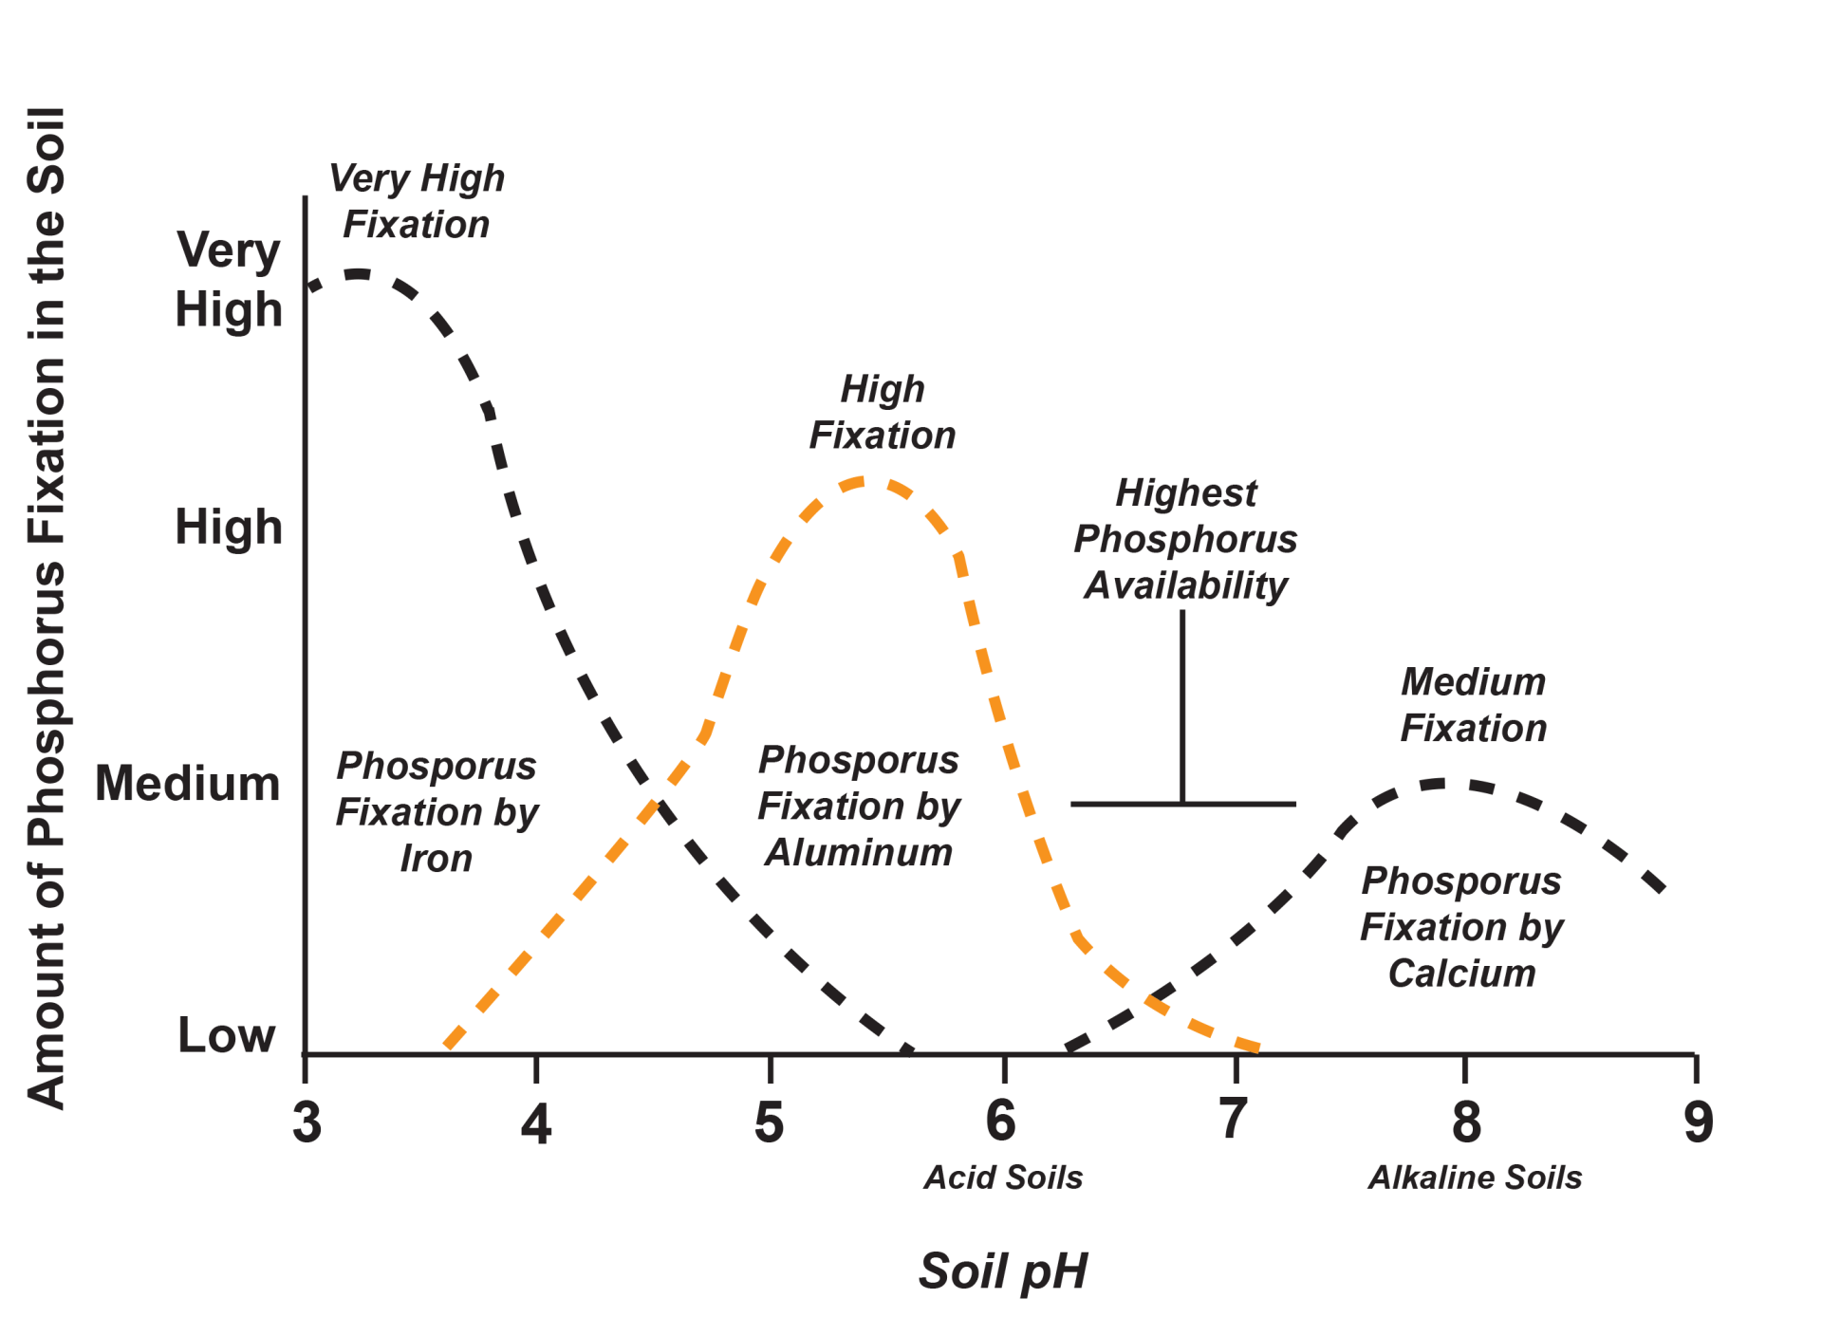

Figure 2. Phosphorus availability relative to pH ranges (adopted from, www. Nachurs-alpine.com)

How does acidification occur and what can be done about it?
As mentioned earlier, acidification is a natural process occurring in high rainfall regions. The rate of acidification is faster in light-textured sandy and sandy loam soils than in heavy clay and clay loam soils. The soils developed on acidic parent materials such as granite are naturally more acidic than soils developed on limestones. In addition to the above factors, intensive farming practices contribute to soil acidity and those practices must be altered to manage the acidification process.
The following points are just some of the farming practices that can be adopted to reduce acidification:
- Replace ammonium-based fertilizers such as Ammonium sulphate (21 per cent N) and Mono ammonium phosphate (11.3 per cent N) – Ammonium nitrogen is readily converted to NO₃⁻ and H⁺ ions and if nitrate is not taken-up by plants, it can leach away from the root zone leaving H⁺ to increase soil acidity. Instead, use fertilisers such as Potassium nitrate (13 per cent N) and Calcium nitrate (15.5 per cent N) or composted poultry manure (3 per cent N approx.) which do not acidify the soil, while Urea (46 per cent N) and Ammonium nitrate (34 per cent N) slightly acidify the soil.
- Reduce the removal of farm produce, primarily hay and silage. These materials are alkaline (i.e. basic pH above 7) and continual removal of hay, silage or fodder crops will leave H⁺ in the soil. If the soil is already acidic, it is advisable to feed out hay/silage produced from those paddocks to feed cattle within the same farm or paddocks, thus returning the nutrients to the soil.
- Test the soil at regular intervals and if required apply the right rate of lime to correct to increase soil pH to more acceptable levels. Regular soil testing, preferably in a laboratory, is important. Portable pH testing kits may indicate whether your soil is acidic or otherwise, but they do not provide the accuracy that is required to work out how much lime needs to be applied.
- Minimising the rate of acidification will maintain long-term soil heath as well as increase the nutrient use efficiency of phosphorus fertilizers.

Further reading
- Crawford D M et al (2020) Recent trends in soil fertility across the farms of East Gippsland, Soil Research, https://doi.org/10.1071/SR19246
- Fernando, N and Commins, J (2020) Acidity of grazing soils in East Gippsland, Information Note, Topsoils Project, Agriculture Victoria.
- Baker F (2014) Manage soil acidity – South West Victoria (Lower), Ever Graze, Future Farm Industries CRC
- Caritat P de et al (2011) The pH of Australian soils: field results from a national survey Soil Research, 49, 173–182
- Don’t let nitrogen acidify your soil – https://www.dpi.nsw.gov.au/agriculture /soils/ improvement/n-acidify
- https://www.nachurs-alpine.com/
- NLWRA (National Land & Water Resources Audit) (2001) Australian dryland salinity assessment 2000: extent, impacts, processes, monitoring and management options, NLWARA Canberra

Neville Fernando and John Bowman
Agriculture Victoria

