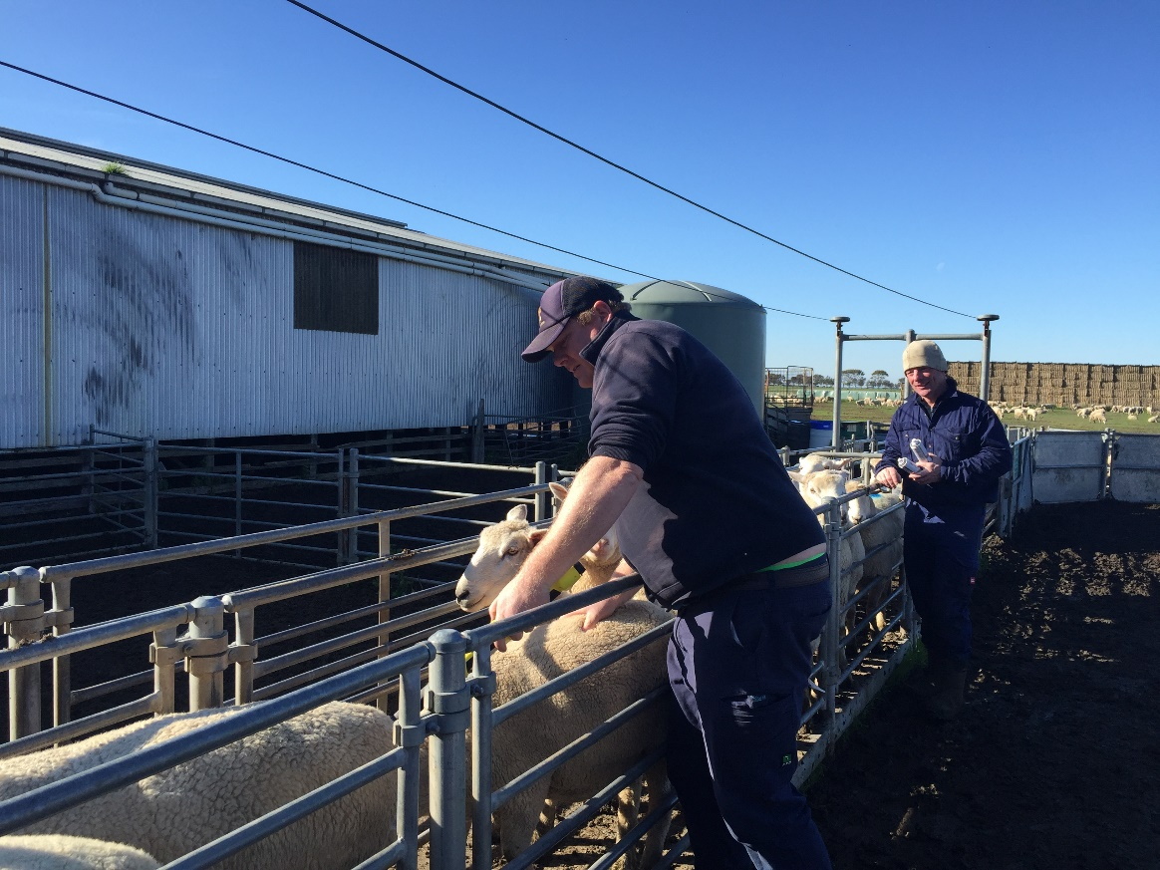
Andrew Kennedy and Nick McClelland condition scoring ewes
Coordinator – Andrew Kennedy
Group – Western Plains
- 15 businesses, Camperdown district
Enterprise mix
- Mixed grazing – sheep, beef, and cropping
Year two demonstration trial results confirm lamb survival management strategies
Two years ago, members of the Western Plains BestWool/BestLamb (BWBL) group began a three-year, on-farm demonstration focused on management strategies for improving lamb survival. During the second year of the demonstration, the focus was on more lambs surviving through to weaning.
Factors such as ewe condition, paddock size, mob size, birth weight, scanning, shelter, and feed availability can all influence lamb survival rates. These factors are being studied by the group to determine what impact their farm management can have on lamb survival rates.
2020 marked the second year of the demonstration and like the first year, the group looked at the influence of ewe condition and lambing mob size on the number of lambs born and raised. A third component was introduced in 2020, which looked at the impact of shelter on lamb survival.
Ewe condition trial (2020)- Demonstration 1
Two trial groups were drafted from a mob of composite ewes scanned in-lamb with twins. The low condition group (Group 1) was condition scored (CS) at 2.0 - 3.0 (average CS 2.83) and the high condition group (Group 2) averaged CS 3.51, with a range of 3.1 - 4.0.
Feed on offer (FOO) and stocking rate were similar in both treatment paddocks with lambing from mid-July 2020.
Similar to year one, the second year of the trial showed twin-bearing ewes in better condition (CS 3.1 - 4.0) produced more surviving lambs through to marking than those in lower condition (CS 2.0 - 3.0). The lamb survival rate for Group 1 (lower condition) was 63 per cent (per fetuses scanned) compared to 92 per cent for Group 2 (higher condition).
Group member and demonstration farm host, Nick McClelland, compared lamb survival from two mobs; low (average CS score 2.8) and high (average CS3.5) ewe condition. The high condition group resulted in 29 per cent more lambs on the ground - producing 147 lambs compared to 101 lambs. . This translates to significantly higher profitability for the ewes in the high condition group. Based on current lamb prices this equates to an extra $7,100 - $9,200 for the additional 46 lambs produced.
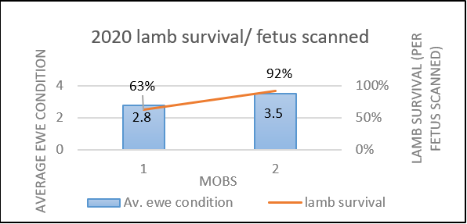
Figure 1: Average ewe condition and lamb survival (per fetuses scanned) of treatment mobs

Mob size trial (2020)- Demonstration 2
Twin-bearing composite ewes in the mob size trial were drafted into 14 groups varying from 36 to 65 ewes per mob. Lambing paddocks were set up with temporary electric fencing, averaging 6 hectares in size. Ewe condition averaged 4.0 CS and FOO at lambing averaged 2,200 kg DM/ha across the 14 paddocks.
The trial found all small sized lambing mobs supported very high lamb survival rates, which reinforced the previous year’s findings (Fig. 3 and Fig. 4). In 2020 (Year 2) lamb survival rates averaged 91 per cent, with survival rates as high as 97 per cent in some mobs. Survival was slightly higher in smaller mobs in 2020 compared to 2019. This may have been partly due to the more favourable 2020 season, as average survival rates across the south west for 2020 were reportedly higher.
BWBL member and demonstration farm host Fiona Cole made the decision last season to lamb all ewes in smaller mobs based on the 2019 results. Results showed the smaller mobs on average had greater lamb survival rates across all age groups.
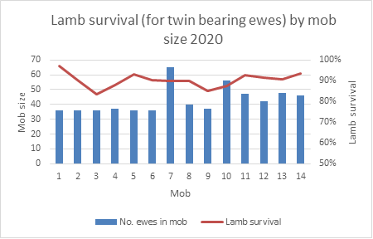
Figure 2: Lamb survival based on mob size
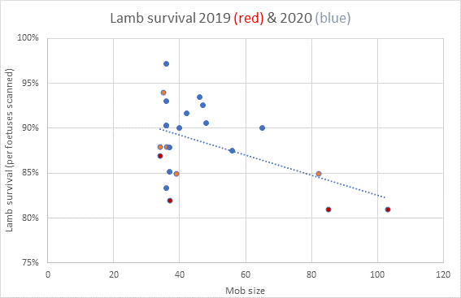
Figure 34: Comparison of 2019 and 2020 mob size lamb survival results
Although not part of this demonstration, it is worth noting that research shows the effect of smaller mobs has not been found to have major benefits for single bearing ewes.
Final year of the demonstration
The benefits of higher condition score and smaller mob size have been well documented through industry research;. managing ewes in the lead up to joining, through joining and throughout gestation can result in higher lamb survival rates, improved welfare outcomes and greater profitability.
Practical group sessions such as condition scoring sheep, assessing pasture and feed availability and setting feed on offer (FOO) targets will resume in 2021 as the trial enters its third and final year.
Producer Demonstration Sites (PDS) provide a unique opportunity for producers to trial, test or monitor a different management strategy or technology within their farming operation. On-farm demonstrations often support established science and provide a supported, local environment in which to test it on-farm. Refer to the Agriculture Victoria website for more information about our network of On-Farm Demonstrations, supported by Meat and Livestock Australia and Agriculture Victoria.
For further information on the project please email Cathy Mulligan or email Andrew Kennedy.

