Victorian Agriculture and Climate Change Statement
We are committed to a profitable and productive agriculture sector that takes ambitious action on climate change.
We are working together to accelerate climate change solutions, including taking steps to:
- understand and reduce our emissions
- adapt to climate risks and
- capture future opportunities.

Why we need a Statement
- Farmers take climate action every day and there is ambition for greater leadership and alignment across the agriculture sector and with government.
- A shared long‑term vision creates a clear direction, encourages collaboration and action, and demonstrates our shared leadership and ambition.

Minister for Agriculture
The Victorian Government is committed to working with the agriculture sector to face the challenges of climate change and position Victoria as a leader in low‑emissions agriculture, building on actions already underway.
We all have a role to play and the ambition and leadership displayed in this Statement is a credit to the industry.
I am excited to see this vision brought to life to drive further climate action.
The Hon. Gayle Tierney MP
Minister for Agriculture

Victorian Agriculture and Climate Change Council
I am proud to be part of this industry, which is facing into the challenges of climate change and working to find opportunities for understanding and action.
The Victorian Agriculture and Climate Change Council gained deep insights facilitating conversations on climate change with farmers, industry and community groups across Victoria, who made clear they are ambitious and motivated to act. This Statement sets up both the Victorian Government and agriculture industry to partner to achieve thriving farms and communities.
Alexandra Gartmann
VACCC Chair

Climate Ready Ag
The Victorian Government is committed to helping farmers understand and reduce emissions, adapt to climate risk and capture future opportunities. Some of the ways we are doing this are:
- An almost $20 million investment in emissions reduction through the first Agriculture Sector Emissions Reduction Pledge.
- $60 million commitment to enhance energy efficiency and productivity through the Agriculture Energy Investment Plan.
- Partnering with the Commonwealth Government to deliver two Future Drought Fund programs that support Victorian farm businesses and their communities to be better prepared for future drought events through the Farm Business Resilience and Regional Drought Resilience Programs.
- $15.3 million Victorian Carbon Farming Program which provides an avenue for private landholders to build resilience to a changing climate through planting agroforestry and shelterbelt trees, accessing existing carbon markets and realising on‑farm benefits.
- A number of free, practical tools and resources have been developed and are available on the Agriculture Victoria website for industry to understand and navigate changing weather and climate patterns, carbon emissions, and energy use on farms.

Partners
The Statement is a shared vision, shaped by people and organisations across the agriculture sector, the Victorian Agriculture and Climate Change Council and the Victorian Government.
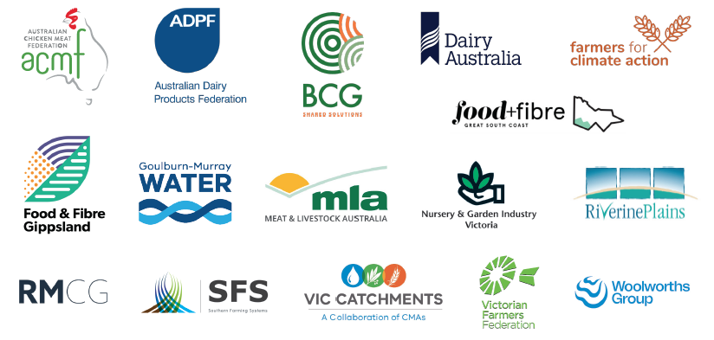
To learn more about becoming a partner email climatechange@agriculture.vic.gov.au

Partners
BCG improves the prosperity of Australian farmers, communities and landscapes through applied research and innovation. Sharing science‑based solutions and ideas integral to reducing greenhouse gas emissions and adapting to climate risk, will continue to be a part of BCG activities.
– BCG
RMCG is committed to climate action to ensure a healthy future for the environment, industry and communities.
– RMCG
As a major provider of irrigation services, Goulburn‑Murray Water recognises the challenges climate change poses to water availability and agriculture. We have taken significant strides to improving water efficiency and our Water Resources Strategy is tackling the risks and opportunities created by a changing and uncertain climate.
The Victorian Agriculture and Climate Change Statement complements our objectives as we work with customers and partners to create a sustainable and resilient irrigated agriculture sector.
– CHARMAINE QUICK, MANAGING DIRECTOR, GOULBURN‑MURRAY WATER
As representatives of the top agricultural production region in Australia, Food and Fibre Great South Coast Inc. is serious about promoting long‑term, meaningful and coordinated climate action.
Through Food and Fibre Great South Coast’s Drive Regional Value‑Add, Investment and Sustainability committee, our aim is to build consensus around the important issues we face right now, like a fair transition to sustainable energy consumption and production as well as modernising agricultural water use policies in Victoria. For example, at our Sustainable Energy Forum in July, we brought the food and fibre sector together to hear about plans for net‑zero livestock industries and forestry production, innovative decarbonisation technologies like hydrogen fuel cells and share some of the ways we are playing our role to accelerate uptake.
Our sector relies on producing quality food and fibre through practices that preserve the sustainability and natural resources of our region. Nurturing the environment is in our DNA.
Australian agriculture, particularly farming, is a leader in sustainability innovation and emissions reduction. We are proud of our collaborative approach to problem solving and remain determined to face the challenges of climate change together.
– GEORGINA GUBBINS, CHAIR, FOOD AND FIBRE GREAT SOUTH COAST INC.
Nursery & Garden Industry Victoria (NGIV) and our members are committed to achieving net zero emissions and improving our climate resilience.
Victoria’s horticulture industry will continue to play a key role in tackling what is one of the defining challenges of the 21st century. We already produce over one third of Australia’s Greenlife; reducing emissions, storing carbon, and cooling our communities, to help mitigate the impacts of a changing climate.
Operationally, our member businesses embed a range of sustainable practices and innovations to lessen their impact on our environment. These include, utilising renewable energy, water saving strategies, improvements to soil health, circular economy practices, plant biodiversity and integrated pest management methods.
NGIV are committed to leading our industry to further improve their sustainable operating practices, whilst continuing to supply the Greenlife which is key to achieving net zero emissions and improving our climate resilience.
– SIMON GOMME, PRESIDENT, NURSERY & GARDEN INDUSTRY VICTORIA
The Red Meat Industry have invested in the order of $200 million in development of technologies and practices in pursuit of our carbon neutral by 2030 (CN30) target. We believe that achieving CN30 through widespread adoption of productivity‑led, net emissions reduction, will enable the red meat industry to double the value of red meat sales as the trusted source of the highest quality protein by 2030. Our success requires collaboration and coordination across industry and government, and Ag Vic’s commitment adds momentum to activities already underway.
– MEAT AND LIVESTOCK AUSTRALIA
Southern Farming Systems (SFS) support the Victorian Agriculture and Climate Change Statement in alignment with the SFS2025 strategic goal to Deliver research to lead the industry towards more profitable and environmentally responsible farming. SFS encourage investment in partnerships for research, tools and services to support a sustainable agriculture sector.
– SOUTHERN FARMING SYSTEMS
The Victorian Farmers Federation endorses the Agriculture and Climate Change Statement and looks forward to partnering with the Victorian Government and across industry to help farmers respond to climate effects. Our collective mission must be to ensure Victorian farmers are acknowledged, valued and respected for the work they have already done, and continue to do, in reducing their on‑farm emissions.
– VICTORIAN FARMERS FEDERATION
Find out more agriculture.vic.gov.au/climate-and-weather/policy-programs-action

