Victorian Food and Fibre Export Performance Report 2021-22

Published by Department of Jobs, Skills, Industry and Regions (DJSIR) and Department of Energy, Environment and Climate Action (DEECA).
January 2023
© Copyright State Government of Victoria 2023
This publication is copyright. No part may be reproduced by any process except in accordance with provisions of the Copyright Act 1968.
Authorised by the Victorian Government, Melbourne.
ISSN 1832-2905 (print)
ISSN 2202-931 (pdf/online)

Disclaimer
The information contained in this report is provided for general guidance and assistance only and is not intended as advice. You should make your own inquiries as to the appropriateness and suitability of the information provided.
While every effort has been made to ensure the currency, accuracy or completeness of the content we endeavour to keep the content relevant and up to date and reserve the right to make changes as required. The Victorian Government, authors and presenters do not accept any liability to any person for the information (or the use of the information) which is provided or referred to in the report.
Except for any logos, emblems, trademarks, artwork and photography this document is made available under the terms of the Creative Commons Attribution 4.0 Australia licence. You are free to re use the work under that licence, on the condition that you credit the State of Victoria (DJSIR and DEECA) as author, indicate if changes were made and comply with the other licence terms.

For further 2021-22 Victorian food and fibre export performance results visit https://agriculture.vic.gov.au/victorias-export-performance.

Contents
Ministerial Forward 4
Victorian Food and Fibre Export Performance Summary 2021-22 5
Victorian Exports by Industry 7
Victorian exports by market 9
Victorian export tables by industry and product 11
Definitions and data 13

Ministerial Forward
Victoria is the premier state for food and fibre exports, which has once again been demonstrated in this latest data. In 2021-22 Victoria exported $17.9 billion in food and fibre exports, up 29 per cent on the previous year. Victorian exports represent 26 per cent of the national total, continuing Victoria’s lead as the nation’s largest food and fibre exporter by value.
Exports increased across nearly all industry categories, up a total of $4 billion in 2021-22. Dairy exports were up 23 per cent to nearly $2.5 billion with strong growth into North Asia and Southeast Asia. Meat exports grew by 31 per cent to $4.3 billion, with major increases coming from beef and sheep meat. Grain exports
jumped 73 per cent to nearly $4.4 billion, driven by international market upheavals. Excluding grain, Victorian exports still increased by over 19 per cent in value
in 2021-22.
While exports benefited from recovering global demand, global supply chain issues continued to impact our food and fibre exporters. However, Victoria’s strong export performance speaks to the quality of Victorian food and fibre exports and the ability of exporters to pursue new market opportunities.
The Victorian Government will continue to support our export sector to innovate, value-add to our quality produce, diversify into new products and markets, and to meet and exceed our $20 billion target for food and fibre exports by 2030.
The Victorian Government’s Made in Victoria Manufacturing Statement commits to building the capability of our already large and sophisticated food manufacturing sector. STRONG, INNOVATIVE, SUSTAINABLE: A new strategy for agriculture in Victoria, has identified clear areas for focus and investment by government to help the sector, including our exports, to remain strong, innovative and sustainable.
Global Victoria, the state’s trade facilitation and promotion agency provides a range of programs and initiatives including trade missions to connect businesses to the world. Through its network of 23 international trade and investment offices, Victorian food and fibre exporters can receive specialist knowledge and networks to access new opportunities in global markets.
The hard work of our farmers, food manufacturing businesses and exporters has delivered an outstanding result for food and fibre exports in 2021-22. Supporting these groups to continue to excel will remain a priority across Victorian Government.

Victoria’s global reach
The Victorian Government has a network of global and local trade and investment offices, making it easier for businesses to access the support they need to invest, grow and enter new markets.

Victorian Food and Fibre Export Performance Summary 2021-22
Victorian exports performed strongly in 2021-22.
Victorian food and fibre exports were valued at $17.9 billion in 2021-22, $4 billion on the previous year. Export value grew by 29%.
Victorian food and fibre export volumes reached 12.4 million tonnes in 2021-22, 500,000 tonnes on the previous year. Export volume grew by 4%.
In 2021-22 Victoria cemented its position as Australia’s largest food and fibre exporter by value, accounting for 26 per cent of the national total.

Victoria’s food and fibre exports by industry value for 2021-22
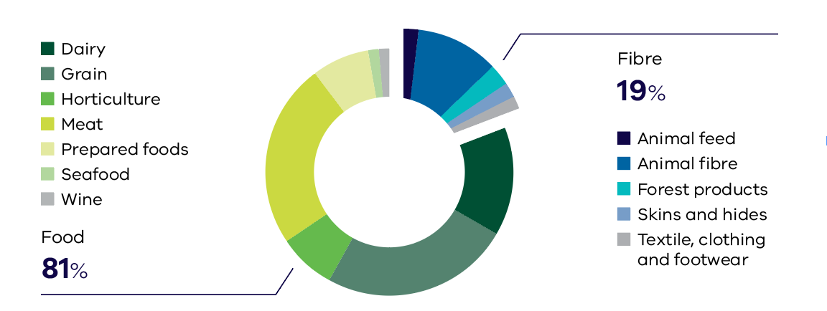
Figure 1
Total exports $17.9 billion

In 2021-22 the value of Victorian food and fibre exports returned to an upward trend.

Total export value (A$ billion) and total export volume (‘000 tonnes)
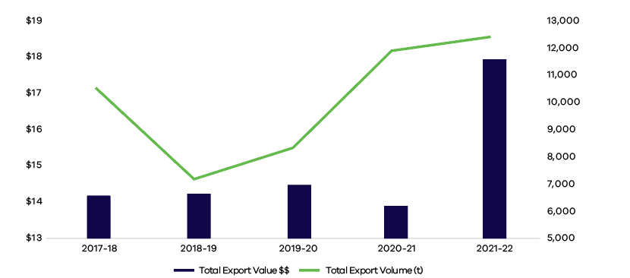
Figure 2
Export values have increased annually over the last four years by 6%*
Export volumes have increased annually over the last four years by 4%*
*Compound Annual Growth Rate
Victoria is on track to meet and exceed the Victorian Government target of growing the states food and fibre exports to $20 billion by 2030.

In 2021-22 Victorian exports commenced a rebound from global supply chain disruptions.

Australia’s food and fibre exports by state value (%).
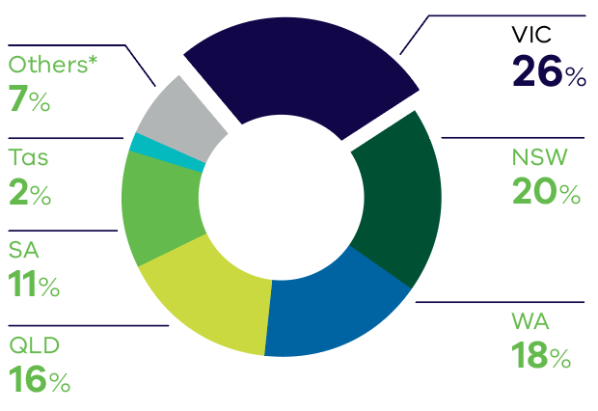
Figure 3
Victoria is Australia’s leading food and fibre exporter. Victoria exported 26% of the national total by value in 2021-22.
*others refer to ACT, NT, re-exports and exports for which no state details are released for confidentiality reasons.

Victoria is the nation’s largest or second largest exporter by value across a range of key industries.

#1 Dairy
#1 Horticulture
#1 Prepared foods
#1 Animal fibre
#2 Meat
#2 Animal feed
#2 Seafood

Victorian Exports by Industry
Victoria has a diverse range of food and fibre exports with a reputation for quality and safety.

Table 1. Top six Victorian exports
Value (A$ million) |  |  |  | Volume (‘000 tonnes)
 | 2020-21 | 2021-22 | % Change | 2020-21 | 2021-22 | % Change
Grain | $2,550 | $4,421 | 73% | 5,861 | 8,011 | 37%
Meat | $3,317 | $4,333 | 31% | 506 | 529 | 4%
Dairy | $2,039 | $2,506 | 23% | 617 | 656 | 6%
Animal fibre | $1,430 | $1,939 | 36% | 262 | 303 | 16%
Horticulture | $1,354 | $1,354 | 1% | 416 | 399 | -4%
Prepared foods | $1,178 | $1,312 | 11% | 261 | 270 | 4%

Victorian food and fibre exports grew in value by 29% in 2021-22.
Excluding grain, Victorian food and fibre exports still grew in value by 19% in 2021-22.

Victoria exports its food and fibre products across the world.
Top markets for select Victorian food and fibre products 2021-22.

USA - Lamb fresh or frozen $457m
UK - Bottled wine $54m
Belgium - Oilseeds $204m
UAE - Fabrics $28m
Bangladesh - Pulses $144m
Japan - Pet food $25m
China - Almonds $200m
Hong Kong - Citrus $39m
Singapore - Yoghurt $19m
Vietnam - Malt $44m

Victoria is Australia’s largest exporter for significant industries, including dairy, horticulture and prepared foods.
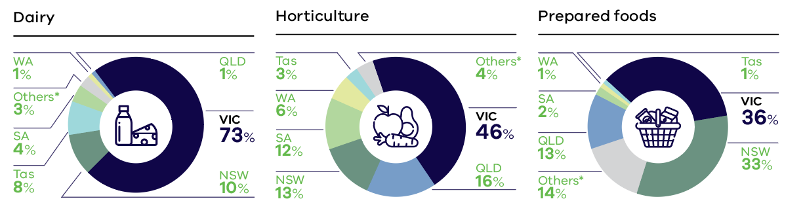
Figure 3
*others refer to ACT, NT, re-exports and exports for which no state details are released for confidentiality reasons.

In 2021-22 Victoria’s food and fibre exports continued their record of success.
Dairy achieved record exports in 2021-22 valued at $2.5 billion with cheese, powdered milk and powdered cream accounting for 71% of Victorian dairy exports.
Meat was Victoria’s second largest export industry with sheep meat the second largest product by value and up 44% on the previous year.
Prepared food exports reached $1.3 billion, with non-alcoholic beverage exports up 29% to $87 million.
Animal fibre exports increased in value by 36% to $1.9 billion underpinned by increased demand for higher value fine wool.
Seafood exports grew strongly with live and fresh fish the largest and fastest growing product valued at $139 million, up 37% on the previous year.
Grain exports jumped due to high prices and favourable growing conditions, with the two largest products by value being wheat and oilseeds both growing by over 80% on the previous year.
Horticulture exports grew modestly to reach $1.4 billion in 2021-22 underpinned by a significant increase in almond exports.
Victoria is Australia’s largest manufactured food and beverage exporter, including exports of premium processed dairy and meat products.

Victorian exports by market
Victoria’s food and fibre products are exported to major and key growth markets, with a focus on Asia.

2021-22 major export markets for Victoria by value.
US up 37% $1,549m
Malaysia up 24% $707m
Thailand up 20% $449m
UAE up 66% $506m
Bangladesh up 206% $342m
China up 21% $4,430m
Singapore up 37% $562m
South Korea up35% $660m
Japan up 33% $1,459m
Vietnam up 26% $631m
Hong Kong down 16% $315m
Indonesia up 37% $841m
New Zealand up18% $951m

Food and fibre exports have increased for the majority of Victoria’s markets.

2021-22 Victoria’s top ten export markets by value.
$A million
China $4,430
United States $1,549
Japan $1,459
New Zealand $951
Indonesia $841
Malaysia $707
South Korea $660
Vietnam $631
Singapore $562
United Arab Emirates $506

2021-22 Victoria’s regional market share by value
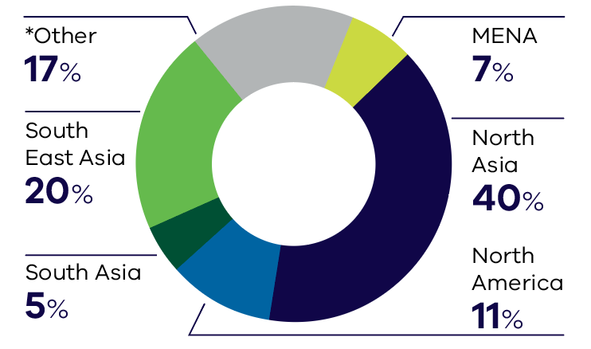
Figure 4
Total food and fibre export figures in 2021-22 was $17.9 billion. *Other countries, including New Zealand and the United Kingdom.

Export diversification

Diversification of both products and international markets is an increasingly important factor shaping the resilience and profitability of Victoria’s food and fibre exports.

Market share of top five markets 2018-19 Market share of top five markets 2021-22
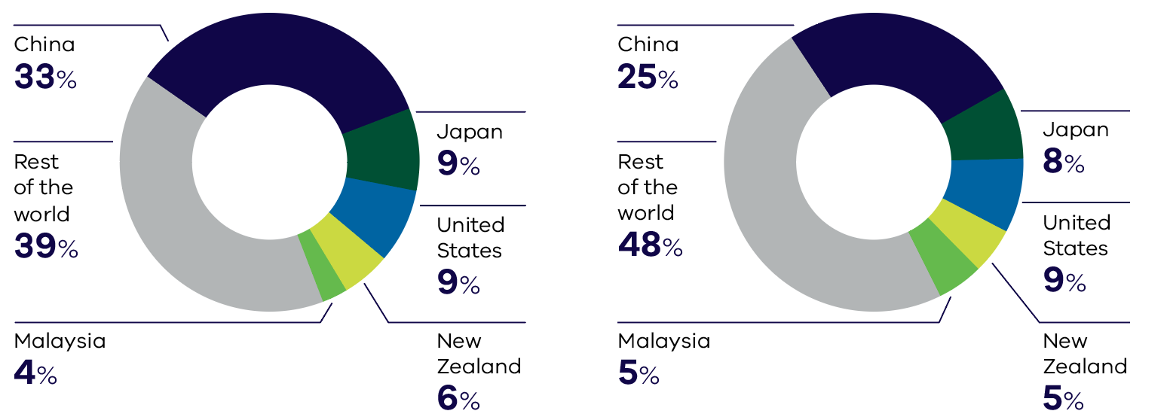
Figure 4 Figure 5
2018-19 total food and fibre exports by value: $14.2 billion 2021-22 total food and fibre exports by value: $17.9 billion

Comparing 2018-19 to 2021-22, the value of Victorian food and fibre exports into markets outside of the top five has grown from 39% to 48%.

Asian markets are the destination for two-thirds of Victoria’s exports by value.
North Asia, which includes China and Japan, is Victoria’s largest regional export market with South Korea the fastest growing major market for Victorian exports over recent years.
Within the South Asia region, India was supplanted by Bangladesh as the largest Victorian export market in 2021-22 with a jump in grain exports but also an increase in horticulture exports.
South East Asia, which includes Indonesia, Malaysia, Singapore and Thailand is a rapidly growing region for Victorian exports. In 2021-22 countries across this region imported record levels of Victorian dairy.
North America is a large importer of Victorian meat, making up 69% by value of all Victorian exports into the region in 2021-22.
Within MENA the United Arab Emirates is Victoria’s largest market with a jump in exports in 2021-22 due mainly to higher grain exports.

Victorian export tables by industry and product
Exports Value ($) |  | Financial Year |  | %
Industry | Product | 2020-21 | 2021-22
Animal feed | Pet food | $62,318,115 | $79,999,159 | 28%
 | Stock feed | $257,998,500 | $290,771,252 | 13%
TOTAL |  | $320,316,615 | $370,770,411 | 16%
Animal fibre | Other animal fibres | $3,512,074 | $5,191,318 | 48%
 | Wool | $1,318,153,578 | $1,676,177,733 | 27%
 | Wool grease and wastes | $107,740,397 | $257,324,580 | 139%
 | Yarn products | $622,212 | $709,881 | 14%
TOTAL |  | $1,430,028,261 | $1,939,403,512 | 36%
Dairy | Butters, fats and oils | $127,465,892 | $130,701,872 | 3%
 | Cheese and whey products | $787,921,486 | $872,702,854 | 11%
 | Milk and cream | $1,031,091,479 | $1,311,909,738 | 27%
 | Milk extracts | $41,440,022 | $141,408,478 | 241%
 | Yoghurt and fermented milk products | $51,161,048 | $49,363,618 | -4%
TOTAL |  | $2,039,079,927 | $2,506,086,560 | 23%
Forest products | Other forest products | $1,193,310 | $1,410,240 | 18%
 | Paper and paperboard | $292,183,214 | $350,143,837 | 20%
 | Pulp | $41,764 | $125,923 | 202%
 | Roundwood | $159,652,488 | $37,755,678 | -76%
 | Sawnwood | $11,616,669 | $10,427,061 | -10%
 | Wastepaper | $62,595,331 | $90,488,311 | 45%
 | Wood-based panels | $7,308,843 | $9,201,505 | 26%
 | Woodchips | $64,803,292 | $0 | -100%
TOTAL |  | $599,394,911 | $499,552,555 | -17%
Grain | Cereals | $1,353,709,142 | $2,474,454,109 | 83%
 | Oilseeds | $653,199,343 | $1,184,435,618 | 81%
 | Processed Grain | $157,666,533 | $214,668,640 | 36%
 | Pulses | $385,581,447 | $547,703,568 | 42%
TOTAL |  | $2,550,156,465 | $4,421,261,935 | 73%
Horticulture | Coffee, tea, herbs and spices | $39,507,368 | $39,713,105 | 1%
 | Extracts and oils | $924,793 | $2,275,164 | 146%
 | Fruit (fresh or dried) | $723,751,822 | $678,646,107 | -6%
 | Nuts (fresh or dried) | $394,941,149 | $438,686,745 | 11%
 | Oils and extracts | $78,140,371 | $90,310,842 | 16%
 | Processed | $67,381,740 | $77,403,205 | 15%
 | Vegetables (fresh or dried) | $49,238,350 | $41,233,601 | -16%
TOTAL |  | $1,353,885,593 | $1,368,268,769 | 1%

Exports Value ($) |  | Financial Year |  | %
Industry | Product | 2020-21 | 2021-22
Meat | Alternative meat | $88,367,898 | $155,583,648 | 76%
 | Animal fats | $80,241,443 | $105,984,000 | 32%
 | Beef | $1,371,891,405 | $1,702,587,367 | 24%
 | Offal | $228,505,432 | $280,579,318 | 23%
 | Other prepared meat products | $91,035,520 | $133,202,092 | 46%
 | Pig meat | $38,428,325 | $31,096,544 | -19%
 | Poultry | $16,227,723 | $35,620,540 | 120%
 | Sheep meat | $1,402,012,854 | $1,888,772,981 | 35%
TOTAL |  | $3,316,710,600 | $4,333,426,490 | 31%
Prepared foods | Beverages | $101,358,695 | $137,478,525 | 36%
 | Cereal based | $413,008,265 | $424,821,161 | 3%
 | Condiments | $105,643,732 | $99,224,731 | -6%
 | Confectionery | $236,118,804 | $281,229,683 | 19%
 | Other food preparations | $277,992,668 | $324,756,959 | 17%
 | Sugars | $44,000,698 | $44,248,463 | 1%
TOTAL |  | $1,178,122,862 | $1,311,759,522 | 11%
Seafood | Crustaceans | $56,472,792 | $63,643,809 | 13%
 | Fish | $104,853,124 | $145,918,676 | 39%
 | Molluscs | $56,040,551 | $66,842,218 | 19%
 | Seafood extracts and oils | $7,075,052 | $5,300,762 | -25%
 | Seaweed | $819,418 | $638,165 | -22%
TOTAL |  | $225,260,937 | $282,343,630 | 25%
Skins and hides | Cattle | $105,236,678 | $117,368,514 | 12%
 | Other skins and hides | $3,592,971 | $3,000,772 | -16%
 | Sheep | $167,747,607 | $223,132,080 | 33%
TOTAL |  | $276,577,256 | $343,501,366 | 24%
Textile, clothing  and footwear | Clothing | $56,935,136 | $78,327,890 | 38%
 | Footwear | $22,050,303 | $17,882,092 | -19%
 | Leather articles | $12,807,401 | $16,610,134 | 30%
 | Textiles | $199,470,845 | $205,251,217 | 3%
 | Woven fabrics | $118,093 | $261,996 | 122%
TOTAL |  | $291,381,778 | $318,333,329 | 9%
Wine | Fortified | $3,606,476 | $2,211,788 | -39%
 | Other | $3,017,608 | $622,178 | -79%
 | Red | $233,416,712 | $135,384,492 | -42%
 | Sparkling | $12,883,975 | $14,547,854 | 13%
 | White | $57,445,781 | $53,304,807 | -7%
TOTAL |  | $310,370,552 | $206,071,119 | -34%
Grand Total |  | $13,891,285,757 | $17,900,779,198 | 29%

Definitions and data

Definitions
This report refers to ‘food exports’ as those products considered suitable for consumption by humans. This classification is made by the Department of Energy, Environment and Climate Action (DEECA) based on the Australian Harmonized Export Commodity Classification (AHECC) code descriptions.
DEECA refers to ‘fibre exports’ as those of wool and other animal fibre products, including skins and hides, forestry products and textile, clothing, and footwear (TCF).
The DEECA classification excludes items such as:
- live animals for breeding purposes
- grains and horticultural products for cultivation
- live ornamental plants, and
- bovine semen.

The DEECA classification includes items such as:
- live animals for purposes other than breeding
- fresh, chilled, frozen and preserved meats and seafood
- dairy and horticultural items for human consumption
- unprocessed grains and pulses
- edible animal by-products
- wine and related products
- wool and other fibres in various forms
- skins and hides from agricultural livestock, and
- prepared foods derived from agricultural commodities.

State of Origin defines the Australian state in which the final stage of production or manufacture occurs (ABS 5489.0 - International Merchandise Trade, Australia, Concepts, Sources and Methods).
State of Loading is the Australian state in which the goods are loaded onto an international carrier for export. Subject to any confidentiality restrictions, this can be further disaggregated to provide information about particular air or seaports in the relevant state (i.e., Port of Loading).
Classification of forest products is based on those used by ABARES in the Australian Forest and Wood Products Statistics publication.
Classification of wool products is based on the AWEX Sheep Breed Compendium, 2010.
The regional classification of North Asia comprises China, Hong Kong, Japan, Macau, Mongolia, South Korea and Taiwan.
The regional classification of South East Asia comprises Brunei Darussalam, Cambodia, East Timor, Indonesia, Laos, Malaysia, Myanmar, Philippines, Singapore, Thailand and Vietnam.
The regional classification of MENA comprises Algeria, Bahrain, Egypt, Iraq, Iran, Israel, Jordan, Kuwait, Lebanon, Libya, Morocco, Oman, Qatar, Saudi Arabia, South Sudan, Sudan, Syria, Tunisia, Turkey, UAE and Yemen.
The regional classification of North America comprises the United States, Canada and Mexico.
The regional classification of South Asia comprises Afghanistan, Bangladesh, Bhutan, India, Maldives, Nepal, Pakistan and Sri Lanka.

Data
The information in this document is based on statistics compiled by the Australian Bureau of Statistics (ABS) from information submitted by exporters and their agents to the Department of Home Affairs (Home Affairs). The data has been sourced from IHS Markit, Global Trade Information Services (GTIS), which compiled the information for DJSIR and DEECA.
Valuation of exports is based on the free on-board transaction value of the goods, expressed in Australian dollars. Values within this publication have been aggregated on a financial year basis. State aggregations are by State of Origin rather than by State of Loading.
Gross weight refers to the shipping weight of goods (measured in tonnes) in the packaged state, excluding the weight of containers. For exports, details of gross weight are available for each commodity.
Restrictions are placed on the release of statistics for some products for reasons of confidentiality. These restrictions may impact on the total aggregated value of exports from Victoria. Alternatively, they may only affect country and commodity details for that export category. Of relevance to Victoria’s food and fibre exports are confidentiality restrictions on specific grain, forestry, textile, clothing, and footwear (TCF) and animal feed product exports including some barley, oats, lupins, canola, beer, pasta and woodchips, products for which no state of origin or export destination details are available.
DEECA uses the AHECC codes for export and import analysis (www.abs.gov.au, Classification 1233.0). These codes concur with international commodity codes, allowing direct import and competitor analysis. Commodity classification also provides greater detail and allows analysis of products from different sectors of the supply chain. These codes enable DEECA to focus on specific fresh and processed export products within industry sectors.
The ABS Australia’s international merchandise trade statistics are subject to revision after they are initially published. Although the revisions made are typically quite small as a proportion of the monthly international merchandise trade results. Revisions may arise because:
- an amending entry is supplied to the Department of Home Affairs
- errors are identified and corrected by the ABS after initial processing errors are identified through queries from statistical users about the published data
- time series are recompiled because of major changes to classifications, concepts, sources or methods (www.abs.gov.au, Classification 5489.0).
The Consumer Price Index rose 6.1% over the 12 months to the June 2022 quarter - the fastest annual increase in 21 years driven primarily by the increasing cost of food and fuel. In the June 2022 quarter, food prices increased 5.9% compared with the June quarter 2021.
The Australian dollar weakened relative to the US dollar in 2021-22. This was likely to have assisted the competitiveness of Australian exports in the international market.

