Marine pests in aquaculture facilities

Victoria’s waterways are teeming with unique animals and plant life. Our marine environment is beautiful and diverse, but it’s also fragile. Keeping marine pests out of Victorian waters and reducing their spread means we have safe and productive oceans to enjoy for recreation, and a sustainable seafood industry.
Marine pests are marine plants and animals that are not native to Victoria. They include crabs, mussels, sea stars, sea squirts and algae. Marine pests can compete with native species and spread disease, can impact on native biodiversity and damage marine infrastructure including vessels. If marine pests go unreported and establish in our marine environment, they can cause impacts to marine industries and are expensive to control. Prevention is therefore the key to limiting the risk of successful introductions, and early detection and reporting is essential to limit the spread of these pests.
Marine pests can damage your aquaculture business and operations, and ultimately Victoria’s seafood industry. They can damage infrastructure, kill your stock, spread disease and affect human health. You can play a key role in helping to prevent the spread of marine pests by learning how to identify them and reporting anything unusual at your aquaculture facility. Marine pests may be found on underwater structures or equipment including racks, trays, nets, cages, lines, ropes, baskets, and vessels.
Marine pests must be reported to Agriculture Victoria. It is critical that authorities are notified as soon as possible to best manage the marine pest. Remember, if you see a suspected marine pest, report it.
More information, including a comprehensive list of marine pests and identification guides, are available at vic.gov.au/marine-pests.

Report marine pests
Protect your aquaculture business. Look out for marine pests growing on your aquaculture equipment, vessels or the local marine environment.
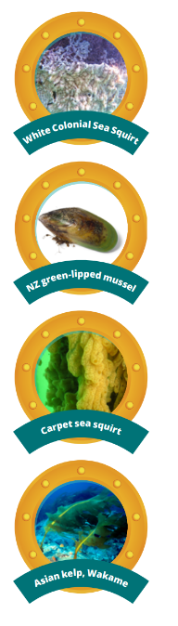

How to protect your Aquaculture business and Victoria’s seafood industry
There are simple steps you can take to help protect your aquaculture business and Victoria’s seafood industry.
• Keep it clean.
• Learn how to identify marine pests and any diseases they may introduce.
• Report unusual marine animals or plants you may find in or on your facility.

Keep it clean
Keeping your aquaculture facility and equipment clean plays a critical part in protecting your aquaculture business and stopping the spread of marine pests into and around Victoria’s waters.
• Look for marine pests or unusual growth on your aquaculture equipment and on your vessels, including hard to reach areas.
• Clean, treat and dry your facility and aquaculture equipment regularly.
• Apply antifouling coating to vessels. Inspect and clean vessels carefully to meet ballast water and biofouling management requirements.

Learn how to identify marine pests
While we need to be vigilant for new pests arriving, we also need to be alert to pests that could spread to unaffected locations. Some marine pests may be under a government eradication or management program. In Victoria, look out for:
• White colonial sea squirt
• New Zealand green-lipped mussel
• Carpet sea squirt
• Asian kelp, wakame.
Other steps you can take:
• Check local biosecurity requirements with your state or territory authority.
• Take care when moving aquaculture stock and equipment to not inadvertently move pests or diseases along with your stock. Read the National policy guidelines for the translocation of live aquatic animals.
• Keep your aquaculture stock and equipment free of biofouling and always follow the aquaculture biofouling management guidelines.
• Learn what marine pests are in your area and report anything unusual.

Report unusual marine animals or plants
Remember that marine pests can attach to anything submerged in water, so it’s important to regularly check your facility and equipment for anything unusual. You can learn more about marine pests of concern relevant to your location or for your aquaculture business by visiting vic.gov.au/marine-pests.
Good biosecurity is everyone’s responsibility – you can help stop the spread of marine pests and keep our seafood industry sustainable.

If you see something unusual, report it
Keeping marine pests out of Victoria’s waters means we have clean and safe ocean to enjoy for recreation, and a sustainable seafood industry.
Go to vic.gov.au/marine-pests to learn more.

