Shelter and Pound data reporting
A guide for data interpretation

Contents
1. About this guide 3
2. Legislative framework 3
3. Purpose of shelter and pound reporting 3
4. Reporting timelines 4
5. Animal care and management data 4
5.1 Animal Fate Data Pathways 4
5.2 Reason codes 6
5.3 Explanatory comments 6
5.4 Data categories 7

About this guide
In June 2022, the Victorian Government updated the Code of Practice for the Management of Dogs and Cats in Shelters and Pounds (the Code) to make data reporting about animal welfare outcomes mandatory for all shelters and pounds.
For each reporting period, shelters and pounds must provide data on the number of dogs and cats:
- in care at the facility, or in foster care, at the start of the reporting period
- physically presented to the facility but not admitted, and why
- accepted for admission
- admitted into foster care
- that waited more than 14 days to be placed in foster care
- permanently transferred to other facilities or groups for rehoming
- reclaimed by their owner
- rehomed
- rehomed but returned, and why
- euthanased, and why
- that died, in the facility or while in foster care but were not euthanased.
This guide is intended to help you view and understand shelter and pound data. It provides:
- a summary of the legislative framework that requires data reporting
- the purpose of data reporting
- descriptions of each data category, as well as definitions for each explanatory (reason) code.

Legislative framework
The Code is made under section 59 of the Domestic Animals Act 1994 (the DA Act). It sets the minimum standards for how registered shelters and pounds should take care of dogs and cats and specifies the records that they must keep.
In June 2022, the Code was updated to introduce additional record keeping and reporting requirements. These changes will allow the Victorian Government to collect and publish data about animal care and management across the state.

Purpose of shelter and pound reporting
Regular publication of data reported by shelters and pounds will help us to better understand how dogs and cats are managed and cared for in these facilities.
To date, a complete, state-wide set of data has not been available to provide information about how many animals are cared for by shelters and pounds, the operational experiences of these facilities, and the range of outcomes they achieve for animal welfare.
The goal of publishing this data is to fill this gap and provide a consistent and reliable source of information on the outcomes experienced by animals in shelters and pounds across Victoria.

Reporting timelines
In 2023, Animal Welfare Victoria (AWV) is piloting the reporting process to test and refine reporting activities. For the pilot, shelters and pounds will be required to report their data for the periods:
- 1 January – 30 June 2023 by 31 August 2023 (for publication in late 2023), and
- 1 July – 31 December by 28 February 2024 (for publication in early 2024).
From 2024, shelters and pounds will report yearly based on the previous calendar year. All data must be reported to AWV by 28 February.

Animal care and management data
This section provides a brief overview of the different types of data that are collected and reported by shelters and pounds. To understand the data better, it is helpful to view the diagram in section 5.1 below and read the descriptions of each data category, as set out in section 5.4.
While the data is collected and reported by individual shelters and pounds, it is important to note that:
- Some councils do not operate their own pounds, instead contracting pound services to other facilities.
- A contracted facility may not be in the same municipality as the council they are servicing and may hold contracts with multiple councils.
- Some facilities may report higher numbers of animals across the data categories, because they admit and care for animals from many areas (e.g. The Lost Dogs’ Home partners with 16 councils).
Data sorted by municipality or council grouping includes all data reported by facilities registered within that municipality or council grouping. Therefore, the data viewed by municipality or council grouping may include animals that came from outside the council area.

5.1 Animal Fate Data Pathways
The following flowchart shows how the various categories of data reported together reflect the different pathways and outcomes that may be experienced by animals that enter a shelter or pound. When viewing the diagram, it is important to keep in mind that, as explained in section 5.4 below, an animal:
- may go into foster care more than once before they exit the facility
- may be returned to the shelter or pound, after being adopted by a new owner, and need be re-admitted to the facility.
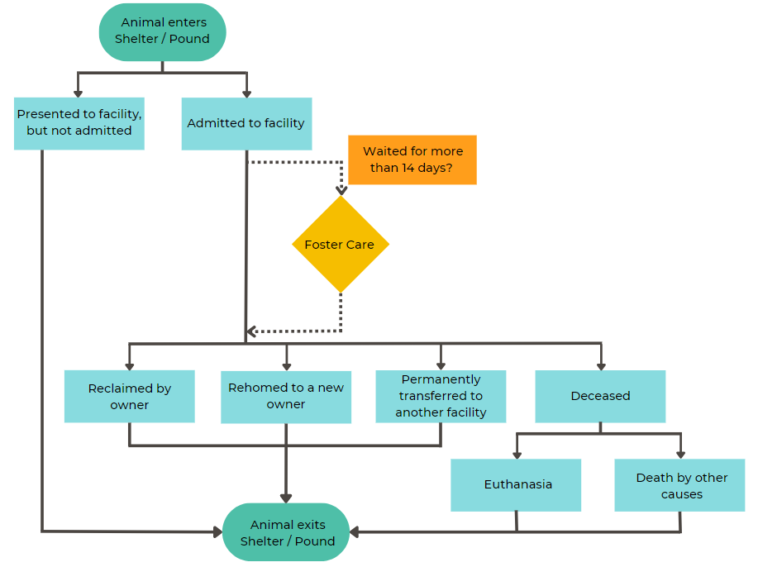
Figure 1 - Flowchart of the various pathways an animal may follow through a shelter or pound

5.2 Reason codes
Three of the data categories will have data reported against reason codes. These are:
- animals physically presented but not admitted
- animals rehomed but returned to the establishment
- euthanasia.
The reason codes help you to understand the data and provide information about why certain animal management decisions may have been made. Animals only have one reason code recorded for each data category, e.g. if an animal has been euthanased for both behaviour and disease, only the main reason will be recorded. A definition for each reason code is provided, where relevant, in the table at section 5.4 below.

5.3 Explanatory comments
Shelters and pounds can provide contextual, or explanatory, comments to accompany their data, for each of the four broad data themes:
- Intake and population
- Foster care
- Reclaimed and rehomed
- Death.
Comments can be no longer than 100 words. This encourages shelters and pounds to clearly and concisely note any important details or issues that data viewers and users should be aware of, to help them understand the data.
Shelters and pounds may choose to provide comments on some, all or for none of the themes. If no comments are provided for a data theme, the comments box will show ‘Establishment did not provide contextual comments’.

5.4 Data categories
The table below defines each of the Code’s data categories and provides guidance on what the data captures, to aid interpretation. It also notes where data categories count animals versus occurrences for a particular activity or outcome.
Data category | What shelters and pounds are required to report | Relevant definitions | Reason Codes | What you should know about this data category
Shelter or pound population on 1 January, at start of reporting period | A head count of all animals physically held by the establishment, including those in foster care arranged by the establishment, on the first day of the reporting period.  If no animals were physically held in the establishment or in foster care on the first day of the reporting period, shelters and pounds will indicate this by reporting ‘0’. | Nil. | Nil. | This is a total count of individual animals.  Most shelters or pounds will already have some animals in its care when a new reporting period begins. It's important to count how many animals are there at the start of each period. This way, we can make sure the data collected for the other categories is accurate and consistent.
Admitted | Number of times that animals were admitted to care, or born while in care, at the establishment during the reporting period. | Admitted: An animal is physically admitted to the establishment or is admitted to the care of the establishment, including a staff member of the establishment, for any period of time. Subsequently, the animal was held in the custody of the establishment, or staff member of the establishment, or euthanased in accordance with the DA Act. | Nil. | This is a total count of occurrences or instances.  This data category will help you understand the total volume of activity in Victoria’s shelter and pound system.  This includes animals that were under the establishment’s care, even if not physically admitted to the establishment. For instance, feral cats euthanased in accordance with the DA Act are recorded as admitted to the facility, though they often do not physically enter it due to the risk they pose to staff and other animals.  Note that for facilities providing pound services, or servicing multiple council areas, numbers reported in this category may be higher.
Animals physically presented but not admitted | The number of times animals presented at the establishment for admission were not admitted during the reporting period, according to each of the following reason codes:  - No capacity  - Significant or unmanageable health concerns  - Significant or unmanageable behaviour concerns  - Animal from another jurisdiction  - Other.  If all animals presented to the establishment during the reporting period were admitted, shelters and pounds will indicate this by reporting ‘0’ against all reason codes. | Not admitted: The animal was determined to be unsuitable for admission to the establishment (i.e. the person who presented the animal was to find an alternative establishment or means for managing the animal). | No capacity: The shelter or pound establishment would normally accept an animal but did not have physical capacity to house it.  Significant or unmanageable health concerns: The shelter or pound establishment did not have the staffing capacity or expertise to meet the animal’s health needs, or an alternative service provider was more suitable (e.g. a vet or other establishment).  Significant or unmanageable behaviour concerns: The shelter or pound establishment did not have the staffing capacity or expertise to manage the animal’s behaviour and ensure the safety of staff and other animals, or an alternative service provider was more suitable (e.g. a vet or other establishment).  Animal from another jurisdiction: Pound service provider unable to accept the animal as it was seized from a jurisdiction other than the municipality serviced by the establishment (as per section 84D of the DA Act).  Other: Any other situation where an animal was physically presented for admission but was not admitted to the establishment. | This is a total count of occurrences or instances.  Victorian shelters and pounds have different rules and procedures for admitting animals. Additionally, the DA Act has a range of requirements for admitting animals that some shelters and pounds are required to follow, while others have more flexibility. For example, under section 33A of the DA Act, council shelters and pounds must accept any animal that is surrendered to them, unless the animal comes from another council area.  By gathering this data, we can develop an understanding of the pressures that shelters and pounds may or may not face. Sometimes, a shelter or pound may not have the capacity, staff, or resources to meet an animal's needs. In these situations, it may be appropriate to refer the animal elsewhere instead of admitting it to the shelter or pound. Alternatively, they may be able to help the owner keep the animal and avoid surrendering it.
Placed in foster care | The total number of times that animals were placed in foster care during the reporting period. If an animal has been placed in foster care multiple times during the reporting period, each stay is counted and reported.  If the establishment has not engaged in any form of foster care during the reporting period, shelters and pounds will indicate this by reporting ‘0’. | Foster care: Described in the Code as either behavioural foster care, juvenile foster care, short-term relief foster care or veterinary rehabilitation foster care. | Nil. | This is a total count of occurrences or instances.  This data reflects the use of, and access to foster care, arranged by the shelter or pound.  Shelters and pounds need to count each time an animal goes into foster care, and this may happen multiple times for one animal. For example, an animal may be placed in foster care, then go back to a shelter for adoption, but if the adoption is not carried out, it may go back into foster care. This will then be counted as two foster care placements.  Capturing data about multiple stays will help the government to understand the pressures and challenges that the foster care sector faces and the kind of support it needs.  There is no minimum length of stay in foster care. An animal may be in foster care for a few hours, or for a longer period of weeks or months.
Wait to access foster care | The number of times that animals assessed as requiring and/or suitable for foster care, and for which foster care was requested, waited more than 14 days to access foster care for any reason.  To calculate whether an animal has waited longer than 14 days for foster care, shelters and pounds deduct the date that foster care was requested for an animal from the date the animal was taken into foster care. For example:  17 March 2023 – 1 March 2023 = 16 day wait  Date foster care requested  Date placed in  foster care  Shelters and pounds report all times that an animal waited longer than 14 days to be placed in foster care during the reporting period. This applies even if the date an animal was assessed as requiring and/or suitable for foster care was in the previous reporting period.  The foster care waiting period includes all or part of the eight-day quarantine period if the animal was assessed as requiring and/or suitable for foster care while in quarantine, and a request for foster care was made before the end of the quarantine period.  If the establishment has either not used foster care services, or no animals waited for more than 14 days for foster care during the reporting period, shelters and pounds will indicate this by reporting ‘0’. | Assessed for foster care: The Code requires the proprietor’s health management plan to include assessment programs for fostering animals. That is, an animal must be assessed as requiring and/or suitable for foster care, prior to a request being made to place that animal in foster care.  14 days: 14 consecutive calendar days (not business days). | Nil. | This is a total count of occurrences or instances.  This data provides information about access to, or demand for, foster care.  Data about foster care services captures multiple stays for the same animal, to reflect reliance on and use of these services by shelters and pounds. This data will help the government understand the demand for foster care services, and the support these service providers may need.  Foster care may improve welfare outcomes for animals, as longer-term stays in shelters and pounds can have negative effects.  Not all animals need or are fit for foster care, and not all shelters and pounds use foster care programs. Dogs that are declared dangerous or menacing, or are of a restricted breed, are not suitable for foster care because they pose a higher risk to community safety.
Reclaimed by owner | The number of times that animals were reclaimed by their owners during the reporting period.  If no animals were reclaimed from the establishment during the reporting period, shelters and pounds will indicate this by reporting ‘0’. | Reclaimed: Animal is retrieved or recovered from the establishment by their owner, or the animal is returned to or reunited with its owner by the establishment. | Nil. | This is a total count of occurrences or instances.  Lost pets are more likely to be reunited with their owner if they are registered and/or microchipped with up-to-date owner contact information.  Shelters and pounds care for many animals that are not registered and/or microchipped, which makes it harder to find their owners, and return them safely home.  Even where an owner can be identified, reuniting them with their pet is not always possible for various reasons. For instance, the owner may no longer be able to care for their pet.
Rehomed | The number of times that animals were rehomed by the establishment during the reporting period.  If the establishment did not rehome any animals, shelters and pounds will indicate this by reporting ‘0’. | Rehomed: Animal is permanently adopted by a new owner. Does not include animals in temporary foster care, or animals permanently transferred to another establishment or organisation for rehoming. | Nil. | This is a total count of occurrences or instances.  Preparing an animal for rehoming requires significant planning and preparation, as it is important to make sure the animal is going to a home that meets its needs.  Some shelters and pounds rehome animals themselves, while others work other organisations that can rehome animals for them. These relationships can help to minimise how long an animal stays at a shelter or pound and improves its chances finding a good home faster.
Permanently transferred to other establishments or groups for rehoming | The number of times that animals were permanently transferred to other shelters or pounds, or to community foster care networks, individual foster carers or rescue groups for rehoming, during the reporting period.  If the establishment did not transfer any animals to another organisation for rehoming during the reporting period, shelters and pounds will indicate this by reporting ‘0’. | Permanently transferred: Custody/ownership of the animal is permanently transferred to another organisation or individual. The animal does not return to the shelter or pound establishment for rehoming. | Nil. | This is a total count of occurrences or instances.  This data shows how many of animals were transferred to different organisations to help them find new homes.  Transfers could be to another shelter or pound, or to a rescue group or foster carer. Organisations and individuals that are not regulated by the Code can have agreements with councils that allow them to rehome animals. Information about council agreements for rehoming is available on the Pet Rehoming page of the AWV website.
Rehomed but returned to the establishment | Number of times that animals rehomed by the shelter or pound were surrendered back to the establishment, within six months immediately following their adoption date, in the reporting period. Data will be reported according to each of the following reason codes:  - Change of mind  - Owner circumstances changed  - Post-adoption health or behavioural issues  - Other.  If no animals were returned following rehoming by the establishment during the reporting period, shelters and pounds will indicate this by reporting ‘0’. | Returned: Animal is returned to the establishment within 6 months of its adoption date. This applies only to animals that were permanently adopted by a new owner. | Change of mind: Owner chooses to no longer provide care for animal post-adoption.  Owner circumstances changed: Owner unable to care for animal due to a change in their living, financial or social circumstances.  Post-adoption health or behavioural issues: Owner unable to provide care to animal due to health issues or behavioural incompatibility, which were not apparent prior to adoption.  Other: Animal is surrendered following rehoming during the reporting period for any other reason. | This is a total count of occurrences or instances.  Rehoming animals is an important job that most shelters and pounds do. Rehoming animals involves a focus on keeping communities safe, promoting good animal welfare, and encouraging responsible pet purchasing and ownership.  Sometimes, an adopted animal is not suited to its new home and may be returned to a shelter or pound. This can happen for many different reasons and may be in the best interests of both the animal and its owner if they find a new match.  Screening potential adopters, teaching people to be responsible pet owners, and providing post-adoption support can help keep animals out of shelters.  The re-admission of a rehomed animal shows that the shelter or pound is committed to providing post-adoption support and ensuring good welfare outcomes for the animal. It shows that the organisation is willing to work with the adopter to find a solution that works for both the animal and the adopter.
Euthanased | Number of animals that were euthanased during the reporting period, according to each of the following reason codes:  - Disease  - Injury  - Behaviour  - Age  - Unsuitability for sale  - Unweaned and orphaned animal  - Unidentified cat that is wild, uncontrollable or diseased.  If no animals were euthanased during the reporting period, shelters and pounds will indicate this by reporting ‘0’. | Nil. | Disease: illness; sickness; ailment of the body or of some organ or part, from which the animal cannot be suitably rehabilitated, as determined or directed by a veterinary practitioner.  Injury: an injury from which the animal will not recover as determined or directed by a veterinary practitioner.  Behaviour: the animal has behavioural trait(s) that pose a risk to the community, or significantly impact the animal’s quality of life, which cannot be rectified.  Age: the animal’s health or welfare is irredeemably compromised due to their age, as determined by a veterinary practitioner.  Unsuitability for sale: the animal is a declared dangerous or menacing dog, or is a restricted breed dog (e.g. this may include animal destructions under Divisions 6 and 7 of the DA Act). Unweaned and orphaned animal: Puppy or kitten under 8 weeks old, without access to its mother or appropriate foster care, as determined or directed by a veterinary practitioner.  Unidentified cat that is wild, uncontrollable, diseased: In accordance with section 84O of the DA Act. | This is a total count of individual animals.  Shelters and pounds will admit different types of animals. This is because pounds (including contracted facilities) support Councils in their animal management responsibilities under the DA Act and Prevention of Cruelty to Animals Act 1986 (POCTA Act). As such, the data may show different reasons and rates for euthanasia between these types of facilities. For example, council-run or contracted pounds may be involved in cat management programs, manage a large number of seized animals, or keep custody of dangerous dogs. Such facilities may have higher rates of euthanasia due to the requirements of the DA Act.  Note that for facilities providing pound services, or servicing multiple council areas, numbers reported in this category may be higher.  Feral cats are a serious threat to Victoria’s wildlife and biodiversity. Feral cats can also spread diseases to livestock and humans, with impacts for Victoria’s economy. As such, feral cats are a declared established pest species on certain Crown land under the Catchment and Land Protection Act 1994, which means that, public land managers (including councils) must take action to control their populations. Cats euthanased under council cat management programs and reported under the ‘Unidentified cat that is wild, uncontrollable, diseased’ reason code are typically feral cats.  Shelters and pounds must care for animals in line with veterinary advice, and any euthanasia must be humane. Veterinary professionals must practice according to the guidelines on end-of-life care issued by the Veterinary Practitioners Registration Board of Victoria and Section 9 of the POCTA Act.
Died, but was not euthanased | Number of animals that died during the reporting period but were not euthanased.  If no animals died for reasons other than euthanasia during the reporting period, shelters and pounds will indicate this by reporting ‘0’. | Nil. | Nil. | This is a total count of individual animals.  This data includes animal deaths that happen in the establishment, in foster care arranged by the establishment, or during transportation. These deaths may be caused by old age, or pre-existing conditions (including a pre-existing injury from a road accident, or another pre-existing illness).

