
Dairying in Victoria

Dairy Farm Monitor Project
2025-26 Victoria statewide performance

There were approximately 2,349 dairy farm businesses in Victoria that produced 5.55 billion litres or 64% of Australia’s national milk production in 2025-26.

Dairy Farm Monitor Project farm locations and rainfall in 2025-26
In 2025-26 farm profitability for the state has been influenced by:


11% increase in average milk price to $9.80/kg MS

4% ↓ in feed costs to $4.39/kg MS
3% ↓ in variable costs to $5.06/kg MS Stable overhead costs of $2.93/kg MS

Profitability
After the decline in profits observed in 2024-25, average profit improved across all regions in 2025-26. The statewide average profit, measured as earnings before interest and tax (EBIT), increased to $2.81/kg MS, above the 10-year DFMP average. Nearly all participants recorded a positive EBIT (86 out of 90), reflecting improved operating conditions compared with the previous year.

$4.00

$3.31

$2.81

$2.69

$2.44
Profit (EBIT $/kg MS)

$3.00

$2.00

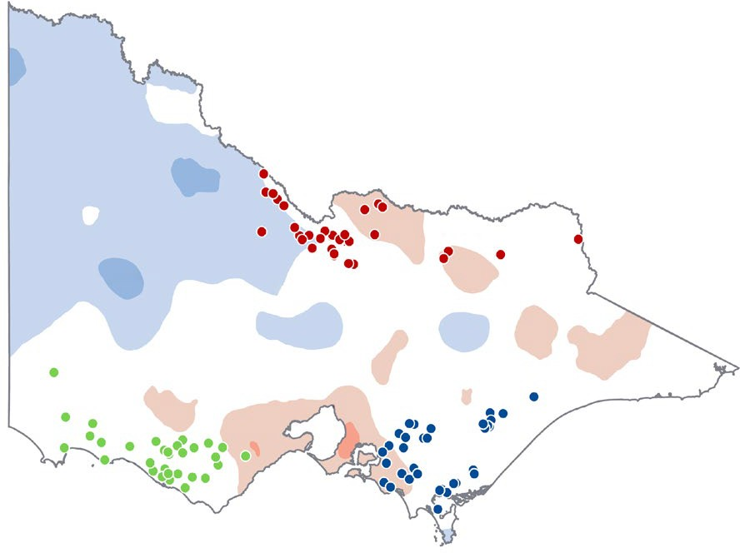
Northern Victoria South West Victoria Gippsland
Rainfall Decile Ranges
$1.00

$0.00

Statewide Northern
Victoria

South West Gippsland Victoria

Highest on record
4,357  t CO2-e/farm | 2025-26  Greenhouse gas emissions | 0.88  kg CO2-e/kg FPCM

Very much above average
Above average
Average Below
average
Very much below average
Lowest on record

Greenhouse gas emissions

In 2025-26, 96% of all Victorian participants had positive returns (86 out of 90)
2024-25 2025-26
$2.81
$1.46
Average EBIT ($/kg MS)
$1.82
$0.47
Victoria
Average net farm income ($/kg MS)

Future expectations 2026-27

More than 80% of farmers expect business returns to improve or stabilise

Further information: www.agriculture.vic.gov.au/dairyfarmmonitor
If you would like to receive this publication in an accessible format, telephone 136 186
or email fmp@victoria.agriculture.vic.gov.au
6.5%
3.7%
Average return on total assets
1.3%
8.2%
Average return on equity

