


Sheep and Goat Compensation Fund
2024-25 Outcomes Summary
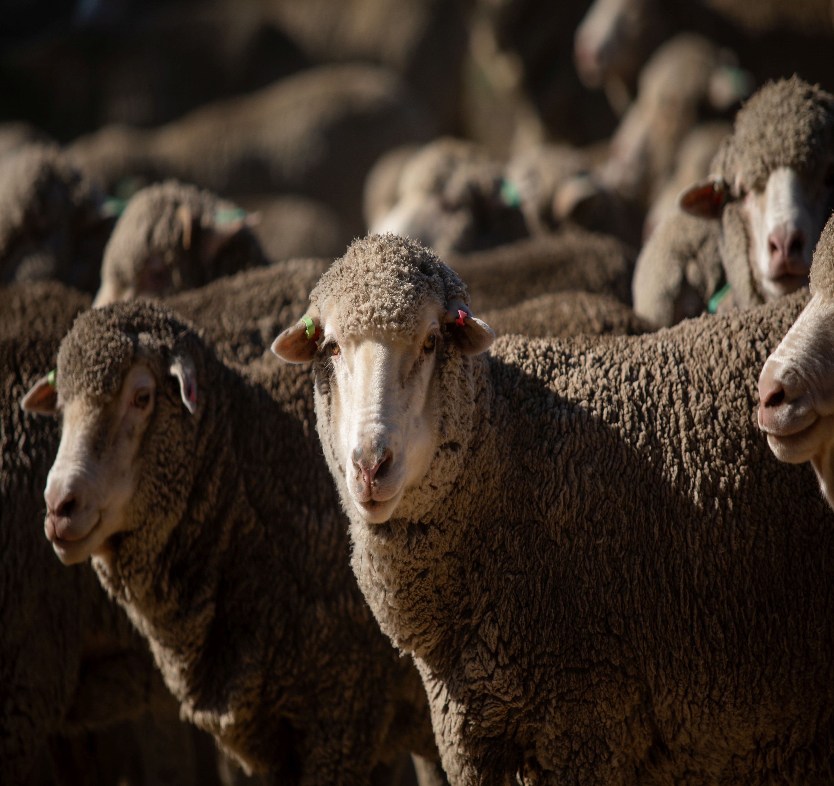

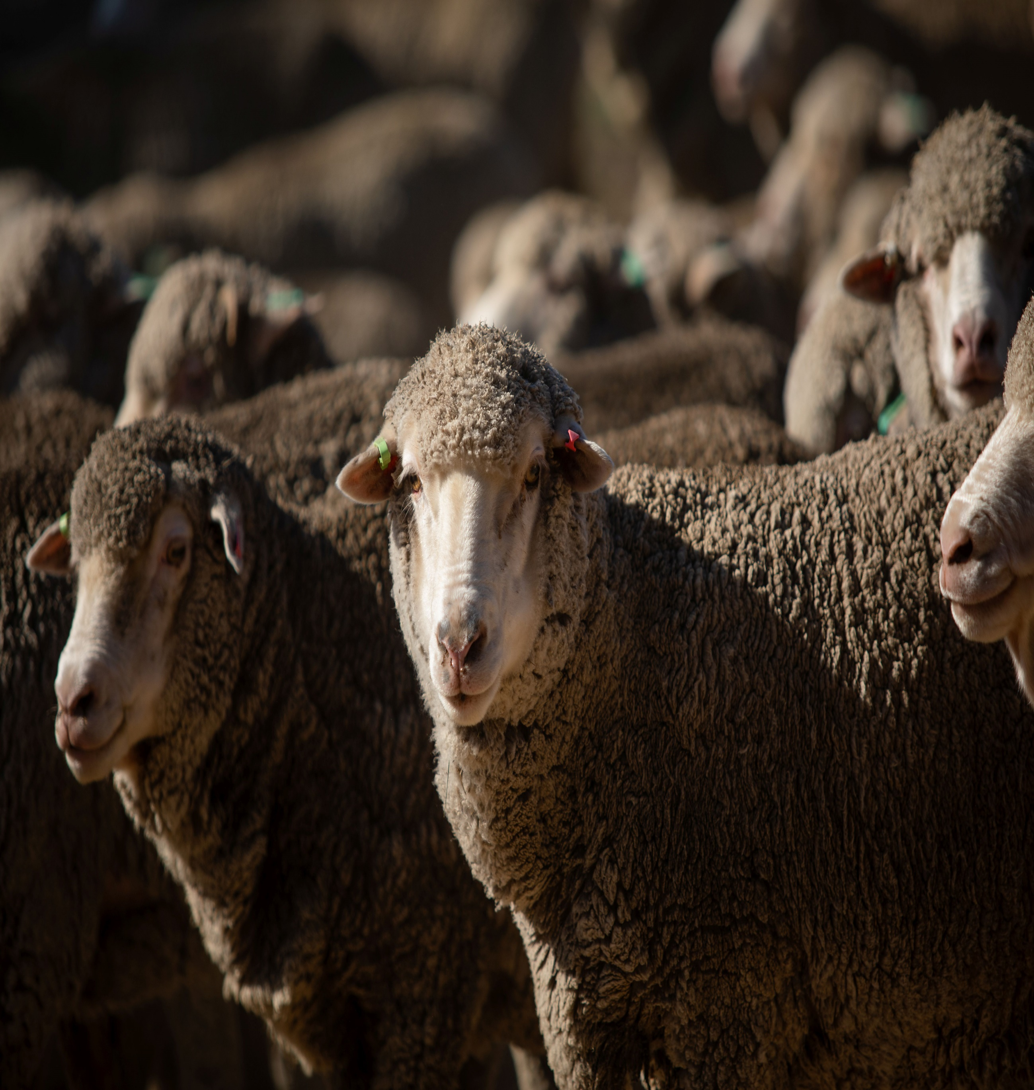

Further information regarding the Livestock Biosecurity Funds may be obtained from:
The Manager, Governance Support and Coordination
Agriculture Victoria
475 Mickleham Road, Attwood, Victoria Australia
LivestockBiosecurityFund@agriculture.vic.gov.au
Authorised and published by the Victorian Government, Department of Energy, Environment and Climate Action (DEECA) 2025. © The State of Victoria Department of Energy, Environment and Climate Action 2025.
This publication is copyright. No part may be reproduced by any process except in accordance with the provisions of the Copyright Act 1968.
For more information contact the Agriculture Victoria Customer Service Centre on 136 186.
Disclaimer
This publication may be of assistance to you, but the State of Victoria and its employees do not guarantee that the publication is without flaw of any kind or is wholly appropriate for your particular purposes and therefore disclaims all liability for any error, loss or other consequence which may arise from you relying on any information in this publication.
Accessibility
If you would like to receive this publication in an accessible format, such as large print or audio, please telephone 136 186.
Deaf, hearing impaired or speech impaired? Call us via the National Relay Service on 133 677 or visit www. relayservice.com.au
This document is also available on the Agriculture Victoria website.

Sheep and Goat Compensation Advisory Committee
The Sheep and Goat Compensation Advisory Committee (SGCAC) provides recommendations to the Minister for Agriculture on the allocation of funds from the Sheep and Goat Compensation Fund (SCGF), delivered annually through Livestock Biosecurity Funds grant program.
Funded projects aim to prevent, monitor and control diseases, thereby improving animal health, biosecurity and supporting market access for the benefit of Victorian sheep and goat industries.
The Minister for Agriculture appoints the SGCAC chairperson and members based on their expertise and experience in accordance with the requirements of the Livestock Disease Control Act 1994 (the Act).

Activities of the Committee
During the 2024-25 financial year, SGCAC convened eight times with secretariat support provided by Agriculture Victoria.
Key activities since July 2024 include:
- Conduct of the 2025 Livestock Biosecurity Funds grant program and contributing to the continuous improvement of the annual grant rounds.
- Reviewed and refined the strategic focus for the 2025 grant program to align with industry priorities.
- Provided oversight of the Sheep and Goat Compensation Fund (SGCF) including monitoring milestones and the progress of funded projects.

2025 Livestock Biosecurity Funds Grant Program
Since the previous report, the SGCF has participated in the 2025 Livestock Biosecurity Funds grant program.
The SGCAC members individually and the Committee collectively assessed each application received against the selection criteria outlined in the program Guidelines. In finalising recommendations and supporting justification to the Minister, the SGCAC members’ individual assessments, the available balance of the SGCF fund and input from an independent assessment panel were considered to determine recommended projects. An independent Probity Advisor oversaw the process, including the management of conflict-of-interest declarations and advised on appropriate actions to ensure integrity and transparency.
The 2025 Livestock Biosecurity Funds Grant Program was open for applications from 7 March to 14 April 2025. The round was launched with a webinar featuring presentations from all four advisory committees.
In May 2025, SGCAC assessed all applications and recommended 7 projects, totalling $6,080,460, to the Minister for Agriculture for approval:
- VFF Stock Sense Peri Urban.
- Healthy, Wealthy and Bio Wise.
- Electronic National Livestock Identification System (NLIS) (Sheep) tag subsidy.
- Commercialisation of a saliva test to breed worm resistence into livestock.
- Epidemological investigations of key infectious abortions in Victorian sheep.
- Antimicrobial prescribing guidelines for goats.
- StrikeBack: Deploying Glyco-Relevant vaccines to combat flystrike on sheep.

Improved communications and engagement
In 2024, the SGCAC developed a three-year Communications and Engagement Strategy to guide how it promotes the grant program and shares the outcomes of funded projects with industry. The strategy outlines key tools, channels, and activities aimed at attracting high-quality applications and increasing awareness of the benefits delivered through Sheep and Goat Compensation Fund (SGCF) projects. Implementation of the strategy commenced in 2024 and will continue over the next two grant rounds, with a formal review scheduled at the end of the 3-year period.
As part of the rollout of the SGCAC Communications and Engagement Strategy, a webinar launching the 2025 LBF grant program was held on 7 March 2025. The
chairpersons of the four Livestock Advisory committees presented an overview of the 2025 program, including each committee’s strategic focus, eligibility criteria, application process and participated in a Q&A session. The recording of the webinar is available on the Program Website.

Strategic focus for annual rounds
The SGCAC reviewed the strategic direction for the SGCF in late 2024 and identified 5 key themes:
- Prevention – build ability for industry to reduce the risks of a biosecurity event.
- Preparedness for response to biosecurity events – building response capability, capacity and planning
- Traceability and early detection – enhance system integrity and effectiveness improved surveillance and monitoring
- Education – awareness and training for industry to better manage biosecurity risks
- Applied research – particularly technologies for testing and treatment (e.g. vaccines).
In addition, the broad focus areas listed above the SGCAC identified the following targeted areas for 2025:
- Livestock veterinary capability – Build the capacity and capability of industry stakeholders and key support staff across the value chain. This includes but is not limited to vet nurses, administration teams, relevant industry consultants and stock and station agents that are available and/or required to respond to an emergency disease event.
- Antimicrobial stewardship – Preserve the effectiveness of antibiotics to support sheep and goat animal health/welfare outcomes. Minimise adverse outcomes of an emergency disease event.
- Data management and animal health feedback – Improved sheep and goat EID management options on-farm and traceability to meet market demand.
- Sheep and goat livestock treatment options and potential residues/chemical resistance issues – Preserve and improve the effectiveness of on-farm sheep and goat animal treatments, including application processes.

LBF grant program projects
Milestone management of the successful projects is overseen by the Department of Energy, Environment and Climate Action (DEECA), in consultation with the SGCAC.
A summary of project activity to date is below.

Summary of active SGCF projects
Project (Recipient) | Project Timeline | Total allocated from SGCF | Achievements to  30 June 2025
25.05 Victorian Farmers Federation (VFF) Stock Sense Peri Urban  (VFF)  Focuses on peri-urban livestock owners or hobby farmers to raise awareness and knowledge of key animal health and welfare issues, with a particular focus on farm biosecurity and traceability responsibilities. | Oct 2025 – Jul 2027 | $415,032 | Successful applicant 2025 LBF grant program.
25.07 Electronic National Livestock Identification System (NLIS) (Sheep) tag subsidy  (Biosecurity Victoria)  The tag subsidy provides producers access to attractively priced NLIS tags through periodic tendering and centralised tag ordering. | Oct 2025 – Apr 2028 | $3,800,000 | Successful applicant 2025 LBF grant program.
25.08 Epidemiological investigations of key infectious abortions in Victorian sheep  (University of Melbourne)  Facilitate improved disease management and reduce losses for Victorian sheep farmers by establishing efficient diagnostics and elucidating disease dynamics. | Oct 2025 – Jun 2028 | $380,444 | Successful applicant 2025 LBF grant program.
25.09 Antimicrobial prescribing guidelines for goats  (University of Melbourne)  Surveys mixed practice veterinarians to determine which diseases to create guidelines for, create comprehensive guidelines and consult with stakeholders on the implement ability before final release. | Oct 2025 – Feb 2028 | $254,674 | Successful applicant 2025 LBF grant program.
25.10 StrikeBack: Deploying Glyco-Relevant Vaccines to Combat Flystrike on Sheep (CSIRO)  To develop a vaccine with biologically relevant antigens (proteins that trigger an immune response) formulated with specialised additives (adjuvants) to provide sheep protection from flystrike. | Oct 2025 – Mar 2028 | $498,310 | Successful applicant 2025 LBF grant program.
25.12 Healthy Wealthy and Bio-Wise  (Biosecurity Victoria)  To deliver a multi-session extension and education initiative that enhances biosecurity and animal health preparedness, management, planning and preventative measures. | Oct 2025 – Oct 2031 | $482,000 | Successful applicant 2025 LBF grant program.
25.16 Commercialisation of a saliva test to breed worm resistance into livestock  (Swabtec Pty Ltd)  To develop a lab-based saliva test available to farmers to easily obtain breeding data to improve worm resistance in livestock. | Oct 2025 – Oct 2028 | $250,000 | Successful applicant 2025 LBF grant program.
24.24 A modular program for the onfarm integration of developing veterinarian  (Herd Health)  To enhance the skills of Victoria’s emerging livestock veterinarians through a modular development program focused on on-farm management, biosecurity, disease investigation, and emergency response. | Oct 2024 – May 2026 | $70,911.00 | A modified Herd Health training program for rural veterinarians has been developed into a series of face-to-face training modules. The program includes extensive refresher content in epidemiology, a contextual summary of AUSVETPLAN, and practical training in disease investigation.  Endemic disease case studies have been created as team exercises to integrate all learned material.  Course flyer developed and circulated.
24.07 Animal Disease Investigation (ADI) Course (Biosecurity Victoria)  A two-day course run by Agriculture Victoria Veterinary Officers and AgriBio pathologists annually in four different regional locations across Victoria delivering training in disease investigation, field epidemiology, biosecurity, and advanced necropsy techniques for Victorian livestock veterinary practitioners. | Aug 2024 – Jun 2027 | $54,528 | The first four Animal Disease Investigation (ADI) courses for veterinarians are being prepared and planned to be held across several locations in Victoria including Ellinbank, Rutherglen, Bendigo and Hamilton.
24.11 Electronic National Livestock Identification System (NLIS) (Sheep) tag tender (Biosecurity Victoria)  Coordinate preparation of tender related material both pre, during and after. Allowing Agriculture Victoria with continued industry support to provide attractively priced electronic NLIS ear tags to Victoria’s 50,000 active cattle producers. | Jan 2025 - Feb 2026 | $62,500 | Grant agreement executed September 2024.
24.13 Enhancing veterinary surveillance capability in Victoria (Biosecurity Victoria, DEECA)  To evaluate and strengthen the capability of private veterinary practitioners to deliver effective surveillance for livestock diseases in Victoria. | Dec 2024 – Jun 2027 | $84,330 | Grant agreement executed September 2024.
24.28 Infected Premises - Livestock Producers Awareness Course  (P2r2 Consulting Pty Ltd)  To inform livestock producers as to what happens on an Infected Premises after an emergency animal disease has been diagnosed. | Oct 2024 –  Dec 2025 | $41,060 | Successful completion of an extensive stakeholder consultation program and subsequent development of training strategy session plans & materials.
24.31 Managing animal mortalities in emergencies - Training Course  (P2r2 Consulting Pty Ltd)  Development of training materials, in consultation with Agriculture Victoria, on how to manage animal mortalities in emergency situations that are appropriate for livestock producers and staff involved in an emergency animal disease or natural disaster response | Aug 2024 – Nov 2026 | $78,675 | Successful completion of course 1 and 2 of the ‘Managing Animal Mortalities in an Emergency’ Training Course. The course participants included both state and local government representatives.  The next two courses are planned for early August and September 2025.
24.18 Stage 2 - Truck wash review - Addressing biosecurity risks  (Biosecurity Victoria, DEECA)  Aims to build on the previously funded RMCG study/report in addressing the gap in Victoria's truck wash network in Melbourne's outer west. | May 2025 – Dec 2025 | $100,000 | Grant agreement executed February 2025.
24.15 Private veterinary practitioner up-skill, online project (Biosecurity Victoria, DEECA)  Aims to increase the capability and confidence of private veterinary practitioners (PVP’s) to identify and respond appropriately to the suspicion of significant diseases (SD’s) in cattle, sheep, goats and pigs. | Dec 2024 – Dec 2026 | $50,000 | Engagement of species specialists to write case studies.  A set of 10 case study diseases for each species group has been agreed upon.  A Learning Management System Platform has been written ready for use and a case study template developed.  Pre and post course evaluation questions developed.  A communication plan and materials have been developed and approved ready for release.
24.37 Producer Led Extension (Stock Sense Livestock)  (Victorian Farmers Federation)  Aims to increase producer awareness and adoption of practices that improve on-farm biosecurity and animal health in Victoria with a particular focus on peri urban landholders who have been identified as the highest biosecurity risk. | Feb 2025 –  Dec 2025 | $395,000 | 8 webinars and 9 face-to face workshops held to the end of June 2025.  Average of 26 participants at face-to-face events to date.  Stock Sense has a full calendar scheduled for the remainder of the 2025.
24.20 Rapid multiplexed immunoassay for priority internal parasites of sheep (CSIRO)  Aims to improve the diagnosis of intestinal parasites through the development of a quantitative and differential ELISA-based coproantigen test that can be built into a lateral flow device with further investment. The test can be performed by an unskilled operator, multiplexed for species differential, is highly correlated with worm burden (especially for Teladorsagia) and can detect infestations earlier. | Oct 2025 – Jun 2028 | $699,788.00 | Grant agreement executed September 2024.
24.03 Risks of potential EAD transmission between feral pigs and farmed livestock  (Arthur Rylah Institute)  To quantify the potential risk of EAD transmission between farmed livestock (cattle, sheep and pigs) and feral pigs by quantifying areas in Victoria where feral pigs could pose a significant reservoir for EADs. Including identification of cost-effective strategies for managing feral pigs in the event of an EAD outbreak to eliminate the potential for disease transmission. | Apr 2025 – Nov 2025 | $100,000 | A spatially balanced, random sampling design was used on 166 sites across Victoria to sample feral pig densities. At each site a heat-in-motion remote camera was deployed in suitable habitat in late March/early April and left in place for 6 weeks. This includes:  - Camera monitoring at 163 sites across Victoria to sample feral pig densities completed.  - Image processing and databasing of all feral pig images complete.  - Feral pigs were detected at 24 of the 163 camera sites.
24.33 Testing and optimising rapid appraisal for outbreaks in Victorian sheep and goats  (University of Melbourne)  To enhance preparedness for responding to emergency animal disease outbreaks and seek to minimise the negative impacts on the Victorian sheep and goat industry from potentially devastating outbreaks. | Mar 2025 – Oct 2026 | $120,000 | Grant agreement executed September 2024.
24.25 Victoria's Footrot Footprint- monitoring, awareness and education program  (J.T. Agri-Source Pty Ltd)  This project aims to increase awareness amongst producers to better identify and treat Dichelobacter Nodosus (footrot) on farms. | Aug 2024 – Jul 2027 | $398,000 | Development of social research questions.  Engagement of first 20/100 producers to assess and map footrot serogroups and virulence.  Commenced building producer awareness of Victoria’s Footrot Footprint and the most effective strategies to manage/eradicate footrot.  Refined swabbing protocol has been developed and samplers trained by Dr Bruce Jackson.  Recruitment of first 21 Victorian farms to swab feet.
22.13 Control and prevention of anthrax  (Biosecurity Victoria, DEECA)  To support anthrax vaccination of sheep and goats on affected and high-risk properties. | Jul 2023 – Oct 2026 | $75,000 | In the year 2024-25, preventive anthrax vaccination of 3,195 sheep and 1 goat was carried out on 12 approved properties (6 properties with sheep, 5 properties with cattle and sheep, and 1 property with sheep and goats).  There were no anthrax outbreaks during this period, so no response vaccination activities were completed.
22.12 Significant Disease Investigation (SDI) (Biosecurity Victoria, DEECA)  To enhance the capacity for early detection and control of diseases in livestock that could impact human health, animal health, farm productivity and market access and trade. | Jul 2023 - Oct 2026 | $360,000 | Between 1 July 2024 and 30 June 2025, the SDI program facilitated 145 investigations in sheep and 6 investigations in goats by private veterinary practitioners across Victoria, including 14 sheep and goat investigations that excluded an emergency animal disease (EAD).
21.14 Risks and Records (Agriculture Sector Development and Services, DEECA)  Externsion program to develop livestock managers understanding, skills and confidence to implement traceability and biosecurity systems that underpin and protect Victoria’s livestock industry. | Jul 2022 – Dec 2025 | $103,500 | A total of 189 participants have attended a Risk and Records workshop in this reporting period.  Participants have been equipped with skills to implement changes including:  - Enhancing farm biosecurity awareness and planning.  - Updating and increasing recordkeeping.  - Sharing information with family members.  - Improving water plans and farm maps.  - Preparing for droughts and farm quarantine.  - Installing biosecurity signs and fencing off pits.  Seven Meat and Wool staff are now competent to deliver and facilitate Risk and Records workshops.
22.11 NLIS Sheep and Goat Tag Subsidy  (Biosecurity Victoria, DEECA)  Subsidies for producers when purchasing NLIS tags for sheep and goats in Victoria. | Jul 2024 – Mar 2026 | $2,925,000 | Continued assistance of Victorian sheep and goat producers with the identification of sheep and goats using NLIS system tags.
22.19 Community pig control and surveillance  (Biosecurity Victoria, DEECA)  Pilot program working with producers on private and private/public interface to control feral pigs and assist in monitoring genetics and presence or proof of absence of disease. | Dec 2023 – Sep 2026 | $118,909 | Establishment of three Community Feral Pig control groups.  Establishment of three Feral Scan community groups.  Three group inception meetings and one exclusion fencing course.
22.08 Rapid On-Farm Test of Barber's Pole Worm  (Federation University)  Production of a fast, accurate and cost-effective test for farmers to implement appropriate management of Barber’s Pole and to detect early infections in sheep and goats before production loss and stock loss occurs. | Aug 2023 – Nov 2025 | $96,860 | Test developed to rapidly detect Barbers Pole DNA in faeces or a faecal float (common test for parasitic worms).  Several workshops have been conducted throughout Victoria to discuss project findings and develop a commercialisation plan for the test.
22.09 Sheep and goat duty reconciliation with animals transacted in Victoria (Biosecurity Victoria, DEECA)  To employ a person for a 12-month period to investigate discrepancies in duties paid by Sheep and Goat producers and what was received. The position will also raise awareness of how duty related income is utilised. | Jul 2023 – Oct 2025 | $160,000 | Appointment of 1 FTE project officer for a period of 12 months to undertake the investigation into where the underpayment of livestock duty to the State Revenue Office (SRO) may be occurring.  Ongoing stakeholder engagement to continue to identify and investigate discrepancies between current payments and expected duties paid.
21.05 Livestock AMR Practices - Industry Review and Survey (Biosecurity Victoria, DEECA)  To increase awareness and support the implementation of best practice antimicrobial stewardship (AMS) and monitoring programs at a producer, veterinary prescriber and industry level.  It will ensure that process guidance given on AMS practices is aligned with State and national AMR Strategy objectives. | Jul 2022 – Nov 2025 | $192,720 | The University of Melbourne Asia Pacific Centre for Animal Health (APCAH) has entered an agreement with the Department of Energy, Environment and Climate Action to conduct a review of Antimicrobial Stewardship (AMS) practices of veterinarians servicing the sheep and goat industries in Victoria.  The final report, titled “A review of antimicrobial stewardship practices of veterinarians servicing the cattle, sheep and goat industries in Victoria” was received from University of Melbourne in January 2024.  Key findings from this report were presented and/communicated to:  - Cattle, sheep and goat veterinarians at the Australian and New Zealand College of Veterinary Scientists (ANCVS) Vet Science week conference in July 2024.  - Animal Health Committee AMR Task Group (established Oct 2024) to identify national priority areas for government leadership from Australia’s Animal Sector Antimicrobial Resistance Action Plan 2023 to 2028 (Action Plan) and to provide leadership on key Plan activities.
21.03 Autogenous Vaccine Development  (Biosecurity Victoria)  To eliminate the sole reliance of antibiotic treatment of a prioritised sheep disease. The research and development of an effective autogenous vaccine will enable sheep to develop immune protection against the endemic disease, reduce antibiotic treatments and improve overall animal health outcomes. | Jul 2022 – Sep 2025 | $154,396 | Development of project plan, scientific literature review, and detailed manufacturing plan.  Application for the APVMA permit in progress.

Summary of SGCF projects closed - July 2024 to June 2025
Project (Recipient) | Project Completed | Total SGCF contribution | Outcomes
20.10 eNVD Uptake - Whole Supply Chain  (Agrinous)  To eliminate inefficiencies in manual handling of paper NVD's and to ensure product integrity and enhanced biosecurity. | Oct 2020 – NA | $66,046 | Project withdrawn from grant program due to significant delays attributed to pandemic.
20.19 Point of Care (POC) testing for worm control  (Federation University)  The development of a diagnostic test (POC test) for producers to easily identify worm-resistant sheep for selective breeding. | Jan 2021 – Jun 2025 | $90,542 | Development of a saliva-based test prototype for farmers to breed worm resistant sheep. This prototype test is now in on-farm validation trials on 30 properties.  A new company called SwabTec has been launched who will bring the test to market once the trait has Sheep Genetics approval.
22.14 Stock Sense Livestock  (Victorian Farmers Federation)  Providing livestock producers with an information source including events, accessing information online and asking industry related questions, with the purpose of improving animal welfare. | Jan 2024 – Dec 2024 | $365,000 | In total the Stock Sense project reached over 800 producers at face-to-face workshops across 53 events since 2022.  Between 2021-2024 Stock sense held 18 webinars and had close to 1000 people attending. Recordings of these events on YouTube have reached 3000 views across the 18 webinars.  The average number of participants in sheep and goat specific workshops increased from 13 in 2023 to 21 participants in 2024.
21.19 Validation of In-field detection of Sheep lice  (La Trobe University)  To develop a rapid, highly sensitive field-based, early identification technology to detect sheep lice (Bovicola ovis), potentially resulting in a significant saving in the sheep industry. | Oct 2022 – Nov 2024 | $58,080 | Validation of an in-field diagnostic tool for detecting sheep lice with high sensitivity and specificity. The assay's ability to confirm infection can significantly impact sheep lice management by providing a clear decision on treatment.

Background

Sheep and Goat Compensation Fund (SGCF)
Victoria's Sheep and Goat Compensation Fund (SGCF) is under the Livestock Disease Control Act 1994 (the Act) and is funded through duties collected on the sale of pigs or pig carcasses.
A duty of 35 cents ($0.35) is payable for each sheep or goat, or each carcass, sold from 01 January 2023.
The Act outlines the permitted uses of funds from the Sheep and Goat Compensation Fund (SGCF). These funds are generally allocated to support projects and programs that benefit the Victorian sheep and goat industries, compensation for specified endemic diseases and cover the administration of SGCF.
All expenditure from the funds require approval from the Minister for Agriculture, following consideration of advice from the Sheep Goat Compensation Advisory Committee (SGCAC).

Livestock Biosecurity Funds grant program
The Livestock Biosecurity Funds grant program is administered by the Department of Energy, Environment and Climate Action, with funding from the respective fund:
- Cattle Compensation Fund
- Sheep and Goat Compensation Fund
- Swine Compensation Fund
- Honey Bee Compensation and Industry Development Fund.
The Livestock Biosecurity Funds grant program aims to support projects and programs that prevent, monitor, and control diseases, thereby improving animal health, biosecurity, and market access for the benefit of Victorian’s cattle, sheep, goat, swine, and honey bee industries.
Funds from the Livestock Biosecurity Funds grant program are allocated to projects that deliver outcomes aligned with the Act, and demonstrate the following principles:
- Innovative solutions and emerging technologies for unsolved livestock biosecurity issues, needs or gaps.
- Collaboration where possible across value chains.
- Quantifiable benefits to the whole of the livestock industries, which are measured and evaluated with evidence and data.
Each fund has a statement of strategic intent, that outlines priority investment areas and desired outcomes aligned with the purpose and objectives of the Act. These statements are incorporated into the Guidelines annually.
For more information on the Program, see agriculture.vic.gov.au/support-and-resources/funds-grants-programs/livestock-biosecurity-funds.

Current membership
- Kaylene Baird (chairperson) is a dedicated professional who seamlessly balances her roles as a critical care registered nurse and a commercial farmer. Alongside her husband Bill, she manages Weeroona Boers, a modest Boer goat and cattle farm in Victoria’s Western District. Kaylene’s passion for agriculture is matched by her commitment to healthcare, and rural communities, where she serves as a critical care nurse in Ballarat.
Kaylene is a long-standing member of the Royal Australian Nursing Corps Reserve, currently posted to the Royal Victoria Regiment (Infantry).
- Peter Baldwin (member) is one of Australia’s finest Property Auctioneers Peter has enjoyed a phenomenal career in the Property and Livestock industry Australia wide having auctioned over 38,000 properties with an aggregate value of over $15 Billion.​Peter Holds a Bachelor of Business majoring in Valuation, is a Class 1 Licensed Stock & Station Agent, Real Estate Agent in NSW, registered valuer, Licensed Estate Agent, General Auctioneer, Chattel Auctioneer, Queensland and Licensed Estate Agent Victoria.​
- Georgina Gubbins (member) is a progressive red meat producer farming in Southwest Victoria. Georgina has a Masters of Agribusiness from the University of Melbourne, a Fellow of the Australian Institute of Company Directors (FAICD), and a past Livestock Councillor for the Victorian Farmers Federation. Georgina was awarded an Order of Australia Medal for services to agriculture and the community in January 2024.
- Celia Scott (member) is a farmer in South West Victoria, running self-replacing composite sheep and seedstock cattle enterprises. This is Celia’s second sitting on the SGCAC and in recent years has been a VFF livestock councillor for the Glenelg region and sat on the Sheep Producers Australia Policy Council.
- Mark Inglis (member) is experience in animal husbandry and animal production working on and managing a broad range of livestock orientated properties including cattle properties in Western Australia’s Kimberley, sheep properties both wool and meat in Victoria and establishing a 900-sow outdoor free range pig breeding operation. Mark spent 7 years working for MLA/MSA with producers, stock agents, saleyards, feedlots and livestock buyers to gain a greater understanding of the pathways into both the cattle and sheep MSA programs.​
- Liz Mann (member) owns and operates a Poll Dorset Stud in Northern Victoria. Liz is actively involved in the Poll Dorset Association being secretary of the Goulburn Valley Region, Secretary of the Vic State, and also a Federal Board Member.​ Liz has a Bachelor of Agricultural Science (Honours), Graduate Diploma in Agricultural Management & Extension, and Diploma from the Australian Institute of Company Directors.
- Thomas Gooden (member) has 16 years of experience in the livestock industry, with a decade spent at Growth Farms Australia, leading to his current role as Group Agricultural Manager for Burgess Rural. Thomas has managed large-scale grazing operations in prime lamb, wool, and beef enterprises across New South Wales and Victoria.

