@




Honey Bee Compensation and Industry Development Fund
2024-25 Outcomes Summary
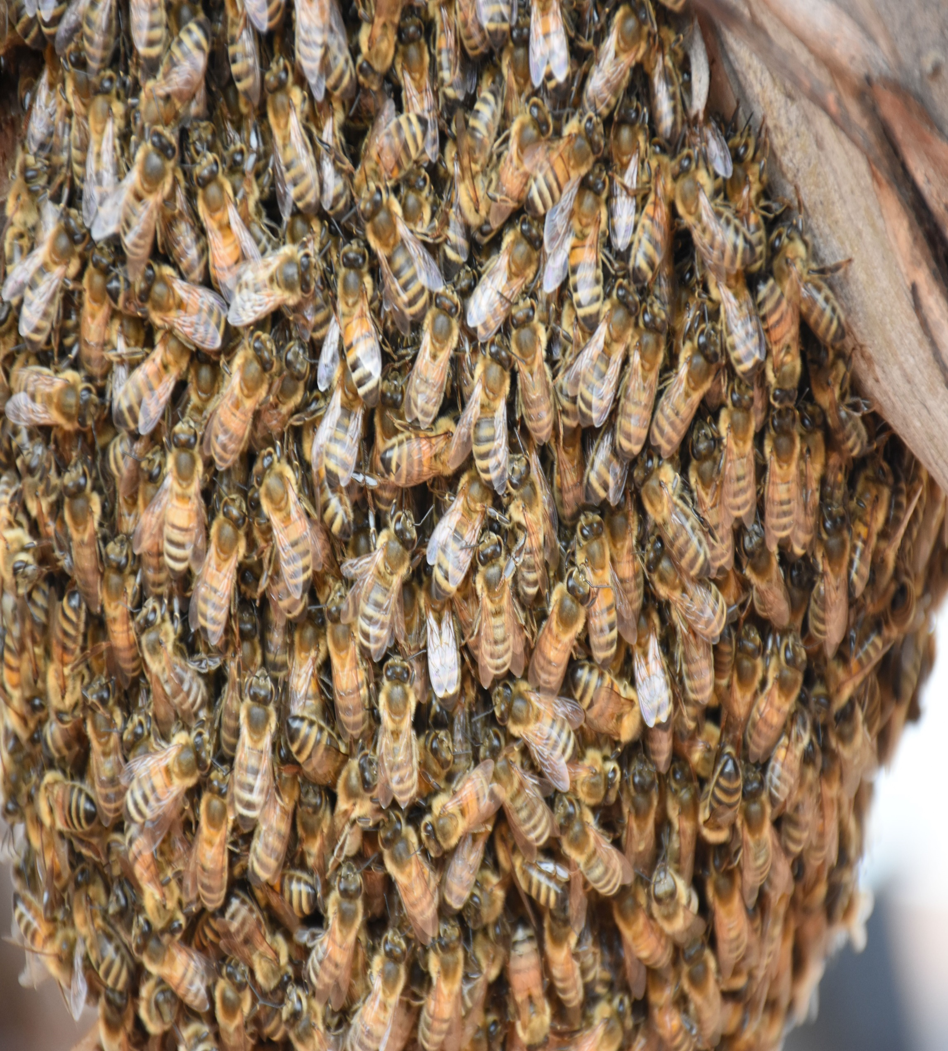



Further information regarding the Livestock Biosecurity Funds may be obtained from:
Manager, Governance Support and Coordination
Agriculture Victoria
475 Mickleham Road, Attwood, Victoria Australia
LivestockBiosecurityFund@agriculture.vic.gov.au
Authorised and published by the Victorian Government, Department of Energy, Environment and Climate Action (DEECA) 2025. © The State of Victoria Department of Energy, Environment and Climate Action 2025.
This publication is copyright. No part may be reproduced by any process except in accordance with the provisions of the Copyright Act 1968.
For more information contact the Agriculture Victoria Customer Service Centre on 136 186.
Disclaimer
This publication may be of assistance to you, but the State of Victoria and its employees do not guarantee that the publication is without flaw of any kind or is wholly appropriate for your particular purposes and therefore disclaims all liability for any error, loss or other consequence which may arise from you relying on any information in this publication.
Accessibility
If you would like to receive this publication in an accessible format, such as large print or audio, please telephone 136 186.
Deaf, hearing impaired or speech impaired? Call us via the National Relay Service on 133 677 or visit www. relayservice.com.au
This document is also available on the Agriculture Victoria website.

Apicultural Industry Advisory Committee
The Apicultural Industry Advisory Committee (AIAC) provides recommendations to the Minister for Agriculture on the allocation of funds from the Honey Bee Compensation and Industry Development Fund (HBCIDF), delivered annually through the Livestock Biosecurity Fund (LBF) grant program.
Funded projects aim to prevent, monitor, and control diseases, thereby improving animal health, biosecurity and supporting market access for the benefit of Victorian apicultural industry.
The Minister for Agriculture appoints the AIAC chairperson and members based on their expertise and experience in accordance with the requirements of the Livestock Disease Control Act 1994 (the Act).

Activities of the Committee
During the 2024-25 financial year, AIAC convened eight times with secretariat support provided by Agriculture Victoria.
Key activities since July 2024 include:
- Conduct of the 2025 Livestock Biosecurity Funds grant program and contributing to the continuous improvement of the annual grant rounds.
- Reviewed and refined the strategic focus for the 2025 grant program to align with industry priorities.
- Provided oversight of the Honey Bee Compensation Industry Fund (HBCIF) including monitoring milestones and the progress of funded projects.

Livestock Biosecurity Funds Grant Program
Since the last report, the HBCIDF has participated in the 2025 Livestock Biosecurity Funds grant program.
The AIAC members individually and the Committee collectively assessed each application received against the selection criteria outlined in the program Guidelines. In finalising recommendations and supporting justifications to the Minister, the AIAC members’ individual assessments, the available balance of the HBCIDF and input from an independent assessment panel were considered to determine recommended projects. An independent Probity Advisor oversaw the process, including the management of conflict-of-interest declarations, and advised on appropriate actions to ensure integrity and transparency.
The 2025 Livestock Biosecurity Funds grant program was open for applications from 7 March 2025 to 14 April 2025. The round was launched with a webinar featuring presentations from all four advisory committees.
In May 2025 AIAC assessed all applications and recommended 2 projects totalling $204,560 to the Minister for Agriculture for approval.
- VAA EDCOMM – Varroa IPM Education Program
- Prescription to restore Box Ironbark Forests for Bee Health

Improved communications and engagement
In 2024 AIAC developed a three year Communications and Engagement Strategy to guide how it promotes the grant program and share the outcomes of funded projects with industry. The strategy outlines key tools, channels and activities aimed at attracting high quality applications and increasing awareness of the benefits delivered through the Honey Bee Compensation and Industry Development Fund (HBCIDF) projects. Implementation of the strategy commenced in 2024 and will continue over the next two grant rounds, with a formal review scheduled at the end of the 3-year period.
As part of the rollout of the AIAC Communications and Engagement Strategy, a webinar launching the 2025 LBF grant program was held on 7 March 2025. The chairpersons of the four Livestock Advisory Committees presented an overview of the 2025 program, including each committee’s strategic focus, eligibility criteria, application process and participated in a Q&A session. The recordings of the webinar is available on the Program Website.

Strategic focus for annual rounds
The AIAC reviewed the strategic direction for the HBCIDF in late 2024 and identified 5 key themes:
- Prevention – build ability for industry to reduce the risks of a biosecurity event.
- Preparedness for response to biosecurity events – building response capability, capacity and planning including the development of innovative control techniques to prevent and manage significant pests and diseases including AFB and the impact of other animal emergency disease events.
- Traceability and early detection – enhance system integrity and effectiveness and build capability to improved surveillance and monitoring.
- Education – awareness and training for industry to better manage apicultural and other animal emergency disease biosecurity risks and impacts, disease treatment and management, and improve bee keeper competency and resilience.
- Applied research – nutrition and genetic breeding programs, including for AFB, building honey bee resistance to significant pests and diseases, understanding of supplementary feeding of bees/husbandry practices to maintain healthy honey bee pollination stocks and benchmarking.
This strategic focus informed the selection criteria for the 2025 grant round and was incorporated into the program Guidelines.

LBF grant program projects
Milestone management of the successful projects is overseen by the Department of Energy, Environment and Climate Action (DEECA), in consultation with the AIAC.
A summary of project activity to date is below.

Summary of active HBCIDF projects
Project  (Recipient) | Project Timeline | Total allocated from HBCIDF | Achievements to 30 June 2025
25.01 Prescription to restore Ironbark Forests for Bee health  (Victorian Apiarist’s Association)  This study explores how hive texture influences colony health and performance, with rough hive surfaces promoting propolis use that reduces pathogens and may lower Varroa mite levels. | Sep 2025 – Sep 2026 | $54,560 | Successful applicant 2025 LBF grant program.
25.02 VAA EDCOMM – Varroa IPM Education Program (Victorian Apiarist’s Association)  This project aims to develop management strategies to sustain healthy Box Ironbark forests, supporting bee health and Victoria’s apiary industry amid climate change challenges. | 01 Oct 2025 – 29 Sep 2028 | $150,000 | Successful applicant 2025 LBF grant program.
24.01 eDNA approaches for early detection and management of varroa mite  (Agriculture Victoria Research, DEECA)  Aims to collect eDNA samples from managed hives to assess the ability to detect varroa mite earlier than traditional methods and therefore enable faster and more effective management through monitoring of varroa mite. | Oct 2024 – Jul 2026 | $80,000 | Over 80 eDNA samples from honeybee hives in Victoria have been collected to detect varroa mites earlier than traditional methods. AgriBio labs are processing samples using validated protocols. More sampling is planned for 2025 with commercial and hobby beekeepers.
24.26 Hemp seed as a feed supplement for managed honey bee populations  (La Trobe University)  Aims to research if hemp seed could be a potential sustainable source as a pollen substitute in both laboratory and field-based experiments. Improving the effectiveness of pollen substitutes is essential for modern beekeeping to maintain the health and nutrition of honey bees. | 2024 –2026 | $8,500 | The second apiary at La Trobe University was successfully established with upgraded hives and stands, improving management and beekeeper comfort. The active comb building shows strong colony growth and effective pest control.
24.35 Online educational resource for beekeepers  (Victorian Apiarists Association)  Will develop the infrastructure, processes and roles to expand and maintain a biosecurity education resource library for beekeepers in Victoria and beyond. | Oct 2024 – Aug 2025 | $8,962 | The VAA launched a successful online video library for bee biosecurity education, boosting its capacity to share up-to-date content. Strong demand and positive feedback position the VAA as a national leader in beekeeper biosecurity.

Background

Honey Bee Compensation Industry Development Fund
Victoria's Honey Bee Compensation and Industry Development Fund (HBCIDF) is established under the Livestock Disease Control Act 1994 (the Act) and is funded by registration fees for Victorian beekeepers.
The HBCIDF funds can be used for projects benefiting the Victorian honey bee industry, disease compensation, and fund administration. All spending must be approved by the Minister for Agriculture, based on AIAC advice.
Victoria's Honey Bee Compensation and Industry Development Fund (HBCIDF) is established under the Act and is funded by registration fees for Victorian beekeeper as follows:
- Beekeepers with up to 5 hives
  - No charge if registration is completed online.
  - $30 if registering and paying via a paper application form
- Beekeepers with more than 5 hives
  - $30 to register 6 – 50 hives
  - 60 cents per hive to register 51 or more hives.
The Act outlines the permitted uses of funds from the Honey Bee Compensation and Industry Development Funds (HBCIDF). These funds are generally allocated to support projects and programs that benefit Victorian honey bee industry, provide compensation for specified endemic diseases and cover the administration of HBCIDF.

Livestock Biosecurity Funds Grant Program
The Livestock Biosecurity Funds grant program is administered by the Department of Energy, Environment and Climate Action, with funding from the respective fund:
- Cattle Compensation Fund
- Sheep and Goat Compensation Fund
- Swine Compensation Fund
- Honey Bee Compensation and Industry Development Fund.
The Livestock Biosecurity Funds grant program aims to support projects and programs that prevent, monitor, and control diseases, thereby improving animal health, biosecurity, and market access for the benefit of Victoria’s cattle, sheep, goat, swine, and honey bee industries.
Funds from the Livestock Biosecurity Funds Grant Program are allocated to projects that deliver outcomes aligned with the Act, and demonstrate the following principles:
- Innovative solutions and emerging technologies for unsolved livestock biosecurity issues, needs, or gaps.
- Collaboration where possible across value chains.
- Quantifiable benefits to the whole of the livestock industries, which are measured and evaluated with evidence and data.
Each fund has a statement of strategic intent that outlines priority investment areas and desired outcomes aligned with the purpose and objectives of the Act. These statements are incorporated into the Guidelines annually.
For more information on the Program, see agriculture.vic.gov.au/support-and-resources/funds-grants-programs/livestock-biosecurity-funds.

Current membership
- Angela Enbom (chairperson) is a director of the family beekeeping business, President of the CVAA. Angela grew up in a farming family in South Gippsland, then spent 20 years overseas, studying, working, travelling and starting a family.​ In 2007 Angela reconnected with her beekeeper cousin Col, established an organic permaculture farm, and joined the Wimmera CMA board.
- Gail Rochelmeyer (member) is a bee keeper and director Ballarat Honey, managing bee and hive health, honey packing, marketing and sales of honey. She is a member of the Geelong and Ballarat Beekeeping clubs. Since 2015, Gail has held the role of Secretary for the Victorian Farmers Federation Beekeeper Branch. Gail is a Registered Nurse Division 1, working at Ballarat Community Health Centre and General Practice.Gail has been a member of the AIAC since 2016 and was the previous chairperson.
- Marc Higgins (member) has been involved in the honeybee industry since 1988. He has served on the Apiculture Advisory Committee since 2020. Marc has been a commercial beekeeper and held numerous other key industry positions, including Deputy Chair of the AHBIC (Australian Honey Bee Industry Council) and Director of BQUAL. He has also held senior executive roles at Capilano and Superbee Honey Factory. Currently, Marc is the CEO of the national charity Community Resources.
- Peter McDonald (member) is first and foremost a Professional beekeeper. He operates within a family run business in Castlemaine for the past 19 years. McDonald Honey are mainly bulk honey producers with a portion of pollination services included. It has a long history through multiple generations of family involvement in both beekeeping and the many beekeeping industry groups that support all beekeepers. Peter has been involved in many industry committees over the years, including a term as Chairperson of the Australian Honey Bee Industry Council (AHBIC).
- Joseph Lewis Riordan (member) was an Apiary Inspector at Agriculture Victoria between 2001 – 2022, hobby beekeeper producing modest quantity of honey sold locally. Joseph is currently running a beekeeping program in a correctional centre and is the Co-founder of the Victorian apiary State Quarantine Response Team (SQRT) 2002.
- Monique Leane (member) has over 15 years of public service experience in primary industry policy, strategy, management, and licensing. Moniques most recent role was the Director of Fisheries Management at the Victorian Fisheries Authority. Monique is currently the Independent Chair of the Victorian Aquatic Organism Translocation Evaluation Panel and western abalone zone annual total allowable catch setting workshop.

